“Role of Exergaming in Memory and Attention Outcomes in Older Adults: A Pre–Post Exploratory Study”.

ABSTRACT
Background: Age-related cognitive decline commonly affects memory, attention, and executive functioning, leading to reduced independence and quality of life in older adults. Exergaming, which integrates physical exercise with interactive digital gaming, has been proposed as a motor–cognitive approach that may support cognitive health.
Objective: To examine changes in attention, working memory, and overall cognitive function following a structured six-week exergaming program in community-dwelling older adults.
Methods: This single-group pre–post exploratory study included 30 adults aged 65 years and above recruited from a university-affiliated physiotherapy center. Participants completed 18 supervised exergaming sessions (30–35 minutes each) over six weeks using a motion-sensing gaming system (Xbox 360 Kinect). Cognitive performance was assessed before and after the intervention using the Trail Making Test (Parts A and B), Digit Span Test (forward and backward), and the Montreal Cognitive Assessment (MoCA). Paired t-tests were used to analyze within-group changes, and effect sizes were calculated to estimate the magnitude of observed differences, with statistical significance set at p ≤ 0.05.
Results: Statistically significant pre–post improvements were observed across all cognitive measures. Completion times for TMT-A and TMT-B decreased significantly, while Digit Span Forward and Backward scores and MoCA total scores increased following the intervention (p < 0.001 for all outcomes). Effect size estimates suggested moderate to large changes across attention, working memory, and global cognition.
Conclusion: Participation in a six-week exergaming program was associated with improvements in attention, working memory, and overall cognitive performance among community-dwelling older adults. However, as the study employed a single-group pre–post design without a control group, causal inferences cannot be drawn. The observed improvements may partly reflect practice effects, participant expectancy, or other concurrent influences. Therefore, these findings should be considered preliminary and exploratory, highlighting the need for randomized controlled trials with appropriate comparator groups to establish effectiveness.
Keywords: Exergaming; cognitive function; memory; attention; older adults; motor–cognitive training

1. INTRODUCTION
Age-related cognitive decline is a major concern in the geriatric population and is typically characterized by impairments in memory, attention, and executive functioning. Such changes increase vulnerability to functional dependence, falls, and diminished quality of life. Globally, approximately one-fifth of older adults are affected by mild cognitive impairment.
Conventional cognitive training programs often report limited success due to poor engagement, repetitive tasks, and low adherence. In contrast, exergaming—defined as the combination of physical exercise with interactive video gaming—offers a more engaging alternative. These systems simultaneously challenge cognitive processes such as attention, visuospatial skills, processing speed, and working memory while encouraging physical activity.
Emerging evidence suggests that exergaming may promote neuroplasticity through activation of motor–cognitive networks, increased cerebral blood flow, and enhanced sensory integration. Features such as real-time feedback, multitasking demands, and motor planning distinguish exergames from traditional exercise approaches and may be particularly suitable for older adults. Nevertheless, structured intervention studies within community-dwelling and Indian elderly populations remain limited.
Accordingly, the present study aimed to examine the effects of a structured six-week exergaming program on attention and memory in older adults.

2. MATERIALS AND METHODS

2.1 Study Design and Setting
A pre–post experimental study was conducted at the Department of Physiotherapy, Sharda Hospital, India. The study was designed to assess changes in attention and memory following a structured exergaming intervention in adults aged 65 years and above.

2.2 Participants
Inclusion criteria:
- Age 65 years or older
- Independent ambulation
- MoCA score ≥18
- Willingness to participate for six weeks
Exclusion criteria:
- Severe visual or auditory impairment
- Uncontrolled neurological or psychiatric conditions
- Recent fractures or cardiovascular instability

2.3 Exergaming Intervention
Participants engaged in exergaming using a motion-capture interactive platform (Xbox 360 Kinect). Each session lasted 30–35 minutes and included:
- Warm-up (5 minutes): marching and upper-limb mobility exercises
- Exergaming (20–25 minutes): activities targeting visuospatial attention, memory recall, task switching, and motor coordination
- Cool-down (5 minutes)
The games incorporated reaction-based tasks, step-sequencing activities, memory-matching challenges, and balance and agility exercises requiring visuomotor integration. Sessions were conducted three times per week for six weeks, total18 sessions. Progression was individualized to maintain optimal task difficulty while ensuring safety. Adherence was defined as completion of at least 85% of sessions.

2.4 Outcome Measures
Cognitive assessments were administered before and after the intervention by a trained physiotherapist using standardized procedures.
- Attention: Trail Making Test Part A (processing speed and attention) and Part B (task switching and divided attention)
- Working Memory: Digit Span Test (forward and backward)
- Global Cognition: Montreal Cognitive Assessment (MoCA)

2.5 Statistical Analysis
Data analysis was performed using SPSS software. Results were expressed as mean ± standard deviation. Paired t-tests were applied to compare pre- and post-intervention scores. Effect sizes (Cohen’s d) and 95% confidence intervals were calculated to aid clinical interpretation. Statistical significance was set at p ≤ 0.05.

3. RESULT & DISCUSSION:

3.1 Participant Characteristics
A total of 30 community-dwelling older adults completed the study. The mean age of participants was 67.5 ± 5.4 years. All participants were independently ambulatory and met the cognitive inclusion criteria at baseline. Baseline Montreal Cognitive Assessment (MoCA) scores indicated mild cognitive impairment on average. No adverse events were reported during the intervention period. Adherence to the intervention protocol was high, with participants attending more than 90% of scheduled sessions.
Table 1 presents changes in attention performance as measured by the Trail Making Test–Part A (TMT-A) and Part B (TMT-B) following the intervention. A statistically significant improvement was observed in both measures.
Table 1. Attention Scores (TMT-A and TMT-B)
(Lower time = better performance)
Variable | Pre-test Mean ± SD | Post-test Mean ± SD | p-value
TMT-A (seconds) | 54.6 ± 9.3 | 42.8 ± 7.5 | <0.001
TMT-B (seconds) | 129.4 ± 28.6 | 103.7 ± 23.5 | <0.001

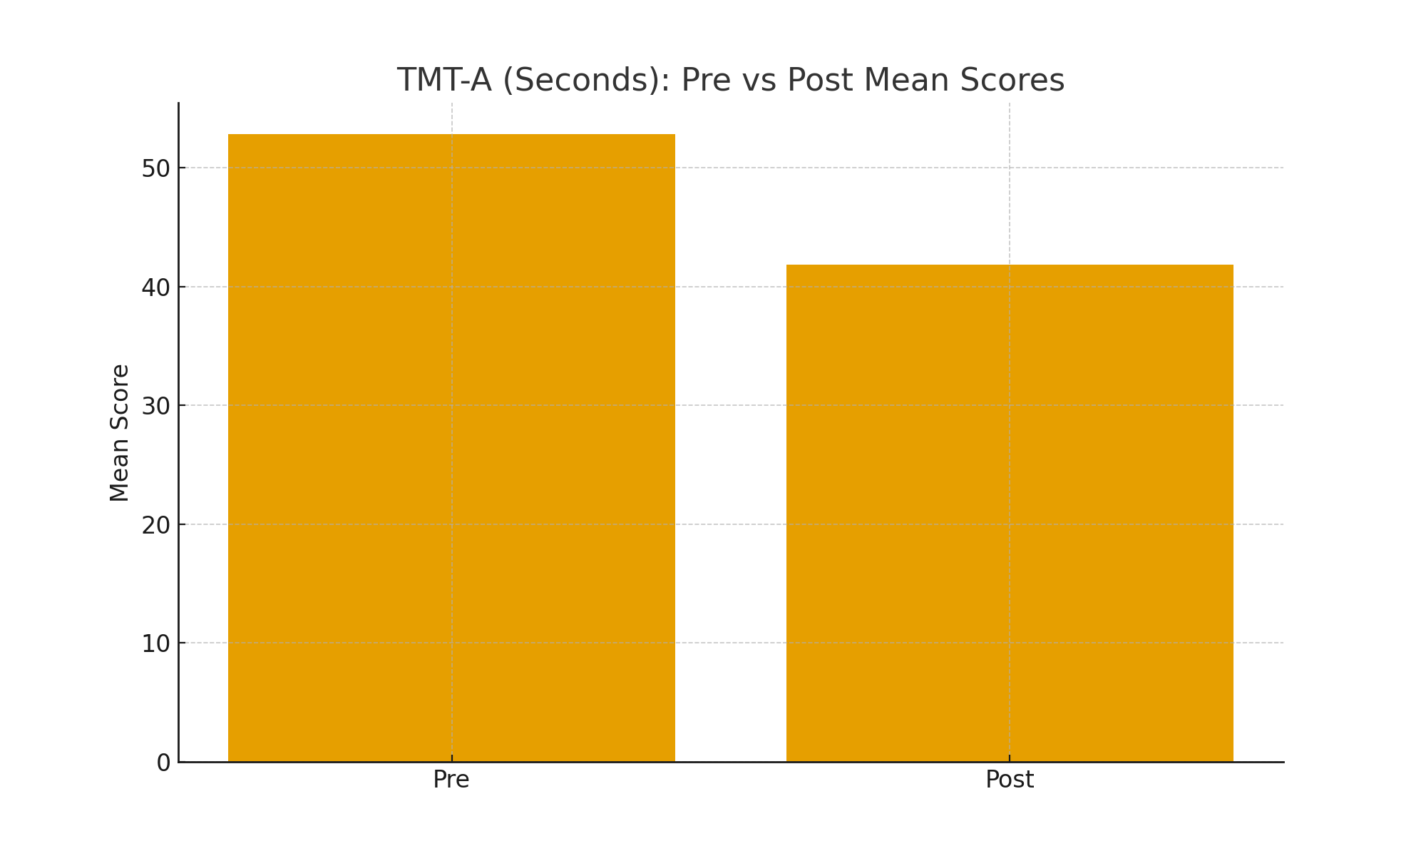
Fig 1- Bar graph showing Trail Making Test–Part A (TMT-A) and Part B (TMT-B)

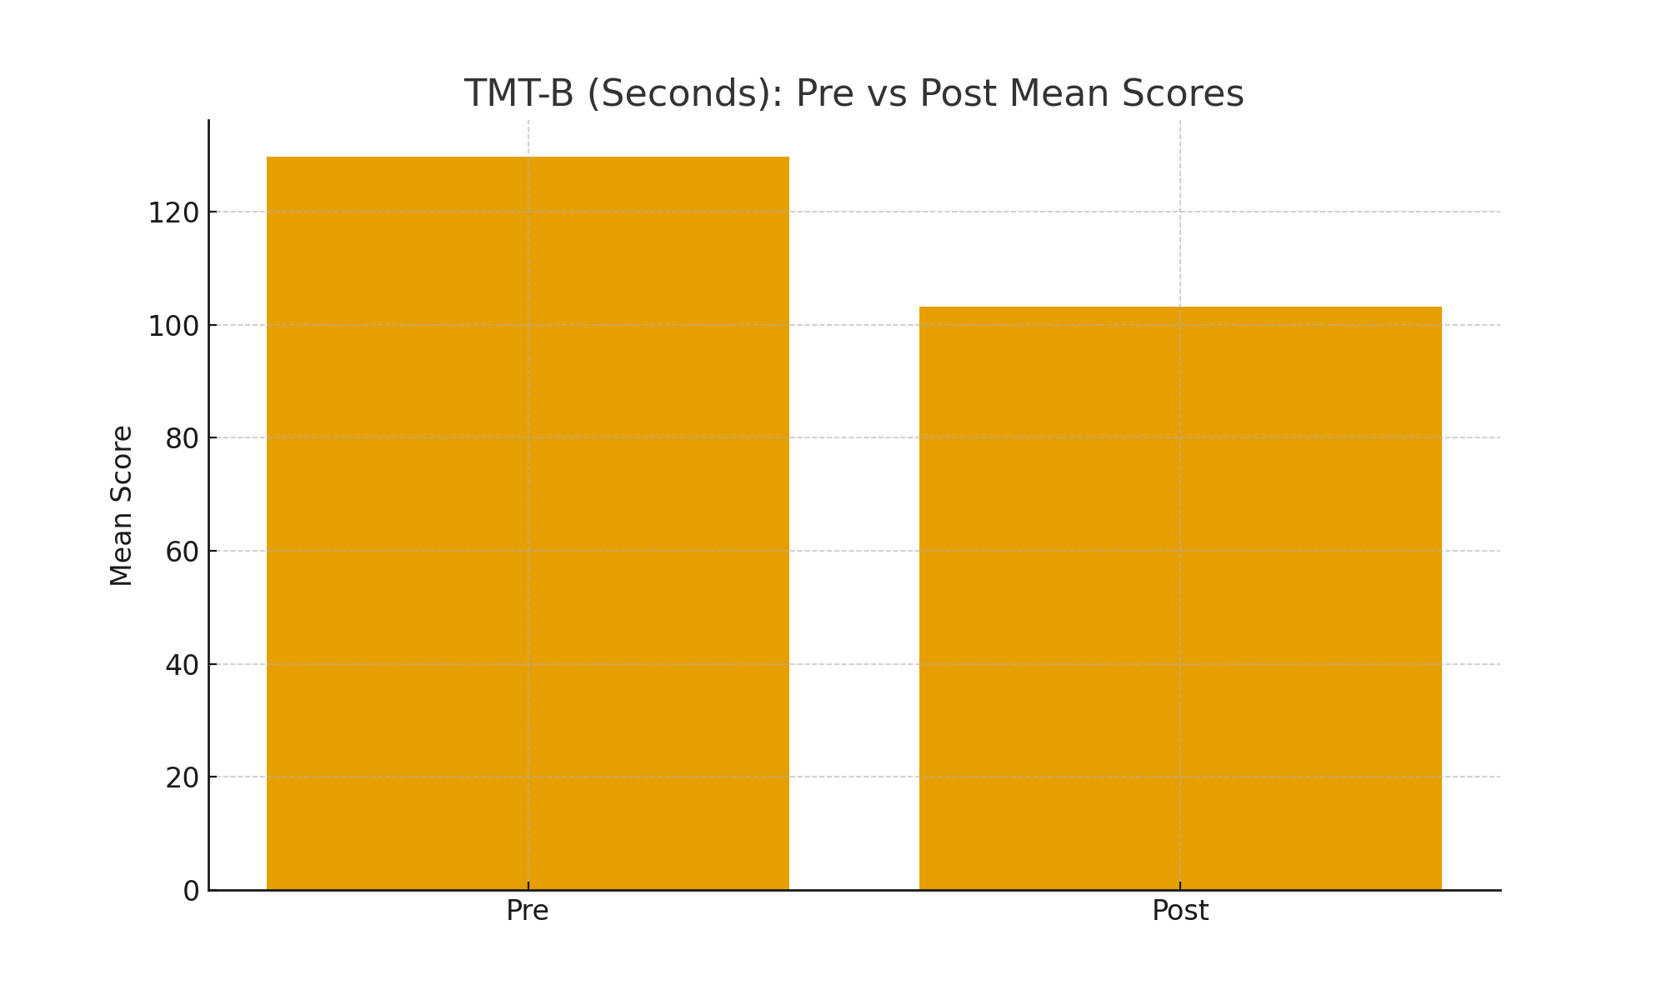

Fig 2- Bar graph showing TMT-B (seconds) pre vs post mean scores

For TMT-A, mean completion time decreased from 54.6 ± 9.3 seconds at pre-test to 42.8 ± 7.5 seconds at post-test, indicating faster visual scanning and psychomotor speed. This reduction was highly significant (p < 0.001).
Similarly, TMT-B completion time improved from 129.4 ± 28.6 seconds to 103.7 ± 23.5 seconds, reflecting enhanced executive function and cognitive flexibility. This change was also statistically significant (p < 0.001).
Overall, the results demonstrate that the intervention led to substantial improvements in attentional processing and executive functioning, as evidenced by significantly reduced completion times on both components of the Trail Making Test.

3.3 Enhancements in Memory
Table 2 summarizes changes in working memory performance as measured by the Digit Span Test. Significant improvements were observed in both the forward and backward components following the intervention.

Table 2. Working Memory (Digit Span Test)
Variable | Pre-test Mean ± SD | Post-test Mean ± SD | p-value
Digit Span Forward | 4.6 ± 1.1 | 5.8 ± 1.0 | <0.001
Digit Span Backward | 3.2 ± 0.9 | 4.1 ± 1.0 | <0.001

Fig 3-Bar graph showing digit span forward for pre vs post mean scores

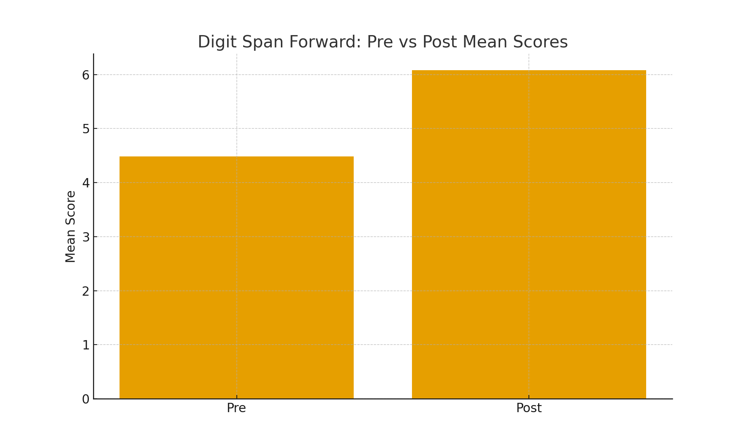
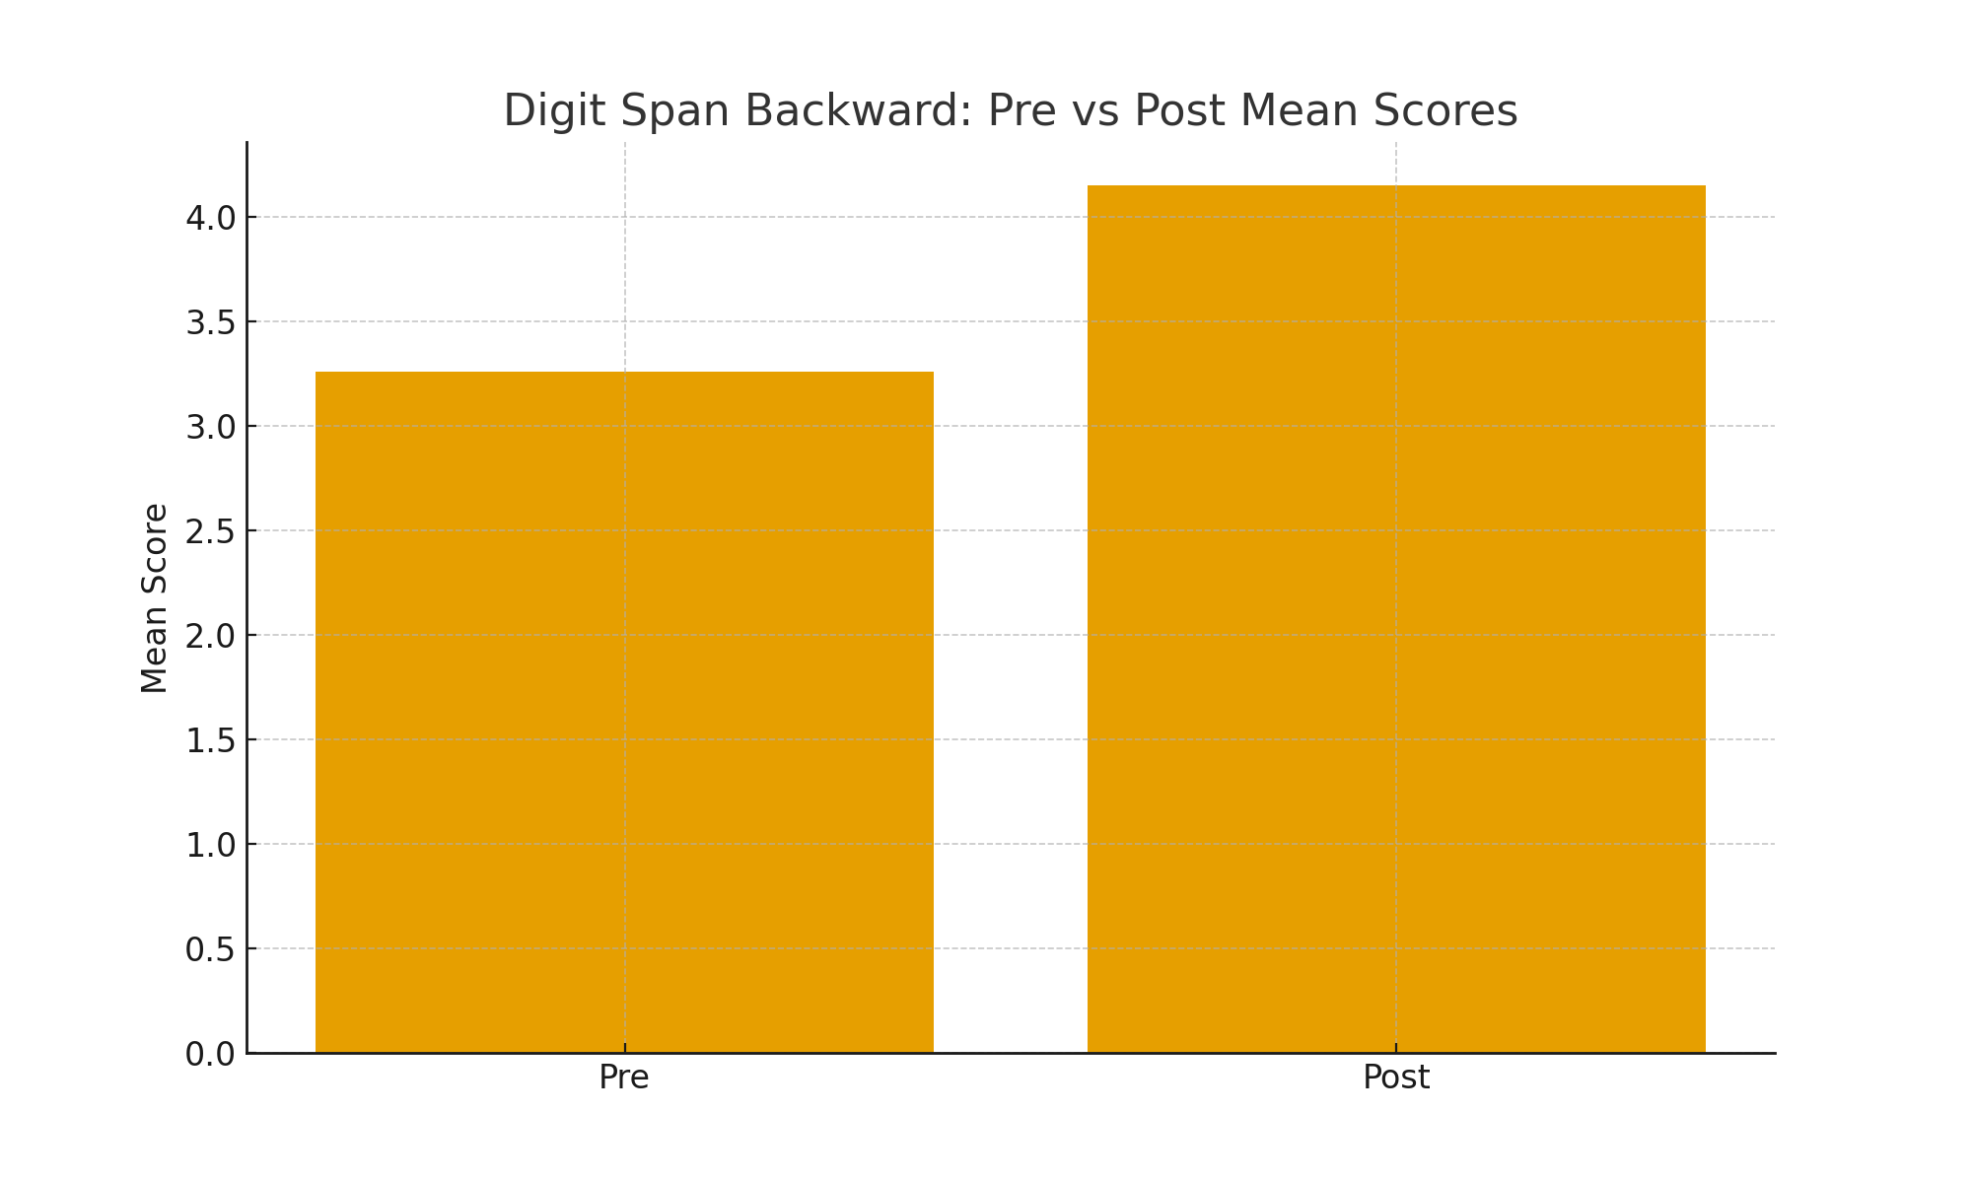
Fig 4- Bar graph showing digit span backward for pre vs post mean scores

For Digit Span Forward, the mean score increased from 4.6 ± 1.1 at pre-test to 5.8 ± 1.0 at post-test, indicating enhanced short-term memory and attention capacity. This improvement was statistically significant (p < 0.001).
Similarly, Digit Span Backward, which reflects working memory manipulation and executive control, showed a significant increase from 3.2 ± 0.9 to 4.1 ± 1.0 (p < 0.001).
These findings demonstrate that the intervention produced robust gains in both simple and complex working memory functions.
Digit Span Forward and Backward scores significantly improved, reflecting gains in immediate memory, working memory, and cognitive flexibility.
Memory-based exergames demand real-time recall, sequencing, and updating of information — all of which stimulate the prefrontal cortex.

3.4 Enhancement in Overall Cognitive Function
Table 3 presents changes in global cognitive functioning as measured by the Montreal Cognitive Assessment (MoCA). A statistically significant improvement was observed following the intervention.
Table 3. Global Cognition (MoCA)

Variable | Pre-test Mean ± SD | Post-test Mean ± SD | p-value
MoCA Total Score | 21.8 ± 2.6 | 25.1 ± 2.9 | <0.001

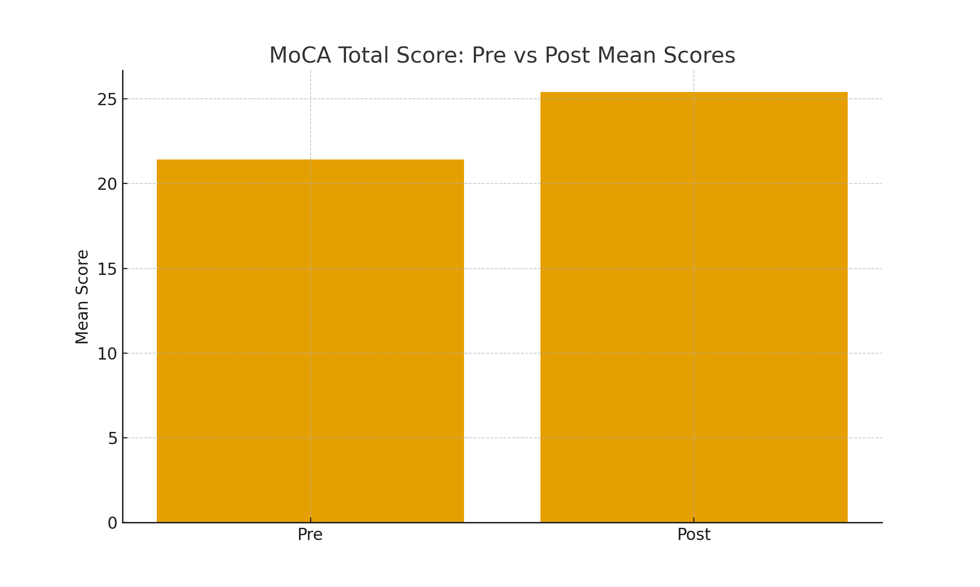
The MoCA total score increased from 21.8 ± 2.6 at pre-test to 25.1 ± 2.9 at post-test, indicating marked enhancement in overall cognitive performance. This improvement was highly significant (p < 0.001).
These results suggest that the intervention was effective in improving global cognition, including memory, attention, executive function, and visuospatial abilities.
Following the exergaming intervention, participants demonstrated a notable increase in general cognitive performance, as indicated by their MoCA scores. The mean MoCA score rose from 21.8 ± 2.6 at baseline to 25.1 ± 2.9 after six weeks of training, reflecting a statistically significant improvement (p < 0.001).
This rise suggests that the combined motor–cognitive demands of the training program contributed to broad gains across multiple cognitive domains, including attention, memory, visuospatial processing, and executive capabilities. Such improvements align with evidence that interactive, cognitively engaging physical activities can stimulate neuroplastic mechanisms, enhance cerebral blood flow, and support overall cognitive resilience in older adults.

The result indicates that a six-week exergaming program is associated with significant improvements in attention, working memory, and overall cognitive functioning in older adults.
Attention: Decreases in completion times on TMT-A and TMT-B reflect improvements in processing speed, selective attention, and cognitive flexibility. Exergaming activities require ongoing visuomotor integration, rapid responses, and environmental monitoring, which may have activated and strengthened attentional networks. [21]
Memory: Significant gains observed in both Digit Span Forward and Backward scores suggest enhancements in short-term and working memory, as well as executive control. Memory-oriented exergames involve continuous recall, sequencing, and information updating, thereby engaging prefrontal cortical regions. [22]
Global cognition: Improvements in MoCA scores indicate broad-based enhancement across multiple cognitive domains, including attention, memory, visuospatial abilities, and executive functions. The combined motor and cognitive demands of exergaming may have promoted neuroplastic changes and increased cerebral perfusion. [23]
Mechanisms and implications: Exergaming may improve cognitive performance through dual task demands, integration of motor and cognitive processes, neuroplastic adaptation, and heightened motivation and engagement. Compared with conventional training, exergames offer immediate feedback, adaptive difficulty, and multisensory input, which can enhance adherence and support sustained cognitive benefits. [24]
Recent literature has highlighted the importance of considering test–retest reliability and practice effects when interpreting cognitive outcomes in older and clinical populations. The MoCA, although highly reliable, has been shown to exhibit measurable practice effects over short retest intervals, with modest effect sizes reported in stroke populations (Cohen’s d ≈ 0.30). [25] Psychometric analyses of digital cognitive assessment tools have also reported variability in practice effects across cognitive domains, emphasizing caution in pre–post comparisons. [26] Similarly, motor–cognitive measures based on the Trail Making paradigm demonstrate differing levels of reliability and learning effects in older adults over short retest periods. [27] To address these concerns, reliable change indices and extended retest intervals have been recommended for MoCA interpretation. Consequently, the cognitive improvements observed in the present study should be interpreted with caution, as repeated testing, expectancy effects, and the absence of a control group limit the ability to attribute changes solely to the intervention. These findings should therefore be regarded as exploratory and hypothesis-generating. [28]

4. CONCLUSION
Engagement in a structured six-week exergaming intervention was linked to observable improvements in attention, working memory, and overall cognitive functioning in community-dwelling older adults. Nevertheless, because the study employed a single-group pre–post design, causal conclusions cannot be established. The improvements noted may be partially attributable to practice effects, participant expectancy, or other non-specific factors. Accordingly, these results should be interpreted as preliminary and indicative of association rather than causation. Further randomized controlled studies incorporating suitable comparison groups, extended follow-up periods, and blinded outcome assessment are needed to confirm efficacy and elucidate underlying mechanisms.

Conflict of Interest: None
Funding: No external funding received.

REFERENCES

- Petersen RC. Mild cognitive impairment. New England Journal of Medicine. 2011 Jun 9;364(23):2227-34.
- Prince, M., Wimo, A., Guerchet, M., Ali, G. C., Wu, Y. T., & Prina, M. (2015). The global impact of dementia: an analysis of prevalence, incidence, cost and trends. World Alzheimer Report, 2015, 84.
- Pérez Silva Mercado, R. R., Ascencio, E. J., Vidal-Cuellar, C. L., Aliaga, E. G., Casas, P. M., Ruiz-Grosso, P., & Tello, T. (2023). Gait speed according to cognitive status in older adults: a cross-sectional study in a resource-limited country. Aging & Mental Health, 27(11), 2153-2161.
- Pendlebury, S. T., Klaus, S. P., Mather, M., De Brito, M., & Wharton, R. M. (2015). Routine cognitive screening in older patients admitted to acute medicine: abbreviated mental test score (AMTS) and subjective memory complaint versus Montreal Cognitive Assessment and IQCODE. Age and ageing, 44(6), 1000-1005.
- Lampit, A., Valenzuela, M., & Gates, N. J. (2015). Computerized cognitive training is beneficial for older adults. Journal of the American Geriatrics Society, 63(12), 2610-2612.
- Sala, G., Tatlidil, K. S., & Gobet, F. (2021). Still no evidence that exergames improve cognitive ability: A commentary on Stanmore et al.(2017). Neuroscience & Biobehavioral Reviews, 123, 352-353.
- Anderson-Hanley, C., Arciero, P. J., Brickman, A. M., Nimon, J. P., Okuma, N., Westen, S. C., ... & Zimmerman, E. A. (2012). Exergaming and older adult cognition: a cluster randomized clinical trial. American journal of preventive medicine, 42(2), 109-119.
- Maillot, P., Perrot, A., & Hartley, A. (2012). Effects of interactive physical-activity video-game training on physical and cognitive function in older adults. Psychology and aging, 27(3), 589.
- Chao, Y. Y., Scherer, Y. K., & Montgomery, C. A. (2015). Effects of using Nintendo Wii™ exergames in older adults: a review of the literature. Journal of aging and health, 27(3), 379-402.
- Pacheco, T. B. F., de Medeiros, C. S. P., de Oliveira, V. H. B., Vieira, E. R., & De Cavalcanti, F. A. C. (2020). Effectiveness of exergames for improving mobility and balance in older adults: a systematic review and meta-analysis. Systematic reviews, 9(1), 163.
- Erickson, K. I., Voss, M. W., Prakash, R. S., Basak, C., Szabo, A., Chaddock, L., ... & Kramer, A. F. (2011). Exercise training increases size of hippocampus and improves memory. Proceedings of the national academy of sciences, 108(7), 3017-3022.
- Guneysu Ozgur, A., Wessel, M. J., Olsen, J. K., Johal, W., Ozgur, A., Hummel, F. C., & Dillenbourg, P. (2020). Gamified motor training with tangible robots in older adults: a feasibility study and comparison with the young. Frontiers in aging neuroscience, 12, 59.
- Eggenberger, P., Wolf, M., Schumann, M., & De Bruin, E. D. (2016). Exergame and balance training modulate prefrontal brain activity during walking and enhance executive function in older adults. Frontiers in aging neuroscience, 8, 66.
- Nouchi, R., Taki, Y., Takeuchi, H., Hashizume, H., Nozawa, T., Kambara, T., ... & Kawashima, R. (2013). Brain training game boosts executive functions, working memory and processing speed in the young adults: a randomized controlled trial. PloS one, 8(2), e55518.
- Buyle, M., Jung, Y., Pavlou, M., Gonzalez, S. C., & Bamiou, D. E. (2022). The role of motivation factors in exergame interventions for fall prevention in older adults: A systematic review and meta-analysis. Frontiers in neurology, 13, 903673..
- Altorfer, P., Adcock, M., de Bruin, E. D., Graf, F., & Giannouli, E. (2021). Feasibility of cognitive motor exergames in geriatric inpatient rehabilitation: a pilot randomized controlled study. Frontiers in aging neuroscience, 13, 739948.
- Gothe, N. P. (2021). Examining the effects of light versus moderate to vigorous physical activity on cognitive function in African American adults. Aging & mental health, 25(9), 1659-1665.
- Reitan, R. M., & Wolfson, D. (2001). The Halstead–Reitan Neuropsychological Test Battery: Research findings and clinical application.
- Verma M, Grover S, Singh T, Dahiya N, Nehra R. Screening for cognitive impairment among the elderly attending the noncommunicable diseases clinics in a rural area of Punjab, North India. Asian journal of psychiatry. 2020 Apr 1;50:102001.
- Nasreddine ZS, Phillips NA, Bédirian V, Charbonneau S, Whitehead V, Collin I, Cummings JL, Chertkow H. The Montreal Cognitive Assessment, MoCA: a brief screening tool for mild cognitive impairment. Journal of the American Geriatrics Society. 2005 Apr;53(4):695-9.

- Smith, P. J., Blumenthal, J. A., Hoffman, B. M., Cooper, H., Strauman, T. A., Welsh-Bohmer, K., ... & Sherwood, A. (2010). Aerobic exercise and neurocognitive performance: a meta-analytic review of randomized controlled trials. Psychosomatic medicine, 72(3), 239-252.

- Anguera, J. A., Boccanfuso, J., Rintoul, J. L., Al-Hashimi, O., Faraji, F., Janowich, J., ... & Gazzaley, A. (2013). Video game training enhances cognitive control in older adults. Nature, 501(7465), 97-101.
- Stanmore, E., Stubbs, B., Vancampfort, D., de Bruin, E. D., & Firth, J. (2017). The effect of active video games on cognitive functioning in clinical and non-clinical populations: A meta-analysis of randomized controlled trials. Neuroscience & Biobehavioral Reviews, 78, 34-43.

- Herold, F., Hamacher, D., Schega, L., & Müller, N. G. (2018). Thinking while moving or moving while thinking–concepts of motor-cognitive training for cognitive performance enhancement. Frontiers in aging neuroscience, 10, 228.

- Chen, T. C., Lee, Y. C., Wang, Y. C., Hsieh, T. L., & Chen, M. H. (2025). A comparison of test-retest reliability and practice effects of short portable mental state questionnaire and montreal cognitive assessment in patients with stroke. Journal of Geriatric Psychiatry and Neurology, 38(1), 53-61.

- Bergman, I., Franke Föyen, L., Gustavsson, A., & Van den Hurk, W. (2025). Test–retest reliability, practice effects and estimates of change: A study on the Mindmore digital cognitive assessment tool. Scandinavian Journal of Psychology, 66(1), 1-14.

- Riis, J., Wølke, S., Danielsen, M. B., Pedersen, M. M., Andersen, S., & Jørgensen, M. G. (2025). Motor–cognitive interactions in older adults: reliability and comparison of Trail Walking and Stepping Trail Making Tests. European Geriatric Medicine, 1-9.

- Aiello, E. N., Solca, F., Torre, S., Curti, B., De Luca, G., Bonetti, R., ... & Poletti, B. (2024). Reliable change indices for the Italian version of the Montreal Cognitive Assessment (MoCA) in non-demented Parkinson’s disease patients. BMC neurology, 24(1), 427.

