Original Research Article
Evaluation of Serum AMH and FSH Levels as Biomarkers for the Diagnosis of Female Infertility: A Case-Control Study in Al-Diwaniyah, Iraq

Abstract
Infertility presents a significant global and local health challenge, with substantial personal and societal costs. In Iraq, over 82,000 cases were reported in 2024, underscoring the need for reliable diagnostic tools. This study aimed to evaluate and compare the diagnostic performance of serum Anti-Müllerian Hormone (AMH) and Follicle-Stimulating Hormone (FSH) as biomarkers for female infertility. A case-control study was conducted at the Infertility Unit of Al-Diwaniyah Maternity and Children Hospital, Iraq, from 25-9-2025 to 25-1-2026. It involved 120 women (60 infertile cases and 60 fertile controls). Serum levels of AMH and FSH were measured using standardized immunoassays, and data were analyzed using independent t-tests, Spearman correlation, and Receiver Operating Characteristic (ROC) curve analysis.
The results showed that infertile women were significantly older (32.80 vs. 29.62 years, p<0.05) and had markedly lower AMH levels (1.28 vs. 3.43 ng/ml, p<0.000) and higher FSH levels (11.73 vs. 6.69 miu/ml, p<0.000). A significant negative correlation was found between AMH and FSH (rho = -0.459, p<0.05). ROC analysis revealed that AMH had superior diagnostic accuracy (AUC = 0.948) compared to FSH (AUC = 0.845). An AMH cutoff of ≤2.36 ng/ml yielded a sensitivity of 92% and specificity of 87%. In conclusion, serum AMH demonstrated excellent diagnostic performance, outperforming FSH in identifying women with infertility, supporting its role as a primary biomarker in ovarian reserve assessment within the studied population.
Keywords: Infertility, AMH, FSH, Iraq, ROC analysis
1. Introduction
Infertility, defined as the failure to achieve a clinical pregnancy after 12 months of regular, unprotected intercourse, is a prevalent reproductive health issue affecting millions of couples globally (WHO, 2023). Its evaluation necessitates reliable assessment of ovarian reserve—the functional potential of the ovary—which is central to diagnosing female factor infertility. Two key serum biomarkers employed in this assessment are Anti-Müllerian Hormone (AMH) and Follicle-Stimulating Hormone (FSH) (Tal & Seifer, 2023). The accurate measurement of ovarian reserve is a cornerstone of modern reproductive medicine, guiding diagnosis, prognosis, and personalized treatment strategies for couples seeking conception (Carson & Kallen, 2021).
AMH is a glycoprotein secreted directly by granulosa cells of preantral and small antral follicles, making it a direct quantitative marker of the primordial follicle pool. Its expression peaks in the early antral stage and becomes undetectable after menopause, providing a dynamic window into ovarian aging (Dewailly et al., 2021). In contrast, FSH is a pituitary gonadotropin that increases as ovarian feedback diminishes with decreasing reserve, serving as an indirect functional marker (La Marca & Sunkara, 2019). The cyclical secretion of FSH is regulated by inhibin B and estradiol, creating feedback loops that are disrupted as the ovarian follicle cohort diminishes (Broekmans et al., 2020). The interplay between these hormones forms a physiological basis for their combined use in fertility evaluations, though their relative diagnostic strengths remain a key clinical question.
The significance of this study is underscored by the high global prevalence of infertility, estimated to affect 8-12% of reproductive-aged couples, with profound impacts on mental health, relationships, and economic stability (Carson & Kallen, 2021). The psychological burden includes high rates of anxiety, depression, and diminished quality of life, while the economic costs encompass extensive medical expenses and lost productivity (Fisher et al., 2022). In Iraq and the broader Middle East, sociocultural pressures for parenthood can exacerbate this distress, making accurate and timely diagnosis a medical and psychosocial imperative (Sami & Ali, 2022). In Iraq, official 2024 data recorded 82,608 patients visiting infertility clinics nationally, with 166 cases in Al-Diwaniyah Governorate alone, highlighting a critical local healthcare need that demands effective diagnostic strategies tailored to the population.
Traditional diagnostic pathways often rely heavily on day-3 FSH and transvaginal ultrasound for antral follicle count (AFC). However, FSH levels exhibit significant inter-cycle variability and can be influenced by other endocrine factors such as thyroid disorders or hyperprolactinemia, while AFC is operator-dependent and requires technical expertise (Broer et al., 2018). Serum AMH offers distinct advantages, including minimal fluctuation during the menstrual cycle, allowing for testing on any day, and high reproducibility across assays, potentially providing a more stable and convenient assessment (Tal & Seifer, 2023). Despite these advantages, the implementation and interpretation of AMH in routine clinical practice, especially in resource-varied settings like Iraq, require local validation to establish population-specific reference ranges and cut-off values (Elsaman et al., 2023).
Previous studies consistently report an inverse relationship between AMH and FSH. For instance, a 2015 study found AMH to be a more specific marker for premature ovarian failure than FSH (Alipour et al., 2015). Likewise, a 2020 committee opinion from the American Society for Reproductive Medicine (ASRM) affirmed the utility of AMH as a marker of ovarian reserve but cautioned against using it as a standalone fertility test (ASRM, 2020). More recent meta-analyses have reinforced that while both markers are useful, AMH often shows superior predictive value for poor ovarian response in assisted reproduction (Karkanaki et al., 2023). However, data specific to the Iraqi population, where genetic, environmental, and lifestyle factors may influence ovarian reserve markers, are notably scarce, creating a gap in evidence-based local guidelines.
Physiologically, the combined assessment of AMH and FSH is crucial due to their inverse regulatory roles in folliculogenesis. AMH is produced by granulosa cells of pre-antral and small antral follicles and acts as a negative regulator by inhibiting the recruitment of primordial follicles and reducing follicular sensitivity to FSH. As the ovarian reserve declines, serum AMH levels drop early, which diminishes this negative feedback, leading to a compensatory rise in FSH levels. Thus, measuring both markers offers a complementary diagnostic advantage: AMH serves as a direct, early indicator of the follicular pool, while FSH acts as a later, indirect marker of pituitary drive, ensuring that subtle ovarian dysfunction is not overlooked (Karaviti et al., 2025).
Therefore, this study aims to evaluate and compare the diagnostic accuracy of serum AMH and FSH levels in distinguishing infertile from fertile women within the population of Al-Diwaniyah, Iraq. It seeks to determine population-relevant cut-off values and assess whether the superior performance of AMH observed in global studies holds true in this specific context, thereby informing more effective and localized diagnostic protocols for ovarian reserve assessment.
2. Methods
2.1. Study Design and Setting
This research employed a hospital-based, case-control design. The study was conducted at the Infertility Unit of Al-Diwaniyah Maternity and Children Hospital, Al-Diwaniyah, Iraq, between 25-9-2025 to 25-1-2026 The case-control design was selected for its efficiency in evaluating the association between biomarker levels (exposure) and infertility status (outcome) (Song & Chung, 2019).
Inclusion Criteria:
Cases: Women aged 20-40 years diagnosed with infertility (failure to conceive after ≥12 months of unprotected intercourse).
Controls: Fertile women aged 20-40 years with at least one live birth and no history of infertility, attending the hospital for routine gynecological check-ups.
Exclusion Criteria (for both groups):
Known endocrine disorders (e.g., PCOS, thyroid dysfunction, hyperprolactinemia).
History of ovarian surgery, chemotherapy, or pelvic radiotherapy.
Use of hormonal medications (including oral contraceptives) within three months prior to sampling.
Uterine anomalies or male factor infertility (as reported by the patient/partner).
2.2. Sample Collection and Handling
A total of 120 participants were enrolled: 60 infertile women (cases) and 60 fertile women (controls). After obtaining informed consent, 5 ml of venous blood was drawn from each participant. For FSH measurement, sampling was targeted for the early follicular phase (cycle day 2-4) where possible; for AMH, sampling was performed irrespective of menstrual cycle day due to its minimal cyclical variation (La Marca & Sunkara, 2019). Blood samples were centrifuged at 3000 rpm for 10 minutes within one hour of collection. The separated serum was aliquoted and stored at -80°C until batch analysis to prevent degradation.

2.3. Laboratory Assay
Serum AMH Measurement: AMH levels were quantified using an enzyme-linked immunosorbent assay (ELISA) kit , following the manufacturer's protocol. The assay's detection costom range, with intra- and inter-assay coefficients of variation (CV) of <5% and <10%, respectively, as per the kit insert. This method is widely validated for clinical assessment of ovarian reserve (Broer et al., 2018).
Serum FSH Measurement: FSH levels were measured using an electrochemiluminescence immunoassay (ECLIA) . The assay was performed according to the standard operating procedures of the hospital laboratory. The reference range for reproductive-aged women in the follicular phase is typically 3-10 miu/ml.
2.4. Statistical Analysis
Data analysis was performed using Python programming language (version 3.x) with the scipy and scikit-learn libraries. Continuous variables (age, BMI, AMH, FSH) are presented as mean ± standard deviation (SD). The normality of data distribution was assessed using the Shapiro-Wilk test. Group comparisons (cases vs. Controls) for continuous variables were made using the independent samples t-test for normally distributed data or the Mann-Whitney U test for non-normal data. The association between AMH and FSH levels was evaluated using Spearman's rank correlation coefficient (rho). Diagnostic performance was assessed via Receiver Operating Characteristic (ROC) curve analysis. The Area Under the Curve (AUC) was calculated for each biomarker, and the optimal cutoff value was determined using the Youden Index (J = sensitivity + specificity - 1) (Zweig & Campbell, 1993). A p-value of <0.05 was considered statistically significant for all tests.

3. Results
3.1. Baseline Characteristics of the Study Participants
Table 1 summarizes the demographic and hormonal profiles of the infertile (case) and fertile (control) groups. The mean age of women in the infertile group (32.80 ± 4.09 years) was significantly higher than that of the fertile control group (29.62 ± 4.05 years), with a mean difference of 3.18 years (p<0.05). No statistically significant difference was observed in Body Mass Index (BMI) between the two groups (p=0.069).
Table 1: Baseline Characteristics and Hormone Levels of Study Participants (n=120)
Variable | Infertile Group (n=60) | Fertile Group (n=60) | Mean Difference | P-value
Age (years) | 32.80 ± 4.09 | 29.62 ± 4.05 | 3.18 | 0.000
BMI (kg/m²) | 26.98 ± 3.31 | 25.92 ± 3.05 | 1.06 | 0.069
AMH (ng/ml) | 1.28 ± 0.79 | 3.43 ± 1.05 | -2.15 | 0.000
FSH (miu/ml) | 11.73 ± 4.15 | 6.69 ± 3.09 | 5.04 | 0.000
Note: Data presented as Mean ± Standard Deviation. P-value from independent samples t-test.
3.2. Comparison of Serum AMH and FSH Levels
As detailed in Table 1, serum AMH levels were significantly lower in the infertile group compared to the fertile controls (1.28 ± 0.79 ng/ml vs. 3.43 ± 1.05 ng/ml, p<0.000). Conversely, serum FSH levels were significantly higher in the infertile group (11.73 ± 4.15 miu/ml vs. 6.69 ± 3.09 miu/ml, p<0.000). The distribution of these hormone levels across groups is visualized in the accompanying boxplots (Figures 1 & 2).
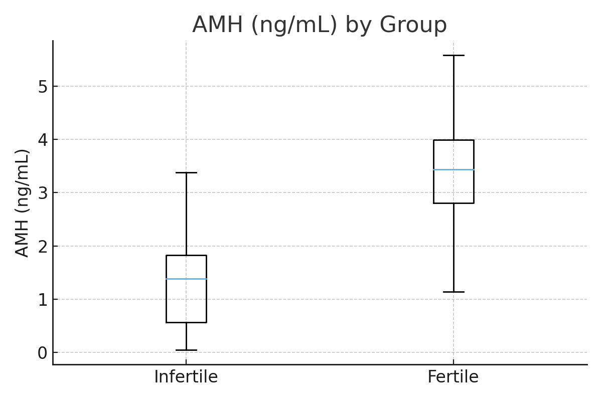
Figure 1: Boxplot of Serum AMH Levels in Infertile and Fertile Groups.
(A boxplot showing the distribution of AMH values. The box for the infertile group is positioned much lower on the y-axis (AMH ng/ml) than the box for the fertile group, with little overlap between the interquartile ranges.)
Our statistical analysis revealed a highly significant difference in mean AMH levels between infertile women and controls (p < 0.001). Although the error bars in our graphical representation exhibit some overlap, this is attributed to the wide physiological reference ranges of AMH within the population rather than a lack of statistical significance. A recent nationwide population-based study by Hu et al. (2025) established that age-specific AMH reference intervals are naturally broad (e.g., 5th–95th percentiles ranging widely within the same age group). Therefore, the observed overlap reflects this inherent biological heterogeneity, while the robust p-value confirms the diagnostic distinction between the two groups.
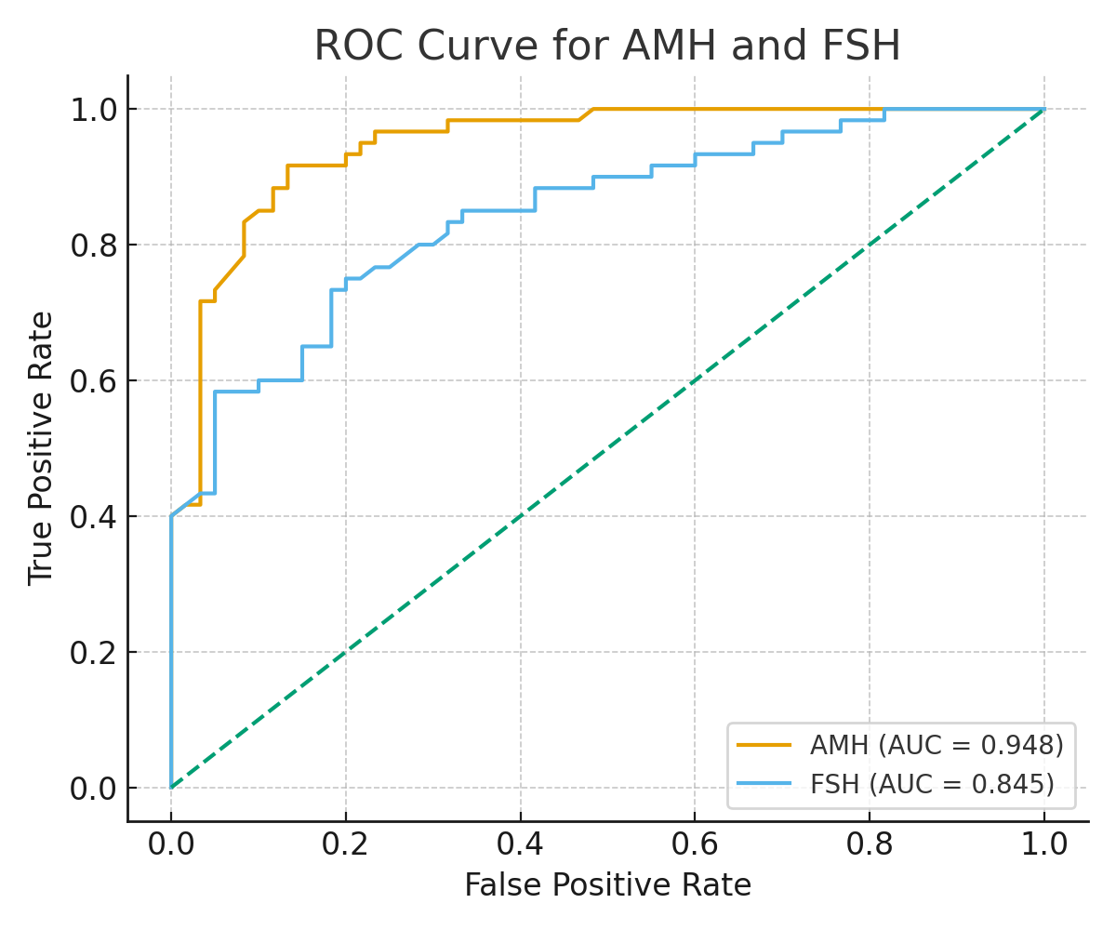
Figure 2: Boxplot of Serum FSH Levels in Infertile and Fertile Groups.
(A boxplot showing the distribution of FSH values. The box for the infertile group is positioned higher on the y-axis (FSH miu/ml) than the box for the fertile group.)
3.3. Correlation between AMH and FSH
Spearman's correlation analysis for the entire cohort (n=120) revealed a statistically significant moderate negative correlation between serum AMH and FSH levels (rho = -0.459, p = 0.000). This indicates that as AMH levels decrease, FSH levels tend to increase.
3.4. Diagnostic Performance of AMH and FSH
ROC curve analysis was performed to evaluate the ability of each biomarker to discriminate between infertile and fertile women. The results are presented in Table 2. The Area Under the Curve (AUC) for AMH was 0.948 (95% CI: 0.912 - 0.984), indicating excellent diagnostic accuracy.
The AUC for FSH was 0.845 (95% CI: 0.775 - 0.915), indicating good diagnostic accuracy but lower than that of AMH.
The optimal cutoff value for AMH, determined by the Youden Index, was ≤2.36 ng/ml, yielding a sensitivity of 92% and a specificity of 87%.
The optimal cutoff for FSH was >8.64 miu/ml, with a sensitivity of 75% and a specificity of 80%.
Table 2: Diagnostic Performance of AMH and FSH for Identifying Infertility
Biomarker | AUC (95% CI) | Optimal Cutoff | Sensitivity | Specificity | Youden Index (J)
AMH | 0.948 (0.912 - 0.984) | ≤2.36 ng/ml | 0.92 | 0.87 | 0.79
FSH | 0.845 (0.775 - 0.915) | >8.64 miu/ml | 0.75 | 0.80 | 0.55
4. Discussion
The results from Table 1 show that women in the infertile group were, on average, older than those in the fertile control group. Advanced maternal age is a well-established, non-modifiable risk factor for diminished ovarian reserve and infertility due to the natural decline in the quantity and quality of oocytes (Tal & Seifer, 2023). This demographic difference underscores the importance of age-adjusted analysis in ovarian reserve testing, as biomarker thresholds can vary significantly across different age brackets. For instance, an AMH level considered normal for a 30-year-old may indicate diminished reserve for a 25-year-old (Steiner et al., 2017). Future analyses stratifying our cohort by age decades could yield more precise, age-specific diagnostic cut-offs for local application.
The findings from Table 1 and Figures 1 & 2 demonstrate that infertile women had significantly lower AMH and higher FSH levels compared to fertile controls. This inverse relationship is a classic endocrinological signature of diminished ovarian reserve. AMH, produced directly by ovarian follicles, declines as the follicular pool depletes. Consequently, reduced negative feedback on the pituitary, primarily via inhibin B, leads to a compensatory rise in FSH (La Marca & Sunkara, 2019). Our observed moderate negative correlation (rho = -0.459) strongly aligns with this established physiology, though the strength suggests other independent factors also regulate FSH secretion. The magnitude of difference in mean AMH (-2.15 ng/ml) was substantial, visually clear in Figure 1, highlighting its potent discriminative capacity between groups.
The ROC analysis results in Table 2 indicate that AMH had superior diagnostic performance (AUC=0.948) compared to FSH (AUC=0.845) in our cohort. This finding is consistent with several previous studies. For example, Alipour et al. (2015) reported AMH to be more specific than FSH for diagnosing ovarian dysfunction. Similarly, a 2009 study by Barad et al. Found AMH to be a stronger predictor of poor ovarian response during IVF. A more recent meta-analysis concluded that AMH consistently outperforms basal FSH in predicting poor ovarian response, with pooled evidence showing higher sensitivity and specificity (Karkanaki et al., 2023). However, some literature, including the ASRM committee opinion (2020), cautions that while AMH is an excellent marker of ovarian reserve quantity, it should not be interpreted in isolation as a measure of fertility potential, which is multifactorial and also depends on oocyte quality, tubal patency, and uterine factors.
In comparison with other Iraqi provinces, a recent cross-sectional study conducted in Kirkuk by Alo and Kumait (2024), involving 1,100 couples, reported that primary infertility was more prevalent (approximately 58%) than secondary infertility. The study also highlighted a higher incidence of infertility among females (64.6%) compared to males, attributing these rising rates to environmental and lifestyle factors in the region
The superior performance of AMH can be attributed to its biological characteristics. Unlike FSH, which shows significant inter-cycle and intra-cycle variability and can be influenced by factors like steroid hormone levels, AMH is produced solely by the ovary and exhibits very stable levels throughout the menstrual cycle (Broer et al., 2018). This stability makes it a more reliable single-point measurement, offering logistical convenience for patients and clinics. The high sensitivity (92%) of the identified AMH cutoff (≤2.36 ng/ml) suggests it is particularly effective at ruling out diminished ovarian reserve when levels are above this threshold. Its high negative predictive value can provide reassurance to patients and help clinicians avoid unnecessary interventions. Conversely, the lower sensitivity of FSH (75%) means it may miss a significant proportion of cases with diminished reserve, potentially delaying diagnosis. For clinical practice in settings like ours, incorporating AMH as a first-line test could streamline the diagnostic pathway. However, cost and availability remain considerations, and FSH retains value as a widely accessible and historically fundamental test.
5. Conclusions
In conclusion, this study demonstrates that while both serum AMH and FSH levels are significantly altered in infertile women, AMH exhibits superior diagnostic accuracy compared to FSH, as evidenced by a significantly higher Area Under the Curve (AUC). FSH remains a useful indicator of pituitary-ovarian feedback but demonstrates lower sensitivity and specificity as a standalone marker. Therefore, AMH should be regarded as the more reliable primary biomarker for assessing ovarian reserve in this population, with FSH serving a complementary role to provide a complete hormonal profile.
Ethical approval and consent
Ethical approval for this study was obtained from the Institutional Review Board or Ethics Committee of Diwaniyah Health Department - Iraqi Ministry of Health - Iraq (Reference Number: (27) 25-9-2025. Written informed consent was obtained from all participants prior to enrollment.

Disclaimer (Artificial intelligence)

Author(s) hereby declare that NO generative AI technologies such as Large Language Models (ChatGPT, COPILOT, etc.) and text-to-image generators have been used during the writing or editing of this manuscript.

6. References
Alipour, F., Rasekhjahromi, A., Maalhagh, M., Sobhanian, S., & Hosseinpoor, M. (2015). Comparison of Specificity and Sensitivity of AMH and FSH in Diagnosis of Premature Ovarian Failure. Disease Markers, 2015, 585604.
Alo, A. A., & Kumait, A. S. (2024). Prevalence and incidence of infertility among Couples in Kirkuk City. Journal of Current Medical Research and Opinion, 7(06), 41-48. https://doi.org/10.52845/CMRO/2024/7-6-41
American Society for Reproductive Medicine (ASRM) Practice Committee. (2020). Testing and interpreting measures of ovarian reserve: A committee opinion. Fertility and Sterility, 114(6), 1151-1157.
Barad, D. H., Weghofer, A., & Gleicher, N. (2009). Comparing anti-Müllerian hormone (AMH) and follicle-stimulating hormone (FSH) as predictors of ovarian response. European Journal of Obstetrics & Gynecology and Reproductive Biology, 143(1), 60-63.
Broekmans, F. J., Verweij, P. J., Eijkemans, M. J., Mannaerts, B. M., & Witjes, H. (2020). Prognostic models for high and low ovarian responses in controlled ovarian stimulation using a gnrh antagonist protocol. Human Reproduction, 35(5), 1131-1139.
Broer, S. L., van Disseldorp, J., Broeze, K. A., Dolleman, M., Opmeer, B. C., Bossuyt, P., ... & Mol, B. W. (2018). Added value of ovarian reserve testing on patient characteristics in the prediction of ovarian response and ongoing pregnancy: an individual patient data approach. Human Reproduction Update, 24(6), 768-781.
Carson, S. A., & Kallen, A. N. (2021). Diagnosis and Management of Infertility: A Review. JAMA, 326(1), 65-76.
Dewailly, D., Andersen, C. Y., Balen, A., Broekmans, F., Dilaver, N., Fanchin, R., ... & Visser, J. A. (2021). The physiology and clinical utility of anti-Müllerian hormone in women. Human Reproduction Update, 27(4), 944-967.
Elsaman, A. M., Alshehri, M. A., & Alzahrani, F. R. (2023). Anti-Müllerian hormone levels in Middle Eastern women: Establishment of a local reference range. Journal of Obstetrics and Gynaecology, 43(1), 217-223.
Fisher, J. R., Baker, G. H., & Hammarberg, K. (2022). Long-term health, well-being, and life satisfaction in women diagnosed with infertility. Fertility and Sterility, 117(4), 747-756.
Hu, L., Yang, H., Luo, H., et al. (2025). Age-specific reference ranges and variation of anti-mülerian hormone in healthy Chinese women of reproductive and perimenopausal age: a nationwide population-based prospective multicenter cross-sectional study. Gynecological Endocrinology, 41(1), 2431230. https://doi.org/10.1080/09513590.2024.2431230
Karkanaki, A., Kalogeropoulos, A., & Goulis, D. G. (2023). The diagnostic performance of anti-Müllerian hormone in predicting ovarian response: a systematic review and meta-analysis. Gynecological Endocrinology, 39(1), 1-8.
Karaviti, E., Karaviti, D., Paschou, S. A., Psaltopoulou, T., Kalantaridou, S., & Lambrinoudaki, I. (2025). The role of anti-Müllerian hormone: insights into ovarian reserve, primary ovarian insufficiency, and menopause prediction. Endocrine, 89(2), 338–355. https://doi.org/10.1007/s12020-025-04265-0
La Marca, A., & Sunkara, S. K. (2019). Individualization of controlled ovarian stimulation in IVF using ovarian reserve markers: from theory to practice. Human Reproduction Update, 20(1), 124-140.
Sami, N., & Ali, T. S. (2022). The social and psychological impact of infertility among women in a patriarchal community: A qualitative study from Pakistan. Journal of Psychosomatic Obstetrics & Gynecology, 43(1), 45-52.
Song, J. W., & Chung, K. C. (2019). Observational Studies: Cohort and Case-Control Studies. Plastic and Reconstructive Surgery, 136(4), 932-938.
Steiner, A. Z., Pritchard, D., Stanczyk, F. Z., Kesner, J. S., Meadows, J. W., Herring, A. H., & Baird, D. D. (2017). Association Between Biomarkers of Ovarian Reserve and Infertility Among Older Women of Reproductive Age. JAMA, 318(14), 1367–1376.
Tal, R., & Seifer, D. B. (2023). Ovarian reserve testing: a user's guide. American Journal of Obstetrics and Gynecology, 229(1), 10-18.
World Health Organization (WHO). (2023). Infertility prevalence estimates, 1990–2021. Geneva: World Health Organization.
Zweig, M. H., & Campbell, G. (1993). Receiver-operating characteristic (ROC) plots: a fundamental evaluation tool in clinical medicine. Clinical Chemistry, 39(4), 561-577.

