Case report

A CASE REPORT ON BURNING MOUTH SYNDROME

ABSTRACT

Burning mouth syndrome (BMS), a chronic orofacial pain disorder with the presence of burning sensation in the oral cavity without any specific oral disease. It commonly affects elderly aged and middle aged women with significant psychological disorders or hormonal changes. Patients also complain of altered taste sensation ,pain in oral mucosa,and dry mouth.It is usually idiopathic in nature and its etiopathogenesis is not yet clear.Following the clinical evaluation,treatment strategies include pharmacological management and reassurance of patients.

Keywords : Burning Mouth Syndrome; Stomatodynia; Psychosomatic; Xerostomia; Glossodynia; Oral pain

1.INTRODUCTION
“Burning mouth syndrome (BMS) is a chronic orofacial pain disorder characterized by a continuous burning sensation in the oral cavity, often affecting the tongue, that lasts at least four to six months” [18, 19]. Patients frequently experience dysgeusia (distorted taste) and xerostomia (a subjective feeling of dry mouth) [18, 3]. The condition predominates in peri- and post-menopausal women, showing a strong gender and age predisposition [19, 4].
BMS may be categorized as either primary (idiopathic), when no underlying condition is identified, or secondary, when the symptoms are associated with systemic, local, or psychological conditions [3, 5]. Although pathophysiology has not yet been clarified, the disorder is considered multifactorial, involving potential neuropathic, hormonal, and psychosocial mechanisms [19, 6]. Some mechanisms include peripheral small-fiber neuropathy, central nervous system sensitization, and hormonal influences affecting the oral mucosa [6]. Psychological stress, anxiety, and depression commonly exist with BMS and may exacerbate symptoms, though their causal relationship is unclear [18, 5]. This case report presents clinical experience regarding treatment protocol for the most common type of oral disease in the elderly population that has no specific etiology.
2.CASE PRESENTATION
A 65-year-old female patient came to the clinic for the primary concern with a persistent burning sensation affecting the inner surfaces of her lips, oral mucosa, and tongue. She reported that these symptoms had been present for approximately 1 year. She had a severe burning sensation in the oral mucosa with dryness of the mouth and tongue with an altered taste sensation. The burning sensation was continuous in onset, aggravated due to intake of hot and spicy food, and relieved by cold water intake. The burning sensation was present upon waking and was severe at sleep hours.
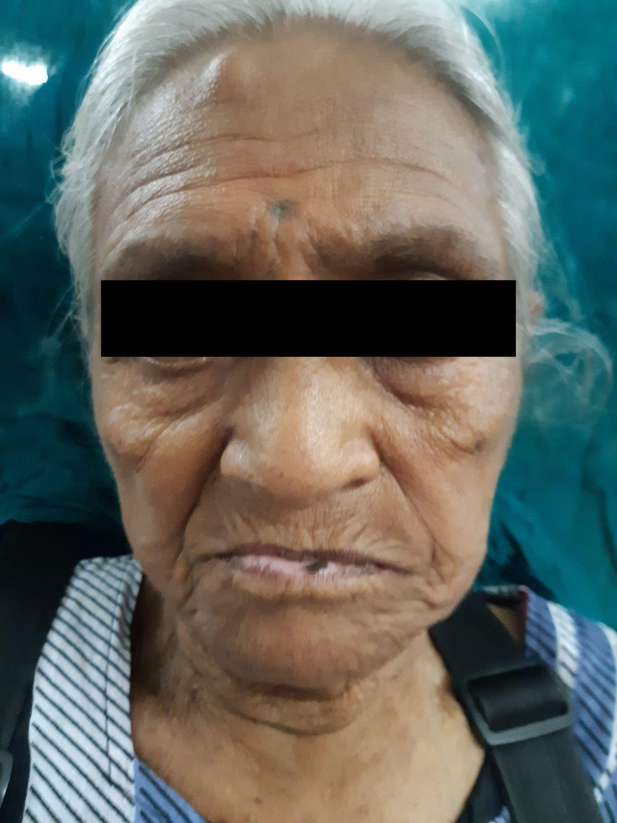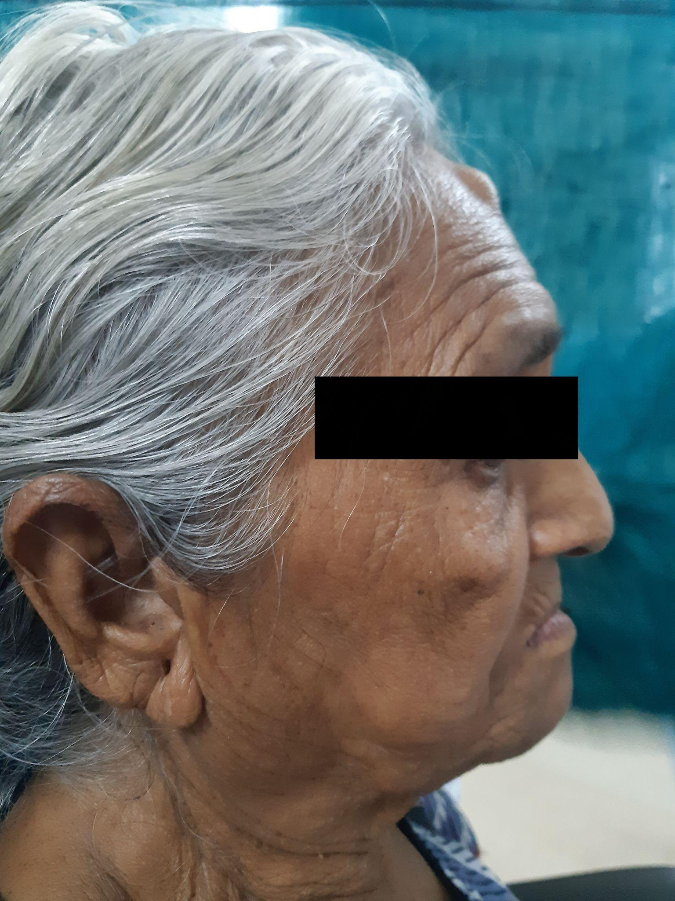
Fig 1 : Extraoral photograph at first vist
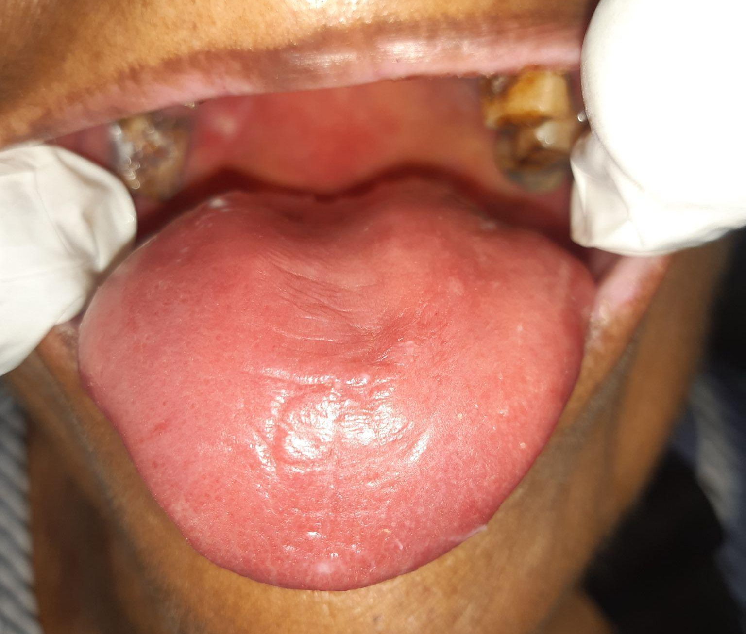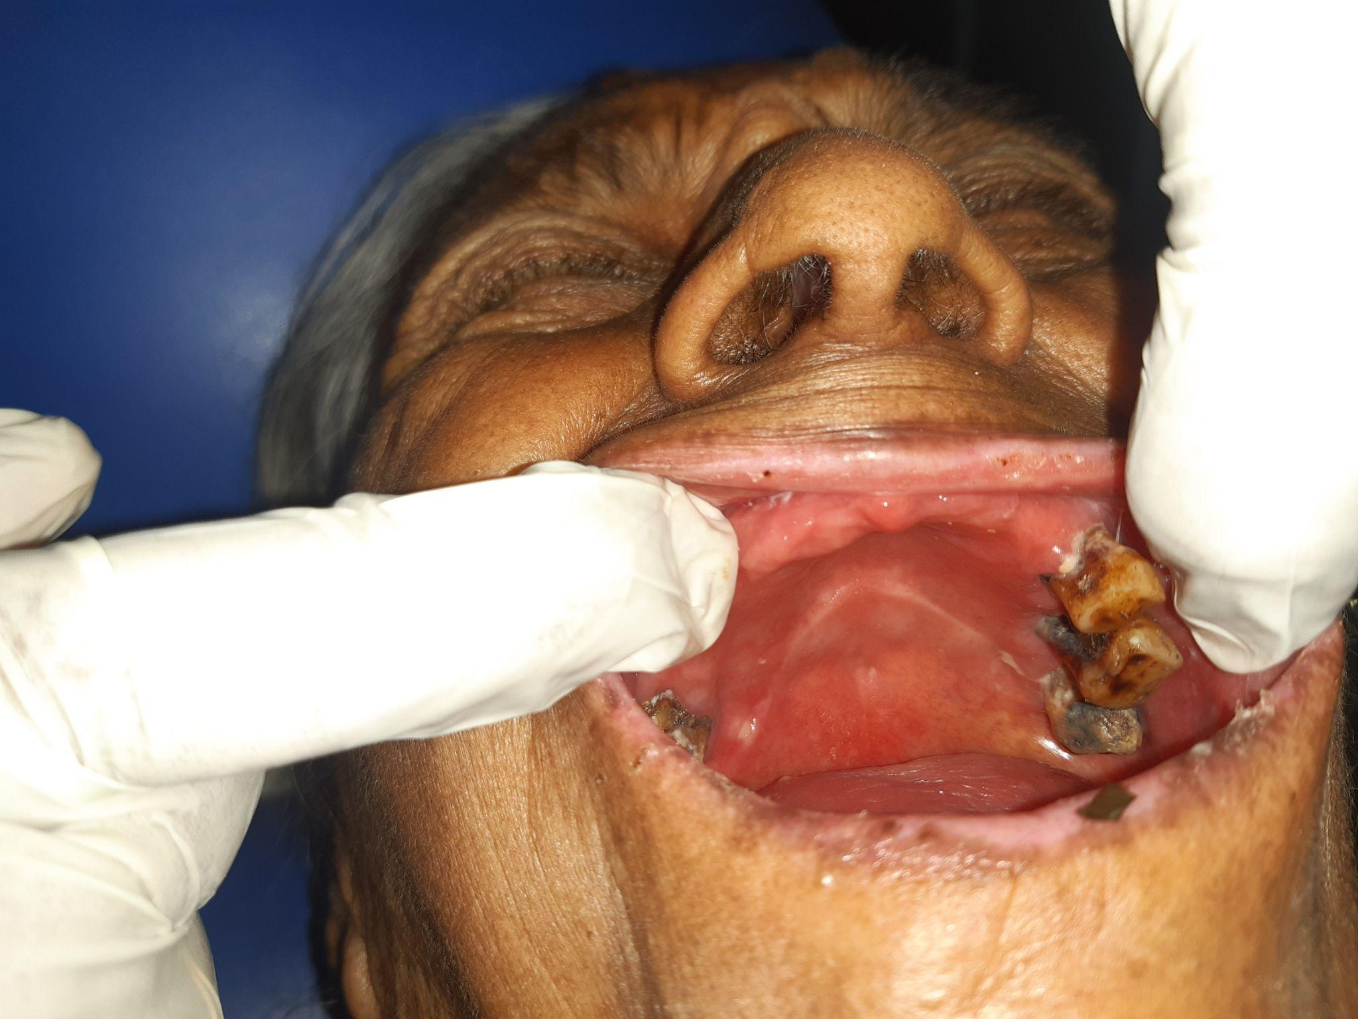
Fig 2 : Intraoral photograph at first visit
During the extraoral examination, no abnormalities were detected. The patient had no deleterious oral habits and reported brushing once daily with a toothbrush and toothpaste. Intraoral examination shows generalized pallor across the buccal mucosa bilaterally, the palatal mucosa, the labial mucosa, along with depapillation in the dorsal aspect of the tongue. The oral cavity appeared dry.The mirror test confirmed decreased salivary wetting, and reduced salivary flow was evident.
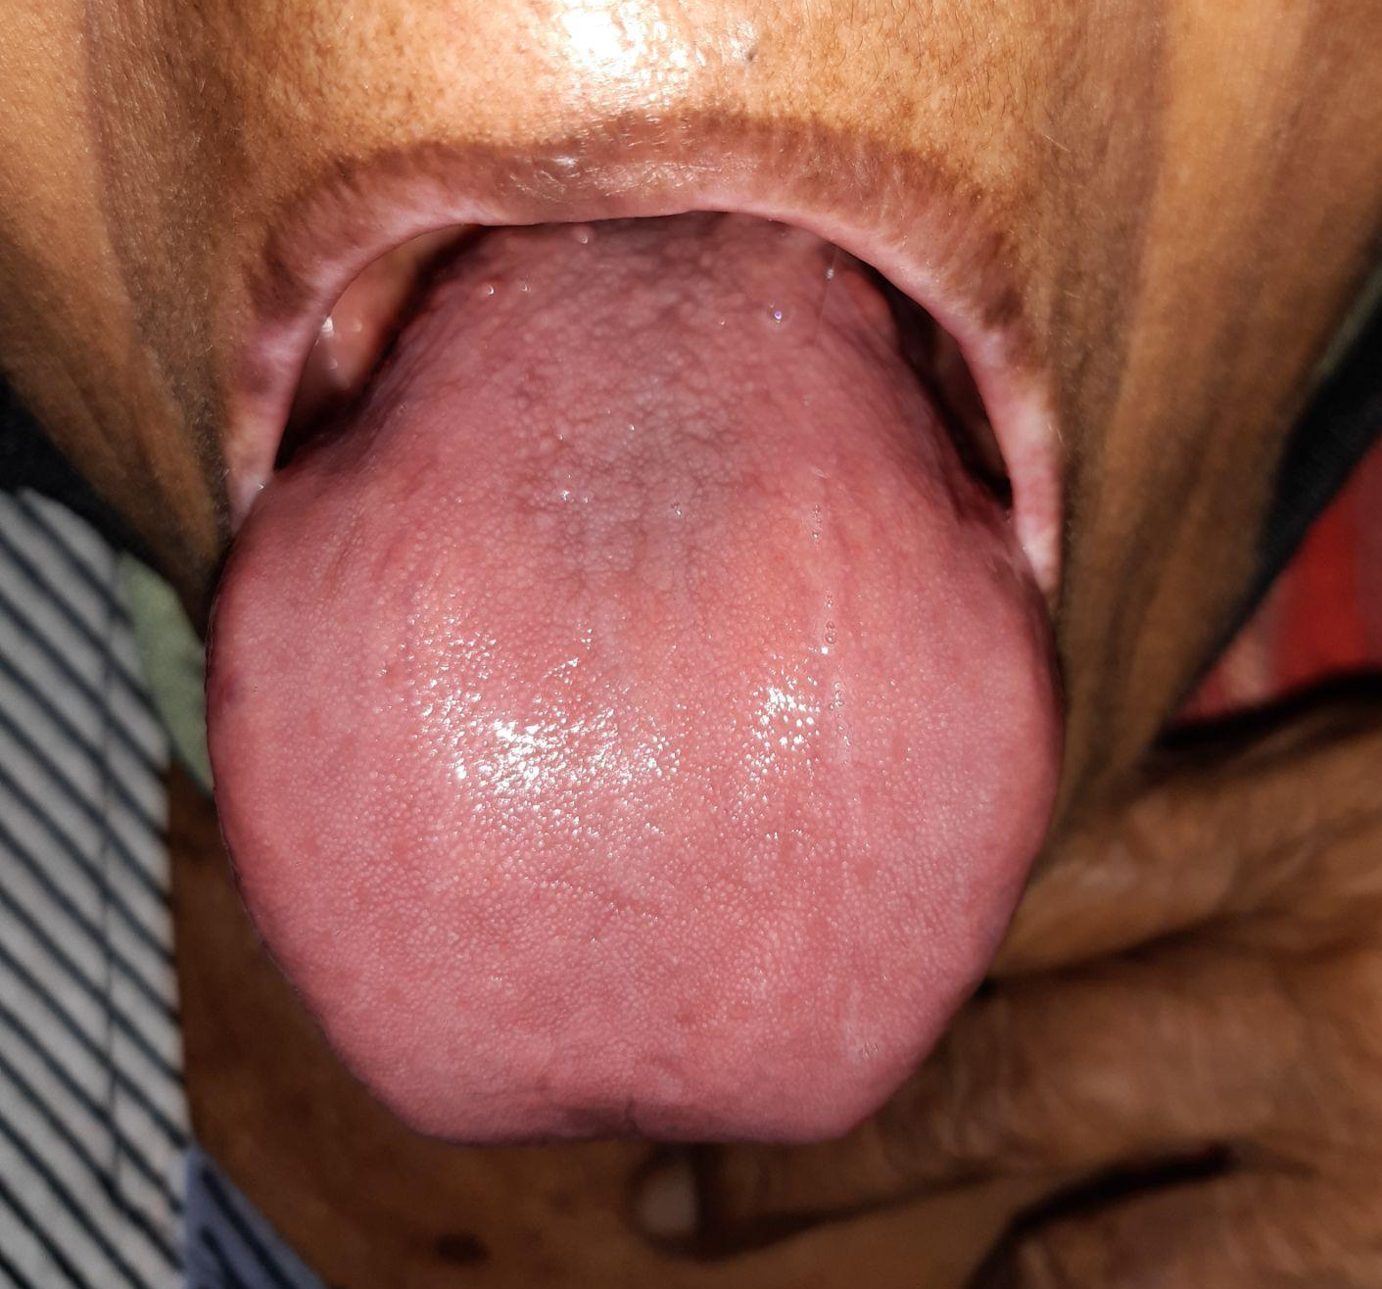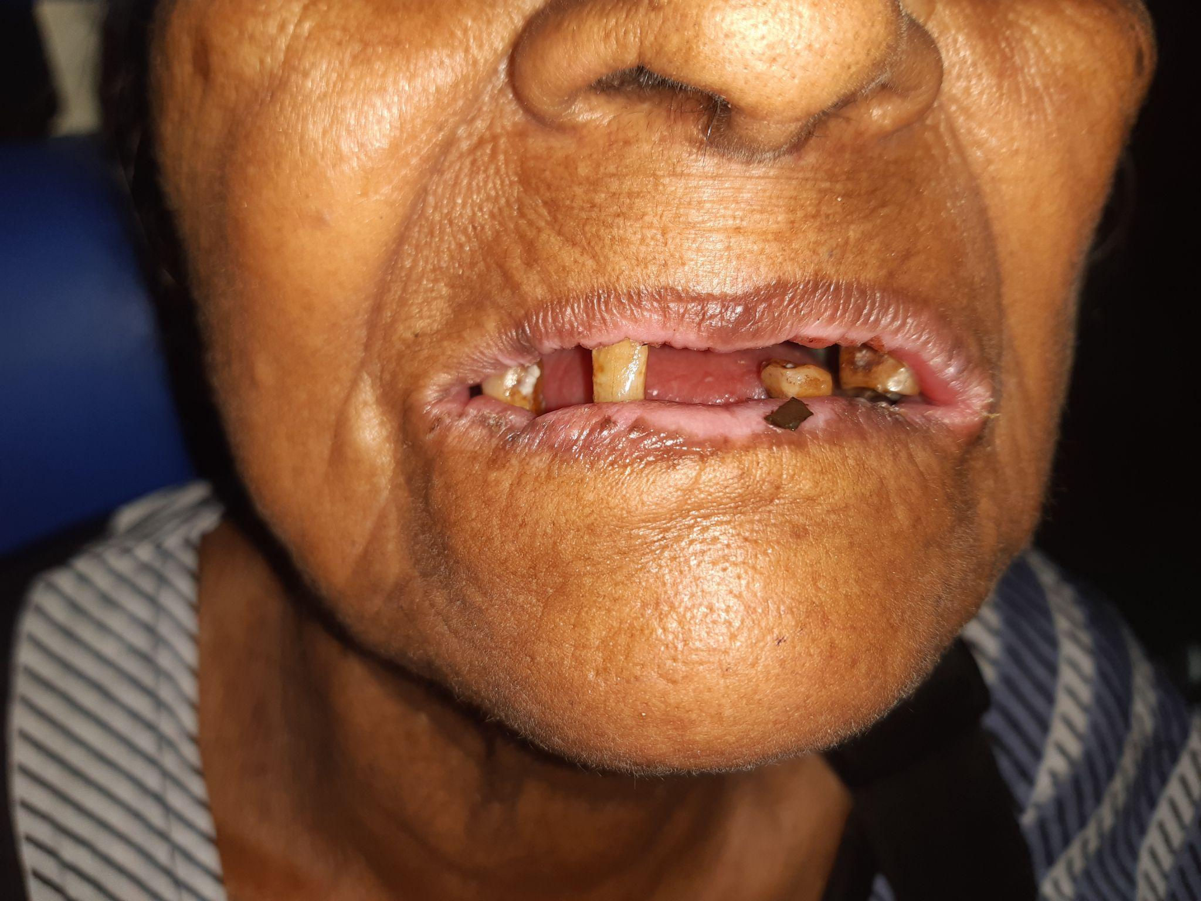
Fig 3 : After review
Hard tissue examination showed generalized gingival recession and attrition. Missing teeth 11–16, 21–23, 25, 31, 32, 34–37, 41, 43, 44, 46, and 47.

We used the pain Visual Analog Scale (VAS) .On a scale of 10 the patient gave the burning sensation a value of 8.
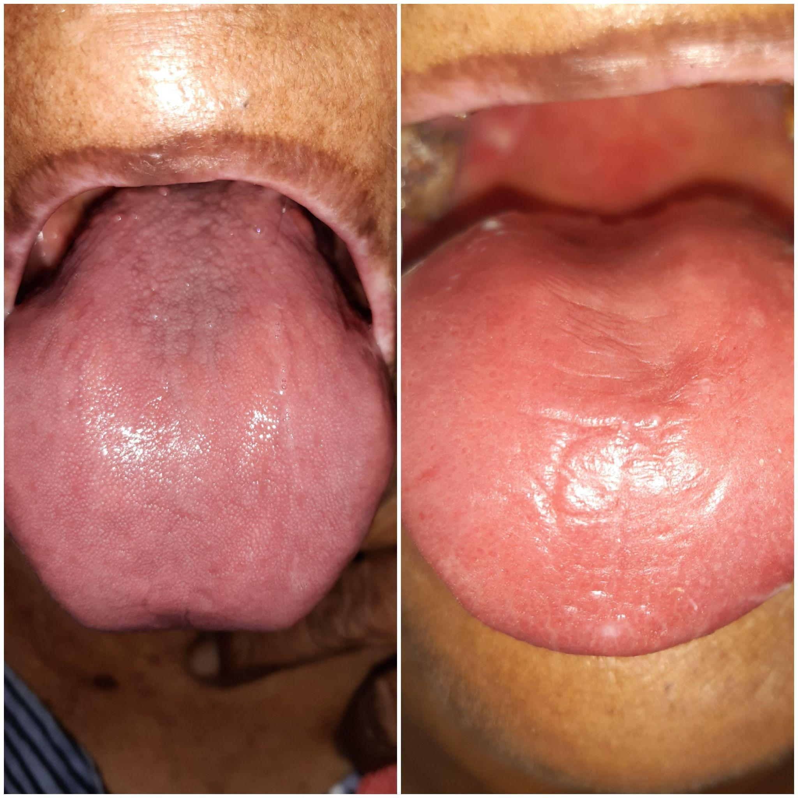
Fig 4 : Before and after
Based on the clinical presentation, the provisional diagnosis was Burning Mouth Syndrome. Differential diagnoses included xerostomia and Sjögren’s syndrome, as these conditions can present with overlapping symptoms. Since no identifiable local or systemic cause could be attributed to her symptoms, the final diagnosis was established as Burning Mouth Syndrome. The following medications were given TAB.TRIPTAZ 10 mg 0-0-1 , TAB.BECOSULES 1-0-1, TAB.ZINCOVIT 0-1-0, TOPICAL CANDID MOUTHPAINT 1%, TOPICAL DENTOGEL for 7 days. The patient was under conservative management for 10 days. The patient was reviewed after 1 week. The patient's healing was satisfactory, and she recovered within 2 consecutive visits.The patient was reviewed after 1 week, and healing was satisfactory. Stress was reduced and the sleep pattern was normal. The patient was advised to take artificial salivary substitutes for 7 days. At the second review after 1 week, healing was satisfactory , patient advised to take TAB.LIMCEE 500mg 1-0-0, TAB.BECOSULES 1-0-1, TAB.ZINCOVIT 0-1-0 FOR 7 DAYS. After 1 week (third review), healing was satisfactory with VAS scale score value was 2.
3.DISCUSSION
“Burning mouth syndrome (BMS) is a chronic orofacial pain disorder with stinging,burning and/or itching of the oral mucosa without any other oral disease or lesion . It lasts up to 4 to 6 months and most commonly involves the tip and anterior two-thirds of the tongue ,followed by the lateral border of the tongue” [16, 17] “with or without extending to the lips, palate and oral mucosa” [6, 7]. BMS can also be accompanied by dysgeusia and xerostomia.The onset was spontaneous, and it has a predilection for peri and postmenopausal women. However, the pathophysiology is not yet clarified. It is associated with anxiety, depression, and sleep deprivation [9].The secondary stage is usually accompanied by oral infections, drug use, thyroid disease, vitamin/mineral deficiencies, psychiatric illnesses, dental treatment, hypercholesterolemia, hyperhomocysteinemia, and hypothyroidism [10, 11], esophageal reflux disease, hypertension and others.Thorough history is the key for ‘diagnosing BMS and it also relates to the symptoms (pain, dry mouth, and taste), their onset,duration, character, intensity, location and factors that improve or worsen its symptoms and pain. Various clinical tests and laboratory tests can be done.”Different diagnostic criteria for BMS have been used over the years for diagnosing BMS after ruling out other causes of burning sensation” [13]. “The most recent diagnostic criteria for BMS is the presence of recurrent intraoral burning sensation for more than 2 hours a day lasting more than 3 months without clinically apparent cause” [14]. “The first step for treating BMS is to consider differential diagnoses and manage those symptoms” [15]. “This precludes secondary BMS and leads to a definitive diagnosis of primary BMS.Management can be broadly discussed as topical medications, systemic medications, and behavioral interactions such as anticonvulsants ( clonazepam, gabapentin, pregabalin), antidepressants (Selective Serotonin Re-uptake Inhibitors(SSRIs), Trazodone, Amitriptyline), H2receptorantogonissts, (lafutidine), antipsychotics, phytomedicine, photobiomodulation, saliva substitutes, vitamins or dietary supplements, (alpha-lipoic acid), mouthwashes (benzydamine hydrochloride & clonazepam), analgesics, and hormone replacements for postmenopausal women” [12] . Herbal agents like ultramicronized palmitoylethanolamide, hypericum perforatum, and lycopene-enriched extra virgin oil are being evaluated for treatment of BMS are recently popular.
4.CONCLUSION
Burning mouth syndrome is a chronic intraoral pain disorder that is often a frustrating condition for patients. It is multifactorial, and the exact etiopathogenesis is unknown. Multidisciplinary approaches for treating BMS include medical and behavioral therapies; however, further well-designed studies with long-term follow-up are necessary to establish optimal treatment and long-term prognosis.

Consent
As per international standards or university standards, patient(s) written consent has been collected and preserved by the author(s).

Disclaimer (Artificial intelligence)
Author(s) hereby declare that NO generative AI technologies such as Large Language Models (ChatGPT, COPILOT, etc.) and text-to-image generators have been used during the writing or editing of this manuscript.

📚 References
- Sun, A., Wu, K. M., Wang, Y. P., Lin, H. P., Chen, H. M., & Chiang, C. P. (2013).
- Burning mouth syndrome: a review and update. Journal of oral pathology & medicine, 42(9), 649-655.
- Grushka M, Epstein JB, Gorsky M. Burning mouth syndrome and other oral sensory disorders: A review. Am J Med. 2002;112(5): 481-487. doi:10.1016/S0002-9343(02)01051-7
- Scala A, Checchi L, Montevecchi M, Marini I, Giamberardino MA. Update on burning mouth syndrome: Overview and patient management. Crit Rev Oral Biol Med. 2003;14(4):275-291. doi:10.1177/154411130301400405
- Patton LL, Siegel MA, Benoliel R, De Laat A. Management of burning mouth syndrome: Systematic review and management recommendations. Oral Surg Oral Med Oral Pathol Oral Radiol Endod. 2007;103 Suppl:S39.e1-13. doi:10.1016/j.tripleo.2006.11.003
- Woda A, Dao T, Gremeau-Richard C. Steroid dysregulation and stomatodynia (burning mouth syndrome). J Orofac Pain. 2009;23(3):202-210.
- .Netto FO, Diniz IM, Grossmann SM, de Abreu MH, do Carmo MA, Aguiar MC. Risk factors in burning mouth syndrome: a case-control study based on patient records. Clin Oral Investig. 2011;15:571-575.
- Lamey PJ, Lamb AB. Prospective study of aetiological factors in burning mouth syndrome. Br Med J (Clin Res Ed). 1988;296:1243-1246.
- Galli F, Lodi G, Sardella A, Vegni E. Role of psychological factors in burning mouth syndrome: a systematic review and meta-analysis. Cephalalgia 2017;37:265-77.
https://doi.org/10.1177/0333102416646769.

10 .Wu YH, Wu YC, Chang JY, Lang MJ, Chiang CP, Sun A. Anemia, hematinic
deficiencies, and hyperhomocysteinemia in younger and older burning mouth
syndrome patients. J Dent Sci2022;17:1144-50.
https://doi.org/10.1016/j.jds.2022.02.005.

11. Russo M, Crafa P, Franceschi M, Rodriguez-Castro KI, Franzoni L, Guglielmetti S, et
al. Burning mouth syndrome and reflux disease: relationship and clinical implications.
Acta Biomed 2022;93:e2022329. https://doi.org/10.23750/abm.v93i6.13391.

12. Tan HL, Smith JG, Hoffmann J, Renton T. A systematic review of treatment for
patients with burning mouth syndrome. Cephalalgia 2022;42:128-61.
https://doi.org/10.1177/03331024211036152.

13. Wu S, Zhang W, Yan J, Noma N, Young A, Yan Z. Worldwide prevalence estimates of
burning mouth syndrome: A systematic review and meta-analysis.
OralDis.2022;28:1431–40. [DOI] [PubMed]

14.The Orofacial Pain Classification Committee. International Classification of Orofacial
Pain, 1st edition(ICOP). Cephalalgia. 2020;40:129–221. [DOI] [PubMed]

15. Ritchie A, Kramer JM. Recent advances in the etiology and treatment of Burning
Mouth Syndrome. J Dent Res 2018;97(11):1193–9.

16.IZ Alajbeg, E Vrbanovic, I Alajbeg, et al.
Time-course of pain and salivary opiorphin release in response to oral capsaicin differ
in burning mouth syndrome patients, temporomandibular disorders patients and
control subjects Clin Oral Investig,
28 (2024), p. 246,10.1007/s00784-024-05653-y2024/04/09

17.M Fang, Y Huang, C Li, et al.
The over-expression of miRNA-206 in peripheral blood of patients with burning mouth
syndrome and its relationship with anxiety and depression J Oral Rehabilitation,
50 (2023), pp. 324-331, 10.1111/joor.1340 2022/12/29

18.Zakrzewska JM. Burning mouth syndrome. BMJ Clin Evid. 2013;2013:1301. [PMCID:
PMC3574592]

19.Jääskeläinen SK. Pathophysiology of primary burning mouth syndrome. Clin
Neurophysiol. 2012;123(1):71-77. doi:10.1016/j.clinph.2011.04.016

