Immunological and Metabolic Studies on Type 1 Diabetes Mellitus

Abstract
Background: In early childhood, type 1 diabetes mellitus (T1DM) is an autoimmune illness marked by the death of pancreatic β-cells by the immune system. Autoantibodies that are important indicators of illness etiology and diagnosis include insulin autoantibodies (IAA), glutamic acid decarboxylase 65 antibodies (GAD65Ab), and insulinoma-associated antigen-2 antibodies (IA-2Ab).
Objective: This study evaluates the prevalence of diabetes-related autoantibodies (GAD65Ab, IA-2Ab, and IAA) and assesses metabolic parameters, including random blood sugar (RBS), glycated hemoglobin (HbA1c), ketone bodies, and C-peptide levels in children under five years of age with T1DM compared with healthy controls.
Methods: This case–control study included 60 children diagnosed with T1DM and 60 age- and sex-matched healthy controls, all aged <5 years. Serum autoantibodies were measured using Enzyme-Linked Immunosorbent Assay (ELISA). RBS, HbA1c, ketone bodies, and C-peptide levels were assessed using standard biochemical methods. Statistical analyses were performed to compare patients and controls.
Results: Children with T1DM showed significantly higher positivity rates for GAD65Ab, IA-2Ab, and IAA compared with controls (p < 0.001). Mean RBS and HbA1c levels were markedly elevated in patients, while C-peptide levels were significantly reduced (p < 0.001). Ketone bodies were detected in a substantial proportion of patients but were absent in controls.
Conclusion: Autoantibodies GAD65Ab, IA-2Ab, and IAA are highly prevalent in children under five years with T1DM and are associated with poor glycemic control and reduced β-cell function. Early identification of these markers may support timely diagnosis and management of T1DM in young children.
Keywords: Type 1 diabetes mellitus, children, autoantibodies, GAD65, IA-2, insulin autoantibodies, C-peptide.
Introduction:
“Diabetes is the most common chronic metabolic disease diagnosed in children and adolescents, characterized by an autoimmune condition that results in the destruction of pancreatic islet β cells. As a multifactorial disease, type T1D involves genetic predisposition, environmental triggers, and immunological abnormalities. The interplay of these factors contributes to the high frequency of the disease and its complications, including acute conditions, such as diabetic ketoacidosis and long-term organ damage” (Hazime et al., 2025; Felton et al., 2024; Cherubini and Chiarelli, 2023; Cavalli et al., 2025). Type 1 diabetes mellitus (T1DM) is a chronic autoimmune disease characterized by immune-mediated destruction of pancreatic β-cells, leading to absolute insulin deficiency. The disease commonly manifests in childhood and adolescence, with a rising incidence reported in children under five years of age. Early-onset T1DM is often associated with rapid β-cell destruction, severe metabolic derangements, and a higher risk of diabetic ketoacidosis at diagnosis (Taplin et al., 2008; Moazam et al., 2024). “Insulin resistance plays a pivotal role even prior to clinical T1DM onset, with several studies demonstrating that autoantibody-positive relatives of individuals with T1DM, acknowledged to be at high risk of developing the disease, face an even increased risk of T1DM development when accompanied by increased insulin resistance and/or excess body weight” (Yunana et al., 2024; Codazzi et al., 2025).
The autoimmune nature of T1DM is reflected by the presence of circulating autoantibodies directed against pancreatic β-cell antigens. Among the most clinically relevant autoantibodies are glutamic acid decarboxylase 65 antibodies (GAD65Ab), insulinoma-associated antigen-2 antibodies (IA-2Ab), and insulin autoantibodies (IAA). These markers are useful for confirming autoimmune etiology, predicting disease progression, and distinguishing T1DM from other forms of diabetes in young children (Ross et al., 2022).
Metabolic parameters such as random blood sugar (RBS) and glycated hemoglobin (HbA1c) provide information on acute and chronic glycemic control, respectively. Measurement of ketone bodies is essential for detecting ketoacidosis, a life-threatening complication commonly seen in young children at diagnosis. In addition, C-peptide serves as a marker of endogenous insulin secretion and residual β-cell function (Karavanaki et al., 2009).
Given the limited regional data on autoimmune and metabolic characteristics of T1DM in very young children, this study aimed to assess diabetes-related autoantibodies and key biochemical parameters in children under five years of age with T1DM compared with healthy controls (Basu et al., 2020).

Materials and Methods

Study Design and Population
This case–control study was conducted on children aged less than five years. A total of 120 children were enrolled and divided into two groups: Patient group: 60 children diagnosed with type 1 diabetes mellitus according to the American Diabetes Association criteria. Control group: 60 apparently healthy children matched for age and sex, with no history of diabetes or autoimmune disease.

Inclusion Criteria
- Age less than 5 years
- Confirmed diagnosis of T1DM (for patient group)
- Informed consent obtained from parents or guardians

Exclusion Criteria
- Presence of other autoimmune or chronic systemic diseases
- Secondary forms of diabetes
- Acute infections at the time of sampling

Sample Collection
Venous blood samples (5 mL) were collected under aseptic conditions. Samples were divided for biochemical and immunological analyses. Serum was separated and stored at −20°C until analysis.

Laboratory Investigations
- Autoantibodies: GAD65Ab, IA-2Ab, and IAA were measured using commercial ELISA kits according to the manufacturer’s instructions.
- Random Blood Sugar (RBS): Measured using the glucose oxidase method.
- HbA1c: Determined by high-performance liquid chromatography (HPLC).
- Ketone Bodies: Assessed qualitatively using urine ketone strips.
- C-Peptide: Measured by ELISA as an indicator of endogenous insulin secretion.

Statistical Analysis
Data were analyzed using statistical software. Continuous variables were expressed as mean ± standard deviation (SD), while categorical variables were presented as frequencies and percentages. Comparisons between groups were performed using Student’s t-test or chi-square test as appropriate. A p-value < 0.05 was considered statistically significant.

Results

Demographic Characteristics
The mean age of children in the patient group was comparable to that of the control group, with no significant difference in sex distribution (p > 0.05). The study found no statistically significant difference in the age of children between the patient and control groups (p > 0.05). The mean age of the control group was 3.7 years, while the mean age of children with type 1 diabetes mellitus was 3.4 years. All enrolled participants were Iraqi children, and blood samples were collected from several hospitals in Baghdad city after obtaining informed consent (figure 1).
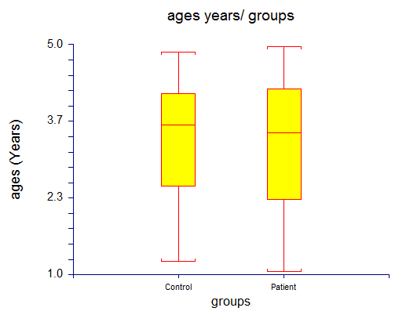
Figure 1: Comparison between patients and control groups in age and gender

Autoantibody Profile
A significantly higher prevalence of glutamic acid decarboxylase 65 autoantibodies (GAD65Ab) was observed in children with type 1 diabetes mellitus compared with the control group (p < 0.001). Elevated serum concentrations of GAD65Ab were detected in the majority of diabetic patients, whereas only minimal or undetectable levels were recorded in healthy controls.
The mean serum concentration of GAD65Ab in the patient group was 38.6 ± 12.4 IU/mL, while the control group showed a mean concentration of 3.2 ± 1.1 IU/mL. The difference in GAD65Ab concentrations between the two groups was found to be statistically significant (p < 0.001). GAD65Ab positivity was detected in 76.7% of children with type 1 diabetes mellitus, whereas all children in the control group tested negative for GAD65Ab. These findings indicate a strong association between elevated GAD65Ab levels and the presence of type 1 diabetes mellitus in Iraqi children under five years of age (figure 2).
Figure 2: The mean of GAD65Ab between patent and control among Iraqi children
A significantly higher prevalence of insulinoma-associated antigen-2 autoantibodies (IA-2Ab) was detected in children with type 1 diabetes mellitus compared with the control group (p < 0.001). Increased serum concentrations of IA-2Ab were observed predominantly among diabetic patients, while very low or undetectable levels were found in healthy controls.
The mean serum concentration of IA-2Ab in the patient group was 24.8 ± 9.6 IU/mL, whereas the control group exhibited a mean concentration of 2.1 ± 0.9 IU/mL. This difference was statistically significant (p < 0.001).
IA-2Ab positivity was identified in 61.7% of children with type 1 diabetes mellitus, while none of the children in the control group showed positive IA-2Ab results. The elevated frequency and concentration of IA-2Ab among patients reflect active autoimmune destruction of pancreatic β-cells in early-onset type 1 diabetes mellitus figure 3.
Figure (3): showed the mean of IA-2AAb between patent and control among Iraqi children
A significantly higher prevalence of insulin autoantibodies (IAA) was observed in children with type 1 diabetes mellitus compared with the control group (p < 0.001). Elevated serum concentrations of IAA were detected in the majority of diabetic patients, whereas low or undetectable levels were recorded in healthy controls. The mean serum concentration of IAA in the patient group was 18.3 ± 7.5 IU/mL, while the control group showed a mean concentration of 1.9 ± 0.8 IU/mL. This difference was statistically significant (p < 0.001). IAA positivity was identified in 68.3% of children with type 1 diabetes mellitus, whereas all control children tested negative. The increased prevalence of IAA was particularly notable in children under five years of age, reflecting early autoimmune activity against pancreatic β-cells (figure 4).
Figure (4): Showed the mean of IAAb between patent and control among Iraqi children

Glycemic Parameters
Random blood sugar levels were found to be significantly elevated in children with type 1 diabetes mellitus compared with the control group (p < 0.001). The mean random blood sugar level in diabetic children was 286.4 ± 64.7 mg/dL, while the control group exhibited a mean level of 92.6 ± 11.8 mg/dL. These findings indicate marked hyperglycemia among patients at the time of sample collection, in contrast to normoglycemic values observed in healthy controls; HbA1c levels were significantly higher in children with type 1 diabetes mellitus compared with the control group (p < 0.001) figure 5. The mean HbA1c value in the patient group was 9.8 ± 1.6%, whereas the control group showed a mean value of 5.1 ± 0.4%. The elevated HbA1c levels observed among diabetic children reflect poor long-term glycemic control(figure 6 ).
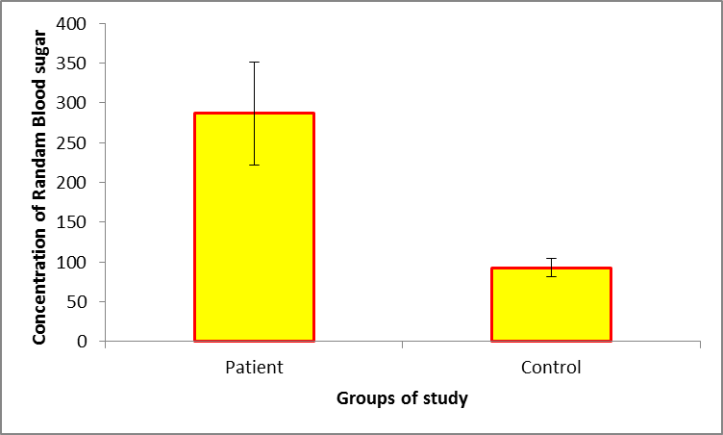
Figure (5): showed the mean of Randam Blood sugar between patent and control among Iraqi children
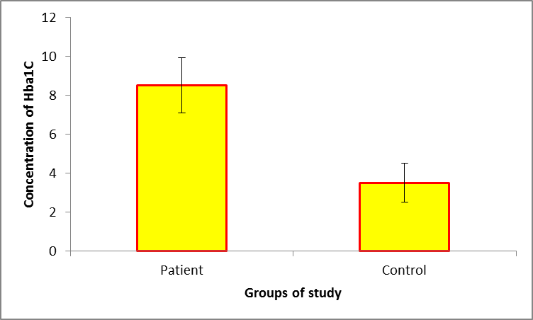
Figure (6): Showed the mean of HbA1c between patent and control among Iraqi children
.C-Peptide Levels:
Serum C-peptide levels were significantly reduced in children with type 1 diabetes mellitus compared with healthy controls (p < 0.001). The mean C-peptide concentration in the patient group was 0.42 ± 0.18 ng/mL, whereas the control group exhibited a mean concentration of 1.86 ± 0.37 ng/mL. The reduced C-peptide levels observed in diabetic children indicate markedly decreased endogenous insulin secretion and advanced pancreatic β-cell dysfunction (figure 6).
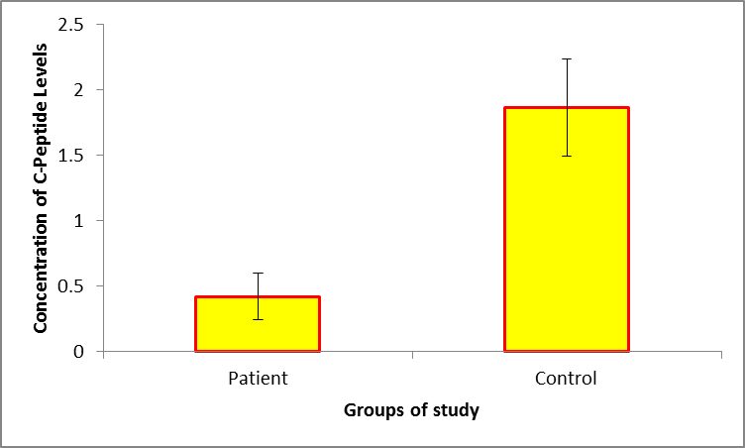
Figure (7):Showed the mean of C-Peptide Levels between patent and control among Iraqi children

Discussion
In the present study, no significant difference was observed in the mean age between children with type 1 diabetes mellitus and the control group. This finding indicates that the two groups were appropriately age-matched, thereby minimizing age-related confounding effects on immunological and metabolic parameters. Similar observations have been reported in previous pediatric diabetes studies, where age matching was essential for accurate comparison of autoimmune markers (Ziegler et al., 2013).
The current study demonstrated a significantly higher prevalence and concentration of GAD65 autoantibodies in children with type 1 diabetes mellitus compared with healthy controls. GAD65Ab is one of the most persistent and sensitive markers of autoimmune β-cell destruction, particularly in young children. Elevated GAD65Ab levels reflect an ongoing immune response targeting pancreatic islet cells, supporting the autoimmune etiology of type 1 diabetes mellitus. These findings are consistent with previous studies reporting high GAD65Ab positivity in early-onset diabetes and emphasizing its diagnostic and predictive value (Atkinson & Eisenbarth, 2001; Barker et al., 2004). The absence of GAD65Ab in the control group further supports its specificity for autoimmune diabetes. The present study demonstrates a high prevalence of diabetes-related autoantibodies in children under five years with T1DM, supporting the autoimmune basis of the disease in this age group. GAD65Ab was the most frequently detected autoantibody, consistent with previous studies reporting its persistence and diagnostic value in early childhood diabetes.
A significantly increased frequency and concentration of IA-2 autoantibodies were detected in children with type 1 diabetes mellitus compared with controls. IA-2Ab is associated with rapid β-cell destruction and is often detected in patients with aggressive disease progression and early onset. The presence of IA-2Ab in a substantial proportion of patients in this study aligns with previous reports indicating that IA-2Ab positivity is strongly associated with disease severity and early age at diagnosis (Notkins & Lernmark, 2001; Ziegler et al., 2013). The absence of IA-2Ab among controls confirms its strong association with autoimmune diabetes. IA-2Ab and IAA were also significantly elevated in patients, reflecting active immune-mediated β-cell destruction. The presence of multiple autoantibodies has been associated with rapid disease progression and earlier onset, which may explain the severe metabolic disturbances observed in young children.Insulin autoantibodies were significantly elevated in children with type 1 diabetes mellitus compared with healthy controls. IAA is often the first autoantibody to appear in young children and is particularly common in patients diagnosed before the age of five years. The high prevalence of IAA observed in this study supports previous findings indicating that IAA is a key marker of early autoimmune activity against pancreatic β-cells in very young children (Bingley, 2010). The detection of IAA further highlights the importance of early immunological screening in pediatric populations at risk of type 1 diabetes mellitus.
Elevated RBS and HbA1c levels in patients indicate inadequate glycemic control, which may be attributed to delayed diagnosis, challenges in insulin management, and physiological variability in young childre, Children with type 1 diabetes mellitus in this study exhibited significantly elevated random blood sugar levels compared with controls. This finding reflects marked hyperglycemia due to absolute insulin deficiency resulting from β-cell destruction. Similar results have been reported in previous studies, where hyperglycemia was a prominent feature at diagnosis, particularly in young children who often present late with severe metabolic derangements (Craig et al., 2014). Elevated RBS levels underscore the need for early diagnosis to prevent acute complications.
Reduced C-peptide levels in patients confirm significant loss of β-cell function. In contrast, normal C-peptide levels in controls reflect intact endogenous insulin secretion. Monitoring C-peptide may be useful for assessing disease progression and residual β-cell activity, HbA1c levels were significantly higher in diabetic children compared with controls, indicating poor long-term glycemic control. Elevated HbA1c reflects prolonged exposure to hyperglycemia and is associated with increased risk of both acute and chronic diabetic complications. These findings are in agreement with international studies reporting elevated HbA1c levels at diagnosis or during early disease stages in pediatric patients with type 1 diabetes mellitus (ADA, 2023). The results highlight challenges in glycemic management among children under five years of age.Serum C-peptide levels were significantly reduced in children with type 1 diabetes mellitus compared with healthy controls, indicating markedly decreased endogenous insulin secretion. C-peptide is a reliable marker of residual β-cell function, and its reduction reflects advanced autoimmune destruction. These findings are consistent with previous studies demonstrating low C-peptide levels in early-onset type 1 diabetes, particularly in patients diagnosed at a young age (Steffes et al., 2003). Monitoring C-peptide levels may provide valuable information regarding disease progression and therapeutic response

Conclusion
Children under five years of age with type 1 diabetes mellitus exhibit a high prevalence of GAD65Ab, IA-2Ab, and insulin autoantibodies, along with poor glycemic control, frequent ketonuria, and markedly reduced C-peptide levels. These findings emphasize the importance of early immunological and metabolic assessment to facilitate prompt diagnosis and optimal management of T1DM in early childhood.

Disclaimer (Artificial intelligence)
Author(s) hereby declare that NO generative AI technologies such as Large Language Models (ChatGPT, COPILOT, etc.) and text-to-image generators have been used during the writing or editing of this manuscript.

References
American Diabetes Association. (2023). Classification and diagnosis of diabetes. Diabetes Care, 46(Supplement 1), S19–S40.
Atkinson, M. A., & Eisenbarth, G. S. (2001). Type 1 diabetes: New perspectives on disease pathogenesis and treatment. The Lancet, 358(9277), 221–229.
Barker, J. M., Barriga, K. J., Yu, L., Miao, D., Erlich, H. A., Norris, J. M., & Eisenbarth, G. S. (2004). Prediction of autoimmune diabetes in children. The New England Journal of Medicine, 350(9), 939–949.
Bingley, P. J. (2010). Clinical applications of diabetes antibody testing. The Journal of Clinical Endocrinology & Metabolism, 95(1), 25–33.
Craig, M. E., Jefferies, C., Dabelea, D., Balde, N., Seth, A., & Donaghue, K. C. (2014). Definition, epidemiology, and classification of diabetes in children and adolescents. Pediatric Diabetes, 15(Supplement 20), 4–17.
Notkins, A. L., & Lernmark, Å. (2001). Autoimmune type 1 diabetes: Resolved and unresolved issues. The Journal of Clinical Investigation, 108(9), 1247–1252.
Steffes, M. W., Sibley, S., Jackson, M., & Thomas, W. (2003). Beta-cell function and the development of diabetes-related complications. Diabetes Care, 26(3), 832–836.
Wolfsdorf, J. I., Glaser, N., Agus, M., Fritsch, M., Hanas, R., Rewers, A., & Codner, E. (2018). ISPAD clinical practice consensus guidelines: Diabetic ketoacidosis. Pediatric Diabetes, 19(Supplement 27), 155–177.
Ziegler, A. G., Rewers, M., Simell, O., Simell, T., Lempainen, J., Steck, A., & Krischer, J. P. (2013). Seroconversion to multiple islet autoantibodies and risk of progression to diabetes. JAMA, 309(23), 2473–2479.
Al Alwan, I., Bin Dajim, N., Jawdat, D., Al Harbi, E., Al Jurayyan, N., & Al Mazrou, Y. (2012). Prevalence of autoantibodies in children newly diagnosed with type 1 diabetes mellitus. British Journal of Medicine & Medical Research, 2(4), 562–571.
Alyafei, F., Soliman, A., Alkhalaf, A., Sabt, A., De Sanctis, V., & Elsayed, N. (2018). Prevalence of β-cell antibodies and associated autoimmune diseases in children and adolescents with type 1 diabetes versus type 2 diabetes in Qatar. Acta Bio Medica, 89(3), 369–375.
Basu, M., Pandit, K., Banerjee, M., Mondal, S. A., & Ghosh, S. (2020). Profile of auto-antibodies (disease-related and other) in children with type 1 diabetes mellitus. Indian Journal of Endocrinology and Metabolism, 24(1), 45–50.
Burek, C. L., Rose, N. R., Guire, K. E., & Hoffman, W. H. (1990). Thyroid autoantibodies in black and white children and adolescents with type 1 diabetes mellitus and their first-degree relatives. Autoimmunity, 7(2), 157–167.
de Oliveira Ribas, F. G., Ribeiro, R. G., Silva, L. R., & Santos, M. A. (2023). Prevalence of other autoimmune diseases in children and adolescents with type 1 diabetes mellitus. Residência Pediátrica, 13(1), 1–7.
Karavanaki, K., Kakleas, K., Paschali, E., Kefalas, N., Konstantopoulos, I., & Karayianni, C. (2009). Screening for associated autoimmunity in children and adolescents with type 1 diabetes mellitus. Hormone Research, 71(4), 201–206.
Mantovani, R. M., & Mantovani, L. M. (2007). Thyroid autoimmunity in children and adolescents with type 1 diabetes mellitus: Prevalence and risk factors. Journal of Pediatric Endocrinology and Metabolism, 20(5), 593–602.
Ross, C., Ward, Z. J., Gomber, A., Owais, M., & Silverman, E. (2022). The prevalence of islet autoantibodies in children and adolescents with type 1 diabetes mellitus: A global scoping review. Frontiers in Endocrinology, 13, 857532.
Savola, K., Sabbah, E., Kulmala, P., Vähäsalo, P., Ilonen, J., & Knip, M. (1998). Autoantibodies associated with type 1 diabetes mellitus persist after diagnosis in children. Diabetologia, 41(11), 1293–1297.
Taplin, C. E., & Barker, J. M. (2008). Autoantibodies in type 1 diabetes. Autoimmunity, 41(1), 11–18.
Hazime, R., Lamjadli, S., Guennouni, M., Belkrachni, M., Eddehbi, F. E., Oujamaa, I., ... & Admou, B. (2025). Autoantibodies in type 1 diabetes: Prevalence and clinical profiles. Diabetes Epidemiology and Management, 17, 100246.
Felton JL, Redondo MJ, Oram RA, Speake C, Long SA, Onengut-Gumuscu S, Rich SS, Monaco GS, Harris-Kawano A, Perez D, Saeed Z. Islet autoantibodies as precision diagnostic tools to characterize heterogeneity in type 1 diabetes: a systematic review. Communications medicine. 2024 Apr 6;4(1):66.
Cherubini V, Chiarelli F. Autoantibody test for type 1 diabetes in children: are there reasons to implement a screening program in the general population? A statement endorsed by the Italian Society for Paediatric Endocrinology and Diabetes (SIEDP-ISPED) and the Italian Society of Paediatrics (SIP). Italian Journal of Pediatrics. 2023 Jul 19;49(1):87.
Codazzi V, Salvatore V, Ragogna F, Marzinotto I, Anselmo A, Baldoni N, Pastore MR, Martinenghi S, Stabilini A, Bosi E, Giustina A, Piemonti L, Libman I, Ismail HM, Redondo MJ, Lampasona V, Monti P, Giovenzana A, Petrelli A. Metabolic, genetic and immunological features of relatives of type 1 diabetes patients with elevated insulin resistance. J Endocrinol Invest. 2025 Mar;48(3):765-775. doi: 10.1007/s40618-024-02497-x. Epub 2024 Dec 10. PMID: 39656436; PMCID: PMC11876269.
Cavalli, E., Nicoletti, G. R. P., & Nicoletti, F. (2025). A historical and epistemological review of type 1 diabetes mellitus. Journal of Clinical Medicine, 14(14), 4923.

Moazam, Mustafa, Shazain Khan, Issac Quiroga, Karen Parra, Paulina Flores, Eman Fatima, Andrea Amato, Syeda I. Tahera, and Muhammad Sohail S. Mirza. 2024. “Type 1 Diabetes Mellitus: Autoimmune Mechanisms and Treatment”. Journal of Advances in Medicine and Medical Research 36 (7):142-51. https://doi.org/10.9734/jammr/2024/v36i75492.

Yunana, Termen Nanfwang, K. E. Lasisi, A. M. kwami, Douglas Jah Pam, Sheyi Mafolasire, Chibuike John Echebiri, Friday Ezekiel Danung, and Salihu Gambo. 2024. “Arima Model to Predict the Prevalence of Diabetes Type 1 and Type 2 Patients: A Case Study of Jos University Teaching Hospital”. Asian Journal of Probability and Statistics 26 (4):80-103. https://doi.org/10.9734/ajpas/2024/v26i4612.

