Original Research Article
Evaluating Land Use Land Cover (LULC) and Urban Built-up Growth Using NDBI: A study of Itanagar Capital Region (ICR), Arunachal Pradesh

Abstract
Itanagar Capital Region (ICR) is more commonly referred to as the capital of Arunachal Pradesh. Over the past few decades, ICR has undergone a wide range of changes Land Use and Land Cover (LULC). The present paper divulges with aim examine the status of LULC and urban built-up growth using geo-spatial tools. Landsat 5, 8 and 9 images from different years have been utilised with a time span of 10 years from 1986, 1996, 2006, 2016, and 2024. The Land use and land cover information was extracted from the satellite images using the Maximum Likelihood Classification algorithm through Supervised image classification in ArcGIS 10.8. The LULC has been done in six classes as waterbodies, dense forest, bare land, shrubland/open forest, built-up and agriculture. Accuracy assessment has been carried out for validating the supervised images. The result shows that there is a decrease in the area of dense forest, open forest, and agricultural land, while built-up area land increased between 1986-2024. From 1.74% (3.72 Km²) to 30.2% (64.58 Km²) in 2024. Normalized Difference Built-up Index (NDBI) has also been used to evaluate built-up and non-built-up areas. The evaluation indicates a sharp rise of 4.82 Km² (2.25%) built-up in 1986 to 49.10 Km² (22.96%) built-up in 2024 within a span of 38 years. The change in built-up is attributed to factors like population explosion, socio-economic change, land use transformation, urban built-up and urbanization. A GIS spatio-temporal study provides crucial data on the transformation of the rapidly urbanizing environmentally sensitive mountainous urban centre located in the frontiers of India. The study findings align with providing a road map towards achieving Sustainable Development Goals (SDGs), particularly SDG 11 which to build sustainable cities and communities particularly in sensitive Himalayan state of Arunachal Pradesh.
Key Words: Arunachal Pradesh, Itanagar Capital Region (ICR), Land Use and Land Cover (LULC), Normalized Difference Built-up Index (NDBI), Urbanization
1. Introduction
The 21st century has witnessed an unprecedented surge in urban populations, particularly within developing nations, presenting a significant global challenge (United Nations, 2015). Currently, approximately 3.9 billion people, or 54% of the world's population, reside in urban areas. This figure is projected to escalate further to 6.3 billion by 2050, with a striking 90% of this urban growth anticipated in developing countries, particularly in third-world nations (United Nations, 2015). This demographic shift underscores the critical need for strategic planning and resource allocation to address the multifaceted implications of rapid urbanization, particularly in the developing nations where it is expected to remain a significant global issue with profound consequences for human populations (Sui & Zeng, 2001). India serves as a perfect example of rapid urbanization and its accompanying challenges. Projections indicate that India's urban population will surge from 277 million in 2011 to over 600 million by 2031 (New Climate Economy Report, 2014), representing an increase of more than 300 million urban residents within two decades. India faces significant pressure from this demographic shift. Effectively managing unchecked urban growth necessitates a thorough understanding of its influence on climate, urban environments, and land use/land cover (LULC) dynamics (Fang et al., 2005; Long et al., 2007; Serra et al., 2008).
The United Nations' Sustainable Development Goal (SDG) 11 emphasizes the importance of cities achieving environmental, social, and economic sustainability. In this context, comprehending the spatial configuration and internal variations of urban areas is essential for effectively monitoring the environmental and socio-economic impacts of urbanization. Prior research consistently highlights the importance of this understanding for evaluating urbanization's diverse effects (Salvati et al., 2016; Schneider & Woodcock, 2008; Siedentop & Fina, 2010). However, the challenge lies in implementing it in a true sense and with the use of proper tools and techniques so as to assess and analyse the emerging trends and patterns and project future planning. It is also imperative to understand the various factors that have been primarily significant in causing such changes. Given the vast geographical area and an equally large spatially distributed population, it is important to generate information and factual data for through a comprehensive method.
In this context, Remote Sensing and Geographic Information Systems (GIS) techniques are fundamental to contemporary urban research. Remote Sensing provides essential geospatial data for urban analysis, while GIS facilitates the spatial analysis of this data (Song et al., 2017; Wu et al., 2016). The integration of these tools has demonstrated considerable efficacy in various applications, including the examination of urban form (Song et al., 2017), the tracking of urban changes (Wu et al., 2016), and the modeling of land use transitions (Liu et al., 2014). Additionally, these combined methodologies have been applied to a range of other urban investigations (Abrantes et al., 2019; Ju et al., 2016; Liu et al., 2010; Zhao et al., 2016). Monitoring and analyzing the spatial patterns of urban growth are the most crucial factors for comprehending both historical and contemporary trends in urban development, and is needed for informing the decisions of urban planners and researchers, ultimately aiding in mitigating the social, economic, and environmental impacts associated with urban expansion prospects.
For monitoring the growth and urban expansion, Land Cover and Land Use (LULC) change become crucial. LULC are terms often used interchangeably while describing land surface features (Vargo et al., 2013; Liping et al., 2018). Land Use depicts land utilisation by anthropogenic intervention and its associated habitat, particularly providing information on socio-economic activities (Vargo et al., 2013). Land Cover, on the other hand, describes the biophysical features on Earth’s surface, like vegetation, waterbodies, soil, and other features on land (Lambin et al., 2001; Rawart and Kumar, 2015; Genet, 2020). Despite the advancement in Remote sensing, Land Use and Land Cover (LULC) monitoring and management, continued scientific and technological development is needed to tackle existing challenges (Kalita, A., & Baruah, D., 2026). Changes in Land Use and Land Cover (LULC) are primary indicators of shifts in landscape patterns (Dadashpoor & Nateghi, 2017; Křováková et al., 2015; Marco et al., 2015). Consequently, comprehending the dynamics of LULC patterns is crucial for understanding landscape transformations and their responses, as LULC alterations directly influence landscape patterns (Nagendra et al., 2004). The global increase in extensive landscape changes and urbanization, particularly in developing nations, is mirrored in the Itanagar Capital Region (ICR) of Arunachal Pradesh over recent decades, resulting in significant alterations to its spatial landscape patterns.
The change becomes more specific in the words of Mandal (Mandal et al., 2022) if this trend is taken into account and projection using the. Since achieving statehood in 1987, it has witnessed a rapid surge of urbanization. Over the past three decades, this process has become more intensified he swift transformation of its towns, which are showing a trend of expanding due to continuous population influx both due to natural growth and migration from within and outside. The 2011 census reported an urban population, of 22.94% in Arunachal Pradesh, reflecting increase from 6.56% in 1981 (Census, 2011). Projections using the least squares method is done then the estimate urban population will reach 44.68% by 2051. Thus, to incorporate this expansion, planned urban spaces are essential for fostering inclusive growth and development.
In the present paper attempt has been made to understand Land Use and Land Cover (LULC) change, recognizing its dynamic nature, which is continuously influenced by population shifts and evolving land characteristics. Specifically, through analyses of the urban built-up area expansion trends and patterns, including growth and sprawl. To authenticate the study utilized the Maximum Likelihood Classification (MLC) algorithm on supervised classified images to analyse past and present LULC distributions. Given that LULC is not uniform over time and space, the study focused on the decadal changes within the Itanagar Capital Region (ICR). For examining LULC patterns over a span of five decades, that is from 1986, 1996, 2006, 2016, and 2024 with an aim to evaluate the spatio-temporal dynamics of land use change and comprehensively examine landscape patterns, and explore the influence of urban development on these transformations. Thus, the goal of the present study is to deepen understanding of urbanization's effects on landscape patterns, so that essential information for identifying potential ecological impacts can be understood that can provide a platform towards the decision of achieving sustainable urban development.
2. Methodology & Data Base
2.1 Study Area: Administratively, the ICR is the state capital and is situated in the Papumpare district of Arunachal Pradesh, serving as the state capital since its establishment as India's 24th state in 1987. ICR was conceptualized as an integrated urban development strategy, encompassing Itanagar and its surrounding areas to foster a well-planned and sustainable urban environment. Its planning boundaries were delineated based on future urban expansion needs, topography, and the specific requirements of the area. Geographically, it spans from 27°01′58′′ N to 27°11′30′′ N latitude and 93°29′01′′ E to 93°49′52′′ E longitude (Fig. 1). As of 2024, the ICR includes Itanagar, Naharlagun, and Banderdewa, along with 103 contiguous villages. The study area covers over 213.8 km², characterized by an irregular shape across valleys and hills, with dissected hills significantly contributing to its distinctive local topography. According to the 2011 Census, a combined population of ICR was 1,22,930, spanning across its Itanagar, Naharlagun, and Banderdewa sub-districts. Of this total population a significant portion, accounting to almost 83.6%, or 95,648 of the ICR's population resided in urban areas. Specifically, located in Itanagar which was 91.1% urbanized (59,490 people), while Naharlagun had the share of 73.6% urbanized (36,158 people). This data brings over dominantly region's substantial urban concentration and reflects broader trends in urbanization.
2.2 Data Base: The study employed a multi-temporal analysis of land use/land cover (LULC) changes, drawing upon Landsat imagery obtained from the United States Geological Survey (USGS). The spatial data, including satellite images, was obtained from Landsat 5, 8, and 9. Satellite data were acquired for the years 1986, 1996, 2006, 2016, and 2024, encompassing nearly four decades (see Table 1 for details).
Table 1. Data Acquisition for Land Use and Land Cover
Year | Satellite | Data Source | Data Acquired (Date) | Spatial Resolution (in m)
1986 | Landsat 5 | USGS | 4/11/1986 | 30 m
1996 | Landsat 5 | USGS | 2/12/1996 | 30 m
2006 | Landsat 5 | USGS | 7/12/2006 | 30 m
2016 | Landsat 8 | USGS | 31/10/2016 | 30 m
2024 | Landsat 9 | USGS | 16/02/2024 | 30 m

Figure 1. Location of the study area, Itanagar Capital Region (ICR)
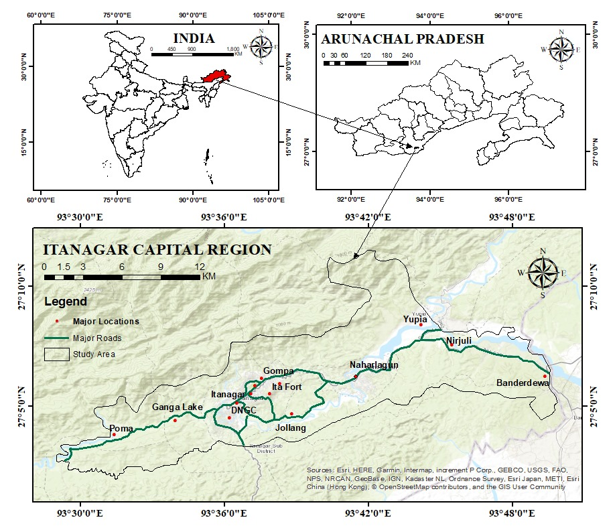
Data Source: Generated by researcher using ArcGIS 10.8
2.3 Image Classification:
For the analysis, five scenes were acquired over 38 years (1986, 1996, 2006, 2016, and 2024), all possessing a spatial resolution of 30 meters. Before analysis of the imagery, a pre-processing was carried out, including georeferencing, mosaicking, and sub setting. Subsequently, land cover classification was performed using the Maximum Likelihood Classifier in ArcGIS 10.8, identifying six distinct land cover classes. This classification process was applied sequentially, beginning with the selection of training areas and concluding with the generation of a signature file from their vector or polygonal forms. Two primary methodologies are employed for the identification and extraction of urban areas from satellite imagery. The flow diagram explicitly illustrates how a theoretical base has been incorporated and empirically justified in the study area.
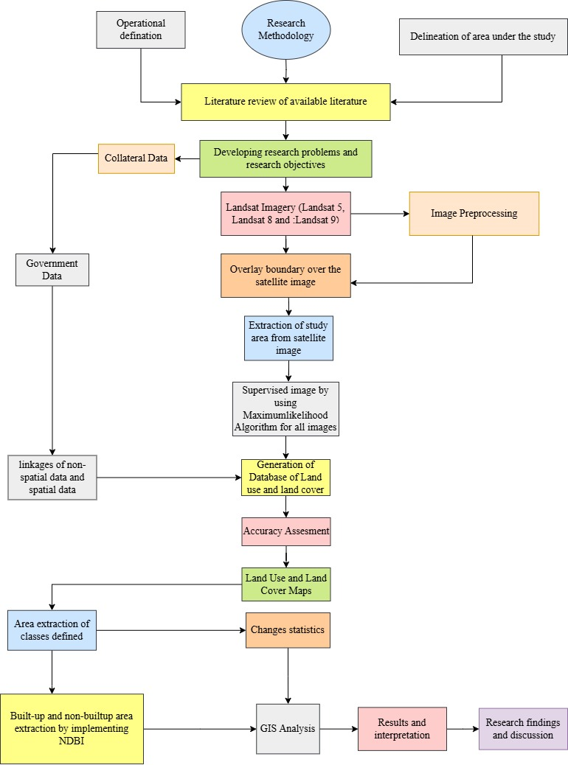
Fig. 2 Flow chart of theoretical base and methodology used for the study

  - Techniques of Analysis:
Following the classification of a Land Use Land Cover (LULC) map, built-up areas were isolated by identifying their specific class. A new raster layer, containing only pixels designated as built-up, is then generated using a raster calculator tool. For enhanced precision, this raster layer has been converted into vector polygons using tools such as the "Raster to Polygon" function within Arc-Toolbox (ESRI, n.d.). Thereby yielding a refined, vectorised representation of urban footprints, suitable for detailed spatial analysis.
  - Normalized Difference Built-up Index (NDBI) for Area Identification:
Another method used for further detailed classification is the Normalized Difference Built-up Index (NDBI). Since NDBI serves as a spectral index for directly identifying built-up regions within satellite imagery, this has been used to compute the value for a given year is using the reflectance values from the Near-Infrared (NIR) and Shortwave Infrared (SWIR) bands, as represented by the formula:
NDBI=(SWIR−NIR)/(SWIR+NIR)
This is then further elaborated by characterising the built-up by higher reflectance in the SWIR band comparing it to the NIR band, resulting in positive NDBI values. Conversely, non-built-up features, such as vegetation and water bodies, generally exhibit negative or near-zero NDBI values. Thus, as this index offers an efficient means of distinguishing urbanized areas based on their distinct spectral signature, it has been taken as one of the methods to understand and analyse the built-up area Index.
3. Results and Discussions
3.1 Land Use and Land Cover Change of ICR: The present study elaborately attempts to assess the LULC through the maps of 1986, 1996, 2006, 2016, and 2024 patterns in the study area reflects notable transformations. Among all the most prominent changes were those seen in forest areas and built-up land, reflecting growing human influence on the landscape. Dense forest cover decreased significantly over the 38 years, dropping from 162.05 km² (75.77%) in 1986 to 125.52 km² (58.70%) in 2024. This reduction of forest cover stems from deforestation driven by infrastructure development, agricultural expansion, and human settlement growth. In contrast, to loss of the forest lands urban and built-up areas expanded rapidly, rising from just 3.72 km² (1.74%) in 1986 to 64.58 km² (30.20%) by 2024, thereby suggesting significant urban sprawl and population growth, with natural and agricultural lands being converted into residential or commercial zones (Seto et al., 2011). There has been a sharp decline in the shrubland and open forest from 29.49 km² (13.79%) to just 0.95 km² (0.44%) by 2024, thus reflecting both natural degradations, particularly induced through anthropogenic activities, resulting in the conversion of agricultural land to built-up lands.
It is, however, interesting to note the pattern of agricultural land development, which reflected a more complex pattern, while it expanded between 1986 and 2006, peaking at 19.77 km² (9.24%), but by 2024 showed a decline of 7.96 km² (3.72%). This can be interpreted as a temporary phase of agricultural growth followed by land abandonment or conversion for other uses (Lambin et al., 2001). The extent of bare land decreased until 2006, but rose again afterward, reaching 9.05 km² (4.23%) in 2024. This may be linked to land clearing for construction or environmental degradation. Water bodies remained relatively stable, increasing slightly from 5.36 km² (2.51%) to 5.81 km² (2.72%). This change may be attributed to improved water conservation or shifts in rainfall and hydrology. Overall, the data points to a major shift from natural and semi-natural landscapes to urbanized areas. These trends emphasize the importance of sustainable land-use planning and ecosystem protection as urban development continues to grow.
Table 2. LULC of ICR for (1986, 1996, 2006, 2016, & 2004)
LULC  Classes | 1986 |  | 1996 |  | 2006 |  | 2016 |  | 2024
LULC  Classes | Area (Km²⁾ | Area (%) | Area (Km²) | Area (%) | Area (Km²) | Area (%) | Area (Km²) | Area (%) | Area (Km²) | Area (%)
Waterbodies | 5.36 | 2.51 | 5.50 | 2.57 | 5.17 | 2.42 | 5.51 | 2.58 | 5.81 | 2.72
Dense Forest | 162.05 | 75.77 | 160.37 | 74.98 | 141.90 | 66.35 | 149.24 | 69.78 | 125.52 | 58.70
Bare Land | 8.00 | 3.74 | 7.51 | 3.51 | 3.04 | 1.42 | 3.96 | 1.85 | 9.05 | 4.23
Shrub land/Open Forest | 29.49 | 13.79 | 16.62 | 7.77 | 23.60 | 11.03 | 6.25 | 2.92 | 0.95 | 0.44
Built-up | 3.72 | 1.74 | 7.34 | 3.43 | 20.40 | 9.54 | 32.72 | 15.30 | 64.58 | 30.20
Agriculture | 5.25 | 2.45 | 16.54 | 7.73 | 19.77 | 9.24 | 16.19 | 7.57 | 7.96 | 3.72

Fig. 3 Graphical Representation of LULC of ICR for (1986, 1996, 2006, 2016, & 2004)

3.2 Accuracy Assessment:
Accuracy Assessment in digital image classification is a process of determining how well a classified image corresponds to real world situations. The validation of LULC in the present context has been done by using Accuracy assessment and the resultant outcome reflects the trend (Table No. 2). The approach selected for this investigation was stratified randomsampling, which was done separately for each kind of LULC. To achieve the classification results with reference data are obtained from reliable sources like field observations, previously published publication of classified images and google Earth Pro. Accuracy Assessment using a confusion matrix is essential to determine the output’s reliability and validity. The validation of LULC for 1986, 1996, 2006, 2016, and 2024 was performed using the Confusion Matrix which provides insights into the classification accuracy across various land cover types, such as water bodies, Bare Land, Built-up areas, Dense Forests, Shrubland/Open Forest, and Agriculture. This matrix quantitatively assesses the maps' accuracy by comparing them with ground reality (Congalton and Green 2009).
The equations used for generating each metric are given in equations (i), (ii), (iii), and (iv) (Indraja et, al., 2024) as follows:
$UA=\frac{True Postive}{True Positive+False Negative}$ (i)
$PA= \frac{True Positive}{True Positive+False Positive}$ (ii)
$OA= \frac{True Postive}{True Positive+False Negative+True Positive+Flase Positive}$ (iii)
$Kc=\frac{Po-Pe}{1-Pe}$ (iv)
Here, UA is the user’s accuracy, PA is the Producer’s accuracy, OA is the overall accuracy, and Kc is the kappa coefficient.
An accuracy assessment was conducted using a confusion matrix based on reference samples across six land use and land cover (LULC) classes. Using the classification achieved an overall accuracy of 78% and a Kappa coefficient of 0.74, indicating substantial agreement beyond chance. Producer’s accuracy was highest for dense forest and waterbodies (both 1.00), reflecting no omission errors. In contrast, bare land had the lowest producer’s accuracy (0.54), suggesting confusion with built-up and agricultural areas. Users’ accuracy ranged from 0.70 to 0.90, with the highest observed in the dense forest class (0.90), indicating reliable classification from the user's perspective. Overall, the classification performed well, though some classes, such as bare land, showed moderate misclassification, highlighting areas for further improvement.

Table 3. Accuracy Assessment of LULC for ICR
LULC Class | Dense Forest | Waterbodies | Bare Land | Shrubland/Open Forest | Agriculture | Built-up | Total | User’s Accuracy | Kappa
Dense Forest | 9 | 0 | 0 | 1 | 0 | 0 | 10 | 0.90 | 0
Waterbodies | 0 | 8 | 2 | 0 | 0 | 0 | 10 | 0.80 | 0
Bare Land | 0 | 0 | 7 | 0 | 1 | 2 | 10 | 0.70 | 0
Shrubland/Open Forest | 0 | 0 | 1 | 7 | 2 | 0 | 10 | 0.70 | 0
Agriculture | 0 | 0 | 2 | 0 | 8 | 0 | 10 | 0.80 | 0
Built-up | 0 | 0 | 1 | 0 | 1 | 8 | 10 | 0.80 | 0
Total | 9 | 8 | 13 | 8 | 12 | 10 | 60 | 0 | 0
Producer’s Accuracy | 1 | 1 | 0.54 | 0.88 | 0.67 | 0.80 | 0 | 0.78 | 0
Kappa | 0 | 0 | 0 | 0 | 0 | 0 | 0 | 0 | 0.74
Overall Accuracy | 78%
Kappa Coefficient | 74%

3.3 Normalized Difference Built-up Index (NDBI)
In academic discourse, image classification techniques, encompassing both supervised and unsupervised methods, are recognized as intricate and time-consuming processes. Their execution necessitates the integration of diverse spectral bands and a series of operational steps to yield a conclusive outcome. The precision of these techniques is notably contingent upon the proficiency of the image analyst and the specific methodological framework adopted. Conversely, the computation of spectral indices, such as the Normalized Difference Built-up Index (NDBI) or the Normalized Difference Vegetation Index (NDVI), is considerably more straightforward. For instance, the NDVI can be derived through a direct mathematical equation that correlates the near-infrared (NIR) and red spectral bands of satellite imagery (Kshetri, 2018). The NDBI, specifically employed for identifying built-up or urban areas, is calculated using the formula:
$$NDBI=\frac{SWIR-NIR}{SWIR+NIR}$$
Here, SWIR denotes the Short-Wave Infrared band, and NIR represents the Near Infrared band. The resulting NDBI values typically range from -1 to +1. Negative values are generally indicative of water bodies, while higher positive values are characteristic of built-up or urban regions. Conversely, vegetation tends to be associated with lower NDBI values.
The provided data illustrates a clear temporal trend in land cover change, specifically highlighting the expansion of built-up areas and a corresponding reduction in non-built-up areas from 1986 to 2024. In 1986, non-built-up areas constituted the vast majority at 97.75% (209.04 Sq. Km), while built-up areas were minimal at 2.25% (4.82 Sq. Km). By 2024, the proportion of built-up areas had significantly increased to 22.96% (49.10 Sq. Km), alongside a substantial decrease in non-built-up areas to 77.04% (164.78 Sq. Km). This consistent shift over four decades underscores a progressive urbanization or development trend within the studied region.

Fig 4: Land use and land cover analysis report
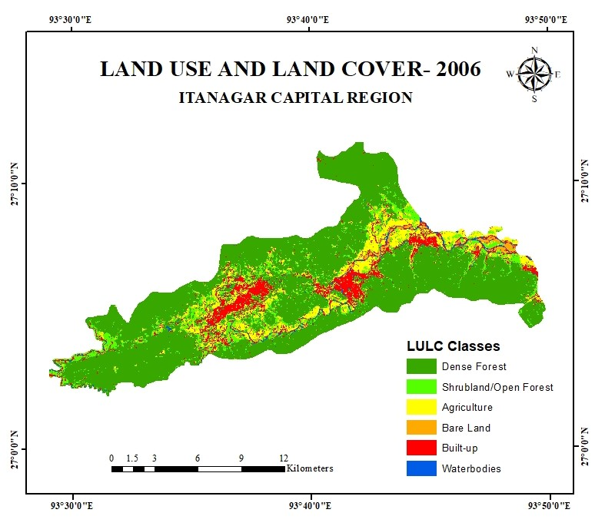
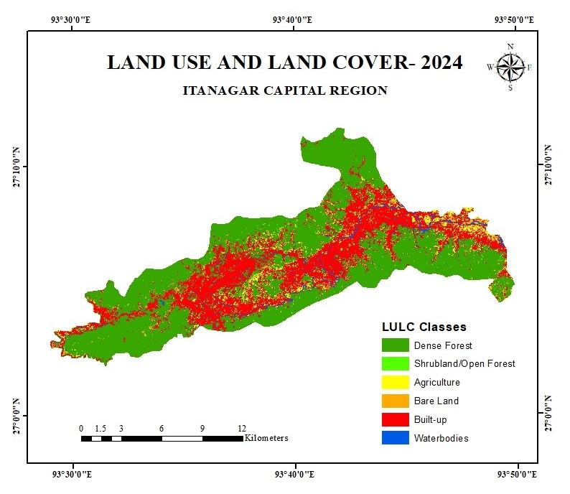
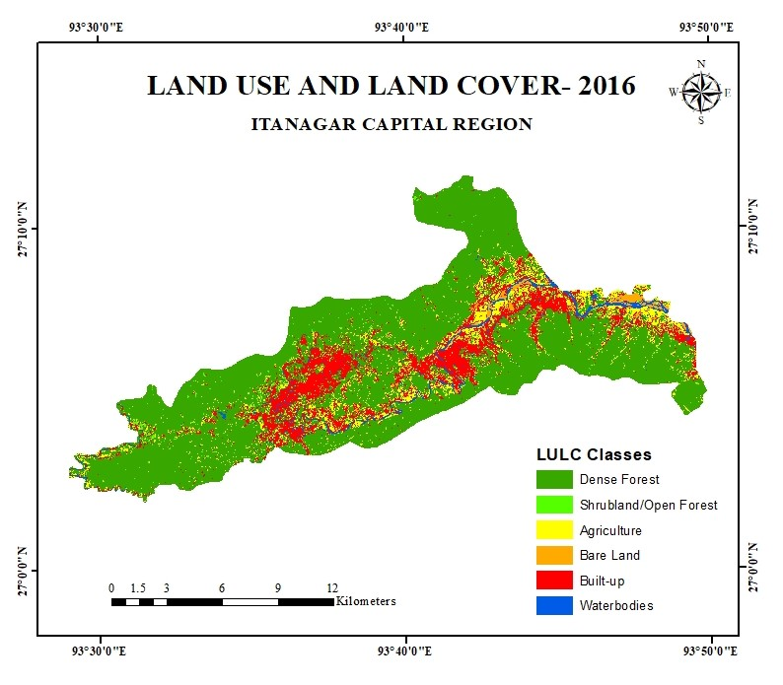
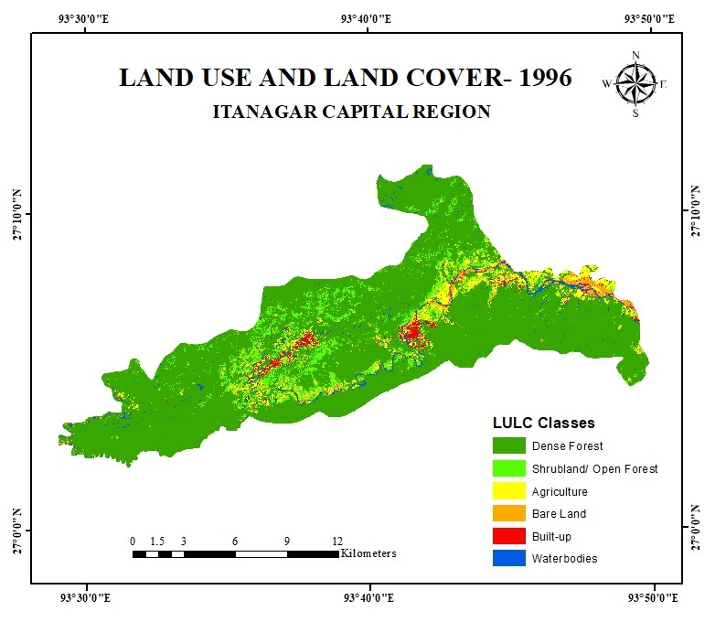
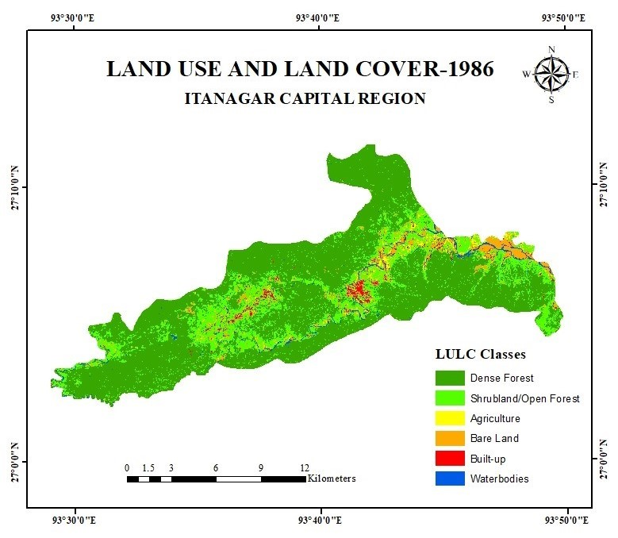

Table 4. NDBI of ICR for 1986, 1996, 2006, 2016 and 2024
NDBI 1986
NDBI Class | Area (Sq. Km) | Area (%)
Non Built-up Area (-0.53- 0) | 209.04 | 97.75
Built-up Area (0- 0.19 ) | 4.82 | 2.25
NDBI 1996
NDBI Class | Area (Sq. Km) | Area (%)
Non Built-up Area (-0,37-0) | 206.66 | 96.63
Built-up Area (0- 0.19) | 7.21 | 3.37
NDBI 2006
NDBI Class | Area (Sq. Km) | Area (%)
Non Built-up Area (-0.31- 0) | 200.98 | 93.97
Built-up Area (0- 0.15) | 12.89 | 6.03
NDBI 2016
NDBI Class | Area (Sq. Km) | Area (%)
Non Built-up Area (-0.31- 0) | 192.88 | 90.38
Built-up Area (0- 0.20) | 20.12 | 9.61
NDBI 2024
NDBI Class | Area (Sq. Km) | Area (%)
Non Built-up Area (-0.25- 0) | 164.78 | 77.04
Built-up Area (0- 0.24) | 49.10 | 22.96

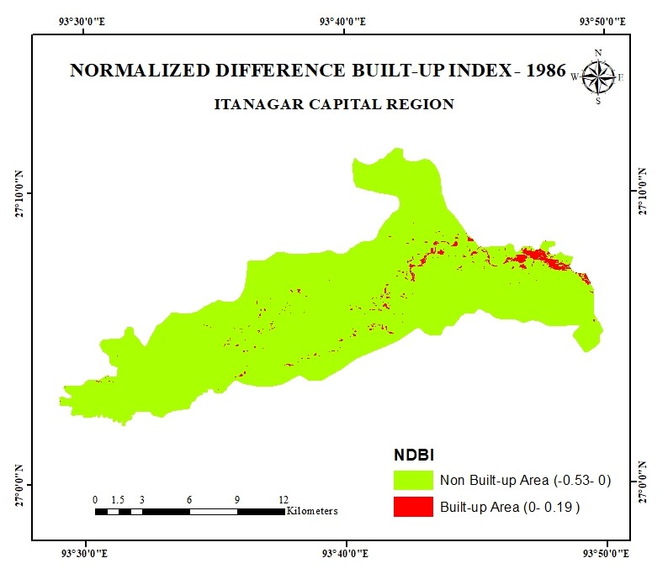
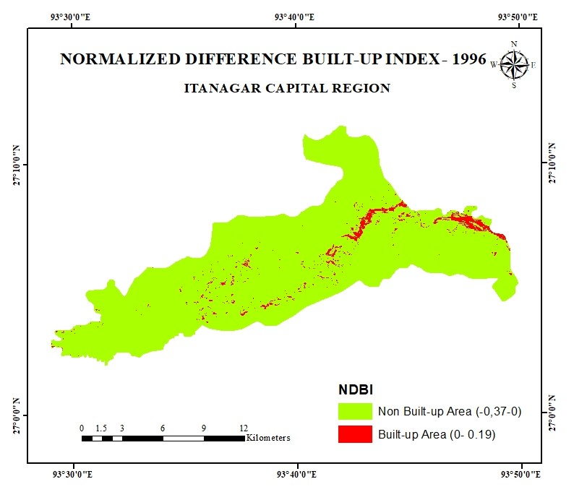
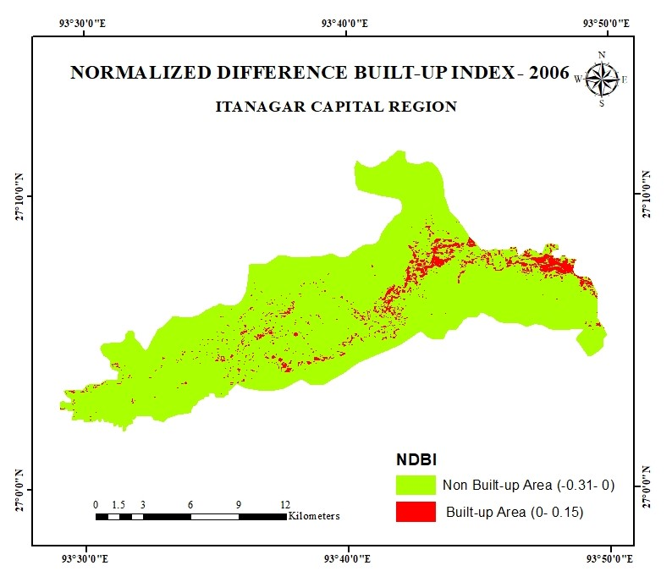

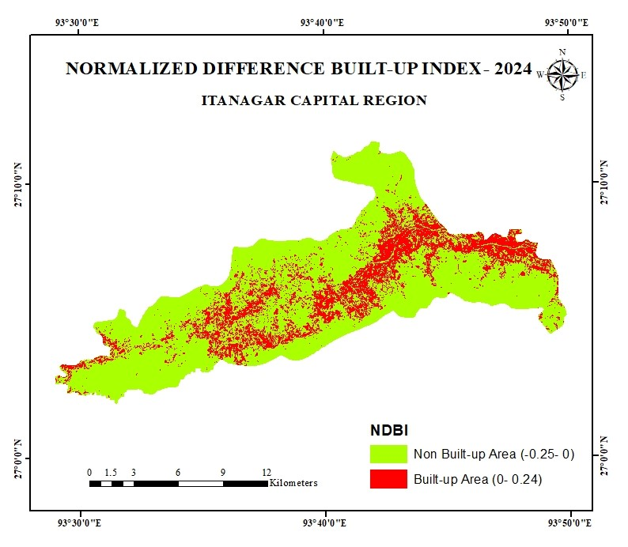
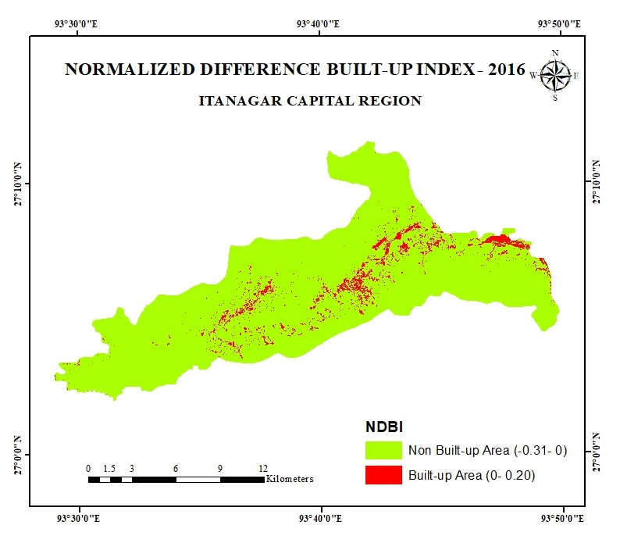

Fig 5 : Normalized difference built-up index
4. Conclusion
Among the many outcomes of the process of urbanization in the developing nations is characterized by sudden spin of the urbanization process resulting to physical and demographic expansion of cities, which has consequently resulted in substantial alteration of LULC. Understanding the urban growth and changes brought on by urbanization is a critical aspect for research endeavour in urban dynamics and management of land resources that is ever changing (Yang and Lo, 2002). The present study has attempted to identify this land use change and landscape patterns from 1986 to 2024 in the ICR region of Arunachal Pradesh over the last 3 decades. The result of the study reveals that there has been a significant change in LULC during the 38 years in the area. The obtained results therefore show that there was a decrease in the area of dense forest, open forest, and agricultural land, while built-up area land increased between 1986-2024. While in 1986, the built-up area was 1.74% (3.72 km²) it showed a massive rise of 30.2% (64.58 Km²) in 2024. The rise in the built-up rate can be attributed to factors like population increase, socio-economic growth, poor planning, and poor plan implementation. One of the major cause being population increase in the area as ICR being the administrative capital, along with the rural depopulation phenomena from other parts of the state, thus to accommodate this rising population, more and more built-up areas are being created by deforestation and encroachment of agricultural land, creating settlement areas. The result of encroachment and weak enforcement of laws and policies to protect and conserve the catchment areas are further hurdles to seen with.
The knowledge of LULC is essential for both land administration and land use planning activities in ICR. Itanagar Municipal Corporation (IMC) and the district administration of Itanagar Capital Region should consider setting aside land for nature conservation and recreational activities to mitigate the effects of environmental loss and degradation. What further can be done is vertical development for both residential and commercial buildings, with the implementation of urban planning. Thus, a combined effort of the land development plan action could be the way forward to a more sustainable city in ICR.
Disclaimer (Artificial intelligence)

Author(s) hereby declares that NO generative AI technologies such as Large Language Models (ChatGPT, COPILOT, etc.) and text-to-image generators have been used during the writing or editing of this manuscript.
5. References
Arpitha, M., Harishnaika, N., & Ahmed, S. A. (2025). Assessment of LULC dynamics and its association with LST distribution and NDVI Using Geospatial approaches in Karnataka state, India. Evolving Earth, 100076. https://doi.org/10.1016/j.eve.2025.100076
Agreement, P. (2015, December). United Nations.
Census of India. (2011). Provisional Population Totals, Paper 2 of 2011, Rural-Urban Distribution, Arunachal Pradesh. Directorate of Census Operations, Arunachal Pradesh.
Congalton, R. G., & Green, K. (2009). Assessing the accuracy of remotely sensed data: Principles and practices (2nd ed.). Lewis Publishers.
Dadashpoor, H., & Nateghi, M. (2017). Simulating spatial pattern of urban growth using GIS-based SLEUTH model: A case study of eastern corridor of Tehran metropolitan region, Iran. Environment, Development and Sustainability, 19(2), 527–547. https://doi.org/10.1007/s10668-015-9744-9
Fang, S., Gertner, G. Z., Sun, Z., & Anderson, A. A. (2005). The impact of interactions in spatial simulation of the dynamics of urban sprawl. Landscape and Urban Planning, 73(4), 294-306.
FAO. (2020). Global Forest Resources Assessment 2020: Main report. Food and Agriculture Organization of the United Nations. https://doi.org/10.4060/ca8753en
Genet, H. (2020). Remote sensing and GIS applications in agricultural research. Intech Open. https://doi.org/10.5772/intechopen.91264
Global Commission on the Economy and Climate. (2014). New Climate Economy Report (2014). The New Climate Economy.
Kalita, A., & Baruah, D. (2026). Assessment of Land Use-land Cover and Normalized Difference Vegetation Index of Darrang District, Assam, India. Asian Journal of Geographical Research, 9(1), 90-98. https://doi.org/10.9734/ajgr/2026/v9i1357
Hassan, M. M. (2017). Monitoring Land Use/Land Cover Change, Urban Growth Dynamics and Landscape Pattern Analysis in Five Fastest Urbanized Cities in Bangladesh. Remote Sensing Applications: Society and Environment, 7, 69-83.
Indraja, G., Aashi, A., & Vema, V. K. (2024). Spatial and temporal classification and prediction of LULC in Brahmani and Baitarni basin using integrated cellular automata models. Environmental Monitoring and Assessment, 196(2), 117. https://doi.org/10.1007/s10661-023-12289-0
Indraja, G., Sankar, K., & Priya, M. (2024). Spatial Analysis of Land Use Land Cover Dynamics in the Madurai District Using Sentinel-2 Data and Supervised Learning Algorithms. The International Archives of the Photogrammetry, Remote Sensing and Spatial Information Sciences, XLVIII-4/W2-2024, 141–148. https://doi.org/10.5194/isprs-archives-XLVIII-4-W2-2024-141-2024
Jatayu, A., Saizen, I., Rustiadi, E., Pribadi, D. O., & Juanda, B. (2022). Urban form dynamics and modelling towards sustainable hinterland development in North Cianjur, Jakarta–Bandung Mega-Urban Region. Sustainability, 14(2), 907.
Khanam, Z., Siddiqui, M. A., Faridi, R. A., Ali, S. A., & Khan, Z. (2022). Analysing Land Use Land Cover Changes and Urban Built-up Growth Using NDBI and Shannon’s Entropy Model: A Spatio-Temporal Analysis of Bulandshahr City, India. Asian Profile.
Křováková, K., Hakrová, P., Novotná, K., Vincíková, H., & Procházka, J. (2015). Biomass production of selected grassland, wetland and cropland vegetation communities. Applied Ecology and Environmental Research, 13(4), 1015-1033. https://doi.org/10.15666/aeer/1304_10151033
Kshetri, N. (2018). Introduction to remote sensing (2nd ed.). M. J. F. Publishing Company.
Lambin, E. F., Baulies, X., Bockstael, N., Fischer, G., Folke, C., Haberl, A. K., & Turner II, B. L. (2001). The causes of land-use and land-cover change: Moving beyond the myths. Global Environmental Change, 11(4), 261-269.
Li, X. (2022). The spatial and temporal characteristics of the urban thermal environment in East Africa: Implications for sustainable urban development. (Doctoral dissertation, University of York).
Liping, C., Yujun, S., & Saeed, S. (2018). Monitoring and predicting land use and land cover changes using remote sensing and GIS techniques—A case study of a hilly area, Jiangle, China. PLoS ONE, 13(7), e0200493. https://doi.org/10.1371/journal.pone.0200493
Liu, J., Wang, J., Deng, C., & Chanussot, J. (2010). Remote sensing of urban and suburban areas. In F. D. van der Meer (Ed.), Remote Sensing of Urban and Suburban Areas (pp. 1–28). Springer.
Long, H., Tang, G., Li, X., & Heilig, G. K. (2007). Socio-economic driving forces of land use change in Kunshan, the Yangtze River Delta Economic Area of China. Journal of Environmental Management, 83(3), 351-364.
Marco, A. L., Jäger, H., Prestele, R., Ruddiman, W. F., & Smith, P. (2015). Diverging land-use projections cause large variability in their impacts on ecosystems and related indicators for ecosystem services. Earth System Dynamics, 6(1), 327–346.
Mishra, V. N., & Rai, P. K. (2016). A remote sensing aided multi-layer perceptron-Markov chain analysis for land use and land cover change prediction in Patna district (Bihar), India. Arabian Journal of Geosciences, 9(10), 1-18.
Nagendra, H., Southworth, J., & Tucker, C. (2004). Accessibility as a determinant of landscape transformations in protected areas: Lessons from Ranthambhore National Park, India. International Journal of Remote Sensing, 25(23), 5403-5429.
Rawat, J. S., & Kumar, M. (2015). Monitoring land use/land cover changes using remote sensing and GIS techniques: A case study of Hawalbagh Block, District Almora, Uttarakhand, India. Egyptian Journal of Remote Sensing and Space Science, 18(1), 59-67.
Salvati, L., Zambon, I., Chelli, F. M., & Serra, P. (2018). Do spatial patterns of urbanization and land consumption reflect different socioeconomic contexts in Europe? Science of the Total Environment, 625, 722-730.
Seyam, M. M. H., Haque, M. R., & Rahman, M. M. (2023). Identifying the land use land cover (LULC) changes using remote sensing and GIS approach: A case study at Bhaluka in Mymensingh, Bangladesh. Case Studies in Chemical and Environmental Engineering, 7, 100293. https://doi.org/10.1016/j.cscee.2022.100293
Schneider, A., & Woodcock, C. E. (2008). Compact, dispersed, fragmented, extensive? A comparison of urban growth in twenty-five global cities using remotely sensed data, pattern metrics and census information. Urban Studies, 45(3), 659-692.
Serra, P., Pons, X., & Sauri, D. (2008). Land-cover and land-use change in a Mediterranean landscape: A spatial analysis of driving forces integrating bio-physical and human factors. Applied Geography, 28(3), 189-209.
Seto, K. C., Fragkias, M., Güneralp, B., & Reilly, M. K. (2011). A meta-analysis of global urban land expansion. PloS One, 6(8), e23777.
Shi, H., Xian, G., Auch, R., Gallo, K., & Zhou, Q. (2021). Urban heat island and its regional impacts using remotely sensed thermal data—a review of recent developments and methodology. Land, 10(8), 867.
Siedentop, S., & Fina, S. (2010). Monitoring urban sprawl in Germany: Towards a GIS-based measurement and assessment approach. Journal of Land Use Science, 5(2), 73-104.
Song, J., Lin, T., Li, X., & Prishchepov, A. V. (2018). Mapping urban functional zones by integrating very high spatial resolution remote sensing imagery and points of interest: A case study of Xiamen, China. Remote Sensing, 10(11), 1737.
Subasinghe, S., Estoque, R. C., & Murayama, Y. (2016). Spatiotemporal analysis of urban growth using GIS and remote sensing: A case study of the Colombo Metropolitan Area, Sri Lanka. ISPRS International Journal of Geo-Information, 5(11), 197.
Sui, D. Z., & Zeng, H. (2001). Modeling the dynamics of landscape structure in Asia’s emerging desakota regions: A case study in Shenzhen. Landscape and Urban Planning, 53(1-4), 37-52.
Vargo, L., Habeeb, D., & Stone Jr., P. H. (2014). Land cover and land use. In Oxford Bibliographies Online: Geography. Oxford University Press. (Original publication 2013, often cited as 2013).
Yang, X., & Lo, C. P. (2002). Using a time series of satellite imagery to detect urban growth and land use changes in the Atlanta, Georgia metropolitan area. International Journal of Remote Sensing, 23(9), 1775-1798.
Zhao, P., Ju, J., & Yin, C. (2016). Investigating the relationship between land alteration and the urban heat island of Seville city using multi-temporal Landsat data. Theoretical and Applied Climatology, 150, 613-635.
Zhao, Q., Haseeb, M., Wang, X., Zheng, X., Tahir, Z., Ghafoor, S., ... & Almutairi, K. F. (2024). Evaluation of land use land cover changes in response to land surface temperature with satellite indices and remote sensing data. Rangeland Ecology & Management, 96, 183-196. https://doi.org/10.1016/j.rama.2024.07.003

