Spatial Pattern of Births and Deaths Using HMIS Data in Ahilyanagar District, India: Tahsil-wise Geographical Analysis

ABSTRACT
Background: The Health Management Information System (HMIS) provides reliable micro-level data on births, deaths and maternal and child health services. HMIS is a facility-based report majorly collecting data from public facilities across the country with meagre reporting from private facilities.
Aims
The present study aims to analyse the tahsil-wise spatial pattern of live births, total deaths, child mortality (0–5 years), and infant mortality (0–1 year) under the Health Management Information System (HMIS) in the former Ahilyanagar District. The study seeks to identify inter-tahsil disparities and health-vulnerable regions to support micro-level health planning.
Study Design
The study adopts a descriptive and analytical research design based on secondary data, integrating demographic and geographical perspectives to assess spatial variations in health indicators.
Place and Duration of Study
The study covers 14 tahsils of the former Ahilyanagar District, Maharashtra, for the reference year 2025. The district represents a heterogeneous region comprising urban centres, rural hinterlands, drought-prone areas, and industrial zones.
Methodology
Secondary data were collected from HMIS records obtained from the District Health Officer, Zilla Parishad, and the Socio-Economic Abstract of Ahilyanagar District (2025). Key variables analysed include male and female live births, total live births, total deaths, child deaths (0–5 years), and infant deaths (0–1 year). The data were analysed using tahsil-wise tabulation, percentage analysis, ratio interpretation, and comparative spatial analysis to examine inter-regional disparities.
Results
The district recorded 63,985 live births and 13,957 total deaths, revealing pronounced spatial variation. Nagar, Sangamner, Rahata, and Newasa emerged as high-birth and high-mortality tahsils due to large populations and urban influence. Elevated child and infant mortality in Sangamner, Newasa, Parner, and Nagar indicates persistent gaps in maternal and child healthcare services. In contrast, Karjat and Jamkhed reported low mortality levels, reflecting smaller populations and rural settlement patterns, though possible under-reporting cannot be ruled out.
Conclusion
The study highlights significant tahsil-wise health inequalities within Ahilyanagar District. High-risk tahsils require targeted interventions, including strengthened primary healthcare, improved neonatal and maternal services, and enhanced nutrition programmes. The findings underscore the importance of micro-level spatial health planning to reduce preventable mortality and promote equitable health development.
Keywords: HMIS, live births, mortality, infant mortality, child mortality, spatial analysis

1. INTRODUCTION
Healthcare inequality is a major issue in developing countries, as it puts increasing pressure on the local population, particularly rural and disadvantaged groups, to maintain a decent standard of living and have equitable access to healthcare (Majumder et al., 2023; Bin Islam et al., 2023). Birth and death patterns are central indicators of health status, social development, and demographic change (Chandna, 2018; Park, 2021). Spatial disparities in these indicators emerge from differences in healthcare access, economic conditions, nutrition, sanitation and maternal health (Ghosh, 2016; Mohanty & Ram, 2020). Although national indicators have improved, intra-district variations remain substantial (Registrar General of India, 2023; NITI Aayog, 2022). Utilisation of maternal healthcare services such as antenatal care, delivery assisted by a skilled birth attendant, and postnatal care plays a crucial role in reducing maternal and child mortality (Chatterjee et al., 2022). At the regional level, India has initiated several efforts to reduce MMR due to avoidable causes related to pregnancy and childbirth. In 2005, the Government of India launched the National Rural Health Mission (NRHM) to achieve the Millennium Development Goals (MDG 5). Further, they focused on maternal and child health through the ‘Reproductive-Maternal-Neonatal-Child and Adolescent Health (RMNCH+A)’ programme (Kigozi et al., 2020; Gupta et al., 2025).
The Health Management Information System (HMIS) provides reliable micro-level data on births, deaths and maternal and child health services (Ministry of Health & Family Welfare, 2024). HMIS is a facility-based report majorly collecting data from public facilities across the country with meagre reporting from private facilities. To ensure reliability and validity of data, HMIS uses various steps in terms of tracking missing values, double-checking of outliers, and inter-data validation. Pre-set criteria are used by HMIS to maintain internal logical consistency in reporting of various indicators (Purbey et al., 2022; Arslan et al., 2013). Former Ahilyanagar District, now Ahilyanagar, is geographically diverse, with a mix of urban centres, drought-prone regions, tribal belts and industrial zones, all of which influence health outcomes. Despite this complexity, systematic tahsil-wise analysis of HMIS data has been limited.

2. REVIEW OF LITERATURE
Fertility and mortality patterns are strongly linked to socio-economic development (Chandna, 2018). Studies highlight the relationship between infant mortality and rural backwardness, weak sanitation and limited maternal care (Ghosh, 2016; Mohanty & Ram, 2020). Kundu (2018) shows how urbanisation improves mortality reporting systems and access to healthcare. The expansion of HMIS has enhanced data accuracy, though under-reporting persists in rural regions (National Health Mission, 2023; Ministry of Health & Family Welfare, 2024).
While national studies are available, micro-level geographical analyses focusing on district-level HMIS data remain scarce, especially for the former Ahilyanagar District. The present study addresses this gap.

3. METHODOLOGY
3.1 Research Objective
The present study aims to analyse the spatial pattern of births and deaths under the Health Management Information System (HMIS) across the tahsils of the former Ahilyanagar District. The focus is on identifying tahsil-wise disparities in live births, total deaths, child mortality (0–5 years), and infant mortality (0–1 year) through a geographical perspective.
3.2 Nature of the Study
This study is descriptive and analytical in nature, based entirely on secondary data. It integrates demographic analysis with spatial interpretation, a method commonly adopted in population and health geography studies (Chandna, 2018; Kundu, 2018).
3.3 Data Sources
The analysis relies on officially published and administratively maintained datasets, ensuring data reliability and reproducibility. The sources include:
- Socio-Economic Abstract of Ahilyanagar District (December 2025)
- Health Management Information System (HMIS) Records, District Health Officer, Zilla Parishad, Ahilyanagar
These sources provide tahsil-level annual data on births, deaths, and age-specific mortality indicators for the year 2025.
3.4 Variables Selected
The following demographic and health indicators were selected for analysis:
- Male live births
- Female live births
- Total live births
- Total deaths
- Child deaths (0–5 years)
- Infant deaths (0–1 year)
These variables are widely used indicators of population dynamics, maternal and child health, and overall health status (Park, 2021; Mohanty & Ram, 2020).
3.5 Analytical Techniques
The methodological framework follows the demographic spatial analysis approach adopted by Kundu (2018), Mishra (2020), and NITI Aayog (2022), with minor modifications to suit tahsil-level HMIS data.
The analysis was carried out using the following steps:
3.5.1 Tahsil-wise Tabulation
Raw HMIS data were organized into tahsil-wise tables to examine the absolute distribution of births, deaths, child deaths, and infant deaths. This step forms the foundation for spatial and comparative analysis.
3.5.2 Percentage and Ratio Analysis
Percentage shares of each tahsil in total district births and deaths were calculated to identify relative concentration. Sex-wise birth ratios and proportions of child and infant deaths were computed to assess demographic imbalance and mortality intensity.
3.5.3 Comparative Spatial Analysis
Tahsil-wise comparisons were made to identify high, moderate, and low birth and mortality regions. The observed patterns were interpreted in relation to population size, urban–rural characteristics, and healthcare accessibility, following the spatial approach suggested by Kundu (2018).
3.5.4 Descriptive Demographic Interpretation
Descriptive demographic techniques were applied to explain variations in health outcomes. The discussion of results precedes the presentation of each table and figure, ensuring that all visual representations are analytically contextualised.

4. Results and Discussion
The HMIS data show that the former Ahilyanagar district recorded 63,985 live births and 13,957 total deaths, indicating wide inter-tahsil variation in health outcomes. Nagar, Sangamner, and Rahata emerge as high-birth and high-death tahsils due to their large population and urban influence. Child deaths (607) and infant deaths (508) are relatively higher in Sangamner, Newasa, Parner, and Nagar, reflecting persistent challenges in maternal and child healthcare. In contrast, Karjat and Jamkhed report the lowest births and deaths due to low population density and rural conditions.
Table 1: Tahsil-wise Distribution of Live Births by Sex (Male, Female and Total)
Sr. No. | Tahsil | No. of Live Births
Sr. No. | Tahsil | Male | Female | Total
1 | Akole | 1593 | 1442 | 3035
2 | Sangamner | 3938 | 3590 | 7528
3 | Kopargaon | 1777 | 1634 | 3411
4 | Rahata | 3561 | 3320 | 6881
5 | Shrirampur | 1384 | 1212 | 2596
6 | Newasa | 3212 | 3043 | 6255
7 | Shevgaon | 1547 | 1465 | 3012
8 | Pathardi | 1086 | 953 | 2039
9 | Nagar | 10229 | 9179 | 19408
10 | Rahuri | 1257 | 1142 | 2399
11 | Parner | 1431 | 1346 | 2777
12 | Shrigonda | 933 | 863 | 1796
13 | Karjat | 596 | 548 | 1144
14 | Jamkhed | 906 | 798 | 1704
Total |  | 33450 | 30535 | 63985
Source: (1) Socio-Economic Abstract of Ahilyanagar District: Dec-2025,
(2) District Health Officer, Zilla Parishad – Health Management Information System (HMIS)
The analysis of tahsil-wise live births in Ahilyanagar district for 2025 reveals significant spatial and demographic variation across the region. A total of 63,985 live births were recorded, comprising 33,450 male and 30,535 female births. The data indicate a persistent gender imbalance, with male births exceeding female births in every tahsil.
Nagar tahsil shows the highest share of live births (19,408), accounting for nearly 30% of the district total. This reflects its larger population size, better healthcare networks, and higher institutional delivery rates. Sangamner (7,528), Rahata (6,881), and Newasa (6,255) follow as major contributors, suggesting concentrated population clusters and stronger health service utilisation in these semi-urban and agriculturally developed regions.
Conversely, tahsils such as Karjat (1,144), Shrigonda (1,796), and Jamkhed (1,704) reported relatively low birth numbers, indicating either smaller populations, limited healthcare accessibility, or socio-economic constraints affecting maternal and child health outcomes.
The consistent pattern of male-biased births across all tahsils highlights a demographic concern that may stem from cultural preferences, differential healthcare-seeking behaviour, or variations in reporting accuracy. If sustained, such a gender imbalance may lead to long-term social and demographic challenges.
Overall, the distribution of live births provides valuable insights into population dynamics, regional disparities, and healthcare performance in Ahilyanagar district. These findings underscore the need for targeted maternal and child health interventions in low-performing tahsils and continued monitoring of sex-ratio trends to ensure equitable and inclusive demographic development.

Table 2: Tahsil-wise Distribution of Total Deaths
Sr. No. | Tahsil | Total No. of Deaths
1 | Akole | 902
2 | Sangamner | 2476
3 | Kopargaon | 584
4 | Rahata | 101
5 | Shrirampur | 525
6 | Newasa | 730
7 | Shevgaon | 616
8 | Pathardi | 1090
9 | Nagar | 2320
10 | Rahuri | 1698
11 | Parner | 571
12 | Shrigonda | 922
13 | Karjat | 888
14 | Jamkhed | 534
Total |  | 13957
Source: (1) Socio-Economic Abstract of Ahilyanagar District: Dec-2025,
(2) District Health Officer, Zilla Parishad – Health Management Information System (HMIS)
The total number of recorded deaths in Ahilyanagar district for 2025 is 13,957, with noticeable variation across tahsils. Sangamner (2,476 deaths) and Nagar (2,320 deaths) account for the highest mortality figures, together contributing over 34% of the district’s total deaths. Their larger populations, higher density, and greater inflow of patients from surrounding rural areas likely influence these numbers. Rahuri (1,698 deaths) and Pathardi (1,090 deaths) also exhibit elevated mortality, suggesting possible gaps in healthcare access, disease burden, or socio-economic vulnerabilities.
On the other hand, tahsils such as Rahata (101 deaths) and Kopargaon (584 deaths) report relatively low mortality. This may reflect better healthcare infrastructure, improved emergency response systems, or a smaller population size. Shrirampur (525 deaths) and Jamkhed (534 deaths) also fall on the lower end but may require further investigation to determine whether these low numbers represent genuine demographic outcomes or underreporting.
The data reveal a broad pattern of spatial inequality in health outcomes across the district. Tahsils with higher death counts often correspond to regions with large populations, dispersed rural settlements, or limited access to specialised medical services. These findings underline the need for targeted health interventions, such as strengthening primary healthcare centres, improving referral systems, and enhancing disease surveillance in high-mortality regions.
Overall, the analysis of death distribution provides important insights into local health conditions and highlights priority areas where health policies and resources must be strategically directed to reduce preventable mortality and promote equitable health outcomes across Ahilyanagar district.

Table 3: Tahsil-wise Distribution of Child Deaths (Age 0–5 Years)
Sr. No. | Tahsil | Total No. of Child Deaths (Age 0 to 5 Years)
1 | Akole | 44
2 | Sangamner | 77
3 | Kopargaon | 37
4 | Rahata | 50
5 | Shrirampur | 32
6 | Newasa | 64
7 | Shevgaon | 44
8 | Pathardi | 29
9 | Nagar | 55
10 | Rahuri | 43
11 | Parner | 58
12 | Shrigonda | 44
13 | Karjat | 25
14 | Jamkhed | 5
Total |  | 607
Source: (1) Socio-Economic Abstract of Ahilyanagar District: Dec-2025,
(2) District Health Officer, Zilla Parishad – Health Management Information System (HMIS)
The district recorded a total of 607 child deaths (0–5 years), with significant variation across tahsils. Sangamner (77 deaths) and Newasa (64 deaths) report the highest child mortality, indicating potential challenges related to maternal health, neonatal care, nutrition, or healthcare accessibility. Parner (58 deaths) and Nagar (55 deaths) also show elevated numbers, suggesting that larger populations and wider rural coverage may contribute to higher risk among young children.
Moderate levels of child mortality are seen in Akole (44 deaths), Shevgaon (44 deaths), and Shrigonda (44 deaths), pointing toward persistent gaps in early childhood health services across multiple regions. Tahsils such as Kopargaon (37 deaths), Rahuri (43 deaths), and Rahata (50 deaths) fall within a mid-range but still require focused interventions to reduce preventable causes such as infections, malnutrition, and preterm complications.
Notably, Jamkhed reports only 5 child deaths, the lowest in the district. This exceptionally low figure may reflect effective maternal and child health practices, smaller population size, targeted community-based programs, or the presence of NGOs and healthcare initiatives like CRHP Jamkhed. However, it may also warrant careful verification to rule out underreporting.
Overall, the spatial pattern of child mortality highlights disparities in early childhood survival across Ahilyanagar district. High-mortality tahsils would benefit from strengthened antenatal and postnatal care, improved neonatal facilities, enhanced nutrition programs, and increased community health outreach. The findings underscore the importance of localised health planning to ensure equitable child health outcomes across all tahsils.

Table 4: Tahsil-wise Distribution of Infant Deaths (Age 0–1 Year)
Sr. No. | Tahsil | No. of Infant Deaths (Age 0 to 1 Year)
1 | Akole | 36
2 | Sangamner | 63
3 | Kopargaon | 32
4 | Rahata | 40
5 | Shrirampur | 25
6 | Newasa | 57
7 | Shevgaon | 34
8 | Pathardi | 25
9 | Nagar | 44
10 | Rahuri | 36
11 | Parner | 56
12 | Shrigonda | 35
13 | Karjat | 21
14 | Jamkhed | 4
Total |  | 508
Source: (1) Socio-Economic Abstract of Ahilyanagar District: Dec-2025,
(2) District Health Officer, Zilla Parishad – Health Management Information System (HMIS)
The district recorded 508 infant deaths (0–1 year), revealing considerable variation across tahsils. Sangamner (63 deaths) and Newasa (57 deaths) show the highest infant mortality, indicating persistent gaps in neonatal care, institutional deliveries, early diagnosis of complications, and access to emergency services. Parner (56 deaths) also ranks high, suggesting that population size, rural dispersion, and healthcare accessibility may be influencing infant survival in these regions.
Mid-level mortality is observed in Nagar (44 deaths), Rahata (40 deaths), Rahuri (36 deaths), Shevgaon (34 deaths), and Kopargaon (32 deaths). These numbers highlight continuing challenges such as low birth weight, infections in the neonatal period, and limited follow-up care for high-risk infants.
Lower infant mortality is recorded in Shrirampur (25 deaths), Pathardi (25 deaths), and Karjat (21 deaths), which may reflect better utilisation of maternal and child health services or smaller population coverage. Jamkhed reports just 4 infant deaths, the lowest in the district. This may indicate strong community health initiatives, such as long-standing primary health programs, but it also requires cautious interpretation to rule out possible underreporting.
Overall, the distribution of infant deaths highlights uneven access to quality maternal and newborn care across the district. High-burden tahsils require targeted interventions, including improved antenatal monitoring, strengthened neonatal intensive care, timely referral systems, and early breastfeeding and nutrition support. The findings emphasise the need for localised health planning to reduce preventable infant deaths and ensure equitable child health outcomes.

4.1 Spatial Pattern of Live Births
A total of 63,985 live births were recorded, including 33,450 male and 30,535 female births. Male births exceeded female births in all tahsils, reflecting a persistent gender imbalance consistent with earlier demographic findings (Bhat & Zavier, 2017).
Nagar recorded the highest births (19,408), followed by Sangamner (7,528), Rahata (6,881) and Newasa (6,255). These regions have high population density and strong institutional delivery systems. Karjat (1,144), Jamkhed (1,704) and Shrigonda (1,796) recorded the lowest births, indicating smaller populations or weaker reporting mechanisms.
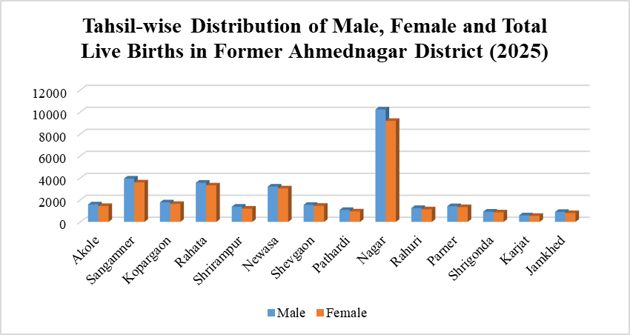
Figure 1: Tahsil-wise Distribution of Male, Female and Total Live Births in Former Ahilyanagar District (2025)
The diagram shows that Nagar tahsil records the highest male and female live births, followed by Sangamner, Rahata, and Newasa, reflecting their large population and urban influence. Karjat, Jamkhed, and Shrigonda register the lowest births due to their rural character. In almost all tahsils, male births slightly exceed female births.

4.2 Total Deaths
The district recorded 13,957 deaths. Sangamner (2,476) and Nagar (2,320) reported the highest mortality, reflecting their large populations and urban-health complexities (Kundu, 2018). Rahuri (1,698) and Pathardi (1,090) also showed elevated mortality.
The lowest mortality was observed in Rahata (101), Jamkhed (534) and Kopargaon (584). These spatial contrasts highlight uneven health service availability and suggest that rural under-reporting may influence low mortality figures.

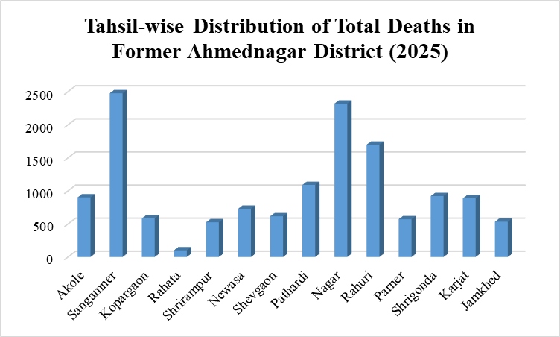
Figure 2: Tahsil-wise Distribution of Total Deaths in Former Ahilyanagar District (2025)

The bar diagram shows that Sangamner, Nagar, and Rahuri record the highest number of deaths, indicating their large population size and urban–industrial influence. Rahata, Jamkhed, and Kopargaon show the lowest death counts due to their rural nature and low population density. Overall, the pattern reflects a clear urban–rural contrast in mortality levels across the district.

4.3 Child Deaths (0–5 Years)
A total of 607 child deaths were recorded. Sangamner (77), Newasa (64), Parner (58), and Nagar (55) reported the highest numbers. These regions require further strengthening of neonatal care, nutrition programmes and sanitation (Ghosh, 2016; NFHS-5, 2021).
Jamkhed (5) recorded the lowest child deaths, likely due to a smaller population size and strong community-based health interventions.

4.4 Infant Deaths (0–1 Year)
The district recorded 508 infant deaths. Sangamner (63), Newasa (57) and Parner (56) reported the highest infant mortality. These patterns indicate gaps in maternal health, neonatal care and emergency services (Park, 2021; Mohanty & Ram, 2020).
The lowest infant deaths were recorded in Jamkhed (4) and Karjat (21). These disparities show the urgent need for targeted policy interventions.
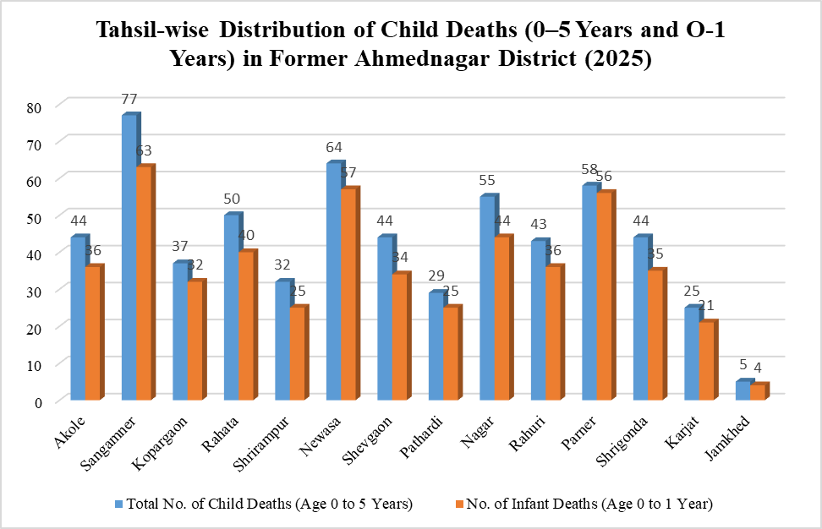
Figure 3: Tahsil-wise Distribution of Child Deaths (0–5 Years and O-1 Years) in Former Ahilyanagar District (2025)

The diagram clearly depicts pronounced tahsil-wise variation in child (0–5 years) and infant (0–1 year) mortality in the former Ahilyanagar District. Sangamner records the highest child (77) and infant (63) deaths, followed by Newasa (64 child and 57 infant deaths) and Parner (58 child and 56 infant deaths), indicating persistent challenges in maternal and child healthcare in these tahsils. Nagar and Rahata also show relatively high mortality, reflecting their large population base. In contrast, Jamkhed and Karjat register the lowest child and infant deaths, due to their smaller population size and rural character. The overall pattern highlights significant spatial inequality in child and infant survival, closely linked with differences in nutrition, healthcare accessibility, sanitation, and socio-economic conditions across the district.

4.5 Spatial Health Regions
On the basis of intensity of births, deaths, child mortality and infant mortality, the district can be divided into distinct spatial health regions. Nagar, Sangamner, Newasa, and Parner form the high mortality zone, characterised by high population concentration, urban influence, and greater exposure to health risks. Rahata, Rahuri, Shrigonda, and Shevgaon constitute the moderate mortality zone, showing intermediate levels of health stress and relatively better living conditions. In contrast, Karjat, Jamkhed, and Pathardi fall under the low mortality zone, reflecting low population density and rural settlement patterns. This regionalisation highlights the uneven spatial distribution of health conditions within the district. These patterns reflect varying population densities, healthcare accessibility and socio-economic conditions.

4.6 Health Geography Interpretation
Urban tahsils report higher births and deaths due to stronger institutional reporting, larger populations and greater health service utilisation. Rural tahsils show lower recorded deaths but higher infant risk. The findings are consistent with national demographic patterns where disparities in healthcare infrastructure lead to uneven health outcomes (NITI Aayog, 2022; Registrar General of India, 2023).

5. CONCLUSION
The present tahsil-wise geographical analysis of births and deaths under the Health Management Information System (HMIS) reveals pronounced spatial disparities in demographic and health outcomes across the former Ahilyanagar District. By examining live births, total deaths, child mortality (0–5 years), and infant mortality (0–1 year), the study provides a micro-level understanding of population dynamics and health inequalities within the district.
The findings clearly demonstrate that population size, degree of urbanisation, healthcare accessibility, and socio-economic conditions play a decisive role in shaping birth and mortality patterns. Tahsils such as Nagar, Sangamner, Newasa, and Parner emerge as high-birth and high-mortality regions. These tahsils are characterised by large population concentrations, semi-urban or urban influence, and high utilisation of institutional health services. However, the persistence of elevated child and infant mortality in these areas indicates that the availability of healthcare facilities alone does not ensure improved health outcomes, pointing to gaps in quality of maternal and neonatal care, timely referral mechanisms, and postnatal follow-up.

Disclaimer (Artificial intelligence)
Author(s) hereby declare that NO generative AI technologies such as Large Language Models (ChatGPT, COPILOT, etc.) and text-to-image generators have been used during the writing or editing of this manuscript.

REFERENCES
- Anderson, B. (1983). Imagined communities: Reflections on the origin and spread of nationalism. Verso. https://www.versobooks.com/books/1046-imagined-communities
- Bhat, P. N. M., & Zavier, A. J. F. (2017). Fertility transition in India: Regional dimensions. Demography India, 46(1), 1–15.
- Chandna, R. C. (2017). Geography of Population. Kalyani Publishers.
- Ghosh, B. (2016). Health and Development in India. Deep & Deep.
- Government of India, & International Institute for Population Sciences. (2021). National Family Health Survey (NFHS-5). International Institute for Population Sciences. http://rchiips.org/nfhs/NFHS-5Reports/NFHS-5_INDIA_REPORT.pdf
- Kundu, A. (2018). Urbanization and mortality in India. Economic and Political Weekly, 53(12), 38–45.
- Ministry of Health & Family Welfare. (2024). Annual Report 2023-24.
- Mohanty, S. K., & Ram, F. (2020). Maternal and child health inequalities in India.
- Journal of Biosocial Science, 52(2), 241–258.
- Ministry of Health and Family Welfare, Government of India. (2023). Rural Health Statistics, 2021-22. https://hmis.mohfw.gov.in/downloadfile?filepath=Rural%20Health%20Statistics%202021-22.pdf
- NITI Aayog. (2023). Healthy States, Progressive India: Report on the Ranks of States and Union Territories (State Health Index 2020-21).
- Park, K. (2021). *Park's Textbook of Preventive and Social Medicine* (26th ed.). Banarsidas Bhanot Publishers.
- Office of the Registrar General & Census Commissioner, India. (2025). Sample Registration System (SRS) Statistical Report 2023. https://censusindia.gov.in/census_and_srs/srs_reports_2023.html
- World Health Organization. (2022). World health statistics 2022: monitoring health for the SDGs, sustainable development goals. https://www.who.int/publications/m/item/world-health-statistics-2022
- Purbey A, Nambiar A, Roy Choudhury D, Vennam T, Balani K, Agnihotri SB. Stillbirth rates and its spatial patterns in India: an exploration of HMIS data. Lancet Reg Health Southeast Asia. 2022 Dec 6;9:100116. doi: 10.1016/j.lansea.2022.100116. PMID: 37383033; PMCID: PMC10306056.
- Gupta, G., Rana, T.S., Karun, S. et al. Spatial pattern and correlates of maternal healthcare utilization in the North Eastern Region of India: evidence from the National Family Health Survey, 2019–2021. Discov Public Health 22, 365 (2025). https://doi.org/10.1186/s12982-025-00660-0
- Majumder, S., Roy, S., Bose, A., & Chowdhury, I. R. (2023). Understanding regional disparities in healthcare quality and accessibility in West Bengal, India: A multivariate analysis. Regional Science Policy & Practice, 15(5), 1086-1114.
- Bin Islam, D., Purbey, A., Roy Choudhury, D., Lahariya, C., & Agnihotri, S. B. (2023). Seasonal and district level geo-spatial variations in stillbirth rates in India: an analysis of secondary data. Indian Journal of Pediatrics, 90(Suppl 1), 47-53.
- Kigozi, S. P., Kigozi, R. N., Sebuguzi, C. M., Cano, J., Rutazaana, D., Opigo, J., ... & Pullan, R. L. (2020). Spatial-temporal patterns of malaria incidence in Uganda using HMIS data from 2015 to 2019. BMC public health, 20(1), 1913.
- Arslan, O. Z. A. N., Cepni, M. S., & Etiler, N. (2013). Spatial analysis of perinatal mortality rates with geographic information systems in Kocaeli, Turkey. Public health, 127(4), 369-379.
- Chatterjee, P., Gupta, A., & Subramanian, S. V. (2022). Can administrative health data be used to estimate population level birth and child mortality estimates? A comparison of India's Health Information Management System data with nationally representative survey data. SSM-Population Health, 19, 101148.

