DETERMINATION OF PROTEIN CONTENT AND POLYCYCLIC AROMATIC HYDROCARBON CONCENTRATION IN SUYA ROASTED AND SOLD AT SENIOR STAFF CLUB, RIVERS STATE UNIVERSITY.
______________________________________________________________________________
ABSTRACT
The consumption of suya, a popular grilled meat delicacy in Nigeria, has raised increasing public health concerns due to possible contamination with harmful substances. This study determined the protein content and polycyclic aromatic hydrocarbon (PAH) concentrations in suya (roasted beef) sold at the Rivers State University Senior Staff Club, Port Harcourt. Eight sticks of suya were purchased and categorized into two groups according to the time of purchase. Three samples from each group were used for protein analysis, while one stick from each group was used to determine PAH concentrations. Sample 1 was the suya purchased at 11:00 a.m., while sample 2 was the suya purchased at 1:00 p.m. Protein content and PAH concentrations were determined using the Kjeldahl method and Gas chromatography–mass spectrometry (GC–MS), respectively. Results showed that the percentage protein content of sample 2 (45.06 ± 0.06%) was significantly higher than that of Sample 1 (37.10 ± 0.13%), and both values exceeded the United States Department of Agriculture (USDA) 2023/2024 recommended range of 21–30% for roasted or grilled meat. Analysis of PAHs revealed the presence of 16 compounds with varying concentrations. Chrysene had the highest concentrations of 11.17ppm and 11.10ppm in samples 1 and 2 respectively, whereas naphthalene had the lowest concentration (0.10 ppm) in both samples. Carcinogenic PAHs, including benzo[a]pyrene, indeno[1,2,3-cd]pyrene, dibenz[a,h]anthracene, benzo[b]fluoranthene, and benzo[k]fluoranthene, were detected. Although most PAH concentrations were similar in both samples, slight variations were observed, and all measured values exceeded the European Union maximum allowable limit of 0.002 ppm for PAHs in roasted or grilled meat.These findings indicate that while suya is a rich source of protein, the presence of harmful PAHs may expose frequent consumers to significant health risks.
____________________________________________________________________________
Keywords: Suya, protein, polycyclic aromatic hydrocarbons, concentrations, roasted.

- Introduction

Suya which is roasted beef is commonly produced by the Hausas in Northern Nigeria. It is produced from boneless meat hung on stick and spiced with peanut cake, salt, vegetable oil and other flavourings followed by roasting around a glowing charcoal fire. It is generally made with skewered beef, ram, or chicken. Innards such as kidney, liver, and tripe are also used (Eke et al., 2012). Suya is classified into three main forms namely Tsire, Kilishi, and Balangu (Ahmadu & Aduwa, 2015). Among the three forms of suya product, Tsire is the most commonly preferred. Although Suya originated in the northern parts of Nigeria, it has permeated Nigerian society, being affordable for all and available everywhere. It has been called a unifying factor in Nigeria and is a popular food item across West Africa (Adebiyi et al., 2018). Suya has become a Nigerian national dish with different regions claiming the superiority of their recipe and methods of preparation, but similar grilled meat recipes are common in many West African countries (Egbebi & Seidu, 2011).
1.1 Suya as a Source of Protein
Suya remains an important dietary source of protein in Nigeria. Proximate analysis shows that suya contains between 20–27% crude protein, making it a high-quality source of animal protein compared to plant-based alternatives (Okonkwo et al., 2022). It also provides essential amino acids, fats, and micronutrients such as iron and zinc, which are vital for growth, immunity, and overall health (Ojo et al., 2021). The addition of groundnut pastes and spices in suya preparation can further enrich its nutritional profile, adding beneficial plant proteins and bioactive compounds (Adebayo et al., 2018).
1.2 Hygiene in Handling
Suya is frequently prepared in open environments along busy roadsides, where exposure to dust, flies, and exhaust fumes may compromise hygiene standards (Oyeleke et al., 2019). Hygiene in the handling of suya meat involves careful attention from slaughtering, transportation, storage, preparation, seasoning, grilling, to final sale. Many vendors often neglect basic hygienic practices such as regular handwashing, use of protective gear (gloves, aprons), and separation of raw and cooked meat, which increases the risk of contamination (Ojo et al., 2021). Cross-contamination is especially common when the same utensils or surfaces are used for both raw and roasted meat. Poor packaging practices, such as using newspapers or unclean wrappers, can also introduce chemical and microbial contaminants (Egbebi & Seidu, 2011).
1.3 Exposure to Contaminants
Suya is exposed to a variety of contaminants, including microbial, chemical, and physical hazards. These contaminants may originate from unhygienic handling, contaminated spices, or unsanitary preparation environments. Chemical contaminants such as heavy metals (arsenic, cadmium, chromium) have also been reported in suya, largely attributed to environmental pollution and the grilling process (Abdulkarim et al., 2020). Additionally, polycyclic aromatic hydrocarbons (PAHs), known carcinogens formed during charcoal grilling, accumulate on suya and pose long-term health risks (Ogbulie et al., 2019). Physical contaminants such as dust, ash, or insect fragments may also be introduced during preparation and sale, especially in outdoor settings (Adebayo et al., 2018).
Methodology
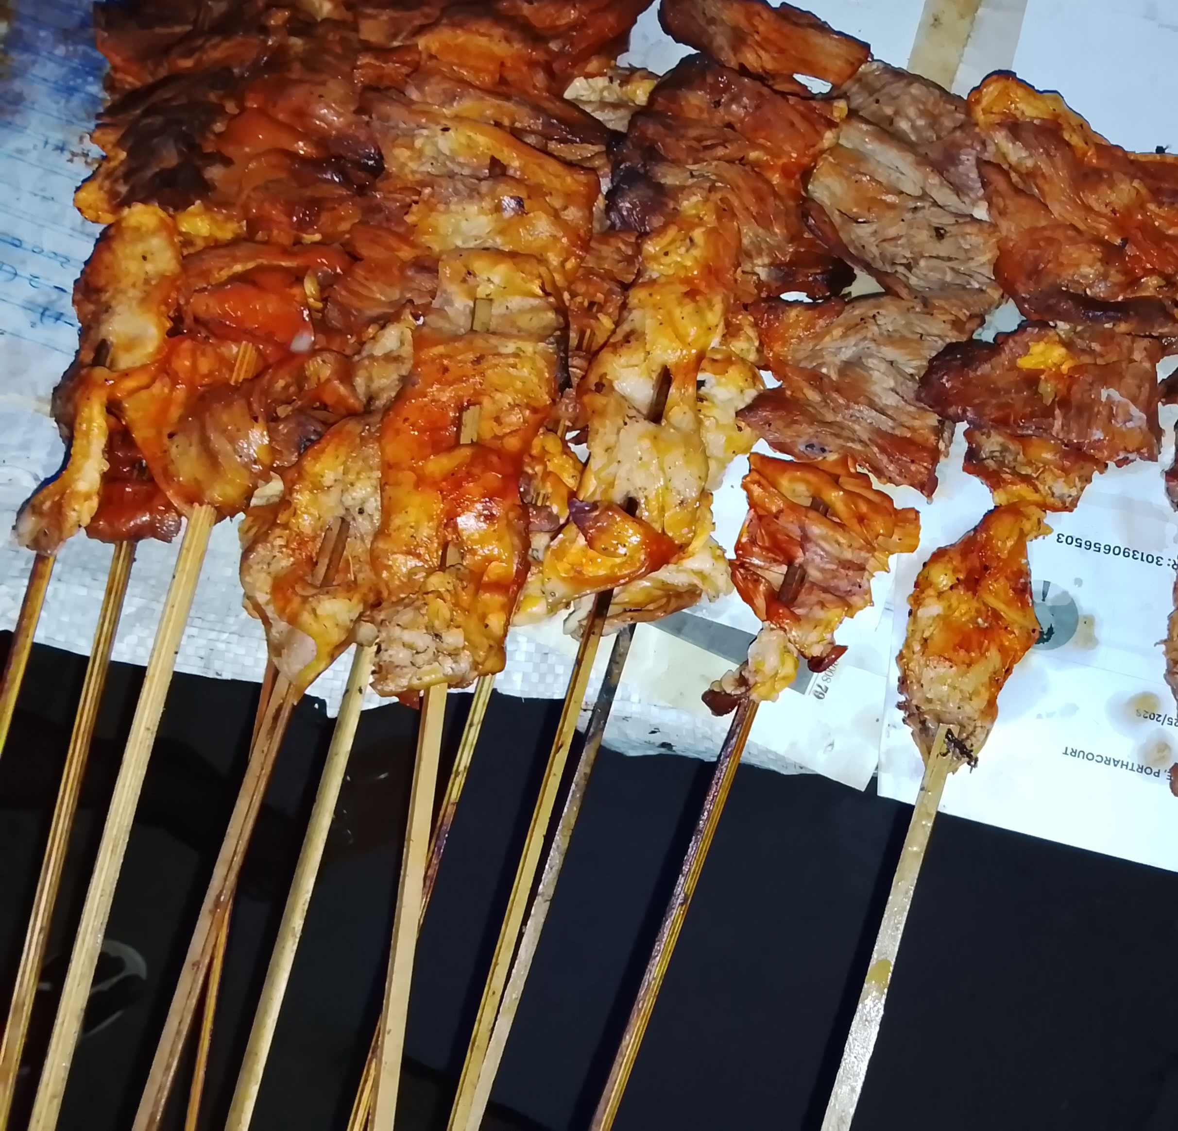
Fig 1: Picture of Suya (Roasted beef).
Research design
This study determined the protein content and polycyclic hydrocarbons concentrations in suya (beef) roasted and sold in Senior staff club of Rivers State University Port Harcourt Campus.
Sample Collection and Preparation
Eight Sticks (kebab) of suya samples were purchased at the Rivers State University, Port Harcourt, Senior Staff Club the same day at different time. The samples wrapped in foil material and placed inside ziplock bags properly labeled and transported to the laboratory for analysis. The suya samples were categorized into two sample groups according to the order of purchase.
Sample1 represents the Suya purchased at 11:00am while sample 2 was the suya purchased by 1:00 pm. Three (3) samples per group was used for the protein content assay while 1 stick from each group was used to determine the PAH concentrations.
Sample Preparation
20g of the suya samples were homogenized to uniformity using mortar and pestle and used for the assay.
Sample Analysis
Protein content was determined using Kjeldahl method while polycyclic aromatic hydrocarbons concentrations was determined using Gas chromatography mass spectrometry (GC-MS) method.

Statistical Analysis
Data obtained from the protein content assay was sujebted to one -way analysis of variance using stastiscal package for social science (SPSS) version 25 and result represents mean ±standard deviation of the variables. Values were considered statistically significant at P< =0.005.
1.9 Results and Discussion

Table 1: Percentage (%) of protein in suya roasted and sold at senior staff club, Rivers State University
Sample | % Protein | USDA (2023/2024) 21 – 30%
1 | 37.10±0.13
2 | 45.06±0.06

Table 2: Polycyclic Aromatic Hydrocarbon Concentrations in Suya Sample 1
S/N | Compounds | Retention time | Concentration (ppm) | EU 2023 Standard (0.002ppm)
1 | Naphthalene | 2.750 | 0.10
2 | Acenaphthylene | 4.419 | 0.29
3 | Acenaphthene | 4.591 | 0.32
4 | Fluorene | 5.122 | 2.16
5 | Phenanthrene | 6.282 | 0.20
6 | Anthracene | 6.425 | 2.58
7 | Fluoranthene | 7.969 | 0.07
8 | Pyrene | 8.329 | 1.10
9 | Benz[a]anthracene | 9.763 | 0.11
10 | Chrysene | 9.935 | 11.17
11 | Benzo[b]fluoranthene | 11.043 | 0.20
12 | Benzo[k]fluoranthene | 11.146 | 1.17
13 | Benzo[a]pyrene | 11.506 | 0.21
14 | Indeno[1,2,3cd] pyrene | 13.164 | 4.19
15 | Dibenz[a,h]anthracene | 13.347 | 3.15
16 | Benzo[ghi]perylene | 13.730 | 2.16

Table 3: Polycyclic Aromatic Hydrocarbon Concentrations in Suya Sample 2
S/N | Compounds | Retention time | Concentration (ppm) | EU 2023 Standard (0.002ppm)
1 | Naphthalene | 2.750 | 0.10
2 | Acenaphthylene | 4.419 | 0.25
3 | Acenaphthene | 4.591 | 0.32
4 | Fluorene | 5.122 | 2.16
5 | Phenanthrene | 6.282 | 0.20
6 | Anthracene | 6.425 | 2.59
7 | Fluoranthene | 7.969 | 0.07
8 | Pyrene | 8.329 | 1.10
9 | Benz[a]anthracene | 9.763 | 0.11
10 | Chrysene | 9.935 | 11.10
11 | Benzo[b]fluoranthene | 11.043 | 0.21
12 | Benzo[k]fluoranthene | 11.146 | 1.17
13 | Benzo[a]pyrene | 11.506 | 0.21
14 | Indeno[1,2,3cd] pyrene | 13.164 | 4.15
15 | Dibenz[a,h]anthracene | 13.347 | 3.15
16 | Benzo[ghi]perylene | 13.730 | 2.16

Results of the suya protein assay showed high protein contents of 37.10% and 45.06%. These values greatly exceeded the United States Department of Agriculture (USDA, 2023) standard of 22–30% for roasted or grilled meat and the 20–27% crude protein reported for suya in the study by Okonkwo et al., (2022), but were consistent with the report of Olaoye et al., (2018), which indicated that crude protein values for roasted and grilled beef suya ranged from 39.91% to 41.82%, confirming its high protein density. The high protein content confirms that suya is a rich source of dietary protein and justifies its high demand for consumption in different parts of Nigeria. The primary reason for the high protein content of suya is the nature of the meat, while the mixture of spices added to suya may also contribute to enhancing its protein content, taste, and texture. Suya is traditionally prepared from lean cuts of beef, which naturally have a high protein concentration (Olaoye et al., 2018). The preparation process, which involves roasting and significant moisture loss, effectively concentrates nutrients, including protein, leading to a higher percentage by weight in the final product compared to raw meat (Adeyeye et al., 2016). For consumers, suya provides a substantial portion of their daily protein requirement. Despite the rich protein content of suya, polycyclic aromatic hydrocarbon (PAH) analysis revealed the presence of 16 components with varying concentrations. Although the concentrations of PAH components in the two groups were similar, some differences were observed, as shown in Tables 2 and 3. Chrysene had the highest concentration of 11.17 ppm in sample 1 and 11.10 ppm in sample 2 respectively, whereas naphthalene had the lowest concentration of 0.10 ppm in both samples. Moreover, six carcinogenic PAHs namely benzo[b]fluoranthene, benzo[k]fluoranthene, benzo[a]pyrene, indeno[1,2,3-cd]pyrene, dibenz[a,h]anthracene, and benzo[ghi]perylene were detected in the suya samples. All detected PAHs, including both carcinogenic and non-carcinogenic compounds were present in high concentrations and exceeded the EU (2023) maximum allowable limit of 0.002 ppm for PAHs in roasted or grilled meat. The high concentration of polycyclic aromatic hydrocarbons is directly linked to the traditional method of suya preparation, which involves roasting meat over open flames from charcoal or wood (Fajuke et al., 2022). The confirmed presence of PAHs in the suya samples poses a significant health risk to consumers, as PAHs are known mutagenic and teratogenic agents as well as endocrine disruptors. Polycyclic aromatic Hydrocarbons are highly lipid-soluble, allowing them to be easily absorbed into the body and stored in fat. They are metabolically activated by enzymes into compounds that bind to DNA, causing mutations. They act as both initiators and promoters of tumor
2.0 Conclusion

Findings of the study show that suya is an excellent source of protein. However, the method of roasting can expose dangerous toxicants to the suya and may predispose people who consume it frequently to adverse health challenges. This therefore, highlights the urgent need for intervention in the preparation methods and adoption of a safer technique in roasting and grilling meat to reduce the emissions and contamination of PAHs.
Disclaimer (Artificial intelligence)

Author(s) hereby declare that NO generative AI technologies such as Large Language Models (ChatGPT, COPILOT, etc.) and text-to-image generators have been used during the writing or editing of this manuscript.

REFERENCES
Abou-Arab, M., Abdel-Shafy, H. I. and Mansour, M. S. (2014). A review on polycyclic aromatic hydrocarbons: source, environmental impact, effect on human health and remediation. Egyptian Journal of Environmental Science, 25(2), 107–123.
Adeyeye, S. A. O., Bolaji, O. T., Abegunde, T. A., & Idowu-Adebayo, F. (2021). Polycyclic aromatic hydrocarbon profile, chemical composition and acceptability of Suya (a West African grilled meat). Polycyclic Aromatic Compounds, 42(1), 249-259.
Ahmadu, J., & Aduwa, M. O. A. (2015). Economic analysis of suya production in Benin City, Edo State, Nigeria. Journal of Agricultural Sciences and Environment, 15(1), 15–24.
Adeyeye, S. A. O., Oyewole, O. B., Obadina, A. O., & Omoniyi, S. A. (2016). Quality and safety assessment of Kundi (a dried meat product) from Lagos State, Nigeria. Journal of Culinary Science & Technology, 14(4), 305–320.
Adebayo, G. A., Lateef, S. A., & Shokalu, A. O. (2018). Safety assessment of the presence of heavy metals and organic pollutants in street-vended foods sourced from three selected locations in Lagos State, Nigeria. European Journal of Nutrition & Food Safety, 8(4), 241-250.
Abdulkarim, A., Dahiru, M., & Abdulkarim, M. S. (2020). Determination of some heavy metals in Suya (roasted meat) sold in Mubi, Adamawa State, Nigeria. Journal of Applied Sciences and Environmental Management, 24(7), 1187–1191.
Adebiyi, M., Ogbonna, I.O., Sunday, D.M., Oyekemi, A. and Odu, C.E. (2018). Microbiological safety and proximate composition of (Suya) stored at ambient temperature for six hours from Maidugari, Northern Nigeria.
Adebayo, A. S., & Oladipo, I. C. (2018). Isolation and identification of bacteria from Suya meat sold in Gwagwalada Market. Journal of Applied Sciences and Environmental Management.
Alomirah, H., Al-Zenki, S., Al-Hooti, S., Zaghloul, S., Sawaya, W., Ahmed, N., & Kannan, K. (2011). Concentrations and dietary exposure to polycyclic aromatic hydrocarbons (PAHs) from grilled and smoked foods. Food Control, 22(12), 2028–2035.
Bouvard, V., Loomis, D., Guyton, K. Z., Grosse, Y., Ghissassi, F. E., Benbrahim-Tallaa, L. and Straif, K. (2015). Carcinogenicity of consumption of red and processed meat. The Lancet Oncology, 16(16), 1599–1600.
Danyi, H., Rengarajan, T., Rajendran, P., Nandakumar, N., Lokeshkumar, B., Rajendran, P. and Nishigaki, I. (2019). Exposure to polycyclic aromatic hydrocarbons with special focus on cancer. Asian Pacific Journal of Tropical Biomedicine, 5(8), 182–189.
Egbebi, A. O., & Seidu, K. T. (2011). Microbiological evaluation of suya (dried smoked meat) sold in Ado and Akure, South West Nigeria. European Journal of Experimental Biology, 1(4), 1-5.
Eke, P., Abdullahi, O.I, Umoh, V.J. and Gaadima, M. (2012). Hazards associated with Kilishi preparation in Zaria, Nigeria. Nigerian Journal of Microbiology. 8(2):337–345.
Eke, M. O., Ariahu, C. C., and Okonkwo, T. M. (2012). Production and quality evaluation of Dambu-nama - A Nigerian dried meat product. Nigerian Food Journal, 30(2), 66–72.
EFSA (2008). Polycyclic Aromatic Hydrocarbons in Food. Scientific Opinion of the Panel on Contaminants in the Food Chain.
European Committee for Standardization (2015). Food analysis - Determination of benzo[a]pyrene, benz[a]anthracene, chrysene and benzo[b]fluoranthene in foodstuffs by gas chromatography-mass spectrometry (GC-MS) (EN Standard No. 16619:2015).
Commission Regulation (EU) 2023/915 of 25 April 2023 on maximum levels for certain contaminants in food and repealing Regulation (EC) No 1881/2006. (2023). Official Journal of the European Union, L 119, 103–157.
Fajuke, A. A., Oluyose, O., & Fajuke, O. O. (2022). Evaluation of Polycyclic Aromatic Hydrocarbons (PAHs) in Suya Meat Roasted with Wood and Charcoal. Journal of Applied Sciences and Environmental Management, 26(11), 1833-1837.
FAO. (2013). Dietary protein quality evaluation in human nutrition (Report of an FAO Expert Consultation). Food and Agriculture Organization of the United Nations.
Godfray, H. C. J., Aveyard, P., Garnett, T., Hall, J. W., Key, T. J., Lorimer, J. andJebb, S. A. (2018). Meat consumption, health, and the environment. Science, 361(6399),5324.
Institute of Medicine. (2005). Dietary reference intakes for energy, carbohydrate, fiber, fat, fatty acids, cholesterol, protein, and amino acids. National Academies Press.
Iyiola, K. A., & Ikpamezie, V. O. (2024). Effects of Meat Types on Proximate and Microbial Qualities of Suya Produced in Wukari Metropolis, Nigeria. Farm Animal Health and Nutrition, 4(1), 14-20.
Kjeldahl, J. (1883): "Neue Methode zur Bestimmung des Stickstoffs in organischen Körpern" (New method for the determination of nitrogen in organic bodies), published in Zeitschrift für Analytische Chemie, 22(1): 366–383.
Olaoye, A.O., Ubbor, S.C., & Iniobong G.L. (2018).Assessment of the Effect of Different Packaging Materials on Some Quality Indices of a Nigerian Stick Meat (Tsire) during Storage. Advances in Food Science and Engineering, 2(1),30-37.
Oyeleke, S. B.& Adesoji, A. J. (2019). Bacteriological qualities and antibiogram studies of bacteria in “suya” and smoked fish from Dutsin-Ma, Katsina State, Nigeria. Pan African Medical Journal, 33, 219.
Ogbulie, Jude-Anthony Nnama, and Ogbulie, Toochukwu Ekwutosi. (2019). A Study on Polycyclic Aromatic Hydrocarbon and Heavy Metal Concentrations of Commercial Grilled Meat (Suya) and Smoked Catfish (Clarias gariepinus Burchell, 1822) Fish from South-West, Nigeria.
Ojo, Ademola O., Onabanjo, Olubodun O., Suleiman, Hassanat T., Sani, Salami A., Akinloye, Adejoke O., Owolabi, Aminat O., & Olagunju, Adeyinka. (2021). Nutritional evaluation and health implications of traditional West African street foods. In H. C. Brittin (Ed.), Nutritional and health aspects of food in Western Africa (pp. 303-316). Elsevier/Academic Press.
Phillips, S. M., Chevalier, S. and Leidy, H. J. (2016). Protein "requirements" beyond the RDA: Implications for optimizing health. Applied Physiology, Nutrition, and Metabolism, 41(5), 565–572.
Rodriguez, N. R., Miller, S. L. and Marlatt, S. (2015). Protein intake for optimal health. Nutrition in Clinical Practice, 30(6), 762–770.
U.S. Department of Agriculture, Agricultural Research Service. (2024). FoodData Central. https://fdc.nal.usda.gov/
Wenzl, T., Simon, R., Kleiner, J., & Anklam, E. (2006). Analytical methods for polycyclic aromatic hydrocarbons (PAHs) in food and the environment. Trends in Analytical Chemistry, 25(7), 716–725.
WHO. (2007). Protein and amino acid requirements in human nutrition (WHO Technical Report Series 935). World Health.

