Global Distribution of the Giant Squid Architeuthis dux: A Systematic Review with Special Focus on the Sea of Japan Hotspot

ABSTRACT
The giant squid (Architeuthis dux) remains one of the most elusive deep-sea megafauna. This paper presents a systematic review of confirmed records on a global scale, documenting a total of 836 specimens through late 2025. We focus on the Sea of Japan, which has emerged as a biological hotspot following an unprecedented 15-month period where 57 specimens were recorded. These events are analyzed through the influence of the Tsushima Warm Current, revealing a 'thermal trap' where water temperatures exceeding 15°C impair hemocyanin oxygen transport, leading to seasonal strandings. Furthermore, the study evaluates the transition from classical sighting data to modern detection frameworks, including environmental DNA and stable isotope analysis. Our findings suggest a return to historical baseline patterns following recent thermal anomalies, providing a consolidated framework for the future conservation of deep-sea biodiversity.
Keywords: Deep-Sea Monitoring, Giant Squid, Hemocyanin Physiology, Marine Heatwaves, Tsushima Current.
INTRODUCTION
The giant squid Architeuthis dux is classified within the class Cephalopoda, order Oegopsida, and family Architeuthidae. It is one of the largest known invertebrates, with specimens estimated to reach lengths exceeding 13 meters (Paxton, 2016). Biologically, it exhibits typical cephalopod characteristics: an elongated body, a well-developed head, enormous eyes, and ten appendages, eight arms and two long, prehensile tentacles used to capture prey, mainly fish and other molluscs (Regueira et al., 2014). It is a known prey of the sperm whale, as evidenced by sucker marks found on adult cetaceans and beaks recovered from their stomachs (Clarke and Pascoe, 1997).
Sightings of the giant squid remain rare and largely incidental to this day, and studying it in its natural habitat proves extremely challenging, as it dwells at great depths (Kubodera and Mori, 2005). Exploration efforts continue to be costly, requiring the use of advanced technologies and expensive underwater equipment (Singh et al., 2022). Although the giant squid has long captured the collective imagination, often featuring prominently in legends and maritime folklore, it remains a creature about which we still know very little (Roper and Shea, 2013). Recently, genetic research supported the hypothesis that A. dux constitutes a single species distributed at a global level with high levels of connectivity, probably facilitated by the dispersal of larval stages through the principal oceanic currents (Winkelmann et al., 2013).
The aim of this research is to assess the presence and distribution of Architeuthis dux on a global scale, comparing it with local distribution patterns and analysing the oceanographic, ecological, and anthropogenic factors that may explain the high frequency of sightings in specific areas compared to others.

MATERIALS AND METHODS
The present work is based on a systematic and critical review of the scientific literature and historical records concerning the presence and distribution of the species Architeuthis dux. The primary objective is to document the transition of the Sea of Japan from an area of anecdotal sightings to a global hotspot for the study of large cephalopods, comparing these data with the global biogeographical context and analysing the oceanographic drivers that determine this density of records. Data collection was conducted following the PRISMA (Preferred Reporting Items for Systematic Reviews and Meta-Analyses) guidelines (Page et al., 2021), consulting international databases (Scopus, Web of Science, Google Scholar) and Japanese regional databases (CiNii, J-STAGE) for the period between 1900 and 2025.
To maximize data recovery, the following Boolean search string was utilized: ("Architeuthis dux" OR "Architeuthis" OR "giant squid") AND ("distribution" OR "occurrence" OR "stranding" OR "bycatch" OR "Sea of Japan" OR "East Sea" OR "Tsushima Current"). For Japanese databases, the search was integrated with terms in the local language ("ダイオウイカ" AND "日本海"), which were fundamental for accessing technical reports from coastal prefectures and bulletins from experimental fishing stations. Inclusion criteria encompassed peer-reviewed articles, conference proceedings, verified technical reports of strandings and accidental captures in fixed nets (set-nets), as well as video and photographic documentation confirmed by experts. Anecdotal reports lacking biological verification were excluded.
Spatial distribution was analyzed and visualized using QGIS 3.33 Bialowieza software (QGIS Development Team, 2024), developing a global map to identify population connectivity. Finally, environmental data (temperature and salinity) were extracted from the Japan Oceanographic Data Center (JODC, 2026) to analyze the interaction between the species' physiology and the seasonal cooling of the basin's surface waters (Brix, 1983).

RESULTS AND DISCUSSION
Global Distribution and Quantitative Analysis
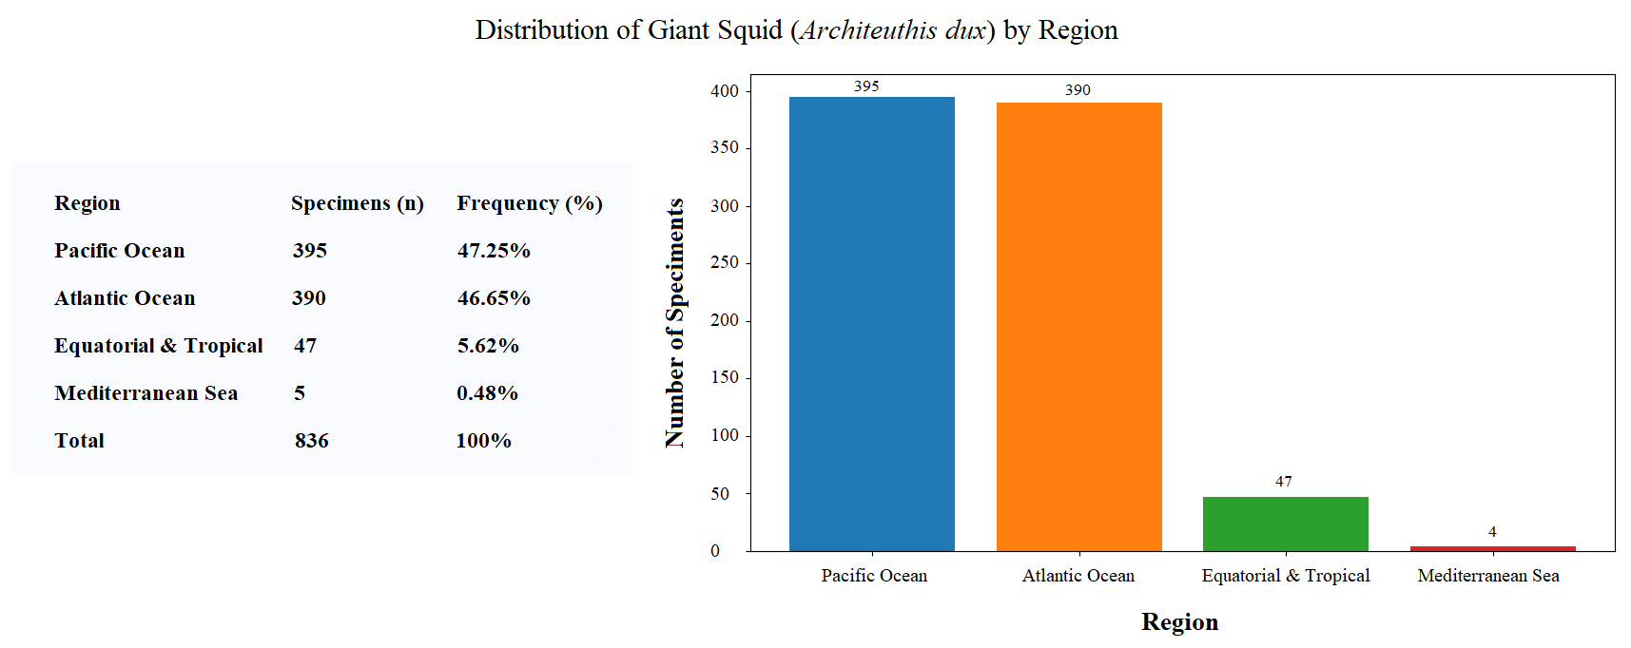
Based on 2011 data from Guerra and colleagues, the number of confirmed giant squid specimens up to 2011 was 677 (Guerra et al., 2011), to which documented sightings up to the present day must be added, resulting in a total estimated count of at least 836 specimens (Roper et al., 2015; Wada et al., 2015; Higuchi et al., 2016; Kubodera et al., 2016; Leite et al., 2016; Funaki, 2017; Kemper, 2017; Romanov et al., 2017; Shimada et al., 2017; Ichisawa et al., 2018; Robinson et al., 2021; Kubodera et al., 2021).
Figure 1. Histogram of the regional distribution of Architeuthis dux specimens.
Globally, the majority of giant squid findings are roughly evenly split between the Pacific Ocean (395 specimens, approximately 47.25%) and the Atlantic Ocean (390 specimens, approximately 46.65%), indicating a strong preference for open oceans in temperate and subpolar regions rather than equatorial and tropical waters (47 specimens, approximately 5.62%), semi-enclosed basins such as the Mediterranean Sea (4 specimens, approximately 0.48%), and the still poorly explored polar waters (Fig. 1). Despite the limited knowledge of the detailed distribution of the giant squid, due to the challenges in sampling these deep-sea and rare organisms (Roper and Shea, 2013), certain areas stand out as having higher abundances of sightings, namely the Pacific waters around Japan (Wada et al., 2015), Australia (Landman et al., 2004), and New Zealand (Bolstad and O’Shea, 2004), as well as the Atlantic waters near Spain (Guerra et al., 2004), South Africa (Roeleveld and Lipinski, 1991), and Newfoundland in Canada (Roper et al., 2015), each with more than 50 recorded specimens. The highest peak occurs in Japanese waters, where over 100 giant squids have been documented, as illustrated in the map (Fig. 2).
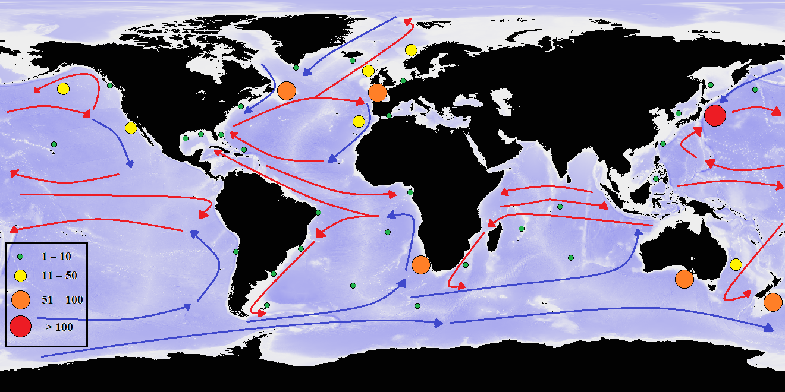
Figure 2. Global map of Architeuthis dux specimen findings (Updated through late 2025) with major warm (in red) and cold (in blue) ocean currents.
The possible reasons for a higher frequency of giant squid sightings in these areas can be attributed to a combination of favourable oceanographic features, such as the frequent presence of cold or western boundary currents rich in nutrients, like the Labrador Current in eastern Canadian waters and the Benguela Current in South Africa, and zones of permanent upwelling, as seen in South Africa, or seasonal upwelling, as occurs in southeastern Australia and northern Spain. These conditions promote the establishment of highly productive ecosystems abundant in potential prey (Carr and Kearns, 2003).
Specifically, the interaction between warm surface currents, which facilitate the global dispersal of larval stages, and cold deep currents, which define the adult feeding niches, creates a thermal and nutritional corridor essential for the species. Evidently, the highest densities of sightings are frequently recorded at the confluence of warm and cold currents. This dynamic is clearly reflected in the global distribution map, where the highest concentrations of sightings align with these major oceanic flows and nutrient-rich boundaries.
Therefore, these environmental contexts appear to favour not only the presence but also a certain stability of Architeuthis dux populations, offering habitats consistent with their ecological requirements. This species is highly adapted to life in deep waters, where it can utilise currents for long-range movements and access specific feeding niches (Guerra et al., 2010). Additionally, there is often an intensification of scientific research and industrial fishing activities in these areas (Kubodera and Mori, 2005). The most complete recoveries and the most detailed sightings have indeed occurred near oceanic ridges, upwelling zones, or deep continental slopes, confirming a direct correlation between underwater topography and the presence of the giant squid (Guerra et al., 2011).
It is important to highlight that, starting from 2011, the number of confirmed A. dux reports has increased significantly, probably due to the growing use of technologies such as remotely operated vehicles (ROVs) equipped with bait, which enhance the likelihood of encountering giant squids (Robinson et al., 2021). A particularly exceptional event, never recorded in other parts of the world, was observed in the Sea of Japan between January 2014 and March 2015, during which 57 specimens were documented within a period of 15 months, attributed both to direct scientific observations and accidental captures by the Japanese fishing fleet and set-nets, as well as the dynamics of the Tsushima Warm Current (Kubodera et al., 2018). Originating as a branch of the Kuroshio, this current enters through the Korea Strait and transports warm, saline water northeastwards along the western coast of Japan (Ichikawa and Beardsley, 2002). The peak in A. dux sightings has been identified as a direct consequence of anomalous heat transport by the Tsushima Current during those winters (Kubodera et al., 2018). In fact, it has been observed that thermal stress, driven by warm water currents bringing temperatures above 15°C, drastically reduces the affinity of hemocyanin for oxygen, suggesting that squids may die of suffocation due to impaired arterial saturation (Brix, 1983). Data consolidated in late 2025 seem to confirm that the recovery rate has returned to its historical baseline prior to the 2015 anomaly.
The study of the giant squid has long posed a challenge for scientific research due to its deep and inaccessible habitat, leading to the development of various techniques, both classical and modern, direct and indirect, for its investigation. Historically, direct observations of the giant squid have relied almost exclusively on occasional strandings of specimens, which have provided valuable information on the morphology of the cephalopod (Guerra et al., 2004; Sasai et al., 2025), and on the discovery of their beaks in the stomach contents of large apex predators, such as sperm whales or sharks (Clarke and Roper, 1998), which has also revealed cannibalistic behaviour within A. dux (Bolstad and O’Shea, 2004). Indeed, the keratinous beaks of the giant squid are not digested and accumulate in the stomachs of these predators, offering indirect evidence of the squid’s presence in a given area (Roeleveld, 2000). However, these techniques are based on rare and unpredictable events and are limited by their inability to provide data on the behaviour, ecology, or active distribution of A. dux (Cherel et al., 2009). In the context of the Sea of Japan, this 'passive' collection has been uniquely integrated through the use of commercial set-nets (fixed nets). These structures provide systematic monitoring along the coasts of the Toyama and Niigata prefectures, frequently capturing specimens in good physiological condition for further analysis (Murai et al., 2021).
The use of advanced technologies, such as ROVs, has marked a significant turning point, especially in the North-West Pacific, where high-definition cameras and luminous lures were used to capture the first live images of A. dux in its natural environment (Kubodera and Mori, 2005). However, high mission costs and complex logistics make systematic large-scale deployment difficult (Singh et al., 2022). Furthermore, the impact of acoustic technologies remains a concern: intense pulses from seismic surveys have been linked to lethal internal injuries to the statocysts of A. dux, causing disorientation and mass strandings (Guerra et al., 2011). Recently, marine biology has benefited from advances in molecular genetics; the sequencing of the A. dux genome in 2020 opened new perspectives on its physiology and adaptation to extreme environments (da Fonseca et al., 2020). The analysis of environmental DNA (eDNA) through water mass sampling, such as those transported by the Tsushima Current, now allows for the detection of genetic fragments of the species even in the absence of the animal itself (Merten et al., 2021), although challenges such as DNA degradation and dilution in deep waters complicate data interpretation (McCartin et al., 2022; Chang et al., 2025; Wu et al., 2025). Another emerging technique is the analysis of stable isotopes of carbon (δ¹³C) and nitrogen (δ¹⁵N) in soft tissues or beaks, which allows for the reconstruction of the animal's diet and migratory movements (Cherel et al., 2009; Guerra et al., 2010). In a rapidly changing oceanic context, understanding the biology of this species is also fundamental for assessing its vulnerability to climate change, such as global warming. In the Sea of Japan, where the thermocline is extremely sharp, this phenomenon is a primary driver of winter strandings, making the integration of robotics, genomics, and monitoring of fishing activities a fundamental goal for the future conservation of deep-sea biodiversity.

CONCLUSION
In conclusion, this systematic review underscores that Architeuthis dux is not merely a sporadic visitor of the deep oceans, but a species whose distribution is strictly governed by specific oceanographic thresholds. The Sea of Japan, as highlighted by the data collected in this study, represents a unique natural laboratory for studying the vulnerability of deep-sea megafauna to climate-driven changes. Our findings confirm that the high frequency of strandings in this region is a direct consequence of the 'thermal trap' created by the Tsushima Warm Current. Furthermore, the stabilization of sightings observed in recent data suggests a return to historical baseline patterns after a period of significant thermal anomalies.
Looking forward, the adoption of modern methodologies, particularly eDNA and stable isotope analysis, will be crucial for monitoring these elusive cephalopods without relying solely on accidental deaths or strandings. Future research should prioritize the integration of real-time satellite oceanographic data with biological monitoring to predict mass stranding events and mitigate the impact of anthropogenic activities on these deep-sea giants.

Disclaimer (Artificial intelligence)

Author hereby declare that NO generative AI technologies such as Large Language Models (ChatGPT, COPILOT, etc.) and text-to-image generators have been used during the writing or editing of this manuscript.

REFERENCES
- Bolstad, K. S. and S. O’Shea. 2004. Gut contents of a giant squid Architeuthis dux (Cephalopoda: Oegopsida) from New Zealand waters. New Zealand Journal of Zoology 31(1): 15–21. https://doi.org/10.1080/03014223.2004.9518354
- Brix, O. 1983. Giant squids may die when exposed to warm water currents. Nature 303: 422 –423. https://doi.org/10.1038/303422a0
- Carr, M.-E. and E. J. Kearns. 2003. Production regimes in four Eastern Boundary Current systems. Deep Sea Research Part II: Topical Studies in Oceanography 50(22–26): 3199–3221. https://doi.org/10.1016/j.dsr2.2003.07.015
- Chang, H., T. Ye, Z. Xie and X. Liu. 2025. Application of Environmental DNA in Aquatic Ecosystem Monitoring: Opportunities, Challenges and Prospects. Water 17(5): 661. https://doi.org/10.3390/w17050661
- Cherel, Y., V. Ridoux and P. Richard. 2009. Stable isotopes document the trophic structure of a deep-sea cephalopod assemblage including giant octopod and giant squid. Biology Letters 5(3): 403–406. https://doi.org/10.1098/rsbl.2009.0024
- Clarke, M. R. and P. L. Pascoe. 1997. Cephalopod Species in the Diet of a Sperm Whale (Physeter Catodon) Stranded at Penzance, Cornwall. Journal of the Marine Biological Association of the United Kingdom 77(4): 1255–1258. https://doi.org/10.1017/S0025315400038819
- Clarke, M. R. and C. F. E. Roper. 1998. Cephalopods represented by beaks in the stomach of a sperm whale stranded at Paekakariki, North Island, New Zealand. South African Journal of Marine Science 20: 129–133.
- da Fonseca, R. R., A. Couto, A. M. Machado, B. Brejova, C. B. Albertin, F. Silva, P. Gardner, T. Baril, A. Hayward, A. Campos, A. M. Ribeiro, I. Barrio‑Hernandez, H.-J., Hoving, R. Tafur‑Jimenez, C. Chu, B. Frazão, B. Petersen, F. Peñaloza, F. Musacchia, G. C. Alexander, H. Osório, I. Winkelmann, O. Simakov, S. Rasmussen, M. Z. Rahman, D. Pisani, J. Vinther, E. Jarvis, G. Zhang, J. M. Strugnell, L. F. C. Castro, O. Fedrigo, M. Patricio, Q. Li, S. Rocha, A. Antunes, Y. Wu, B. Ma, R. Sanges, T. Vinar, B. Blagoev, T. Sicheritz‑Ponten, R. Nielsen and M. T. P. Gilbert. 2020. A draft genome sequence of the elusive giant squid, Architeuthis dux. GigaScience 9(1): giz152. https://doi.org/10.1093/gigascience/giz152
- Funaki, S. 2017. First record of giant squid Architeuthis dux stranded at Kosagawa coast, Nikaho City, Akita Prefecture. Annual Report of Akita Prefectural Museum 42(Mar.): 3–5.
- Guerra, Á, Á. F. González and F. Rocha. 2004. A Review of the records of giant squid in The North-Eastern Atlantic and severe injuries in Architeuthis Dux stranded after acoustic explorations. International Council for the Exploration of the Sea, Vigo, Spain.
- Guerra, Á, A. Rodríguez-Navarro, Á. F., González, C. S. Romanek, P. Álvarez-Lloret and G. J. Pierce. 2010. Life-history traits of the giant squid Architeuthis dux revealed from stable isotope signatures recorded in beaks. ICES Journal of Marine Science 67(7): 1425–1431. https://doi.org/10.1093/icesjms/fsq091
- Guerra, Á, Á. F. González, S. Pascual and E. G. Dawe. 2011. The giant squid Architeuthis: An emblematic invertebrate that can represent concern for the conservation of marine biodiversity. Biological Conservation 144(7): 1989–1997. https://doi.org/10.1016/j.biocon.2011.04.021
- Higuchi, M., S. Abe, S. Ikeda and T. Kubodera. 2016. Report on the collecting of giant squids Architeuthis dux off Sado Island in the Sea of Japan, 2014. Chiribotan: Newsletter of the Malacological Society of Japan 46(3–4): 154–160.
- Ichikawa, H. and R. C. Beardsley. 2002. The Current System in the Yellow and East China Seas. Journal of Oceanography 58: 77–92. https://doi.org/10.1023/A:1015876701363
- Ichisawa, K., Y. Ota, Y. Tanabe, T. Sakakiyama and Y. Kawakami. 2018. Marine animals recorded in the Sea of Japan around Tottori Prefecture from 2014 to 2017: cetaceans, pinnipeds, sea turtles and the other noteworthy marine animals. Bulletin of the Tottori Prefectural Museum 55 (30 Mar.): 9–15.
- Japan Oceanographic Data Center (JODC) 2026. Hydrographic and Oceanographic Data. Japan Coast Guard. https://www.jodc.go.jp
- Kemper, J. 2017. Creature of the deep - a giant squid strands at Lüderitz. Namibian Environment & Wildlife Society (NEWS) Newsletter 4: 1–2.
- Kubodera, T. and K. Mori. 2005. First-ever observations of a live giant squid in the wild. Proceedings of the Royal Society B 272(1581): 2583–2586. http://doi.org/10.1098/rspb.2005.3158
- Kubodera, T., T. Wada, M. Higuchi and A. Yatabe. 2018. Extraordinary numbers of giant squid, Architeuthis dux, encountered in Japanese coastal waters of the Sea of Japan from January 2014 to March 2015. Marine Biodiversity 48: 1391–1400. https://doi.org/10.1007/s12526-016-0618-7
- Kubodera, T., Y. Koyama and W.-S. Chung. 2021. How the giant squid, Architeuthis dux, maneuver long tentacles for hunting. Annals of Marine Biology and Research 7(1): 1031.
- Landman, N. H., J. K. Cochran, R. Cerrato, J. Mak, C. F. E. Roper, C. C. Lu. 2004. Habitat and age of the giant squid (Architeuthis sanctipauli) inferred from isotopic analyses. Marine Biology 144: 685–691. https://doi.org/10.1007/s00227-003-1245-y
- Leite, L., D. Campbell, L. Versiani, J. A. C. C. Nunes and T. Thiele. 2016. First report of a dead giant squid (Architeuthis dux) from an operating seismic vessel. Marine Biodiversity Records 9: 26. https://doi.org/10.1186/s41200-016-0028-3
- McCartin, L. J., S. A. Vohsen, S. W. Ambrose, M. Layden, C. S. McFadden, E. E. Cordes, J. M. McDermott and S. Herrera. 2022. Temperature controls eDNA persistence across physicochemical conditions in seawater. Environmental Science & Technology 56(12): 8629–8639. https://doi.org/10.1021/acs.est.2c01672
- Merten, V., T. Bayer, T. B. H. Reusch, O. Puebla, J. Fuss, J. Stefanschitz, A. Lischka, H. Hauss, P. Neitzel, U. Piatkowski, S. Czudaj, B. Christiansen, A. Denda, and H.-J. T. Hoving. 2021. An integrative assessment combining deep‑sea net sampling, in situ observations and environmental DNA analysis identifies Cabo Verde as a cephalopod biodiversity hotspot in the Atlantic Ocean. Frontiers in Marine Science 8: 760108. https://doi.org/10.3389/fmars.2021.760108
- Murai, R., M. Shiomi, M. Yoshida, S. Tomano, Y. Iwata, K. Sugai and N. Hirohashi. 2021. All the spermatangia on a female were implanted by single-pair copulation in giant squid Architeuthis dux. Deep Sea Research Part I: Oceanographic Research Papers 175, 103585. https://doi.org/10.1016/j.dsr.2021.103585
- Page, M. J., J. E. McKenzie, P. M. Bossuyt, I. Boutron, T. C. Hoffmann, C. D. Mulrow, L. Shamseer, J. M. Tetzlaff, E. A. Akl, S. E. Brennan, R. Chou, J. Glanville, J. M. Grimshaw, A. Hróbjartsson, M. M. Lalu, T. Li, E. W. Loder, E. Mayo-Wilson, S. McDonald, L. A. McGuinness, L. A. Steward, J. Thomas, A. C. Tricco, V. A. Welch, P. Whiting and D. Moher. 2021. The PRISMA 2020 statement: an updated guideline for reporting systematic reviews. BMJ 372: 71. https://doi.org/10.1136/bmj.n71
- Paxton, C. G. M. 2016. Unleashing the Kraken: on the maximum length in giant squid (Architeuthis sp.). Journal of Zoology 300(2): 82–88. https://doi.org/10.1111/jzo.12347
- QGIS Development Team 2024. QGIS Geographic Information System. https://qgis.org
- Regueira, M., P. Belcari and A. Guerra. 2014. What does the giant squid Architeuthis dux eat? Hydrobiologia 725: 49–55. https://doi.org/10.1007/s10750-013-1662-y
- Robinson, N. J., S. Johnsen, A. Brooks, L. Frey, H. Judkins, M. Vecchione and E. Widder. 2021. Studying the swift, smart, and shy: Unobtrusive camera-platforms for observing large deep-sea squid. Deep Sea Research Part I: Oceanographic Research Papers 172: 103538. https://doi.org/10.1016/j.dsr.2021.103538
- Roeleveld, M. A. C. and M. Lipinski. 1991. The giant squid Architeuthis in southern African waters. Journal of Zoology 224(3): 431–477. https://doi.org/10.1111/j.1469-7998.1991.tb06036.x
- Roeleveld M. A. C. 2000. Giant squid beaks: implications for systematics. Journal of the Marine Biological Association of the United Kingdom 80(1): 185–187. https://doi.org/10.1017/S0025315499001769
- Romanov, E. V., S. Jaquemet and L. Puetz. 2017. A giant squid (Architeuthis dux) off Reunion Island, western Indian Ocean: the greatest giant ever? Journal of the Marine Biological Association of the United Kingdom 98(8): 2087–2093. https://doi.org/10.1017/S0025315417001588
- Roper, C. F. F. and E. K. Shea 2013. Unanswered Questions About the Giant Squid Architeuthis (Architeuthidae) Illustrate Our Incomplete Knowledge of Coleoid Cephalopods. American Malacological Bulletin 31(1): 109–122. https://doi.org/10.4003/006.031.0104
- Roper, C. F. E., H. Judkins, N. A. Voss, E. E. Shea Dawe, D. Ingrao, P. L. Rothman and I. H. Roper 2015. A compilation of recent records of the giant squid, Architeuthis dux (Steenstrup, 1857) (Cephalopoda) from the western North Atlantic Ocean, Newfoundland to the Gulf of Mexico. American Malacological Bulletin 33(1): 78–88. https://doi.org/10.4003/006.033.0116
- Sasai, S., Y Tanaka and N. Hirohashi 2025. Evidence for direct use of terminal organ for spermatophore transfer in giant squid, Architeuthis dux.
microPublication Biology. https://doi.org/10.17912/micropub.biology.001476
- Shimada, K., A. Mizuno and K. Sakai. 2017. Notes about making formalin-fixed specimen of the giant squid Architeuthis dux drifted at the coast of Noto Peninsula, Sea of Japan. Bulletin of the Ishikawa Museum of Natural History 7 (Mar.): 1–14.
- Singh, R., P. Sarkar, V. Goswami and R. Yadav 2022. Review of low-cost micro remotely operated underwater vehicle. Ocean Engineering 266(2): 112796. https://doi.org/10.1016/j.oceaneng.2022.112796
- Wada, T., T. Kubodera, M. Yamada and H. Terakado 2015. First records of small-sized young giant squid Architeuthis dux from the coasts of Kyushu Island and the south-western Sea of Japan. Marine Biodiversity Records 8: e153. https://doi.org/10.1017/S175526721500127X
- Winkelmann, I. E. H., P. Campos, J. Strugnell, Y. Cherel, P. J. Smith, T. Kubodera, L. Allcock, M.-L. Kampmann, H. Schroeder, A. Guerra, M. Norman, J. Finn, D. Ingrao, M. Clarke and T. Gilbert 2013. Mitochondrial genome diversity and population structure of the giant squid Architeuthis: genetics sheds new light on one of the most enigmatic marine species. Proceedings of the Royal Society B: Biological Sciences 280(1759): 20130273. https://doi.org/10.1098/rspb.2013.0273
- Wu, Q., T. Nakano, S. Ishida, T. Komai, Y. Fujiwara, T. Yoshida, M. Kawato, S. Oka, K. Fujikura, M. Miya and T. Minamoto 2025. Development of universal PCR primers for the environmental DNA metabarcoding of cephalopod (Mollusca) diversity. Marine Environmental Research 208: 107094. https://doi.org/10.1016/j.marenvres.2025.107094

