Original Research Article

Opportunities for the Development of Processed Tuna Products from Capture Fisheries of Indonesia Towards the International Market

.
ABSTRACT

Tuna fisheries are a strategic component of Indonesia’s capture fisheries, supported by substantial resources across the Indian Ocean, eastern Indonesian waters, and the Pacific Ocean. The catch is dominated by skipjack, yellowfin, and bigeye tuna, species that thrive in Indonesia’s warm and highly productive tropical waters shaped by strong currents and upwelling processes. These conditions have positioned Indonesia as one of the world’s leading tuna exporters. This study examines the potential and performance of processed tuna exports from the Cilacap Ocean Fishing Port, with a key role in supporting national fisheries exports. A descriptive approach was applied to analyze export volume and export value data for tuna products from 2020 to 2024. The data were processed using descriptive statistics and presented through tables, bar charts, and line graphs to illustrate export dynamics over time. The results indicate that PPS Cilacap exported 13 types of processed tuna products during the study period, with canned tuna and tuna pouches as the dominant products. Export composition showed marked fluctuations, with the highest level of product diversification occurring in 2021, followed by a reduction in product types and the absence of recorded processed tuna exports in 2024. Export volumes increased in 2021 and 2022 but declined sharply in 2023, with the downward trend continuing into 2024. This pattern reflects a broader decline in overall fisheries export performance at PPS Cilacap. The United States emerged as the primary destination for processed tuna exports. Although Indonesia remains competitive in fresh, frozen, and processed tuna markets, the processed tuna segment faces intense competition within an oligopolistic global market dominated by a limited number of major exporting countries. These findings underscore the need for more targeted strategies to enhance Indonesia’s competitiveness in the global processed tuna market.

Keywords: Cilacap, export, processed tuna product, production

1. INTRODUCTION

Tuna fisheries are among Indonesia's main potential sectors. Tuna resources are abundant across Indonesia, from the Indian Ocean (Nusa Tenggara, Bali, South Java, West Sumatra) to the eastern waters (Makassar, Flores, Banda, Arafura, Maluku, and Sulawesi Seas) and the Pacific Ocean (Pranowo et al., 2016; Rochman et al., 2015). Yellowfin (Thunnus albacares) and bigeye (Thunnus obesus) dominate the catch. Tuna primarily inhabit Indonesia's warm, nutrient-rich tropical waters, particularly areas with significant upwellings and strong currents, as these support their migration routes and high population levels (Zainuddin et al., 2015).

According to the FAO, Indonesia's tuna catches are quite high, dominated by skipjack tuna (Katsuwonus pelamis) at 52%, followed by yellowfin tuna (20%), bigeye tuna (15%), albacore tuna (11%), and southern bluefin tuna (1%) (Yosafat et al., 2025). These significant catches cater to the high demand from international markets. As a result, Indonesia has become one of the world's major exporters of skipjack and frigate tuna. The main export destinations for these commodities are Japan, the United States, and European Union countries (KKP, 2023; Rahmansyah et al., 2021).

One of the fishing ports near the Indian Ocean serving as a landing site for caught tuna is the Cilacap Ocean Fishing Port (PPS Cilacap). As a type A or ocean port, PPS Cilacap plays an important role in supporting fishery exports (Khoerunnisa et al. 2025). At this port, exported tuna products can include frozen, fresh, or processed forms, such as loin and fillet. These products from PPS Cilacap are primarily destined for the United States, Japan, and the European Union markets, thereby contributing to the country's foreign exchange up to USD 374.69 million (PPSC, 2024).

Exports of processed tuna from PPS Cilacap play a key role in the supply chain and can serve as a model for exporting this commodity from other fishing ports in Indonesia. Despite this, competitiveness needs to be enhanced for global export dominance. By using a descriptive approach based on port data, such as that available from PPS Cilacap, it is possible to identify value-added opportunities, address low export market share, and recommend sustainability strategies to maximize foreign exchange from processed tuna.

This study aims to identify the potential of processed tuna from capture fisheries for the international market. To achieve this aim, a descriptive approach and a fisheries database from the fishing port were used. The results are expected to provide recommendations for the development of Indonesia's processed tuna exports.

2. MATERIAL AND method

2. 1 Time and Research Location

The research was conducted using fisheries statistical data from PPS Cilacap, Central Java, Indonesia. The data used in this study were export data of processed tuna commodities from 2020 to 2024. The research location map is as follows (Figure 1).
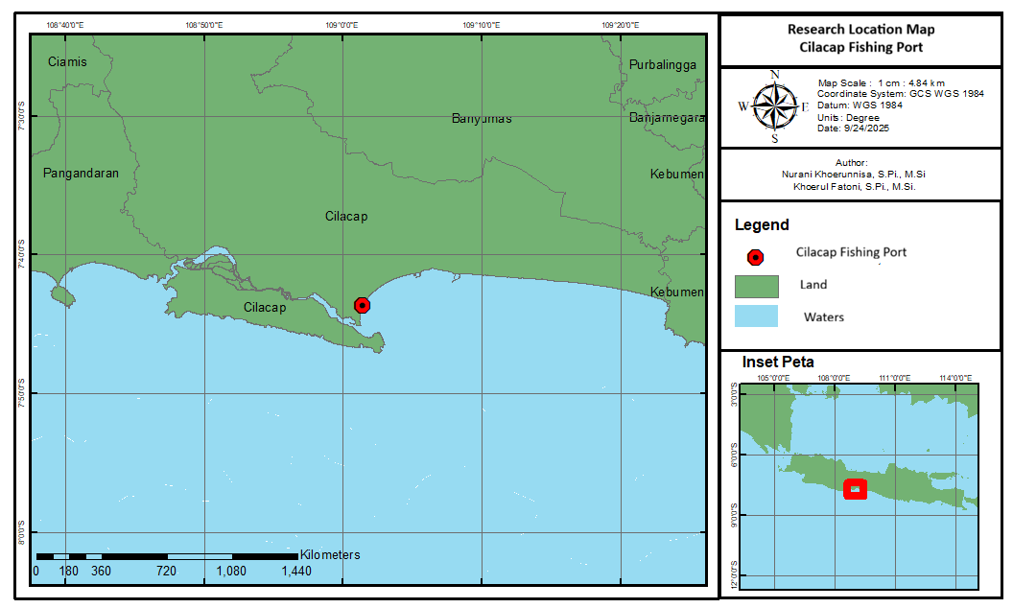
Fig. 1. Research location map, Cilacap Fishing Port

2. 2 Material

The materials used in this study are secondary data, namely, fisheries statistical reports from PPS Cilacap. These fisheries statistical reports are in the form of annual data, collected over the last 5 years. The parts of the PPS Cilacap report used in this study include the export volume by type of processed tuna, export value by type of processed tuna, and export destination countries by type of tuna. All data were taken for each year and then combined over 5 years.
In addition to the fisheries statistical reports, other materials used include literature from national and international publications to support the research findings. Research materials such as Microsoft Excel for data processing were also used in the study. Additionally, the ArcGIS application was used for creating the research location maps.

2. 3 Method

The data collected in this study are the volume and export value of tuna fishery commodities at PPS Cilacap from 2020 to 2024. The data were processed using descriptive statistics in tables, line charts, and bar charts. The analysis results are interpreted to show the performance of processed tuna exports at PPS Cilacap, to observe the potential for developing these commodity exports.

Following this overview of export destinations and considerations, the production volume data from 2020 to 2024 will be collected in Microsoft Excel and displayed in a bar chart to show trends across different processed tuna export products. The results of this trend can indicate whether the export conditions for processed tuna from PPS Cilacap abroad have increased or decreased over the past five years. Data on tuna processing types and destination countries will be compiled in a table to illustrate specific export preferences by country. Separately, production value data for each fish type from 2020 to 2024 will be visualized in a line chart, highlighting the economic trends and export developments over time. This result can indicate the competitiveness of Indonesia's processed tuna exports in international trade.

3. results and discussion

The results of this study discuss the potential of processed tuna as an export commodity. This potential can be seen from the production volume, export market destinations, and the value of processed tuna products.

3.1 Export Production Volume of Processed Tuna

Tuna is a high-value export commodity from Indonesia. Tuna exports are usually handled by processing or deep-sea fishing companies based at oceanic fishing ports, which are the largest in Indonesia. One of these is the Cilacap Oceanic Fishing Port (PPS Cilacap). Tuna commodities at PPS Cilacap are exported in fresh, frozen, and processed forms. This study specifically focuses on processed tuna exported from PPS Cilacap, given the wide variety of processed products sent abroad. The volume of processed tuna exports from PPS Cilacap is shown in Figure 2.
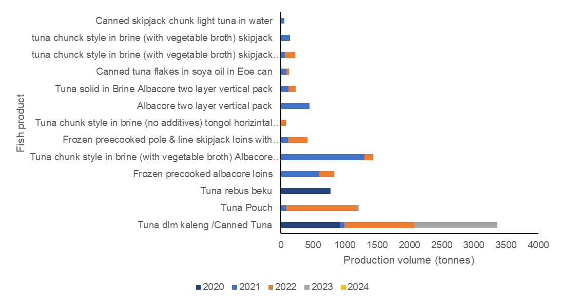
Fig. 2. Export production volume of processed tuna from PPS Cilacap in 2020-2024
Source: PPSC fisheries statistic 2020-2024 (with reprocessed data)

From 2020 to 2024, PPS Cilacap exported 13 types of tuna products: canned tuna, tuna pouch, frozen boiled tuna, frozen precooked albacore loins, tuna chunk style in brine (with vegetable broth) Albacore two-layer vertical pack, frozen precooked pole & line skipjack loins with flakes, tuna chunk style in brine with (no additives) tongol horizontal pack, Albacore two-layer vertical pack, tuna solid in brine Albacore two-layer vertical pack, canned tuna flakes in soybean oil EOE can, tuna chunk style in brine (with vegetable broth) skipjack two-layer vertical horizontal pack, tuna chunk style in brine (with vegetable broth) skipjack, and canned skipjack chunk light tuna in water.

Each type of tuna product has its own advantages and enthusiasts. Canned tuna is tuna that is processed through cooking and packaging in a can, generally using water, oil, or brine as the medium. Tuna pouch is ready-to-eat tuna packaged in flexible packaging (pouch). This product is lighter, easier to open, and often preferred in the modern market as well as by consumers who prioritize convenience. Frozen boiled tuna is tuna that has been boiled before freezing. This product is usually used as a raw material for further processing in the food industry or for catering and restaurant needs. Frozen precooked albacore loins are the main meat portions (loins) of albacore tuna that have been partially cooked and frozen. Tuna chunk style in brine (with vegetable broth) albacore two-layer vertical pack consists of chunk-style pieces of albacore tuna packaged in a brine solution with added vegetable broth. The vertical double-layer packaging is designed to maintain the product's quality and appearance. Frozen precooked pole & line skipjack loins with flakes are skipjack tuna loins caught using the pole & line method (environmentally friendly), partially cooked, frozen, and contain meat flakes. Tuna chunk style in brine (no additives), tongol horizontal pack is tuna chunks in salt solution without additives, packaged horizontally. Albacore two-layer vertical pack is a vertical double-layer packaging system for albacore tuna, designed to preserve the meat's texture and quality during storage and distribution. Tuna solid in brine Albacore two-layer vertical pack is whole (solid) albacore tuna meat in brine, packaged in a vertical double-layer. Canned tuna flakes in soybean oil EOE can are tuna flakes in soybean oil packaged in an EOE (easy open end) can. Tuna chunk style in brine (with vegetable broth), skipjack two-layer vertical horizontal pack consists of skipjack tuna chunks in brine with vegetable broth, packaged using a two-layer system with vertical and horizontal orientation to maintain product quality. Tuna chunk style in brine (with vegetable broth), skipjack is skipjack tuna cut into chunks, packed in a salt solution with added vegetable broth. This product is commonly used for direct consumption or as a cooking ingredient. Canned skipjack chunk light tuna in water consists of canned skipjack tuna chunks in water.

The annual export composition of processed tuna from PPS Cilacap reveals key trends. In 2020, only canned and frozen boiled tuna were exported, with frozen boiled tuna discontinued thereafter. From 2020 to 2023, canned tuna remained the most consistently exported product. A notable diversification occurred in 2021, expanding to 12 export types without any frozen boiled tuna. In 2022, a few varieties were dropped, showing a narrowing focus. By 2023, exports concentrated on canned tuna and tuna pouches, and in 2024, no processed tuna exports were recorded (PPSC, 2020; PPSC 2021; PPSC, 2022; PPSC, 2024).

The volume of tuna exports fluctuated from 2020 to 2024. Exports in 2021 increased by 1,401.782 tons from 2020. Similarly, in 2022, they increased by 164.699 tons from 2021. Meanwhile, in 2023, there was a decrease of 1,945.43 tons from 2021, and the decline continued in 2024.

This decline not only occurred in processed tuna exports but also in the average of all fishery product exports. According to PPS Cilacap data, the export volume from 2020 to 2024 decreased by an average of 1.27%, including fresh and frozen fish, with the highest export volume in 2022 at 3,877.38 tons (PPSC, 2024). Although several processed fish products declined, ribbonfish production actually increased. Export frozen ribbonfish production from 2020 to 2024 increased by 9.57%, from 660.17 tons in 2020 to 912.84 tons in 2024 (PPSC, 2024).

Nationally, tuna export volumes also experience fluctuations. These increases and decreases in export volumes represent a dynamic situation for Indonesia, the world's largest tuna producer, which contributes approximately 19.1% of the global tuna supply (Cristy et al., 2025). Indonesia's dynamic export volume is influenced by several factors, there are tuna production, tuna export prices, and the U.S. dollar exchange rate (Syahnaz et al., 2025). If tuna production decreases, so will the volume of tuna exports. The same goes for prices; when a lot of tuna is exported, prices will rise. The exchange rate between the dollar and rupiah also affects export volume; the higher the exchange rate, the greater the export volume (Nurjasari et al. 2023).

3.2 Export Market Destinations

Various processed tuna products from PPS Cilacap are exported to several countries. These export markets include the USA, Taiwan, and Thailand. The export destinations for processed tuna are shown in Table 1 below.

Table 1. Destination countries for tuna exports

Tuna Products | Export Destination Country
Canned Tuna | Taiwan
Tuna Pouch | USA
Tuna rebus beku | USA, Thailand
Frozen precooked albacore loins | USA
Tuna chunk style in brine (with vegetable broth) Albacore two-layer vertical pack | USA
Frozen precooked pole & line skipjack loins with available flakes | USA
Tuna chunk style in brine (no additives) tongol horizontal pack | Thailand
Albacore two-layer vertical pack | USA
Tuna solid in Brine Albacore two-layer vertical pack | USA
Canned tuna flakes in soya oil in Eoe can | Taiwan
Tuna chunk style in brine (with vegetable broth) skipjack two-layer vertical pack horizontal pack | USA
Tuna chunk style in brine (with vegetable broth) skipjack | USA, Thailand
Canned skipjack chunk light tuna in water | USA

Tuna products from Indonesia are marketed to international markets, including the United States, Taiwan, and Thailand, through exporting companies. Export fish commodities from Cilacap generally already have regular buyers. Several types of tuna and similar fish, such as skipjack tuna and longfin tuna, are exported through Jakarta in both fresh and frozen forms. Specifically, for fresh tuna commodities, the main export market is Japan (PPSC, 2024). In general, Indonesia has strong competitiveness in the global market for fresh, frozen, and processed tuna products (Suwarno et al., 2012).

Based on Table 1, the USA is the main export destination for processed tuna products from PPS Cilacap. This condition is suspected to be due to the relatively higher price of tuna in the USA compared to other countries. The high price is the main consideration for exporters, as it yields higher production value, making the USA the primary market for Indonesian tuna despite stricter export requirements (Arthatiani et al., 2020).

However, the full potential of capture fisheries has not yet been fully reflected in Indonesia's position as a tuna producer. In the ASEAN region, Indonesia is still ranked second after Thailand, influenced by differences in the level of resource exploitation, both in terms of production volume and the use of fishing gear technology (Putri et al., 2018). Thailand is the world's largest exporter of processed tuna, with a 46.75% market share, making it a dominant player in the global tuna trade (Lestari et al., 2013). Therefore, increasing Indonesia's tuna product exports is important because the market share remains very large, Thailand currently dominates, and Thailand continues to import raw materials from Indonesia (Hartanto et al., 2021).

Indonesia has a tremendous opportunity to explore and develop new market destinations for processed tuna exports. So far, markets such as Taiwan, Thailand, and the United States have been dominated, with these markets consistently becoming the main customers. This situation provides a strong foundation not only for relying on existing markets but also for expanding export reach to other countries. Japan and the European Union are examples of markets with high demand for tuna products, driven by both quality and sustainability. However, market expansion efforts cannot be carried out instantly. A deep understanding of consumer preferences, quality standards, and food safety requirements, as well as the export requirements applicable in each target country, is needed. In addition, strengthening networks with credible buyer partners is a key factor for Indonesian processed tuna products to be accepted and compete sustainably in the international market.

3.3 Export Production Value of Processed Tuna

The volume of tuna production and the countries of destination for tuna exports are related to the value of tuna production. The value of tuna production indicates the extent to which the price of processed tuna products contributes to the economy. The export value of processed tuna is shown in Figure 3.

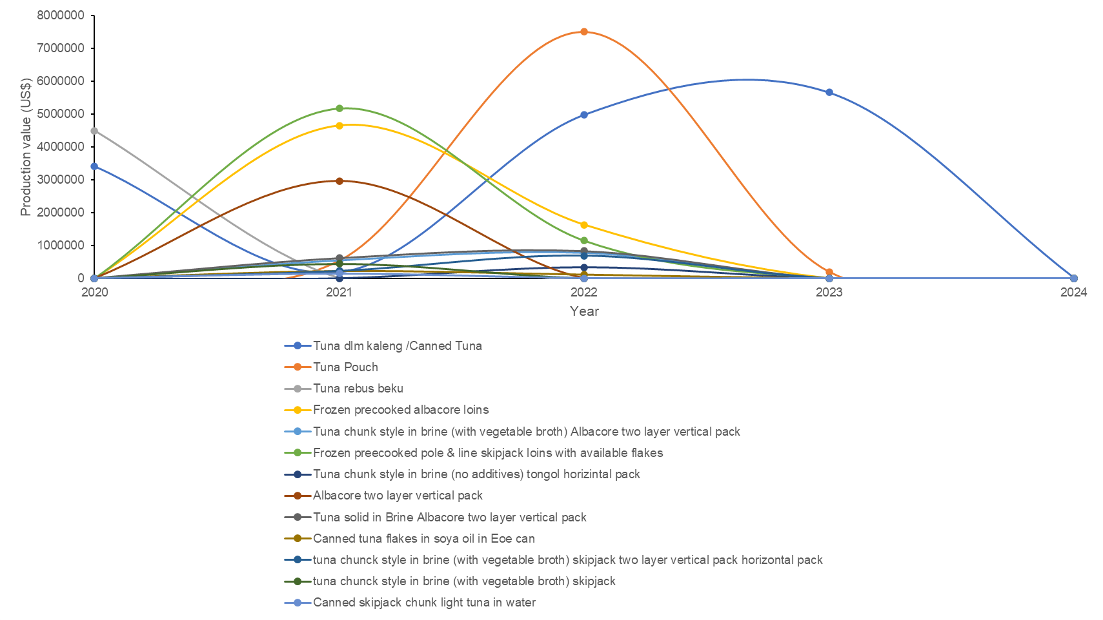

Fig. 3. Export production value of processed tuna at PPS Cilacap 2020-2024
Source: PPSC fisheries statistic 2020-2024 (with reprocessed data)

In terms of production volume, canned tuna exports contribute the highest production value at PPS Cilacap. Processed canned tuna has consistently remained an export product from 2020 to 2024, although its production value has been quite fluctuating. From 2020 to 2024, tuna pouches contributed the highest production value in 2022, reaching 7,503,795.17 US dollars. However, the production value of these tuna pouches decreased in 2023 and was not exported again until 2024. Meanwhile, boiled frozen tuna had the lowest production value, as it was only exported in 2020.

The fresh and frozen tuna markets tend to be characterized by perfect competition, with many business actors, relatively homogeneous products, and no price control by individual actors. In contrast, the processed tuna market is characterized by an oligopoly structure, in which trade is dominated by a small number of countries or large companies that exert strong influence over prices and market share (Osmaleli et al. 2023). This condition indicates that although the processed tuna market offers significant opportunities, the level of competition is much tighter than in the fresh and frozen tuna markets.

Processed tuna is one way to add value to products (Muharom et al. 2019). This added value enables the utilization of processed tuna's potential to produce ready-to-eat food products that can be marketed safely and of high quality to the public (Atmajaya et al. 2021). The marketing flow of processed tuna, from customer orders to the distribution of goods to consumers, is called the supply chain. The processed tuna supply chain involves several stages: responding to customer orders, planning, procuring raw materials, production, warehousing, transportation, and distributing goods (Faizza et al., 2025). During this process, various steps are taken to ensure product quality and delivery efficiency, including quality inspections, packaging, temperature-controlled shipping, stock management, and efficient delivery methods.

In this context, Indonesia needs to enhance the competitiveness of its processed tuna exports by developing appropriate strategies to survive and compete in the global processed tuna market. The export value of Indonesian tuna to destination countries is significantly influenced by tuna export prices, making price a key factor that requires serious attention. Therefore, the government has an important role in maintaining and managing tuna prices to remain competitive in the international market. The implications of these findings underscore the need for further research on sustainable tuna export management to enhance the economic benefits Indonesia gains.

4. Conclusion

The results indicate that PPS Cilacap has significant potential as a hub for processed tuna exports, particularly canned tuna products, which consistently generate the highest production value. However, the sharp decline in export volume and product diversity after 2022, culminating in the absence of processed tuna exports in 2024, signals structural challenges in competitiveness and market sustainability. The dominance of the United States as an export destination confirms the importance of price as a key determinant of export value, especially within an oligopolistic global processed tuna market. To enhance Indonesia’s position relative to leading exporters such as Thailand, strategic efforts are required to stabilize production, improve value addition, and maintain competitive pricing. Strengthening export-oriented processing capacity at fishing ports, supported by consistent government price and market policies, is essential. Further research on sustainable export management is needed to ensure that economic gains from processed tuna exports can be maintained and expanded over the long term.

Disclaimer (Artificial intelligence)

Authors hereby declare that NO generative AI technologies such as Large Language Models (ChatGPT, COPILOT, etc.) and text-to-image generators have been used during the writing or editing of this manuscript.

References

- Arthatiani, F. Y., Lusur, E. A., Suryawati, S. H., & Kurniawan, T. (2020). Structure, Conduct and Performance Analysis of Tuna Industries in Indonesia. Journal of Marine and Fisheries Socioeconomics, 15(1), 69-82. http://dx.doi.org/10.15578/jsekp.v15i1.8343
- Atmajaya, O. D. D., Agam, & B., Wahyudi, A. (2021). Development Strategy of Tuna Fisheries Business Post-COVID-19 Pandemic in Pondokdadap Coastal Fishing Port Sendang Biru Malang. Jurnal Perikanan dan Kelautan. 11(1), 114-125.
- Cristy, A., Hartanti, A. F., Kurniawan, A. Z., & Saleh, M. Z. (2025). The Impact of Free Trade on the Export of Indonesian Tuna and Skipjack Products. Jurnal Manajemen dan Bisnis Ekonomi. 3(1), 244-250. https://doi.org/10.54066/jmbe-itb.v3i1.2765
- Faizza, F. N., Sholihah, S. A., & Firmansyah, I. (2025). Performance Measurement Analysis of the Tuna Commodity Supply Chain Using the Supply Chain Operations Reference Method at Tuna Exporting Companies in Bitung City. Jurnal Sistem Transportasi & Logistik, 4(3), 138-147.
- Hartanto, T. R., Suharno, Burhanuddin. (2021). Export Competitiveness of Indonesian Tunas-Skipjack Tunas-Eastern Littles Tunas in The United States of America’s Market. Jurnal Pengolahan Hasil Perikanan Indonesia, 24(2), 227-235. http://dx.doi.org/ 10.17844/jphpi.v24i2.36075
- Khoerunnisa, N., Aisyah, & Fatoni, K. (2025). Optimization of frozen shrimp export commodity through correlation analysis of production volume and value at PPS Cilacap. Jurnal Pasir Laut, 9(2), 89-95. https://doi.org/10.14710/jpl.2025.77760
- [KKP] Ministry of Marine Affairs and Fisheries. (2023). Indonesian fisheries export statistics. Jakarta: Ministry of Marine Affairs and Fisheries.
- Lestari, W., Syarief, R. & Sumantadinata, K. (2013). Strategies to improve the competitiveness of Indonesian processed tuna in the international market. Agribusiness Forum, 8(1), 36-44.
- Muharom, Y. P., Anna, Z., Riyantini, I., Suryana, A. A. H. (2019). Analysis of value added in the tuna processing industry in The Ocean Fishery Port (PPS) Nizam Zachman, Jakarta. Jurnal Perikanan dan Kelautan, 10(2), 9-16.
- Nurjasari, Amarullah, T., Rahmawati, Insani, S. A. (2023). Factors Influencing Fresh Tuna Export Volume at PT. Yakin Pacific Tuna Banda Aceh. Jurnal Perikanan Terpadu, 1-7.
- Osmaleli, O., Hana, H., Tridoyo, K. (2023). What Market Structures and Factors Influencing Tuna Exports? (Case Study: Indonesia). BIO Web of Conferences MaCiFIC 2023, 70(06001), 1-8. https://doi.org/10.1051/bioconf/20237006001
- [PPSC] Cilacap Ocean Fisheries Port. (2020). Fisheries Statistics 2020. Cilacap: Cilacap Ocean Fisheries Port.
- [PPSC] Cilacap Ocean Fisheries Port. (2021). Fisheries Statistics 2021. Cilacap: Cilacap Ocean Fisheries Port. [PPSC] Cilacap Ocean Fishing Port. (2022). Fisheries Statistics 2022. Cilacap: Cilacap Ocean Fishing Port.
- [PPSC] Cilacap Ocean Fishing Port. (2023). Fisheries Statistics 2023. Cilacap: Cilacap Ocean Fishing Port.
- [PPSC] Cilacap Ocean Fishing Port. (2024). Fisheries Statistics 2024. Cilacap: Cilacap Ocean Fishing Port.
- Pranowo, W. S., Kuswardani, A. R. T. D., Nugraha B., Novianto, D., Muawanah, U., Prihatno, H., & Yu, W. (2016). Ocean-climate interaction of South Eastern Indian Ocean for tuna fisheries & its socio-economy impacts. International Journal of Science and Research (IJSR), 5(4), 1956-1961.
- Putri, D.A.S., Rosjadi, F., & Sundari, M.S. (2018). Export competitiveness and market share development of Indonesian tuna in the international market for the 2012-2016 Period. Ekonomi dan Bisnis, 23 (1), 1-18. https://doi.org/10.24123/jeb.v23i1.2007
- Rahmansyah, R., Nuraini, C., Rofatin, B., & Mutolib, A. (2021). A Study of the competitiveness of Indonesian processed tuna export products in the European market. JSHP, 5(2), 180-189. https://doi.org/10.32487/jshp.v5i2.1154
- Rochman, F., Nugraha, B., & Wujdi, A. (2015). Estimation of skipjack tuna (Katsuwonus pelamis, Linnaeus, 1758) population parameters in the Southern Indian Ocean of Java. Bawal Widya Riset Perikanan Tangkap, 7(140), 77–85.
- Suwarno, Oktaviani, R., Siregar, H., & Murniningtya, E. (2012). Competitive advantage and export supply of Indonesian tuna in the international market: constant market share analysis. Journal of Economics and Development Policy, 1(2), 120-143.
- Syahnaz, C., Brillyantina, S., Agustina, J., & Slamet, A. H. H. (2025). The influence of tuna production volume, tuna export prices, and the dollar exchange rate on indonesia's tuna export volume. Jurnal Agribisnis Unisi, 14(1), 26-37.
- Yosafat, Y., Yusrudin, Sumaryam. (2025). Analysis of skipjack tuna (Katsuwonus pelamis) catch production in WPPNRI 572 landed at Nizam Zachman Ocean Fishing Port, Jakarta. Manfish: Scientific Journal of Fisheries and Livestock, 3(1), 339-354. https://doi.org/10.62951/manfish.v3i1.147
- Zainuddin, M., Selamat, M. B., Ridwan, M., Hidayat, S., & Mallawa, A. (2015). Estimating total allowable catch and mapping potential fishing zones for tuna in the Flores Sea: A remote sensing-geographic information system perspective. Indonesian Journal of Ichthyology, 15(2), 129-141.

