Original Research Article

A Study on the Need of Social Emotional Learning among School Adolescents

.
Abstract

This study investigates social and emotional learning (SEL) needs among secondary and senior secondary adolescents in India. It aims to find the level of students' familiarity and understanding of SEL concepts. It also explores classroom and school-based SEL activities as shared by respondents. Expectations of students from schools regarding SEL education have also been recorded. Employing a cross-sectional survey design, data was collected from 57 adolescents aged 14-18, across eight schools in the Bhopal district, M.P., India. Questionnaire developed to capture data on student’s familiarity with SEL was administered. Findings indicate moderate SEL awareness, limited structured activities (e.g., group discussions and debates), and strong student demands for integrated programs, teacher tFIraining, and peer support to strengthen social and emotional skills. The findings underscore the urgency of embedding SEL in curricula to unlock adolescents' potential as productive citizens, offering policy and pedagogical insights for diverse school settings.

Key words: Adolescents, Social and Emotional learning, Mental well being, Class room practices.

- INTRODUCTION
Adolescence is a difficult intermediary stage from childhood to adulthood. For adoloscents, its a journey of self-exploration and interaction with the world as they experience rapid physical, cognitive and psychosocial growth. This affects how they feel, think, make decisions, and interact with the world around them. (World Health Organization. n.d.) Though adoloscents is thought of as a healthy stage of life, there is significant death, illness and injury in the adolescent years. (World Health Organization. n.d.) Harikrishnan and Sailo (2021) reported a significant (little more than a tenth) of school-going adolescents as having emotional and behavioural problems. Similarly, Timalsina et al. (2018) reported that 12.9% of school-going adolescents in Nepal experienced psychosocial problems underscoring the need for focused social and emotional interventions. Adolescents is also a time when behavioural and health problems can emerge or worsen, with negative consequences that last long into adulthood. (Yeager 2017) For instance, people who are victimized or bullied during adolescence can later become more aggressive and more depressed.
According to WHO, to grow and develop in good health, adolescents need information, including age-appropriate comprehensive sexuality education; opportunities to develop life skills; health services that are acceptable, equitable, appropriate and effective; and safe and supportive environments. They also need opportunities to meaningfully participate in the design and delivery of interventions to improve and maintain their health. Expanding such opportunities is key to responding to adolescents’ specific needs and rights. (WHO) Jacob and Philip (2022) note that Damon (2004), Lerner et al. (2011), Phelps et al. (2009), and Shek et al. (2012) emphasize PYD's importance (Positive youth Development program. PYD offers educators a perspective that supports social and emotional learning (SEL) to enhance student protective factors, supports youth affected by bullying, and improves school climate.
India has over 253 million adolescents (10–19), (UNFPA India, 2025), with immense potential to propel economic growth, spur innovation, and foster social advancement. A safe and successful passage from adolescence into adulthood is the right of every child. This right can only be fulfilled if families and societies make focused investments and provide opportunities to ensure that adolescents and youth progressively develop the knowledge, skills and resilience needed for a healthy, productive and fulfilling life. (UNFPA) National and global development, security and social justice can only be achieved if adolescents and youth are included as full and active participants. Investments in young people now are in everyone’s interest and are everyone’s responsibility: families, community leaders, non-governmental organizations, governments, the private sector, the international community, and others alike.
National Education policy 2020, lays particular emphasis on the development of the creative potential of each individual. It is based on the principle that education must develop not only cognitive capacities - both the ‘foundational capacities ’of literacy and numeracy and ‘higher-order’ cognitive capacities, such as critical thinking and problem solving – but also social, ethical, and emotional capacities and dispositions. (NEP 2020, p.4) This can be addressed through social emotional learning (SEL).
Jacob and Philip (2022) using a cross sectional survey design and a SEL need assessment checklist collected data from 110 students from low-resourced schools in South Bangalore. The results of the study demonstrate that 80 percent of the respondents felt a strong need to develop the five core SEL competencies, such as self-awareness, social awareness, relationship skills, self-management, and responsible decision-making skills. In addition, the study examined social and emotional skills that adolescents require for success in school and prosper as perceived by students. Greenberg, M. (2023) also reiterated by a consensus among educators, parents, and policymakers that education should include a focus on supporting essential social and emotional capacities to help children navigate the world successfully. Grant et al. (2023) reported limited attention to the integration of SEL approaches in the context of SEL offering practical strategies for measuring and using SEL implementation data in schools. Ross & Tolan, (2017) tested the CASEL model empirically for measurement utility, using large U.S. dataset of students from class 5 to 7. Findings showed students with higher SEL scores usually have better grades and engagement.
SEL programs for adolescents are also essential because they might prevent problems like aggression, anxiety,depression and insecurity. SEL programs try to help adolescents cope with their difficulties more successfully by improving skills and mind sets, and they try to create respectful school environments that young people want to be a part of by changing the school’s climate. (Yeager 2017). Green et al. (2021) conducted a randomized controlled trial of the SPARK (Speaking to the Potential, Ability, and Resilience Inside Every Kid) Pre‑Teen Mentoring Curriculum using the CASEL five‑competency framework. The study showed that students receiving SPARK intervention exhibited stronger SEL skills. (Grant et al.) The above literature review establishes the need and importance of SEL for adolescents. It also shows that their awareness and perceptions of SEL have not been much researched. The present study is to find out adolescents perceptions about SEL and practices that may enable them to strengthen their SEL.

- Understanding Social and Emotional Learning
SEL is an integral part of education and human development. SEL is particularly important for our adolescents who are in the process of becoming a responsible adult. They need to acquire and apply the knowledge, skills, and attitudes to develop a healthy identity of self, manage emotions and achieve personal and collective goals. They need to be humane citizens and feel and show empathy for others, establish and maintain supportive relationships, and make responsible and caring decisions.
The SEAL model (Social and Emotional Aspects of Learning) introduced by English Government in 2005 aims to develop self- awareness, managing feelings, motivation, empathy and social skills in the learners. (Humphrey et al., 2010)
Collaborative for Academic, Social, and Emotional Learning (CASEL) a non- profit organization founded in 1994, has developed the SEL framework. This model addresses five broad, interrelated areas of competence which include self awareness, self-management, social awareness, relationship skills and responsible decision making. Self- awareness and self- management relate to recognizing and understanding one's own emotions, thoughts, and values, and how they influence behaviour across contexts.
Social awareness is the ability to understand others perspectives and to be empathetic. This includes being empathetic to those from diverse backgrounds, cultures and contexts. Relationship skills enable establishing and maintaining healthy and supportive relationships and effectively navigating settings with diverse individuals and groups. (CASEL) Responsible decision-making includes abilities to make caring and constructive choices about personal behaviour and social interactions across diverse situations.
The ISELF (Indian Social and Emotional Framework) has been developed by the teacher foundation in India. The model has been adapted from CASEL. Besides, CASEL components, it also includes decision making. (Shahid, M. 2020).
SEL is pivotal to happy and healthy learning and growing. It advances educational equity and excellence, helps students to cope up better with emotional stress, solve problems, and avoid peer pressure. It prevents students from engaging in harmful activities. It also helps in building safe, healthy, and just communities. SEL is an important aspect of holistic development of learners. It is hence pertinent to study student’s perception and understanding of it.
- Research Questions
The following research questions guide this study:
- Are the students familiar with the concept of SEL?
- What do students understand by SEL?
- What kind of SEL activities are carried out in classroom practices and in the school.
- What are the expectations of the students from school viz a viz SEL education?
- What according to the students are the challenges in incorporating SEL in the teaching -learning process.

3.1 Objectives of the Study
- To study the students’ understanding of SEL.
- To examine the need for SEL as perceived by adolescents aged between 14 and 18 years.
- To identify the kind of SEL activities being carried out in schools
- To find out the expectations of students from school on SEL.
- To find out the challenges according to the students in the implementation of SEL in the teaching -learning processes.

3.2. Methodology
The aim of the study is to investigate the need for SEL among secondary and senior secondary students.
It involved data collection using convenience sampling. Teachers from different schools were asked to share google form link with their students for data collection. The respondents were randomly selected, without a structured quota for varied school management types (government, private etc.). This non- probability convenience sampling was done to ensure voluntary participation rather than balanced representation across groups. The anonymous data collection ensured student privacy. It was time effective and enabled rapid data collection. Data was collected from 57 respondents aged 14 to 18 from eight different schools of Bhopal, M.P, India.
The cross-sectional survey design helped in capturing respondents’ perceptions, experiences, and attitudes without requiring prolonged follow-up. It enabled in examining the perceived need for SEL among secondary and senior secondary students within a specific time frame.
The sample may not adequately represent the broader population of secondary and senior secondary students and may not be used for generalisation. However, it gives rich insights into perceptions of students on SEL, the need to embed SEL in learning- teaching process. It also brings out challenges faced in implementing SEL and leaves academia to explore strategies for overcoming these challenges.
A need assessment checklist was administered to examine the need of SEL to the respondents. The first part of the check list consisted of demographic details of the students like age and gender. (Students names, contact numbers and name of school were not asked to ensure confidentiality and so that students may respond without hesitation.) The second part of the checklist consisted of items based on SEL. These consisted of both objective and subjective questions. The data collected was analysed and interpreted accordingly.

- DEMOGRAPHIC CHARACTERISTICS: AGE AND GENDER
4.1 Respondents Age
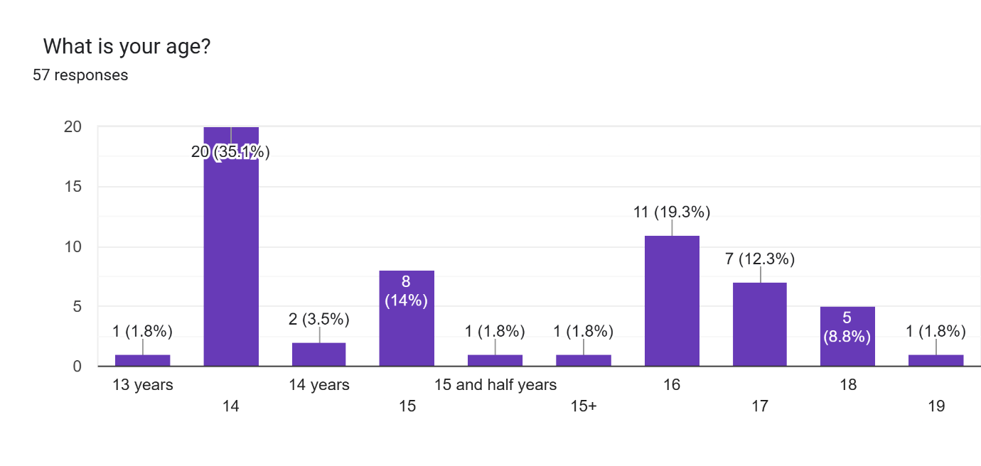
Fig. 1. Socio – Demographic profile of the respondents

The respondents are between 14 to 18 years of age. The highest percentage of participants were 14 and 16-year-old 35.1%) and 19.3% respectively. This could be interpreted as a need for addressing SEL, as soon as learners reach adolescents.
4.2 Respondents Gender
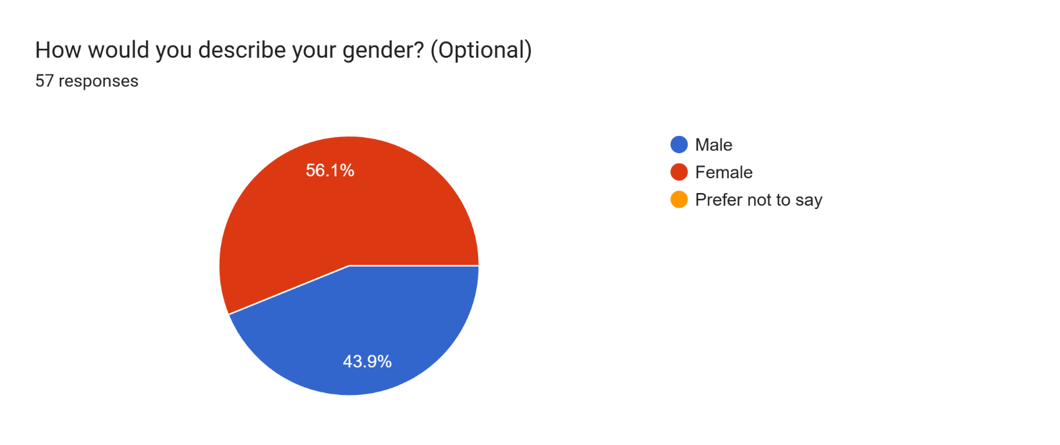

Fig 2. Gender composition of the respondents
As can be seen from the above chart, 56% percent respondents were girls and 44 percent boys, which can be considered to be fairly balanced. The relatively balanced gender indicates that the observed needs and concerns related to SEL may be considered relevant across genders.

- Findings
5.1 Respondents familiarity with SEL

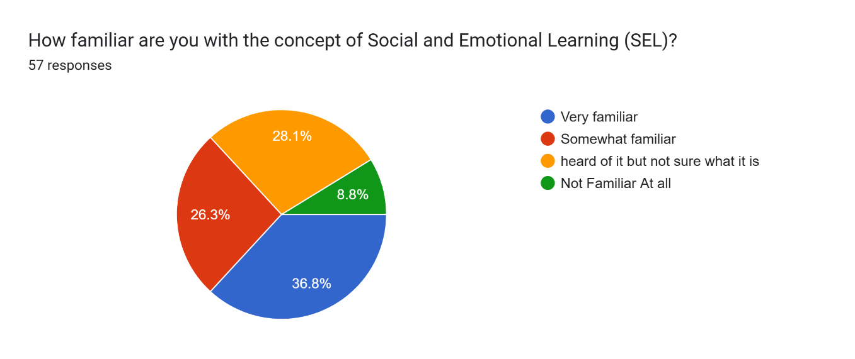
Fig 3: Respondents familiarity with SEL

As can be seen from the chart, approximately 37% of the students are very familiar with SEL which shows their high level of awareness. 28 % had heard about it but are not sure what it is about. While almost 9% of the students shared that they were not familiar with SEL at all. This suggests that SEL has not been systematically or uniformly introduced to all students, underscoring the need for structured orientation, guided explanation, and consistent integration of SEL concepts within the school curriculum and classroom practices.

5.2 Areas in which respondents feel they need to improve.

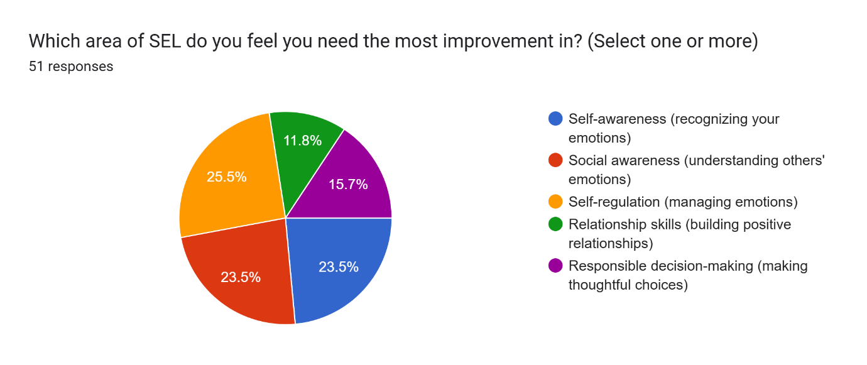
Fig 4: Areas in which respondents feel they need to improve.

These findings indicate that students perceive notable gaps across multiple domains of SEL, with the strongest need for improvement in self-regulation, self-awareness, and social awareness. This question was responded to by 51 respondents. Nearly one-fourth, identify self-regulation (about 25%) as an area needing improvement, suggesting difficulties in managing emotions, impulses, and stress. A comparable proportion report the need to strengthen self-awareness (23%) and social awareness (23.5%), pointing to challenges in understanding their own emotions as well as empathizing with others. Although fewer report difficulties in relationship skills (12%) and responsible decision-making (16%), these areas still represent significant concerns. Overall, the data suggest that SEL interventions should prioritize foundational competencies such as self-regulation, self-awareness, and social awareness, while also reinforcing relationship skills and decision-making to ensure holistic emotional and social development.
5.3 : SEL activities in which respondents participated
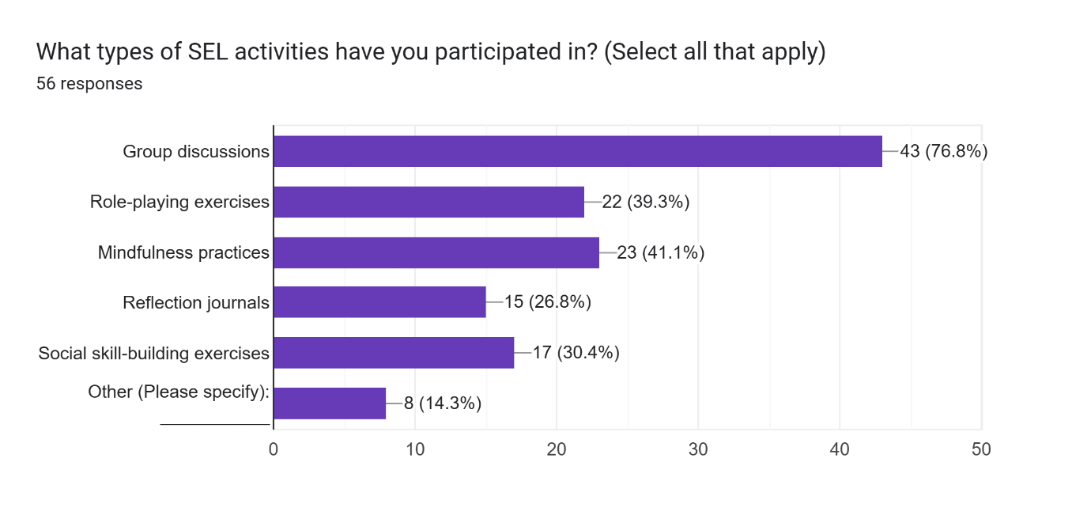

Fig 5: SEL activities in which respondents participated

As reflected in the chart, participation in group discussions as an SEL activity is the highest,(one respondent did not respond to the question) with nearly 77% of students reporting involvement, indicating that collaborative and discussion-based approaches are the most commonly used SEL practices. A moderate proportion of students have participated in mindfulness activities (41%) and role-playing exercises (39%), suggesting some exposure to experiential and reflective SEL strategies. However, participation in social skill-building exercises (30%) and reflective journal writing (27%) remains relatively limited, pointing to underutilization of deeper self-reflection and interpersonal skill development activities. Additionally, 14% of students reported engagement in other SEL activities, though the lack of specification makes it difficult to assess their nature. Overall, the findings suggest that while interactive group discussions dominate SEL implementation, there is scope to diversify SEL activities by strengthening reflective, experiential, and skills-based practices for more balanced social and emotional development. Whole School Activities related to SEL included counselling sessions on issues like career guidance, anxiety and stress management.
5.4 Perception on effectiveness of SEL activities in improving SEL skills.

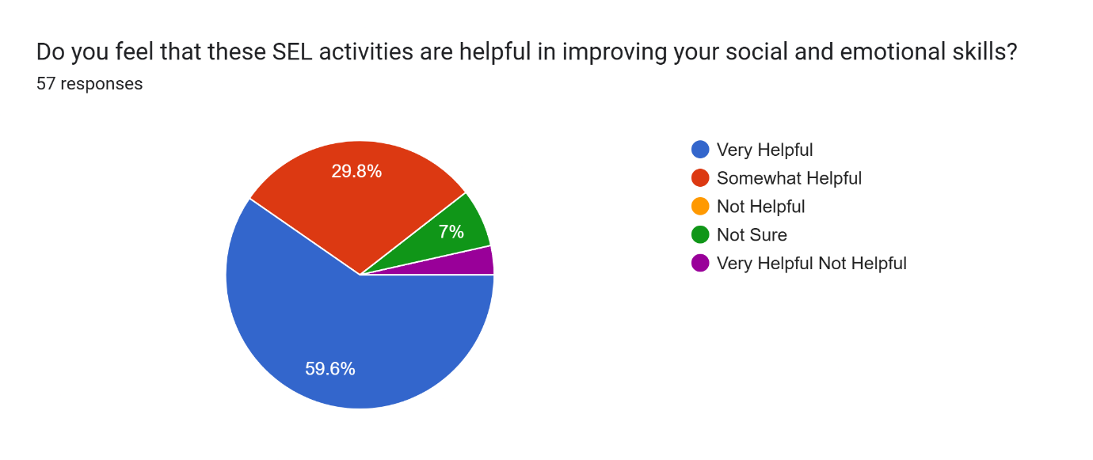
Fig 6: Respondents perception on effectiveness of SEL activities in improving SEL skills.

The findings suggest a strongly positive perception of SEL activities among students. With nearly 60% of students rating SEL activities as very helpful and an additional 30% considering them somewhat helpful, a substantial majority perceive clear benefits from these activities. This indicates that SEL initiatives are largely effective in supporting students’ emotional and social development. The relatively small proportion of students who do not view SEL activities as helpful indicates that there is a need for better planning an effective implementation. There is also a need to develop better understanding of SEL among the learners and also for better alignment with students’ needs or more engaging methods. This will convince students in understanding and appreciating the value of SEL. Overall, the data underscore the relevance and positive impact of SEL activities in the school context.
5.5 Importance of SEL in helping students in managing their emotions

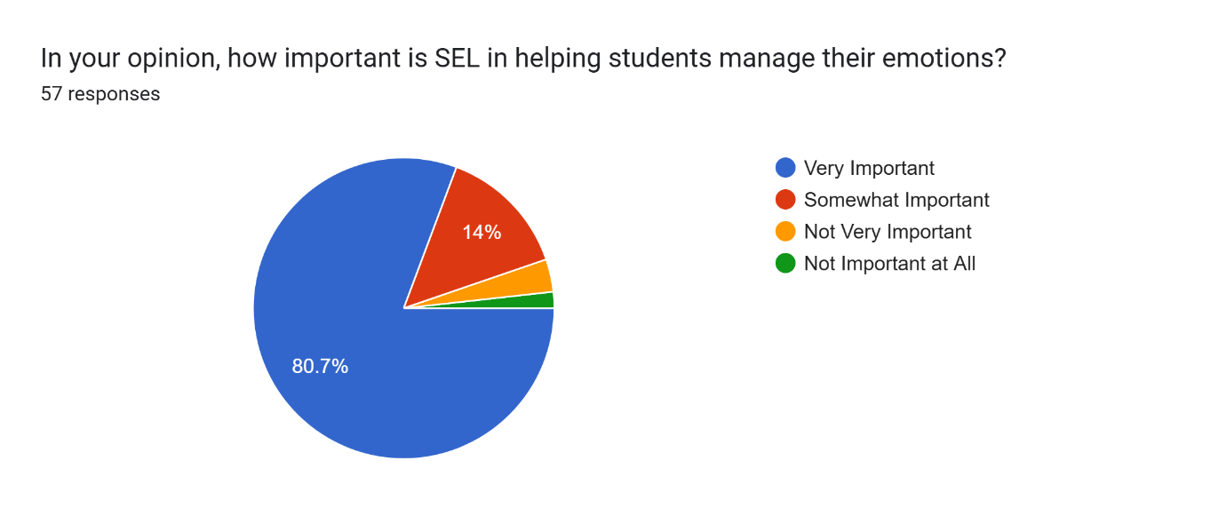
Fig:7: Importance of SEL in helping students in managing their emotions

Almost 81% of respondents perceive SEL as important in helping them in managing their emotions, shows that an overwhelming majority acknowledge the core benefits of SEL. A further 14% of students consider it somewhat important, which may be due to their limited understanding of SEL. Only a small minority regard SEL as not very important or not important at all, which may reflect limited engagement or understanding. Overall, the findings highlight that SEL is widely valued by students as an effective means of emotional management, reinforcing the need for its continued and systematic integration within the school curriculum.

5.6 Role of SEL in improving the ability to work with others.

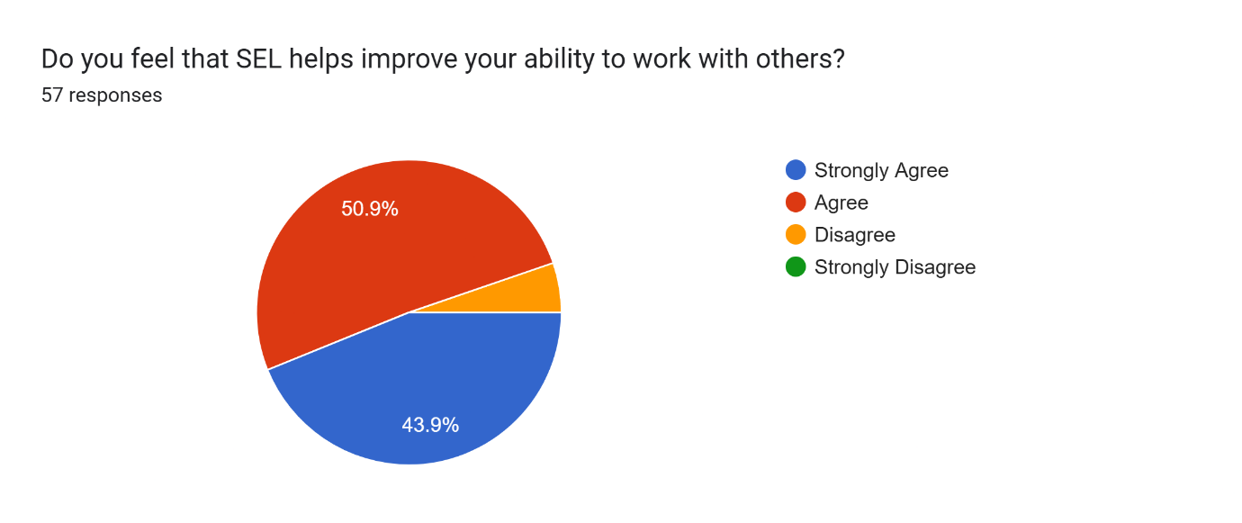
Fig :8 Role of SEL in improving the ability to work with others.

The findings reveal a strong consensus among students regarding the collaborative benefits of SEL. An overwhelming majority (95%) agree or strongly agree that SEL enhances their ability to work effectively with others, highlighting its role in fostering cooperation and teamwork.
5.7 Influence of SEL in ability to handle stress and challenges in school

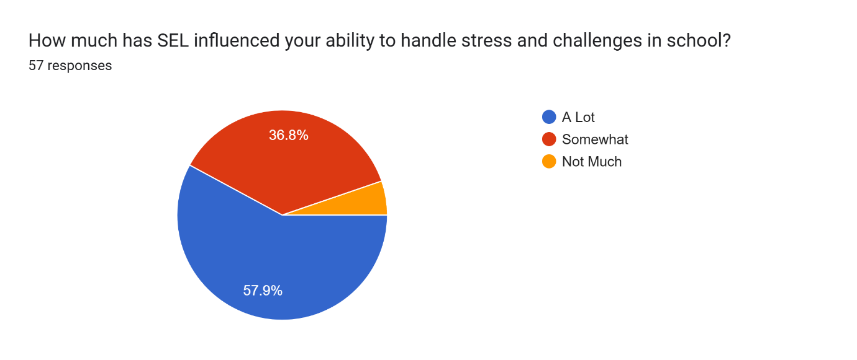

Fig:9 Influence of SEL in ability to handle stress and challenges in school

The findings indicate that SEL has a positive influence on students’ ability to handle stress and challenges in school. Nearly 58% of students report a strong positive impact, while an additional 36.8% perceive SEL as somewhat helpful in this regard. Only a small proportion of students feel that SEL has had little or no influence. Overall, the results suggest that SEL plays a significant role in enhancing students’ coping mechanisms and resilience within the school environment. Almost 58 percent students feel that SEL has influenced their ability to handle stress and challenges in the school.

5.7 Recommendation of students for focus on SEL
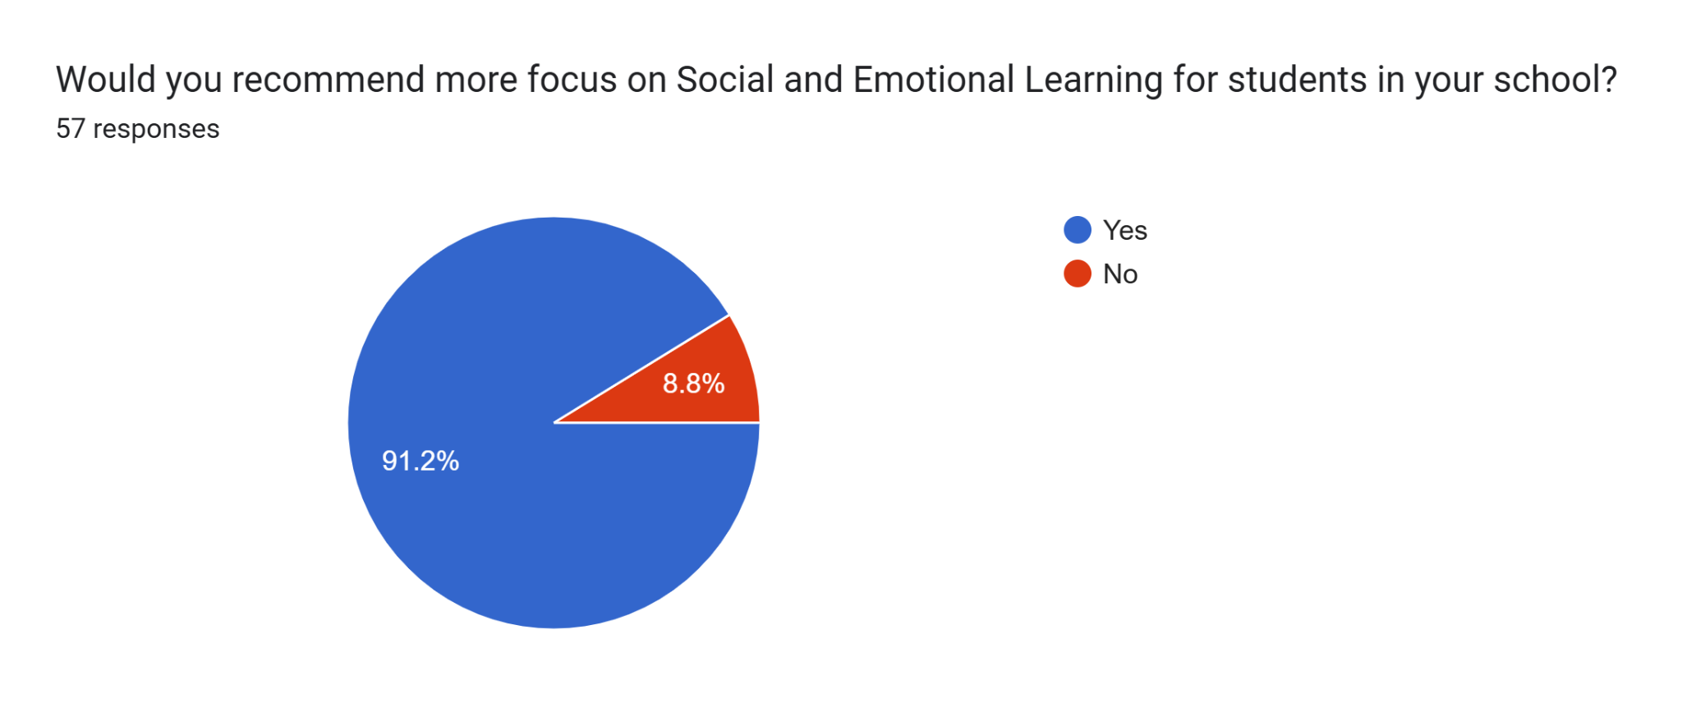

Fig:10 Recommendation of students for focus on SEL

An overwhelming majority of students (91 percent) are of the opinion that schools must focus more on SEL for students. This highlights a clear demand for stronger institutional focus on SEL within schools. It also suggests the need for systematic integration of SEL into curriculum planning, classroom practices, and a whole school approach to support students’ holistic development.

5.8 Challenges faced by students while engaging with SEL activities
Challenges shared by the students while engaging with SEL activities at school include:
    - Limited time for SEL activities under academic pressure such as course completion and good marks of learners.
    - Lack of differentiated assessment for diverse learners.
    - Managing classroom dynamics during group work, debates, open discussions and other activities on the part of students and teachers.
    - Lack of harmony and unity between the student and lack of help and support from peers.
    - Dominance of outspoken individuals who control discussions.
    - Apathy and indifference of members of team in group activities, resulting in two or three sincere members being pushed to carry out the task.
    - Interpersonal conflicts hinder effective collaboration and equal participation.
    - Differences in approach and sincerity in responsibility to share task in collaborative works.
    - Student resistance to self-reflection and self-improvement.
    - Lack of understanding of concepts.
    - Lack of confidence (shy or introvert) in team members. Along with fear of being judged or misunderstood preventing open participation. Peer pressure discourages honest expression.
    - Discomfort in expressing emotions.
    - Lack of proper mechanism of feed back and handholding of assessment done.
    - Inability of teachers to plan and assess SEL activities.
    - Balancing SEL with academic pressure, and potential lack of support from peers and parents.
The challenges shared by the students can be addressed by developing a healthy culture and environment in the school, with guided capacity building of all stake holders- adolescents, teachers, academic leaders and parents. The same are being discussed in the section on educational implications of the study

- Discussion
The present study gives adequate evidence of a compelling need for SEL among secondary and senior secondary students as almost 63 percent of respondents shared their limited or no understanding of SEL.
Many respondents were able to articulate their understanding of SEL correctly. Their responses included ‘the ability to understand and manage one's own emotions, build healthy relationships with others, make responsible decisions, and navigate social situations effectively, the ability to understand and manage your own emotions, build positive relationships with others, and make responsible decisions by developing skills like self-awareness, empathy, communication, and conflict resolution’. However, it seems that some respondents had directly pasted from AI. Even then, the silver lining is that it gave an insight into their not being aware of the concept. Secondly, at least in the process of responding they became familiar with the SEL concept!
One of the respondent ‘X’ stated ‘nothing is done…. I wish my school does something about it’. The statement indicates disappointment, as also a strong desire for SEL inclusion. These responses suggest that students are not only aware of the importance of social and emotional competencies but also express a strong desire for structured guidance and support in developing these skills. This reflects the growing recognition that academic learning alone is insufficient for holistic development.
Another respondent ‘Y’ shared ‘…In my classroom there aren't exactly any social and emotional learning sessions carried out but teachers do tell us how to manage stress and work more efficiently’. Group discussions, debates and role playing, dance and sports were shared as an SEL activity. A respondent ‘Z’ shared ‘... .in the classroom, I am very friendly with everyone and in school it has improved my confidence level so that I do not hesitate to take part in any competition.’ This indicates that although, teachers generally counsel and hand hold students, mindful integration of SEL in the learning- teaching processes can bring in more positive outcomes.
The relatively balanced gender representation (56% girls and 44% boys) enhances the credibility of the findings and suggests that the identified concerns are broadly applicable across genders. The need for emotional regulation, interpersonal skills, and responsible decision-making does not appear to be confined to one gender, thereby strengthening the argument for universal SEL implementation within schools.
The results also imply that students may face challenges in collaborative and reflective activities due to peer-related dynamics, confidence levels, and limited facilitative structures. This underscores the importance of not merely introducing isolated activities but adopting a systematic and sustained approach to SEL. The findings support the urgent need to implement SEL as a whole-school approach, integrating it within curriculum practices, classroom culture, teacher training, and parent engagement.
These conclusions align with widely accepted SEL frameworks, such as those proposed by CASEL, SEAL and ISELF, which emphasize adolescence as a crucial stage for developing SEL competencies. As the findings indicate that students perceive notable gaps across multiple domains like self-regulation, self-awareness, social awareness, relationship skills and decision making. Thus, the present study reinforces the applicability of such frameworks within the Indian school contexts. The study also aligns with findings of Jacob and Philip (2022) for need of SEL for adolescents. Greenberg, M (2023) findings of need of SEL in low-resourced schools in South Bangalore, is as much true for well-resourced schools. Grant et al. (2023) and Ross and Tolan’s (2017) research indicating improved performances upon SEL intervention makes a strong case for effective implementation of SEL in schools.
The researcher would like to acknowledge some limitations.
  - The use of non-probability convenience sampling and the relatively small sample size limit the generalizability of the findings.
  - The unequal age representation may have influenced the dominance of early adolescent perspectives.
Despite these limitations, the study provides meaningful insight into students’ perceived need for SEL and highlights the urgency of implementing well- structured SEL programs in schools.
7.Educational Implications of the Study
The findings of the SEL assessment study demonstrate an urgent need for integrating SEL as a whole school approach.
  - Integrating SEL in curriculum and pedagogy: There needs to be integration of SEL into formal curriculum. It should be a part of school’s regular activity. Structured SEL modules can be embedded within subjects or introduced as dedicated periods. The ‘Education for values in schools-A framework’ (NCERT, 2012) brought out by NCERT can serve as a guiding principle for schools to evolve its own plan of values, create goals and lay down assessment criteria. The Central Board of Secondary Education (CBSE) has brought out Values Education Manual and Values Education Kit for classes I-XII which may serve as a guiding document for SEL integration. (CBSE,2012) These important documents are often overlooked and must be sincerely made use of for learners’ betterment. The recent NCERT text books on physical education and well-being ‘Khel yatra’ for classes 6 to 8 suggest activities to build team work, self-awareness, social awareness and relationship skills among learners. (Khel yatra, 2024) Activities such as these have been suggested in other discipline text books as well which can be effectively used by the teachers.
  - Capacity building programs for teachers and school administrators: Transformative pedagogies in classroom learning-teaching process will lead to a shift from rote memorisation to holistic learning and ensure social and emotional strengthening of the learners. There is an urgent need to organize capacity building programs for teachers to handhold them into understanding the need and importance of SEL, and ways to embed it in their learning-teaching processes.
  - Capacity building programs for learners: Programs like camps in the school may be organized as a part of ten bagless days activity recommended in NEP 2020.Various fun -filled and exciting activities may be planned for learners to strengthen social-awareness, relationship skills and self- management. These could be role playing real-life adolescents, ‘walk in my shoes activity’, active listening fun games etc. Developing age appropriate SEL camp plans/ programs will not only strengthen learners SEL but also make school spaces happy and safe. Assessment rubrics of various SEL skills must also be developed and a positive feedback and handholding be provided to the learners for improvement. SEL activities may be assigned on a regular basis and learners be encouraged and supported in carrying them out mindfully, thereby acquiring SEL competencies.
  - Partnering with parents: Schools can organize orientation sessions to explain the importance of SEL, its goals, and how it supports adolescents’ academic and personal growth. Awareness will help parents in understanding the importance of SEL for mental well being of adoloscents and their academic success. Schools can also partner with parents in helping in supporting learners with emotional issues that they may be facing. Such collaboration enhances emotional connectedness between parents and adolescents, promoting empathy, support, and positive family relationships.
  - Provision of full-time school counsellors: CBSE has made the appointment of one socio-emotional and career counsellors mandatory for every 500 students in all affiliated schools, through a circular dated January 19, 2026. This was done as a response to a Public Interest Litigation filed in July 2025 before the Rajasthan High Court. The PIL plea highlighted rising mental health challenges among students, including academic stress and lack of structured career guidance. (The Hindu.2026, January 24)
School counsellors can play a very important role in strengthening SEL practices and creating a supportive social–emotional environment in the school.
    - They can co‑plan and deliver SEL lessons that explicitly teach the five CASEL skills. They can support teachers with SEL themes, classroom activities, and routines (e.g. mindfulness, conflict‑resolution circles) that can be built into daily teaching.
    - Availability of a counsellor will create safe spaces for learners to share their issues and seek advice. Counsellors will also be able to monitor students at risk (behaviour, attendance, emotional difficulties) and offer timely SEL‑focused interventions to prevent escalation.
    - They can also work with parents to help learners facing emotional challenges. However, there should be a provision for monitoring that counsellors are appointed by the schools. It should also be ensured that the dedicated school counsellor, is freed from regular teaching and other administrative duties so that they are fully available to address students’ and teachers’ concerns.

Conclusion
Children’s social and emotional abilities are strongly associated with their academic skills and their ability to learn and be successful in school as well as their willingness to share their knowledge with their peers. It is important for educators to understand that they have the greatest potential to make a difference in their students’ learning. (Ee & Quek, 2013). Individual researches have shown increased exposure to SEL leads to improved student self-perception. These findings suggest that incorporating SEL in the classroom fosters greater student engagement, academic achievement, and self-confidence. It is recommended that schools provide educators with the necessary training and support to effectively implement SEL programs (Broderick, 2024). The majority of studies indicated that SEL programs aid high school students in reducing tension, adapting to new social environments, and coping with life’s challenges. (Tran-Chi, Huynh, Nguyen, Giang, & Luu-Thi, 2023).
This study also establishes that students realize the need and importance of SEL for their personal well being. The study also shows lack of proper understanding of SEL in the addoloscents. The study reveals a pronounced need and demand among students for mentorship and facilitation in SEL development. The study thus establishes that there is an urgent need to implement SEL as a comprehensive whole-school approach. Therefore, educational institutions must move beyond purely academic instruction and adopt a holistic approach that nurtures emotional intelligence, interpersonal skills, and responsible decision-making among students.

Declaration: AI support has been taken for improvement of language but the ideas are of the authorseal
.

COMPETING INTERESTS DISCLAIMER:
Authors have declared that they have no known competing financial interests OR non-financial interests OR personal relationships that could have appeared to influence the work reported in this paper.

References
- Broderick, T. (2024). Effects of social-emotional learning on student perceptions of themselves, their academics, and their behaviors (Master's thesis, Northwestern College, Iowa).
- CBSE makes appointment of socio-emotional, career counsellors mandatory in all affiliated schools (2026, January 24). The Hindu. https://www.thehindu.com/news/national/cbse-makes-appointment-of-socio-emotional-career-counsellors-mandatory-in-all-affiliated-schools/article70546961.ece accessed on 15 feb. 2026.
- Central Board of Secondary Education. (2012). Values Education Kit (Classes 1–12). CBSE. https://cbseacademic.nic.in/tir/ValueEdu.html
- Collaborative for Academic, Social, and Emotional Learning. (n.d.). What is SEL? Understanding social and emotional learning. CASEL. Retrieved from https://casel.org/what-is-SEL
- Ee, J. & Quek (2013). Teachers’ Perceptions of Students’ Social Emotional Learning and their Infusion of SEL. An International Journal of Teaching & Teacher Education. 1(2), 59-72
- Government of India. (2020). National education policy 2020. Ministry of Education. https://www.education.gov.in/sites/upload_files/mhrd/files/NEP_Final_English_0.pdf
- Government of India. (2020). National Education Policy 2020. Ministry of Education (MoE), New Delhi. Retrieved from https://www.education.gov.in/sites/upload_files/mhrd/files/NEP_Final_English_0.pdf
- Grant N, Meyer JL, Strambler MJ. Measuring social and emotional learning implementation in a research-practice partnership. Front Psychol. 2023 Jul 26;14:1052877. doi: 10.3389/fpsyg.2023.1052877. PMID: 37564314; PMCID: PMC10410557.
- Green, A. L., Ferrante, S., Boaz, T. L., Kutash, K., & Wheeldon‑Reece, B. (2021). Social and emotional learning during early adolescence: Effectiveness of a classroom‑based SEL program for middle school students. *Psychology in the Schools, 58*(6), 1056–1069. https://doi.org/10.1002/pits.22487
- Greenberg, M. (2023). Evidence for social and emotional learning in schools [Brief]. Learning Policy Institute. https://learningpolicyinstitute.org/product/evidence-social-emotional-learning-schools-brief
- Harikrishnan U, Sailo GL. Prevalence of Emotional and Behavioral Problems among School-Going Adolescents: A Cross-Sectional Study. Indian J Community Med. 2021 Apr-Jun;46(2):232-235. doi: 10.4103/ijcm.IJCM_451_20. Epub 2021 May 29. PMID: 34321732; PMCID: PMC8281858.
- Humphrey, N., Lendrum, A., & Wigelsworth, M. (2010). Social and emotional aspects of learning (SEAL) programme in secondary schools: National evaluation (Research Report DFE‑RR049). Department for Education. https://assets.publishing.service.gov.uk/media/5a7b0ce6ed915d429748c77a/DFE-RR049.pdf
- Jacob, Annie & Philip, Smitha. (2023). A Study on the Need for Social Emotional Learning among Adolescents. 2022. 10.9756/INTJECSE/V14I5.436. 3851-3858
- National Council of Educational Research and Training. (2012) ‘Education for values in schools-A framework, https://ncert.nic.in/pdf/publication/otherpublications/Framework_educationCOMPLETEBOOK.pdf
- National Council of Educational Research and Training. (2024). Khel yatra: Physical education and well‑being textbook for Class 6,7 and 8. NCERT.
- Ross, K. M., & Tolan, P. (2018). Social and emotional learning in adolescence: Testing the CASEL model in a normative sample. The Journal of Early Adolescence, 38(8), 1170-1199.
- Shahid, M. (2020). Fostering SEL the ISELF way! UNESCO MGIEP. https://mgiep.unesco.org/article/fostering-sel-the-iself-way
- Timalsina M, Kafle M, Timalsina R. Psychosocial Problems among School Going Adolescents in Nepal. Psychiatry J. 2018 Jul 2;2018:4675096. doi: 10.1155/2018/4675096. PMID: 30057903; PMCID: PMC6051039.
- Tran-Chi, V.-L., Huynh, S. V., Nguyen, H. T., Giang, T.-V., & Luu-Thi, H.-T. (2023). The perception of implementing social-emotional learning in soft skills among Vietnamese high school students. ASEAN Journal of Psychiatry, 24(2), 1-10. https://doi.org/10.54615/2231-7805.47331
- UNFPA India. (2025). UNFPA India annual report 2024. United Nations Population Fund (UNFPA) India. https://india.unfpa.org
- United Nations Population Fund. (n.d.). UNFPA adolescents and youth strategy. UNFPA. https://www.unfpa.org/sites/default/files/resourcepdf/UNFPA%20Adolescents%20and%20Youth%20Strategy.pdf
- World Health Organization. (n.d.). Adolescent health. https://www.who.int/health-topics/adoles
- Yeager, David. (2017). Social-Emotional Learning Programs for Adolescents. The Future of Children. 27. 10.1353/foc.2017.0004.73-94

