Short Research Article

Fostering Higher-Order Thinking in Advanced Mathematics: A Problem-Driven Approach Using Knowledge Graphs

Abstract: In advanced mathematics education, compartmentalized knowledge acquisition and inadequate development of higher-order thinking skills remain persistent challenges. This study introduces a problem-driven teaching model that incorporates knowledge graphs as a cognitive framework to facilitate inquiry-based learning. Focusing on "Multivariable Differential Calculus" and "Curve Integrals" as key units, we designed teaching cases to help undergraduate students in computer science actively build and integrate knowledge through problem-solving. A quasi-experimental comparative study was conducted over one semester with 120 second-year students (60 in the experimental class using the model and 60 in the control class using traditional lectures). Higher-order thinking skills, such as analysis, synthesis, and transfer, were measured through a unified comprehensive test, including a basic knowledge section (60 points) and a higher-order thinking section (40 points). Results showed that the experimental class significantly outperformed the control class in both structured knowledge mastery and higher-order thinking development (p < 0.05). These findings offer empirical evidence and practical guidance for reforming advanced mathematics teaching and fostering innovative talent.
Keywords: Problem-driven teaching method; Knowledge graph; Advanced mathematics; Higher-order thinking; Teaching reform

Introduction
Advanced mathematics is a foundational course for science and engineering majors. Its teaching quality directly impacts students' disciplinary learning and innovative capacities. However, traditional approaches face several issues. Traditional lecture-based methods tend to focus on knowledge transmission at the expense of deep conceptual understanding and the development of application skills. This leads to students who can solve problems mechanically but struggle to apply knowledge flexibly. Additionally, the subject's vast and abstract content makes it hard for students to form a systematic framework, resulting in compartmentalized learning that significantly hinders higher-order thinking development (Gradini et al., 2025; Mohd Tajudin et al., 2018; Tajudin et al., 2017).
In recent years, researchers worldwide have explored reforms in advanced mathematics teaching. For information technology integration, Duan et al. (2026) built an IT-based precision teaching model for university mathematics. Their work highlights IT's positive role in personalized learning, pre-class scenarios, and supporting struggling students, showing a strong correlation between IT and precision teaching. On artificial intelligence, Brandibur et al. (2025) examined AI prompt patterns in university mathematics. Students with prior AI experience rated AI-assisted activities more positively, and prompt designs provided structured learning experiences for mathematics instruction. For capability assessment, Liu et al. (2025) proposed a neural network and multivariate regression-based system for mathematical problem-solving. It combines cognitive and behavioral dimensions, using CNN and BiLSTM for 95% prediction accuracy, offering a framework with predictive and instructional value for intelligent education. For teacher development, Santagata et al. (2026) created a video-based program focusing on student thinking and equity, enhancing teachers' multidimensional noticing abilities. Finally, Szilágyi et al. (2025) used LEGO robots in advanced mathematics. The hands-on experimental group outperformed controls, underscoring educational robots' value in visualizing abstract concepts.
Despite these advances in IT integration, AI support, and assessment systems, gaps remain. Most studies focus on isolated technological interventions rather than integrating methods like knowledge graphs and problem-driven teaching. There is limited focus on higher-order thinking, with few systematic frameworks or evaluations. Knowledge graphs are mostly used for visualization, not deeply embedded in teaching. Problem-driven methods often lack structured tools, leading to compartmentalized inquiry.
To bridge these gaps, this study proposes a knowledge graph-integrated problem-driven model. It uses knowledge graphs to build a systematic cognitive framework, supporting problem-driven teaching and enabling deep knowledge integration and higher-order thinking during problem-solving. We selected "Multivariable Differential Calculus" and "Curve Integrals," designed cases, and conducted experiments to verify the model's effectiveness.
The study's innovations include: (1) Deeply integrating knowledge graphs with problem-driven teaching to link theory and practice; (2) Creating a tiered problem chain based on knowledge graphs for progressive thinking development; (3) Validating the model through experiments, providing empirical evidence and practical approaches for advanced mathematics reform. These findings have theoretical and practical significance for teaching innovation in Educational Informatization 2.0 and fostering innovative talent.

Theoretical Foundations and Related Research Review

2.1 Application of Knowledge Graphs in the Educational Domain
A knowledge graph structures knowledge using nodes (concepts) and edges (relationships), clearly showing semantic and logical connections. Educational research on knowledge graphs has evolved from basic visualization to personalized learning and intelligent assessment (Cui & Yu, 2019).
In medical education, knowledge graphs have been effectively applied to enhance blended learning. For instance, Li Bugang et al. (2025) developed a knowledge graph-based blended learning design to address low engagement, showing significant improvements in student absorption. Similarly, Liu Xia et al. (2025) constructed a graph for clinical microbiology testing, categorizing 99 conceptual, 110 skill-based, and 90 cognitive points to support personalized paths and progress tracking. Extending to engineering education, Yang Dingding et al. (2026) created a three-stage progressive model for chemical safety engineering, dividing the curriculum into 6 modules and 251 points, and applying it in flipped classrooms to enhance core competencies through personalized monitoring and evaluation.
Furthermore, in basic education and teacher development, knowledge graphs facilitate evaluation and personalization. Qin Shaojiao et al. (2026) proposed a knowledge graph and complex question answering model for interactive teaching evaluation, achieving high accuracy and efficiency. Li Aili et al. (2026) reviewed knowledge graph-based personalized learning path recommendations, emphasizing Bloom's Taxonomy in design and summarizing algorithms and datasets. Vergara et al. (2025) used knowledge graphs for teacher development, creating a collective pedagogical content knowledge graph to track personal PCK growth, mainly in student learning and strategies. These applications demonstrate the versatility of knowledge graphs across educational levels, from personalized paths to professional development.

2.2 Theory and Practice of the Problem-Driven Teaching Method
Problem-driven teaching (PDT) centers on problems, making students active learners and teachers guides. It creates authentic scenarios to spark exploration and knowledge construction. Originating in 1950s medical education, PDT is now applied across fields.
In medical education, PDT often pairs with case-based methods to address complex clinical challenges. Liao Pengjun et al. (2025) integrated PBL and CBL for lymphoma training, using problem chains and cases to improve diagnostic skills, critical thinking, and decision-making. Another study (Zheng Zhang, 2023) in obstetrics and gynecology noted traditional methods' shortcomings in clinical thinking, while PDT enhanced deep learning and skills via real cases.
In mathematics education, PDT has shown promise in fostering core competencies. Jin Chang (2025) applied PDT to high school geometry, aiding knowledge construction and literacy. Liu Zhenzhen (2025) outlined PDT principles for middle school mathematics, focusing on problems, key points, and deep thinking. These examples illustrate PDT's adaptability from medical training to school-level subjects, emphasizing its role in promoting active inquiry and skill development.

2.3 Integration of Knowledge Graphs and Problem-Driven Teaching
Knowledge graphs and PDT complement each other naturally. PDT focuses on inquiry but risks knowledge compartmentalization; knowledge graphs provide a systematic framework for navigation and support. Their integration can be observed in three aspects. First, knowledge graphs inform structured problem design, creating hierarchical question sequences to build complete networks. Second, PDT enables dynamic graph updates via student-generated insights, fostering a feedback loop. Third, together they cultivate higher-order thinking: graphs support analysis and synthesis, while PDT offers practice contexts, aligning with Bloom's Taxonomy.
Current integration research is nascent but promising. Yang Dingding et al. (2026) combined them in chemical safety education for a progressive model. Liu Xia et al. (2025) used graphs to support blended teaching in medicine. Despite progress, challenges persist: limited interdisciplinary studies, weak theoretical foundations, incomplete evaluations, and technical barriers for teachers. A recent systematic review synthesizes evidence on integrating mathematical competencies and critical thinking through active methodologies, advocating for improved assessment in educational settings (Alvarez-Tinajero et al., 2026).
Future directions include developing cross-disciplinary models, deepening integration theories, creating user-friendly tools, and establishing robust evaluation systems. Through this literature review, knowledge graphs have advanced from visualization to personalized and intelligent applications, aiding educational digitization. PDT excels in student-centered higher-order skill development. Integration research is emerging, with verified complementarity.
This study integrates knowledge graphs and PDT for an innovative advanced mathematics model. It will build a graph to reveal connections, design graph-based PDT, validate via empirical research, and offer practical reforms. Innovations include pioneering deep integration, tailoring to advanced mathematics, and empirical validation.

3. Teaching Model Design and Implementation Strategies

3.1 Construction of the Knowledge Graph-Integrated Problem-Driven Teaching Model
The model focuses on the deep integration of systematic knowledge representation with inquiry-based learning. Based on Constructivist and Cognitive Load Theories, it emphasizes active meaning construction through interactions. Problem-driven teaching creates scenarios to spark cognitive conflict and exploration. Knowledge graphs structure disciplinary logic, reducing extraneous load and optimizing resources for deep understanding.
The model has three cycling modules: Knowledge Graph Construction, Problem-Driven Teaching, and Assessment/Feedback. They form a closed loop of design, implementation, assessment, and optimization (Figure 1).
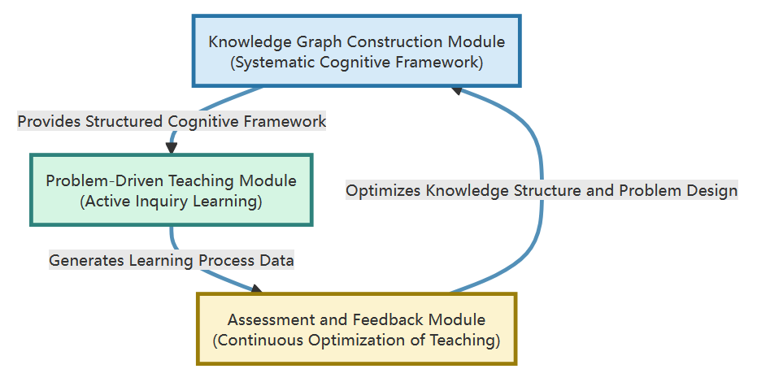
Figure 1. Knowledge Graph-Integrated Problem-Driven Teaching Model Framework
The Problem-Driven Teaching Module serves as the core engine of the model. This module utilizes the knowledge graph as a navigational blueprint to design and implement instruction. Its operation consists of three stages: 1) Problem Design Phase: Based on the structure and relationships within the knowledge graph, a logically interconnected "tiered problem chain" is designed. This chain spans multiple levels, progressing from foundational questions involving factual and conceptual knowledge to higher-order problems requiring analysis, synthesis, and creation. 2) Problem Inquiry Phase: The teacher presents the problem scenario, after which students engage in self-directed inquiry—individually or in groups—to find solutions, using the knowledge graph as a cognitive map. During this process, the knowledge graph helps students locate relevant information, understand conceptual connections, and plan solution paths. 3) Knowledge Construction Phase: Students integrate new understandings, methods, and case studies gained from the inquiry into their personal or shared class knowledge graph by adding annotations, creating links, or inserting new nodes. This facilitates the internalization and deepening of shared knowledge into individual cognitive structures.
The Assessment and Feedback Module ensures the continuous optimization of the model. It employs a diversified, mixed-methods evaluation approach that runs throughout the teaching process. Formative assessment focuses on students' performance during problem inquiry, such as their abilities in information retrieval and integration, critical thinking, and collaborative communication. This can be analyzed through learning behavior data, discussion records, and procedural artifacts. Summative assessment, conducted via standardized tests and comprehensive project reports, evaluates students' mastery of structured knowledge and the development of higher-order thinking skills, including analysis, evaluation, and creation. All assessment data is systematically collected and analyzed to serve a dual purpose: first, providing personalized feedback and guidance to students; second, informing refinements to the Knowledge Graph Construction Module and the Problem-Driven Teaching Module. This includes updating relationships within the graph, optimizing problem design, and adjusting teaching strategies, thereby enabling the iterative evolution of the teaching model.
By combining systematic knowledge support with an active inquiry process, this model effectively addresses prevalent issues in traditional teaching—such as the disconnection between knowledge transmission and skill development, and the compartmentalization of knowledge acquisition. It provides a structured instructional pathway for fostering students' higher-order thinking skills.

3.2 Design of Teaching Cases
To concretely illustrate the application of the model, this study selects the content units "Multivariable Differential Calculus" and "Curve Integrals" and designs the following teaching cases.

3.2.1 Case 1: Construction and Application of the Knowledge Graph for Multivariable Differential Calculus
This case addresses the teaching challenges arising from the abstract and interconnected concepts in multivariable differential calculus. First, the knowledge graph for this unit is constructed: with "Multivariable Differential Calculus" as the root node, it branches into three main trunks—"Conceptual System," "Computational System," and "Application System." The "Conceptual System" branch delineates the conceptual progression from "Partial Derivatives" (describing changes along coordinate axes) to "Directional Derivatives" (describing changes in arbitrary directions) and then to "Gradient" (integrating information from all directional derivatives and indicating the direction of steepest ascent). This branch connects via the "Geometric Interpretation" node to concepts such as tangent planes and normal lines of surfaces. The "Computational System" branch links various differentiation rules, while the "Application System" branch extends to optimization problems, including "Unconstrained Extrema" and "Constrained Extrema" (using the Lagrange Multipliers Method). Semantic relationships between concepts—such as "generalization," "special case," and "applied to"—are explicitly annotated in the graph (Figure 2).
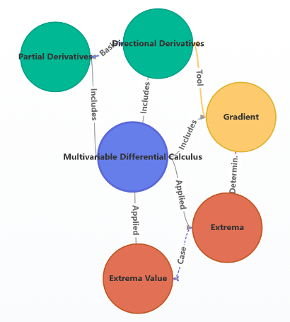
Figure 2. Knowledge Graph of Multivariable Differential Calculus

Based on this graph, a tiered problem chain is designed to progressively deepen students' thinking. First-tier problems (Conceptual Understanding) include, for example: "By analogy with the derivative of a single-variable function, what is the geometric meaning of the partial derivative of a two-variable function? Why does it only reflect 'local' properties?" This question guides students to leverage analogical relationships in the graph for initial comprehension. Second-tier problems (Relationship Analysis and Application) include: "How are partial derivatives 'synthesized' to yield the directional derivative in any arbitrary direction? Why does the gradient direction represent the steepest ascent in function value? Please explain the relationship between the gradient's magnitude and the maximum directional derivative, referencing the graph." This question prompts students to trace the derivation path "Partial Derivatives → Directional Derivatives → Gradient" in the graph, fostering knowledge association and integration. Third-tier problems (Synthesis, Transfer, and Creation) present a realistic scenario: "Suppose a mountainous terrain is modeled by a two-variable function. As a rescue team member, how would you use the gradient concept to plan the fastest ascent path? Please model this and discuss the method's practical limitations and potential improvements." This higher-order problem encourages students to link the "Application System" in the graph to real-world issues, promoting critical application and innovative thinking. During implementation, students use the graph as a navigation tool, engage in group discussions, and add the newly developed "Application Case of Gradient in Path Optimization" as supplementary knowledge to the graph, completing the cycle from knowledge understanding to creation.

3.2.2 Case 2: Construction of the Knowledge Graph and Problem-Driven Teaching for Curve Integrals
This case focuses on distinguishing between the often-confused Line Integrals of the First Kind (with respect to arc length) and the Second Kind (with respect to coordinates). The knowledge graph employs a comparative structure, centered on "Curve Integrals," with parallel branches for the two types. Each branch outlines its "Physical Background" (e.g., calculating mass vs. work/flow), "Mathematical Definition" (summation of scalars vs. vector projections), "Properties," and "Calculation Methods." A key node, "Connections and Differences," bridges the branches to emphasize their essential distinctions. Additionally, the core node "Green's Theorem" establishes a transformation relationship between Second Kind curve integrals (under certain conditions) and double integrals, with applicability conditions clearly noted (Figure 3).
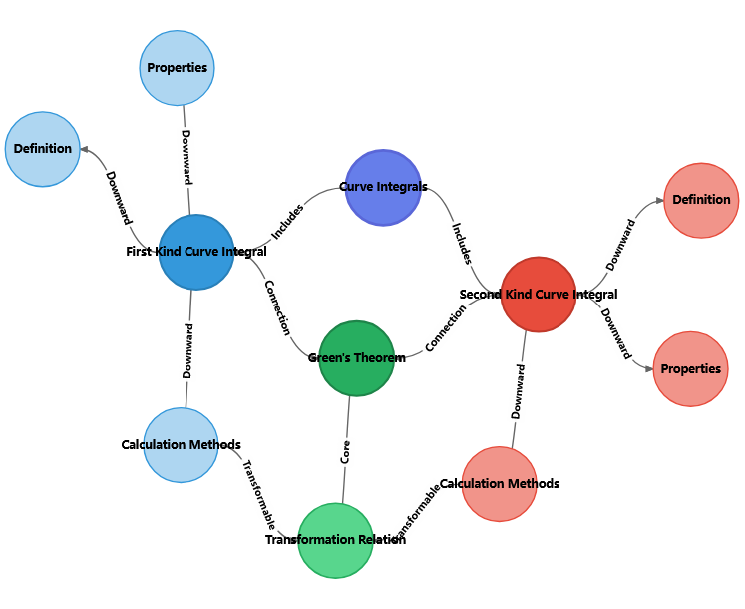
Figure 3. Knowledge Graph of Curve Integrals
Instruction centers on a series of comparative inquiry-based problems. Problem 1 (Discriminating Physical Essence): "Why is the Line Integral of the First Kind used to compute the mass of a curved object, while the Second Kind calculates work done by a variable force? Explain the fundamental difference in terms of the integrand's composition." This question directs students to explore the graph's branches, clarifying concepts from physical origins and mathematical definitions. Problem 2 (Computational Exploration and Discovering Intrinsic Connections): "Calculate a given Line Integral of the First Kind and Second Kind over the same curve and observe the processes. Under what conditions does the Second Kind integral become path-independent? Which graph node suggests this possibility?" This problem allows students to experience differences through computation and connect to the "Green's Theorem" node and its conditions, building a foundation for understanding conservative fields in vector calculus. Problem 3 (Synthesis and Transformative Application): "Explain how Green's Theorem facilitates transformation between integral types. Design a specific problem to demonstrate its advantage in simplifying calculations, and analyze scenarios where the theorem may fail." This problem requires students to synthesize the "Connections," "Green's Theorem," and "Conditions" elements in the graph, engaging in knowledge integration, application, and critical evaluation to deepen their appreciation of mathematical rigor. Throughout the process, students use the graph for comparative learning, associative inquiry, and integrated application, effectively resolving conceptual confusion and building a systematic knowledge network.

3.3 Teaching Implementation Process and Strategies
To ensure effective model implementation, this study outlines a standardized four-phase teaching process following a "Pre-set – Inquiry – Extension – Iteration" closed loop.
The first phase is Pre-class Preparation and Presetting. Teachers construct the core knowledge graph, design a corresponding tiered problem chain aligned with the graph's structure, and anchor resources such as micro-lectures, literature, and simulations to graph nodes. These are released via an online platform to guide students in previewing and forming an initial cognitive map.
The second phase is In-class Inquiry and Construction. Classroom activities are student-centered and unfold in five steps: "Context Introduction and Problem Focus," "Independent/Collaborative Inquiry (using the knowledge graph as a navigation tool)," "Result Sharing and Idea Exchange," "Knowledge Integration and Graph Refinement (jointly by teachers and students)," and "Reflection Summary and Preview of Transfer." This phase facilitates collaborative knowledge construction and internalization.
The third phase is Post-class Consolidation and Extension. Students create personalized knowledge graph notes based on in-class insights and complete targeted exercises via the platform. The system analyzes learning behavior data to provide personalized resource recommendations.
The fourth phase is Evaluation, Feedback, and Iteration. Comprehensive assessment integrates process data (e.g., graph interactions, discussion records) and outcome data (e.g., tests, projects). Results optimize the knowledge graph, refine problem design, and adjust teaching strategies, enabling continuous model improvement.
Throughout the process, three core strategies are essential. First, Differentiated Scaffolding: The knowledge graph diagnoses prior knowledge gaps and provides dynamic, tiered hints and resources during inquiry. Second, Collaborative Knowledge Construction: Tasks like "group refinement of a graph branch" encourage dialogue and debate, leveraging collective wisdom for deeper understanding. Third, Formative Feedback: Teachers review personalized graphs for structural completeness, relational accuracy, and innovativeness, guiding metacognitive development.

4. Implementation Results and Evaluation
To scientifically validate the practical effectiveness of the Knowledge Graph-Integrated Problem-Driven Teaching Model (hereafter referred to as the "Integrated Model"), a comparative teaching experiment was conducted over one semester with second-year Computer Science majors at Liaoning University of Science and Technology. The experimental class (N=60) implemented the Integrated Model, while the control class (N=60) used a traditional lecture-based approach, with the same instructor teaching both classes to minimize extraneous variables. A pre-test confirmed no significant differences in prior knowledge between the groups (p > 0.05). The study adopted a mixed-methods approach, evaluating outcomes across three dimensions: academic performance, thinking abilities, and learning experience. Data collection included in-class supervised administration of pre- and post-tests, online distribution of questionnaires immediately post-experiment (100% response rate), text-recorded semi-structured interviews with 10 stratified-sampled students one week after the experiment (lasting 20-30 minutes each, with informed consent), and automatic logging of platform-based learning behavior data.

4.1 Quantitative Comparison of Academic Achievement
At the end of the experiment, both classes completed a unified comprehensive test, which assessed fundamental concepts and calculations (60 points) and items requiring higher-order thinking skills, such as analysis, synthesis, and transferable application (40 points). Independent samples t-test results (see Table 1) showed that the experimental class significantly outperformed the control class in total scores (t = 2.42, p < 0.05, Cohen's d = 0.52), indicating a medium effect size.
Sub-score analysis revealed that the experimental class achieved significantly higher means in both the basic and applied section (with a small effect size, d = 0.38) and the higher-order thinking section (p < 0.05, d = 0.42, approaching a medium effect). These findings confirm that the Integrated Model had a statistically significant positive impact on students' mastery of procedural knowledge and, notably, on fostering higher-order cognitive skills such as analysis, synthesis, and transfer.
Table 1. Comparison of Post-test Scores between Experimental and Control Classes (M ± SD)
 | Experimental Class | Control Class | t-value | p-value | Effect Size  (d)
Total Score (100) | 78.15 ± 9.24 | 74.03 ± 9.87 | 2.42 | <0.05 | 0.52
Basic & Applied Part (60) | 51.23 ± 5.89 | 48.77 ± 7.21 | 2.07 | <0.05 | 0.38
Higher-order Thinking Part (40) | 27.92 ± 6.88 | 25.26 ± 7.45 | 2.18 | <0.05 | 0.42

4.2 Multidimensional Feedback on Learning Processes and Affective Attitudes
In addition to academic achievement, the study examined students' learning processes and subjective experiences through post-test questionnaires and platform-based learning behavior data. The questionnaire employed a five-point Likert scale (1 = strongly disagree, 5 = strongly agree), with the experimental class scoring significantly higher than the control class across all affective-attitudinal dimensions (all p < 0.05). Questionnaire reliability was confirmed with Cronbach's alpha = 0.89, based on items adapted from established scales (e.g., from Duan et al., 2026). The most notable differences were in "Perception of Structured Knowledge Understanding" (Experimental: 4.41 vs. Control: 3.52) and "Overall Satisfaction with the Teaching Model" (Experimental: 4.48 vs. Control: 3.78). This suggests that students not only endorsed the model but also experienced tangible improvements in their cognitive structures (see Figure 4).
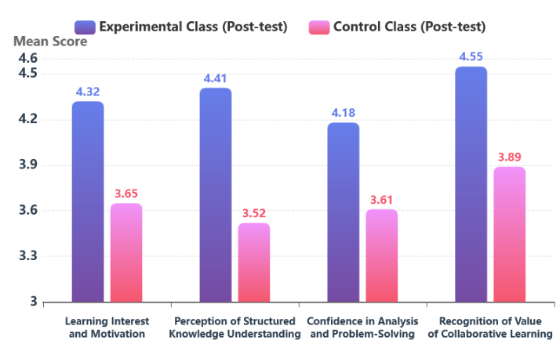
Figure 4 Comparison of Questionnaire Results between Experimental and Control Classes
Platform backend data objectively supported these perceptions. Experimental class students accessed the knowledge graph an average of 18.5 times per unit, with over 70% proactively using it for assignments and reviews. Node click heatmaps indicated frequent engagement not only with core concepts but also with relational links such as "distinctions," "connections," and "application conditions," reflecting a shift toward relational and systematic learning rather than isolated memorization.

4.3 Qualitative Evidence Revealing the Deepening of Thinking Processes
To explore the mechanisms underlying the quantitative results, semi-structured interviews were conducted with ten students of varying academic levels from the experimental class. Additionally, classroom observations and student-generated personalized knowledge graphs were analyzed. Thematic analysis of interview transcripts involved independent coding by two researchers, with themes emerging from the data. Thematic analysis of interview transcripts identified three core themes:
1. The Navigational Role of the "Cognitive Map": Most students described the knowledge graph as a "learning map" or "thinking navigator." One student noted: "Previously, learning felt like scattered beads on the ground—very disorganized. Now, with the knowledge graph, it's like having a string to thread them. I can clearly see how partial derivatives, directional derivatives, and gradients connect and extend step-by-step. When solving problems, I know which knowledge block to draw upon."
2. Shifts in Thinking Patterns Driven by Problems: Students reported that problem chains prompted deeper engagement. For example: "When discussing 'Why is the gradient direction the fastest?', we couldn't just memorize the conclusion. We had to follow the logical chain on the graph, deriving and explaining from partial derivatives to directional derivatives. This 'why' inquiry made understanding much more profound."
3. From Passive Reception to Active Construction: In collaborative tasks refining graph branches, students showed high engagement, adding examples, annotating pitfalls, and linking to other chapters (e.g., field theory). This marked a transition from passive recipients to active integrators.
Classroom observations reinforced this: Experimental discussions emphasized conceptual comparisons (e.g., physical distinctions between line integral types) and theorem conditions (e.g., Green's Theorem premises), contrasting with the control class's procedural focus. End-of-semester personalized graphs demonstrated structural completeness, relational accuracy, and insightful annotations, visually evidencing systematized cognitive structures.

4.4 Discussion and Reflection
Combining quantitative and qualitative evidence, this study confirms the Integrated Model's significant effectiveness in advanced mathematics teaching. Its success stems from a virtuous cycle between a "structural scaffold" (the knowledge graph, reducing cognitive load and providing a clear framework) and a "cognitive engine" (the problem chain, stimulating conflict and guiding active differentiation, integration, and application). This integration resolves traditional disconnects between knowledge transmission and thinking cultivation, advancing both mastery and higher-order skills.
However, challenges emerged: The model demands substantial instructor effort for graph construction and problem design. Future enhancements could include subject-specific templates, case libraries, and student co-construction activities to distribute workload and boost engagement. Current assessments, though diversified, lack refined tracking of cognitive evolution; learning analytics could analyze interaction paths and self-constructed graphs for precise diagnosis. Finally, generalizability requires testing across majors and courses, with resources like training materials and tools to support broader adoption.

5. Conclusion
To address compartmentalized knowledge acquisition and insufficient higher-order thinking cultivation in advanced mathematics, this study developed and empirically validated a Knowledge Graph-Integrated Problem-Driven Teaching Model. Theoretical analysis and experiments show that the model enhances structured understanding of core units like Multivariable Differential Calculus and Curve Integrals via the knowledge graph's systematic framework. Meanwhile, graph-navigated tiered problem chains drive inquiry, significantly improving analysis, synthesis, and transfer abilities. The experimental class outperformed the control class on higher-order thinking tasks (p < 0.05), with feedback affirming boosts in interest and cognitive depth. By innovatively integrating knowledge graphs and problem-driven teaching, this study offers a theoretically grounded, practically effective reform path for advanced mathematics, providing valuable insights for nurturing innovative talents.

COMPETING INTERESTS DISCLAIMER:
Authors have declared that they have no known competing financial interests OR non-financial interests OR personal relationships that could have appeared to influence the work reported in this paper.

Disclaimer (Artificial intelligence)

Author(s) hereby declare that NO generative AI technologies such as Large Language Models (ChatGPT, COPILOT, etc.) and text-to-image generators have been used during the writing or editing of this manuscript.

References
- Alvarez-Tinajero, N., Basantes-Andrade, A., Ayala-Vásquez, O., Pereira-González, L.-M., & Arciniegas-Romero, G. (2026). Mathematical Competencies and Critical Thinking in Secondary Education: A PRISMA-Based Systematic Review (2019–2025). F1000Research, 14, 1407. https://doi.org/10.12688/f1000research.173462.2
- Brandibur, O., Filipowicz-Chomko, M., Girejko, E., Kaslik, E., Mozyrska, D., Mureșan, R., Pappas, N., Tănasie, A. L., & Zaharia, C. (2025). Higher Mathematics Education and AI Prompt Patterns: Examples from Selected University Classes. Applied Sciences, 16(1), 339. https://doi.org/10.3390/app16010339
- Chang Jin. (2025). Research on problem-driven inquiry-based teaching for high school mathematics—Taking “determining the perpendicularity of a line and a plane” as an example. Frontiers in Educational Research, 8(4). https://doi.org/10.25236/FER.2025.080402
- Cui, J., & Yu, S. (2019). Fostering deeper learning in a flipped classroom: Effects of knowledge graphs versus concept maps. British Journal of Educational Technology, 50(5), 2308–2328. https://doi.org/10.1111/bjet.12841
- Duan, L., Li, B., & Han, X. (2026). A precision teaching model for college mathematics based on information technology. Current Psychology, 45(1), 43. https://doi.org/10.1007/s12144-025-08822-8
- Gradini, E., Firmansyah B, F. B., Noviani, J., & Ulya, K. (2025). Fostering Higher-Order Thinking Skills in Mathematics Education: Strategies, Challenges, and Classroom Practices. Prisma Sains : Jurnal Pengkajian Ilmu Dan Pembelajaran Matematika Dan IPA IKIP Mataram, 13(2), 135. https://doi.org/10.33394/j-ps.v13i2.15099
- Li, A., Li, Y., & Gao, X. (2026). Personalized Learning Path Recommendation Based on Knowledge Graphs: A Survey. Electronics, 15(1), 238. https://doi.org/10.3390/electronics15010238
- Li, B., Hu, W., Duan, A., Li, Q., Li, L., Li, C., Weng, C., Peng, Z., Chen, W., & Li, Y. (2025). Improving medical students’ learning absorption in a knowledge graph based blended learning course. BMC Medical Education, 26(1), 96. https://doi.org/10.1186/s12909-025-08428-5
- Liao, P., Liu, S., Luo, C., & Wei, X. (2025). Dual-track drive for precision education: Developing a targeted teaching model in the standardized training of lymphoma subspecialty physicians through the integration of problem-based learning and case-based learning. BMC Medical Education, 25(1), 1590. https://doi.org/10.1186/s12909-025-08200-9
- Liu, T., & Li, C. (2025). Improvement of college students’ higher mathematics problem solving ability based on neural network and multiple regression model. Scientific Reports, 15(1), 42755. https://doi.org/10.1038/s41598-025-27138-y
- Liu, X., Shen, P., Xu, X., Meng, L., Ni, J., Lin, G., & Jiao, F. (2025). The study of blended teaching based on knowledge graph: The case of clinical microbiology examination course. Education and Information Technologies, 30(16), 22841–22863. https://doi.org/10.1007/s10639-025-13626-1
- Liu, Z. (2025). Teaching Strategies of Junior High School Mathematics Classroom Based on Problem-Driven Method. Education Reform and Development, 7(8), 15–21. https://doi.org/10.26689/erd.v7i8.11719
- Mohd Tajudin, N., Puteh, M., & Adnan, M. (2018). Guiding Principles to Foster Higher Order Thinking Skills in Teaching and Learning of Mathematics. International Journal of Engineering and Technology, 7, 195–199. https://doi.org/10.14419/ijet.v7i4.15.21445
- Qin, S., & Li, L. (2026). Interactive Teaching Evaluation Method Based on KG-CQA. International Journal of Computational Intelligence Systems, 19(1), 46. https://doi.org/10.1007/s44196-025-01139-1
- Santagata, R., Fuentes Acevedo, P., Kimmerling, C., Pelayo, R., Pantano, A., & Tschönhens, F. (2026). Fostering expansive noticing practices through video-based professional development in college mathematics. ZDM – Mathematics Education, 58(1–2), 295–309. https://doi.org/10.1007/s11858-025-01744-6
- Szilágyi, S., Körei, A., & Vaičiulytė, I. (2025). Teaching and Learning Trochoid Curves: The Importance of LEGO® Drawing Robots and Educational Robotics in Tertiary Mathematics Education. Education Sciences, 15(11), 1472. https://doi.org/10.3390/educsci15111472
- Tajudin, N. M., Puteh, M., & Adnan, M. (2017). Developing Themes of Guiding Principles to Foster Higher Order Thinking Skills in Teaching and Learning of Mathematics. International Journal of Academic Research in Progressive Education and Development, 6(4), Pages 90-103. https://doi.org/10.6007/IJARPED/v6-i4/3464
- Vergara, C., Bassaber, A., Núñez Nieto, P., Becerra, B., Hurtado, H., Santibáñez, D., & Cofré, H. (2025). A map of collective pedagogical content knowledge as a basis for studying the development of biology teachers’ personal PCK of evolution. International Journal of Science Education, 47(17), 2279–2301. https://doi.org/10.1080/09500693.2024.2381841
- Yang, D., Zheng, J., Wang, B., Li, Z., & Tian, X. (2026). A three-stage progressive teaching model for chemical safety engineering: Integrating flipped classroom and knowledge graphs for competency development. Education for Chemical Engineers, 54, 100491. https://doi.org/10.1016/j.ece.2025.10.001
- Zheng Zhang. (2023). Exploration and Implementation of Problem Driven Learning Model in Obstetrics and Gynecology Education. Advances in Educational Technology and Psychology, 7(12). https://doi.org/10.23977/aetp.2023.071218

