CONTRIBUTION OF CO-TEACHING MODELS (TEAM TEACHING AND ONE TEACH- ONE ASSIST) ON LEARNERS’ ACADEMIC ACHIEVEMENT IN RWANDA - EVIDENCE FROM THE THREE SELECTED PRIVATE SCHOOLS IN KIGALI CITY

ABSTRACT
Individualized classroom instructional approaches play a critical role in enhancing learner’s academic achievement. This is a critical concern in elementary schools across Rwanda. This study aimed at investigating the impacts of co-teaching models, specifically Team Teaching and One Teach-One Assist, on learners' performance in private schools in Kigali City, Rwanda. The study leveraged a quantitative research approach with descriptive and correlational research designs. The study focused on three selected private schools in Kigali City and 124 teachers participated in this study. The findings indicated that Team Teaching has a positive and significant impact on learner's academic achievement (β1=0.375, p=0.001), while One Teach-One Assist shows a positive but not significant impact (β1=0.083, p=0.458) on learner’s academic achievement. The adjusted R^2 value is 0.175, indicating that co-teaching models contribute to 17.5% of the variance in learner's academic achievement. The study concluded that co-teaching models have a significant impact on academic achievement where Team Teaching was identified as a significant contributor to improved academic achievement, with a 1% increase/change in the Team-Teaching model resulting in a 0.375% increase in learner's academic achievement in the selected private schools in Kigali City. These results reject the null hypothesis, indicating that co-teaching models play a beneficial role in enhancing a learner's academic achievement. However, it's important to note that while these models have a statistically significant impact, they do not account for all the variance in these educational outcomes, as other unexamined factors also contribute.
Key words: Co-teaching models, Team Teaching, One teach One assist

INTRODUCTION
Learners’ performance is a fundamental aspect of education, which involves how knowledge and skills are transferred to learners by teachers. Over the past years, various methods and approaches have been developed and implemented to improve learner’s outcomes/performance (Global Partnership for Education, 2021). In the early days of education, classroom instruction mainly consisted of lectures and rote learning, where teachers would impart knowledge to learners through lengthy lectures, and learners would memorize and repeat the information. However, this approach has been found to be ineffective in promoting student engagement, inclusiveness, motivation, and deeper learning, and success as a whole (Global Partnership for Education, 2021).
The study conducted by Ndihokubwayo, Nyirigira, Murasira, and Munyensanga (2021) explored the application of different approaches being implemented in different schools in Rwanda towards boosting the education system and learner’s performance in general and some of the observation included overcrowded classes and practical activity limitations. This study has, in the end, concluded that SEIs desire for different training to enhance their practices in the classrooms which will add a value to overall learners’ performance.
In recent decades, there has been a shift towards more student-centered approaches to enhance learners’ performance, which prioritize active learning, critical thinking, and problem-solving. One of the most widely used student-centered approaches is inquiry-based learning, which involves learners asking questions, investigating topics, and constructing their own knowledge through hands-on activities and research. Inquiry-based learning has been found to promote student engagement, motivation, and higher-order thinking skills (Gholam, 2019).
Another approach to classroom instruction is differentiated instruction, which involves tailoring teaching methods and materials to meet the diverse needs and interests of learners. Differentiated instruction recognizes that learners have different learning styles, abilities, and backgrounds, and aims to provide multiple pathways for learning. This approach has been found to promote student achievement and motivation, particularly for learners with special needs or who come from disadvantaged backgrounds.

In addition to these student-centered approaches, there has been an increased emphasis on technology-based instruction, which utilizes digital tools and resources to enhance learning. Technology-based instruction can include online learning platforms, educational software, interactive whiteboards, and multimedia resources. Technology-based instruction has been found to improve student engagement, motivation, and achievement, particularly in subjects such as Science, Technology, Engineering, and Mathematics (STEM).
Overall, learner’s performance is a complex and dynamic process that involves multiple factors, including the teaching approach, teacher-student interactions, classroom environment, and student characteristics. To attain effective learners’ performance requires a balance between teacher-directed and student-centered approaches, and the use of evidence-based practices that are tailored to meet the needs and interests of diverse learners.
Different reports in Rwanda have revealed that learners in Rwanda are not performing as well as they might in both national and international examinations (MINEDUC, 2013; UNICEF, 2013). Would such questionable performance be a result of one teacher giving instructions to many learners in one class? This study therefore sought to understand how a co-taught classroom supports learners in their performance in the selected private schools in Kigali city.
The objective of this study was to investigate the impact of co-teaching models (team teaching and One teach One assist) on learners’ academic achievement in the selected private schools in Kigali City.

LITERATURE REVIEW
This part presents the theoretical foundation of the study and the review of the previous review on empirical literature in the domain of co-teaching models (Team Teaching and One Teach- One Assist).

Co-teaching Models

Co-teaching, a teaching approach, is referred to as a collaborative approach to classroom instruction in which two or more teachers plan, deliver/instruct, and assess a group of students together (Cook & Friend, 1995). Literally, there are six co-teaching models namely:
- One teach, One observe
- One teach, One assist
- Team teaching
- Station teaching
- Alternative/Differentiated teaching
- Parallel teaching

Some common co-teaching models include:

- One Teach, One Assist: In this model, one teacher takes the lead role in delivering instruction while the other teacher circulates the classroom to provide support to students who need it (Cheeseman, n.d.).

- Station Teaching: In this model, teachers divide the classroom into stations, with each teacher responsible for delivering instruction at one of the stations. Students rotate through the stations to receive instruction from each teacher (Cheeseman, n.d.).
- Parallel Teaching: In this model, teachers divide the class into two or more smaller groups and teach the same content simultaneously, allowing for more individualized instruction and increased student engagement (Cheeseman, n.d.).

- Team Teaching: In this model, both teachers share the responsibility for planning, delivering, and evaluating instruction, and work together to provide a cohesive learning experience for all students (Cheeseman, n.d.).

- One teach, One Observe: This model emphasizes on One teacher who plays a primary role while the other teacher is sitting gathering specific observational information on either students on the teacher. The second teacher mainly focusses on observing leaner’s behaviors (Cheeseman, n.d.).

- Alternative/Differentiated teaching: This model allows teachers to use two different approaches to teach the same information. Learners acquire the same learning outcomes however the avenue for acquisition is different (Cheeseman, n.d.).

On another hand, Morin has defined co-teaching models by tying them to special education. Amanda Morin greatly supports co-teaching as a great tool to support learners with special needs as they need too much attention in terms of differentiated instruction, learning pace, and modality (Morin, 2020).
Numerous publications were made talking about co-teaching models and their implications in education sector, specifically on the segment of instruction delivery. Based on how each model operates, it is clear that co-teaching models can work in both special education schools and/or normal/general schools. Learners with disability may want to have a general teacher and a special education teacher to co-teach together ensuring that all categories of learners are supported accordingly. Same as normal learners can have two co-teachers where they can co-facilitate to manage behaviours and instructions.

Just because the scope of my study will focus on the two co-teaching models; team teaching and One teach, One Assist more emphasis is going to be drawn on the two models in the next paragraphs.

Fig 1: Team Teaching 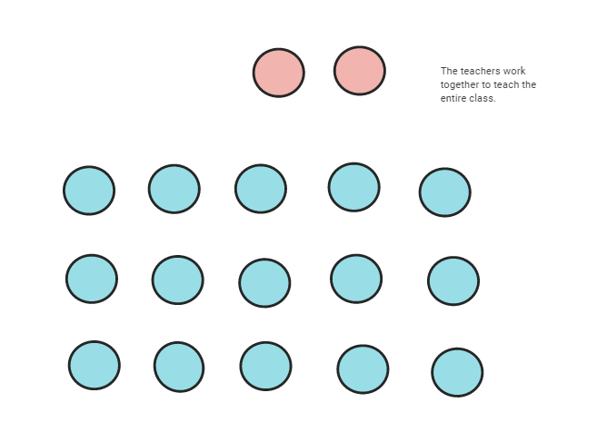
Image by (Cheeseman, n.d.)

Team teaching as reflected in the six co-teaching models; it is ranked as the commonly used one among the five others. It is a form of co-teaching in which two or more instructors collaborate to organize, instruct, and evaluate a class of students. When two teachers work together to teach and learn, they each take an active role in the process and are accountable for different aspects of instruction, evaluation, and classroom management (Aitsl.edu, n.d.).

This model can be used in numerous ways: The first approach is that one teacher assumes the lead position while the other one acts as support. The lead teacher is mainly in charge of organizing and teaching the class, and the supporting teacher gives extra help to students who require it. To ensure that each teacher has an equal opportunity to instruct and assist the students, this model calls for the teachers to alternate in charge of the class (Aitsl.edu, n.d.).

It does not require a class to be physical/in-person for those particular co-teaching models to apply; they can also be applied in an online teaching environment. A few of the recommended tips to use such approaches in an online class includes setting aside time for planning meetings, select a learning platform together, discuss the roles before each lesson, and make some reflections after the lesson (Aitsl.edu, n.d.).

Fig 2: One Teach, One Assist

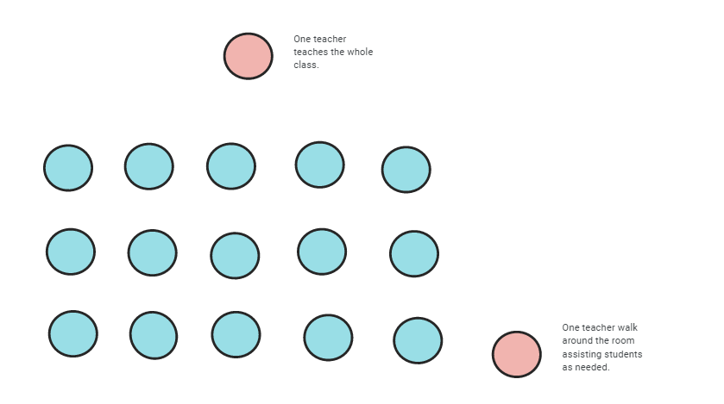

Image by (Cheeseman, n.d.)
As pre-discussed, One teach, One assist model gives a room to one teacher to take the lead role in delivering instruction while the other teacher circulates the classroom to provide support to students who need it. It is an extension of One Teach, One Observe.

Also, One teach, One Assist model can work both in a physical or online environment class. While one teacher can act as a lead for instruction, the assistant can take over tasks related to monitoring the chat texts, attendance, small groups in breakout rooms, etc.

Otherwise, the One Teach, One Assist model in a physical/in-person classroom, the assisting teacher can offer pupils a range of supports including: offering specialized assistance and support to students who require extra assistance or are having difficulty understanding the subject matter, adjusting instruction to each student's unique requirements in the classroom, supplying more tools or resources to students who require them., and to guarantee a secure and effective learning environment, monitoring and managing student behaviour is necessary.

Co-teaching Models and Academic Achievement

Academic achievement may have different connotations depending on who defines it and the why behind. In this context, let’s consider academic achievement as learners’ performance and success in academic activities such as coursework, tests, and assignments. The academic achievement we are discussing here can be measured through grades, text scores, or any other kind of assessment that intends to evaluate a learners knowledge, skills, and abilities in a particular subject or course (Steinmayr, Meißner, Weidinger, & Wirthwein, 2020).

Education system across the globe tends to figure out what can work here and there to enhance the learning outcomes that’s why countries are not on the same level in education system. In Rwanda, a lot was done from back then to enhance the academic learning outcomes among students in all levels of education. The shift from knowledge based to competency-based model is a good example.

A meta- analytic synthesis, study, conducted by Christopher Khoury has pictured out that co-teaching models plays a role in improving leaners academic achievement through providing students with different individualized instruction, more time for practice and feedback, and great access to a variety of teaching strategies and techniques (Khoury, 2014). In his publication, Khoury emphasized on the influence of co-teaching models in an inclusive classroom where learners with special needs, backgrounds, and learning styles get fully accommodated when a particular co-teaching model is applied (one teach, one assist or any other) leading to a better academic performance.

There is limited research on the relationship between co-teaching models and learner motivation. However, based on the shared responsibility between two teachers who plays a co-teaching role in a classroom, there is an association with a higher level of student motivation and achievement. It is objective to note that the effectiveness of co-teaching models may depend on various factors, such as the level of collaboration between teachers, the experience and training of the co-teachers, and the specific needs of the students.

EMPIRICAL REVIEW
In Rwanda, the academic performance of learners is a critical concern, with initiatives like the "Supporting Teacher Achievement in Rwandan Schools" (STARS) project aiming to enhance student outcomes by improving teacher motivation and effort through pay-for-performance contracts. This project, led by Georgetown University in collaboration with the Ministry of Education of Rwanda, focuses on scaling up innovative approaches to raise teacher effectiveness and, consequently, improve student learning outcomes.
Additionally, research in Rwanda has shown that teachers' academic collaboration significantly impacts student academic performance in secondary schools. Teachers' collaborative efforts, such as discussion-based pedagogical approaches and team investigations, have been found to positively influence academic performance, including improved grades in national exams, class participation, homework completion, and attendance.
Moreover, studies in Rwanda have highlighted the importance of teachers' teaching strategies in influencing learners' academic achievement in national examinations. While some teachers tend to focus on exam-oriented teaching methods, emphasizing passing exams over deep understanding, others recognize the value of learner-centered strategies in helping learners grasp mathematical concepts and succeed academically.
In conclusion, the available evidence suggests that collaborative teaching models and effective teaching strategies play a crucial role in enhancing learner's academic achievement in Rwanda. By promoting teacher collaboration, implementing learner-centered approaches, and emphasizing deep understanding over exam performance, Rwanda can further improve student outcomes and academic success.

THEORETICAL REVIEW
Based on theories and several hypotheses, these theories are presumed to be crucial in the study in one way or another. They again help in explaining the bond among the studies, the highlight of each study is well presented.
The past research and studies show the critical role of co-teaching in teaching and learning sessions. In this section, there are several findings from the observations, experiences and evidence obtained from researches conducted in the field of education specifically in co-teaching approach.
Hibbard (2016), in his study on the impact of Co-teaching on grades of learners in secondary schools of Brunei, he mentioned that “Performance-based learning and assessment achieve a balanced approach by extending traditional fact-and-skill instruction” this in return was found to improve learners’ performance. They continued stating that the modern learning techniques coupled with Co-teachings allows for learners to master content standards and learning objectives. This is because the effectiveness of a Co-teaching’ components depend on the competency and dependability of the people using it (Hibbard 2016). It was clearly concluded that there are positive and significant effects of Co-teachings on learner grades.

Marsh (2012) suggested that educators adopt the Co-teaching practices to skills acquired in schools by providing the same content to schools, regardless of their composition and their learners’ socioeconomic status. Only the development and maintenance of the school’s Co-teachings helps to ensure skills acquired and there is a significant relationship between Co-teaching and skills acquired.
In a study by Gabriel (2018), on co-teachings components and student engagement, it is indicated that student engagement is intrinsically linked to two important metrics in learning: knowledge assessment and the quality of the student experience. One of the ways that engagement can be influenced is through careful curriculum design. Using the knowledge that many learners are ‘assessment-driven’, a low-stakes continuous weekly summative assessment was introduced to a module. The impact this had on student engagement was measured by studying student activity within the module virtual learning environment. It was found that introduction of the e-assessments led to a significant increase in virtual learning environment activity compared to the virtual learning environment activity in that module the previous year, and also compared to the virtual learning environment activity of two other modules studied by the same student cohort. As many institutions move towards greater blended or online deliveries, it becomes more important to ensure that virtual learning environments encourage high levels of student engagement in order to maintain or enhance the student experience (Gabriel, 2018).
According to the study conducted by Maye (2021) that intended to examine teacher’s perceptions of co-teaching and the impact it had on student achievement in general, it has been observed that a co-taught class supports to attain a good level of academic achievement in general compared to a class where co-teaching is not applied. The result of the study mentions that teachers indicated a large difference in the way they responded to different questions asked about co-teaching models. Concerning large dispersion/differences of responses, Maye, the researcher, attributed it to the teacher's low understanding of the characteristics of the co-teaching models. This research only used 50 population who have been the totality of general and special education teachers in rural Black Belt area school in Western Alabama (Maye, 2021, p. xx). Such a small number of populations is questionable in terms of data reliability. Besides, the study dealt with student achievement in general. It is important to break this variable down to get to learn more about the impacts co-teaching is playing.
Keeley, Brown, and Knapp (2017) studied the Evaluation of the learners’ experience in the co-taught classroom and found out that the One teach One assist teaching model is very beneficial to learners when it comes to boosting their confidence as compared to the other models. However, on the other hand, teachers revealed that their authority is diminished during the class when One teach One assist is applied (Keeley, Brown, & Knapp, 2017, p. xx).
The study of Farahi and Mohseni (2014) about the Impact of Co-teaching Model on Improving Motivation and Achievement of Iranian Young EFL Learners revealed that using co-teaching models brings a great impact on improving motivation and of young learners. This study engaged young learners at Salehin English Language Department in Tehran (Farahai & Mohseni, 2014, p. xx). Though this study tackled on one of the variables of my research, Farahi and Mohseni in their study, they leveraged a sample of 91 participants which was later diminished to 62 participants (Farahai & Mohseni, 2014, p. xx). My perspective is that this study had a small number of responses which restrict the general reliability of the findings.

Fig 3: Conceptual Framework

H
0
1

Co
-
teaching Model

Learners’
Performance

Team Teaching

One Teach
, One
Assist

Academic
Achievement

Source: (Researcher 2025).

METHODS, VARIABLES AND SOURCES OF DATA
This study employed quantitative research approach using descriptive and correlational designs. Data were collected through a structured, closed-ended questionnaire build based on five Likert-scale where 1= Strongly Disagree 2= Disagree 3= Neutral 4= Agree 5= Strongly Agree. Primary data were collected using a validated and reliable questionnaire. The study population consisted of 124 teachers from the three selected private schools in Kigali city including Excella School, Imanzi City of Mainz, and Mount Carmel Private Christian school. Inferential analysis was conducted using multiple regression analysis to test the hypothesis. The inferential statistics that were used is multiple regression analysis with an emphasis to test the hypotheses. To achieve the objective of this study the following function was developed and tested:

X= Co-teaching Models (Independent Variable) X= (x1 and x2)
x1= TT = Team Teaching x2= OTOA = One Teach, One Assist
y1= AA = Academic Achievement
Based on this, the following functional relationships have been developed in line with research objectives using primary data.
Function: AA = f (TT, OTOA). Where 1.1., is the functional relationships of this study. The function was used to test the effect of the studied co-teaching models (Team teaching and One teach One assist) on Learner’s academic achievement.
Model: AA = β0+β1TT+ β2OTOA+ μ
Where β0 is the intercept for each model (1-3), β1 - β2 are coefficients of explanatory variables, using primary data and μ= error term.

ESTIMATION TECHNIQUE
The study aims to examine the importance and contribution of co-teaching (Team teaching, One teach-One Assist) in the learners academic achievement. To achieve this objective, the study utilizes the Maximum Likelihood Estimation(MLE). The fundamental idea behind MLE is to find the values of the parameters that maximize the likelihood of the observed data, assuming that the data are generated by the specified distribution (Agrawal, 2023, #). This is achieved by maximizing a likelihood function so that, under the assumed statistical data, the observed data is most probable. The point in the parameter space that maximizes the likelihood function is called the maximum likelihood estimate (Richal J., 2018, #).
Suppose that the random variables X1, · · · , Xn form a random sample from a distribution f(x|θ); if X is continuous random variable, f(x|θ) is pdf, if X is discrete random variable, f(x|θ) is a point mass function. We use the given symbol — to represent that the distribution also depends on a parameter θ, where θ could be a real-valued unknown parameter or a vector of parameters. For every observed random sample x1, · · ·, xn, we define f (x1, · · ·, xn|θ) = f(x1|θ) · · · f(xn|θ) (1) If f(x|θ) is pdf, f(x1, · · · , xn|θ) is the joint density function; if f(x|θ) is pmf, f(x1, · · · , xn|θ) is the joint probability. Now we call f(x1, · · · , xn|θ) as the likelihood function. As we can see, the likelihood function depends on the unknown parameter θ, and it is always denoted as L(θ).
Empirical results
This section presents the results from the data collected that helps in answering research questions, achievement of objective and testing the null hypothesis.
Testing Hypothesis
Objective: To investigate the impact of co-teaching models (Team teaching and One teach one assist) on learners’ academic achievement.
Research question: To what extent do co-teaching models (Team Teaching and One teach One assist) impact a learner's academic achievement?
Ho: There is no significant impact of co-teaching models on learner’s academic achievement.

Table 1. Model Summary on Learners’ Academic Achievement
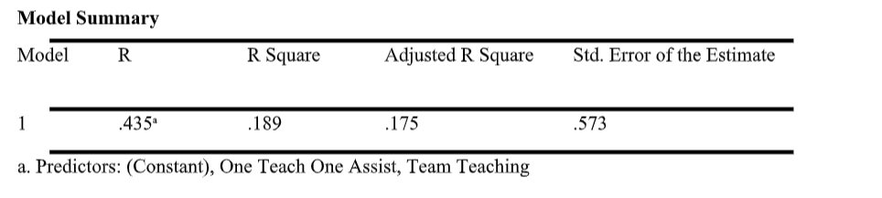
The result from table 1 shows that the adjusted coefficient of determination was 0.175. This implies that the predictors of Co-teaching models affect learner’s academic achievement in the selected private schools in Kigali city by 17.5%, while 82.5% of the changes in learner's academic achievement are attributed to factors not considered in this model.
Table 2. ANOVAª of Learners’ Academic Achievement
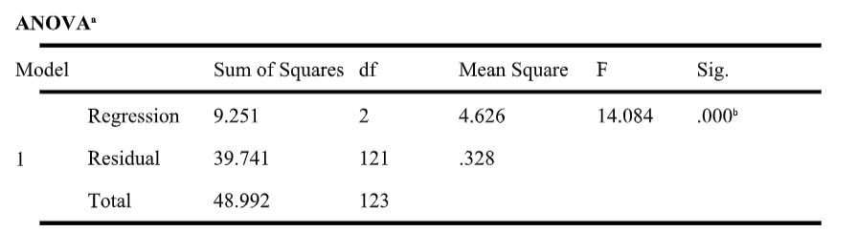
a. Dependent Variable: Learners’ Academic Achievement
b. Predictors: (Constant), One Teach One Assist, Team Teaching

The F-test is 14.084 and P-Value= .000 therefore it means that all Co-teaching models variables jointly have positive and significant effect on Learner’s Academic Achievement in the selected private schools in Kigali city. Therefore, the hypothesis (Ho) of no significant impacts of co-teaching models on learner’s academic achievement is rejected.
Table 3. Coefficients of Learner’s Academic Achievement
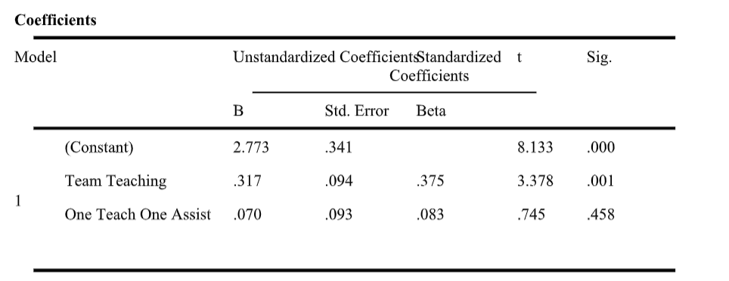
a. Dependent Variable: Learners’ Academic Achievement
Source: SPSS Regression Output
The researcher found out that both studied co-teaching models have positive but different impacts on learner's academic achievement. Team Teaching exhibits a positive and significant influence on learner's academic achievement in the selected private schools in Kigali city (β1=-0.375, t= 3.378, sig. =0.001). This means that a 1% increase/change in the Team-Teaching model results in a 0.375% increase in learner's academic achievement.
On the other hand, One Teach-One Assist shows a positive but there is no significant impact on learner's academic achievement in the selected private schools in Kigali city (β1=-0.083, t= 0.745, sig. =0.458).
In summary, the overall significance of the model indicates that the research rejects the null hypothesis, demonstrating a significant impact of co-teaching models, with Team Teaching being the primary driver of positive impacts on learners' academic achievement in the selected private schools in Kigali city.

DISCUSSION
The findings of this study provide important insights into the effectiveness of co-teaching models in enhancing learners; academic achievement in selected private schools in Kigali City. The results indicate that while both Team Teaching and One Teach-One Assist have a positive impact on academic achievement, the significance and extent of this impact differ between the two models.
TEAM TEACHING
Team Teaching emerged as a significant contributor to improved academic performance. The statistical analysis revealed that a 1% increase in the application of the Team-Teaching model results in a 0.375% increase in learners; academic achievement.
How Collaborative teaching/Team Teaching Influences learners’ Academic Performance
This significant positive relationship between team teaching and academic achievement is attributed to several factors. Team Teaching model allows for a dynamic classroom environment where two teachers can provide diverse perspectives, co-develop instructional materials, and offer more individualized attention to learners. The fact that learners are able to obtain diverse inputs from two expert teachers plays a considerable role in enhancing their content understanding, hence better performance. Also, this collaborative approach not only enhances the quality of instruction but also facilitates better classroom management. The team teaching provides an opportunity to teachers to make more effective differentiation in a class, which is a core basis of increased student engagement. Assuming a class size of 30-40 learners, a single teacher may be unable to give adequate attention to all learners, yet in team teaching approach, teachers can divide the class into manageable groups, facilitating each teacher to offer focused or individualized support, which in turn enhances student engagement, participation, and understanding. All these factors collectively contribute to a more supportive learning environment, thereby improving academic outcomes.
The significance of Team Teaching in this study aligns with existing literature that highlights the benefits of collaborative teaching practices. For instance, previous research by Hibbard (2016) and Marsh (2012) underscores that performance-based learning and assessment, coupled with team-teaching strategies, can significantly enhance learners; mastery of content standards and learning objectives. The positive impact observed in Kigali’s private schools reinforces these findings, suggesting that Team Teaching can be a powerful tool in the Rwandan educational context.
The study by Khairul (2024) supports the hypothesis that team teaching is an effective and efficient strategy in improving the academic achievement of elementary school learners. It found out that the success of this approach is highly influenced by active role of the teacher, cooperation between students, and a well structured implementation procedure. The study highly recommends integrating collaborative or team teaching into the basic education curriculum. These observations significantly align with the results of my research, providing further evidence that team teaching should be adopted as an educational model for elementary schools in Rwanda.

ONE TEACH-ONE ASSIST
In contrast, the One Teach-One Assist model, while showing a positive impact, did not exhibit a statistically significant effect on learners’ academic achievement (β1=0.083, p=0.458). This finding suggests that while having an assisting teacher in the classroom can provide additional support and help address individual student needs, it may not be as effective in driving overall academic performance as the more integrated approach of Team Teaching.
One possible explanation for this could be the nature of the One Teach-One Assist model itself.
This approach often involves one teacher leading the instruction while the other provides individualized support to learners who may be struggling. While this can be beneficial for learners requiring extra help, it might not create the same level of overall classroom engagement and instructional diversity as Team Teaching. The study by Keeley, Brown, and Knapp (2017) supports this observation, indicating that while the One Teach-One Assist model can boost student confidence, it may also diminish the authority and effectiveness of the assisting teacher, thereby limiting its overall impact on academic achievement.

CONCLUSION AND RECOMMENDATION
The study concluded that co-teaching models have a significant impact on academic achievement with Team Teaching being identified as a significant contributor to improved academic achievement. The study recommends Education policy makers in Rwanda/Authorities like Rwanda Education Board to include co-teaching training and methodologies in teacher preparation programs and ongoing professional development for educators since it has proven its relevance in the learning process of learners.

LIMITATIONS AND SUGGESTIONS FOR FUTURE STUDIES
The limitation of interferences from other variables in conjunction with co-teaching models necessitates further research to fully understand their impact on a learner's academic achievement. Therefore, I recommend that future studies investigate the influence of other independent variables on a learner's academic performance. This could include factors such as socioeconomic status, student attitudes, and parental involvement, among others. By examining the interplay between these variables and co-teaching models, researchers can gain a more comprehensive understanding of the complex factors that contribute to learner outcomes.

COMPETING INTERESTS DISCLAIMER:
Authors have declared that they have no known competing financial interests OR non-financial interests OR personal relationships that could have appeared to influence the work reported in this paper.

Disclaimer (Artificial intelligence)

Author(s) hereby declare that NO generative AI technologies such as Large Language Models (ChatGPT, COPILOT, etc.) and text-to-image generators have been used during the writing or editing of this manuscript.

REFERENCES

- Aitsl.edu. (n.d.). Team teaching. Retrieved from https://www.aitsl.edu.au/teach/improve-practice/how-to-guides/collaborating-and-team-teaching
- Cheeseman, K. (n.d.). Team teaching – co-teaching. Retrieved from https://wp.csusm.edu/co-teaching/team-teaching/
- Cook, L., & Friend, M. (1995). Co-Teaching: Guidelines for Creating Effective Practices. Retrieved from https://www.researchgate.net/publication/234620116_Co-Teaching_Guidelines_for_Creating_Effective_Practices
- Farahai, T., & Mohseni, A. (2014). The Impact of Co-teaching Model on Improving Motivation and Achievement of Iranian Young EFL Learners (7). Retrieved from: https://journals.iau.ir/article_514843_487fd47e02400879bd54ff9f7233f755.pdf
- Gabriel, K. F. (2018). Teaching unprepared learners and Strategies for promoting success and retention in higher education. New York: Stylus Publishing, LLC.
- Gholam, A. (2019). Inquiry-Based Learning: Student Teachers’ Challenges and Perceptions. Journal of Inquiry & Action in Education, 10(2), 2019, 10, 133. Retrieved from chrome-extension://efaidnbmnnnibpcajpcglclefindmkaj/https://files.eric.ed.gov/fulltext/EJ1241559.pdf
- Global Partnership for Education. (2021, March). Rwanda: Making strides in equity and inclusion. Retrieved from https://www.globalpartnership.org/where-we-work/rwanda
- Hibbard, K. (2016). the impact of comprehensive assessment on grades of learners in secondary schools of Brunei. Brunei.
- Keeley, R. G., Brown, M. R., & Knapp, D. (2017). Evaluation of the Learners Experience in the Co-taught classroom (3). Retrieved from chrome-extension://efaidnbmnnnibpcajpcglclefindmkaj/https://files.eric.ed.gov/fulltext/EJ1184125.pdf
- Khairul, A. (2024). The effect of collaborative learning methods on elementary school students' academic achievement. Retrieved from Universitas Muhammadiyah Luwuk, Indonesia website: https://injotel.org/index.php/12/article/view/271
- Khoury, C. (2014). THE EFFECT OF CO-TEACHING ON THE ACADEMIC ACHIEVEMENT OUTCOMES OF STUDENTS WITH DISABILITIES: (Doctoral dissertation, UNIVERSITY OF NORTH TEXAS). Retrieved from https://digital.library.unt.edu/ark:/67531/metadc699966/m2/1/high_res_d/dissertation.pdf
- Marsh, K. (2012). Comprehensive Assessment Practices. Lagos.
- Maye, T. (2021). To Examine Teachers’ Perception of Co-teaching and Student Achievement. Retrieved from chrome-extension://efaidnbmnnnibpcajpcglclefindmkaj/https://files.eric.ed.gov/fulltext/EJ1322101.pdf
- MINEDUC (2014). 2013 Education Statistics Yearbook. Kigali: MINEDUC. Retrieved from www.MINEDUC.go.rw.
- Morin, A. (2020, March 9). 6 co-teaching models. Retrieved from https://www.understood.org/en/articles/6-models-of-co-teaching
- Ndihokubwayo, K., Nyirigira, V., Murasira, G., & Munyensanga, P. (2021). Is Competence-Based Curriculum well Monitored? Learning from Rwandan Sector Education Officers (Vol. 5, No. 1). Retrieved from Rwandan Journal of Education website: file:///C:/Users/Sylidio%20M/Downloads/ajol-file-journals_534_articles_202577_submission_proof_202577-6289-507154-2-10-20210218.pdf
- Republic of Rwanda Ministry of Education. (2019). 2019 EDUCATION STATISTICS. Retrieved from Rwanda Ministry of Education website: https://www.mineduc.gov.rw/index.php?eID=dumpFile&t=f&f=57556&token=46e2f488cbbedb7100d047093bf3e61cdaff908c
- Steinmayr Linda, R., Meißner, A., Weidinger, A. F., & Wirthwein, L. (2020, August 5). Academic achievement. Retrieved from https://www.oxfordbibliographies.com/display/document/obo-9780199756810/obo-9780199756810-0108.xml
- UNICEF (2013). UNICEF Annual Report for Rwanda 2012. Kigali: UNICEF. Retrieved from www.UNICEF.org

