Phytolith Carbon Sequestration as a Sustainable Pathway for Climate Change Mitigation

.
ABSTRACT

Phytolith carbon sequestration is one of the lesser-known long-term carbon storage mechanisms, where carbon is trapped inside the silica formed in plant tissues. Phytolith is strongly resistant to decomposition; hence, the carbon inside it can be trapped for millions of years. This process helps in a stable pathway for the reduction of the atmospheric carbon dioxide level. Phytolith formation is controlled by the uptake of monosilicic acid by plants and silica polymerization. And, the carbon occlusion depends on soil conditions, phytolith type, plant species, and environment. Phytolith contributes to carbon sequestration across ecosystems. For example, 1.7 Tg CO₂ is trapped annually in China’s forests, where bamboo is the high contributor. Wetlands, particularly peat-forming wetlands (sequestering 0.003-0.077 t CO₂ ha⁻¹ yr¹) and eelgrass beds, store high phytolith-occluded carbon. Phytoliths are a promising long-term carbon-capturing material. This paper provides a broader knowledge on phytolith carbon sequestration and their importance as a nature-based pathway for climate mitigation.

Keywords: Phytolith-occluded carbon; Long-term carbon sequestration; Silicon biogeochemical cycle; Nature-based climate solutions; Terrestrial and wetland ecosystems

1. INTRODUCTION

Carbon sequestering in reducing atmospheric CO₂ is a critical phenomenon in addressing global warming and climate change. Globally, both natural and man-made methods are studied to enhance carbon sequestration, including innovative technologies and sustainable land management practices. Natural ecosystems such as forests and oceans play a major role in absorbing substantial amounts of atmospheric CO₂ (Pasquier et al., 2025; Zhu et al., 2025). Agricultural activities also contribute to carbon sequestration; with improved land management, they can sequester potentially up to 0.75 Pg C annually (Kaur et al., 2023).
Engineered technologies like direct air capture (DAC) and bioenergy with carbon capture and storage (BECCS) have gained attention for reducing atmospheric CO₂ while producing sustainable energy (Lefvert & Grönkvist, 2024; Ozkan, 2025). However, conventional carbon capture and storage (CCS) remains economically and technologically challenging, with costs ranging from 19 to 332.5 euros per metric ton of CO₂ and risks associated with the long-term storage and leakage (Malz et al., 2025). These limitations highlight the necessity for complementary, low-risk, nature-based solutions alongside emission reduction strategies (Thakur & Pillai, 2024).

Phytoliths, the silica-based structures formed in plant tissues, offer such a solution. During plant growth organic carbon is trapped within the phytoliths, which is commonly known as phytolith-occluded carbon (PhytOC). This paper aims to provide a comprehensive understanding of the role of phytoliths in carbon sequestration and their potential as a sustainable way in mitigating climate change.

2. Phytolith Formation and Characteristics

Phytoliths are formed in over 50 families of higher plants, with particularly high abundance in grasses (Poaceae) and sedges (Cyperaceae) (Blinnikov & Yost, 2025). They are formed by the uptake of monosilicic acid (H₄SiO₄) from the soil, which is transported through the vascular system (Shakoor et al., 2014). And, they are stored inside and outside plant cells, often in areas where water is absorbed or lost (Nawaz et al., 2019). Phytoliths are inorganic and resistant to decomposition, making them valuable for long-term preservation in various environmental conditions (Cabanes, 2020). They provide mechanical strength, enhance water balance, and offer protection against herbivores and pathogens (Shakoor et al., 2014). The morphology of phytoliths varies, helping in taxonomic studies and paleo-environmental reconstructions (Shakoor et al., 2014; Blinnikov & Yost, 2025).

Phytoliths play a significant role in carbon sequestration through the mechanism of phytolith-occluded carbon (PhytOC) (Figure 1). This process involves the trapping of carbon within phytoliths, creating a stable, long-term carbon sink in soil storage that helps in mitigating atmospheric CO₂ levels. Phytoliths can enclose carbon during their formation, creating PhytOC. The efficiency of this occlusion depends on factors such as plant species, tissue type, and environmental conditions like precipitation and temperature. The primary producers of phytoliths are grasses which have diverse morphotypes like short-cell phytoliths and bulliform cells (Karmakar et al., 2024). Tree species like Norway spruce and other deciduous trees have also been reported to have distinct morphotypes (Lisztes-Szabo et al., 2019). Further, ferns and a few flowering plants have been reported to have phytoliths (Blinnikov & Yost, 2025). Morphotypes of phytoliths, particularly short-cell phytoliths are common in grasses, and this form is the essential one for identifying species (Karmakar et al., 2024). Also, blocky phytoliths found in coniferous species indicate specific plant types and their environmental adaptations (Lisztes-Szabo et al., 2019). Epidermal phytoliths identified in various plant tissues contribute to the understanding of plant responses to environmental stressors. Phytolith provides valid information about past ecosystems.
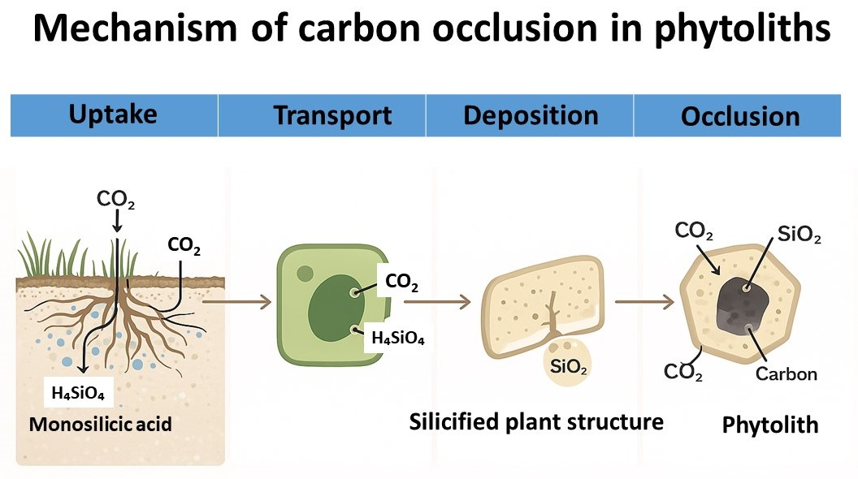
Fig. 1. Mechanism of Carbon occlusion in phytoliths.

3. Environmental Controls on Phytolith Development

Environmental factors like moisture levels and salinity significantly control the development of phytolith. These factors can affect the size and morphology of the phytolith, leading to variations in phytolith size and morphology within a single plant. For example, in Phragmites australis, plants grown in saline-alkaline environments produce larger but less abundant phytoliths, while those grown in wetter environments are smaller and fewer (Liu et al., 2016). When the humidity level increases, the diversity of phytolith also increases, revealing the positive correlation between the moisture and phytolith diversity. Lanceolate phytoliths are particularly sensitive to humidity change (Liu et al., 2016). Phytolith longevity is influenced by plant species, phytolith morphology, and environmental conditions (Solomonova et al., 2019; Cabanes, 2020; de Tombeur et al., 2021; Blinnikov & Yost, 2025). Grasses and sedges produce high phytoliths (Blinnikov & Yost, 2023). Water balance of ecosystem influence phytolith production as well as dissolution rates (de Tombeur et al., 2021). Temperature and moisture content also play a crucial role in phytolith morphotypes (Solomonova et al., 2019) that affect phytolith longevity in mountain ecosystem.

4. Mechanisms of Carbon Sequestration in Phytoliths

Carbon sequestration through plant absorption is a key process that uses photosynthesis to convert atmospheric CO₂ into organic compounds (Figure 2). Besides carbon sequestration, this process helps in enriching soil fertility. During photosynthesis plants absorb CO₂ and convert it into carbohydrates and oxygen. This process takes place in leaves when CO₂ diffuses into mesophyll cells (Flexas et al., 2012). A major portion of the carbon captured is allocated to roots (Jansson et al., 2010; Siddique et al., 2024). Phytolith-occluded carbon is formed during plant growth and can remain stable even after plant decomposition, thereby serving as a long-term carbon sink (Ahla & Swaroop, 2024). The incorporation of carbon into silica structures requires multiple processes that ultimately result in novel materials with unique characteristics.

Long-term carbon stabilization is regulated by a combination of biogeochemical, pedogenic, and ecological mechanisms that support phytolith carbon sequestration (Ahla & Swaroop, 2024). The transpiration stream is followed by the intake of monosilicic acid during plant growth, where it polymerizes as biogenic silica in the tissues. This procedure can be shown as:

H₄SiOH₄ → SiO₂·nH₂O (phytolith) + H₂O ……(Eq. 1)

Simultaneously, atmospheric carbon is fixed through photosynthesis:

6CO₂ + 6H₂O → C₆H₁₂O₆ + 6O₂ ……(Eq. 2)

A fraction of this assimilated carbon becomes occluded within silica matrices:

Plant C + Biogenic Silica → PhytOC (stable carbon pool) ……(Eq. 3)

After litter deposition, phytoliths enter soil horizons via decomposition, bioturbation, and aggregation (Liu et al., 2019; Cheng et al., 2023). Soil aggregation enhances physical protection of phytolith-occluded carbon through microaggregate encapsulation, reducing microbial mineralization rates. The long-term stabilization potential depends on soil texture, mineralogy, and hydrological regime, which regulate dissolution kinetics:

SiO₂ + 2H₂O ⇌ H₄SiO₄ ……(Eq. 4)

Phytolith sequestration supports several ecosystem service routes in sustainability frameworks, including soil fertility improvement, water retention, climate regulation, and carbon storage (Parr & Sullivan, 2005; de Tombeur et al., 2024). Synergistic benefits are promoted across the carbon, nitrogen, and silica cycles by systems-based land management that incorporates silicate fertilization, residue recycling, agroforestry, and conservation tillage. As a semi-permanent carbon sink pool separate from labile soil organic carbon, phytolith carbon can be included in life-cycle carbon accounting models from the standpoint of sustainability assessment.

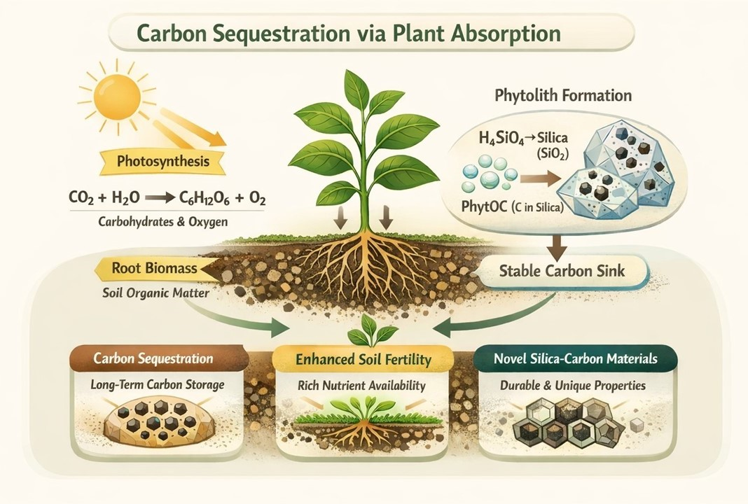

Fig. 2. Integrated framework of photosynthesis, root biomass, and phytolith-associated carbon storage.

5. STABILITY AND LONGEVITY OF PHYTOLITHS IN SOIL

Soil deposition plays a key role in long-term carbon sequestration. However, the stability of carbon storage in soil remains uncertain (Schmidt et al., 2011). The deposited soil organic carbon can remain in the soil for 300 to 1500 years, with 20-50% retention at equilibrium, highlighting its importance in the global carbon cycle (Schmidt et al., 2011). Phytolith, the silica structure developed in plants, can remain intact for millions of years, contributing to long-term carbon sequestration. These resilient characters can be attributed to their inorganic nature and their protective interactions with organic matter, which can enhance their stability in various soil environments.

Phytoliths are highly resistant to decomposition and can account for nearly 82% of the total carbon in soil after 1000 years of organic matter decomposition (Parr & Sullivan, 2005). Phytoliths from certain plants like Dicranopteris linearis have low dissolution rates (Nguyen et al., 2019). Stability of phytoliths is influenced by soil characters such as pH, clay content, and organic carbon (Li et al., 2013). Dissolution rates are higher in paddy soils than non-paddy soils (Koebernick et al., 2024). Although phytoliths are resistant to degradation, they can be affected by the mechanical weathering process (Morgan-Edel et al., 2015). The parent soil material affects the durability of phytolith. For example, carbonate-rich soils exhibit different dynamics compared to carbonate-poor soils (de Tombeur et al., 2021).

6. Ecosystem Contributions to Phytolith Carbon Sequestration

High phytolith accumulation increases soil carbon storage (Parr & Sullivan, 2005). The long-term stability of phytoliths makes them special for understanding carbon dynamics in different ecosystems. Phytoliths have been reported to sequester between 11 and 190 Tg C annually (de Tombeur et al., 2024).

6.1 Croplands

Buckwheat, a widely cultivated crop, is globally estimated to sequester 5102.09 t CO₂ in 2018 through phytolith carbon sequestration (Wang & Sheng, 2022). Approximately 26.35 Tg of CO₂ is reported to be sequestered annually in global cropland phytoliths, primarily contributed by rice, wheat, and maize (Song et al., 2013). Since 1961, the applications of fertilizers and managed cropping systems have tripled phytolith carbon storage (Song et al., 2013). At the global scale, rice crops alone sequester approximately 16.4 Tg e-CO₂ annually via phytOC (Prajapati et al., 2016).

6.2 Forests

Different forests store different quantities of phytOC. Bamboo forests sequester high phytOC content compared to fir and chestnut forests (Zhang et al., 2016). The total organic carbon in phytoliths is significantly higher in bamboo forests than in other terrestrial ecosystems, including grasslands, croplands, and forests (Cheng et al., 2023). Different ecosystems sequester varying amounts of phytolith-occluded carbon; bamboo forests are widely reported to sequester high amounts of phytolith-occluded carbon (Cheng et al., 2023; Zhen et al., 2024).

6.3 Wetlands

In wetlands, herb-dominated fens sequester high phytOC content up to 0.077 t-e-CO₂ ha⁻¹ a⁻¹ (Li et al., 2013). Soil depth and vegetation types affect phytOC content (Yang et al., 2019), as phytolith and phytOC content decreases from surface soil layer or litter layers to deeper soil layers, highlighting the importance of surface processes in carbon sequestration (Yang et al., 2019).

7. Management Practices to Enhance Phytolith Carbon Sequestration

Agricultural practices, such as the use of silicon fertilizers and compost application, have the potential to increase phytolith production and carbon sequestration rates in agricultural systems (Rutkowska et al., 2024). Maintaining the crop residues in the soil can increase soil organic carbon levels and improve both carbon sequestration and soil health. Agricultural practices like cover cropping and reduced tillage, besides increasing phytolith carbon sequestration improve soil structure, nutrient cycling, and water retention, supporting high crop yields (Pandao et al., 2023; Patil et al., 2024).

The quantity of phytolith carbon sequestration in croplands can be increased by silicate minerals-rich fertilizer usage (Kundu et al., 2020; Rutkowska et al., 2024; Wang et al., 2024) crop rotation using high phytolith-producing plants such as rice, wheat, and maize (Song et al., 2013). Further, controlling soil pH can increase silica availability for uptake by plants, thereby increasing phytolith formation and phytolith carbon sequestration (Huang et al., 2020). Addition of organic matter improves soil structure and nutrient availability, leading to high phytolith production (Shakoor et al., 2014).

Choosing plants that accumulate a lot of silica, like bamboos and grasses, is the first step in management strategies to improve phytolith carbon sequestration (Figure 3). To improve plant uptake of soluble silica, silicate-rich amendments, such as rice husk ash or silicate fertilizers, can be used. Silica mobility and bioavailability are supported by maintaining ideal soil pH and moisture levels, while phytolith loss from soil systems is decreased by limited tillage and vegetation cover (Min et al., 2021). Crop residues should be returned after harvest to support long-term storage and stabilize phytolith-occluded carbon. Adaptive management and long-term monitoring are necessary for sustained sequestration (Nguyen et al., 2025). This integrated approach improves soil structure, increases soil carbon retention, improves biogeochemical cycling, and supports ecosystem resilience and global climate mitigation.

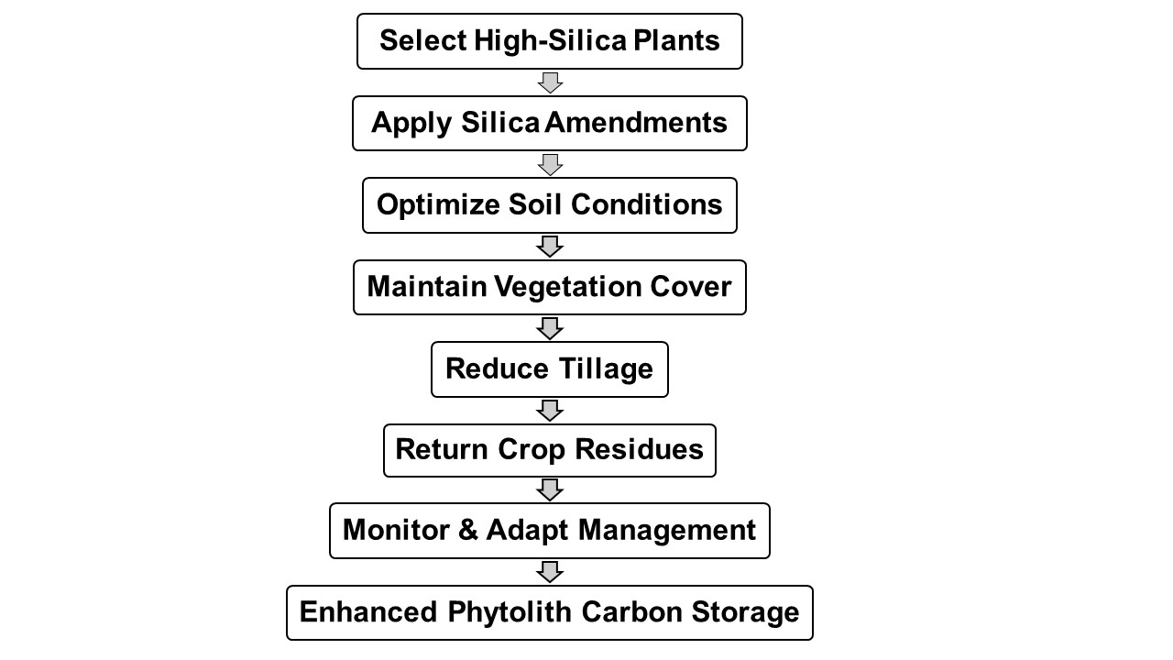
Fig. 3. Flowchart showing management practices to enhance phytolith carbon sequestration.

8. ECOLOGICAL AND CLIMATE MITIGATION IMPLICATIONS

Phytoliths improve the soil structure and aeration, which help in root growth and improve nutrient uptake by the plants (Ahla & Swaroop, 2024). Also, the presence of phytolith in soil increases the retention of moisture and nutrients, which ultimately helps in promoting healthier plant growth and higher agricultural yields (Song et al., 2013). Management practices like optimizing cropping systems and proper soil management can increase phytolith carbon sequestration, which in turn helps improve soil health and fertility (Song et al., 2013; Ahla & Swaroop, 2024). Land use practices, such as grazing and tillage, highly influence phytolith-occluded carbon dynamics. For example, in croplands, cutting and tillage can alter phytOC storage more than grazing (Kundu et al., 2020; Cheng et al., 2023). In forests, management practices such as thinning and artificial tending can increase phytOC sequestration (Zheng et al., 2024).

Phytolith-occluded carbon improves soil fertility and stability, which helps in ecosystem resilience and biodiversity conservation (Luo et al., 2024). It helps in climate change mitigation efforts by supporting the carbon cycle (Kundu et al., 2020). There are challenges in accurately estimating phytOC storage, and its complex interaction within the ecosystems. Besides the benefits, there are challenges like economic constraints and policy support that would limit the widespread adoption of phytolith carbon sequestering strategies.

9. CONCLUSION

Phytolith-occluded carbon represents a stable and long-lasting form of carbon sequestration that complements existing climate mitigation strategies (Huang et al., 2014; Zhao et al., 2016). Unlike traditional soil organic carbon pools, phytoliths act as a semi-permanent carbon sink due to their extreme resistance to breakdown and ability to remain in soils for geological timeframes. Their development combines biological, geochemical, and ecological mechanisms that improve long-term carbon stabilization. These processes include soil deposition, carbon occlusion, and plant silica uptake. Evidence from wetlands, forests, and croplands shows that phytolith carbon sequestration takes place in a variety of environments, with silica-accumulating plants like bamboo, grasses, and cereals contributing the most. Phytoliths increase ecosystem resilience and production by enhancing soil structure, nutrient retention, and water balance in addition to providing climate advantages.

Despite these advantages, uncertainties remain regarding global quantification, dissolution dynamics, and the influence of environmental variables on phytolith stability. Addressing these gaps requires standardized analytical protocols, long-term field monitoring, and improved integration of phytolith carbon into ecosystem and Earth system models. Future works should focus on (i) identifying high-silica plant species and genotypes for climate-smart agriculture and forestry, (ii) optimizing land management practices such as residue retention, silicate amendments, and reduced tillage, (iii) developing regional and global inventories of phytolith carbon stocks, and (iv) incorporating phytolith-based sequestration into carbon accounting frameworks and climate policy mechanisms. Advancing interdisciplinary research linking soil science, plant physiology, and biogeochemistry will be essential for scaling this nature-based solution. Overall, phytolith carbon sequestration offers a scientifically promising, environmentally sustainable, and policy-relevant pathway for enhancing long-term carbon storage and supporting global climate mitigation efforts.

Disclaimer (Artificial intelligence)
Author(s) hereby declare that NO generative AI technologies such as Large Language Models (ChatGPT, COPILOT, etc.) and text-to-image generators have been used during the writing or editing of this manuscript.

References

Ahla, K., & Swaroop, R. (2024). Phytolith-Mediated Biocarbon Sequestration. International Journal of Plant & Soil Science, 36(10), 665-677. https://doi.org/10.9734/ijpss/2024/v36i105139

Blinnikov, M. S., Yost, C. L. (2025). Phytoliths. In Elias, S. (Ed.) Encyclopedia of Quaternary Science (Third edition), Elsevier (3rd edition), Pages 434-451. https://doi.org/10.1016/B978-0-323-99931-1.00097-0

Cabanes, D. (2020). Phytolith Analysis in Paleoecology and Archaeology. In Henry, A.G. (eds) Handbook for the Analysis of Micro-Particles in Archaeological Samples. Interdisciplinary Contributions to Archaeology. Springer, Cham., Pages 255-288. https://doi.org/10.1007/978-3-030-42622-4_11

Cheng, X., Lv, H., Liu, S., Li, C., Li, P., Zhou, Y., ... & Zhou, G. (2023). The phytolith carbon sequestration in terrestrial ecosystems: the underestimated potential of bamboo forest. Ecological Processes, 12(1), 62.

de Tombeur, F., Cornelis, J. T., Laliberté, E., Lambers, H., Mahy, G., Faucon, M. P., & Turner, B. L. (2021). Impact of ecosystem water balance and soil parent material on silicon dynamics: insights from three long-term chronosequences. Biogeochemistry, 156(3), 335-350. https://doi.org/10.1007/s10533-021-00849-w

de Tombeur, F., Hodson, M. J., Saunders, M., & Clode, P. L. (2024). How important is carbon sequestration in phytoliths within the soil? Plant Soil. 505: 185-198. https://doi.org/10.1007/s11104-024-06700-z

Flexas, J., Barbour, M. M., Brendel, O., Cabrera, H. M., Carriquí, M., Díaz-Espejo, A., ... & Warren, C. R. (2012). Mesophyll diffusion conductance to CO2: an unappreciated central player in photosynthesis. Plant Science, 193, 70-84.
https://doi.org/10.1186/s13717-023-00476-3

Huang, C., Wang, L., Gong, X., Huang, Z., Zhou, M., Li, J., ... & Jiang, P. (2020). Silicon fertilizer and biochar effects on plant and soil PhytOC concentration and soil PhytOC stability and fractionation in subtropical bamboo plantations. Science of The Total Environment, 715, 136846. https://doi.org/10.1016/j.scitotenv.2020.136846

Huang, Z. T., Li, Y. F., Jiang, P. K., Chang, S. X., Song, Z. L., Liu, J., & Zhou, G. M. (2014). Long-term intensive management increased carbon occluded in phytolith (PhytOC) in bamboo forest soils. Scientific reports, 4(1), 3602.

Jansson, C., Wullschleger, S. D., Kalluri, U. C., & Tuskan, G. A. (2010). Phytosequestration: carbon biosequestration by plants and the prospects of genetic engineering. Bioscience, 60(9), 685-696. https://doi.org/10.1525/BIO.2010.60.9.6

Karmakar, M., Biswas, R., Mukherjee, B., Biswas, O., Naskar, M., Paruya, D. K., ... & Bera, S. (2024). Chloridoideae grass phytoliths can distinguish two different rainfall zones: A case study from northern parts of Western Ghats, India. Quaternary International, 681, 11-23.

Kaur, R., Kaur, N., Kumar, S., Dass, A., & Singh, T. (2023). Carbon capture and sequestration for sustainable land use – A review. Indian Journal of Agricultural Sciences, 93(1): 11-18. https://doi.org/10.56093/ijas.v93i1.124838

Koebernick, N., Mikutta, R., Kaiser, K., Klotzbücher, A., Nguyen, A. T., Nguyen, M. N., & Klotzbücher, T. (2024). Controls on phytolith stability upon exposure in paddy soils. Geoderma, 443, 116821. https://doi.org/10.1016/j.geoderma.2024.116821

Kundu, S., Rajendiran, S., Coumar, M. V., Ajay (2020). Effect of Land Use and Management Practices on Quantifying Changes of Phytolith-Occluded Carbon in Arable Soils. In Ghosh, P., Mahanta, S., Mandal, D., Mandal, B., Ramakrishnan, S. (eds) Carbon Management in Tropical and Sub-Tropical Terrestrial Systems. Springer, Singapore. Pages 37-55. https://doi.org/10.1007/978-981-13-9628-1_3

Lefvert, A., & Grönkvist, S. (2024). Lost in the scenarios of negative emissions: The role of bioenergy with carbon capture and storage (BECCS). Energy Policy, 184, 113882. https://doi.org/10.1016/j.enpol.2023.113882

Li, Z., Song, Z., & Jiang, P. (2013). Biogeochemical sequestration of carbon within phytoliths of wetland plants: a case study of Xixi wetland, China. Chinese Science Bulletin, 58(20), 2480-2487. https://doi.org/10.1007/s11434-013-5785-3

Lisztes-Szabo, Z., Braun, M., Csík, A., & Pető, Á. (2019). Phytoliths of six woody species important in the Carpathians: characteristic phytoliths in Norway spruce needles. Vegetation History and Archaeobotany, 28(6), 649-662. https://doi.org/10.1007/S00334-019-00720-X

Liu, L., Jie, D., Liu, H., Gao, G., Gao, Z., Li, D., ... & Guo, J. (2016). Response of phytoliths in Phragmites australis to environmental factors in northeast China. Ecological Engineering, 92, 119-131. http://dx.doi.org/10.1016/j.ecoleng.2016.03.027

Liu, L., Li, D., Jie, D., Liu, H., Gao, G., & Li, N. (2019). Translocation of phytoliths within natural soil profiles in Northeast China. Frontiers in Plant Science, 10, 1254. https://doi.org/10.3389/fpls.2019.01254

Luo, M., Wang, L., Liu, L., Song, L., Lu, X., & Sheng, M. (2024). PhytOC sequestration characteristics and phytolith carbon sink capacity of the karst grasslands in southwest China. Science of The Total Environment, 955, 176949. https://doi.org/10.1016/j.scitotenv.2024.176949

Min, H. G., Kim, M. S., & Kim, J. G. (2021). Effect of soil characteristics on arsenic accumulation in phytolith of gramineae (Phragmites japonica) and fern (Thelypteris palustris) near the gilgok gold mine. Sustainability, 13(6), 3421. https://doi.org/10.3390/su13063421

Morgan-Edel, K. D., Boston, P. J., Spilde, M. N., & Reynolds, R. E. (2015). Phytoliths (plant-derived mineral bodies) as geobiological and climatic indicators in arid environments. New Mexico Geology, 37(1), 3-20.

Nawaz, M. A., Zakharenko, A. M., Zemchenko, I. V., Haider, M. S., Ali, M. A., Imtiaz, M., ... & Golokhvast, K. S. (2019). Phytolith formation in plants: from soil to cell. Plants, 8(8), 249. https://doi.org/10.3390/plants8080249

Nguyen, M. N., Meharg, A. A., Carey, M., Dultz, S., Marone, F., Cichy, S. B., ... & Nguyen, T. T. (2019). Fern, Dicranopteris linearis, derived phytoliths in soil: Morphotypes, solubility and content in relation to soil properties. European Journal of Soil Science, 70(3), 507-517. https://doi.org/10.1111/ejss.12754

Nguyen, T. T., Bekin, N., Altman, A., Maier, M., Agam, N., & Levintal, E. (2025). Overcoming barriers in long-term, continuous monitoring of soil CO2 flux: a low-cost sensor system. Soil, 11(2), 639-653. https://doi.org/10.5194/soil-11-639-2025

Ozkan, M. (2025). Atmospheric alchemy: The energy and cost dynamics of direct air carbon capture. MRS Energy & Sustainability, 12(1), 46-61. https://doi.org/10.1557/s43581-024-00091-5

Pandao, M. R., Jejal, A. D., Shukla, E. P., Prabhumitrareddy, S., Rout, S., Baral, K., & Bhadani, M. (2023). Unlocking the benefits of carbon sequestration for enhancing soil health. Int J Environ Clim Change, 13(12), 1349-1359. https://doi.org/10.9734/ijecc/2023/v13i123803

Parr, J. F., & Sullivan, L. A. (2005). Soil carbon sequestration in phytoliths. Soil Biology & Biochemistry, 37(1), 117–124. https://doi.org/10.1016/J.SOILBIO.2004.06.013

Pasquier, B., Matear, R. J., Chamberlain, M. A., Ziehn, T., Hutchinson, D. K., Primeau, F. W., ... & Bardin, A. (2025). The sequestration efficiency of the deep ocean. Geophysical Research Letters, 52(18), e2025GL116799. https://doi.org/10.1029/2025GL116799

Patil, P., Deepika, J. T., Saniga, N. S., Kumar, S., Tejaswini, R., Siddiqua, A., & Behera, H. S. (2024). Harnessing Earth’s Green Guardians: Exploring Carbon Sequestration in Agricultural Practices. International Journal of Environment and Climate Change, 14(6), 86-104. https://doi.org/10.9734/ijecc/2024/v14i64213

Prajapati, K., Rajendiran, S., Coumar, V., Dotaniya, M. L., Kumar, A., & Kundu, S. (2016). Carbon occlusion potential of rice phytoliths: implications for global carbon cycle and climate change mitigation. Applied Ecology and Environmental Research, 14(2), 265–281. https://doi.org/10.15666/aeer/1402_265281

Rutkowska, B., Schröder, P., Mench, M., Rineau, F., Szulc, W., Szulc, W., ... & Loit, E. (2024). Role of phytolith occluded carbon of cereales plants for climate change mitigation. Journal of Water and Land Development, (60), 50-58. https://doi.org/10.24425/jwld.2023.148459

Schmidt, M. W., Torn, M. S., Abiven, S., Dittmar, T., Guggenberger, G., Janssens, I. A., ... & Trumbore, S. E. (2011). Persistence of soil organic matter as an ecosystem property. Nature, 478(7367), 49-56.

Shakoor, S. A., Bhat, M. A., & Mir, S. H. (2014). Phytoliths in Plants: A Review. Research & Reviews: Journal of Botanical Sciences, 3(3), 10–24.

Siddique, K. H., Bolan, N., Rehman, A., & Farooq, M. (2024). Enhancing crop productivity for recarbonizing soil. Soil and Tillage Research, 235, 105863. https://doi.org/10.1016/j.still.2023.105863

Solomonova, M. Y., Blinnikov, M. S., Silantyeva, M. M., & Speranskaja, N. Y. (2019). Influence of moisture and temperature regimes on the phytolith assemblage composition of mountain ecosystems of the mid latitudes: a case study from the Altay Mountains. Frontiers in Ecology and Evolution, 7, 2. https://doi.org/10.3389/fevo.2019.00002

Song, Z., Liu, H., Li, B., & Yang, X. (2013). The production of phytolith-occluded carbon in China’s forests: implications to biogeochemical carbon sequestration. Global Change Biology, 19(9), 2907–2915. https://doi.org/10.1111/gcb.12275

Thakur, A., & Pillai, A. K. S. (2024). Carbon dioxide sequestration, conversion and utilization. In Kulkarni, N. V., Kharissov, B. I. (eds), Handbook of Emerging Materials for Sustainable Energy, Elsevier, Pages 571–589. https://doi.org/10.1016/b978-0-323-96125-7.00031-9

Wang, F., Zhu, F., Li, Y., Liu, D.-Z., Qu, Y.-Y., Qin, Y., Wang, Y., Wang, W., Xie, J., & Fang, Y. (2024). Effect of enhanced silicate minerals weathering on carbon sequestration by plant-soil systems in rice fields. Chinese Journal of Applied Ecology, 35(10), 2733–2743. https://doi.org/10.13287/j.1001-9332.202410.017

Wang, L., & Sheng, M. (2022). Phytolith occluded organic carbon in Fagopyrum (Polygonaceae) plants: Insights on the carbon sink potential of cultivated buckwheat planting. Frontiers in Plant Science, 13: 1014980. https://doi.org/10.3389/fpls.2022.1014980

Yang, Y., Wang, F., Jin, J., Hu, S., & Gao, Y. (2019). Carbon storage potential and seasonal dynamics of phytolith from different vegetation types in a subtropical region, China. Environmental Science and Pollution Research, 26(29), 29834–29844. https://doi.org/10.1007/S11356-019-06143-5

Zhang, X., Song, Z., McGrouther, K., Li, J., Li, Z., Ru, N., & Wang, H. (2016). The impact of different forest types on phytolith-occluded carbon accumulation in subtropical forest soils. Journal of soils and sediments, 16(2), 461-466. https://doi.org/10.1007/s11368-015-1259-3

Zhao, Y., Song, Z., Xu, X., Liu, H., Wu, X., Li, Z., Guo, F., & Pan, W. (2016). Nitrogen application increases phytolith carbon sequestration in degraded grasslands of North China. Ecological Research, 31(1), 117–123. https://doi.org/10.1007/S11284-015-1320-0

Zheng, X., Sheng, M., Zhang, Y., Gong, Z., & Wang, L. (2024). PhytOC sequestration characteristics and phytolith carbon sink potential of karst Masson pine forest in southern China. Science of the Total Environment, 913, 169688. https://doi.org/10.1016/j.scitotenv.2023.169688

Zhu, X., Long, Y., & Zhang, H. (2025). Impact of carbon policies on forest carbon sequestration supply at intensive and extensive margins. Forest Policy and Economics, 181, 103665. https://doi.org/10.1016/j.forpol.2025.103665

