Emotional Consumer Engagement in the Loneliness Economy: The Role of AI Companions, Virtual Influencers and Nostalgia

Abstract
The study explores the role of AI companions, virtual influencers, and nostalgia in shaping Emotional Consumer Engagement (ECE) within the loneliness economy, with Nostalgic Sentiment (NS) as a mediating factor. The growing issue of loneliness has led to the rise of digital technologies aimed at offering emotional support, such as AI companions and virtual influencers. These technologies provide companionship yet raise concerns about emotional dependence and vulnerability. The research adopts a deductive approach, using primary data from 170 respondents, collected through convenient sampling and analyzed using Structural Equation Modeling (SEM). Findings show that AI companions, virtual influencers, and nostalgia positively influence ECE, with nostalgic sentiment playing a significant mediating role. The study is grounded in Parasocial Interaction Theory, which explains one-way relationships where consumers feel emotional connections with AI and virtual influencers. Additionally, Conservation of Resources Theory helps explain how nostalgia, as a coping mechanism, can alleviate feelings of loneliness, while Social Identity Theory highlights how collective nostalgia fosters group identification and belonging. The study underscores the power of nostalgia-driven content in fostering emotional bonds and increasing consumer engagement, while raising ethical concerns regarding the commodification of emotional experiences. Managers can leverage nostalgic content to enhance consumer engagement, though they must carefully consider the ethical implications of exploiting emotional vulnerabilities.
Keywords:
AI Companions, Virtual Influencers, Nostalgia, Emotional Consumer Engagement, Nostalgic Sentiment, Loneliness Economy, Bangladesh.
1.0 Introduction
The loneliness economy is an emerging and rapidly growing phenomenon in contemporary society, driven by the increasing prevalence of emotional isolation across various demographics. As individuals experience heightened feelings of loneliness, a growing concern emerges regarding its impact on both mental and physical well-being. This pervasive sense of isolation has prompted the development of various AI-driven technologies aimed at addressing this emotional void. AI companions and virtual influencers, two prominent innovations in the loneliness economy, offer individuals personalized emotional support, companionship, and a sense of connection. These technologies, although presented as remedies to combat loneliness, raise profound questions about their long-term implications for human relationships and mental health. This introduction will explore how AI companions, virtual influences, and nostalgia, particularly through the mediating effect of nostalgic sentiment, shape Emotional Consumer Engagement (ECE) in the context of the loneliness economy. Loneliness, once considered a personal challenge, has increasingly been recognized as a public health issue with widespread implications. Research has shown that feelings of loneliness are linked to various health problems, including depression, anxiety, and even cardiovascular disease (Cacioppo & Patrick, 2008). With the rise of digital technologies, individuals who experience loneliness are increasingly turning to AI-driven solutions to address their emotional needs. AI companions, such as Replika and Character.AI, have become popular as emotional substitutes for human interaction, providing users with personalized support in the form of friendly, romantic, or therapeutic engagements (Bickmore & Picard, 2005). These AI entities aim to alleviate the emotional burdens of loneliness by offering simulated companionship, which mimics human interaction but lacks the depth and reciprocity of genuine human relationships. Despite their growing popularity, concerns about the psychological impact of AI companions are emerging. Studies indicate that while these AI-driven entities can provide short-term emotional relief, they may also foster emotional dependence, reinforce unhealthy attachment patterns and contributing to users’ emotional vulnerability (Laestadius et al., 2024). AI companions are designed to simulate empathy, affection, and understanding, yet these emotional simulations present a paradox. Users may form deep emotional connections with algorithms that are fundamentally incapable of fulfilling their true emotional needs, leading to a cycle of dependency that does not resolve the underlying causes of loneliness (Kirk et al., 2025). As AI companions become more sophisticated, they blur the lines between authentic human connections and artificial emotional responses, raising critical ethical concerns about the exploitation of vulnerable individuals for profit (Pentina et al., 2023). Another facet of the loneliness economy is the rise of virtual influencers, digital personas that interact with users on social media platforms. These influences, created using advanced technologies such as computer-generated imagery (CGI) and artificial intelligence, are designed to evoke emotions and engage users through carefully crafted personalities and curated content (Freberg et al., 2011). While virtual influencers are marketed as a novel form of engagement, there is a growing critique surrounding their role in deepening the sense of emotional disconnection. Critics argue that virtual influencers, much like AI companions, provide superficial emotional connections that replace authentic human interactions and may perpetuate a false sense of intimacy (Banks, 2025). Consumer engagement with brands or brand-related elements can either induce stress or act as a stress-relief mechanism. Their framework, informed by conservation of resources theory, highlights that consumer engagement can function as a stressor (depleting consumer resources) or as a coping mechanism (fostering skills and resilience) (Hollebeek et al., 2023). One of the most significant issues with virtual influencers is their ability to exploit nostalgia for emotional engagement. Many virtual influencers use nostalgia-driven content strategies that evoke memories of an idealized past, creating a sense of longing for times that may never truly exist. This nostalgia can resonate deeply with individuals, especially those seeking comfort in their emotional vulnerabilities. However, critics argue that this strategy reinforces superficial emotional connections that ultimately detract from the authenticity of human relationships (Skjuve et al., 2023). The commodification of nostalgia through virtual influencers has led to what some have described as "cruel companionship," where users seek emotional fulfillment through technologies that offer no real human connection, but rather deepen their sense of loneliness and emotional fragility (Muldoon & Parke, 2025). Nostalgia is a powerful psychological mechanism that plays a crucial role in the emotional engagement offered by both AI companions and virtual influencers. It serves as a tool for evoking positive emotional responses by connecting individuals to memories of a perceived better past. While nostalgia can offer short-term relief from loneliness, critics argue that it can foster emotional dependence, where users increasingly rely on AI-driven interactions to recapture fleeting moments of comfort. This growing attachment to nostalgia-driven technologies raises important ethical concerns, as these emotional experiences are commodified for profit, potentially distorting users' perceptions of themselves and their relationships (Ho et al., 2025; Li & Zhang, 2024). The connection between nostalgia and emotional consumer engagement is further complicated by the role of Nostalgic Sentiment (NS), a mediating factor that shapes how consumers emotionally connect with brands, virtual influencers, and AI companions. Nostalgic sentiment taps into vulnerable emotional states, creating a longing for a time or experience that may not be attainable, thus shaping how individuals engage emotionally with products, services, and digital entities. This interaction raises ethical questions about the manipulation of consumers' emotions for commercial gain, particularly when these technologies are designed to exploit emotional vulnerabilities without offering the deeper emotional fulfillment that genuine human relationships provide.
1.1 Research Question
How do AI companions, virtual influencers, and nostalgia influence emotional consumer engagement (ECE) within the loneliness economy, and what are the ethical implications of these technologies on human emotional well-being?
1.2 Research Objective
- To explore the role of AI companions, virtual influencers, and nostalgia in addressing emotional isolation and enhancing emotional consumer engagement (ECE) in the context of the loneliness economy.
- To investigate how nostalgic sentiment mediates the relationship between AI companions, virtual influencers, and emotional consumer engagement.
2.0 Theoretical Concept, Literature Review and Hypotheses Development
2.1 Theoretical Concept
Parasocial Interaction Theory explains one-way relationships where consumers feel friendship and connection with AI companions and virtual influencers despite the lack of reciprocal relationship (Skandali et al., 2025). The theory is particularly effective because Users form emotional attachments and perceived relationships through automated interactions (Hwang et al., 2025), treating AI as social actors. Research shows AI-powered digital human avatar influencers create parasocial relationships that drive consumer engagement and attachment (Shah et al., 2025). Additionally, Conservation of Resources Theory explains how nostalgia evokes comfort, familiarity, and self-continuity, making it particularly appealing to lonely consumers (Diany & Yuliyanti, 2025). It acts as an antidote to meaninglessness and boredom (van Tilburg, 2025), which are often linked to loneliness. Social Identity Theory highlights how collective nostalgia strengthens group identification and sense of belonging (Yin et al., 2025), which is why retro-themed AI companions and nostalgic virtual influencers create strong emotional bonds. Research shows that temporal landmarks (like anniversaries or "the good old days") trigger nostalgic consumption partly through fulfilling the need to belong. This connects directly to the loneliness economy nostalgia sells belonging.
2.2 Literature Review and Hypotheses Development
2.2.1 The Relationship Between AI Companions (AIC) and Emotional Consumer Engagement (ECE)
The advent of artificial intelligence (AI) has significantly impacted on emotional consumer engagement (ECE), particularly with the rise of AI companions (AICs) designed to address loneliness and provide personalized emotional support. AI companions are artificial entities, typically in the form of digital avatars or chatbots, that offer interactions ranging from friendly conversation to therapeutic engagements. Their relationship with ECE is pivotal, as these technologies aim to bridge the gap of emotional isolation and create connections with users. However, the intersection of AICs and ECE also raises critical concerns regarding dependency, emotional vulnerability, and the ethical implications of using such technologies.
2.2.2 AI Companions and Emotional Consumer Engagement
AI companions are designed to simulate emotional interactions and provide companionship, often targeting individuals experiencing loneliness. These digital entities, such as Replika and Character.AI, aim to foster emotional connections by mimicking human empathy and affection (Bickmore & Picard, 2005). Emotional engagement with AI companions has been linked to several positive outcomes, particularly in mitigating feelings of isolation. By providing a sense of companionship and emotional support, AI companions help users cope with their emotional needs, especially for those who may have limited social interactions (Laestadius et al., 2024). Users interact with these companions for various reasons, including receiving emotional validation, mitigate loneliness, or as a means of personal reflection (Kirk et al., 2025). The core of AI companions’ role in ECE lies in their ability to simulate human-like interactions, which can result in the development of a personalized emotional bond. However, while these interactions are perceived as comforting, they often fall short of the depth and reciprocity that authentic human relationships provide. Emotional consumer engagement is typically defined as the degree of emotional involvement a consumer has with a brand, product, or service. In the context of AI companions, ECE is driven by the emotional connections that users form with these digital entities. Studies have shown that this engagement is heavily influenced by the AI companions’ ability to simulate empathetic responses, making them feel more “human-like” to users (Pentina et al., 2023). As users interact more with AICs, the sense of emotional connection becomes deeper, blurring the lines between artificial and genuine relationships. Based on this, the following hypothesis is proposed:
H1: AI Companions have a positive effect on Emotional Consumer Engagement.
2.2.3 Virtual Influencers and Emotional Consumer Engagement
The core of the relationship between virtual influencers and emotional consumer engagement lies in their ability to create meaningful connections through emotional resonance. VI’s carefully curated personalities and digital presence are designed to trigger emotional responses from their followers, offering them companionship and a sense of emotional fulfillment (Banks, 2025). The presence of a VI can simulate human interaction and build an emotional bond, even though these connections are ultimately artificial. The ability of virtual influencers to engage emotionally with their audience is particularly effective in alleviating the loneliness many users experience, as their interactions often mimic the comfort and support provided by genuine human relationships (Freberg et al., 2011). However, while VIs provides a sense of companionship, the emotional engagement they offer is fundamentally different from authentic human relationships. VI’s emotional engagement remains superficial, as it is built on pre-programmed algorithms designed to mimic human emotions, but not truly understand or reciprocate them. As a result, these digital personas may offer short-term emotional relief but can also contribute to the deepening of loneliness when users realize that these relationships lack the emotional depth of human connections (Banks, 2025). Based on this, the following hypothesis is proposed:
H2: Virtual Influencers have a positive effect on Emotional Consumer Engagement.
2.2.4 Nostalgia and Emotional Consumer Engagement
Nostalgia has emerged as a critical factor in enhancing emotional consumer engagement with AI companions. Nostalgic sentiment taps into the desire for a connection with a better past perceived, often evoking feelings of comfort and longing for simpler times. This longing can be particularly potent for individuals experiencing emotional isolation, as nostalgia provides a form of emotional solace and connection to more familiar and comforting memories. In the context of AI companions, nostalgic sentiment is often leveraged by these digital entities to foster deeper emotional bonds with users. Research has shown that nostalgia-driven content strategies are effective in evoking positive emotional responses, especially among individuals who may be seeking relief from feelings of loneliness or emotional fragility. Nostalgia can create a sense of belonging and connection, making users feel understood and supported by AI companions (Ho et al., 2025; Li & Zhang, 2024). However, critics argue that this use of nostalgia can lead to emotional dependence on AI companions, where users increasingly seek comfort in past memories rather than engaging with the present (Skjuve et al., 2023). The commercialization of nostalgia through AI companions can be problematic, as it exploits vulnerable emotional states for profit, potentially distorting users’ perceptions of themselves and their relationships. Based on this, the following hypothesis is proposed:
H3: Nostalgia has a positive effect on Emotional Consumer Engagement.
2.2.5 The Mediating Effect of Nostalgic Sentiment (NS)
The mediating effect of nostalgic sentiment plays a crucial role in bridging the emotional engagement between users and digital companions. Nostalgic sentiment is defined as the emotional response triggered by nostalgia-driven content, which taps into users' emotional vulnerabilities by evoking positive memories from the past. This sentiment mediates the relationship between AI companions, virtual influencers, and emotional consumer engagement by acting as an emotional trigger that enhances user attachment. The mediating effect suggests that nostalgia-driven content does not only evoke emotional responses but also shapes how these responses translate into deeper emotional engagement with the technologies. In the case of AI companions, nostalgia-driven interactions often create a sense of longing for companionship or warmth from the past, leading users to invest more emotionally in their interactions with these digital entities. Similarly, virtual influencers exploit nostalgic content strategies to generate an emotional pull, often relying on users’ memories of simpler, more comforting times to establish an emotional connection (Skjuve et al., 2023). As users engage with nostalgic content, their emotional attachment to these digital entities increases, enhancing their emotional involvement and reliance on these technologies. This emotional investment, mediated by nostalgic sentiment, strengthens the users’ engagement and attachment to virtual influencers and AI companions, which ultimately boosts emotional consumer engagement (Ho et al., 2025). Based on this, the following hypothesis is proposed:
H4: Nostalgic Sentiment mediates the relationship between AI Companions (AIC) and Emotional Consumer Engagement.
H5: Nostalgic Sentiment mediates the relationship between Virtual Influencers (VI) and Emotional Consumer Engagement.
H6: Nostalgic Sentiment mediates the relationship between Nostalgia (NOS) and Emotional Consumer Engagement.
2.2.6 Nostalgic Sentiment (NS) and Emotional Consumer Engagement (ECE)
Nostalgic sentiment (NS) plays a key role in emotional consumer engagement (ECE), as it taps into consumers' emotional memories of the past, creating deeper emotional connections with brands, products, or digital entities. Initially seen as a coping mechanism, nostalgia is now understood as a powerful tool in marketing, enhancing emotional attachment by evoking positive memories (Sedikides et al., 2008). Research shows that nostalgia-driven content increases consumer preference, emotional attachment, and loyalty to brands (Holak & Havlena, 1998), particularly through emotionally resonant advertising or experiences (Merchant & Ford, 2008). In the digital age, nostalgia is used by AI-driven technologies and virtual influencers to foster emotional connections with users, especially those seeking comfort in their emotional vulnerabilities. These technologies leverage nostalgia to create a sense of belonging and emotional engagement, which strengthens ECE (Freberg et al., 2011). However, while nostalgia offers short-term relief, it can also create emotional dependence, reinforcing superficial relationships that may exacerbate loneliness (Skjuve et al., 2023). Nostalgic sentiment acts as a mediator between emotional vulnerabilities and consumer engagement, amplifying the emotional pull of digital experiences. It enhances user attachment to AI companions and virtual influencers, making interactions more personally meaningful. However, critics argue that this emotional engagement may be exploited for commercial gain, raising ethical concerns about the manipulation of vulnerable consumers (Pentina et al., 2023). Based on this, the following hypothesis is proposed:
H7: Nostalgic Sentiment has a positive effect on Emotional Consumer Engagement.
3.0 Conceptual Framework
The diagram illustrates a mediation model where Nostalgic Sentiment (NS) mediates the relationship between AI Companions (AIC), Virtual Influencers (VI), Nostalgia (NOS), and Emotional Consumer Engagement (ECE). According to Baron and Kenny (1986), a mediator explains how an independent variable influences a dependent variable. In this case, NS explains how AIC, VI, and NOS impact ECE. The model shows that AIC has a strong influence on NS (81%), and NS then strongly affects ECE (74%). VI has a moderate effect on NS (34%), and NOS also moderately influences NS (33%). Overall, NS significantly mediates the relationship between the independent variables and ECE (61%). This suggests that emotional connections, particularly through nostalgia, are key drivers of consumer engagement (Fournier, 1998) (Figure 1).
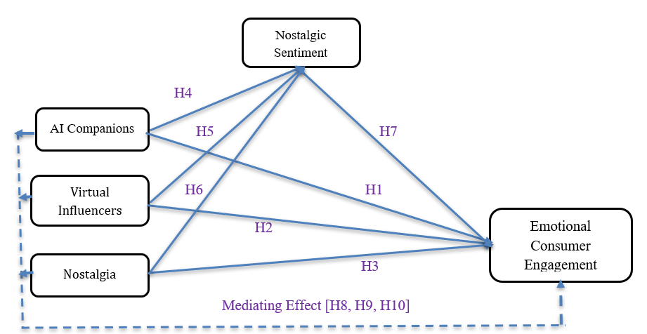
Figure 1: Theoretical Framework
4.0 Research Methodology
4.1 Research Method
The research focuses on examining how AI Companions (AIC), Virtual Influencers (VI), and Nostalgia (NOS) influence Emotional Consumer Engagement (ECE), with Nostalgic Sentiment (NS) serving as a mediator. The goal is to explore the mediating role of NS in the relationship between the independent variables (AIC, VI, NOS) and the dependent variable (ECE). The study involves a total of 170 respondents, using convenient sampling to collect data. It explores 5 factors in total, with 3 independent variables (AIC, VI, and NOS), 1 mediator (NS), and 1 dependent variable (ECE). The study is structured around 10 hypotheses, which are tested to understand the impact of the independent variables on the dependent variable through the mediator. To gather data, a structured questionnaire survey was conducted, containing 20 items. The research follows a deductive approach, where existing theories and literature inform the hypotheses and the design of the study. The data collected is primary, meaning it was directly gathered from the survey respondents. The analysis of the data was performed using IBM SPSS 29.0 and SmartPLS 4.1.1.1, two statistical software tools that aid in both basic statistical analysis and advanced structural equation modeling (SEM) to test the relationships between the variables. These tools are essential for analyzing complex data structures and validating the research model. This methodological framework allows for a detailed understanding of how AI Companions, Virtual Influencers, and Nostalgia influence consumer engagement through the mediating effect of Nostalgic Sentiment.
4.2 Description of measurements
The research framework incorporates several key factors influencing Emotional Consumer Engagement (ECE), each supported by relevant sources. AI Companions (AIC), based on (Bickmore & Picard, 2005), assesses the emotional support and personalized interactions provided by AI companions, which impact emotional connection and engagement. Virtual Influencers (VI), outlined by (Freberg et al., 2011), measures the personal connection, community feeling, and emotional resonance of virtual influencers' content, influencing consumer trust and engagement. Nostalgia (NOS), supported by (Wildschut et al., 2006), captures how nostalgic content creates emotional connections to the past, influencing purchasing decisions and consumer attachment to brands. Nostalgic Sentiment (NS), emphasized by (Wildschut et al., 2006), measures the emotional uplift and attachment to products or brands created by nostalgic content, fostering positive feelings and well-being. Emotional Consumer Engagement (ECE), supported by (Bowden, 2009; Thomson et al., 2005), evaluates how emotional connections with brands, loyalty, and recommendations reflect a deeper level of engagement. Nostalgic Sentiment (NS) acts as a mediator, influencing the relationships between AI Companions (AIC), Virtual Influencers (VI), Nostalgia (NOS), and Emotional Consumer Engagement (ECE), highlighting the role of emotional connections in driving consumer engagement (Table 1).
Table 1: Factor wise items information with sources
AI Companions | Sources
1. I feel emotionally supported when interacting with AI companions. | (Bickmore & Picard, 2005; De Freitas et al., 2025)
2. AI companions provide me with personalized interactions that make me feel understood. | (Bickmore & Picard, 2005; De Freitas et al., 2025)
3. I enjoy engaging with AI companions because they make me feel connected. | (Bickmore & Picard, 2005; De Freitas et al., 2025)
4. The responses of AI companions make me feel like I am having a meaningful conversation. | (Bickmore & Picard, 2005; De Freitas et al., 2025)
Virtual Influencers | (Freberg et al., 2011; Kim et al., 2024)
1. I feel a personal connection to virtual influences I follow on social media. | (Freberg et al., 2011; Kim et al., 2024)
2. Virtual influences make me feel like I’m part of a community. | (Freberg et al., 2011; Kim et al., 2024)
3. The content shared by virtual influencers resonates with my emotions. | (Freberg et al., 2011; Kim et al., 2024)
4. I trust virtual influencers’ recommendations for products or services. | (Freberg et al., 2011; Kim et al., 2024)
Nostalgia | (Jain et al., 2025; Wildschut et al., 2006)
1. When I encounter nostalgic content, I feel a strong emotional connection to the past. | (Jain et al., 2025; Wildschut et al., 2006)
2. Nostalgic advertisements make me feel more connected to a brand. | (Jain et al., 2025; Wildschut et al., 2006)
3. Nostalgic content influences my decision to purchase a product or service. | (Jain et al., 2025; Wildschut et al., 2006)
4. I often seek out nostalgic experiences that remind me of memories. | (Jain et al., 2025; Wildschut et al., 2006)
Nostalgic Sentiment | (Wildschut et al., 2006)
1. Nostalgic content reminds me of happy and meaningful times in my life. | (Wildschut et al., 2006)
2. I feel emotionally uplifted when I experience nostalgic marketing. | (Wildschut et al., 2006)
3. Nostalgia makes me feel more emotionally attached to products or brands. | (Wildschut et al., 2006)
4. Nostalgic experiences help me feel better during difficult times. | (Wildschut et al., 2006)
Emotional Consumer Engagement | (Bowden, 2009; Thomson et al., 2005)
1. I feel emotionally connected to the brands I engage with. | (Bowden, 2009; Thomson et al., 2005)
2. I enjoy spending time interacting with brands on social media or their websites. | (Bowden, 2009; Thomson et al., 2005)
3. I feel loyal to brands that I have a strong emotional connection with. | (Bowden, 2009; Thomson et al., 2005)
4. I am willing to recommend brands I feel emotionally connected to. | (Bowden, 2009; Thomson et al., 2005)
Source: Literature Review
4.3 Sample size
The required sample size for this study was determined using G*Power 4.0 software, following established guidelines and recommendations (Cohen, 2013; Gefen et al., 2011; Hair et al., 2019). Based on an effect size of 0.30 (f²), a significance level (α) of 0.05, seven predictors, and 20 observed variables, the minimum sample size to detect effect was estimated to be 150. For the model structure, the minimum required sample size was calculated to be 100, with the recommended minimum sample size for ensuring adequate statistical power set at 150 to achieve 80% power for the model. While regression analysis typically recommends 10–15 respondents per predictor (Green, 1991), Structural Equation Modeling (SEM) generally requires larger samples to ensure model robustness and statistical power. According to (Kline, 2023), a sample size between 200 and 500 respondents is generally sufficient for producing stable and interpretable SEM results. In this study, data were collected through a structured questionnaire distributed via Google Forms to maximize response rates. A total of 300 questionnaires were distributed, resulting in 180 responses. After data screening, 170 valid responses were obtained and deemed suitable for subsequent analysis. This methodological approach ensures that the study meets the sample size requirements for both detecting significant effects and providing robust SEM results.
5.0 Results
5.1 Demographic Information
The demographic data of the 170 participants reveals a variety of characteristics across different variables. In terms of gender, the majority of the participants are male, comprising 80% of the sample, while females make up 20%. Regarding age, the largest group is between 25 and 34 years, accounting for 52.4% of the participants, followed by 32.9% in the 18–24 age range, and 14.7% who are 35 years and older. For education level, a majority of the respondents are graduates or have higher qualifications (57.6%), while 42.4% have completed up to an undergraduate degree. When examining social media usage, a significant portion (85.3%) reports using social media for up to 3 hours per day, with the remaining 14.7% engaging for more than 3 hours daily. In terms of income level, most participants belong to the middle-income bracket (85.3%), and a smaller group (14.7%) falls into the high-income category. Lastly, the participants' cultural background is diverse, with 36.5% identifying with Western culture, 24.1% with Eastern culture, and 39.4% aligning with other global or regional perspectives. This overview provides insight into the varied demographic makeup of the sample group (Table 2).
Table 2: Demographic Information
Variable Name | Category | Frequency | Percent
Gender | Male | 136 | 80.0
Gender | Female | 34 | 20.0
Gender | Total | 170 | 100.0
Age | 18–24 years | 56 | 32.9
Age | 25–34 years | 89 | 52.4
Age | 35 years and above | 25 | 14.7
Age | Total | 170 | 100.0
Education Level | Up to Undergraduate | 72 | 42.4
Education Level | Graduate and above | 98 | 57.6
Education Level | Total | 170 | 100.0
Social Media Usage | Up to Medium usage (0–3 hours/day) | 145 | 85.3
Social Media Usage | High usage (more than 3 hours/day) | 25 | 14.7
Social Media Usage | Total | 170 | 100.0
Income Level | Up to Middle Income | 145 | 85.3
Income Level | High income | 25 | 14.7
Income Level | Total | 170 | 100.0
Cultural Background | Western culture | 62 | 36.5
Cultural Background | Eastern culture | 41 | 24.1
Cultural Background | Other (Global/Regional perspectives) | 67 | 39.4
Cultural Background | Total | 170 | 100.0
Source: SPSS 29.0
5.2 Univariate Normality Test
The figure displays the distribution of variables AIC, PSC, NOS, VI, NS, and ECE through histograms and KDE curves. AIC, PSC, and VI show relatively even distributions, while NOS is slightly skewed toward higher values, indicating a preference for higher scores. NS has a near-normal distribution, with moderate variation. ECE is fairly balanced but with some dips in certain ranges. The KDE curves highlight the general spread and central tendency, revealing moderate variability across the data without extreme skewness (Figure 2).
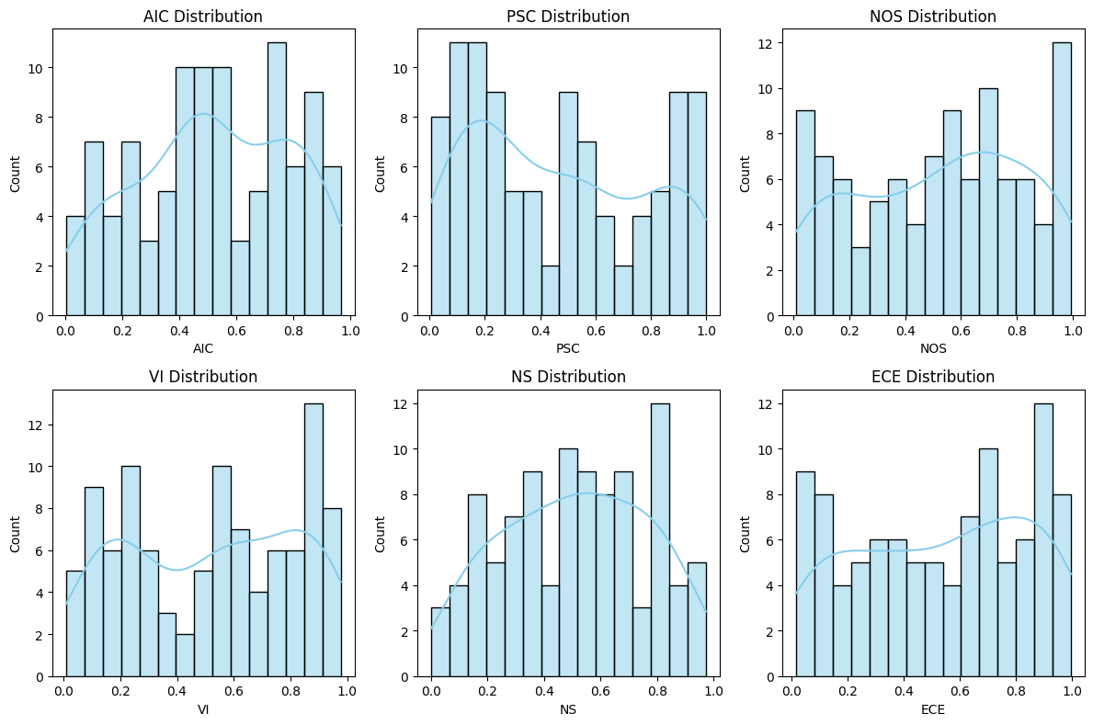
Figure 2: Univariate Normality Test; Source: Python with Jupyter Notebook
5.3 Heatmap Analysis
The heatmap visually illustrates the correlation relationships between various factors: AIC, PSC, NOS, VI, NS, and ECE. The values within the heatmap represent the strength and direction of these correlations, with the color gradient from blue (indicating negative correlations) to red (indicating positive correlations). From the heatmap, several key relationships emerge. Firstly, AIC and ECE exhibit a strong positive correlation of 0.81, which suggests that an increase in AIC is associated with a corresponding increase in ECE. This highlights the strong relationship between AIC and ECE. On the other hand, VI has a moderate negative correlation with NOS (-0.46), implying that as VI increases, NOS tends to decrease, suggesting an inverse relationship between the two variables. Additionally, the correlation between NS and ECE is positive but moderate (0.34), indicating a weaker yet positive relationship, where higher NS is associated with higher ECE. The heatmap provides a clear, visual representation of the varying strengths and directions of the correlations between these constructs, with stronger relationships indicated by higher absolute values (Figure 3).
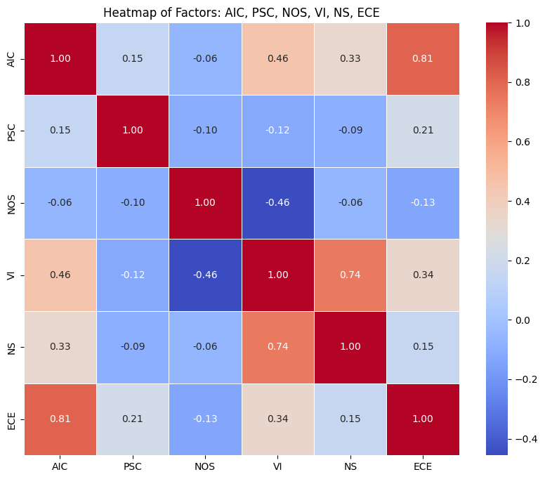
Figure 3: Correlation matrix; Source: (Python with Jupyter Notebook)
5.4 Assessment of the Model
5.4.1 Measurement Model
In this section, the results of the Exploratory Factor Analysis (EFA) and Confirmatory Factor Analysis (CFA) for the various constructs in the study are presented. The analysis is based on a total of 170 valid responses obtained from the survey. Table 3 and Figure 4 summarize the factor loadings, reliability, and validity for each construct under investigation.
For AI Companions, the EFA factor loadings range from 0.89 to 0.93 for items AIC1 to AIC4, indicating a strong relationship between the observed variables and the latent construct. The CFA loadings for the same items range from 0.88 to 0.92, further confirming the construct validity. The Cronbach’s Alpha (CA) and Composite Reliability (CR) values for AI Companions are both 0.94, demonstrating excellent internal consistency. The Average Variance Extracted (AVE) for AI Companions is 0.78, which exceeds the recommended threshold of 0.5, indicating good convergent validity. Additionally, AI Companions accounts for a total variance of 8.542, contributing 42.709% to the total variance, with a cumulative percentage of 42.709%.
For Emotional Consumer Engagement, the EFA factor loadings range from 0.73 to 0.91 for items ECE1 to ECE4, suggesting that the items are strongly associated with the latent construct. The CFA loadings for Emotional Consumer Engagement range from 0.85 to 0.91, confirming construct validity. The Cronbach’s Alpha and Composite Reliability values for this construct are both 0.93, indicating good internal consistency, while the AVE is 0.77, confirming convergent validity. This construct accounts for a total variance of 3.016, contributing 15.078% to the total variance, with a cumulative percentage of 57.787%.
For Nostalgia, the EFA factor loadings range from 0.85 to 0.92 for items NOS1 to NOS4, showing strong relationships between the observed variables and the latent construct. The CFA loadings for Nostalgia are similarly high, ranging from 0.83 to 0.92, further affirming construct validity. The Cronbach’s Alpha and Composite Reliability values for this construct are both 0.92, indicating excellent internal consistency. The AVE for Nostalgia is 0.74, suggesting good convergent validity. Nostalgia accounts for 2.670 total variance, contributing 13.352% to the total variance, with a cumulative percentage of 71.139%.
For Nostalgic Sentiment, the EFA factor loadings range from 0.80 to 0.94 for items NS1 to NS4, indicating strong loadings for each item. The CFA factor loadings range from 0.83 to 0.94, confirming construct validity. The Cronbach’s Alpha and Composite Reliability values for this construct are both 0.91, demonstrating good internal consistency. The AVE for Nostalgic Sentiment is 0.72, which exceeds the 0.50 threshold, indicating good convergent validity. This construct contributes a total variance of 1.377, accounting for 6.883% of the total variance, with a cumulative percentage of 78.022%.
For Virtual Influencers, the EFA factor loadings range from 0.84 to 0.91 for items VI1 to VI4, suggesting strong relationships between the items and the latent construct. The CFA loadings range from 0.79 to 0.88, confirming construct validity. The Cronbach’s Alpha and Composite Reliability values for Virtual Influencers are both 0.91, indicating good internal consistency, while the AVE is 0.72, confirming good convergent validity. Virtual Influencers contribute a total variance of 1.015, accounting for 3.318% of the total variance, with a cumulative percentage of 81.340%.
Overall, the reliability and validity of all constructs are supported by Cronbach’s Alpha (CA) values greater than 0.70, indicating good internal consistency, and Composite Reliability (CR) values exceeding 0.70, confirming the reliability of each construct. Additionally, the Average Variance Extracted (AVE) for each construct exceeds the 0.50 threshold, confirming good convergent validity (Table 4). These findings suggest that the constructs used in this study are reliable and valid measures for further analysis.
The methodology employed for the analysis included Principal Component Analysis (PCA) for factor extraction and Promax rotation with Kaiser Normalization. The Kaiser-Meyer-Olkin (KMO) measure of sampling adequacy was 0.911, indicating excellent sampling adequacy, and Bartlett’s Test of Sphericity was significant (p < 0.01), suggesting that the data was suitable for factor analysis. The rotation converged in six iterations, and the results show that the constructs have clear factor loadings, which further supports the validity of the constructs used in this study. In conclusion, the results from both EFA and CFA show that all constructs exhibit strong factor loadings, good internal consistency, and good convergent validity. The total variances explained by the factors are appropriate, and the reliability and validity measures for each construct meet the recommended thresholds, making the constructs suitable for further analysis in the study.
Table 3: Exploratory and Confirmatory Factor Analysis
Factor’s Name | Items | EFA | CFA | IR | CA | CR | AVE
AI Companions (Total variance= 8.542, % of Variance=42.709, Cumulative % = 42.709) | AIC1 | 0.89 | 0.88 | 0.78 | 0.94 | 0.94 | 0.78
 | AIC2 | 0.91 | 0.90 | 0.81 | 0.94 | 0.94 | 0.78
 | AIC3 | 0.92 | 0.88 | 0.78 | 0.94 | 0.94 | 0.78
 | AIC4 | 0.93 | 0.88 | 0.77 | 0.94 | 0.94 | 0.78
Emotional Consumer Engagement (Total variance= 3.016, % of Variance=15.078, Cumulative % = 57.787) | ECE1 | 0.91 | 0.90 | 0.81 | 0.93 | 0.93 | 0.77
 | ECE2 | 0.73 | 0.85 | 0.72 | 0.93 | 0.93 | 0.77
 | ECE3 | 0.87 | 0.91 | 0.82 | 0.93 | 0.93 | 0.77
 | ECE4 | 0.87 | 0.85 | 0.72 | 0.93 | 0.93 | 0.77
Nostalgia (Total variance= 2.670, % of Variance= 13.352, Cumulative % = 71.139) | NOS1 | 0.88 | 0.88 | 0.77 | 0.92 | 0.92 | 0.74
 | NOS2 | 0.92 | 0.87 | 0.76 | 0.92 | 0.92 | 0.74
 | NOS3 | 0.85 | 0.83 | 0.68 | 0.92 | 0.92 | 0.74
 | NOS4 | 0.92 | 0.87 | 0.75 | 0.92 | 0.92 | 0.74
Nostalgic Sentiment (Total variance= 1.377, % of Variance=6.883, Cumulative % = 78.022) | NS1 | 0.80 | 0.83 | 0.70 | 0.91 | 0.91 | 0.72
 | NS2 | 0.88 | 0.88 | 0.78 | 0.91 | 0.91 | 0.72
 | NS3 | 0.82 | 0.84 | 0.70 | 0.91 | 0.91 | 0.72
 | NS4 | 0.94 | 0.85 | 0.72 | 0.91 | 0.91 | 0.72
Virtual Influencers (Total variance= 1.015, % of Variance=3.318, Cumulative % = 81.340) | VI1 | 0.90 | 0.88 | 0.77 | 0.91 | 0.91 | 0.72
 | VI2 | 0.91 | 0.79 | 0.63 | 0.91 | 0.91 | 0.72
 | VI3 | 0.84 | 0.83 | 0.69 | 0.91 | 0.91 | 0.72
 | VI4 | 0.89 | 0.88 | 0.77 | 0.91 | 0.91 | 0.72
Extraction Method: Principal Component Analysis. Rotation Method: Promax with Kaiser Normalization. KMO=0.911, Bartlett's Test of Sphericity; Sig. =0.000, a. Rotation converged in 6 iterations.
CA=Cronbach’s Alpha; CR=Composite Reliability; IR= Internal reliability; AVE=Average variance extracted; Source: Reliability indexes and criteria
Table 4: Reliability Indexes
Reliability Indexes | Criteria | Reference
AVE | >0.50 | (Hair Jr et al., 2021)
CR | >0.80 | (Henseler et al., 2009)
Alpha | >0.70 | (Chin, 1998)
ILV | 0.60 to 0.70 or above | (Hair Jr et al., 2021)
Note. AVE = Average Variance Extracted; CR = Composite Reliability; α = Cronbach’s Alpha; ILV = Indicator Loading Value; Source: Literature review
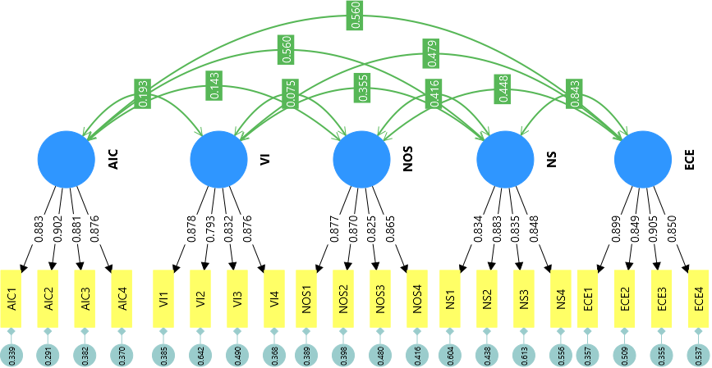
Figure 4: CFA Model; Source: SmartPLS software 4.1.1.1
5.4.2 Discriminant Analysis
The findings indicate a strong relationship between the indicators of the model constructs, as presented in Table 5. Additionally, the convergence validity of all the constructs in the model is assessed by examining the factor loadings. According to (Sarstedt et al., 2019), the loading values for each indicator of the latent variables should be above 0.70, as suggested by (Fornell & Larcker, 1981). Any items with factor loadings below this threshold were removed from the analysis. After eliminating these indicators, the remaining loading values ranged from 0.849 to 0.946, all exceeding the recommended threshold of 0.70. These results confirm the convergence validity of the research model, indicating a high level of correlation between all construct indicators, as shown in Table 5. To assess the discriminant validity of the model's constructs, the researchers examined the square root of the Average Variance Extracted (AVE) for each latent construct. According to (Fornell & Larcker, 1981), these values must be larger than the correlations between the constructs. Discriminant validity is confirmed when the square root of the AVE for each latent construct is greater than its correlations with other constructs. This is verified by checking the correlation matrix, where the square roots of the AVE values appear along the diagonal (Hair et al., 1998). As shown in Table 5, the AVE square root values are indeed higher than the correlations with any other constructs in the model, confirming the discriminant validity.
Table 5: Discriminant Analysis
HTMT Analysis | Fornell Larker Criteria
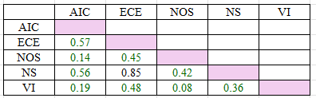 | 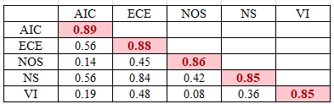
Source: SmartPLS software 4.1.1.1
5.4.3 Structural Medel
A multivariate analysis technique, specifically variance-based structural equation modeling, was used to identify the relationships among the constructs: AI Companions (AIC), Virtual Influencers (VI), Nostalgia (NOS), Nostalgic Sentiment (NS), and Emotional Consumer Engagement (ECE). The relationships are detailed in Table 6.
H1 posits that AI Companions (AIC) has a positive impact on Emotional Consumer Engagement (ECE). The results show that AIC has a positive and significant relationship with ECE (β = 0.149, t = 2.282, p = 0.023; 95% CI = [0.023, 0.279]), thus supporting Hypothesis 1. H2 suggests that Virtual Influencers (VI) positively influence Emotional Consumer Engagement (ECE). The relationship between VI and ECE is highly significant (β = 0.219, t = 4.288, p = 0.000; 95% CI = [0.116, 0.318]), providing strong support for Hypothesis 2. H3 examines whether Nostalgia (NOS) affects Emotional Consumer Engagement (ECE). The findings indicate a significant positive relationship (β = 0.153, t = 2.730, p = 0.006; 95% CI = [0.040, 0.263]), supporting Hypothesis 3.
H4 proposes that AI Companions (AIC) has a positive influence on Nostalgic Sentiment (NS). The relationship is highly significant (β = 0.466, t = 7.627, p = 0.000; 95% CI = [0.341, 0.581]), providing strong support for Hypothesis 4. H5 suggests that Virtual Influencers (VI) positively affect Nostalgic Sentiment (NS). The results show a significant relationship (β = 0.240, t = 3.890, p = 0.000; 95% CI = [0.120, 0.363]), supporting Hypothesis 5. H6 posits that Nostalgia (NOS) positively impacts Nostalgic Sentiment (NS). The results confirm this relationship (β = 0.331, t = 5.188, p = 0.000; 95% CI = [0.202, 0.451]), strongly supporting Hypothesis 6. H7 examines the relationship between Nostalgic Sentiment (NS) and Emotional Consumer Engagement (ECE). The relationship is found to be highly significant (β = 0.618, t = 8.410, p = 0.000; 95% CI = [0.463, 0.753]), providing strong evidence for Hypothesis 7.
In terms of explanatory power, the R-squared values indicate the strength of the model's fit. The R-squared for Emotional Consumer Engagement (ECE) is 0.778, suggesting that 77.8% of the variance in ECE is explained by the predictors in the model. The R-squared for Nostalgic Sentiment (NS) is 0.484, indicating that 48.4% of the variance in NS is explained by the model. These values show that the model explains a significant proportion of the variability in the dependent variables.
In conclusion, all hypotheses were supported, with each relationship showing strong statistical significance. The R-squared values further demonstrate the robustness of the model in explaining the variance in Emotional Consumer Engagement and Nostalgic Sentiment.
Table 6: Path model estimation
Hypotheses | Relationship | Beta | SD | LL | UL | T statistics | P values | Comment
H1 | AIC -> ECE | 0.149 | 0.065 | 0.023 | 0.279 | 2.282 | 0.023 | Supported
H2 | VI -> ECE | 0.219 | 0.051 | 0.116 | 0.318 | 4.288 | 0.000 | Supported
H3 | NOS -> ECE | 0.153 | 0.056 | 0.040 | 0.263 | 2.730 | 0.006 | Supported
H4 | AIC -> NS | 0.466 | 0.061 | 0.341 | 0.581 | 7.627 | 0.000 | Supported
H5 | VI -> NS | 0.240 | 0.062 | 0.120 | 0.363 | 3.890 | 0.000 | Supported
H6 | NOS -> NS | 0.331 | 0.064 | 0.202 | 0.451 | 5.188 | 0.000 | Supported
H7 | NS -> ECE | 0.618 | 0.073 | 0.463 | 0.753 | 8.410 | 0.000 | Supported
 |  | R-square
ECE |  | 0.778
NS |  | 0.484
Source: SmartPLS software 4.1.1.1
5.5 Mediating Effect
The study examines the mediating role of Nostalgic Sentiment (NS) in the relationships between the independent constructs AI Companions (AIC), Virtual Influencers (VI), Nostalgia (NOS), and the dependent construct Emotional Consumer Engagement (ECE). The results (Table 7 & Figure 5) reveal that Nostalgic Sentiment (NS) partially mediates these relationships, as shown in Hypotheses 8, 9, and 10.
In Hypothesis 8 (H8), the analysis suggests that AI Companions (AIC) influence Nostalgic Sentiment (NS), which then affects Emotional Consumer Engagement (ECE). The direct relationship between AIC and ECE is statistically significant (β = 0.149, SD = 0.065, LL = 0.023, UL = 0.279, t = 2.282, p = 0.023), indicating that AIC has a positive effect on ECE. The relationship between AIC and NS is also highly significant (β = 0.466, SD = 0.061, LL = 0.341, UL = 0.581, t = 7.627, p = 0.000), confirming that AIC influences NS. Moreover, NS significantly impacts ECE (β = 0.618, SD = 0.073, LL = 0.463, UL = 0.753, t = 8.410, p = 0.000), reinforcing the role of NS in enhancing ECE. The indirect relationship between AIC → NS → ECE is also significant (β = 0.323, SD = 0.055, LL = 0.226, UL = 0.443, t = 5.875, p = 0.000), showing that NS partially mediates the relationship between AIC and ECE. Hence, H8 is supported, with NS acting as a partial mediator.
In Hypothesis 9 (H9), the analysis shows that Virtual Influencers (VI) influence Nostalgic Sentiment (NS), which subsequently affects Emotional Consumer Engagement (ECE). The direct relationship between VI and ECE is significant (β = 0.219, SD = 0.051, LL = 0.116, UL = 0.318, t = 4.288, p = 0.000), suggesting that VI has a positive effect on ECE. Similarly, the relationship between VI and NS is significant (β = 0.240, SD = 0.062, LL = 0.120, UL = 0.363, t = 3.890, p = 0.000), confirming that VI affects’ NS. The relationship between NS and ECE is also significant (β = 0.618, SD = 0.073, LL = 0.463, UL = 0.753, t = 8.410, p = 0.000). The indirect effect (VI → NS → ECE) is significant (β = 0.160, SD = 0.048, LL = 0.078, UL = 0.267, t = 3.351, p = 0.001), indicating that NS partially mediates the relationship between VI and ECE. Thus, H9 is supported, with NS acting as a partial mediator.
In Hypothesis 10 (H10), the study suggests that Nostalgia (NOS) influences Nostalgic Sentiment (NS), which subsequently impacts Emotional Consumer Engagement (ECE). The direct relationship between NOS and ECE is significant (β = 0.153, SD = 0.056, LL = 0.040, UL = 0.263, t = 2.730, p = 0.006), showing that NOS positively affects ECE. The relationship between NOS and NS is also significant (β = 0.331, SD = 0.064, LL = 0.202, UL = 0.451, t = 5.188, p = 0.000), confirming that NOS influences NS. Furthermore, NS significantly influences ECE (β = 0.618, SD = 0.073, LL = 0.463, UL = 0.753, t = 8.410, p = 0.000). The indirect effect (NOS → NS → ECE) is significant (β = 0.221, SD = 0.052, LL = 0.132, UL = 0.337, t = 4.261, p = 0.000), showing that NS partially mediates the relationship between NOS and ECE. Therefore, H10 is supported, with NS partially mediating the NOS-ECE relationship. In conclusion, Nostalgic Sentiment (NS) plays a significant partial mediating role in the relationships between AI Companions (AIC), Virtual Influencers (VI), Nostalgia (NOS), and Emotional Consumer Engagement (ECE). The indirect effects in all three hypotheses (H8, H9, and H10) are significant, confirming the partial mediation of NS in these relationships. This highlights the important role of Nostalgic Sentiment in shaping Emotional Consumer Engagement through these independent constructs.
Table 7: Mediating Effect
Hypotheses | Relationship | Beta | SD | LL | UL | T statistics | P values | Comment
H8 | AIC -> NS -> ECE | 0.323 | 0.055 | 0.226 | 0.443 | 5.875 | 0.000 | Partially Mediated
H8 | AIC -> ECE | 0.149 | 0.065 | 0.023 | 0.279 | 2.282 | 0.023 | Partially Mediated
H8 | AIC -> NS | 0.466 | 0.061 | 0.341 | 0.581 | 7.627 | 0.000 | Partially Mediated
H8 | NS -> ECE | 0.618 | 0.073 | 0.463 | 0.753 | 8.410 | 0.000 | Partially Mediated
H9 | VI -> NS -> ECE | 0.160 | 0.048 | 0.078 | 0.267 | 3.351 | 0.001 | Partially Mediated
H9 | VI -> ECE | 0.219 | 0.051 | 0.116 | 0.318 | 4.288 | 0.000 | Partially Mediated
H9 | VI -> NS | 0.240 | 0.062 | 0.120 | 0.363 | 3.890 | 0.000 | Partially Mediated
H9 | NS -> ECE | 0.618 | 0.073 | 0.463 | 0.753 | 8.410 | 0.000 | Partially Mediated
H10 | NOS -> NS -> ECE | 0.221 | 0.052 | 0.132 | 0.337 | 4.261 | 0.000 | Partially Mediated
H10 | NOS -> ECE | 0.153 | 0.056 | 0.040 | 0.263 | 2.730 | 0.006 | Partially Mediated
H10 | NOS -> NS | 0.331 | 0.064 | 0.202 | 0.451 | 5.188 | 0.000 | Partially Mediated
H10 | NS -> ECE | 0.618 | 0.073 | 0.463 | 0.753 | 8.410 | 0.000 | Partially Mediated
Source: SmartPLS software 4.1.1.1

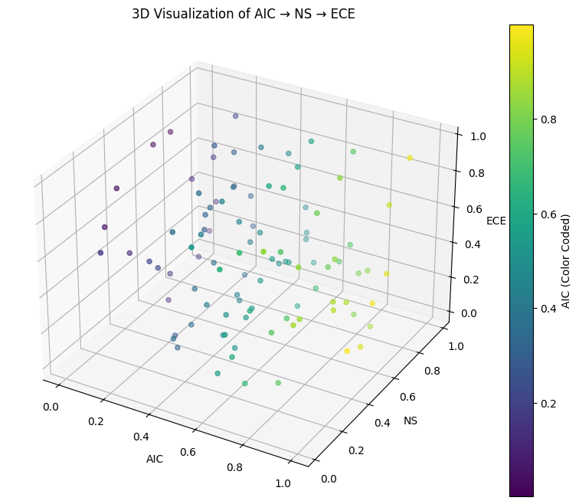 | 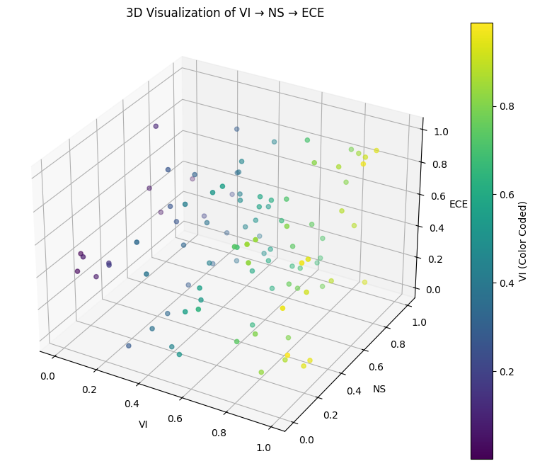
Figure 5: 3D Visualization; Source: Python with Jupyter Notebook
5.6 Model Fit
The model fit indices in the provided table indicate a strong overall fit. The Chi-Square/df ratio of 1.104 is well below the threshold of 5, indicating a good fit for the model (values below 5 are considered acceptable as per (Marsh & Hocevar, 1985). The RMSEA value of 0.025 is excellent, as it is well below the ideal threshold of 0.05, suggesting a very good model fit (Hu & Bentler, 1999). The CFI value of 0.994 exceeds the threshold of 0.90, reflecting an outstanding fit (Bentler, 1990). The GFI value of 0.909 is close to the optimal value of 0.90, showing a good fit overall, while the AGFI value of 0.881 is slightly below 0.90 but still within an acceptable range, indicating that the model performs reasonably well (Anderson & Gerbing, 1984; Jöreskog & Sörbom, 1996). The SRMR value of 0.039 is well below the ideal threshold of 0.08, suggesting an excellent fit (Hu & Bentler, 1999). The NFI value of 0.941 is above 0.90, indicating a good fit (Bentler & Bonett, 1980). Lastly, the TLI value of 0.993 exceeds the recommended threshold of 0.95, indicating a very good fit (Bentler, 1990). Overall, the model fit indices suggest that the model demonstrates a strong fit, with all indices meeting or exceeding the required thresholds. This confirms the adequacy of the model in representing the data (Table 8).
Table 8: Model Fit
Ingredient | Estimated Model | Level of Acceptance | Reference
ChiSqr/df | 1.104 | <5.0 | (Marsh & Hocevar, 1985)
RMSEA | 0.025 | <0.08 | (Hu & Bentler, 1999)
CFI | 0.994 | >0.90 | (Bentler, 1990)
GFI | 0.909 | >0.85 | (Anderson & Gerbing, 1984; Jöreskog & Sörbom, 1996)
AGFI | 0.881 | >0.85 | (Anderson & Gerbing, 1984; Jöreskog & Sörbom, 1996)
TLI | 0.993 | >0.90 | (Bentler, 1990)
SRMR | 0.039 | <0.08 | (Hu & Bentler, 1999)
Source: SmartPLS software 4.1.1.1
6.0 Discussion
This study examined the relationships between AI Companions (AIC), Virtual Influencers (VI), Nostalgia (NOS), Nostalgic Sentiment (NS), and Emotional Consumer Engagement (ECE), revealing significant insights into how digital technologies shape emotional consumer behavior. The findings support all the hypotheses, confirming the pivotal role of Nostalgic Sentiment as a mediator and reinforcing the theoretical and practical implications of emotional engagement in the digital era. The relationship between AI Companions and Emotional Consumer Engagement (ECE) is well-documented in literature, with AI companions such as Replika and Character.AI designed to address emotional isolation by simulating human-like interactions (Bickmore & Picard, 2005). The findings of this study (β = 0.149, t = 2.282, p = 0.023) align with previous research, which highlights that AI companions can foster emotional bonds, mitigate feelings of loneliness and provide emotional support (Laestadius et al., 2024). The results indicate that AI Companions positively influence ECE by offering a sense of companionship, validating the hypothesis that digital entities designed to mimic human empathy can significantly enhance emotional engagement (Pentina et al., 2023). However, as noted by (Kirk et al., 2025), while AI companions can deepen emotional connections, the relationships they offer remain distinct from genuine human bonds, often lacking the depth and reciprocity inherent in authentic human interactions. The role of Virtual Influencers (VI) in creating emotional engagement mirrors findings in existing literature, which suggests that VIs can trigger emotional responses and foster connections despite being artificial entities (Freberg et al., 2011). Virtual Influencers, through their curated personalities and digital presence, offer companionship and emotional fulfillment to their followers (Banks, 2025). The study's findings (β = 0.219, t = 4.288, p = 0.000) demonstrate that Virtual Influencers have a significant positive impact on ECE, confirming their role in alleviating loneliness and enhancing emotional connections. While Virtual Influencers can simulate human interaction, the emotional engagement they provide remains superficial (Banks, 2025), raising concerns about the long-term effects of relying on these technologies for emotional support. As highlighted in the literature, these digital relationships can potentially exacerbate feelings of loneliness when users realize their lack of emotional depth (Freberg et al., 2011). Nostalgia has emerged as a key factor in enhancing emotional consumer engagement, particularly with AI companions and Virtual Influencers. Nostalgia evokes positive emotions linked to the past, creating a sense of comfort and belonging (Li & Zhang, 2024). The findings of this study (β = 0.153, t = 2.730, p = 0.006) indicate that Nostalgia significantly contributes to ECE, aligning with previous research that emphasizes the emotional power of nostalgic content (Ho et al., 2025). For consumers experiencing emotional isolation, nostalgia offers emotional solace and a connection to more comforting times, which enhances their engagement with digital companions (Skjuve et al., 2023). However, as (Skjuve et al., 2023) caution, the commercialization of nostalgia can lead to emotional dependency, where users increasingly seek comfort in the past rather than engaging with the present. This highlights a potential ethical concern regarding the manipulation of consumers' emotional vulnerabilities for commercial gain. A significant contribution to this study is the identification of Nostalgic Sentiment (NS) as a mediator in the relationships between AI Companions, Virtual Influencers, Nostalgia, and Emotional Consumer Engagement. The results of the mediation analysis (H8, H9, H10) indicate that Nostalgic Sentiment partially mediates the relationship between these independent variables and Emotional Consumer Engagement. The indirect effects, particularly the AIC → NS → ECE path (β = 0.323, t = 5.875, p = 0.000), show that nostalgia-driven interactions create deeper emotional connections with digital entities, enhancing user attachment (Ho et al., 2025). This finding supports the hypothesis that nostalgic sentiment plays a crucial role in strengthening the emotional bonds between users and AI-driven technologies, reinforcing the idea that nostalgia can serve as a powerful emotional trigger for engagement (Sedikides et al., 2008). The results also align with (Skjuve et al., 2023), who argue that nostalgia-driven content increases emotional attachment, making interactions with digital entities more personally meaningful.
7.0 Implications
7.1 Theoretical Implications
The findings of this study contribute significantly to the literature on emotional consumer engagement, particularly in the context of AI-driven technologies and virtual influencers. This research provides a deeper understanding of how nostalgic sentiment acts as a mediator in enhancing emotional bonds with digital entities. By highlighting the mediating role of nostalgia, the study offers new insights into the mechanisms by which digital technologies foster emotional engagement, contributing to the growing body of work on AI, virtual influencers, and consumer psychology. Additionally, the study emphasizes the potential for emotional engagement to blur the boundaries between artificial and genuine relationships, suggesting that digital entities could play a more significant role in shaping consumer behavior than previously thought.
7.2 Practical Implications
For marketers and businesses, these findings underscore the importance of leveraging AI-driven technologies and nostalgic content to create meaningful emotional connections with consumers. Brands and digital entities can enhance consumer engagement by incorporating nostalgia-driven strategies into their marketing campaigns. The ability to evoke nostalgia through AI companions and virtual influencers can strengthen brand loyalty and emotional attachment, particularly for consumers experiencing emotional vulnerability. However, businesses must be mindful of the ethical implications of using nostalgic sentiment to manipulate emotional vulnerabilities, as this can lead to dependency and potential exploitation of consumers.
8.0 Conclusion
In conclusion, this study has demonstrated that AI Companions, Virtual Influencers, and Nostalgia all significantly influence Emotional Consumer Engagement, with Nostalgic Sentiment playing a crucial mediating role in these relationships. The findings highlight the power of digital technologies in shaping emotional consumer behavior and suggest that nostalgia can be a potent tool in fostering deeper emotional connections with consumers. While these technologies offer significant benefits in terms of emotional support and engagement, it is important for businesses to consider the ethical implications of using nostalgia and emotional manipulation in their marketing strategies. As the role of AI and virtual influencers continues to grow, future research will be essential in understanding the long-term effects of these technologies on consumer behavior and emotional well-being. While this study makes significant contributions, there are limitations that warrant further investigation. The cross-sectional nature of the study limits the ability to assess the long-term impact of AI companions and Virtual Influencers on Emotional Consumer Engagement. Future research could adopt longitudinal designs to examine the sustainability of these emotional bonds over time. Additionally, this study focused primarily on digital entities' role in enhancing emotional engagement, and future research could explore other factors, such as social influence or perceived authenticity, that may also contribute to these relationships.
Moreover, future studies could examine the impact of demographic variables (e.g., age, cultural background) on the effectiveness of nostalgia-driven engagement strategies. By exploring these factors, researchers can gain a more nuanced understanding of how different consumer segments respond to nostalgic content and AI-driven technologies.

Limitations:

Several limitations should be acknowledged. First, the study adopts a cross-sectional survey design, which limits causal inference and makes it difficult to establish temporal ordering among AI companions, virtual influencers, nostalgia-related stimuli, nostalgic sentiment, and emotional consumer engagement. Future research should use longitudinal, experimental, or experience-sampling methods to capture how affect and engagement evolve over time and to better address endogeneity concerns. Second, the data were collected through convenience sampling via an online questionnaire, which may over-represent digitally active respondents and restrict the generalizability of findings beyond the studied context and platforms. Broader, stratified sampling across regions, age cohorts, and user segments (e.g., heavy vs. light users) would strengthen external validity.

Third, all constructs were measured through self-reports collected within a single instrument, increasing susceptibility to common method variance, social desirability bias, and inflated associations. Subsequent studies should triangulate survey measures with behavioral indicators (e.g., usage frequency, interaction depth, sharing, and purchase behavior) and implement additional procedural and statistical remedies for method bias. Fourth, some constructs—particularly nostalgia and nostalgic sentiment—are conceptually proximate; future work should further refine construct boundaries, test alternative operationalizations, and assess potential redundancy.

Finally, although the manuscript discusses broader ethical and well-being implications of the “loneliness economy,” the current model does not directly measure key outcomes or boundary conditions such as loneliness severity, vulnerability, dependency risk, ethical concern, or psychological well-being. Accordingly, the results should be interpreted as associations with engagement rather than evidence of benefit or harm, and future studies should explicitly incorporate these outcomes and moderators.
Consent
As per international standards or university standards, respondents’ written consent has been collected and preserved by the author(s).

Disclaimer (Artificial intelligence)
Author(s) hereby declare that NO generative AI technologies such as Large Language Models (ChatGPT, COPILOT, etc.) and text-to-image generators have been used during the writing or editing of this manuscript.

References
- Anderson, J. C., & Gerbing, D. W. (1984). The effect of sampling error on convergence, improper solutions, and goodness-of-fit indices for maximum likelihood confirmatory factor analysis. Psychometrika, 49(2), 155-173.
- Banks, J. (2025). Measuring Machine Companionship: Scale Development and Validation for AI Companions. arXiv preprint arXiv:2511.00654.
- Bentler, P. M. (1990). Comparative fit indexes in structural models. Psychological bulletin, 107(2), 238.
- Bentler, P. M., & Bonett, D. G. (1980). Significance tests and goodness of fit in the analysis of covariance structures. Psychological bulletin, 88(3), 588.
- Bickmore, T. W., & Picard, R. W. (2005). Establishing and maintaining long-term human-computer relationships. ACM Transactions on Computer-Human Interaction (TOCHI), 12(2), 293-327.
- Bowden, J. L.-H. (2009). The process of customer engagement: A conceptual framework. Journal of Marketing theory and Practice, 17(1), 63-74.
- Cacioppo, J. T., & Patrick, W. (2008). Loneliness: Human nature and the need for social connection. WW Norton & Company.
- Chin, W. W. (1998). The partial least squares approach to structural equation modeling. Modern methods for business research/Lawrence Erlbaum Associates.
- Cohen, J. (2013). Statistical power analysis for the behavioral sciences. routledge.
- De Freitas, J., Oğuz-Uğuralp, Z., Uğuralp, A. K., & Puntoni, S. (2025). AI companions reduce loneliness. Journal of consumer research, ucaf040.
- Diany, A. A., & Yuliyanti, R. (2025). The Influence of Local Cultural Values and Nostalgic Expectations on Consumer Purchasing Decisions of Lontong Orari Banjarmasin. Maneggio, 2(3), 44-54.
- Fornell, C., & Larcker, D. F. (1981). Evaluating structural equation models with unobservable variables and measurement error. Journal of marketing research, 18(1), 39-50.
- Freberg, K., Graham, K., McGaughey, K., & Freberg, L. A. (2011). Who are the social media influencers? A study of public perceptions of personality. Public relations review, 37(1), 90-92.
- Gefen, Rigdon, & Straub. (2011). Editor's Comments: An Update and Extension to SEM Guidelines for Administrative and Social Science Research. MIS quarterly, 35(2). https://doi.org/10.2307/23044042
- Green, S. B. (1991). How many subjects does it take to do a regression analysis. Multivariate behavioral research, 26(3), 499-510.
- Hair, J., Anderson, R., Tatham, R., & Black, W. (1998). Multivariate Data Analysis. 5th Edn Prentice Hall International. Upper Saddle River, NJ.
- Hair, J. F., Risher, J. J., Sarstedt, M., & Ringle, C. M. (2019). When to use and how to report the results of PLS-SEM. European Business Review, 31(1), 2-24.
- Hair Jr, J. F., Hult, G. T. M., Ringle, C. M., Sarstedt, M., Danks, N. P., & Ray, S. (2021). Partial least squares structural equation modeling (PLS-SEM) using R: A workbook. Springer Nature.
- Henseler, J., Ringle, C. M., & Sinkovics, R. R. (2009). The use of partial least squares path modeling in international marketing. In New challenges to international marketing (pp. 277-319). Emerald Group Publishing Limited.
- Ho, S. S., Wijaya, S. A., & Ou, M. (2025). Designing Chatbots for Misinformation Correction: Examining the Roles of Chatbot Expertise and Anthropomorphism. International Journal of Human–Computer Interaction, 1-15.
- Holak, S. L., & Havlena, W. J. (1998). Feelings, fantasies, and memories: An examination of the emotional components of nostalgia. Journal of Business Research, 42(3), 217-226.
- Hollebeek, L. D., Hammedi, W., & Sprott, D. E. (2023). Consumer engagement, stress, and conservation of resources theory: A review, conceptual development, and future research agenda. Psychology & marketing, 40(5), 926-937.
- Hu, L. t., & Bentler, P. M. (1999). Cutoff criteria for fit indexes in covariance structure analysis: Conventional criteria versus new alternatives. Structural equation modeling: a multidisciplinary journal, 6(1), 1-55.
- Hwang, A. H.-C., Li, F., Anthis, J. R., & Noh, H. (2025). How AI Companionship Develops: Evidence from a Longitudinal Study. arXiv preprint arXiv:2510.10079.
- Jain, T., Mishra, V. K., & Kothari, M. D. (2025). Digital Nostalgia Marketing: How Past-Centric Ads Affect Gen Z Consumption. Advances in Consumer Research, 2, 4279-4291.
- Jöreskog, K. G., & Sörbom, D. (1996). LISREL 8: User's reference guide. Scientific Software International.
- Kim, I., Ki, C.-W., Lee, H., & Kim, Y.-K. (2024). Virtual influencer marketing: Evaluating the influence of virtual influencers’ form realism and behavioral realism on consumer ambivalence and marketing performance. Journal of Business Research, 176, 114611.
- Kirk, H. R., Gabriel, I., Summerfield, C., Vidgen, B., & Hale, S. A. (2025). Why human–AI relationships need socioaffective alignment. Humanities and Social Sciences Communications, 12(1), 1-9.
- Kline, R. B. (2023). Principles and practice of structural equation modeling. Guilford publications.
- Laestadius, L., Bishop, A., Gonzalez, M., Illenčík, D., & Campos-Castillo, C. (2024). Too human and not human enough: A grounded theory analysis of mental health harms from emotional dependence on the social chatbot Replika. New Media & Society, 26(10), 5923-5941.
- Li, H., & Zhang, R. (2024). Finding love in algorithms: deciphering the emotional contexts of close encounters with AI chatbots. Journal of Computer-Mediated Communication, 29(5), zmae015.
- Marsh, H. W., & Hocevar, D. (1985). Application of confirmatory factor analysis to the study of self-concept: First-and higher order factor models and their invariance across groups. Psychological bulletin, 97(3), 562.
- Merchant, A., & Ford, J. (2008). Nostalgia and giving to charity: A conceptual framework for discussion and research. International Journal of Nonprofit and Voluntary Sector Marketing, 13(1), 13-30.
- Muldoon, J., & Parke, J. J. (2025). Cruel companionship: How AI companions exploit loneliness and commodify intimacy. New Media & Society, 14614448251395192.
- Pentina, I., Xie, T., Hancock, T., & Bailey, A. (2023). Consumer–machine relationships in the age of artificial intelligence: Systematic literature review and research directions. Psychology & marketing, 40(8), 1593-1614.
- Sarstedt, M., Hair Jr, J. F., Cheah, J.-H., Becker, J.-M., & Ringle, C. M. (2019). How to specify, estimate, and validate higher-order constructs in PLS-SEM. Australasian marketing journal, 27(3), 197-211.
- Sedikides, C., Wildschut, T., Arndt, J., & Routledge, C. (2008). Nostalgia: Past, present, and future. Current directions in psychological science, 17(5), 304-307.
- Shah, T. R., Purohit, S., Das, M., & Arulsivakumar, T. (2025). Do I look real? Impact of digital human avatar influencer realism on consumer engagement and attachment. Journal of Consumer Marketing(ahead-of-print).
- Skandali, D., Bayar, S. B., Ali, F., & Cobanoglu, C. (2025). Artificial intimacy at work: how digital nomads build trust in generative AI companions and implications for remote corporate communication. Corporate Communications: An International Journal, 1-17.
- Skjuve, M., Følstad, A., & Brandtzaeg, P. B. (2023). The user experience of ChatGPT: findings from a questionnaire study of early users. Proceedings of the 5th international conference on conversational user interfaces,
- Thomson, M., MacInnis, D. J., & Whan Park, C. (2005). The ties that bind: Measuring the strength of consumers’ emotional attachments to brands. Journal of consumer psychology, 15(1), 77-91.
- van Tilburg, T. G. (2025). Unravelling the socio-cultural influence on loneliness. In Macro Social Influences on Loneliness in Later Life: Towards a Better Understanding of the Loneliness Paradox in Europe (pp. 43-62). Springer Nature Switzerland Cham.
- Wildschut, T., Sedikides, C., Arndt, J., & Routledge, C. (2006). Nostalgia: content, triggers, functions. Journal of personality and social psychology, 91(5), 975.
- Yin, Y., Jiang, T., Wildschut, T., & Sedikides, C. (2025). Nostalgia, ritual engagement, and meaning in life. Personality and Social Psychology Bulletin, 51(10), 1884-1896.

