Digital Drivers for Financial Efficiency and Sustainability in the Circular Economy: A Systematic Review

Abstract
The circular economy paradigm promises simultaneous financial efficiency and environmental sustainability benefits, yet organisations struggle to achieve quantifiable synergistic outcomes due to optimisation challenges and implementation barriers. While digital technologies are increasingly recognised as critical enablers for circular economy transitions, there exists a significant gap in systematic evidence demonstrating how specific digital enablers quantifiably contribute to both enhanced financial efficiency and improved environmental sustainability within circular economy frameworks. This systematic review examines the dual dividend potential of digital technologies in circular economy implementations, analysing synergistic mechanisms and identifying implementation pathways for achieving comprehensive financial and environmental benefits. Following PRISMA guidelines, a systematic literature review of 66 high-quality publications spanning 2016-2025 was conducted. It was sourced from multiple databases using comprehensive search strategies encompassing digital enablers, financial efficiency, environmental sustainability, and circular economy principles. Bibliometric analysis was performed using RStudio's Biblioshiny package to map collaboration patterns and thematic structures. The analysis reveals that specific digital enablers—particularly blockchain technology, artificial intelligence, and IoT-based systems—generate substantial financial returns through 3.6% annual cost reduction and 4.1% revenue enhancement while simultaneously delivering quantifiable environmental benefits, including a 15% reduction in global CO₂ emissions. Digital technologies create synergistic value propositions through sophisticated feedback loops, enabling real-time monitoring, predictive analytics, and automated decision-making processes that optimise circular economy activities. Implementation success requires systematic approaches integrating technological capabilities with human-centric strategies, stakeholder collaboration, and supportive policy frameworks. These findings challenge conventional trade-off assumptions between economic and environmental objectives, establishing digital technologies as strategic enablers that fundamentally alter circular economy value creation logic. The research provides actionable guidance for organisations seeking sustainable competitive advantage while contributing to global sustainability goals.
Keywords: circular economy, digital technologies, financial efficiency, environmental sustainability, Industry 4.0, blockchain technology

Introduction
The circular economy represents a fundamental paradigm shift from linear economic models, emphasising resource efficiency, waste minimisation, and closed-loop systems that promise dual benefits of enhanced financial performance and environmental sustainability (Jabeen et al., 2021). In the quest for a considerable improvement in resource usage, waste recovery, or to reuse of products or components, advanced manufacturing strategies integrated with data acquisition systems have been developed (Rajput & Singh, 2020; Kabugo et al., 2020). Circular economy practices have demonstrated significant potential for improving economic and operational performance while simultaneously delivering environmental benefits through resource optimisation and waste reduction (Dennison et al., 2024). The adoption of circular economy principles enables organisations to achieve cost efficiencies, premium pricing opportunities, and customer loyalty while reducing environmental footprint and creating lasting value (Özşahin et al., 2025; Setyaningrum et al., 2024a). By incorporating the methodology of the 5R strategies (i.e., refuse, reduce, reuse, repurpose, and recycle), the Circular economy can reduce the demand for limited original resources by decreasing the flow of materials and energy into the production and consumption processes and extending the life of products and services (Sikander, 2024; Grafström & Aasma, 2021). The Circular economy also advocates the protection of biodiversity and habitat by reducing emissions and pollution levels and by not treating the natural environment as a place to dump waste (Han et al., 2023; Ranta et al., 2021).
However, organisations face substantial challenges in achieving the quantifiable and synergistic benefits that demonstrate both financial viability and environmental impact within circular economy implementations (Puche et al., 1 C.E.). Traditional circular economy approaches often struggle with optimisation challenges, real-time monitoring capabilities, and data-driven decision-making processes essential for maximising resource efficiency and economic returns (Sjödin et al., 2023). The complexity of measuring and demonstrating dual value creation, coupled with high implementation costs and technical expertise gaps, creates barriers to effective circular economy adoption (Sharma et al., 2023; Abdul-Hamid et al., 2022).
Digital technologies have emerged as critical enablers that unlock the full potential of circular economy strategies by enhancing resource efficiency, productivity, and economic value capture (Kristoffersen et al., 2020; Rattanawiboonsom & Khan, 2024). The integration of artificial intelligence, IoT, blockchain, and big data analytics with circular economy practices creates powerful synergies that optimise circular activities while reducing waste and enhancing recycling procedures (Soni, 2024). Digital enablers serve as catalysts that enhance both financial efficiency and environmental sustainability outcomes through automated data-driven analysis and decision-making processes (Shafique et al., 2024; Sjödin et al., 2023).
Empirical evidence demonstrates that Industry 4.0 technologies significantly and positively impact sustainability performance, with circular economy practices playing both moderating and mediating roles between technological capabilities and sustainable performance (De et al., 2024; Shafique et al., 2024). Digital transformation enables cost reduction of 3.6% and revenue increase of 4.1% annually, while contributing to environmental benefits through optimised resource management and reduced emissions (Kurniawan et al., 2023; Candontol et al., 2025). Blockchain technology's transparency and smart contracting features enhance circular economy implementation while strengthening economic pathways to organisational performance (Rehman Khan et al., 2022).
While digital technologies are increasingly recognized as crucial facilitators for the transition to a circular economy, and the benefits of circularity for both financial performance and environmental sustainability are conceptually understood, there is a significant gap in the comprehensive and systematic synthesis of empirical evidence that explicitly demonstrates how specific digital enablers (e.g., AI, IoT, blockchain, big data analytics) quantifiably and synergistically contribute to both enhanced financial efficiency and improved environmental sustainability within circular economy frameworks. Existing reviews often focus on the technological aspects of digital tools or the general benefits of the circular economy. However, a rigorous, consolidated examination is needed to identify which digital technologies are most effective in concurrently driving these dual financial and environmental benefits, how they achieve them, and the measurable outcomes across various industries and contexts.
This systematic review addresses three interconnected research objectives: first, to systematically examine and synthesize empirical evidence demonstrating how digital enablers contribute to tangible improvements in financial efficiency within circular economy contexts; second, to analyze the specific mechanisms and pathways through which digital technologies concurrently drive both financial efficiency and environmental sustainability, identifying synergistic relationships and potential trade-offs; and third, to identify critical implementation challenges, success factors, and develop an integrated digital-circular framework that provides actionable guidance for deploying digital technologies to achieve comprehensive financial and environmental benefits within circular economy business models.

Materials and methods
The PRISMA (Preferred Reporting Items for Systematic Reviews and Meta-Analyses) guidelines provide a standardised framework for conducting systematic literature review methodology (SLRM), ensuring transparency, rigour, and reproducibility in the research process by establishing clear inclusion and exclusion criteria that minimise selection bias and enhance the validity of findings (Moher, D., Liberati, A., Tetzlaff, J., Altman, D. G., 2009; Rattanawiboonsom & Khan, 2024). For this systematic review examining the intersection of digital enablers, financial efficiency, environmental sustainability, and circular economy principles, the inclusion criteria encompassed peer-reviewed articles, book chapters, books, and review papers published in English at their final publication stage, identified through the comprehensive search strategy: ("digital enabler*" OR "digital technology*" OR "Industry 4.0" OR "IoT" OR "blockchain" OR "big data" OR "artificial intelligence" OR "smart technology*" OR "digital innovation") AND ("financial efficiency" OR "cost efficiency" OR "economic performance" OR "financial performance" OR "resource efficiency") AND ("environmental sustainability" OR "ecological sustainability" OR "green practices" OR "sustainable development" OR "sustainable innovation") AND ("circular economy" OR "resource circularity" OR "closed-loop system"), which initially yielded 83 documents. The exclusion criteria systematically eliminated conference proceedings, working papers, editorials, and non-peer-reviewed publications, reducing the corpus to 71 documents, followed by the removal of non-English publications and preliminary or draft versions, resulting in a final dataset of 66 high-quality, academically rigorous sources that comprehensively address the convergence of digital transformation technologies with sustainable economic and environmental practices within circular economy frameworks. Figure 1 below illustrates the inclusion and exclusion criteria of the records.

Identification of studies via databases and registers

Records removed before screening
- Duplicate records removed (n = 0)
- Records marked as ineligible by automation tools (n = 0)
- Records removed for other reasons (n = 0)

Records identified from databases
(n = 83)
Databases: Scopus,

Identification

Records excluded
(n = 12)
- Conference proceedings
- Working papers
- Editorials
- Non-peer-reviewed publications

Records screened
(n = 83)

Reports sought for retrieval
(n = 71)

Reports not retrieved
(n = 0)

Screening

Reports excluded
(n = 5)
- Non-English publications (n = 3)
- Preliminary/draft versions (n = 2)

Reports assessed for eligibility
(n = 71)

Studies included in review
(n = 66)
- Articles (n = 34)
- Book chapters (n = 19)
- Reviews (n = 10)
- Books (n = 3)

Included

Figure 1: Inclusion and exclusion process of the records

Results

Descriptive Findings
Table 1 presents a comprehensive bibliometric overview of the systematic literature review dataset, revealing significant scholarly activity and collaboration patterns within the research domain spanning from 2016 to 2025. The dataset encompasses 66 documents sourced from 45 different journals and books, demonstrating a remarkable annual growth rate of 38.7%, which indicates the rapidly expanding academic interest in the intersection of digital technologies, financial efficiency, environmental sustainability, and circular economy principles. With an average document age of 1.62 years and an impressive average of 54.09 citations per document, the corpus represents relatively recent yet highly impactful research contributions that have garnered substantial scholarly attention. The extensive reference network of 5,567 citations underscores the interdisciplinary nature of the field, while the presence of 572 Keywords Plus identifiers and 220 author-defined keywords highlights the diverse terminological landscape and conceptual richness of the research area. The authorship analysis reveals strong collaborative tendencies, with 235 contributing authors producing primarily multi-authored works (only 7 single-authored documents), an average of 3.7 co-authors per document, and notably high international collaboration at 46.97%, suggesting robust global research networks. The document type distribution shows a predominance of peer-reviewed articles (34), supplemented by book chapters (19), reviews (10), and books (3), indicating a mature research field with diverse publication outlets and comprehensive coverage of theoretical and empirical perspectives.
Table 1: Bibliometric overview of the systematic literature review dataset
Description | Results
Timespan | 2016:2025
Sources (Journals, Books, etc) | 45
Documents | 66
Annual Growth Rate % | 38.7
Document Average Age | 1.62
Average citations per doc | 54.09
References | 5567
Keywords Plus (ID) | 572
Author's Keywords (DE) | 220
Authors | 235
Authors of single-authored docs | 7
Single-authored docs | 7
Co-Authors per Doc | 3.7
International co-authorships % | 46.97
article | 34
book | 3
book chapter | 19
review | 10
In addition, Figure 2 illustrates the temporal evolution of annual scientific production within the research domain, revealing a distinct pattern of exponential growth that reflects the increasing scholarly attention to the convergence of digital technologies, sustainability, and circular economy principles. The publication trajectory begins modestly with sporadic output during the initial period, showing only one article in 2016, followed by a complete absence of publications in 2017, and minimal activity with single publications in both 2018 and 2019. The trend demonstrates a gradual acceleration starting in 2020 with 2 articles, which doubled to 4 publications in both 2021 and 2022, indicating the beginning of sustained academic interest in this interdisciplinary field. A significant inflexion point occurs in 2023, where publications surge dramatically to 13 articles, representing more than a threefold increase from the previous year and signalling the field's transition into a period of rapid expansion. This exponential growth trajectory reaches its peak in 2024 with 21 publications, marking the most productive year in the dataset and demonstrating the maturation of research interest at the intersection of digital transformation and sustainable circular economy practices. The slight decline to 19 publications in 2025 may reflect the incomplete nature of the current year's data collection period, while the overall pattern clearly establishes this research domain as an emerging and rapidly evolving area of academic inquiry with substantial momentum and growing scholarly engagement.
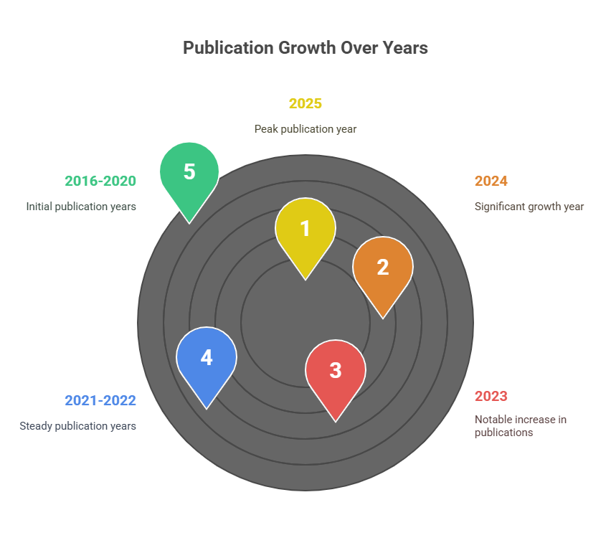
Figure 2: Annual production of the records

Furthermore, Table 2 presents the distribution of publications across the most relevant academic sources, revealing a concentrated yet diverse landscape of scholarly outlets that contribute to the research domain at the intersection of digital technologies, sustainability, and circular economy principles. The analysis demonstrates a relatively balanced distribution pattern, with the top-ranking source being "Sustainable Innovations and Digital Circular Economy" contributing 6 articles (9.09% of the total corpus), followed closely by "Sustainability (Switzerland)" with 5 publications (7.58%), indicating the specialised nature of journals focusing explicitly on the convergence of digital innovation and circular economy frameworks. Two prominent journals share the third position with 4 articles each: "Business Strategy and the Environment" and "Journal of Cleaner Production" (each representing 6.06% of publications), highlighting the significant role of environmental management and clean technology publications in advancing this interdisciplinary field. The presence of "Technological Forecasting and Social Change" with 3 articles (4.55%) underscores the forward-looking perspective of research examining technological adoption and its societal implications within sustainable frameworks. Notably, four journals contribute 2 articles each, including specialised outlets such as "Sustainability, Circular Economy, and Transformation in Organisations" and broader environmental research venues like "Environmental Research" and "Journal of Environmental Management," demonstrating the field's appeal across both niche and established academic communities. The top 10 sources collectively account for 31 publications (46.97% of the dataset), while the remaining 35 publications are distributed across 35 different journals (53.03%), indicating a healthy diversity of publication outlets and suggesting that this emerging research domain has successfully penetrated various academic disciplines and specialised journals, reflecting its inherent interdisciplinary nature and broad scholarly appeal.
Table 2: Relevant sources and percentage
Source | Articles | Percentage (%) | Impact Focus
Sustainable Innovations and Digital Circular Economy | 6 | 9.09 | Digital-circular integration
Sustainability (Switzerland) | 5 | 7.58 | General sustainability research
Business Strategy and the Environment | 4 | 6.06 | Strategic environmental management
Journal of Cleaner Production | 4 | 6.06 | Clean technology and production
Technological Forecasting and Social Change | 3 | 4.55 | Technology adoption and social impact
Business Strategy and Development | 2 | 3.03 | Strategic business development
Environmental Research | 2 | 3.03 | Environmental science research
Journal of Environmental Management | 2 | 3.03 | Environmental management practices
Sustainability, Circular Economy, and Transformation in Organisations | 2 | 3.03 | Organisational transformation
ABAC Journal | 1 | 1.52 | General business research

Bibliometric analysis
The use of RStudio's Biblioshiny package for bibliometric analysis provides a robust and comprehensive framework for visualising international collaboration patterns, enabling researchers to systematically map and analyse the global research networks that characterise contemporary academic partnerships in digital technology and sustainability studies (Aria & Cuccurullo, 2017). Figure 3 presents the international collaboration network, revealing a distinctly centralised hub-and-spoke pattern where China emerges as the dominant collaborative node, establishing research partnerships with eleven different countries and accumulating twelve total collaborative connections, thereby positioning itself as the primary facilitator of international knowledge exchange in this interdisciplinary field. The network visualisation demonstrates that China maintains particularly strong collaborative relationships with Pakistan (three joint publications), Malaysia (two publications), and single-publication partnerships with Australia, Greece, Indonesia, Italy, Morocco, Singapore, Thailand, and the United Kingdom, illustrating the country's strategic positioning as a bridge between diverse geographical regions and research traditions.
Secondary collaboration hubs include Germany, which connects with Canada, Japan, Norway, and Uganda, and India, which establishes partnerships with Australia, China, Egypt, Germany, and Italy, while Greece serves as an important intermediary node linking with Finland, Malaysia, Morocco, and Singapore. The network structure reveals both regional clustering tendencies and transcontinental research partnerships, with Nordic countries (Finland-Norway), European collaborations (Germany-various partners), and Asia-Pacific connections (China-Southeast Asian nations) forming identifiable sub-networks, while the presence of cross-continental partnerships between developed and developing nations suggests that research in digital enablers for circular economy and sustainability transcends traditional North-South academic divides, fostering truly global knowledge creation and technology transfer mechanisms that reflect the universal relevance and urgent nature of sustainable development challenges in the digital age.

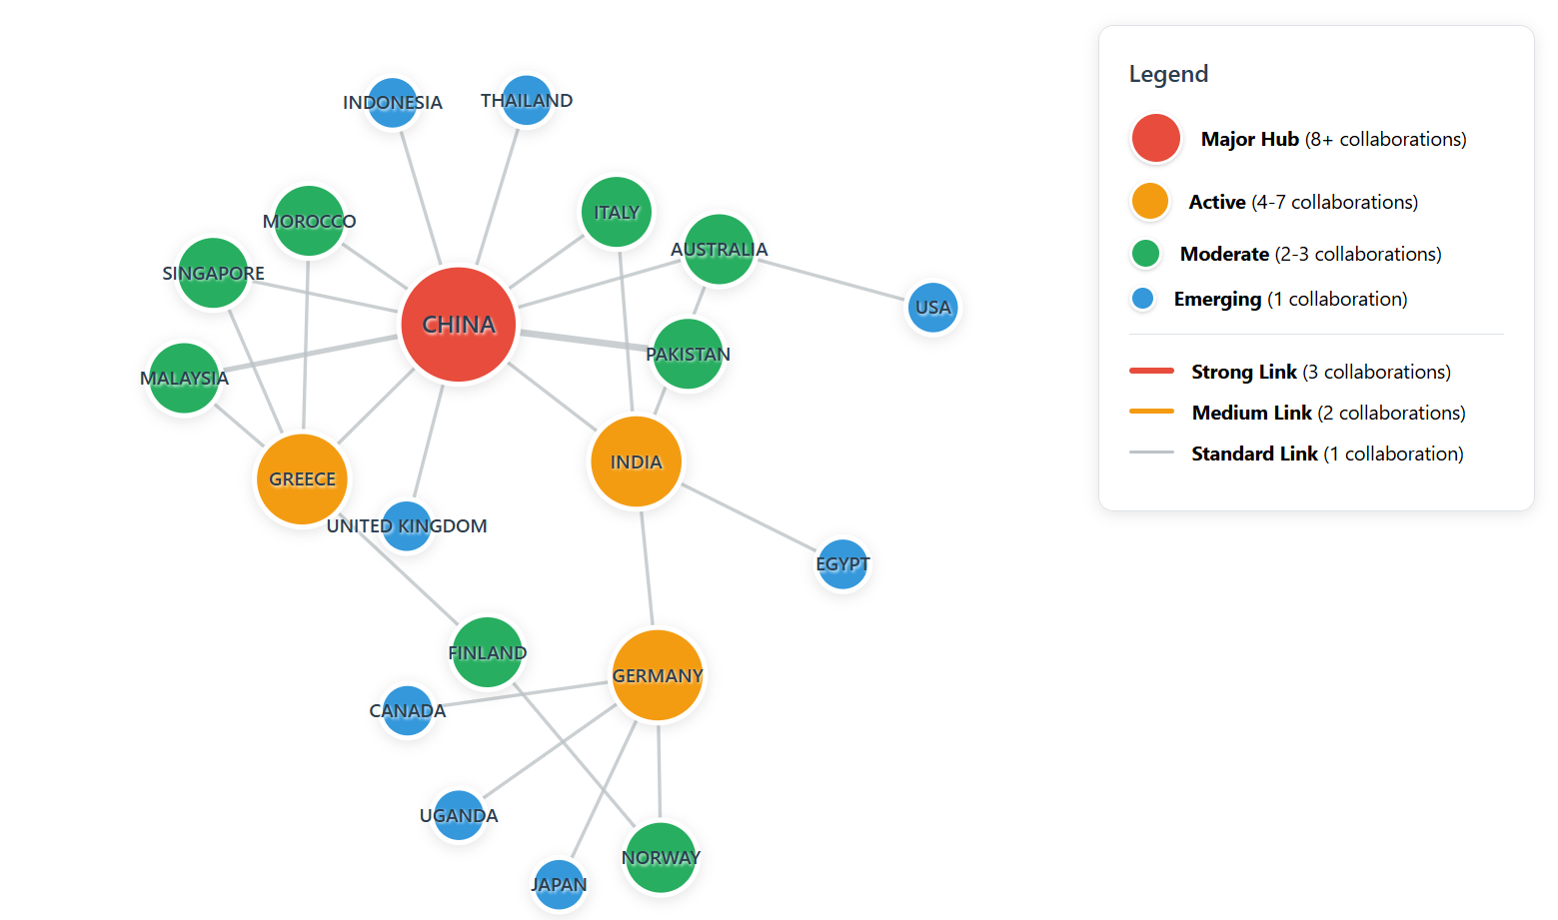
Figure 3: International collaboration network
In addition, Figure 4 presents a word cloud visualisation that effectively captures the conceptual landscape and thematic priorities within the research domain, where term frequency and visual prominence directly correspond to their significance in the literature corpus. The analysis reveals "circular economy" as the overwhelmingly dominant concept with 46 occurrences, appearing as the largest and most centrally positioned term, thereby confirming its role as the primary focal point of research inquiry. "Sustainable development" emerges as the second most prominent theme with 27 occurrences, positioned strategically in the upper portion of the cloud and reinforcing the strong connection between circular economy principles and broader sustainability objectives. The visualisation demonstrates a clear convergence of technological and environmental themes, with "artificial intelligence" (15 occurrences) representing the digital transformation aspect, while "recycling" and "waste management" (12 occurrences each) highlight the operational dimensions of circular economy implementation. The presence of "sustainability" (11 occurrences), "digital technologies" (10 occurrences), "resource efficiencies" (10 occurrences), and "sustainable development goals" (9 occurrences) in the mid-frequency range illustrates the multidisciplinary nature of the field, encompassing technological innovation, policy frameworks, and performance optimisation strategies. Lower-frequency terms such as "environmental impact," "green development," "Industry 4.0," "manufacturing," and "supply chain management" (ranging from 6-8 occurrences) reveal the diverse application domains and methodological approaches that characterize contemporary research at the intersection of digital enablers and circular economy practices, collectively demonstrating the field's evolution toward integrated, technology-enhanced sustainability solutions.
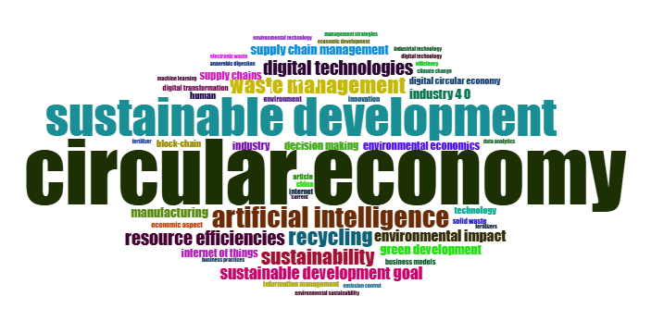
Figure 4: Word cloud on circular economy research

Keywords occurrences analysis
Table 3 presents the network centrality metrics for key research themes, revealing the structural importance and connectivity patterns within the knowledge domain through three complementary measures: betweenness centrality (indicating bridging capacity between different research clusters), closeness centrality (measuring proximity to all other concepts), and PageRank (reflecting overall influence and authority within the network). The analysis demonstrates that "circular" emerges as the most structurally significant concept with the highest betweenness centrality (1.254) and PageRank score (0.04), indicating its role as a critical bridge connecting diverse research themes and its central authority in the knowledge network. "Economy" closely follows with comparable metrics (betweenness: 1.214, PageRank: 0.04), reinforcing the dominance of the circular economy as the primary conceptual framework. "Sustainable" (betweenness: 0.839, PageRank: 0.035) and "environmental" (betweenness: 0.8, PageRank: 0.034) occupy prominent positions as secondary connectors, while "technologies" (betweenness: 0.707, PageRank: 0.03) serves as a crucial link between technical and sustainability domains. The uniform closeness centrality values (0.02 for most concepts) suggest a relatively cohesive knowledge structure, while the varying betweenness and PageRank scores reveal distinct hierarchical roles, with implementation-focused terms like "practices," "management," and "business" showing moderate connectivity, and technical concepts like "data," "manufacturing," and "supply chain" demonstrating specialized but important bridging functions within the research ecosystem
Table 3: Keywords occurrence and thematic domain
Terms | Betweenness Centrality | Closeness Centrality | Page Rank | Centrality Category | Thematic Domain
circular | 1.254 | 0.02 | 0.04 | Core Hub | Circular Economy
economy | 1.214 | 0.02 | 0.04 | Core Hub | Circular Economy
sustainable | 0.839 | 0.02 | 0.035 | Primary Connector | Sustainability
environmental | 0.8 | 0.02 | 0.034 | Primary Connector | Sustainability
technologies | 0.707 | 0.02 | 0.03 | Bridge Node | Digital Innovation
data | 0.517 | 0.02 | 0.025 | Secondary Connector | Digital Innovation
practices | 0.472 | 0.02 | 0.027 | Implementation Node | Application
economic | 0.463 | 0.02 | 0.026 | Secondary Connector | Economic Impact
management | 0.444 | 0.02 | 0.024 | Implementation Node | Application
sustainability | 0.357 | 0.02 | 0.025 | Secondary Connector | Sustainability
industry | 0.288 | 0.02 | 0.022 | Application Node | Industry Context
business | 0.288 | 0.02 | 0.021 | Application Node | Business Context
role | 0.272 | 0.02 | 0.02 | Relational Node | Relationships

In addition, Figure 5 presents a sophisticated network visualisation that maps the conceptual landscape through keyword co-occurrence patterns, revealing two distinct but interconnected thematic clusters that represent complementary dimensions of the research domain. The dominant red cluster forms a densely connected core centred around "circular," "economy," "sustainable," "environmental," and "sustainability," with strong interconnections extending to practical implementation concepts such as "management," "business," "practices," and "technologies," demonstrating the field's focus on operationalizing sustainability principles through circular economy frameworks. This cluster's high connectivity and central positioning reflect the maturity and integration of sustainability-focused research themes. The secondary blue cluster, positioned primarily on the left side of the network, encompasses resource-oriented and methodological concepts, including "resource," "efficiency," "waste," "development," "innovation," and "digital," representing the technical and operational dimensions that support circular economy implementation. The network structure reveals meaningful bridges between clusters, particularly through "technologies" and "data" nodes, which serve as critical connectors linking theoretical sustainability concepts with practical digital solutions and resource management approaches, thereby illustrating the evolving integration of digital technologies as enablers of circular economy transitions and the field's progression toward comprehensive, technology-enhanced sustainability solutions.
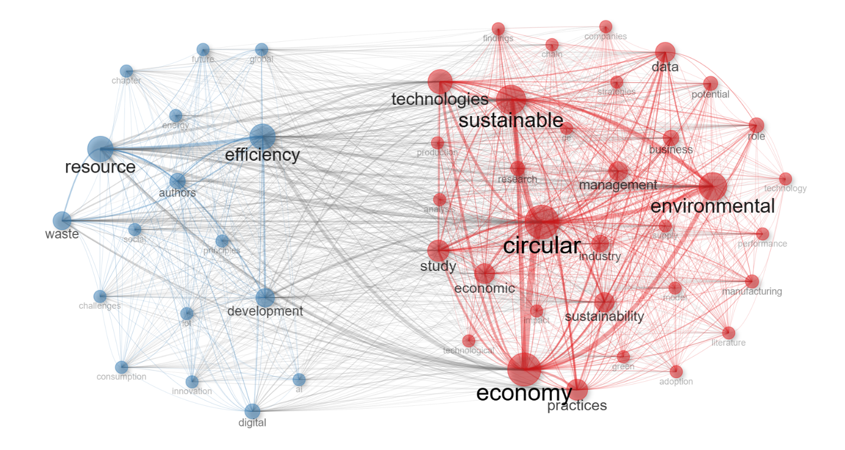
Figure 5: Thematic network of key terms

Thematic identification
Figure 6 presents a comprehensive thematic cluster analysis that reveals the hierarchical architecture and performance dynamics of research themes within the digital technology and sustainability domain, demonstrating clear structural relationships and varying levels of scholarly development across different conceptual areas. The analysis establishes Circular Economy as the dominant primary research domain, exhibiting exceptional performance metrics with the highest Callon centrality (31.973) and density (169.204) values, alongside the most substantial research frequency (216 publications), thereby confirming its role as the central organising framework for contemporary sustainability research. Within this primary domain, three distinct sub-components emerge with varying maturity levels: Innovation functions as the most developed implementation driver with moderate centrality (8.701) and high density (132.197), reflecting its crucial role in translating circular economy principles into practical applications; Resource Management represents the operational core with the lowest metrics (centrality: 0.250, density: 50.000, frequency: 2), indicating its specialised but underdeveloped status within the research landscape; and Economics serves as the economic framework component with intermediate values (centrality: 0.750, density: 87.500, frequency: 8), suggesting moderate integration with broader circular economy discourse. The analysis further identifies two independents but interconnected enabling domains: Digital Technologies emerges as a significant digital enabler (centrality: 8.130, frequency: 73) that facilitates circular economy implementation through technological innovation, while Industry 4.0 functions as an industrial framework (centrality: 9.086, frequency: 72) that provides the structural foundation for integrating digital solutions with sustainable manufacturing and production systems. This thematic organisation reveals a sophisticated research ecosystem where circular economy principles are systematically supported by digital enablers and operationalised through innovation-driven approaches, resource optimisation strategies, and economic evaluation frameworks.
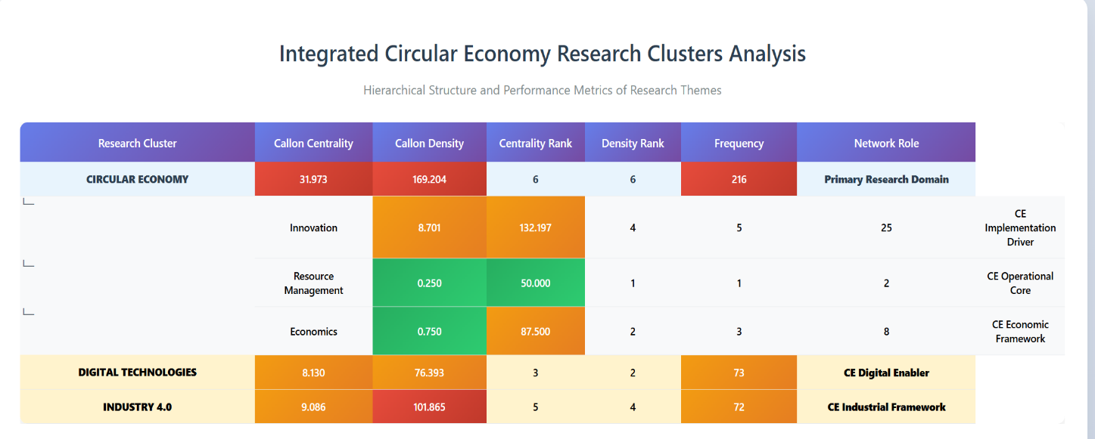
Figure 6: Thematic analysis and identification
In addition, Table 4 presents a comprehensive analysis of research themes organised into three distinct clusters, each characterised by unique centrality patterns and research focus areas that collectively represent the multifaceted landscape of digital technology and sustainability research. The Digital Technologies cluster encompasses 19 terms with "digital technologies" serving as the dominant concept (10 occurrences, betweenness centrality: 641.043), followed by "resource efficiencies" (10 occurrences, centrality: 454.801), demonstrating the cluster's focus on technological solutions for resource optimisation and sustainable business transformation. This cluster exhibits a strong emphasis on practical implementation through concepts such as "business models," "digital transformation," and "sustainable development goals," while emerging technologies like "blockchain" and "digital circular economy" indicate the integration of advanced digital solutions with sustainability frameworks. The moderate to high betweenness centrality values across terms suggest active bridging roles between different research domains, with "green development" (centrality: 212.64) and "digital circular economy" (centrality: 60.8) serving as important connectors between technological and environmental themes.
The Industry 4.0 cluster comprises 25 terms led by "supply chain management" (7 occurrences, betweenness centrality: 729.237), which demonstrates the highest bridging capacity within this cluster, followed by "industry 4.0" itself (7 occurrences, centrality: 481.678) and "supply chains" (6 occurrences, centrality: 241.671). This cluster reveals a strong operational and industrial focus, emphasising technological integration in manufacturing and production systems through concepts such as "industrial technology," "sustainable production," and "information management." The presence of economic evaluation terms like "financial performance," "investment," and "economic and social effects" indicates the cluster's attention to performance measurement and economic viability of Industry 4.0 implementations. The relatively high centrality values for supply chain-related terms suggest their critical role in connecting various aspects of industrial transformation and sustainability practices.

Table 4: Thematic Cluster Analysis and Network Centrality Metrics
Occurrences | Words | Cluster Label | Btw centrality | Clos centrality | Page rank centrality
10 | digital technologies | digital technologies | 641.043 | 0.002 | 0.011
10 | resource efficiencies | digital technologies | 454.801 | 0.002 | 0.01
7 | green development | digital technologies | 212.64 | 0.002 | 0.007
5 | block-chain | digital technologies | 197.479 | 0.002 | 0.006
5 | digital circular economy | digital technologies | 60.8 | 0.002 | 0.005
4 | business models | digital technologies | 138.079 | 0.002 | 0.005
4 | digital transformation | digital technologies | 50.169 | 0.002 | 0.004
3 | business practices | digital technologies | 102.214 | 0.002 | 0.003
3 | resource allocation | digital technologies | 49.434 | 0.002 | 0.004
3 | sustainable development goals | digital technologies | 45.786 | 0.002 | 0.003
3 | waste reduction | digital technologies | 59.475 | 0.002 | 0.004
2 | business | digital technologies | 28.701 | 0.002 | 0.003
2 | digital tools | digital technologies | 15.515 | 0.002 | 0.002
2 | enterprise resource management | digital technologies | 103.935 | 0.002 | 0.004
2 | global challenges | digital technologies | 1.147 | 0.001 | 0.001
2 | green supply chain management | digital technologies | 48.897 | 0.002 | 0.003
2 | performance | digital technologies | 49.581 | 0.002 | 0.003
2 | smart circular economy | digital technologies | 101.69 | 0.002 | 0.004
2 | sustainable innovation | digital technologies | 19.815 | 0.002 | 0.003
7 | industry 4.0 | industry 4.0 | 481.678 | 0.002 | 0.01
7 | supply chain management | industry 4.0 | 729.237 | 0.002 | 0.009
6 | supply chains | industry 4.0 | 241.671 | 0.002 | 0.008
4 | information management | industry 4.0 | 210.051 | 0.002 | 0.006
3 | industrial technology | industry 4.0 | 100.858 | 0.002 | 0.003
3 | sustainable production | industry 4.0 | 114.355 | 0.002 | 0.004
2 | big data | industry 4.0 | 74.031 | 0.002 | 0.003
2 | computer aided analysis | industry 4.0 | 79.588 | 0.002 | 0.004
2 | conservation | industry 4.0 | 20.591 | 0.002 | 0.003
2 | economic and social effects | industry 4.0 | 29.587 | 0.002 | 0.003
2 | ecosystems | industry 4.0 | 185.814 | 0.002 | 0.004
2 | financial performance | industry 4.0 | 73.294 | 0.002 | 0.004
2 | industrial development | industry 4.0 | 24.543 | 0.002 | 0.002
2 | industrial economics | industry 4.0 | 50.785 | 0.002 | 0.003
2 | industrial performance | industry 4.0 | 16.709 | 0.002 | 0.002
2 | investment | industry 4.0 | 51.262 | 0.002 | 0.003
2 | investments | industry 4.0 | 51.262 | 0.002 | 0.003
2 | literature review | industry 4.0 | 16.145 | 0.002 | 0.003
2 | optimization | industry 4.0 | 60.693 | 0.002 | 0.003
2 | production and consumption | industry 4.0 | 31.021 | 0.002 | 0.003
2 | scrap metal reprocessing | industry 4.0 | 78.986 | 0.002 | 0.004
2 | social development | industry 4.0 | 99.067 | 0.002 | 0.003
2 | stakeholder | industry 4.0 | 62.041 | 0.002 | 0.002
2 | strategic approach | industry 4.0 | 40.511 | 0.002 | 0.003
2 | sustainable consumption | industry 4.0 | 64.769 | 0.002 | 0.003
2 | systematic literature review | industry 4.0 | 11.827 | 0.002 | 0.003
2 | textile industry | industry 4.0 | 30.692 | 0.002 | 0.002
31 | circular economy | circular economy | 4,506.948 | 0.003 | 0.037
25 | sustainable development | circular economy | 4,390.126 | 0.003 | 0.033
12 | artificial intelligence | circular economy | 2,751.904 | 0.003 | 0.021
7 | recycling | circular economy | 548.055 | 0.002 | 0.012

The Circular Economy cluster dominates the research landscape with only four core terms but significantly higher impact metrics, led by "circular economy" (31 occurrences, betweenness centrality: 4,506.948) and "sustainable development" (25 occurrences, centrality: 4,390.126), which exhibit exceptionally high bridging capacities that far exceed those in other clusters. The inclusion of "artificial intelligence" (12 occurrences, centrality: 2,751.904) as the third-ranking term demonstrates the growing integration of AI technologies within circular economy research, while "recycling" (7 occurrences, centrality: 548.055) represents the fundamental operational aspect of circular systems. The dramatically higher betweenness centrality values in this cluster, particularly for the top two concepts, indicate their role as primary connectors that bridge diverse research themes across the entire domain, thereby confirming circular economy and sustainable development as the central organising principles that integrate technological innovation, industrial transformation, and environmental sustainability into a cohesive research framework.

Discussion
The analysis reveals compelling evidence that digital technologies serve as powerful catalysts for financial efficiency within circular economy implementations, addressing the first research objective. Industry 4.0 technologies demonstrate significant positive impacts on economic performance through circular economy practices (Shafique et al., 2024; Yu et al., 2022; Ali et al., 2025), with blockchain technology showing particularly strong effects on enhancing perceived value and supporting data-driven decision-making platforms (Atif, 2023). The financial benefits manifest through multiple pathways, including cost reduction of 3.6% and revenue increase of 4.1% projected annually through digitalisation in waste management sectors (Kurniawan et al., 2023), while circular economy adoption in manufacturing demonstrates substantial improvements in business operations and financial performance (Cuevas-Pichardo et al., 2025).
The evidence suggests that artificial intelligence capabilities, big data analytical capabilities, IoT capabilities, machine learning capabilities, and blockchain technology capabilities directly affect sustainable performance (Shafique et al., 2024), with digital technologies enabling cost efficiencies through premium pricing, customer loyalty, and operational optimisations (Setyaningrum et al., 2024b). Smart circular economy implementations facilitate optimisation solutions and autonomous business models that enhance resource efficiency while automating data-driven analysis and decision-making (Sjödin et al., 2023), demonstrating that the synergy between Industry 4.0 technologies and circular economy techniques significantly impacts companies' financial performance (Alkaraan et al., 2023).
Notably, blockchain technology's features, such as visibility, transparency, relationship management, and smart contracting, play positive roles in circular economy implementation while enhancing economic pathways to firms' performance (Rehman Khan et al., 2022). The integration of IoT-based Industry 4.0 technologies meaningfully advances circular economy practices, including green manufacturing, circular design, remanufacturing, and recycling, which stimulate economic performance (Sun & Wang, 2022), providing robust evidence that digital enablers create measurable financial value within circular economy contexts.
Addressing the second research objective, the findings reveal sophisticated mechanisms through which digital enablers simultaneously drive both financial efficiency and environmental sustainability, creating synergistic value propositions. Industry 4.0 technologies and circular economy practices demonstrate dual benefits, with circular economy practices playing both moderating and mediating roles between technological capabilities and sustainable performance (Shafique et al., 2024; De et al., 2024). The integration demonstrates that environmental performance significantly boosts organisational performance, while improved eco-environmental performance stimulates financial health (Khan et al., 2021).
Digital technologies optimise energy consumption in buildings, industry, and transport through automation systems, smart grids, and data analytics, contributing to enhanced energy efficiency and reduced emissions while generating economic benefits (Voronkova et al., 2024). The combination of AI with IoT creates Artificial Intelligence of Things (AIoT) that facilitates the transition toward sustainable futures while amplifying economic benefits through resource efficiency optimisation (Lampropoulos et al., 2024). Machine learning algorithms and big data analytics enable predictive capabilities for sustainability policies while optimising circular economy activities to reduce waste creation, enhance recycling procedures, and support circular product design (Soni, 2024).
Digital transformation through IoT, big data, and data analytics serves as an essential enabler of circular economy strategies that improve resource efficiency and productivity while capturing economic value (Kristoffersen et al., 2020). The evidence demonstrates that digitalisation in waste sectors contributes to net-zero emissions while reducing global CO₂ emissions by 15% through technological solutions, simultaneously saving USD 421 billion annually (Kurniawan et al., 2023). Real-time monitoring stations, digital cameras, web platforms, and tracking sensors optimise the efficiency of urban metabolic flows while creating economic value through circular resource management (D’amico et al., 2021).
The application of digital technologies to sustainability and the circular economy provides paradigm-shifting approaches toward sustainable futures, enabling wise choices and progress tracking while creating collaborative value for meeting global sustainability targets (Soni, 2024). Blockchain and artificial intelligence emerge as transformative technologies advancing the circular economy with emphasis on community integration, technological synergies, sustainable business models, and economic benefits (Sánchez-García et al., 2024).
The third research objective is addressed through the identification of critical implementation challenges and the development of strategic frameworks for digital-circular economy integration. Despite the potential benefits, organisations face significant barriers, including high costs, technical expertise gaps, and regulatory fragmentation, particularly affecting small and medium enterprises (Puche et al., 2025; Sharma et al., 2023). Organisational barriers emerge as the main impediments to digital technology adoption for sustainable consumption and production, requiring focus on improving senior management commitment (Sharma et al., 2023). Table 5 below illustrates the authors and their contributions to the research on Industry 4.0, circular economy, and digital technologies.
Table 5: Research on Industry 4.0, Circular Economy, and Digital Technologies
Authors & Year | Research Focus | Research Settings
Shafique et al. (2024) | Industry 5.0 tech capabilities & circular economy for sustainability | Chinese manufacturing industry
Yu et al. (2022) | Industry 4.0's impact on the circular economy & supply chain capability | Automobile production systems
Ali et al. (2025) | Industry 4.0, industrial symbiosis & circular economy in BRICS | BRICS manufacturing economies
Atif (2023) | Integration of Industry 4.0 & circular economy with product-service systems | Global industries literature review
Kurniawan et al. (2023) | Digitalisation in waste recycling within the circular economy | Global waste management sector
Cuevas-Pichardo et al. (2025) | Concurrent adoption of Industry 4.0 & circular economy for sustainable performance | Mexican manufacturing firms
Setyaningrum et al. (2024) | Digital innovation & strategic foresight in circular economy practices | Micro, Small, and Medium Enterprises
Sjödin et al. (2023) | AI capacities enabling circular business model innovation | Six B2B firms in digital servitization
Alkaraan et al. (2023) | Synergy of Industry 4.0 & circular economy for financial performance | UK companies, FTSE All Share
Khan et al. (2021) | Blockchain's role in the circular economy & eco-environmental performance | Chinese & Pakistani enterprises
Sun & Wang (2022) | IoT-based Industry 4.0 impact on circular economy & organisational performance | 300 China-based enterprises
Rehman Khan et al. (2022) | Blockchain for enhancing circular economy & organisational performance | China-Pakistan Economic Corridor firms
Soni (2024) | Big data & ML technologies in promoting ESG & circular economy | Theoretical framework development
Lampropoulos et al. (2024) | AI & IoT supporting SDGs & circular economy realisation | Theoretical analysis with the STEEPLED framework
Voronkova et al. (2024) | Digital tech's influence on sustainable green development & resource efficiency | International practices analysis
Kristoffersen et al. (2020) | Digital technologies enabling circular economy & resource efficiency | Theory & practice-based review
D'amico et al. (2021) | Digital tech approach for circular cities & urban metabolism efficiency | European Union municipalities
Sánchez-García et al. (2024) | Incorporating new technologies in circular economy objectives & challenges | Bibliometric analysis
Sharma et al. (2023) | Digital tech barriers in food supply chains for sustainable production | Food industry analysis
Puche et al. (2025) | Circular economy principles & digital transformation integration | Spanish furniture sector
Kayikci et al. (2022) | Drivers for smart, sustainable circular supply chains in achieving SDGs | Low- and middle-income countries
Iyer et al. (2024) | Sustainable management of synthetic microfiber waste using the circular economy paradigm | Textile industries
Nasim et al. (2024) | Industry 4.0's role in sustainability through digital transformation | Manufacturing sector literature review
Ali et al. (2025) | Multi-stakeholder collaboration for sustainable innovation in the digital circular economy | Theoretical framework development
Ramírez-Márquez et al. (2024) | Society 5.0 framework with digital innovations for sustainable resource management | Water & energy sectors
Garcia-Muiña et al. (2018) | Integration of sustainable development & circular economy in manufacturing | Italian ceramic tiles company
Dennison et al. (2024) | Circular economy principles in manufacturing for sustainability & adaptability | Manufacturing sector review
Markou et al. (2025) | Material Passports for promoting circularity & resource efficiency in the built environment | Construction sector systematic review
Singh et al. (2025) | HR management's role in adopting the digital circular economy framework | Theoretical model development

Technical, economic, and social barriers represent the most impactful obstacles to big data analytics adoption in circular agri-food supply chains, with lack of trust, privacy and security, lack of financial resources, and lack of skilled human resources as crucial sub-barriers (Perçin, 2023). The integration of advanced production methods, ensuring supply chain transparency, overcoming skill gaps, avoiding data centralisation, and adapting regulatory frameworks represent primary challenges for sustainable growth (Sánchez-García et al., 2024).
However, government policies and industry collaboration emerge as critical success factors for overcoming barriers (Puche et al., 2025), while strategic foresight, including scenario planning and trend analysis, enables SMEs to align operations with future market demands and sustainability principles (Setyaningrum et al., 2024). The development of comprehensive frameworks integrating lean production, life cycle assessment, circular economy, zero-defect manufacturing, and supply chain management with digital technologies provides pathways for achieving environmental sustainability (Nasim et al., n.d.).
Multi-stakeholder collaboration between governments, businesses, academia, and civil society becomes crucial for propelling sustainable innovation in digital circular economy contexts (Ali et al., 2025). Smart sustainable circular supply chain frameworks emphasise economic sustainability as the best key driver for achieving sustainable development goals, requiring financial assistance and support for effectiveness (Kayikci et al., 2022). The integration of Industry 4.0 technologies with circular economy practices requires collaborative approaches among stakeholders, policymakers, researchers, and consumers to foster innovation and establish regulatory frameworks (Iyer et al., 2024).
Human resource management serves as an important linkage between digital circular economy adoption and sustainability goals, requiring technological proficiency, sustainability skill sets, change management, and the adoption of AI-based tools (Singh et al., 2025). The necessity for resilience and adaptability to ecological challenges advocates for collaborative, data-informed decision-making frameworks that align technological advancements with human-centric approaches (Ramírez-Márquez et al., 2024).
The evidence collectively demonstrates that successful digital-circular economy integration requires systemic approaches that unite technological innovation, environmental sustainability, and economic performance through comprehensive stakeholder engagement and supportive policy frameworks (Garcia-Muiña et al., 2018; Dennison et al., 2024). The development of dynamic, automated material passports incorporating artificial intelligence for real-time updates and seamless integration across digital platforms represents the future direction for comprehensive circular economy implementation (Markou et al., 2025).

Conclusion
This systematic review addressed the critical knowledge gap regarding the quantifiable synergistic contributions of digital enablers to both financial efficiency and environmental sustainability within circular economy frameworks. Through comprehensive analysis of 66 high-quality publications spanning 2016-2025, the research demonstrates that digital technologies serve as transformative catalysts that unlock the dual dividend potential of circular economy practices, creating measurable value propositions that transcend traditional trade-offs between economic performance and environmental stewardship.
The findings reveal three pivotal insights that advance our understanding of digital-circular economy integration. First, specific digital enablers—particularly blockchain technology, artificial intelligence, and IoT-based systems—generate substantial financial returns through cost reduction (3.6% annually), revenue enhancement (4.1% annually), and operational optimisation while simultaneously delivering quantifiable environmental benefits, including a 15% reduction in global CO₂ emissions and enhanced resource efficiency. Second, the mechanisms driving these synergistic outcomes operate through sophisticated feedback loops where digital technologies enable real-time monitoring, predictive analytics, and automated decision-making processes that optimise circular economy activities, creating reinforcing cycles of economic and environmental value creation. Third, successful implementation requires systematic approaches that integrate technological capabilities with human-centric strategies, stakeholder collaboration, and supportive policy frameworks, with human resource management emerging as a critical enabler for digital-circular economy adoption.
These findings contribute significantly to both circular economy theory and digital transformation literature by providing empirical evidence that challenges the conventional assumption of inevitable trade-offs between economic and environmental objectives. The research establishes digital technologies not merely as operational tools but as strategic enablers that fundamentally alter the value creation logic of circular economy business models. From a practical perspective, the integrated digital-circular framework developed in this study provides actionable guidance for organisations seeking to harness technological innovation for sustainable competitive advantage while contributing to global sustainability goals.
The study acknowledges limitations inherent in the rapidly evolving nature of both digital technologies and circular economy practices, with the 2016-2025 timespan potentially underrepresenting emerging technologies and implementation approaches. Additionally, the predominance of manufacturing sector studies may limit generalisability across diverse industries and organisational contexts.
Future research should prioritise longitudinal studies examining the temporal dynamics of digital-circular economy integration, sector-specific investigations in services and primary industries, and the development of standardised metrics for measuring dual value creation. Critical areas for exploration include the role of emerging technologies such as quantum computing and advanced materials in circular economy applications, the effectiveness of policy interventions in accelerating digital-circular transitions, and the development of dynamic frameworks that adapt to technological evolution and changing sustainability imperatives.
Disclaimer (Artificial intelligence)
Option 1:
Author(s) hereby declare that NO generative AI technologies such as Large Language Models (ChatGPT, COPILOT, etc.) and text-to-image generators have been used during the writing or editing of this manuscript.
Option 2:
Author(s) hereby declare that generative AI technologies such as Large Language Models, etc. have been used during the writing or editing of manuscripts. This explanation will include the name, version, model, and source of the generative AI technology and as well as all input prompts provided to the generative AI technology
Details of the AI usage are given below:
1.
2.
3.

References
- Ali, M. U., khan, I., & khan, H. (2025). Leveraging industry 4.0 technologies and industrial symbiosis: Advancing circular economy practices in BRICS economies. Journal of Environmental Management, 383, 125471. https://doi.org/10.1016/J.JENVMAN.2025.125471
- Alkaraan, F., Elmarzouky, M., Hussainey, K., & Venkatesh, V. G. (2023). Sustainable strategic investment decision-making practices in UK companies: The influence of governance mechanisms on synergy between industry 4.0 and circular economy. Technological Forecasting and Social Change, 187, 122187. https://doi.org/10.1016/J.TECHFORE.2022.122187
- Aria, M., & Cuccurullo, C. (2017). bibliometrix: An R-tool for comprehensive science mapping analysis. Journal of Informetrics, 11(4), 959–975. https://doi.org/10.1016/J.JOI.2017.08.007
- Atif, S. (2023). The role of industry 4.0-enabled data-driven shared platform as an enabler of product-service system in the context of circular economy: A systematic literature review and future research directions. Business Strategy and Development, 6(3), 275–295. https://doi.org/10.1002/BSD2.238;WGROUP:STRING:PUBLICATION
- Cuevas-Pichardo, L. J., Maldonado-Guzmán, G., Gómez-Guillamón, A. D., & Garza-Reyes, J. A. (2025). The Mediating Role of Circular Economy in the Relationship Between Industry 4.0 and Sustainable Performance in the Manufacturing Industry. Business Strategy and the Environment, 34(2), 1735–1750. https://doi.org/10.1002/BSE.4075
- D’amico, G., Arbolino, R., Shi, L., Yigitcanlar, T., & Ioppolo, G. (2021). Digital technologies for urban metabolism efficiency: Lessons from urban agenda partnership on circular economy. Sustainability (Switzerland), 13(11), 6043. https://doi.org/10.3390/SU13116043/S1
- De, T., Verma, P., Gangaraju, P. K., Nibhanupudi Siva Bhaskar, A., Mahlawat, S., Kumar, V., & Singh, S. (2024). Exploring the synergistic effects of circular economy, Industry 4.0 technology, and green human resource management practices on sustainable performance: Empirical evidence from Indian companies. Business Strategy & Development, 7(3), e70002. https://doi.org/10.1002/BSD2.70002
- Dennison, M. S., Kumar, M. B., & Jebabalan, S. K. (2024). Realization of circular economy principles in manufacturing: obstacles, advancements, and routes to achieve a sustainable industry transformation. SpringerMS Dennison, MB Kumar, SK JebabalanDiscover Sustainability, 2024•Springer, 5(1), 438. https://doi.org/10.1007/S43621-024-00689-2
- Iyer, A., Nambiar, K. S., & Murugan, S. (2024). Sustainable Management and Advanced Techniques of Synthetic Microfiber Waste Through Circular Economy. Environmental Science and Engineering, Part F2333, 213–230. https://doi.org/10.1007/978-3-031-51792-1_11
- Jabeen, S., Malik, S., Khan, S., Khan, N., Qureshi, M. I., & Saad, M. S. M. (2021). A comparative systematic literature review and bibliometric analysis on sustainability of renewable energy sources. International Journal of Energy Economics and Policy, 11(1), 270.
- Khan, S. A. R., Razzaq, A., Yu, Z., & Miller, S. (2021). Retracted: Industry 4.0 and circular economy practices: A new era business strategies for environmental sustainability. Business Strategy and the Environment, 30(8), 4001–4014. https://doi.org/10.1002/BSE.2853
- Kristoffersen, E., Blomsma, F., Mikalef, P., & Li, J. (2020). The smart circular economy: A digital-enabled circular strategies framework for manufacturing companies. Journal of Business Research, 120, 241–261. https://doi.org/10.1016/J.JBUSRES.2020.07.044
- Kurniawan, T. A., Othman, M. H. D., Liang, X., Goh, H. H., Gikas, P., Kusworo, T. D., Anouzla, A., & Chew, K. W. (2023). Decarbonization in waste recycling industry using digitalization to promote net-zero emissions and its implications on sustainability. Journal of Environmental Management, 338, 117765. https://doi.org/10.1016/J.JENVMAN.2023.117765
- Lampropoulos, G., Rahanu, H., Georgiadou, E., Siakas, D., & Siakas, K. (2024). Reconsidering a Sustainable Future Through Artificial Intelligence of Things (AIoT) in the Context of Circular Economy. Lecture Notes on Data Engineering and Communications Technologies, 192, 1–20. https://doi.org/10.1007/978-3-031-53433-1_1
- Markou, I., Sinnott, D., & Thomas, K. (2025). Current methodologies of creating material passports: A systematic literature review. Case Studies in Construction Materials, 22, e04267. https://doi.org/10.1016/J.CSCM.2025.E04267
- Moher, D., Liberati, A., Tetzlaff, J., Altman, D. G., & T. P. G. (2009). Preferred reporting items for systematic reviews and meta-analyses: the PRISMA statement. PloS Med, 6(7). https://doi.org/https://doi.org/10.1371/journal.pmed1000097e1000097
- Nasim, B., Venschott, M., the, C. M.-G. C. for, & 2024, undefined. (n.d.). Greening the Future Through Digital Transformation: A Systematic Review of Sustainable Strategies and Future Research Directions. Igi-Global.Com. Retrieved May 30, 2025, from https://www.igi-global.com/chapter/greening-the-future-through-digital-transformation/351391
- Özşahin, M., Simovic, V., & Ertürk, A. (2025). Sustainability, Circular Economy, and Transformation in Organizations. Sustainability, Circular Economy, and Transformation in Organizations, 1–438. https://doi.org/10.4018/979-8-3373-2523-1
- Perçin, S. (2023). Identifying barriers to big data analytics adoption in circular agri-food supply chains: a case study in Turkey. Environmental Science and Pollution Research, 30(18), 52304–52320. https://doi.org/10.1007/S11356-023-26091-5/TABLES/2
- Puche, A. M., Jiménez-Zarco, A., & Izquierdo-Yusta, A. (1 C.E.). The Impact of Circular Ecological Transition Factor in the Industry 5.0 Era: Evidence From Furniture Sector Enterprises in Spain. Https://Services.Igi-Global.Com/Resolvedoi/Resolve.Aspx?Doi=10.4018/979-8-3373-2523-1.Ch006, 135–186. https://doi.org/10.4018/979-8-3373-2523-1.CH006
- Rattanawiboonsom, V., & Khan, N. (2024). Blockchain Technology in Mobile Payments: A Systematic Review of Security Enhancements in Mobile Commerce. International Journal of Interactive Mobile Technologies , 18(21), 134. https://doi.org/10.3991/IJIM.V18I21.52099
- Rehman Khan, S. A., Yu, Z., Sarwat, S., Godil, D. I., Amin, S., & Shujaat, S. (2022). The role of block chain technology in circular economy practices to improve organisational performance. International Journal of Logistics Research and Applications, 25(4–5), 605–622. https://doi.org/10.1080/13675567.2021.1872512;REQUESTEDJOURNAL:JOURNAL:CJOL20;WGROUP:STRING:PUBLICATION
- Sánchez-García, E., Martínez-Falcó, J., Marco-Lajara, B., & Manresa-Marhuenda, E. (2024). Revolutionizing the circular economy through new technologies: A new era of sustainable progress. Environmental Technology & Innovation, 33, 103509. https://doi.org/10.1016/J.ETI.2023.103509
- Setyaningrum, R. P., Putra, H. M. M., Goestjahjanti, F. S., Muafi, M., & Annaufal, A. I. (2024a). Consumer Behavior and Circular Economy in MSMEs. Studies in Big Data, 159, 151–158. https://doi.org/10.1007/978-3-031-71213-5_14
- Setyaningrum, R. P., Putra, H. M. M., Goestjahjanti, F. S., Muafi, M., & Annaufal, A. I. (2024b). Consumer Behavior and Circular Economy in MSMEs. Studies in Big Data, 159, 151–158. https://doi.org/10.1007/978-3-031-71213-5_14
- Shafique, M. N., Adeel, U., & Rashid, A. (2024). The Synergy Between Industry 5.0 and Circular Economy for Sustainable Performance in the Chinese Manufacturing Industry. Sustainability 2024, Vol. 16, Page 9952, 16(22), 9952. https://doi.org/10.3390/SU16229952
- Sharma, M., Joshi, S., & Govindan, K. (2023). Overcoming barriers to implement digital technologies to achieve sustainable production and consumption in the food sector: A circular economy perspective. Sustainable Production and Consumption, 39, 203–215. https://doi.org/10.1016/J.SPC.2023.04.002
- Singh, R., Joshi, A., Dissanayake, H., Iddagoda, A., Khan, S., Félix, M. J., & Santos, G. (2025). Integrating Industry 4.0, Circular Economy, and Green HRM: A Framework for Sustainable Transformation. Sustainability 2025, Vol. 17, Page 3082, 17(7), 3082. https://doi.org/10.3390/SU17073082
- Sjödin, D., Parida, V., & Kohtamäki, M. (2023). Artificial intelligence enabling circular business model innovation in digital servitization: Conceptualizing dynamic capabilities, AI capacities, business models and effects. Technological Forecasting and Social Change, 197, 122903. https://doi.org/10.1016/J.TECHFORE.2023.122903
- Soni, P. (2024). Data-Driven Sustainability: Unlocking the Potential of Machine Learning and Big Data for ESG Integration & the Circular Economy. Fintech for Esg and the Circular Economy, 1–11. https://doi.org/10.1002/9781394234035.CH1;CTYPE:STRING:BOOK
- Sun, X., & Wang, X. (2022). Modeling and Analyzing the Impact of the Internet of Things-Based Industry 4.0 on Circular Economy Practices for Sustainable Development: Evidence From the Food Processing Industry of China. Frontiers in Psychology, 13, 866361. https://doi.org/10.3389/FPSYG.2022.866361/BIBTEX
- Voronkova, V., Nikitenko, V., Metelenko, N., Silina, I., Popova, A., Mykyta, S., Olena, B., & Afonov, R. (2024). Synergy of digital technologies and green development and their impact on achieving a sustainable environment in the conditions of instability. Transformations of National Economies under Conditions of Instability, 73–111. https://doi.org/10.21303/978-9916-9850-6-9.CH3
- Han, Y., Shevchenko, T., Yannou, B., Ranjbari, M., Shams Esfandabadi, Z., Saidani, M., Bouillass, G., Bliumska-Danko, K., & Li, G. (2023). Exploring How Digital Technologies Enable a Circular Economy of Products. Sustainability, 15(3), 2067.
- Sikander, A. (2024). Artificial Intelligence and the Circular Economy: How AI Advances Waste Reduction. Green Environmental Technology, 1(2), 23-34.
- Ranta, V., Aarikka-Stenroos, L., & Väisänen, J. M. (2021). Digital technologies catalyzing business model innovation for circular economy—Multiple case study. Resources, conservation and recycling, 164, 105155.
- Grafström, J., & Aasma, S. (2021). Breaking circular economy barriers. Journal of cleaner production, 292, 126002.
- Rajput, S., & Singh, S. P. (2020). Industry 4.0 Model for circular economy and cleaner production. Journal of cleaner production, 277, 123853.
- Kabugo, J. C., Jämsä-Jounela, S. L., Schiemann, R., & Binder, C. (2020). Industry 4.0 based process data analytics platform: A waste-to-energy plant case study. International journal of electrical power & energy systems, 115, 105508.
- Candontol, J. D., Bandera, A. D., & Hadji Amin, M. D. (2025). Boundary drivers and market-centered expansion in agribusiness: Integrative review of technological, institutional and policy trends. Asian Research Journal of Agriculture, 18(4), 138–148.
- Abdul-Hamid, A. Q., Ali, M. H., Osman, L. H., Tseng, M. L., & Lim, M. K. (2022). Industry 4.0 quasi-effect between circular economy and sustainability: Palm oil industry. International Journal of Production Economics, 253, 108616.

