A COMPARATIVE STUDY ON EFFECTIVENESS OF MUSIC DISTRACTION VERSUS CONVENTIONAL BEHAVIOUR MANAGEMENT TECHNIQUE IN REDUCING ANXIETY AND STRESS INCHILDREN AGED 6-12 YEARS.

Introduction: Dental fear and anxiety are common problems for children visiting the dentist, and may impact on the success of dental treatment. Behaviour management techniques without medication have been shown to be effective in decreasing anxiety and stress for children during dental treatments. Owing to the limited availability of proven and conclusive studies, this research was chosen to address the existing research gap.

Objective:The aim of this research was to compare the effectiveness of music distractions vs conventional behaviour management (CBM) techniques on reducing anxiety and stress for children under dental treatment.

Methods:This project used a comparative study with 50 children aged between 6 to 12 years who were receiving dental treatment at the Paediatric Dentistry Department. The children were placed into one of two groups (Group 1 – Conventional behaviour management, Group 2 - Music Distraction). Anxiety levels were measured using MCDAS and VPT at two points of time-pre and post dental treatment; Pulse rate was assessed as a measure of stress. Both assessments were made prior to the commencement of treatment and again at completion of treatment. Statistical analyses were performed using SPSS version 21, utilizing Mann-Whitney U test and chi-square test to evaluate pre and post anxiety levels during dental treatment between the two groups.
Result:The results indicate that both groups have substantially lowered their respective pre-operative and postoperative anxiety scores on the MCDAS and VPT instruments after undergoing dental treatment; the mean postoperative anxiety scores on the MCDAS and VPT for patients in Group 1 (Music Distraction Group [MDG1]) were lower p=0.430, than those of Group 2 (Conventional Group [CG]); however the p-values were greater than or equal to 0.05; as such, the findings are not statistically significant. No patients in the MDG1 demonstrated high levels of post-operative anxiety.
Conclusions:Music distraction (MD) has been shown to reduce the level of dental anxiety experienced by paediatric patients; however MD is not statistically superior to other conventional behaviour management techniques. Music distraction can be recommended as an easy to use, safe and effective option for additional behavioural management for paediatric patients in dentistry.

ABSTRACT:
Key words: Behaviour Management, Dental Anxiety, Music Distraction, Paediatric Dentistry

1.INTRODUCTION:
The introduction to dental anxiety in children begins by discussing how to recognize that a child is anxious and can impact their experience of and response to treatment. As stated earlier, anxiety is characterized by an inability to control feelings of fear associated with the pain and uncertainty of dental procedures (for example, being able to predict how painful it will be or what will happen next).
Additionally, children who demonstrate a high level of dental anxiety also demonstrate non-cooperative behaviours, greater sensitivity to pain, disruptive response behaviours (such as crying), and a tendency to avoid going to the dentist (Klingberg and Broberg, 2007).[1]
Dental anxiety in children has many causes, including fear of the pain, being in an unknown clinical environment, past negative experiences related to dental treatment, parents having been anxious about dental treatment, the child's personality, etc. Anxious children often show a significant increase in sympathetic nervous system activity during dental treatment, resulting in an increased heart rate, sweating, increased muscle tension, and altered breathing (Corah et al., 1979).[2]
Therefore, behaviour management in children receiving dental care is essential. Over the years, many behaviours guidance techniques have been developed for use in paediatric dental care, such as various non-pharmacological ways to reduce anxiety and improve cooperation. Distraction techniques have gained considerable attention for their effectiveness. Distraction causes the anxietyinducing stimuli associated with the experience of visiting a dentist to be removed from the child's focus. Corah et al. (1979)[2] and Ingersoll et al. (1984)[3] identify factors that contribute to anxiety as including the sound of dental instruments, any movement of the chair, and the visual cues that accompany the procedure. Music is one of the most common ways pediatric dentists use non-invasive techniques to distract their patients. Music evokes emotional responses in the limbic system of the brain, which has an effect on the autonomic nervous system and thereby lowers the amount of cortisol (a stress hormone) produced and regulates breathing and heart rate (White, 2000[4]; Watkins, 1997)[5]. Studies conducted in a variety of medical and dental environments confirm that music helps to reduce anxiety, increase the level of relaxation in the patient, and promote cooperation from the patient (Aitken et al., 2002[6]; Marwah et al., 2005[7]).
The ancxiolytic properties of music are related to the characteristics of the music itself. Music that is slow, has a regular rhythm and uses melodic elements has proven to be helpful for reducing sympathetic nervous system arousal and creating a relaxed state in an individual (Corah et al.,1981[8];Fernandez & Turk, 1989[9]). Examples of musical pieces that have been and are still frequently utilized in therapeutic settings for treating children experiencing stress and anxiety include "The Enchanted Garden" by Kevin Kern, which is comprised of softly played pianos at a slow tempo.
When assessing dental anxiety in children, it can be done one of two ways: Subjectively or objectively. The Modified Child Dental Anxiety Scale (MCDAS) is a self-report tool used to measure anxiety to dental procedures among children. (Howard & Freeman; 2007[10]). The Venham Picture Test (VPT) is a pictorial two-image scale that allows children to express feelings of anxiety that they experience. (Venham & Gaulin-Kremer; 1979[11]. Physiological parameters (pulse rate) are objective measures of how the body is responding to stress during the procedure. (Corah & al.; 1979[12]). A growing trend for managing anxiety has been to use non-pharmacological behaviour management techniques. The use of music distraction as an adjunct to traditional behaviour management has many advantages; it is relatively inexpensive, non-invasive, easy to implement, and does not have adverse effects on patients. However, because of differences in study design and assessment methods, there has been variation in results. Therefore, the purpose of this research is to evaluate the efficacy of using music distraction in reducing anxiety and stress in paediatric dental patients using music, "The Enchanted Garden" by Kevin Kern, versus conventional behaviour management.

2.MATERIALS AND METHOD:

2.1Study Design
A comparative study was held in the Department of Pediatric Dentistry,Adhiparasakthi dental college and hospital,melmaruvathur, where ethics approval was given and written parental consent along with verbal child assent was collected from all participant children.

2.2Study Population
Children 6–12 years of age who presented to the pediatric dentistry OPD and needed dental tretament for the first time were considered eligible for inclusion. Of the 135 children initially screened,50 fulfilled the inclusion criteria and were recruited into the study. All children were healthy as per the American Society of Anesthesiologists (ASA) Physical Status , meaning no systemic disease. Both the parents or guardians and the children were explained the purpose of the study and procedures prior to their participation.

2.3 Sampling Technique
A convenience sampling method was applied because eligible participants were available for the study
period. Participants were non-randomly divided into two groups of twenty five. The grouping was established for easier comparison among groups that received distraction methods and one
group with no distraction.
The two groups were:
Group I: control(no distraction)(n=25)
Group II: Music distraction (n = 25)
Gender distribution was not taken into account in the analysis, since differences between genders in
anxiety response were not in the ambit of this study.

2.4Inclusion Criteria
- The children must be healthy to ASA I classification.
- The children will require non-invasive dental procedures.
- The children must be able to understand the MCDAS and VPT, & respond accordingly.
- The children must be a first visit patient or non-traumatic dental history.

2.5Exclusion Criteria
- The children must not have an auditory impairment.
- The children must not have a cognitive or developmental disability.
- The children must not have any emergency or invasive dental procedure.
- The children will not receive any pharmacological behaviour management.
2.6Ethical Considerations
The research proposal was given and certified by the Institutional Ethical Committee of Adhiparasakthi Dental College and Hospital, Melmaruvathur(ECR/1742/APDCH/PEDO/UG 06/TN OCT 2025). The research conformed to the ethical standards of the Declaration of Helsinki (2013) for studies with human subjects. Informed consent was achieved from parents or guardians, and verbal assent was obtained from every child prior to recruitment. Confidentiality of the participants was ensured throughout the study, and they were made aware of their right to withdraw at any point without affecting their treatment.
2.7Anxiety Assessment Tools:
The Modified Child Dental Anxiety Scale (MCDAS), Venham Picture Test (VPT) will be used as tools to assess preoperative and postoperative anxiety. The patient’s pulse rate will also be monitored preoperatively and postoperatively with a digital pulse oximeter.
2.8Intervention:
The children in the music distraction group will listen to instrumental music called “The Enchanted Garden” by Kevin Kern throughout the duration of the dental procedure. The control group will receive conventional behaviour management techniques.
2.9Data Collection:
The following data collection will be conducted; preoperative MCDAS, VPT, and Pulse Rate, Postoperative MCDAS, VPT, and Pulse Rate.
2.10Statistical Analysis:
All data collected were analyzed with Statistical Package for the Social Sciences (SPSS) version 17.0(IBM Corp., USA). Descriptive statistics of mean and standard deviation were calculated for all the groups.statistical tests used were Mqann-Whitney test is used to find pre- and post-LA anxiety scores difference in each group.Chi square is used to find the mean anxiety score difference between the two groups.A p-value < 0.05 was taken as statistically significant. The results were tabulated and interpreted to check the efficacy of each distraction technique to reduce the dental anxiety.
3.RESULT :
This study is assessing how effective the use of music as a distraction technique is in reducing anxiety experienced while undergoing dental procedures in young people. The assessment of anxiety was evaluated using the Venham Picture Scale and the Modified Child Dental Anxiety Scale. The scores were compared with each other and were taken pre and post-operatively by all participants in each group.
3.1Venham Picture Scale

3.1.1Pre-operative Assessment
Pre-operatively, both groups scored shows moderate levels of anxiety on the VPS. The conventional behavior management group scored a mean of 4.20 ± 0.384 and the music distraction group recorded a mean of 4.24 ± 0.65; the difference was not statistically significant (p = 0.884), which indicated that both groups were not statistically different from each other at the beginning.

3.1.2 Post-operative Assessment
Post-operatively, the VPS results from both groups demonstrated a significant improvement in anxiety levels. The conventional behavior management group had a mean of 2.36 ± 0.22 , while the music distraction group had a mean of 2. 6± 0. 43, indicating that both groups scored lower on the VPS postoperatively; however, the difference in results between the groups was also not statistically significant (p = 0.574).

3.1.3Categorical Analysis
Upon analysis of this category, it was apparent that both groups of children showed a decrease in anxiety levels, with children in the music distraction group showing no children with hiqh anxiety after their dental treatment; although this was also not statistically significant (p=0.597).

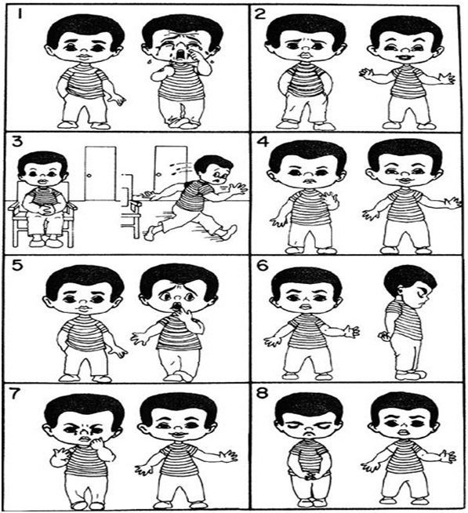
Figure 1: Venham Picture Test (VPT) used to assess dental anxiety in children through paired images depicting relaxed and anxious emotional states.

3.2Modified Child Dental Anxiety Scale (MCDAS):

3.2.1Assessment of Children Preoperative
The scores obtained from each child’s MCDAS were indicative of their overall feelings about their dental visit. The scores for the children who underwent dental treatment using traditional means (conventional group) had an average of 22.00 +/- 5. 96, whereas the scores of the children who underwent dental treatment using music as a distraction had an average of 20.92 +/- 4.2 2. The data also indicated that the average scores were not statistically significant (p=0.392), which indicated that both groups started with similar levels of anxiety.

3.2.2Assessment of Children Postoperative
Children’s scores on the MCDAS scale indicated that significantly less anxiety existed in both groups following the dental treatment procedures. The children in the conventional group had an average score of 7.04 +/- 4.704 following dental treatment, whereas the children in the music distraction group had an average of 6.20 +/- 4. 03; despite these differences, the two groups did not demonstrate statistically significant differences between them (p=0.430).

3.2.3Categorical Data Analysis
Postoperatively, a categorical data analysis showed that the number of children classified as having low anxiety levels post-treatment increased for both groups. No children from either group experienced high levels of anxiety after the treatment intervention. While there was no statistically significant correlation between anxiety level and type of treatment, p = 0.774, there appeared to be some correlation; therefore, it may be possible that type of treatment did have some impact on the results.
In summary, the findings from this study indicate that both intervention methods (traditional behavior management and music distraction) are effective interventions to reduce children’s dental anxiety, while the music intervention, though providing a clinically significant but statistically insignificant benefit over traditional behavior management, demonstrated a positive effect on the reduction of dental anxiety in children.

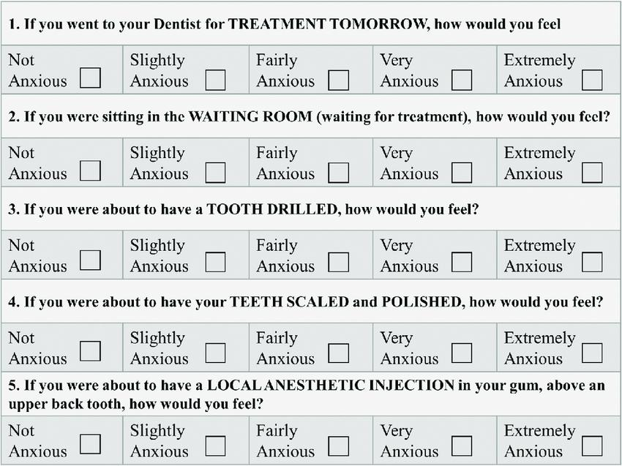
Figure 2: Modified Child Dental Anxiety Scale (MCDAS) questionnaire used to evaluate dental anxiety levels in patients under various dental treatment situations.

Anxiety measurement scale |  | Group | Mean | Std.  Deviation | p-value
Venham  picture scale | Preoperative | Conventional method | 4.20 | 1.384 | 0.884 (NS)
Venham  picture scale | Preoperative | Music Distraction | 4.24 | 1.165 | 0.884 (NS)
Venham  picture scale | Postoperative | Conventional method | 2.36 | 1.221 | 0.574 (NS)
Venham  picture scale | Postoperative | Music Distraction | 2.16 | 1.143 | 0.574 (NS)
Modified  Child  Dental Anxiety Scale | Preoperative | Conventional method | 22.00 | 5.196 | 0.392 (NS)
Modified  Child  Dental Anxiety Scale | Preoperative | Music Distraction | 20.92 | 4.212 | 0.392 (NS)
Modified  Child  Dental Anxiety Scale | Postoperative | Conventional method | 17.04 | 4.704 | 0.430 (NS)
Modified  Child  Dental Anxiety Scale | Postoperative | Music Distraction | 16.20 | 4.103 | 0.430 (NS)
NS – Not Significant, p > 0.05, Independent Samples Mann-Whitney U Test
Table1: Mean Operative Anxiety Scores in Conventional vs Music Distraction
Using the Venham Picture Scale and Modified Child Dental Anxiety Scale.

Anxiety measurement scale |  | Group | Low  Anxiet y n  (%) | Moderate Anxie  ty  n (%) | High  Anxiet y  n (%) | p-  valu e
Venham  picture scale | Preoperativ  e | Convention al method | 3 (6) | 12 (24) | 10  (20) | 0.58  1  (NS)
 |  | Music  Distraction | 1 (2) | 13 (26) | 11  (22)
 | Postoperativ e | Convention al method | 15 (30) | 9 (18) | 1 (2) | 0.59  7  (NS)
 |  | Music  Distraction | 16 (32) | 9 (18) | 0 (0)
Modified | Preoperativ  e | Convention al method | 3 (6) | 16 (32) | 6 (12) | 0.77 2
Child  Dental Anxiet  y  Scale |  | Music  Distraction | 3 (6) | 18 (36) | 4 (8) | (NS)
Child  Dental Anxiet  y  Scale | Postoperativ e | Convention al method | 10 (20) | 15 (30) | 0 (0) | 0.77  4  (NS)
 |  | Music  Distraction | 11 (22) | 14 (28) | 0 (0)
NS – Not Significant, p > 0.05, Chi-Square Test
Table 2 : The Distribution of Anxiety Level Before and After Surgery in the Music vs Conventional Distraction Group (number of patients in Group).

4.DISCUSSION:

There are many cognitive, emotional, and environmental variables that influence pediatric patients’ dental anxiety. In the past, studies have found that anxiety stems from numerous sources, including fear of pain, a potential lack of familiarity with the clinical setting, negative past experiences, and parental anxiety, all of which can affect how a child behaves during the process of being treated (Klingberg & Broberg, 2007) [1]. If not effectively managed, anxiety can interfere with the delivery of appropriate/predictable levels of care to children, as well as increase the likelihood of developing oral disease by avoiding needed dental care.

On the other hand, both the CBM and “music distraction” groups exhibited a statistically significant decrease in anxiety scores from pre- to post-treatment using the VPT and MCDAS measures. These results are consistent with previous studies demonstrating the effectiveness of nonpharmacologic methods (such as the ‘tell-show-do’ method and positive reinforcement) in reducing fears while simultaneously increasing a child’s ability to cooperate during treatment. (Lawrence et al., 1991; Murphy et al., 1984) [13][14]. Nonpharmacological behavior guidance techniques are essential in managing pediatric dental patients (Dhar et al., 2023).[20] Behavior guidance techniques significantly impact dental anxiety levels in pediatric patients (Dhaliwal et al., 2025)[21].

While there were no statistically significant differences found among the two study groups, the mean value of the postoperative scores from the group receiving music distraction was lower and no participants showed evidence of high-levels of anxiety after treatment. This result gives credence to the clinical application of music as an adjunct to treatment, rather than proving it to be statistically superior to any other method used for distraction. These same findings were reported by Aitken, who also found that individuals treated with music distraction displayed less unfavorable behaviors and less discomfort after treatment, although they did not show statistically meaningful differences between the two treatment groups (Aitken et al., 2002) [6].

There are two pathways through which music helps alleviate anxiety: through cognitive and physiological pathways. Music stimulates the auditory cortex and limbic system, reducing sympathetic nervous system function ( Watkins, 1997) [5]. Studies have demonstrated that listening to slow and rhythmic pieces of music, during any moment of the day, produces relaxation responses and cognitive distraction that result in decreased cortisol, decreased heart rate and perceived stress (Fernandez & Turk, 1989; Corah et al., 1979) [9] [2]. Thus, while the perception of anxiety is subjective, the physiological benefits provided by music support the legitimacy of incorporating music in the clinical setting.

More accurately, the techniques for distraction are used to move a person’s attention away from stressful and painful situations, like the unpleasant sounds of dental instruments and being closely monitored by the dentist, to more comforting and enjoyable things . This process is consistent with a theory-based approach to cognitive-behavioral strategies, in which distraction is used as a means of coping with the anticipation of pain and the perception of danger.

The effectiveness of cognitive-behavioral therapies and their related adjunctive benefit when used in conjunction with music (Klassen et al. 2008) [15].Klassen et al. noted that the effectiveness of music across studies varies due to heterogeneity of study methodology and types of music.

Limitation of this study ,A small sample size reduces the statistical power, Exposure to music at one visit only, Variability in music preference from person to person.

Despite the limitations presented, the findings are clinically relevant, as there was no evidence of high anxiety in the music and distraction group, indicating a decrease in high anxiety levels and a meaningful paediatric outcome. Venham & Gaulin-Kremer reported that the ability to detect subtle changes in emotional expression, as measured by VPT, allows for the determination of clinical relevance beyond statistically significant tests (Venham & Gaulin-Kremer, 1979) [11].

In addition, music distraction has practical advantages that conventional behaviour management approaches do not always provide. Music distraction is inexpensive, simple to use, well accepted by parents and children, and does not result in side effects (White, 2000) [4]. Additionally, the fact that music distraction can be combined with other techniques not involving drugs adds to its value as an adjunctive method when performing minimally invasive dental procedures with children.

As a result, while there are no statistically significant advantages of using music distraction as a means of preventing anxiety in pediatric patients, improvements noted clinically support its potential as an adjunctive behavioral support for use in pediatrics.

5.CONCLUSION:

The data obtained from this comparative study show that both traditional means and music distraction have positive effects on reducing dental-related anxiety among children. Even though music distraction was not statistically more effective than traditional methods, it was able to demonstrate better clinical improvements than traditional means, as evidenced by the ability to eliminate the occurrence of children exhibiting high-anxiety levels post-op with respect to dental treatment. Moreover, music distraction is a non-pharmacological, cost-effective, and easily adaptable approach that is well accepted by children, making it a valuable adjunct in pediatric dental settings for anxiety reduction.Incorporating the use of music distraction into regular behavior management practices would also assist in increasing comfort, cooperation, and results in better overall clinical dental treatment outcomes for children.

REFERENCES :

1Klingberg G, Broberg AG. Dental fear/anxiety and dental behaviour management problems in children and adolescents: a review of prevalence and concomitant psychological factors. Int J Paediatr Dent. 2007 Nov;17(6):391-406. doi: 10.1111/j.1365-263X.2007.00872.x.
2Corah NL, Gale EN, Illig SJ. Psychological stress reduction during dental procedures. J Dent Res. 1979 Apr;58(4):1347-51. doi: 10.1177/00220345790580040801. .
3.Ingersoll BD, Nash DA. Blount RL. Gamber C. Dis-traction and contingent reinforcement with pediatric dental patients. ASDC/ Dent Child 1984:51(3):203-207.
4.White JM. Stare of the science of music interventions Critical care and perioperative practice. Crit Care Nurs Clin North Ave. 2000;12(2)-219-225.
5. Watkins GR. Music therapy: proposed physiological mechanisms and clinical implications. Clin Nurse Spec. 1997 Mar;11(2):43-50. doi: 10.1097/00002800-199703000-00003.
6.Aitken JC, Wilson S, Courц D, Moursi AM. The effect of music distractionj on pain, anxiety and behavior in pediatric dental patients. Pediatr Dent. 2002;24(2): 4– 8.
7.Marwah N, Prabhakar AR, Raju OS. Music distraction--its efficacy in management of anxious pediatric dental patients. J Indian Soc Pedod Prev Dent. 2005 Oct-Dec;23(4):168-70. doi: 10.4103/0970-4388.19003.
8. Corah NL, Gale EN, Pace LF, Seyrek SK. Relaxation and musical programming as means of reducing psychological stress during dental procedures. J Am Dent Assoc. 1981 Aug;103(2):232-4. doi: 10.14219/jada.archive.1981.0245.
9. Fernandez E, Turk DC. The utility of cognitive coping strategies for altering pain perception: a meta-analysis. Pain. 1989 Aug;38(2):123-35. doi: 10.1016/0304-3959(89)90230-3.
10. Howard KE, Freeman R. Reliability and validity of a faces version of the Modified Child Dental Anxiety Scale. Int J Paediatr Dent. 2007 Jul;17(4):281-8. doi: 10.1111/j.1365-263X.2007.00830.x.
11.Venham LL, Gaulin-Kremer E. A self-report measure of situational anxiety for young children. Pediatric Dent. 979; (2):9 –96.
12Corah NL, Gale EN, Illig SJ. The use of relaxation and distraction to reduce psychological stress during dental procedures. J Am Dent Assoc. 1979 Mar;98(3):390-4. doi: 10.14219/jada.archive.1979.0049.
13.Lawrence SM. McTigue DJ, Wilson S, Odom JG. Waggoner WF. Fields HW, Jr. Parental attitudes toward behavior management techniques used in pediatric dentistry. Pediatr Dent. 1991:13(3):151-155.
14.Murphy MG. Fields HW, Jr., Machen JB. Parental ac-ceptance of pediatric dentistry behavior management techniques. Pediatr Dent. 1984,6(4):193-198.
15. Klassen JA, Liang Y, Tjosvold L, Klassen TP, Hartling L. Music for pain and anxiety in children undergoing medical procedures: a systematic review of randomized controlled trials. Ambul Pediatr. 2008 Mar-Apr;8(2):117-28. doi: 10.1016/j.ambp.2007.12.005.
16. Parkin SF. The effect of ambient music upon the reac tions of children undergoing dental treatment. ASDC Dent Child. 1981;48(6):430-432.
17.Chambers WL, Fields HW, Machen JB. Measuring se lected disruptive behaviors of the 36- to 60month-old patient. Part 1: Development and assessment of a rat ing scale. Pediatr Dent. 1981;3(3):251-256.
18.Klein SA, Winkelstein ML. Enhancing pediatric health care with music. J Pediatr Health Care. 1996 Mar-Apr;10(2):74-81. doi: 10.1016/S0891-5245(96)90030-9.
19. Nitecka L, Frotscher M. Organization and synaptic interconnections of GABAergic and cholinergic elements in the rat amygdaloid nuclei: single- and double-immunolabeling studies. J Comp Neurol. 1989 Jan 15;279(3):470-88. doi: 10.1002/cne.902790311.
20. Dhar V, Gosnell E, Jayaraman J, Law C, Majstorović M, Marghalani AA, Randall CL, Townsend J, Wells M, Chen CY, Wedeward R. Nonpharmacological Behavior Guidance for the Pediatric Dental Patient. Pediatr Dent. 2023 Sep 15;45(5):385-410
21.Dhaliwal JK, Alzyood M, Al Rawashdeh R. A systematic review and narrative synthesis of evidence from randomised controlled trials: the impact of behaviour guidance techniques on dental anxiety in paediatric patients. BMC Oral Health. 2025 Oct 28;25(1):1690. doi: 10.1186/s12903-025-06533-x.

