Case report:
Title:
Comprehensive Dual-Arch Prosthetic Rehabilitation with a Convertible Mandibular Cast Partial Denture and Maxillary Overdenture: A Case Report
Abstract:
Preservation of the residual alveolar ridge is a primary goal in prosthodontic rehabilitation. Overdentures represent a proven treatment modality that aids in alveolar bone preservation while maintaining proprioceptive feedback through retained natural teeth. Hemisectioned molars can serve as effective abutments for overdenture support. This case report describes rehabilitation using a maxillary tooth-supported overdenture and a convertible mandibular cast partial overdenture, using a hemisectioned molar as an abutment. A 62-year-old male patient reported with multiple missing teeth and difficulty in chewing. As the patient was not willing for extractions, a preventive prosthodontic approach involving tooth-supported overdentures was planned. The present report highlights use of hemisectioned molar as an overdenture abutment. A convertible cast partial overdenture was designed to allow future modification in situation of abutment loss. This approach improves esthetics, mastication and overall patient satisfaction.
Keywords:
Alveolar ridge preservation, Cast partial denture, Convertible denture, Dual-arch rehabilitation, Hemisectioned teeth, Overlay Denture, Preventive prosthodontics, Tooth-supported overdenture.
Introduction:
According to DeVan, “Perpetual preservation of what remains is more important than the meticulous replacement of what is missing” which continues to guide modern prosthodontic practice. ¹ Preventive prosthodontics is based on this philosophy, focusing on conservation of remaining oral structures while formulating treatment plans, aimed at improving patient comfort and function. Among the available preventive treatment modalities, overdentures serve as a practical and reliable option and often provide superior outcomes when compared to conventional complete dentures, which are associated with several limitations.
According to the Glossary of Prosthodontic Terms (GPT-10), an Overdenture is defined as a removable partial or complete denture that covers and is supported by one or more remaining natural teeth, tooth roots, and/or dental implants. Such prostheses are also referred to as overlay dentures, overlay prostheses, or superimposed prostheses. ² Subsequent prosthodontic literature further elaborated on the principles, indications, and clinical protocols associated with overdenture treatment. ³ Appropriate treatment planning which includes careful abutment selection and elective endodontic therapy all these plays important role in long-term success. ³ Miller (1958) conducted a six-year longitudinal study involving 46 overdenture patients and reported significantly reduced alveolar bone resorption when compared to complete denture wearers.^{4,5} An observational study by Chen et al. (2002) demonstrated improved masticatory efficiency in tooth-supported overdenture patients compared with conventional denture wearers, with no statistically significant difference between tooth-supported and implant-supported overdentures.⁶ Crown and Rooney (1978) further confirmed that retention of mandibular canines for overdenture support resulted in effective preservation of alveolar bone.⁶ Glen et al. (1977) reported that hemisectioned teeth can be successfully employed as overdenture abutments.⁷ Hemisection is indicated in those situations involving severe vertical bone loss affecting one root while the remaining root demonstrates healthy periodontal support, interradicular bone loss where osteotomy is not feasible, or non-restorable caries involving the furcation area.⁷ The primary objective of hemisection is to preserve a root with a healthy periodontium, thereby enabling its use as a functional abutment, particularly in mandibular distal extension cases.⁷ The present case report integrates the advantages of both overdentures and cast partial dentures. A hemisectioned mandibular molar with a retained mesial root was modified and used as an overdenture abutment. The mandibular prosthesis was termed as convertible cast partial overdenture due to its adaptability for future modifications in the event of abutment loss.

Case Report:
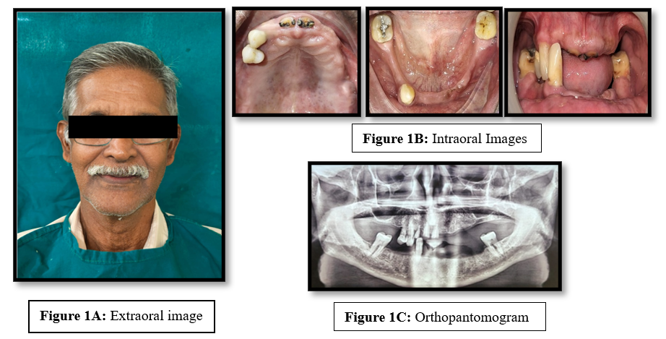
A 62-year-old male patient reported with the chief complaint of difficulty in chewing due to multiple missing teeth in both upper and lower arches. Detailed medical and dental histories were recorded, followed by a comprehensive extraoral (Figure 1A) and intraoral examination (Figure 1B). An orthopantomogram (OPG) was advised for further evaluation (Figure 1C). Radiographic assessment revealed previously underwent root canal treatment with respect to teeth 11, 12, and 21 (Figure 1C). Furcation involvement and a periapical lesion was noted with respect to tooth 37 (Figure 1C).

Figure 1: Extraoral and Intraoral images

As the patient was not willing to undergo extractions, a preventive prosthodontic approach involving tooth-supported overdentures was planned after evaluating the tentative jaw relations. Due to poor prognosis, 12 was advised for extraction.
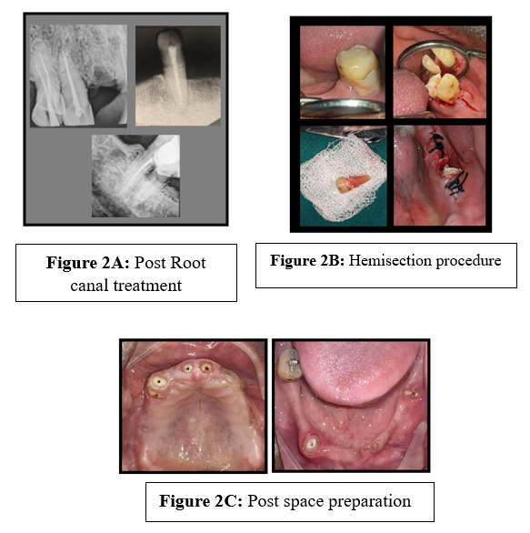
Diagnostic impression was made using irreversible hydrocolloid impression material (Zhermack SpA, Italy). Endodontic evaluation was done with respect to 11, 21 followed by root canal treatment was advised with respect to tooth 37. Intentional root canal treatment was performed with respect to 13, 14, and 43(Figure 2A). Hemisection was carried out with respect to 37 following endodontic therapy, retaining the healthy mesial root (Figure 2). Tooth 47 demonstrated a favourable prognosis and was consequently retained as an abutment for a ring clasp in the mandibular cast partial denture. The observed cervical abrasion was restored with composite resin.
Figure 2: Abutment tooth preparation

A healing period of three months was allowed following hemisection. Soft tissue coverage over the retained root was further subjected to crown lengthening. Carious lesions with respect to 11 and 21 were excavated, followed by crown lengthening to facilitate proper seating of metal copings.
Post space and abutment preparation was done to receive the copings (Figure 3). Impression was made using Putty and light-body elastomeric impression material (DPI (Dental Products of India, The Bombay Burmah Trading Corporation Ltd, Mumbai, Maharashtra) and the metal copings were fabricated and cemented using Glass ionomer cement (GC India Dental Pvt Ltd, Medak, India) (Figure 3A).
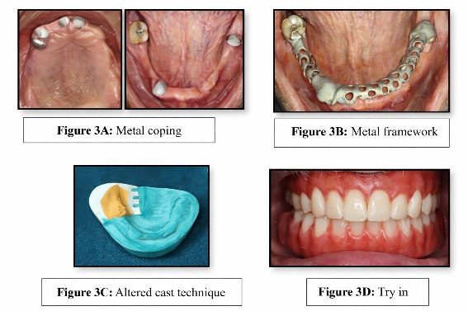
A mandibular cast partial overdenture was planned with a ring clasp engaging mesial and distal rest with respect to 47. After the rest seats preparation, impression for metal framework fabrication was made using Putty and light body elastomeric impression material (DPI (Dental Products of India, The Bombay Burmah Trading Corporation Ltd, Mumbai, Maharashtra). The designing of cobalt-chromium framework was made using EXOCAD software followed by milling (Figure 3B).
Figure 3: Try in

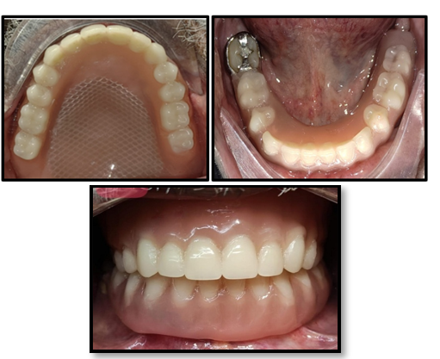
The framework try-in confirmed satisfactory fit (Figure 3B). Maxillary primary impression was made, followed by custom tray fabrication, border molding, and final impression procedures. A custom tray was fabricated over the mandibular metal framework and an Altered cast technique was employed to record the edentulous areas in functional state (Figure 3C). Occlusion rims were fabricated, followed by jaw relation and facebow transfer was done using Hanau’s spring bow. The casts were mounted on a semi-adjustable articulator and teeth arrangement was done. The trial denture was evaluated for esthetics and phonetics (Figure 3D). Acrylization was completed using heat-cured polymethyl methacrylate. The maxillary denture was reinforced with a titanium mesh (Figure 4). The final prostheses was delivered, and evaluated for occlusion, retention, stability, and esthetic outcomes. Necessary adjustments were made, and post-insertion instructions were given. Follow-up visits were scheduled at one week, three months, and six months. Clinical evaluation confirmed the integrity of the abutment teeth, with absence of secondary caries or pathological findings. The patient expressed complete satisfaction with the treatment outcome.

Figure 4: Final Insertion

Discussion:
Preservation of natural teeth offers several advantages, including maintenance of alveolar bone, preservation of proprioception, enhanced retention and support, and reduced psychological impact associated with tooth loss.⁸ In the present case, patient had preferred for preserving the remaining natural teeth, which supported the choice of a preventive prosthodontic approach. Tooth supported overdentures derive significant support from remaining natural teeth and their distribution and strategic positioning are critical for successful treatment planning.⁹ Although overdentures are associated with increased risk of abutment caries and technical complications, meticulous oral hygiene practices and regular use of topical fluorides significantly reduces these risks.⁹ Retention of natural teeth provides psychological reassurance to the patients and contributes to reduced alveolar bone resorption, thereby improving prosthesis stability and support.⁹ Louis et al.(1978) demonstrated superior masticatory efficiency in overdenture wearers compared to complete denture patients, which substantiates the extra clinical effort and expense.¹⁰ Although prefabricated intraradicular attachments offer enhanced prosthetic flexibility, clasp-retained abutments, as used in the present case, also provide adequate retention.⁹ Glen et al. (1977) emphasized the successful use of hemisectioned tooth as overdenture abutments, this concept was effectively applied in this case.⁷ The term convertible denture was used for the mandibular cast partial overdenture due to its adaptability following potential distal abutment loss.

Limitations of the case:
The primary limitation of this case report is the relatively short follow-up duration, which restricts assessment of long-term clinical performance, prosthesis durability, and potential biological or mechanical complications. Extended observation would be necessary to comprehensively evaluate the longevity and maintenance outcomes of the prosthetic rehabilitation.
Conclusion:
Tooth-supported overdenture represents the final conservative option before complete edentulism. They provide functional benefits, residual alveolar ridge preservation, and maintain proprioception through retained natural teeth. Critical considerations during treatment planning include strategic abutment selection, assessment of undercuts, evaluation of interocclusal space and reinforcement of the denture base. Patient-specific factors, such as oral hygiene, periodontal health, and bone support must be considered during the planning phase. Long-term success depends on careful case selection, precise execution of clinical steps, and regular follow-up visits to monitor abutment health. This article has described about a convertible cast partial denture which has added advantage to overdenture treatment where in the needed for new prosthesis fabrication is eliminated after the loss of abutment teeth.

References:
- Samra RK, Bhide SV, Goyal C, Kaur T. Tooth supported overdenture: A concept overshadowed but not yet forgotten. J Oral Res Rev. 2015;7(1):16-21.
- The Glossary of Prosthodontic Terms 2023: Tenth edition. J Prosthet Dent. 2023;130(4 Suppl 1):e1-e3. doi:10.1016/j.prosdent.2023.03.003
- Fenton AH. The decade of overdentures: 1970-1980. J Prosthet Dent. 1998;79(1):31-36. doi:10.1016/S0022-3913(98)70190-8
- Crum RJ, Rooney GE Jr. Alveolar bone loss in overdentures: A 5-year study. J Prosthet Dent. 1978;40(6):610-613.
- Miller PA. Complete dentures supported by natural teeth. J Prosthet Dent. 1958;8(6):924-928.
- Samantaray RK, Nanda K, Sahoo D. Overdentures and attachments: A review of literature. Indian J Forensic Med Toxicol. 2020;14(4):8660-8666.
- Richard GE, Sarka RJ, Arnold RM, Knowles KI. Hemisected molars for additional overdenture support. J Prosthet Dent. 1977;38(1):16-21.
- Prakash VS, Shivaprakash G, Hegde S. Four- and two-tooth supported conventional overdenture: Two case reports. Int J Oral Health Sci. 2013;3(1):61-64.
- Preiskel HW. Overdentures Made Easy: A Guide to Implant and Root Supported Prostheses. London: Quintessence Publishing Co Ltd; 1996.
- Rissin L, House JE, Manly RS, Kapur KK. Clinical comparison of masticatory performance and electromyographic activity of patients with complete dentures, overdentures, and natural teeth. J Prosthet Dent. 1978;39(5):508-511. doi:10.1016/S0022-3913(78)80181-4
- Ahmed T, Mirza AJ. Oral rehabilitation with mandibular cast partial overdenture opposing maxillary cast complete denture: A case report. Ann Abbasi Shaheed Hosp Karachi Med Dent Coll. 2014;19(2).
- Mohd NR, Ahmad SF, Etajuri EA. An alternative technique for fabrication of a tooth-supported removable partial overdenture: A case report. J Int Oral Health. 2021;13(5):514-518.
- Lord JL, Teel S. The overdenture: patient selection, use of copings, and follow-up evaluation. The Journal of Prosthetic Dentistry. 1974 Jul 1;32(1):41-51.
- Mohd NR, Ahmad SF, Etajuri EA. An alternative technique for fabrication of a tooth-supported removable partial overdenture: A case report. Journal of International Oral Health. 2021 Sep 1;13(5):514-8.
- Leong JZ, Beh YH, Ho TK. Tooth-supported overdentures revisited. Cureus. 2024 Jan 29;16(1).
- Sharma S, Shankar R, Pandey V, Kiran SR, Kumar P, Kiran BS. Tooth-Supported Overdenture: Rediscovering What We Thought We Outgrew. Cureus. 2026 Jan 16;18(1).
- Al-Kordy NM, Al-Saadi MH. Finite element study of stress distribution with tooth-supported mandibular overdenture retained by ball attachments or resilient telescopic crowns. European Journal of Dentistry. 2023 May;17(02):539-47.
- Donos N, André Mezzomo L, Mardas N, Goldoni M, Calciolari E. Efficacy of tooth‐supported compared to implant‐supported full‐arch removable prostheses in patients with terminal dentition. A systematic review. Journal of Clinical Periodontology. 2022 Jun;49:224-47.
- Koul R, Verma S, Kalia D, Verma K. Tooth-Supported Overdenture–Preventive Prosthodontics to Redeem Ridge Resorption. Journal of Primary Care Dentistry and Oral Health. 2024 May 1;5(2):82-5.
- Goswami M, MV S, Kumar R, Saxena R, Kumar K. A case report on tooth-supported overdentures: Restoring function and aesthetics. INTERNATIONAL JOURNAL OF APPLIED. 2024;10(4):230-4.
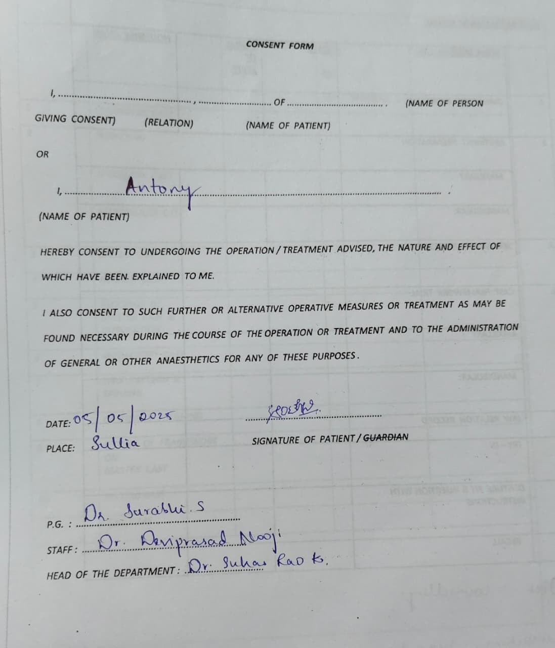
Patient Consent Form

