Minireview Article
Soft Tissue Calcifications in the Orofacial Region: A Review

Abstract
Soft tissue calcifications in the orofacial region are relatively frequent and are often observed unexpectedly during standard radiographic evaluations. They represent a broad group of conditions arising from abnormal calcium salt deposition, which may occur through dystrophic, metastatic, or idiopathic pathways. While most calcifications are asymptomatic and benign, certain cases can reflect underlying local or systemic disorders that require additional clinical assessment. Radiographic interpretation is crucial, focusing on factors like anatomical site, size, morphology, and distribution of the calcified deposits. This review provides a detailed discussion of soft tissue calcifications affecting the orofacial complex, with particular focus on their etiological factors, classification, radiological features, and clinical relevance. By synthesising evidence from existing literature, the article highlights the significance of proper identification and interpretation of these entities for dental clinicians and radiologists, thereby improving diagnostic accuracy and patient management.
Keywords: Soft tissue calcifications, Radiological features, Dystrophic, Metastatic, Idiopathic

Introduction
Pathologic calcification describes the disordered accumulation of calcium salts, predominantly calcium phosphate, within non-mineralised soft tissues—a phenomenon termed heterotopic calcification. Heterotopic calcifications are broadly divided into three categories: (1) dystrophic, typically associated with necrotic or chronically inflamed tissues; (2) metastatic, found in otherwise normal tissues in the presence of elevated serum calcium or phosphate; and (3) idiopathic (calcinosis), which occurs in normal tissues despite normal metabolic profiles.
Within the oral and maxillofacial complex, such calcifications are commonly encountered, often as incidental discoveries on routine imaging studies. Although these calcifications remain asymptomatic and clinically insignificant, certain lesions may indicate underlying pathologic processes that necessitate further investigation, monitoring, or treatment. Radiographic interpretation plays a crucial role in their evaluation, with factors such as anatomical location, number, distribution, and radiographic pattern serving as important diagnostic criteria.
This review aims to explore the occurrence, classification, and diagnostic features of soft tissue calcifications within the orofacial complex, emphasizing their clinical significance and the role of imaging in differentiating benign incidental findings from conditions requiring clinical intervention.^{[1][2][3]}

LIST 1 : Classification of Soft Tissue Calcifications in the Orofacial Region Based on Pathogenesis
Main Category | Subcategory | Conditions Included
Heterotrophic Calcification | Dystrophic Calcification | Tonsilloliths
 |  | Calcified Lymph Node
 |  | Cysticercosis
 |  | Medial Calcific Sclerosis
 |  | Calcified Atherosclerotic Plaque
 | Idiopathic Calcification | Sialolith
 |  | Phleboliths
 |  | Laryngeal Cartilage Calcification
 |  | Rhinolith
 |  | Antrolith
 | Metastatic Calcification
Heterotrophic Ossification
  Ossification of Stylohyoid Ligament
 |  | Osteoma Cutis
 |  | Myositis Ossificans

- Dystrophic Calcification:

Tonsilloliths, or tonsil stones, are small, hard lumps that form in tiny pockets of the tonsils when trapped germs and dead cells harden into calcium. They are most common in young and middle-aged adults. Usually, they are small, appear alone, and form on one side, but sometimes several can form on both sides. Many people have no symptoms, but tonsil stones can cause bad breath, a feeling of something stuck in the throat, trouble or pain when swallowing, sore throat, ear pain, swelling, or even an infection near the tonsil. Tonsilloliths are often discovered incidentally on panoramic radiography as radiopaque spots near the mid-portion of the mandibular ramus (Fig 1) and also frequently immediately inferior to the mandibular canal. Only a small number of X-rays show them. Therefore, dentists should always rule out tonsilloliths so that asymptomatic patients aren’t sent for unnecessary investigations.^{[2][4][5][6]}
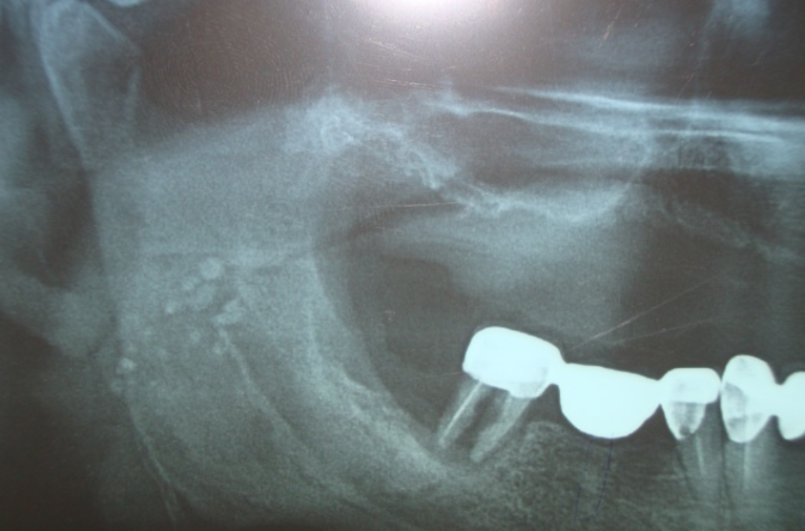
Figure 1: Tonsilloliths presenting as multiple radiopacities over the ramus ^{[4]}

Calcified Lymph Nodes in the Orofacial Region are relatively rare, observed in only a small proportion of enlarged cervical nodes (approximately 1%). It represents a typical form of dystrophic calcification, where mineral deposition occurs in lymphatic tissue that has undergone chronic inflammation or necrosis, while serum calcium and phosphate levels remain unaffected. The condition is most often linked to longstanding infections, particularly tuberculosis and other granulomatous diseases, though it can also arise from nonspecific inflammatory changes. Radiographically, calcified lymph nodes usually appear as irregular, lobulated, or “cauliflower-shaped” radiopacities situated along the cervical, submandibular, or parotid chains. They may occur singly or in clusters and are frequently detected as incidental findings on panoramic radiographs or cone-beam computed tomographic (CBCT) scans. Their radiographic appearance can closely resemble other calcifications, including salivary stones, phleboliths, vascular atheromas, myositis ossificans, or even calcified tumours. For this reason, advanced imaging methods such as ultrasonography, sialography, and CT reconstruction are often necessary for accurate differentiation. On histopathological examination, these calcifications are associated with features of chronic inflammation, including infiltration by lymphocytes and plasma cells, fibrosis, and acinar atrophy. These pathological changes create a framework for dystrophic calcification, even if calcified deposits are not always demonstrable microscopically due to fragmentation during surgical removal. Clinically, affected individuals may present with firm, non-tender nodular swellings that remain unchanged during meals, helping to distinguish them from salivary calculi. However, many cases remain asymptomatic and are discovered incidentally. Asymptomatic lesions may simply be monitored, while cases causing discomfort or diagnostic confusion often require surgical excision to both alleviate symptoms and confirm the diagnosis histologically. The prognosis is generally excellent, with low recurrence risk once the underlying infection has resolved. Importantly, recognising calcified lymph nodes in dental and maxillofacial imaging is essential, as they not only mimic other calcified lesions but may also serve as indicators of previous or chronic infections.^{[2][7][8]}

Oral Cysticercosis is an uncommon parasitic condition caused by the larval stage (cysticercus cellulosae) of Taenia solium.^{[9]} Infection may occur either by consuming inadequately cooked pork containing larvae or, more frequently, through the fecal–oral route when food or water is contaminated with eggs. After ingestion, the embryos penetrate the intestinal mucosa, enter the circulatory system, and may lodge in different tissues such as the central nervous system, skeletal muscles, subcutaneous tissue, eyes, and, less commonly, the oral cavity. Within the maxillofacial region, the larvae often localize in the muscles of mastication, tongue, buccal mucosa, or lips, where they can undergo degeneration followed by dystrophic calcification. Clinically, oral cysticercosis usually manifests as a solitary, painless, well-defined submucosal nodule with intact overlying mucosa. Owing to its nonspecific presentation, it is frequently mistaken for benign conditions such as fibroma, lipoma, mucocele, or minor salivary gland tumors. Radiographically, calcified cysticerci in oral or cervical muscles may appear as multiple, elongated, rice-grain–like radiopacities. Histopathological examination remains the definitive diagnostic tool, typically showing a fibrous capsule enclosing cystic spaces with parasite remnants, duct-like invaginations, and occasionally calcified corpuscles. Although localized, their identification is clinically significant as they may signal systemic dissemination. Neurocysticercosis, the most severe form, is associated with seizures, raised intracranial pressure, and neurological deficits. For this reason, patients with oral cysticercosis should be carefully screened for involvement of other organs. Treatment most often involves surgical excision of isolated lesions, which is curative. In disseminated cases, antiparasitic agents such as albendazole or praziquantel may be indicated. Overall, oral cysticercosis carries an excellent prognosis, but comprehensive evaluation is essential to rule out potentially life-threatening complications.^{[10][11][12]}

Medial calcific sclerosis (Mönckeberg’s sclerosis) is an age-related degenerative vascular condition characterized radiographically by calcification within the medial wall of arteries. On panoramic imaging, it most commonly involves the facial artery and less frequently the carotid artery. The calcified arterial wall outlines the vessel, producing two thin, parallel, linear radiopaque lines that may appear straight or tortuous, classically described as a “pipe-stem” or “tram-track” appearance (Fig 2). In cross-section, the calcification may present as a circular or ring-like pattern. There is no internal structure, as calcium deposition is diffuse and confined to the medial layer of the vessel wall. This radiographic appearance is considered pathognomonic for medial calcific sclerosis, although clinical correlation may be required to differentiate it from calcified atherosclerotic plaques.^{[13]}
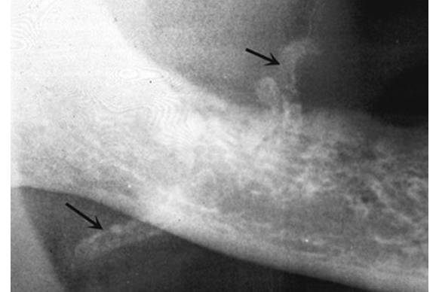
Figure 2: Cropped panoramic image showing tram track appearance due to calcification of a blood vessel
Calcified atherosclerotic plaque is a dystrophic calcification that develops within the intima of the extracranial carotid arteries, most commonly at the carotid bifurcation, and is a significant source of cerebrovascular embolic and occlusive disease. On panoramic radiographs, it appears as heterogeneous, irregular, and often multiple radiopacities located in the soft tissues of the neck, typically adjacent to the greater cornua of the hyoid bone and at the level of C3–C4 cervical vertebrae or the intervertebral space between them (Fig 3). These calcifications are usually sharply defined and show a vertical linear distribution. The main differential diagnosis is calcified triticeous cartilage, which can be distinguished by its uniform size, shape, and consistent anatomical location. Patients with suspected calcified carotid plaque should be referred for medical evaluation.^{[14]}
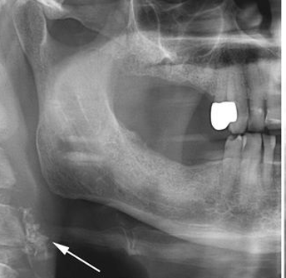
Figure 3: Calcification related to the carotid artery
    - Idiopathic Calcification
Sialoliths (salivary gland calculi) are the most common pathology of the major salivary glands, occurring most frequently in the submandibular gland (about 80%), less often in the parotid gland (10–20%), and rarely in the sublingual gland (1–5%). They develop through the deposition of calcium salts around a nidus such as epithelial cells, mucus, bacteria, or foreign material, and may range in size from 0.1 to 30 mm, with roughly one-quarter of cases presenting with multiple stones. The alkaline nature of submandibular saliva and the gland’s ductal anatomy make it especially prone to stone formation. Clinically, patients often present with painful glandular swelling that worsens during meals, reduced salivary flow, and, in some cases, recurrent acute or chronic sialadenitis, with potential complications including infection, abscess formation, ductal stenosis, mucoceles, and glandular damage.^{[15][16]} Projection imaging (intraoral occlusal and panoramic) is the first-line investigation for suspected sialolithiasis, effectively detecting calcified stones. Occlusal views are used for submandibular duct sialoliths and panoramic views for both parotid and submandibular glands, though it fails to identify non-calcified stones; multidetector CT evaluates large, well-calcified sialoliths, though small or poorly calcified stones and ductal strictures may be missed; sialography allows detailed assessment of ductal morphology and gland function, is mainly indicated in chronic inflammatory and obstructive conditions, and when combined with CBCT provides high-resolution 3D imaging; Sialendoscopy enables direct visualization and minimally invasive management of ductal obstructions, with acute inflammation being its main contraindication.^{[13]}

Phleboliths are small calcified bodies that develop within veins, most often in association with venous malformations, and are observed in 40–50% of affected individuals, with prevalence increasing with age. They usually represent incidental, clinically insignificant findings, but may mimic other calcifications. Their formation is attributed to sluggish blood flow leading to thrombus formation and subsequent calcification. They are typically round or oval in cross-section, measure up to 6 mm in diameter, and have a smooth periphery; when viewed longitudinally, they may appear elongated or sausage-shaped. Radiographically, they demonstrate a mixed radiolucent–radiopaque appearance with characteristic concentric laminations, producing a bull’s-eye or target-like pattern, and may show radiolucent flow voids representing patent portions of the vessel. Phleboliths may be incidentally detected on routine dental radiographs such as occlusal views, panoramic radiographs (OPG), and lateral cephalograms. Although they can resemble sialoliths, sialoliths are usually solitary or arranged linearly, whereas phleboliths are commonly multiple and randomly clustered; correct identification is important as their presence suggests an underlying vascular lesion such as a hemangioma, particularly before surgical intervention.^{[13]}
On CT, they are seen as calcified foci often accompanied by a soft-tissue tail corresponding to the draining vein or venous plexus, while ultrasound demonstrates venous malformations as hypoechoic or heterogeneous lesions containing echogenic foci. Magnetic resonance imaging (MRI) is regarded as the gold standard for evaluating venous malformations due to its ability to depict phleboliths, slow-flow characteristics, and enhancement patterns, and phleboliths manifest as signal voids on all sequences. Although benign, their recognition is important to avoid confusion with vascular or urinary tract calculi, and unlike high-flow vascular lesions that produce tram-track arterial calcifications, phleboliths are diagnostic of low-flow venous malformations. Biopsy is not recommended because of the vascular nature of these lesions and the associated risk of bleeding.^{[17][18][19]}
Laryngeal cartilage calcification is a physiological, age-associated process that predominantly affects the hyaline cartilages of the larynx, particularly the thyroid, cricoid, and arytenoid cartilages. With advancing age, these cartilages undergo progressive mineralisation beginning with calcification and, in some cases, leading to ossification. In a study conducted by Sycińska-Dziarnowska et al (2017) [20], which evaluated 957 lateral cephalometric radiographs, calcification of the laryngeal cartilages was identified in 37.8% of individuals, with a significant correlation observed between its presence and both age and sex. The findings revealed that all female participants exhibited calcification by the age of 30, while this was true for all male participants by the age of 50. The study emphasised the necessity of recognising laryngeal cartilage calcification as a normal anatomical variant, particularly in radiographic assessments, to prevent misinterpretation as pathological calcification. Awareness of these age- and sex-related patterns is clinically significant in fields such as orthodontics, diagnostic radiology, and head and neck imaging.^{[21][22]}
Calcified triticeous cartilages are small, paired structures located within the lateral thyrohyoid ligaments and are commonly seen on lateral skull or panoramic radiographs as soft-tissue calcifications in the pharyngeal region, inferior to the greater cornua of the hyoid bone and adjacent to the superior border of the fourth cervical vertebra (C4), while the superior cornua of the calcified thyroid cartilage appears medial to C4. The triticeous cartilage, meaning “grain of wheat,” typically measures about 7–9 mm in length and 2–4 mm in width and has a well-defined, smooth periphery with a highly regular shape; on panoramic images, usually only the superior 2–3 mm of the calcified thyroid cartilage is visible. Radiographically, calcified triticeous cartilages are generally homogeneously radiopaque, sometimes with a visible peripheral cortex, and although they may be confused with calcified atheromatous plaque at the carotid bifurcation, their solitary nature and uniform size and shape aid in correct differentiation.^{[13]}
Antroliths and Rhinoliths are uncommon calcified masses that develop in the maxillary sinus and nasal cavity, respectively, through the gradual deposition of mineral salts primarily calcium and magnesium around a central nidus, which may be endogenous (e.g., mucus, epithelial debris) or exogenous (e.g., foreign bodies, surgical remnants). These concretions often remain asymptomatic for extended periods, only becoming clinically evident when they obstruct normal drainage or provoke local inflammation. Antroliths are usually identified incidentally during imaging for recurrent unilateral sinusitis and may present with facial discomfort, purulent nasal discharge, or dental issues when enlarged. Their radiographic appearance can resemble benign or malignant tumours, making CT imaging and histopathological analysis essential for accurate diagnosis. A history of prior sinonasal surgery, such as the Caldwell–Luc procedure, may increase the risk of antrolith formation. Rhinoliths, on the other hand, typically result from long-retained nasal foreign bodies—often introduced in childhood—that become encrusted over time, leading to unilateral nasal obstruction, foul-smelling discharge, epistaxis, or chronic rhinitis. Diagnosis is primarily clinical, aided by anterior rhinoscopy, nasal endoscopy, and imaging when needed. Recognizing these rare conditions is critical in patients with chronic unilateral sinonasal symptoms or unexplained radiopaque findings to ensure appropriate management and avoid misdiagnosis. ^{[24][25][26]}
- Metastatic calcification
Metastatic calcification is a pathological process in which calcium salts accumulate in previously normal, healthy soft tissues as a result of systemic disturbances in mineral metabolism. Unlike dystrophic calcification, which occurs in damaged or necrotic tissues despite normal serum calcium levels, metastatic calcification arises from elevated serum calcium and/or phosphate levels that lead to inappropriate mineral deposition throughout the body. The condition is most frequently associated with chronic kidney disease, secondary hyperparathyroidism, vitamin D disorders, and other systemic conditions that disrupt the delicate balance between calcium, phosphate, and regulatory hormones such as parathyroid hormone (PTH). In these states, impaired renal excretion of phosphate and altered calcium regulation create a biochemical environment conducive to the precipitation of calcium-phosphate crystals in soft tissues. Although metastatic calcification often involves highly vascularized organs such as the lungs, kidneys, gastric mucosa, and blood vessels, soft tissue deposition can also occur in the orofacial region. In the oral cavity, metastatic calcifications may form within the mucosa, salivary glands, or submucosal tissues. They are frequently asymptomatic and may be discovered incidentally during clinical examination or radiographic imaging. Radiographically, these calcifications typically appear as multiple small, well-defined radiopaque structures, while clinical examination may reveal a firm or granular texture depending on the extent and location of the deposits. Because the presence of metastatic calcification reflects an underlying systemic metabolic disorder rather than a local pathology, diagnosis should prompt a comprehensive evaluation of the patient’s calcium–phosphate balance, renal function, and endocrine status. Management focuses primarily on correcting the systemic abnormality, such as restoring phosphate balance, controlling hypercalcemia, optimising renal care, or regulating PTH levels, rather than treating the calcified deposits themselves, which may remain stable or regress once metabolic control is achieved. In the context of oral health care, awareness of metastatic calcification is essential because orofacial findings may represent early indicators of significant systemic disease. Identifying such calcifications through routine examination can therefore play an important role in early detection, interdisciplinary referral, and comprehensive patient management.^{[27]}

    - HETEROTROPHIC OSSIFICATION
Heterotopic ossification is defined as the formation of mature lamellar bone in soft tissues at sites where bone does not normally exist, such as muscles, tendons, ligaments, or other connective tissues, usually following trauma, surgery, inflammation, or neurologic injury.
Ossifcation of the Stylohyoid Ligament Eagle syndrome is a rare clinical condition characterized by an abnormally elongated styloid process or calcified stylohyoid ligament, leading to irritation or compression of adjacent neurovascular structures. It typically presents with craniofacial or cervicopharyngeal symptoms such as unilateral throat pain, odynophagia, foreign body sensation, earache, and in some cases, symptoms resembling trigeminal or glossopharyngeal neuralgia. While the normal length of the styloid process ranges from 2.5 to 3 cm, elongation beyond this can become symptomatic depending on anatomical variation and nerve involvement. Diagnosis is often delayed due to its nonspecific symptomatology and resemblance to other head and neck disorders. Imaging, particularly 3D CT with multiplanar reconstructions, is the most reliable modality for confirming the diagnosis, allowing precise assessment of styloid process length, angulation, and spatial relationship to nearby structures. Management typically involves surgical shortening or resection of the styloid process, either via intraoral or transcervical approaches, with excellent symptomatic relief in most cases. Early recognition and appropriate imaging are critical to avoid misdiagnosis and ensure effective treatment.^{[28][29][30]}
Osteoma cutis is a rare, benign dermatologic condition characterized by the formation of ectopic bone within the dermis or subcutaneous tissue. It is classified into two types: primary, which arises spontaneously without an underlying cause and accounts for approximately 15% of cases, and secondary, which is more common (85%) and develops in association with trauma, inflammatory skin conditions, metabolic disorders, neoplasms, or scarring [12]. The condition is seen more frequently in females, particularly in the second and third decades of life. Clinically, osteoma cutis presents as firm, often asymptomatic papules, nodules, or plaques ranging from 0.1 cm to 5 cm in size. Variants include solitary, miliary, plate-like, and, in rare instances, perforating forms where bone extrudes through the epidermis. The exact pathogenesis remains unclear, though proposed mechanisms include fibroblast metaplasia into osteoblasts, mesenchymal cell migration, and genetic mutations such as those affecting the GNAS gene. Diagnosis involves clinical assessment, imaging (radiographs, ultrasound, CT, or cone-beam CT showing radiopaque lesions), and histopathological confirmation.
Radiographically, osteoma cutis most commonly involves the cheek and lip regions. In these areas, the ossified focus may be superimposed over tooth roots or the alveolar process, mimicking dense bone. The internal structure may be homogeneously radiopaque, but usually a radiolucent centre representing normal fatty marrow may be visualised, giving the lesion a doughnut appearance radiographically. Accurate localisation can be achieved by placing an intraoral receptor between the cheek and alveolar process (Fig 4) or by using a low kVp (60) soft-tissue posteroanterior skull radiograph with the cheek blown outward.^{[13]} Laboratory evaluation may be necessary to rule out systemic causes, particularly in secondary cases. Treatment strategies vary based on the size, number, and cosmetic impact of the lesions, ranging from topical retinoids for minor cases to surgical excision, dermabrasion, punch removal, or laser therapies (e.g., CO₂, erbium: YAG, or Q-switched Nd: YAG lasers). While the condition is benign and non-invasive, complete removal generally yields good outcomes, though recurrence and pigmentary changes may occur, especially in extensive or cosmetically sensitive presentations.^{[31][32]}
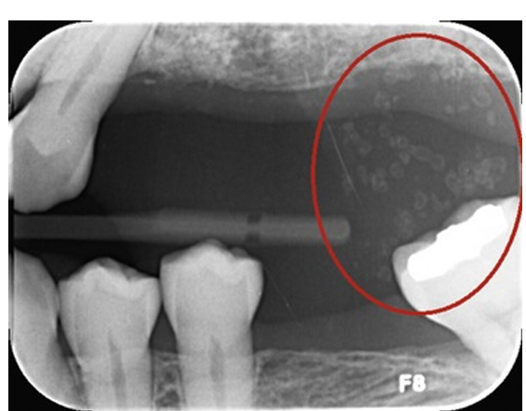
Figure 4: Osteoma cutis presenting as doughnut-like radiopaque calcifications

Myositis ossificans (MO) is a benign condition characterised by the abnormal formation of bone tissue within muscle or soft tissues, often following trauma, especially in the extremities, though it can also occur without any prior injury. Clinically, MO typically presents as a firm, tender mass that develops after muscle contusion and progresses through distinct phases, starting with inflammation, then a proliferative stage marked by cartilage formation, and ultimately ossification. Radiographically, early lesions may be challenging to differentiate from other soft tissue masses, but as the condition advances, well-defined, radiopaque ossified areas become evident within the muscle. Histologically, MO shows mature bone tissue surrounded by a fibrous capsule, with the ossification believed to result from mesenchymal cell metaplasia into osteoblasts. Management is usually conservative, as many cases resolve spontaneously; however, surgical removal may be necessary when significant symptoms or functional impairment occur.[33]

Conclusion
Soft tissue calcifications in the orofacial region comprise a wide spectrum of entities that are often detected incidentally on routine radiographs. Although many of these deposits are clinically insignificant, their recognition is important since specific patterns may serve as diagnostic indicators of underlying local or systemic conditions. Rather than being dismissed as incidental findings, these calcifications should be considered potential diagnostic markers that enhance clinical insight into oral and systemic health. Ongoing research and increased professional awareness remain essential to improve imaging interpretation, refine diagnostic accuracy, and ultimately optimise patient care in oral and maxillofacial radiology.
Disclaimer (Artificial intelligence)
Author(s) hereby declare that NO generative AI technologies such as Large Language Models (ChatGPT, COPILOT, etc.) and text-to-image generators have been used during the writing or editing of this manuscript.

References:
- Omami G. Soft tissue calcification in oral and maxillofacial imaging: a pictorial review. Int J Dent Oral Sci. 2016;3(4):219-224.
- Muduli M. Soft tissue calcifications in the orofacial region. Indian J Forensic Med Toxicol. 2020;14(4):8573-8576.
- Monsour PA, Romaniuk K, Hutchings RD. Soft tissue calcifications in the differential diagnosis of opacities superimposed over the mandible by dental panoramic radiography. Aust Dent J. 1991;36(2):94-101.
- Babu BB, Avinash Tejasvi ML, Anulekha Avinash CK, Chittaranjan B. Tonsillolith: a panoramic radiograph presentation. J Clin Diagn Res. 2013;7(10):2378-2379.
- Hiranandani LH. A giant tonsillolith. J Laryngol Otol. 1967;81(7):819-822.
- Pruet CW, Duplan DA. Tonsil concretions and tonsilloliths. Otolaryngol Clin North Am. 1987;20:305-309.
- Hirschfeld JJ. Calcification in lymph nodes. Oral Surg Oral Med Oral Pathol. 1986;61(4):412-413.
- Eisenkraft BL, Som PM. The spectrum of benign and malignant etiologies of cervical node calcification. AJR Am J Roentgenol. 1999;172(5):1433-1437.
- Hosur MB, Byakodi S, Puranik RS, Vanaki SS, Puranik SR, Shivakumar MS. Oral cysticercosis: a case report and review of literature. J Maxillofac Oral Surg. 2015;14(3):853-857.
- Deshmukh A, Avadhani A, Tupkari JV, Sardar M. Cysticercosis of the upper lip. J Oral Maxillofac Pathol. 2011;15(2):219-222.
- Jay A, Dhanda J, Chiodini PL, Woodrow CJ, Farthing PM, Evans J, et al. Oral cysticercosis. Br J Oral Maxillofac Surg. 2007;45(4):331-334.
- Rzymska-Grala I, Stopa Z, Grala B, Gołębiowski M, Wanyura H, Zuchowska A, et al. Salivary gland calculi: contemporary methods of imaging. Pol J Radiol. 2010;75(3):25-30.
- Mallya S, Lam E, editors. White and Pharoah’s Oral Radiology: Principles and Interpretation. 8th ed. St. Louis: Elsevier; 2019.
- Karjodkar FR. Essentials of Oral and Maxillofacial Radiology. 2nd ed. New Delhi: Jaypee Brothers Medical Publishers; 2019.
- Madani G, Beale T. Inflammatory conditions of the salivary glands. Semin Ultrasound CT MRI. 2006;27(6):440-451.
- Jäger L, Menauer F, Holzknecht N, Scholz V, Grevers G, Reiser M. Sialolithiasis: MR sialography of the submandibular duct. Radiology. 2000;216(3):665-671.
- Abrantes TC, Barra SG, Silva LVO, Abrahão AC, Mesquita RA, Abreu LG. Phleboliths of the head and neck region: a case report. Ann Maxillofac Surg. 2022;12(2):231-233.
- Keberle M, Robinson S. Physiologic and pathologic calcifications and ossifications in the face and neck. Eur Radiol. 2007;17:2103-2111.
- Eivazi B, Fasunla AJ, Güldner C, Masberg P, Werner JA, Teymoortash A. Phleboliths from venous malformations of the head and neck. Phlebology. 2013;28:86-92.
- Sycińska-Dziarnowska M, Lindauer SJ, Szyszka-Sommerfeld L, Spagnuolo G, Woźniak K. Laryngeal cartilage calcifications on lateral cephalometric radiographs. Sci Rep. 2024;14:2388.
- Chievitz JH. Untersuchungen über die Verknocherung der menschlichen Kehlknorpel. Arch Anat Physiol. 1882;49:303-349.
- Turk LM, Hogg DA. Age changes in the human laryngeal cartilages. Clin Anat. 1993;6:154-162.
- Shenoy V, Maller V, Maller V. Maxillary antrolith: a rare cause of recurrent sinusitis. Case Rep Otolaryngol. 2013;2013:527152.
- Polson CJ. On rhinoliths. J Laryngol Otol. 1943;58(3):79-116.
- Duce MN, Talas DU, Özer C, Yildiz A, Apaydin FD, Özgür A. Antrolithiasis: a retrospective study. J Laryngol Otol. 2003;117(8):637-640.
- Brehmer D, Riemann R. The rhinolith: a possible differential diagnosis of unilateral nasal obstruction. Case Rep Med. 2010;2010:845671.
- Verma DK, Thelekkat Y, Bansal S. Metastatic calcification of the floor of the mouth secondary to chronic renal failure. Dentomaxillofac Radiol. 2015;44(5):20140023.
- Marioni G, Staffieri C, Zuccon A, Staffieri A. Eagle’s syndrome: a frequently missed diagnosis. Acta Otorhinolaryngol Ital. 2018;38(2):166-169.
- Eagle WW. Elongated styloid process: report of two cases. Arch Otolaryngol. 1937;25:584-587.
- Langlais RP, Miles DA, Van Dis ML. Elongated and mineralized stylohyoid ligament complex. Oral Surg Oral Med Oral Pathol. 1986;61:527-532.
- Lau K, Massasso D, Wood B. A rare case of perforating osteoma cutis. Australas J Dermatol. 2017;58(3):e113-e115.
- Thompson C, Saeed M. Osteoma cutis. In: StatPearls [Internet]. Treasure Island (FL): StatPearls Publishing; 2024.
- Jung HJ, Lee SJ, Kim MJ, Jeong SH, Kim SW. Myositis ossificans of the masticatory muscle. Exp Ther Med. 2020;19(5):3622-3626.

