Revolutionizing Root Biomodification: SEM Insights Into Glycolic Acid Vs. EDTA
ABSTRACT
Background: Mechanical instrumentation of periodontally diseased root surfaces results in the formation of a smear layer containing organic debris and microorganisms, which may interfere with periodontal regeneration. Root biomodification (RB) aims to remove this smear layer and enhance the biologic compatibility of the root surface.
Aim: To evaluate and compare the effectiveness of 5% and 10% glycolic acid (GA) with 17% ethylenediaminetetraacetic acid (EDTA) on smear layer removal, dentinal tubule surface characteristics, and dentinal erosion on periodontally affected root surfaces using scanning electron microscopy (SEM).
Materials and Methods: Thirty extracted periodontally affected human teeth were used to prepare 60 root specimens, which were randomly allocated into four groups: Group I (control), Group II (5% GA), Group III (10% GA), and Group IV (17% EDTA). Root biomodification agents were applied for 3 minutes using active burnishing. SEM analysis at ×2000 magnification was performed to assess smear layer removal, dentinal tubule surface area, and dentinal erosion using a standardized scoring system. Statistical analysis was carried out using one-way ANOVA with post-hoc analysis, and p < 0.05 was considered statistically significant.
Results: The 5% GA group showed the highest smear layer removal score (3.86 ± 0.66), followed by 10% GA (3.14 ± 0.66) and 17% EDTA (2.43 ± 0.51), with significant intergroup differences (p < 0.001). Dentinal tubule surface area was significantly greater in the 5% GA group (45.7%). Dentinal erosion was observed only in the 10% GA group.
Conclusion: Within the limitations of the study, 5% glycolic acid demonstrated superior smear layer removal and increased dentinal tubule surface area without causing dentinal erosion, suggesting its potential as an effective root biomodification agent.
Keywords: Glycolic acid; Root biomodification; Smear layer; Dentinal tubules; Periodontitis.
INTRODUCTION:
Periodontal disease results from inflammation of the supporting structures of the teeth, leading to progressive loss of attachment and eventual tooth loss. This condition is triggered by harmful substances released by periodontal pathogens¹. In addition to inflammatory destruction, periodontitis induces significant alterations in the root surface, including degradation of collagen fibers embedded in cementum and penetration of microorganisms into cementum and dentinal tubules. These pathologic changes, combined with mechanical instrumentation during periodontal therapy, result in the formation of a smear layer composed of organic debris, bacteria, endotoxins, and necrotic tissue. The presence of this smear layer interferes with fibrin clot adhesion and prevents intimate contact between the root surface and regenerating tissues, thereby hindering the formation of new periodontal attachment necessary for regeneration².
The success of regenerative periodontal therapy is influenced by several factors, including defect morphology, surgical technique, wound stability, biomaterials employed, and clinician expertise. Among these variables, the biologic condition of the root surface plays a critical role in determining healing outcomes. Root surface biomodification (RSB) has therefore been proposed as an adjunctive approach to enhance periodontal regeneration. However, despite extensive investigation, its effectiveness in procedures involving intra-bony defects, furcation involvement, and root coverage remains controversial³. RSB aims to detoxify and condition the root surface, enhance surface wettability, promote blood clot formation, and improve clot stabilization, all of which are essential for successful periodontal wound healing. Nevertheless, conflicting evidence regarding its clinical benefits has resulted in ongoing debate about its routine application.
Various root biomodification (RB) agents, including citric acid, EDTA, fibronectin, tetracyclines, and LASERs, have been investigated, with citric acid and EDTA being the most commonly studied⁴˒⁵. Citric acid is effective in smear layer removal and exhibits strong antimicrobial properties; however, its lack of chemical stability and aggressive demineralizing action limit its clinical acceptability⁶. Seventeen percent EDTA is widely accepted due to its chelating action and controlled demineralization, but it demonstrates limited antimicrobial activity against certain periodontal pathogens and may leave potentially harmful residues on the root surface⁷. Recent systematic reviews have reported no consistent therapeutic advantages of currently available RB agents, underscoring the need for more biologically favorable alternatives.
Glycolic acid (GA) is a naturally occurring alpha-hydroxy acid with two carbon atoms and high water solubility. It is extensively used in dermatology due to its antimicrobial properties, particularly against Gram-negative anaerobic microorganisms. GA has also been shown to promote fibroblast initiation, proliferation, and connective tissue attachment. Emerging dental literature suggests that GA is comparable to EDTA in smear layer removal from root canal walls and is effective as a pre-etching agent in restorative procedures⁸. However, limited evidence exists regarding its effect on periodontally affected root surfaces. Hence, the present study was undertaken to evaluate and compare the effectiveness of different concentrations of GA with EDTA on root surface characteristics
MATERIALS AND METHODS
Thirty human teeth, which were recommended for extraction due to periodontitis, were collected from the department of surgery post-extraction and included in the current in vitro study.
Teeth from patients who had not received periodontal treatment in the past 6 months, had a hopeless periodontal prognosis, no endodontic treatment, minimal instrumentation during extraction, no root caries, and complete root formation were included. Teeth with a history of acute pain or swelling in the last 3 months, root resorption, and fractures were excluded. 60 specimens were prepared from extracted teeth. Samples were divided into four groups, Group 1 is control group without application of root biomodification agent, Group 2 samples were treated with a 5% GA, Group 3 samples were treated with a 10% GA solution, and group 4 were treated with 17% EDTA solution for 3 mins respectively.
The freshly extracted teeth were thoroughly cleaned in a saline solution to eliminate any blood or debris. Visible calculus was meticulously removed using hand scalers, and the roots underwent thorough planing with Gracey Curettes. Crowns were separated at the Cemento-Enamel Junction (CEJ) through transverse sectioning with a high-speed bur. A 5 mm segment of the tooth from the CEJ was selected, and markings were applied to the root surface. Longitudinal sectioning was performed along the pulp chamber to divide the tooth into individual halves, and a 5 mm × 5 mm specimen was prepared. To differentiate between the mesial and distal parts of the specimen, markers were applied on the pulpal side.

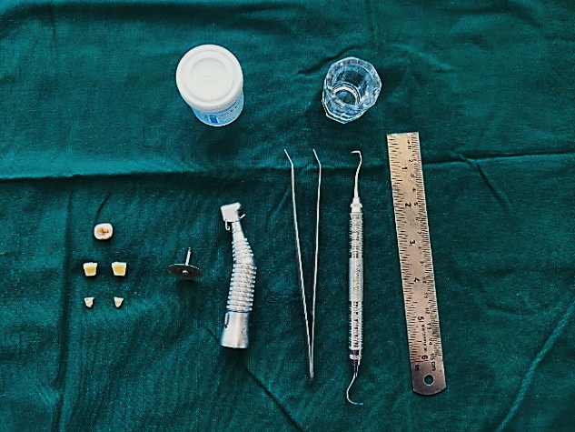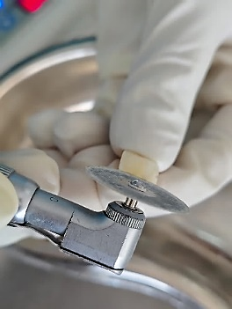
FIGURE 1: ARMAMENTARIUM FIGURE 2: SAMPLE SECTIONING
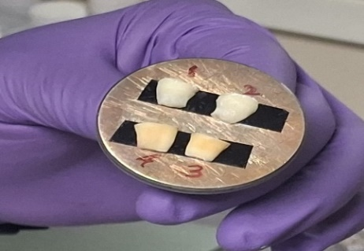
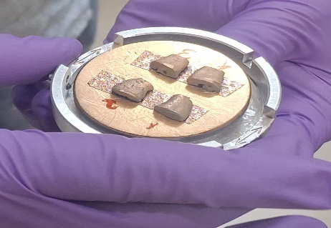

FIGURE 3: GOLD SPUTTER COATING

Specimens were treated with root biomodification agents using cotton pellets for 3 minutes, replaced every 30 seconds to maintain concentration, then rinsed with distilled water. They were dehydrated with ethanol and 100% acetone, dried for 30 minutes, mounted on SEM stubs, and sputter-coated with gold for conductivity. The root surfaces were scanned and analysed at ×2000 magnification using an SEM, with images displayed on a computer screen. Photomicrographs of representative areas were examined for changes in surface topography. The micrographs were examined for evaluation of smear layer removal, total number of dentinal tubules, total number of patent dentinal tubules using ranking criteria for the surface characteristics given by west et al in 1998.⁹
- Smear layer with some tubules just apparent
- Less than or equal to 10 tubules visible with majority occluded
- Greater than 10 tubules visible with majority occluded
- Less than or equal to 10 tubules visible with majority patent
- Greater than 10 tubules visible with majority patent
Statistically analysis was done using ANOVA with POST-HOC analysis. Mean and standard deviation were used to represent descriptive statistics. P = 0.05 was considered statistically significant in all the analyses.
RESULTS
A total of 30 extracted teeth yielding 60 root specimens were evaluated under scanning electron microscopy. All specimens within each group demonstrated uniform surface characteristics, ensuring consistency and reproducibility of observations.
Smear Layer Removal
The Group 1( control), which received no root biomodification, demonstrated the poorest surface characteristics, with a mean smear layer removal score of 1.71 ± 0.61, indicating heavy smear layer presence and minimal dentinal tubule exposure. Among the experimental groups, Group 2 (5% GA) showed the highest mean smear layer removal score (3.86 ± 0.66), reflecting substantial removal of the smear layer and improved dentinal surface cleanliness. This was followed by the Group 3(10% GA)(3.14 ± 0.66) and the Group 4 (17% EDTA) (2.43 ± 0.51).
Statistical analysis using one-way ANOVA revealed a highly statistically significant difference among the groups (p < 0.001). Post-hoc comparisons confirmed that 5% GA was significantly more effective in smear layer removal than both 10% GA and EDTA. Although 10% GA performed better than EDTA, the difference was comparatively less pronounced. These findings indicate a concentration-dependent effect of GA, with 5% concentration providing optimal smear layer removal.

GROUPS | N | Mean | Std. Deviation
Group 1 | 15 | 1.7333 | 0.59362
Group 2 | 15 | 3.8000 | 0.67612
Group 3 | 15 | 3.1333 | 0.63994
Group 4 | 15 | 2.4000 | 0.50709
Total | 60 | 2.7667 | 0.98060

TABLE 1: MEAN SMEAR LAYER

Dentinal Tubule Surface Area
Quantitative analysis revealed a significant increase in the surface area of exposed dentinal tubules in the 5% GA group, with a mean value of 45.7%, which was statistically superior to both the 10% GA group (39.1%) and the EDTA group (38.8%).
The enhanced tubule surface area observed with 5% GA suggests more effective demineralization and removal of smear plugs, facilitating better exposure of the underlying dentin matrix. Although the number and patency of dentinal tubules did not differ markedly among experimental groups, qualitative SEM observations revealed improved surface uniformity and tubule openness in the 5% GA group.

GROUPS | Area | Mean | Std dev | Mode | Min | Max | Median
group 2 | 0.0105 | 45.7821 | 16.5818 | 30.6 | 24.1 | 102.3 | 41.6
group 3 | 1.695833 | 39.16242 | 15.5535 | 25.08333 | 16.91667 | 97.5 | 35.16667
group 4 | 0.000926 | 38.86117 | 9.758167 | 33.83333 | 24.16667 | 63.5 | 37

TABLE 2: MEAN SURFACE AREA

MEAN SURFACE AREA

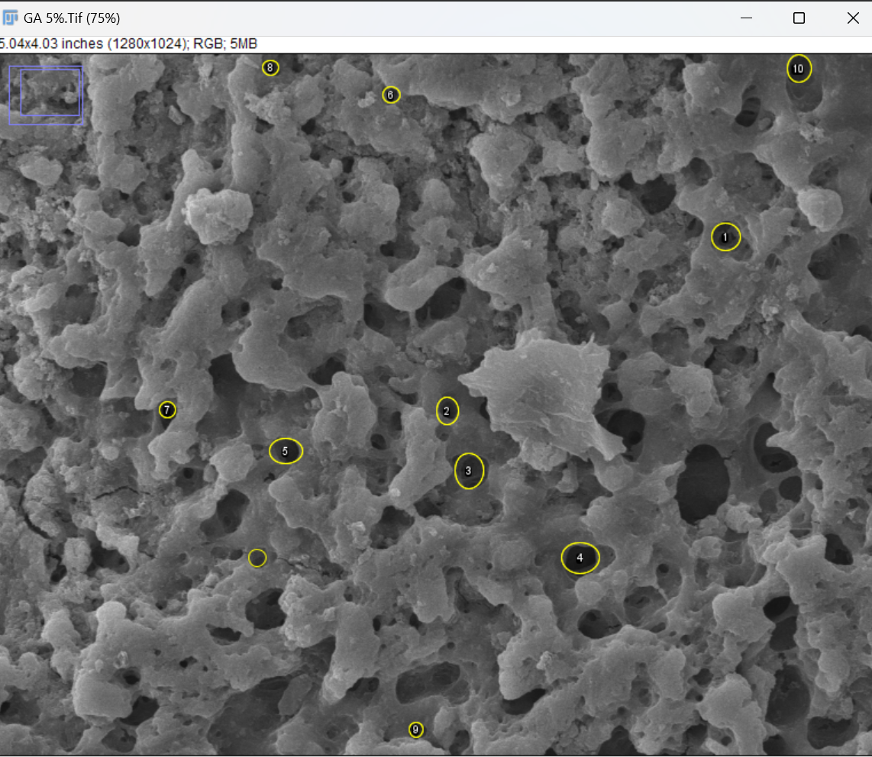
FIGURE 4: GROUP 1 (Control) FIGURE 5: GROUP 2 - 5% GA

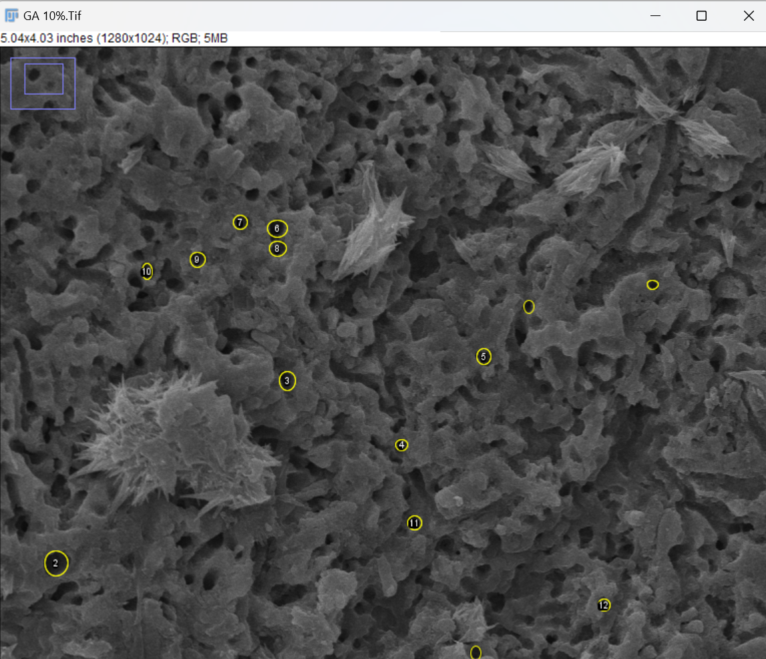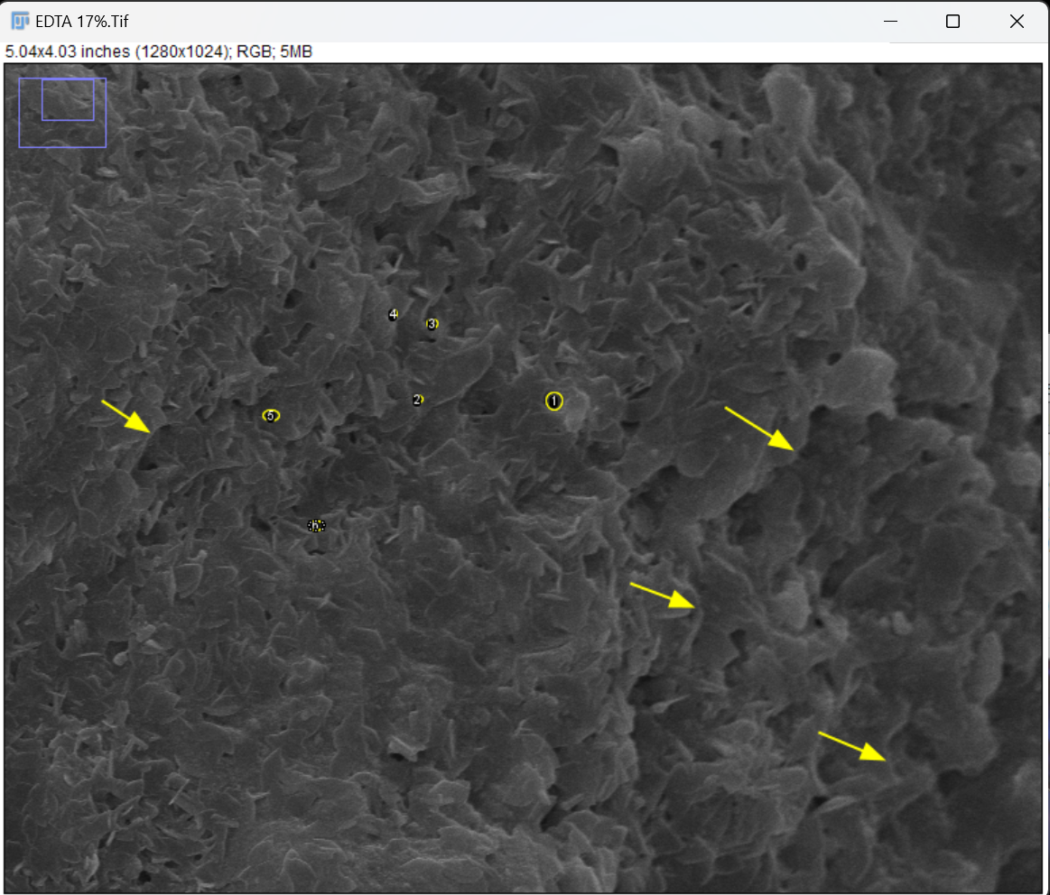
FIGURE 6: GROUP 3 - 10% GA FIGURE 7: GROUP 4 – 17% EDTA
Dentinal Erosion
Scanning electron microscopic analysis revealed pronounced dentinal erosion in specimens treated with 10% glycolic acid (GA). The erosive changes were characterized by loss of peritubular dentin, irregular enlargement of dentinal tubule orifices, and diffuse surface roughness, indicating excessive and uncontrolled demineralization. These alterations extended beyond smear layer removal and suggest disruption of the dentin’s mineral–organic framework, thereby compromising surface integrity.
In addition, crystalline deposits were evident on the dentin surface in the 10% GA group. These deposits may be attributed to mineral precipitation or recrystallization phenomena resulting from chemical interactions between GA and calcium ions released during aggressive demineralization. Such surface irregularities may adversely influence fibrin clot adhesion and subsequent cellular attachment, potentially impairing early wound stabilization.
Conversely, specimens treated with 5% GA and 17% EDTA demonstrated preservation of dentinal ultrastructure, with well-defined tubule orifices and minimal surface irregularities. EDTA produced controlled chelation limited to smear layer removal, while 5% GA achieved effective surface conditioning without inducing erosive damage. These findings emphasize the concentration-dependent effects of glycolic acid and support the use of 5% GA as a biologically favorable root biomodification agent, balancing effective smear layer removal with preservation of dentin integrity.

DISSCUSSION:
Periodontal disease induces profound structural and biological alterations in root surfaces, including bacterial invasion, collagen degradation, and cementum resorption. Mechanical instrumentation during periodontal therapy, although essential, inevitably produces a smear layer composed of organic debris, microorganisms, and endotoxins, which interferes with fibrin adhesion, blood clot stabilization, and new connective tissue attachment. This biological limitation has led to the development of root biomodification (RB) strategies aimed at enhancing periodontal wound healing.
Chemical root conditioning agents function by removing the smear layer, exposing collagen fibrils, and increasing dentinal tubule patency, thereby creating a biologically favorable surface for periodontal regeneration. However, despite extensive research, no single RB agent has consistently demonstrated predictable clinical benefits, highlighting the need for alternative agents with improved biological compatibility.
Root biomodification agents like citric acid has been evaluated as a root conditioning agent due to its strong demineralizing action and ability to expose dentinal collagen fibers, which are thought to aid fibroblast attachment; however, its very low pH (~1.0) resulted in excessive dentinal erosion and surface decalcification, raising concerns about structural compromise of the root surface and inconsistent biologic effects which was reported in studies done by Caffesse et al.¹⁰
Research on MTAD, a mixture of doxycycline, citric acid, and a detergent, showed favorable smear layer removal in endodontic contexts but did not significantly enhance fibroblast attachment on periodontal root surfaces.¹¹ Etidronic acid, a bisphosphonate chelator, has demonstrated only modest demineralizing ability and limited smear layer removal, often requiring adjunctive activation to match EDTA’s effects, which underscores the ongoing search for more effective but biologically friendly agents.¹²
In the present study, 17% EDTA demonstrated moderate smear layer removal, which is consistent with previous reports by Nanda et al. and Gottumukkala et al..^{13,14} EDTA acts by chelation of calcium ions, resulting in superficial demineralization without significant antimicrobial activity. The moderate efficacy observed in the present study may be attributed to its limited ability to disrupt organic smear components and bacterial remnants.
In contrast, glycolic acid (GA) demonstrated superior smear layer removal, particularly at a 5% concentration. GA is a low-molecular-weight alpha-hydroxy acid with excellent water solubility, enabling deeper penetration into the smear layer and dentin surface. Its antimicrobial activity against Gram-negative anaerobes and its ability to promote fibroblast proliferation further enhance its potential as a root biomodification agent.
The significantly higher smear layer removal observed in the 5% GA group aligns with findings reported by Gottumukkala et al, who identified 5% GA as a promising alternative to EDTA.¹⁴The improved efficacy at this concentration suggests that GA achieves adequate demineralization without excessive dentin damage.
The increase in dentinal tubule surface area observed in the 5% GA group further supports its effectiveness. Greater tubule exposure may enhance fibrin linkage, blood clot adhesion, and subsequent connective tissue attachment. This is biologically significant, as early wound stability is critical for periodontal regeneration. Similar observations were made by Barcellos et al., although the concomitant use of sodium hypochlorite in their protocol may have influenced their results.¹⁵
Interestingly, increasing the concentration of glycolic acid (GA) to 10% resulted in undesirable dentinal erosion, characterized by loss of peritubular dentin, surface irregularities, and crystalline deposits, suggesting excessive demineralization and compromised dentin integrity. Such structural alterations may adversely affect fibrin clot adhesion and subsequent periodontal healing. These findings corroborate the observations of Bello et al., who reported increased surface roughness and reduced dentin microhardness with higher GA concentrations. Additionally, the same study demonstrated a concentration-dependent cytotoxic effect, with higher GA concentrations significantly reducing fibroblast cell viability. Collectively, these results indicate that higher concentrations of GA may exert unfavorable structural and biological effects, emphasizing the need for optimal concentration selection for safe and effective root biomodificationThe presence of crystalline deposits in the 10% GA group may reflect chemical interactions between GA and dentin minerals, leading to precipitation or remineralization phenomena. Such surface alterations could interfere with fibroblast attachment and negatively impact regenerative outcomes.¹⁶
Contrasting results reported by Çobancı et al., who observed no significant differences among GA, EDTA, and etidronic acid under ultrasonic activation, emphasize the influence of application technique, exposure time, and activation methods on RB outcomes.¹⁷ The absence of ultrasonic activation in the present study likely contributed to the observed concentration-dependent effects of GA.
Overall, the findings of this study suggest that 5% GA provides an optimal balance between effective smear layer removal and preservation of dentin ultrastructure, whereas higher concentrations may predispose to dentinal erosion.
LIMITATIONS
To establish GA as an effective root biomodifier, it is essential to conduct in vitro assessments of its mechanical properties and cytotoxicity. These evaluations will help determine GA's impact on dentin structure, its ability to preserve or enhance biomechanical integrity, and its potential effects on surrounding biological tissues. Understanding these factors is crucial to ensuring that GA can be safely and effectively integrated into clinical applications, optimizing its benefits while minimizing any adverse effects.
CONCLUSION
At 5% concentration of glycolic acid (GA) demonstrates superior efficacy in smear layer removal, surpassing EDTA and enhancing dentinal tubule surface area. However, increasing the concentration to 10% GA poses a risk of dentinal erosion, emphasizing the importance of careful application. Challenges in formulation and exposure time indicate the need for further research with larger sample sizes to substantiate findings and expand potential clinical applications.
Consent
As per international standards or university standards, patient(s) written consent has been collected and preserved by the author(s).

Disclaimer (Artificial intelligence)
Author(s) hereby declare that NO generative AI technologies such as Large Language Models (ChatGPT, COPILOT, etc.) and text-to-image generators have been used during the writing or editing of this manuscript.
REFERENCES
- Kinane DF. Causation and pathogenesis of periodontal disease. Periodontol 2000. 2001;25:8–20. doi: 10.1034/j.1600-0757.2001.22250102.x.
- Ruben MP, Shapiro A. An analysis of root surface changes in periodontal disease a review. J Periodontol. 1978;49:89–91. doi: 10.1902/jop.1978.49.2.89.
- Lowenguth RA, Blieden TM. Periodontal regeneration: root surface demineralization. Periodontol 2000. 1993 Feb;1(1):54-68. PMID: 8401861.
- Caffesse RG, De LaRosa M, Garza M, Munne-Travers A, Mondragon JC, Weltman R. Citric acid demineralization and subepithelial connective tissue grafts. J Periodontol. 2000;71:568–72. doi: 10.1902/jop.2000.71.4.568.
- Bittencourt S, Ribeiro Edel P, Sallum EA, Sallum AW, Nociti FH, Jr, Casati MZ. Root surface biomodification with EDTA for the treatment of gingival recession with a semilunar coronally repositioned flap. J Periodontol. 2007;78:1695–701. doi: 10.1902/jop.2007.060507.
- Machado R, Garcia LD, da Silva Neto UX, Cruz Filho AM, Silva RG, Vansan LP. Evaluation of 17% EDTA and 10% citric acid in smear layer removal and tubular dentin sealer penetration. Microsc Res Tech. 2018;81:275–82. doi: 10.1002/jemt.22976.
- Souza MA, Tumelero Dias C, Zandoná J, Paim Hoffmann I, Sanches Menchik VH, Palhano HS, et al. Antimicrobial activity of hypochlorite solutions and reciprocating instrumentation associated with photodynamic therapy on root canals infected with Enterococcus faecalis –An in vitro study. Photodiagnosis Photodyn Ther. 2018;23:347–52. doi: 10.1016/j.pdpdt.2018.07.015.
- Gambin DJ, Leal LO, Farina AP, Souza MA, Cecchin D. Antimicrobial activity of glycolic acid as a final irrigant solution for root canal preparation. Gen Dent. 2020;68:41–4.
- Effects of some proprietary mouth washes on dentine smear layer. Journal of Indian Dental Association (2002) VOL. 73.
- Caffesse RG, Nasjleti CE, Anderson GB, et al. Periodontal healing following guided tissue regeneration with citric acid and fibronectin application. Journal of Periodontology. 1991 Jan;62(1):21-29. DOI: 10.1902/jop.1991.62.1.21. PMID: 2002428.
- Ghandi M, Houshmand B, Nekoofar MH, Tabor RK, Yadeghari Z, Dummer PM. The effect of MTAD, an endodontic irrigant, on fibroblast attachment to periodontally affected root surfaces: A SEM analysis. J Indian Soc Periodontol. 2013 Mar;17(2):188-92. doi: 10.4103/0972-124X.113067. PMID: 23869124; PMCID: PMC3713749.
- Vidal-Montolío, M.-I.; Sanz, J.L.; Ghilotti, J.; Folguera, S.; Llena, C. Efficacy of Etidronic Acid for Smear Layer Removal: A Systematic Review of In Vitro Studies. J. Funct. Biomater. 2026, 17, 48. https://doi.org/10.3390/jfb17010048.
- Nanda T, Jain S, Kapoor D, Kaur H, Nanda S. Comparison of the efficacy of ethylenediaminetetraacetic acid and tetracycline hydrochloride as root conditioning agents: An in vitro study. J Int Clin Dent Res Organ. 2012;4:2.
- Gottumukkala SNVS, Lakshmi MR, Penmetsa GS, Ramesh KSV, Pasupuleti MK, Bypalli V. Scanning electron microscopic analysis of 5% glycolic acid as a novel alternative to 17% ethylenediaminetetraacetic acid in root biomodification: An in vitro study. J Indian Soc Periodontol. 2024 Jan-Feb;28(1):79-83. doi: 10.4103/jisp.jisp_150_23. Epub 2024 Jun 4. PMID: 38988961; PMCID: PMC11232807.
- Barcellos DP, Farina AP, Barcellos R, Souza MA, Borba M, Bedran-Russo AK, et al. Effect of a new irrigant solution containing glycolic acid on smear layer removal and chemical/mechanical properties of dentin. Sci Rep. 2020;10:7313. doi: 10.1038/s41598-020-64450-1.
- Bello YD, Porsch HF, Farina AP, Souza MA, Silva EJ, Bedran-Russo AK, et al. Glycolic acid as the final irrigant in endodontics: Mechanical and cytotoxic effects. Mater Sci Eng C Mater Biol Appl. 2019;100:323–9. doi: 10.1016/j.msec.2019.03.016.
- Çobancı F, Kaya S, Adıgüzel Ö. Smear layer removal efficacy of various irrigation solutions with an ultrasonic activation system: An in vitro study. Turk Endod J 2023;8:20-24.

ACKNOWLEDGMENT: The author sincerely acknowledges Dr. Rajkumar, Indian Institute of Science (IISc), Bengaluru, for his valuable guidance and support. The author also expresses heartfelt gratitude to the department staff for their constant assistance and cooperation throughout the course of this study.
COMPETING INTERESTS: No
DISCLAIMER: The authors used artificial intelligence–based tools (ChatGPT and Copilot) solely for language editing and rephrasing of the manuscript. No content generation, data analysis, interpretation, or conclusions were produced by these tools. The authors take full responsibility for the originality, accuracy, and integrity of the work.

