Case report
Comparative Evaluation of Probiotic Strips and Tetracycline Fibres as Adjuncts to Non-Surgical Periodontal Therapy: A Case Series

Abstract
Introduction:
Probiotics have gained attention in periodontal therapy due to their potential to modulate the oral microbiota and improve periodontal health. This study wants to evaluate the effectiveness of probiotic strips VS tetracycline fibres in non-surgical pocket reduction in periodontitis patients.

Objectives:
The primary objective is to assess the reduction in pocket depth following the use of probiotic strips compared to a tetracycline fibres.
Secondary objectives include evaluating changes in clinical attachment level, bleeding on probing in the periodontal pockets.

Case presentation :
A split-mouth design was employed, with 10 participant receiving both interventions in different quadrants of the mouth. Pocket depths was measured at baseline and after treatment with either probiotic strips or tetracycline fibres. The primary outcome measure was the reduction in pocket depth following treatment. Secondary outcomes, including changes in clinical attachment level and bleeding on probing, was also be assessed.

Discussion :
The study results will be presented in terms of changes in probing pocket depth, clinical attachment level, bleeding on probing, between the site A and site B. Statistical analysis will be conducted to determine the significance of these changes.

Conclusion:
The findings of this study provided valuable insights into the effectiveness of probiotic strips and tetracycline fibres in non-surgical pocket reduction in patients with periodontal disease. If proven effective, it could serve as a promising adjunctive therapy in periodontal treatment protocols.

Keywords
Probiotic, tetracycline, periodontitis, microbiota, periodontal pocket

Introduction
Periodontitis is known as polymicrobial disease which is caused by dental plaque. [1] In periodontics, there is an ongoing quest to find effective non-surgical methods for pocket reduction. One of the current areas of interest is the evaluation of probiotic strips versus tetracycline fibres in addressing this concern. This study aims to compare the effectiveness of these split mouth treatment methods and provide valuable insights into their outcomes. By exploring the potential benefits of probiotic strips and tetracycline fibres, this study holds the promise of enhancing the standard of care in periodontics and positively impacting patient well-being.

Overview of Probiotic Strips and Tetracycline Fibres
Probiotic Strips are thin, dissolvable strips infused with beneficial bacteria such as bacillus coagulans. They are designed to be placed directly into periodontal pockets, releasing the helpful microbes to restore the oral microbiome balance.
Tetracycline fibres are small, thread-like materials saturated with the antibiotic tetracycline. When inserted into periodontal pockets, they gradually release the antibiotic to combat the harmful bacteria causing the infection and inflammation.
Differences and Similarities: While probiotic strips aim to introduce beneficial microbes, tetracycline fibres focus on reducing harmful bacteria. Both methods target non-surgical pocket reduction, but through different mechanisms of action.

Case presentation
Case series of 10 patients.
A split-mouth design was used, with participant treated with both interventions in different quadrants of the mouth. After scaling and root planning local drug delivery was done using tetracycline fibres and probiotic strip. Periodontal dressing was given for a week. 21 days follow up was taken. The outcome measure was the reduction in pocket depth including changes in bleeding on probing and CAL was also assessed before and following treatment.
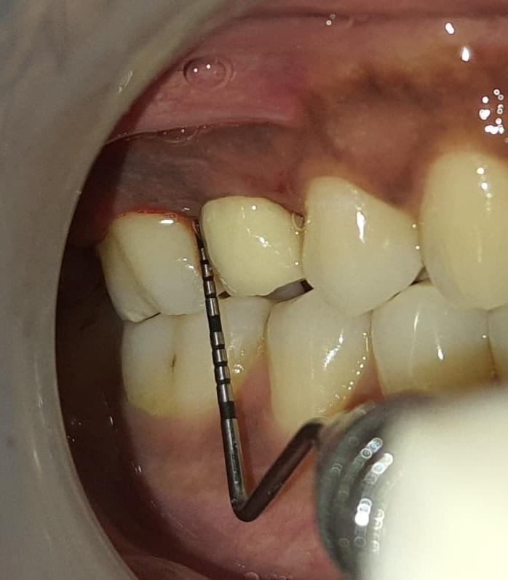
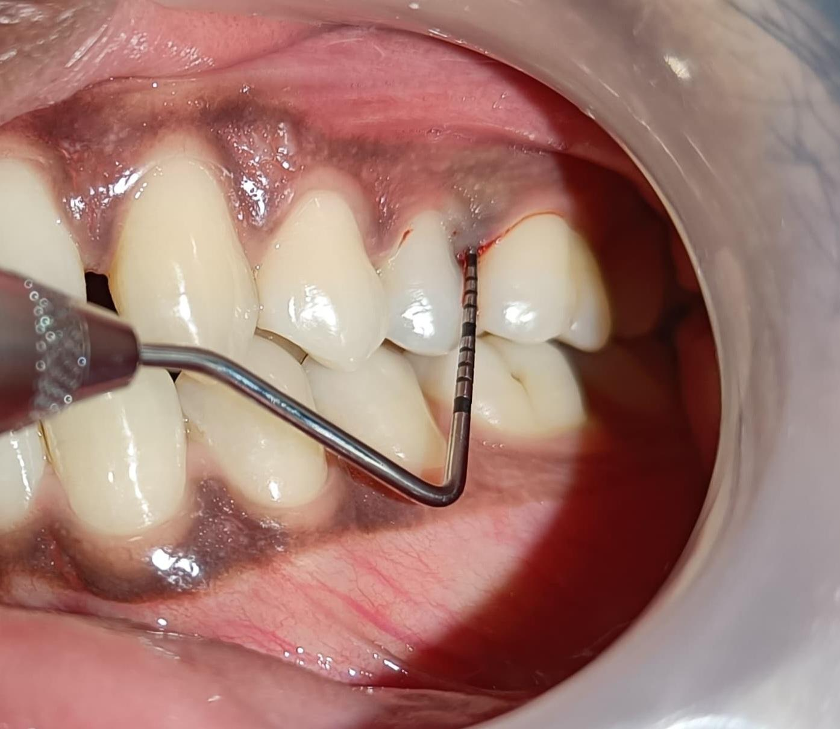
Fig 1 Baseline photographs of pocket depth Fig 2: Baseline photographs of pocket
depth
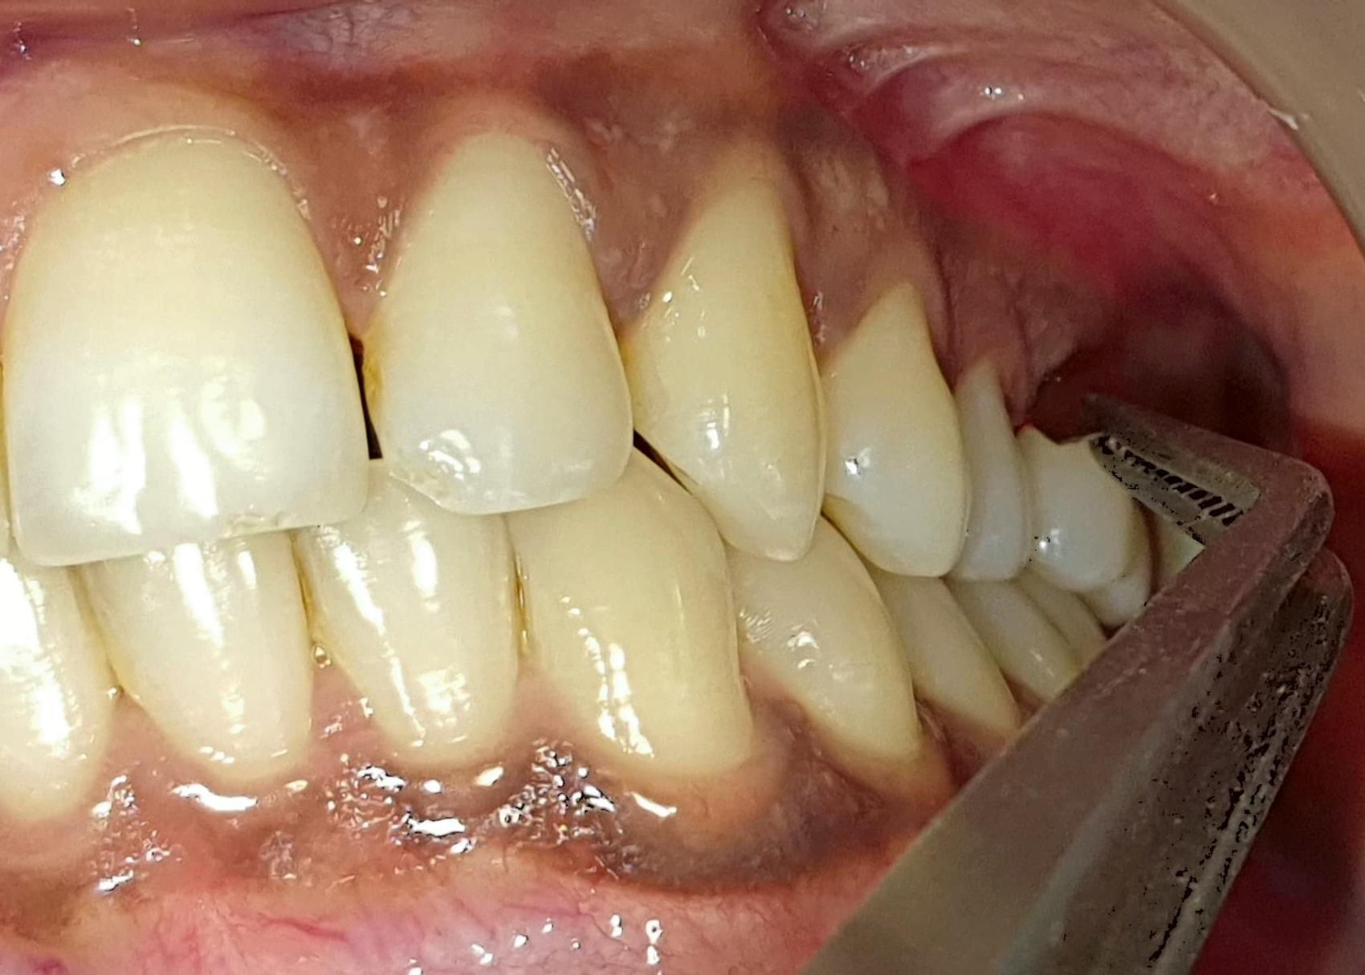
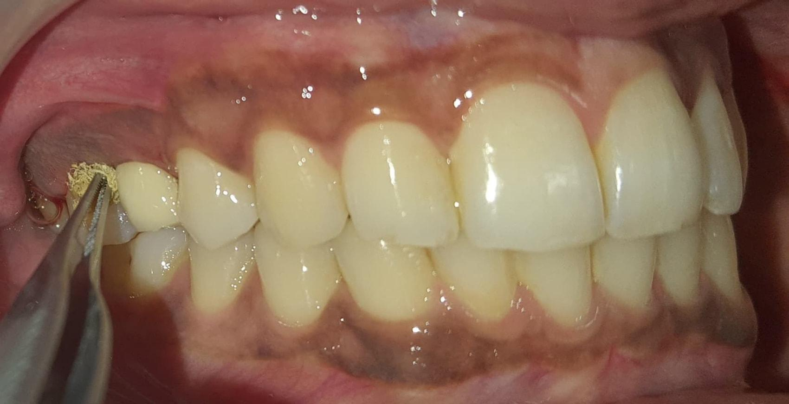
Fig 3 : Local drug delivery using tetracycline fibre Fig 4 : Local drug delivery using
probiotic strip
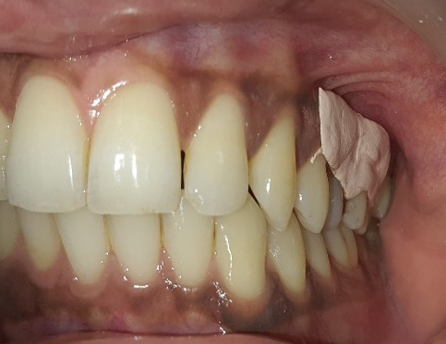
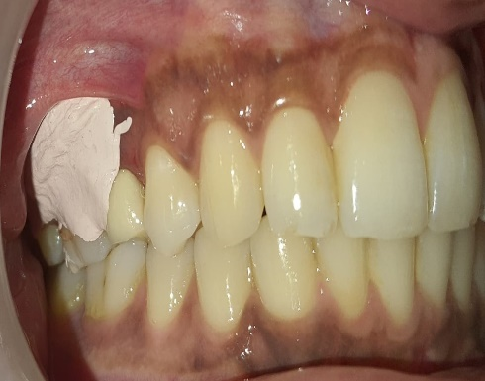

Fig 5: Periodontal dressing placed after tetracycline Fig 6 : Periodontal dressing placed
placement after probiotic placement
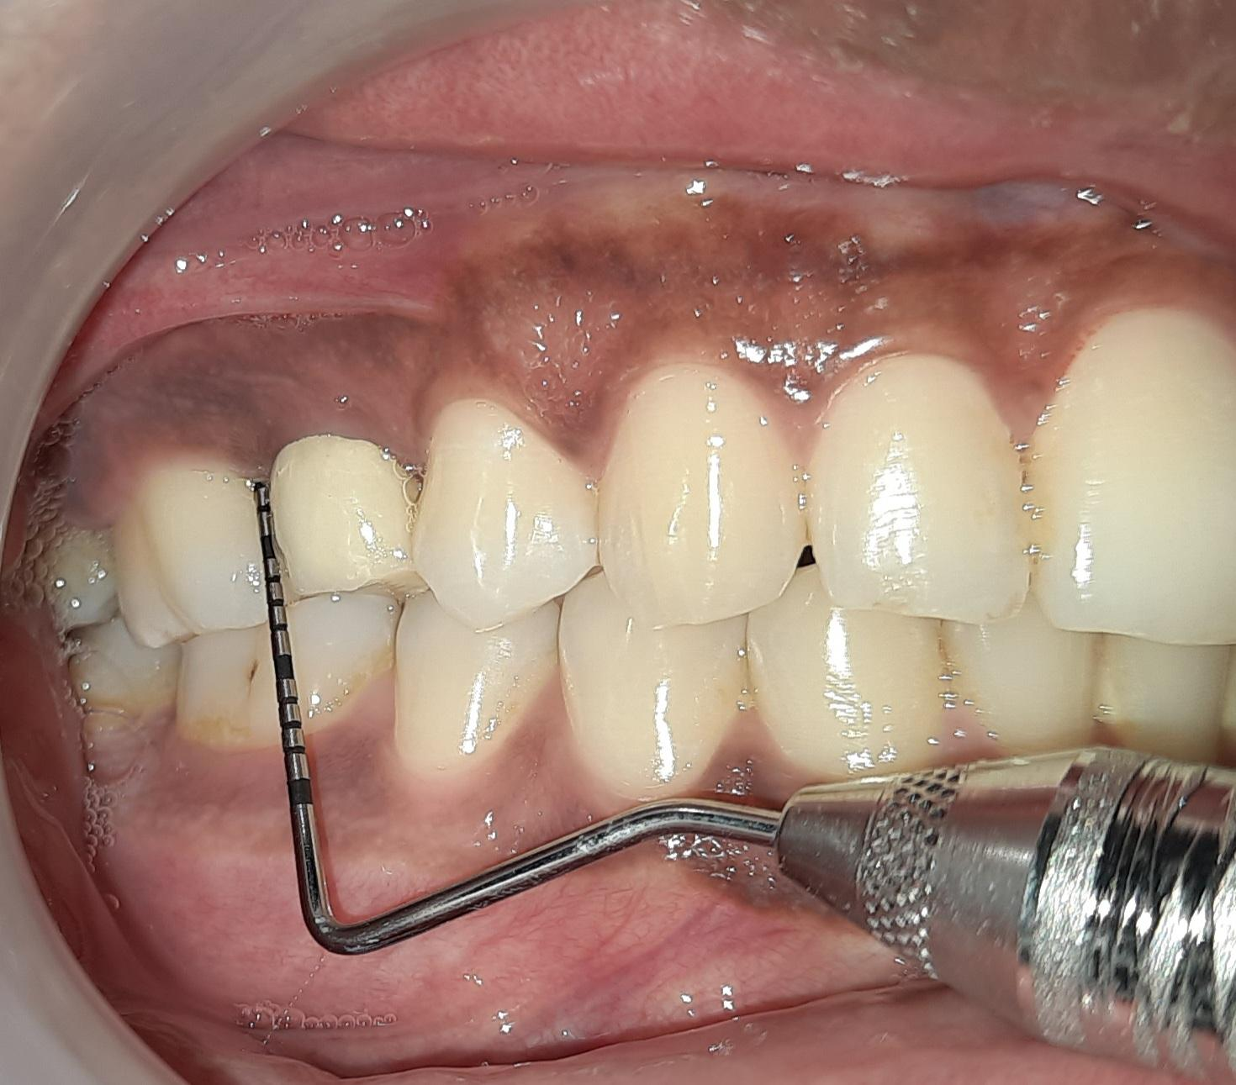
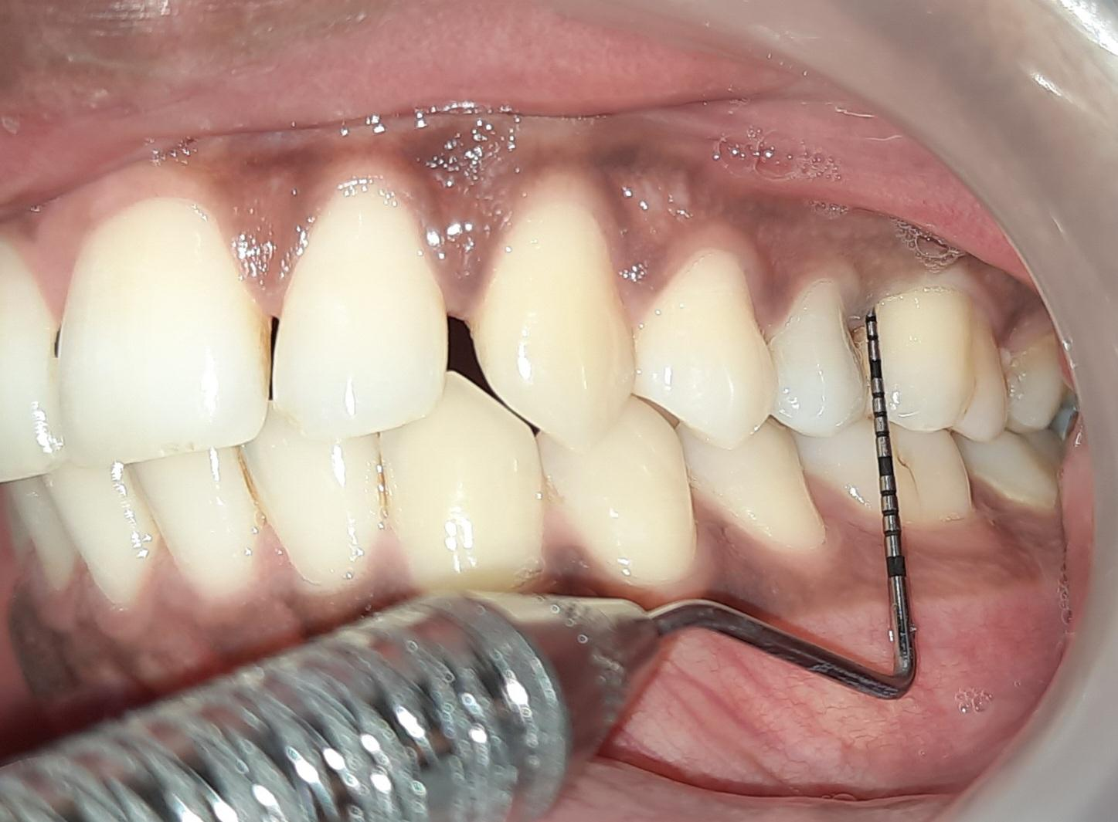

Fig 7 : Pocket depth after 21 days follow-up Fig 8 : Pocket depth after 21 days
follow-up

Inclusion and Exclusion Criteria
Inclusion Criteria-
- Systemically healthy Patients.
- Patients with at least 20 teeth, with suprabony periodontal pockets which show bleeding on probing and probing depths (PDs) ≥5 mm, were included in the study.

Exclusion Criteria –
- Smokers.
- Patients with systemic diseases.
- patients on medications, such as corticosteroids or calcium channel blockers, which are known to interfere with periodontal wound healing,
- patients allergic to medications,
- pregnant or lactating women.
- patients who underwent periodontal therapy in the past 6 months were excluded from the study.

Discussion
On comparing site A (tetracycline fibres) and site B (probiotic strip), it was found that probotic strips are equally effective on comparison with tetracycline fibres in terms of pocket depth reduction, CAL and bleeding on probing.
Table 1 : Comparison of Probiotic strips and Tetracycline fibres in terms of pocket depth reduction, CAL and bleeding on probing
Site | Mean pocket depth at baseline(mm) | Mean CAL (mm) at baseline | Bleeding on probing at baseline
Probiotic strips | 5mm | 5mm | present
Tetracycline fibres | 5mm | 5mm | present

Table 2 : After 21 days
Site | Mean pocket depth at 21 day (mm) | Mean CAL (mm) at 21 day (mm) | Bleeding on probing at 21 day
Probiotic strips | 3mm | 3mm | absent
Tetracycline fibres | 3mm | 3mm | absent

The first objective of the study is to assess the effectiveness of probiotic strips in non-surgical pocket reduction. This will involve analysing the impact of probiotic strips on the reduction of periodontal pockets and the improvement of gum health. When the probing depth at baseline and at 21 day is compared comparable results are seen.
Silva et al. (1987) reported that “Lactobacillus acidophilus strains suppress the growth of numerous bacterial species through the production of bacteriocins, making them among the most commonly utilized probiotic agents in therapy”.

Bunting et al. (1999) highlighted “ongoing uncertainty regarding the ability of probiotic microorganisms to survive and establish themselves within the oral cavity. Conventional culture-based studies have failed to demonstrate long-term adherence of probiotic strains to dental plaque or saliva in individuals consuming probiotics over extended periods”.

Teughels et al. (2007) observed that “local drug delivery (LDD) effectively reduces microbial burden within periodontal pockets, thereby supporting the healing of affected tissues. Their study compared the outcomes of probiotics, tetracycline fibers, and a combined regimen of both in patients with periodontitis”.

Ravn et al. (2012) investigated “whether three probiotic bacteria contained in the milk product Cultura dofilus naturell could be detected in saliva, oral mucosa, and dental surfaces of eight caries-free individuals following eight daily exposures over three days. Using fluorescence in situ hybridization and confocal laser scanning microscopy, the researchers found that while probiotics were occasionally present in saliva and on mucosal surfaces, they were absent from dental surfaces”.

Krasse et al. (2006) demonstrated that “Lactobacillus reuteri (LR) was effective in reducing both gingival inflammation and plaque accumulation in patients with moderate-to-severe gingivitis”.

Dhawan et al. (2013) emphasized “the role of probiotics as host-modulating agents. They noted that probiotics lower salivary pH, thereby inhibiting plaque and calculus formation. Additionally, probiotics generate antioxidants that neutralize free radicals, which are key contributors to plaque development and staining”.

Pothoulakis, 2009 shows “beneficial effects in gastrointestinal inflammatory conditions wich are mediated through modulation of host pro-inflammatory responses by interfering with the host’s signalling molecules controlling inflammation at different levels, such as the NF κB and MAP kinase pathways”. “Additionally, S. boulardii whole yeast administration also reduces mucosal levels of the pro-inflammatory mediators IL-1β, IL-6, TNF-α, and iNOS” [18]

Teughels et al., 2007 This study confirmed the hypothesis and provided a proof of concept for a guided pocket recolonization (GPR) approach in the treatment of periodontitis patients.[19]

Ann et al., 2007 study “utilizes S. boulardii – FOS as a probiotic-prebiotic mixture. No fixed probiotic-prebiotic ratio exists, and ratios of 2:1 and 4:1 have been recommended if FOS is the intended prebiotic”. “A mixture at a 4:1 ratio was utilized in this study as it results in an increased concentration of the prebiotic” [20]

Challa et al. (2013) investigated “the impact of locally delivered probiotics on chronic periodontitis, assessing both clinical and microbiological outcomes. Their findings indicated a favorable shift in the subgingival microbial profile; however, no statistically significant differences were observed in clinical parameters when comparing the probiotic group with the placebo group”.

In the study by Harini and Anegundi (2010), “a notable reduction in gingival index scores was reported. The probiotic group demonstrated greater improvement compared to the chlorhexidine group, highlighting the potential of probiotics in managing gingival inflammation”.

Canani et al. (2011) described “Saccharomyces boulardii as a non-pathogenic yeast widely employed for both prevention and treatment of gastrointestinal disorders. Pharmacokinetic analyses suggested that this organism rapidly achieves steady-state concentrations and sustains high, stable levels in the host”.

Research by Riquelme et al. (2003), conducted “on animal models and human volunteers, confirmed the oral safety of S. boulardii. A review of published cases revealed that adverse effects were rare, with only nine reports documented, and the risk was minimal in immunocompetent individuals”.

Thomas et al. (2009) demonstrated that “culturing human dendritic cells with S. boulardii supernatant led to a reduction in pro-inflammatory cytokines such as TNF-α and IL-6, while simultaneously enhancing the secretion of the anti-inflammatory cytokine IL-10. These findings are particularly relevant to the inflammatory pathways implicated in periodontitis”.

Deepak et al. (2010) reported that various “Lactobacillus strains (including L. reuteri, L. salivarius, L. casei, and L. acidophilus) were effective in decreasing gingival inflammation and reducing populations of black-pigmented rods such as Porphyromonas gingivalis in saliva and subgingival plaque. Additionally, Streptococcus sanguinis and S. uberis inhibited the growth of periodontal pathogens, with a strong inverse relationship observed between Aggregatibacter actinomycetemcomitans and S. sanguinis”.

Conclusion And future directions
After analysing the results, we come to know that probiotic strips will give promising result as compared to tetracycline fibres. The findings of this will provide insights into the effectiveness of probiotic strips and tetracycline fibres in non-surgical pocket reduction in patients with periodontal disease. It could serve as a promising adjunctive therapy in periodontal treatment protocols.
Future directions should include establishing a framework for long-term efficacy monitoring. This involves tracking patient progress over an extended period to assess the sustained impact of the interventions.
Ethical clearance
Ethical clearance was obtained from the institutional ethical committee. [CSMSS/DCH/EC/SS/2024-02]

Disclaimer
This article was previously presented as paper presentation at 22nd ISP PG CONVENTION 2024 ON 23rd march 2024.
Disclaimer (Artificial intelligence)
Author(s) hereby declare that NO generative AI technologies such as Large Language Models (ChatGPT, COPILOT, etc.) and text-to-image generators have been used during the writing or editing of this manuscript.

References
- Boyeena L, Koduganti RR, Panthula VR, Jammula SP. Comparison of efficacy of probiotic versus tetracycline fibers as adjuvants to scaling and root planning. J Indian Soc Periodontal. 2019 Nov-Dec;23(6):539-544. Doi:10.4103/jisp.jisp_590_18.

- Teughels W, Newman MG, Coucke W, Haffajee AD, Van Der Mei HC, Haake SK, et al. Guiding periodontal pocket recolonization: A proof of concept. J Dent Res. 2007;86:1078–82. 10.1177/154405910708601111

- Dhawan R, Dhawan S. Role of probiotics on oral health: A randomized, double-blind, placebo-controlled study. J Interdiscip Dent. 2013;3:71–8. 10.4103/2229-5194.126862

- Ishihara K, Miyakawa H, Hasegawa A, Takazoe I, Kawai Y. Growth inhibition of Streptococcus mutans by cellular extracts of human intestinal lactic acid bacteria. Infect Immun. 1985;49:692–4. 10.1128/iai.49.3.692-694.1985

- Bunting RW, Nickerson G, Hard DG, Crowley M. Further studies of the relation of Bacillus acidophilus to dental caries. J D Cosmos. 1928;70:1–8.

- Busscher HJ, Mulder AF, van der Mei HC. In vitro adhesion to enamel and in vivo colonization of tooth surfaces by lactobacilli from a bio-yoghurt. Caries Res. 1999;33:403–4. 10.1159/000016541

- Caglar E, Topcuoglu N, Cildir SK, Sandalli N, Kulekci G. Oral colonization by Lactobacillus reuteri ATCC 55730 after exposure to probiotics. Int J Paediatr Dent. 2009;19:377–81. 10.1111/j.1365-263X.2009.00989.x.

- Ravn I, Dige I, Meyer RL, Nyvad B. Colonization of the oral cavity by probiotic bacteria. Caries Res. 2012;46:107–12. 10.1159/000336960

- Krasse P, Carlsson B, Dahl C, Paulsson A, Nilsson A, Sinkiewicz G. Decreased gum bleeding and reduced gingivitis by the probiotic Lactobacillus reuteri. Swed Dent J. 2006;30:55–60. 16878680

- Silva M, Jacobus NV, Deneke C, Gorbach SL. Antimicrobial substance from a human Lactobacillus strain. Antimicrob Agents Chemother. 1987;31:1231–3. 10.1128/aac.31.8.1231

- Vivekananda MR, Vandana KL, Bhat KG. Effect of the probiotic Lactobacilli reuteri (Prodentis) in the management of periodontal disease: A preliminary randomized clinical trial. J Oral Microbiol. 2010;2:5344. 10.3402/jom.v2i0.5344

- Balaghi S, Mohammadifar MA, Zargaraan A, Gavlighi HA, Mohammadi M. Compositional analysis and rheological characterization of gum tragacanth exudates from six species of Iranian Astragalus. Food Hydrocoll. 2011;25:1775–84. 10.1016/j.foodhyd.2011.04.003

- Balaghi S, Mohammadifar MA, Zargaraan A. Physicochemical and rheological characterization of gum tragacanth exudates from six species of Iranian Astragalus. Food Biophys. 2010;5:59–71. 10.1007/s11483-009-9144-5

- Eastwood MA, Brydon WG, Anderson DM. The effects of dietary gum tragacanth in man. Toxicol Lett. 1984;21:73–81. 10.1016/0378-4274(84)90226-1

- Page RC, Offenbacher S, Schroeder HE, Seymour GJ, Kornman KS. Advances in the pathogenesis of periodontitis: Summary of developments, clinical implications and future directions. Periodontol 2000. 1997;14:216–48. 10.1111/j.1600-0757.1997.tb00199.x.

- Apatzidou DA, Kinane DF. Nonsurgical mechanical treatment strategies for periodontal disease. Dent Clin North Am. 2010;54:1–2. 10.1016/j.cden.2009.08.006.

- Siddharth T, Nikhil S, Rahul C. Local drug delivery: A current concept in periodontology. Mod Appl Bioequiv Availab. 2017;1:555552. 10.19080/MABB.2017.01.555552

- Pothoulakis C. Anti-infl ammatory mechanisms of action of Saccharomyces boulardii. Alimentary Pharmacology and Therapeutics 2009; 30:826-833.

- Teughels W, Newman MG, Coucke W, et al. Guiding periodontal pocket recolonization: a proof of con cept. Journal of Dental Research 2007; 86:1078-1082.

- Ann EY, Kim Y, Oh S, et al. Microencapsulation of Lactobacillus acidophilus ATCC 43121 with prebiotic substrates using a hybridization system. International Journal of Food Science and Technology 2007; 42:411-419.

- Challa R, Sylvia DS, Renuka V, Kumar RV, Vasudevan S and Reddy A. Effi cacy of probiotic gel on chronic periodontitis – A clinico-microbiological study. Journal of Research and Advancement of Dentistry 2013; 2:152-163.

- Harini PM and Anegundi RT. Effi cacy of a probiotic and chlorhexidine mouth rinses: A short-term clini cal study. Journal of the Indian Society of Pedodontics and Preventive Dentistry 2010; 28:179-182.

- Canani RB, Cucchiara S, Cuomo R, Pace F and Papale F. Saccharomyces boulardii: a summary of the evidence for gastroenterology clinical practice in adults and children. European Review for Medical and Pharmacological Sciences 2011; 15:809-822.

- Riquelme AJ, Calvo MA, Guzman AM, et al. Saccharomyces cerevisiae fungemia after Saccharomyces boulardii treat ment in immuno-compromised patients. Journal of Clinical Gastroenterology 2003; 36:41-43.

- Thomas S, Przesdzing I, Metzke D, Schmitz J, Radbruch A and Baumgart DC. Saccharomyces boulardii inhibits lipopolysaccharide-induced activation of human dendritic cells and T cell proliferation. Clinical and Experimental Immunology 2009; 156:78-87.

- Deepak TA, Manjunath M and Pewa S. Antibiotics are passé: take a look at probiotics. World Journal of Dentistry 2010; 25:109-111.

- Magnusson I, Lindhe J, Yoneyama T and Liljenberg B. Recolonization of a subgingival microbiota following scaling in deep pockets. Journal of Clinical Periodontology 1984; 11:193-207.

- Maiden MF, Tanner A, McArdle S, Najpauer K and Goodson JM. Tetracycline fi ber therapy monitored by DNA probe and cultural methods. Journal of Periodontal Research 1991; 26:452-459.

- Mcfarland LV, Surawicz CM, Greenberg RN, et al. Prevention of beta-lactam-associated diarrhea by Saccharomyces boulardii compared with placebo. The American Journal of Gastroenterology 1995; 90:439-448.

- Mitterdorfer G, Kneifel W and Viernstein H. Utilization of prebiotic carbohydrates by yeasts of therapeutic rel evance. Letters in Applied Microbiology 2001; 33:251-255.

- Mohanty R and Nazareth B. The potential role of pro biotics in periodontal health. Revista Sul-Brasileira de Odontologia 2012; 9:85-88.

- Mutanda T, Mokoena MP, Olaniran AO, Wilhelmi BS and Whiteley CG. Microbial enzymatic production and applications of short-chain fructooligosaccha rides and inulooligosaccharides: Recent advances and current perspectives. Journal of Industrial Microbiology and Biotechnology 2014; 41:893-906.

- Sanders ME. Probiotics: defi nition, sources, selection, and uses. Clinical Infectious Diseases 2008; 46(S2):S58 S61.

- Sareen M, Roy S, Singh SK and Gupta A. A review on probiotics and their implications in dentistry. Journal of Dentofacial Sciences 2012; 1:7-10.

- Sazawal S, Hiremath G, Dhingra U, Malik P, Deb S and Black RE. Effi cacy of probiotics in preven tion of acute diarrhoea: a meta-analysis of masked, randomised, placebo-controlled trials. The Lancet Infectious Diseases 2006; 6:374-382.

- Schneider SM, Girard-Pipau F, Filippi J, et al. Effects of Saccharomyces boulardii on fecal short-chain fatty acids and microfl ora in patients on long-term total enteral nutrition. World Journal of Gastroenterology 2005; 11:6165-6169.

- Shimazaki Y and Shirota T. Intake of dairy products and periodontal disease: The Hisayama study. Journal of Periodontology 2008; 79:131-137.

- Shinde PB. Probiotic: An overview for selection and evaluation. International Journal of Pharmacy and Phar maceutical Sciences 2011; 4:14-21. Silness J and Löe H. Correlation between oral hygiene and periodontal condition. Acta Odontologica Scandi navica 1964; 22:121-135. Socransky SS. Dental biofi lms: Diffi cult therapeutic targets. Periodontology 2000 2002; 28:12-55.

- Villarruel G, Rubio DM, Lopez F, et al. Saccharomyces boulardii in acute childhood diarrhoea: a randomized, placebo-controlled study. Acta Paediatrica 2007; 96:538-554.

- Rhemrev GE, Timmerman MF, Veldkamp I, Van Win kelhoff AJ and Van der Velden U. Immediate effect of instrumentation on the subgingival microfl ora in deep infl amed pockets under strict plaque control. Journal of Clinical Periodontology 2006; 33:42-48.

- DeSouza DM, Martins GB and Noguez SR. Probiotic actions of Bacillus cereus var. toyoi and Saccharomyces bou lardii in silver catfi sh larvae culture. Revista Brasileira de Zootecnia 2012; 41:3-7.

- Elmer GW, Macfarland LV and Surawicz CM. Biothera peutic Agents and Infectious Diseases, 1st ed. Totowa, New Jersey, USA: Humana Press, 1999; 647-652.

- Duarte de Mendonça C, et al Probiotics in the non-surgical treatment of periodontitis: a systematic review and network meta-analysis. BMC Oral Health. 2024.

- Clinical effects of probiotics on the treatment of gingivitis and periodontitis: a systematic review and meta-analysis. BMC Oral Health. 2025.

- Hoare, A., Soto, C., Rojas-Celis, V., &amp; Bravo, D. (2019). Chronic inflammation as a link between periodontitis and carcinogenesis. Mediators of inflammation, 2019(1), 1029857.

