Original Research Article
Comparative Diagnostic Performance of Remote Dielectric Sensing and Lung Ultrasound for Detecting Pulmonary Congestion in Stable Ambulatory Heart Failure Patients
ABSTRACT
Aims: To compare the diagnostic accuracy of remote dielectric sensing (ReDS) and lung ultrasound (LUS) for detecting pulmonary congestion in stable ambulatory patients with chronic heart failure using a blinded composite clinical–biomarker reference standard.
Study Design: Prospective single-center diagnostic accuracy study.
Place and Duration of Study: Single center, conducted between March and November 2024.
Methodology: A total of 112 stable outpatients with chronic heart failure underwent sequential clinical assessment, ReDS measurement, and standardized eight-zone LUS during the same visit. Congestion status was adjudicated by a blinded senior cardiologist using a pragmatic composite clinical score combined with NT-proBNP ≥1500 ng/L as the reference standard. The prespecified ReDS threshold was >35%. The LUS threshold of ≥24 B-lines was derived using the Youden index and considered exploratory. The primary outcome was area under the receiver operating characteristic curve (AUC). Secondary outcomes included sensitivity, specificity, likelihood ratios, agreement, and correlation.
Results: Fifty-nine patients (52.7%) met criteria for pulmonary congestion. ReDS demonstrated an AUC of 0.831 (95% CI 0.748–0.899), and LUS demonstrated an AUC of 0.845 (95% CI 0.764–0.909), with no significant difference (P = .80). At >35%, ReDS sensitivity was 71.2% and specificity 81.1%. At ≥24 B-lines (exploratory), LUS sensitivity was 69.5% and specificity 83.0%. Overall accuracy was 75.9% for both methods. Inter-method concordance was 83.0% (κ = 0.65). Continuous measures correlated modestly (r = 0.36, P < .001). Inter-observer agreement for thresholded LUS classification was substantial (κ = 0.75).
Conclusion: ReDS and LUS demonstrated comparable discrimination for detecting pulmonary congestion in stable ambulatory heart failure patients. Modest correlation and clinically relevant discordance suggest complementary physiological information. The pragmatic composite reference standard and absence of invasive validation represent limitations. Further multicenter validation is warranted.
Keywords: Heart failure; pulmonary congestion; remote dielectric sensing; lung ultrasound; diagnostic accuracy

1. INTRODUCTION
Heart failure affects more than 64 million individuals worldwide and remains a major driver of hospitalization and healthcare expenditure (Savarese et al., 2023). Pulmonary congestion is the principal determinant of symptoms, clinical deterioration, and hospital admission (Gheorghiade et al., 2010; McDonagh et al., 2021). Early identification of congestion in ambulatory settings is essential for optimizing diuretic therapy and preventing decompensation. However, bedside assessment alone lacks sensitivity and reproducibility (Thibodeau & Drazner, 2018; Wang et al., 2005).
Lung ultrasound identifies B-lines reflecting alveolar–interstitial edema and demonstrates high diagnostic accuracy in heart failure populations (Platz et al., 2017). In ambulatory cohorts, B-line burden predicts hospitalization and mortality (Platz et al., 2016; Domingo et al., 2021; Rastogi et al., 2024; Miglioranza et al., 2017). Performance depends on operator expertise and standardized acquisition (Ceriani et al., 2021).
Remote dielectric sensing provides automated estimation of lung fluid percentage using electromagnetic signals. Validation studies demonstrate correlation with invasive filling pressures and computed tomography–derived lung water (Amir et al., 2013; Bensimhon et al., 2016; Amir et al., 2016). Elevated ReDS values are associated with adverse outcomes (Imamura et al., 2017; Abraham et al., 2017; Olesen et al., 2022; Lala et al., 2021).
Few studies have compared ReDS and LUS using blinded adjudication in stable outpatient populations. We therefore evaluated their comparative diagnostic performance using a blinded pragmatic composite clinical–biomarker reference standard in ambulatory heart failure patients.

2. MATERIAL AND METHODS
2.1. Study Design
Prospective diagnostic accuracy study conducted at Apollo Hospital, Chennai (March–November 2024). Ethics approval: AMH – DNB-078/08-23. Written informed consent was obtained from all participants. STARD 2015 reporting standards were followed (Bossuyt et al., 2015).
A formal pre-study sample size calculation was not performed. Consecutive eligible patients were enrolled, and the final sample size was considered adequate for exploratory diagnostic accuracy estimation.
2.2. Participants
Adults ≥18 years with established chronic heart failure attending outpatient clinics were included (McDonagh et al., 2021). Exclusion criteria included cardiac implantable electronic devices, recent thoracic surgery, significant chest wall deformity, and active pulmonary disease. Of 125 screened patients, 112 were included.
The inclusion of stable ambulatory patients may introduce spectrum bias and limits generalizability to acutely decompensated populations.
2.3. ReDS
A single-pad ReDS sensor system (Sensible Medical) was applied to the right lateral thoracic wall. Measurements were obtained in the seated position according to manufacturer protocol (~90 seconds). The prespecified diagnostic threshold was >35% (Amir et al., 2013; Bensimhon et al., 2016; Abraham et al., 2017). Operators were blinded to LUS and laboratory results.
2.4. Lung Ultrasound
A standardized eight-zone protocol was performed in the semi-recumbent position. Six-second cine clips per zone were recorded. Coalescent artifacts were counted as single lines and capped at 10 per zone. Total B-lines were summed. Two experienced cardiologists performed scans. Twenty-three studies (21%) were independently reinterpreted. The ≥24 B-line threshold was derived using the Youden index and considered exploratory.
LUS operators were blinded to NT-proBNP values and clinical congestion scores.
2.5. Reference Standard: A blinded senior cardiologist with approximately 10 years of heart failure experience adjudicated congestion using a pragmatic composite reference standard.
Clinical Score (1–12): JVP (0–3), edema (0–4), crackles (0–1), NYHA class (1–4).
Biomarker: NT-proBNP ≥1500 ng/L (Januzzi et al., 2018). NT-proBNP was summarized as median (IQR) due to skewed distribution.
Congestion was defined as:
- Score ≥5, or
- Score 3–4 with NT-proBNP ≥1500 ng/L
Renal function (eGFR) and loop diuretic dose were recorded as potential confounders influencing NT-proBNP levels.
2.6. Statistical Analysis: Continuous variables were summarized as mean ± SD or median (IQR). Categorical variables were expressed as counts and percentages. Comparisons used t test or Mann–Whitney U test and χ² or Fisher exact test as appropriate. ROC curves were compared using paired DeLong testing. Agreement was assessed using Cohen κ and McNemar testing. Pearson and Spearman correlations were calculated. Separate multivariable logistic regression models evaluated ReDS and LUS adjusted for age and BMI. NT-proBNP and NYHA were not included in multivariable models due to incorporation bias, as both variables were components of the reference standard.
Analyses were conducted using Python 3.11 (pandas, NumPy, SciPy, scikit-learn, statsmodels).

3. RESULTS
3.1. Study Population: A total of 125 patients were assessed for eligibility during the study period. Thirteen were excluded, eight due to the presence of cardiac implantable electronic devices and five due to recent thoracic surgery. The remaining 112 patients met inclusion criteria and were enrolled. All enrolled participants underwent both index tests, remote dielectric sensing and lung ultrasound, along with reference standard assessment using the composite clinical congestion score and NT-proBNP measurement. No patients were lost after enrollment, and all 112 were included in the final analysis. Based on blinded adjudication, 59 patients were classified as having pulmonary congestion, while 53 were classified as non-congested. Study flow is shown in Figure 1.
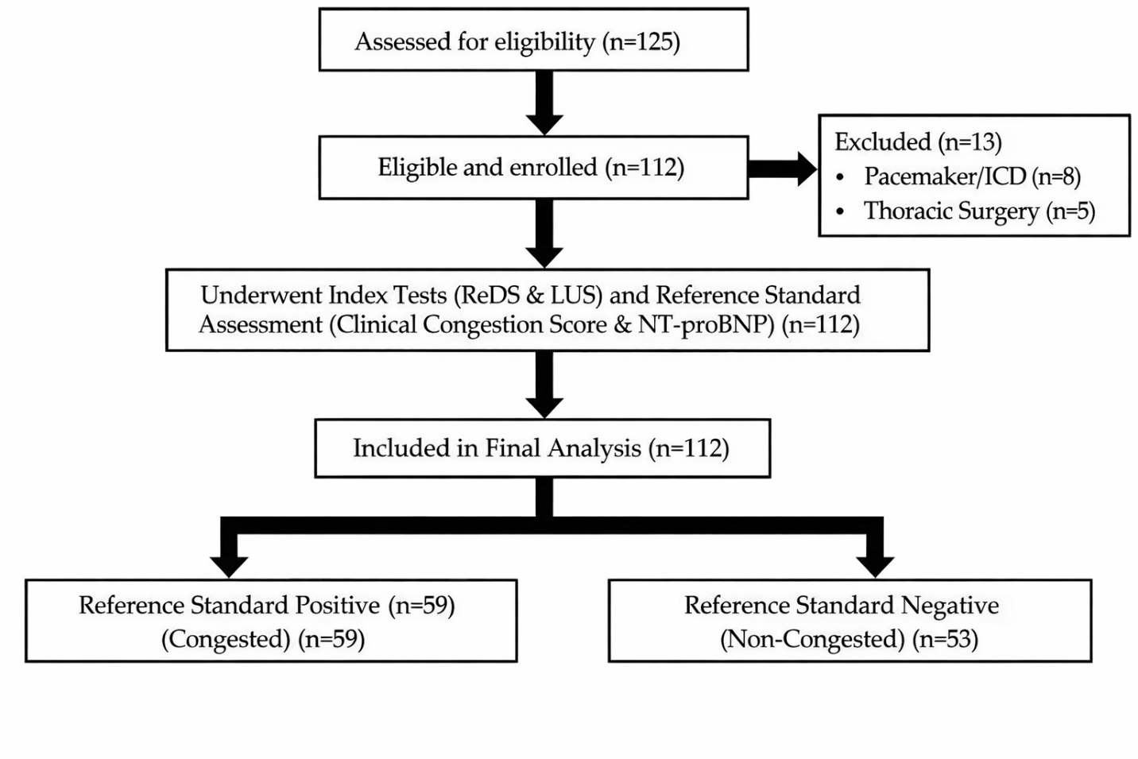
Figure 1. Study flow diagram
3.2 Baseline Characteristics: The cohort had a mean age of 68.7 years, and 46% were women. Left ventricular ejection fraction averaged 46%, with HFpEF accounting for 67% of cases. Baseline age, sex distribution, BMI, LVEF, and HF phenotype did not differ significantly between congested and non-congested groups. In contrast, markers of congestion showed clear separation. Patients classified as congested had higher NYHA class, markedly elevated NT-proBNP levels, and substantially higher ReDS values and total B-line counts, all with P values below .001. These findings (as shown in Table 1) confirm that objective congestion measures aligned with clinical adjudication, while demographic and structural characteristics remained comparable across groups. Median furosemide equivalent dose was higher in congested patients compared with non-congested patients (120 [60–240] vs 40 [20–80] mg/day, p<0.001). Median eGFR was lower in the congested group (50 [40–68] vs 62 [50–85] mL/min/1.73 m², p=0.02), indicating a greater burden of renal dysfunction and diuretic requirement in patients with adjudicated congestion.
Table 1. Baseline Characteristics
Variable | Total (n=112) | Congested (n=59) | Non-Congested (n=53) | P-value
Age, years | 68.7 ± 12.3 | 67.3 ± 11.8 | 70.2 ± 12.7 | .21
Female, n (%) | 52 (46.4) | 28 (47.5) | 24 (45.3) | .81
BMI, kg/m² | 27.2 ± 4.7 | 27.2 ± 5.3 | 27.2 ± 3.9 | .99
LVEF, % | 46.1 ± 11.2 | 45.3 ± 11.5 | 47.0 ± 10.8 | .43
HFrEF, n (%) | 37 (33.0) | 22 (37.3) | 15 (28.3) | .31
HFpEF, n (%) | 75 (67.0) | 37 (62.7) | 38 (71.7) | .31
NYHA class, median | 3 | 3 | 2 | <.001
NT-proBNP, ng/L, median (IQR) | 1136 (579–2323) | 2139 (1500–4163) | 537 (319–812) | <.001
Furosemide equivalent dose, mg/day (median [IQR]) | 80 (40–160) | 120 (60–240) | 40 (20–80) | <.001
eGFR, mL/min/1.73 m² (median [IQR]) | 55 (45–80) | 50 (40–68) | 62 (50–85) | .02
ReDS, % | 33.1 ± 8.8 | 37.9 ± 7.4 | 27.8 ± 7.1 | <.001
LUS B-lines | 22.3 ± 11.4 | 28.6 ± 10.1 | 15.4 ± 8.3 | <.001

3.3. Diagnostic Accuracy
Both modalities demonstrated similar discriminative performance for detecting pulmonary congestion. The area under the ROC curve (Figure 2) was 0.831 for ReDS and 0.845 for LUS, with no significant difference between them, P = .80. The ROC curves closely overlapped across most threshold ranges, indicating comparable sensitivity–specificity trade-offs. These findings support that ReDS and LUS provide similar overall diagnostic accuracy in this outpatient cohort, without clear superiority of one modality over the other.
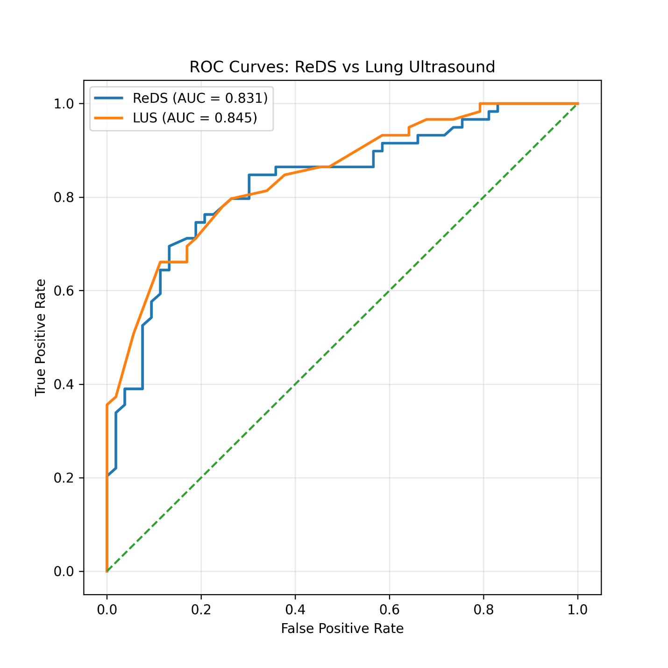
Figure 2. ROC curves comparing ReDS (%) and LUS B-line counts using the blinded composite reference standard. AUCs were compared using a paired DeLong test for correlated ROC curves.
3.4. Threshold performance
At the prespecified ReDS threshold of greater than 35 percent, sensitivity was 71 percent and specificity 81 percent. At the exploratory LUS cutoff of 24 B-lines or more, sensitivity was 70 percent and specificity 83 percent. Positive and negative predictive values were similar for both methods, and overall accuracy was identical at 75.9 percent. This is detailed in Table 2.
Likelihood ratios and diagnostic odds ratios were also comparable, with slightly higher rule-in performance for LUS. These findings indicate that, at clinically relevant thresholds, both tools perform similarly, with good specificity and moderate sensitivity in this outpatient population. Identical overall accuracy reflects a similar number of correctly classified cases despite different distributions of false positives and false negatives.
Table 2. Diagnostic Performance
Metric | ReDS >35% (95% CI) | LUS ≥24 B-lines (95% CI)
Sensitivity | 71.2% (58.1–81.8) | 69.5% (56.0–80.8)
Specificity | 81.1% (68.0–90.0) | 83.0% (70.2–92.0)
PPV | 80.8% (67.5–90.4) | 82.0% (68.6–91.4)
NPV | 71.7% (58.6–82.5) | 71.0% (57.9–82.2)
Accuracy | 75.9% | 75.9%
LR+ | 3.77 | 4.08
LR− | 0.36 | 0.37
DOR | 10.6 | 11.1

3.5. Concordance
ReDS and LUS agreed in 93 of 112 patients, yielding an overall concordance of 83.0 percent. Both tests were positive in 36 patients and negative in 57 patients. Discordant results occurred in 19 cases, with 6 patients classified as ReDS positive but LUS negative, and 13 classified as ReDS negative but LUS positive.
Inter-method agreement was substantial, with a Cohen kappa of 0.65. McNemar testing showed no significant asymmetry between discordant pairs, P = .16 (Table 3). These findings indicate consistent classification across modalities, with a moderate proportion of clinically meaningful discordance.
Table 3. Agreement Matrix
 | LUS Positive | LUS Negative | Total
ReDS Positive | 36 | 6 | 42
ReDS Negative | 13 | 57 | 70
Total | 49 | 63 | 112

3.6. Correlation
Continuous ReDS percentages showed a modest positive correlation with total B-line counts (Figure 3). Pearson correlation was r=0.36 with P < .001, indicating a statistically significant but moderate linear association. As ReDS values increased, B-line burden generally increased, although substantial scatter was present across the range of measurements.
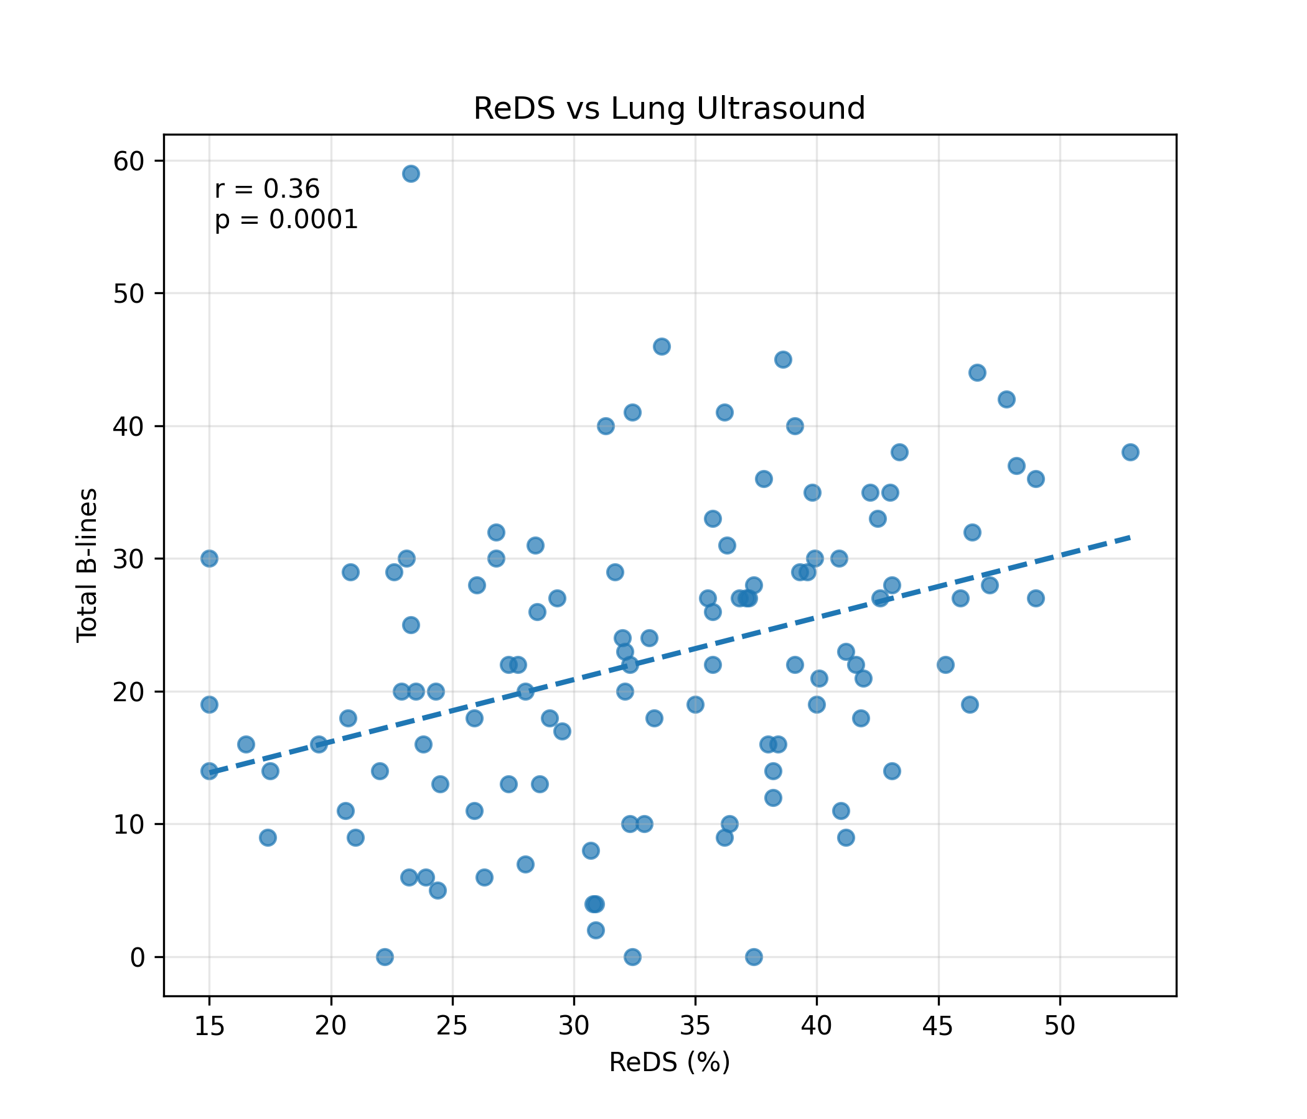
Figure 3. Scatter plot illustrating the correlation between ReDS percentage and total B-line count on lung ultrasound (Pearson r=0.36, P<.001).
3.7. Subgroup analysis
Diagnostic performance remained broadly consistent across phenotypic subgroups. As seen in Table 4, in HFrEF patients, both modalities showed high discrimination, with AUCs of 0.862 for ReDS and 0.879 for LUS. In HFpEF, performance was slightly lower but remained acceptable, with AUCs of 0.812 and 0.828 respectively.
Body mass index influenced performance more noticeably. Among patients with BMI <30 kg/m², AUCs were strong for both ReDS and LUS at 0.871 and 0.865. In those with BMI ≥30 kg/m², discrimination declined, particularly for ReDS at 0.728, while LUS remained relatively preserved at 0.803. Confidence intervals were wider in higher BMI groups due to smaller sample size, so these findings should be interpreted as exploratory.
Table 4. Subgroup AUCs
Subgroup | ReDS AUC (95% CI) | LUS AUC (95% CI)
HFrEF (n=37) | 0.862 (0.71–0.96) | 0.879 (0.73–0.97)
HFpEF (n=75) | 0.812 (0.69–0.90) | 0.828 (0.71–0.91)
BMI <30 (n=78) | 0.871 (0.77–0.94) | 0.865 (0.76–0.93)
BMI ≥30 (n=34) | 0.728 (0.55–0.87) | 0.803 (0.63–0.92)

3.8. Multivariable analysis
In multivariable models adjusted for age and BMI, both ReDS and LUS remained independently associated with adjudicated congestion. In the ReDS-based model (Table 5), each 1 percent increase in ReDS was associated with a 20 percent higher odds of congestion, adjusted OR 1.20, 95% CI 1.12 to 1.29, P < .001. Age and BMI were not independently associated with congestion in this model. In the LUS-based model (Table 6), each 5-line increase in total B-lines was associated with a 48 percent higher odds of congestion, adjusted OR 1.48, 95% CI 1.22 to 1.79, P < .001. Again, age and BMI did not show significant independent associations.
Table 5: ReDS-Based Model
Variable | Adjusted OR | 95% Confidence Interval | P - value
ReDS (% per 1% increase) | 1.20 | 1.12 – 1.29 | <.001
Age (per year) | 0.98 | 0.94 – 1.02 | .31
BMI (per kg/m²) | 1.01 | 0.92 – 1.11 | .84

Table 6: Lung Ultrasound–Based Model (Comparator)
Variable | Adjusted OR | 95% Confidence Interval | P -value
LUS B-lines (per 5-line increase) | 1.48 | 1.22 – 1.79 | <.001
Age (per year) | 0.97 | 0.93 – 1.01 | .17
BMI (per kg/m²) | 0.99 | 0.90 – 1.09 | .82

3.9. Inter-observer reliability: Inter-observer reliability was evaluated in 23 randomly selected LUS examinations that were independently re-interpreted. Agreement for the predefined threshold of ≥24 B-lines was substantial, with Cohen’s κ of 0.75. This indicates consistent classification of congestion status between observers at the clinically relevant cutoff. Agreement analysis focused on threshold-based categorization. Continuous duplicate measurements were not systematically recorded; therefore, intraclass correlation for total B-line counts could not be calculated. ReDS provides an automated output and is less operator-dependent. Formal test–retest reproducibility was not assessed in this study.
3.10. Sensitivity analysis: Sensitivity analysis restricted to a clinical score ≥5 produced similar AUC estimates for both modalities.
4. DISCUSSION
Principal Findings
In this prospective cohort of stable ambulatory heart failure patients, ReDS and LUS demonstrated comparable discrimination for pulmonary congestion. Both modalities showed good specificity and moderate sensitivity. Overall agreement was substantial, although continuous measures correlated only modestly, suggesting detection of overlapping but distinct congestion phenotypes.
Interpretation
ReDS estimates global thoracic fluid content through dielectric properties (Amir et al., 2013; Bensimhon et al., 2016). LUS identifies interstitial edema via B-lines (Platz et al., 2017). Discordant findings likely reflect physiological heterogeneity in congestion distribution. Similar modest correlations have been observed in prior comparative studies (Kato et al., 2023; Kobalava et al., 2023).
B-lines are not specific to cardiogenic congestion and may occur in interstitial lung disease, pneumonia, or pulmonary fibrosis, which could contribute to false-positive LUS findings despite exclusion of active lung pathology. Such conditions were excluded where clinically evident, but subclinical pulmonary pathology cannot be fully excluded.
Clinical Implications
ReDS offers rapid, operator-independent screening suitable for ambulatory workflows. LUS provides anatomical characterization and may guide diuretic titration. A sequential strategy may enhance congestion assessment while balancing practicality and physiological insight.
Strengths
Prospective design, blinded adjudication, standardized protocols, and complete follow-up strengthen internal validity.
5. CONCLUSION
ReDS and LUS demonstrated similar diagnostic accuracy for detecting pulmonary congestion in stable ambulatory heart failure patients. Modest correlation and substantial agreement support complementary physiological roles. Multicenter studies incorporating invasive validation and longitudinal outcomes are needed.
Limitations
Several limitations should be considered when interpreting these findings. The reference standard was a pragmatic composite clinical–biomarker construct and lacks external validation, which may have led to misclassification, particularly in stable outpatient populations (Gheorghiade et al., 2010; Januzzi et al., 2018). Invasive hemodynamic confirmation, such as pulmonary capillary wedge pressure, was not performed, limiting mechanistic correlation with true filling pressures. The single-center design and inclusion of stable ambulatory patients introduce potential spectrum bias and restrict generalizability to acute or inpatient settings. The moderate sample size limits statistical power for subgroup analyses, which should be viewed as exploratory. Renal function and diuretic dose were available and reported, but atrial fibrillation status and other modifiers of natriuretic peptide levels were not systematically collected. Lung ultrasound was performed by experienced operators, which may overestimate performance in less specialized environments (Ceriani et al., 2021). B-lines are not specific to cardiogenic congestion and may occur in interstitial lung disease, pneumonia, or pulmonary fibrosis, which could contribute to false-positive LUS findings despite exclusion of active lung pathology. ReDS test–retest reproducibility and continuous LUS reproducibility were not independently assessed, and device positioning may have influenced measurements. Finally, longitudinal clinical outcomes, including hospitalization and mortality, were not evaluated, limiting assessment of prognostic utility.
CONSENT
All authors declare that ‘written informed consent was obtained from all patients.
ETHICAL APPROVAL
Ethical committee approval was obtained prior to initiating study (Ethics Committee approval number- AMH – DNB-078/08-23). All study related protocols, consent and documents were submitted and approved by the committee.

COMPETING INTERESTS DISCLAIMER:
Authors have declared that they have no known competing financial interests OR non-financial interests OR personal relationships that could have appeared to influence the work reported in this paper.

Disclaimer (Artificial intelligence)

Author(s) hereby declare that NO generative AI technologies such as Large Language Models (ChatGPT, COPILOT, etc.) and text-to-image generators have been used during the writing or editing of this manuscript.

REFERENCES
- Abraham, W. T., Bensimhon, D. R., Pinney, S. P., et al. (2017). Evaluation of remote dielectric sensing technology-guided therapy for decreasing heart failure re-hospitalizations. International Journal of Cardiology, 240, 279–284.
- Amir, O., Rappaport, D., Zafrir, B., & Abraham, W. T. (2013). A novel approach to monitoring pulmonary congestion in heart failure. Congestive Heart Failure, 19, 149–155.
- Amir, O., Azzam, Z. S., Abraham, W. T., et al. (2016). Validation of remote dielectric sensing technology for quantification of lung fluid status. International Journal of Cardiology, 221, 841–846.
- Bensimhon, D., Burton, J., Wang, H., et al. (2016). Remote dielectric sensing for detecting pulmonary congestion. JACC: Heart Failure, 4, 729–730.
- Bossuyt, P. M., Reitsma, J. B., Bruns, D. E., et al. (2015). STARD 2015. BMJ, 351, h5527.
- Ceriani, E., Knol, M. J., van der Worp, H. B., et al. (2021). Methodological quality of lung ultrasound diagnostic studies. Journal of Ultrasound in Medicine, 40, 2553–2565.
- Domingo, M., Conangla, L., Lupón, J., et al. (2021). Prognostic value of lung ultrasound in ambulatory HF. Revista Española de Cardiología, 74, 862–869.
- Gheorghiade, M., Follath, F., Ponikowski, P., et al. (2010). Assessing congestion in acute heart failure. European Journal of Heart Failure, 12, 423–433.
- Januzzi, J. L., Jr., Chen-Tournoux, A. A., Christenson, R. H., et al. (2018). ICON-RELOADED. Journal of the American College of Cardiology, 71, 1191–1200.
- Kato, M., Stevenson, L. W., Goda, A., et al. (2023). Remote dielectric sensing and lung ultrasound. Heart and Vessels, 38, 672–681.
- Kobalava, Z., Safarova, A. F., Tolkacheva, V., et al. (2023). Pulmonary congestion in HFrEF. Arquivos Brasileiros de Cardiologia: Imagem Cardiovascular, 36, e20230027.
- Kobalava, Z., Safarova, A. F., Tolkacheva, V., et al. (2024). Ultrasound and ReDS in hospitalized HF. Arquivos Brasileiros de Cardiologia, 121, e20240128.
- Lala, A., Barghash, M. H., Lanfear, D. E., et al. (2021). Early ReDS use after hospitalization. ESC Heart Failure, 8, 1047–1054.
- Miglioranza, M. H., Gargani, L., Sant’Anna, R. T., et al. (2017). Pulmonary congestion evaluated by lung ultrasound predicts decompensation in heart failure outpatients. International Journal of Cardiology, 240, 271–278.
- Olesen, A. S. O., Miger, K., Fabricius-Bjerre, A., et al. (2022). ReDS to detect acute heart failure in dyspnea. European Heart Journal Open, 2, oeac073.
- Platz, E., Merz, A. A., Jhund, P. S., et al. (2016). Detection and prognostic value of pulmonary congestion. European Heart Journal, 37, 1244–1251.
- Platz, E., Merz, A. A., Jhund, P. S., et al. (2017). Dynamic changes in pulmonary congestion. European Journal of Heart Failure, 19, 1154–1163.
- Rastogi, T., Gargani, L., Pellicori, P., et al. (2024). Prognostic implication of lung ultrasound. European Heart Journal : Cardiovascular Imaging, 25, 1216–1225.
- Savarese, G., Becher, P. M., Lund, L. H., et al. (2023). Global burden of heart failure. Cardiovascular Research, 118, 3272–3287.
- Wang, C. S., FitzGerald, J. M., Schulzer, M., et al. (2005). Does this dyspneic patient have CHF? JAMA, 294, 1944–1956.

ABBREVIATIONS
Abbreviation Full Term
AUC Area Under the Receiver Operating Characteristic Curve
BMI Body Mass Index
CI Confidence Interval
DOR Diagnostic Odds Ratio
HF Heart Failure
HFpEF Heart Failure with Preserved Ejection Fraction
HFrEF Heart Failure with Reduced Ejection Fraction
LUS Lung Ultrasound
LR+ Positive Likelihood Ratio
LR− Negative Likelihood Ratio
LVEF Left Ventricular Ejection Fraction
NT-proBNP N-terminal pro–B-type Natriuretic Peptide
NPV Negative Predictive Value
NYHA New York Heart Association
OR Odds Ratio
PPV Positive Predictive Value
ReDS Remote Dielectric Sensing
ROC Receiver Operating Characteristic
SD Standard Deviation
STARD Standards for Reporting of Diagnostic Accuracy Studies

