Case report

Diagnostic Challenges in Infero-Basal STEMI with Double Coronary Occlusion: Two Clinical Cases and Literature Review

Abstract
Background: Determining the infarct-related artery (IRA) in inferior ST-elevation myocardial infarction (STEMI) is generally guided by electrocardiographic (ECG) and angiographic characteristics. Diagnostic uncertainty increases when both the right coronary artery (RCA) and left circumflex artery (LCx) are diseased or occluded, particularly in the presence of chronic total occlusion or heavy calcification.
Case presentations: We describe two patients presenting with infero-basal STEMI and severe multivessel coronary artery disease. In the first case, dual occlusion of the RCA and LCx occurred in a patient with prior in-stent LCx revascularisation. ECG and echocardiography yielded discordant territorial patterns, whereas angiography revealed diffuse calcification. Selective guidewire probing demonstrated that the RCA lesion was chronic, whereas the in-stent LCx occlusion was acute and thrombotic, restoring TIMI 3 flow. In the second case, an apparently thrombotic RCA occlusion with full collateralization co-existed with a severe proximal LCx stenosis. Progressive wire escalation confirmed chronic RCA occlusion and acute LCx occlusion, both successfully revascularized.
Discussion & conclusion: These cases illustrate the limitations of isolated ECG or angiographic interpretation for culprit lesion identification in complex inferior STEMI. Contemporary evidence confirms that the RCA is the most frequent culprit artery, although LCx occlusion remains under-recognised. We integrate two complementary diagnostic strategies: an ECG-based algorithm derived from Fiol et al., and an angiography-guided algorithm incorporating selective wire probing when diagnostic ambiguity persists. Accurate IRA identification in infero-basal STEMI with dual occlusions requires a structured multimodal diagnostic approach.
Keywords: Inferior STEMI, culprit artery, right coronary artery, left circumflex artery, electrocardiography, angiography, multivessel disease

Introduction
Coronary arteries with anomalous origin from the aorta or anomalous course may represent a trouble for interventional cardiologists [12]. Acute coronary syndrome (ACS) encompasses conditions characterised by a sudden decrease in myocardial perfusion, presenting as ST-segment elevation myocardial infarction (STEMI), non–ST-segment elevation myocardial infarction (NSTEMI), or unstable angina. Globally, over 7 million individuals are diagnosed with ACS annually, with more than 1 million cases requiring hospitalisation in the United States each year. STEMI results from the complete blockage of a coronary artery and represents about 30% of all ACS cases. An acute STEMI is marked by transmural myocardial ischemia resulting in myocardial injury or necrosis [13,14]. Inferior STEMI most commonly results from acute occlusion of the right coronary artery (RCA) and less frequently from the left circumflex artery (LCx). Early and accurate identification of the infarct-related artery (IRA) is essential for procedural planning, prompt reperfusion, and prognostic assessment. Several electrocardiographic (ECG) criteria — including greater ST elevation in lead III than in lead II and reciprocal ST depression in aVL or lead I — have been proposed to differentiate RCA- from LCx-related inferior STEMI; however, their diagnostic performance decreases in multivessel coronary artery disease or when chronic and acute lesions coexist [1-3].
Coronary angiography remains the reference modality, yet distinguishing acute thrombotic occlusion from chronic total occlusion (CTO) may be challenging. Features such as tapered caps, dense circumferential calcification, and mature collateral networks suggest chronicity, whereas a blunt cap and intraluminal thrombus favour acute occlusion. Nonetheless, calcification may mimic thrombus, and collateral circulation does not invariably exclude recent ischemia.
We report two cases of infero-basal STEMI with concomitant RCA and LCx occlusions in patients with diffuse atherosclerotic disease, illustrating the complexities of culprit lesion identification and highlighting the value of combining an ECG-based diagnostic algorithm with a complementary angiography-guided algorithm.

Case Presentations
Case 1 :
A 65-year-old man with a medical history of diabetes mellitus, hypertension, and long-standing coronary artery disease was admitted for persistent chest pain evolving for seven hours. Fifteen years earlier, he had experienced an uncomplicated infero-basal ST-elevation myocardial infarction (STEMI) related to a distal left circumflex artery (LCx) occlusion, which had been successfully treated with drug-eluting stent implantation.
On admission, coronary angiography performed via a right radial approach revealed severe multivessel coronary artery disease. The left main coronary artery was free of significant disease. The left anterior descending artery showed diffuse atherosclerosis with heavy calcification and significant proximal-to-mid stenoses, while maintaining TIMI 3 flow. The LCx presented with an in-stent occlusion originating at the ostium, with no distal opacification. The right coronary artery (RCA) was severely calcified and exhibited a long mid-segment occlusion associated with poor distal vessel visualisation. These findings were consistent with severe triple-vessel disease, with concomitant occlusion of both the RCA and LCx. (Figure 1)
Culprit lesion identification was challenging due to discordant diagnostic data. The electrocardiogram demonstrated infero-basal ST-segment elevation predominantly in lead III, with reciprocal ST depression in lead I (Figure 2), suggesting an RCA-related infarction. Conversely, transthoracic echocardiography revealed lateral wall hypokinesia, favoring LCx involvement. Angiographically, contrast staining was observed at the inferior bend of the RCA, raising suspicion of either acute thrombus or dense calcification, while the LCx occlusion appeared “cupped,” without clear features of acuity.
To resolve this ambiguity, an interventional assessment was performed using an Amplatz Left 2 guiding catheter to selectively probe both coronary systems. Multiple guidewire crossing attempts of the RCA lesion were unsuccessful, consistent with a chronic total occlusion. In contrast, the LCx occlusion was easily crossed, resulting in immediate restoration of TIMI 3 flow and visualisation of two obtuse marginal branches (Figure 3). These findings confirmed the LCx in-stent occlusion as the acute culprit lesion, likely thrombotic in nature.
Given the complexity of the coronary anatomy and the presence of extensive calcification, glycoprotein IIb/IIIa inhibitor therapy was initiated, and the patient was referred for staged surgical revascularisation.

Case 2:
A 70-year-old diabetic former smoker with a prior history of anterior STEMI treated by overlapping stents in the left anterior descending artery (LAD) presented with infero-basal STEMI six hours after symptom onset. Coronary angiography demonstrated a complete occlusion of the mid-RCA with well-developed collateral circulation, a severe proximal LCx stenosis, and patent LAD stents without restenosis (Figure 4).
Based on previous angiographic data showing only intermediate RCA disease and the absence of prior anginal symptoms, the RCA occlusion was initially suspected to be acute. However, guidewire escalation strategies were required to clarify lesion chronicity. An initial attempt using a standard workhorse guidewire failed to cross the RCA lesion. A second femoral access was obtained to allow retrograde injections, which revealed a poorly developed distal vessel bed. Subsequent use of a polymer-coated Fielder XT guidewire enabled the difficult crossing of the RCA lesion, uncovering a long, heavily calcified chronic total occlusion.
Attention was then directed to the LCx lesion, which was identified as the acute culprit. Percutaneous coronary intervention was performed with sequential non-compliant balloon predilatation and implantation of drug-eluting stents in both the RCA CTO and the LCx (Figure 5). The final angiographic result was optimal, and the patient was discharged uneventfully on day three.

Discussion
Inferior ST-elevation myocardial infarction most commonly results from acute occlusion of the right coronary artery, while the left circumflex artery represents a less frequent but clinically significant culprit. Large angiographic and electrocardiographic studies report RCA involvement in approximately 60–85% of inferior STEMI cases, with LCx occlusion accounting for 15–40%, depending on coronary dominance and infarct distribution [1–6]. RCA-related infarctions predominate in right-dominant coronary systems and classical inferior or infero-basal patterns, whereas LCx occlusion is more often observed in left-dominant anatomies or in lateral and posterobasal infarctions [4–6].
Culprit artery identification becomes particularly challenging when RCA and LCx disease coexist, especially in the presence of chronic total occlusions, extensive calcification, or well-developed collateral circulation. Both cases presented here illustrate these diagnostic pitfalls and emphasise the limitations of relying on a single diagnostic modality [2,3,10].
Electrocardiographic criteria, such as greater ST-segment elevation in lead III compared with lead II and reciprocal ST depression in lead I or aVL, have demonstrated moderate diagnostic accuracy in differentiating RCA from LCx occlusion [1,3,7]. However, their reliability decreases significantly in patients with multivessel disease or prior myocardial infarction [2,3]. In this context, we applied a stepwise ECG-based algorithm derived from the Fiol model, which sequentially evaluates ST-segment deviations in lead I, the relative magnitude of ST elevation in leads II and III, the relationship between inferior ST elevation and anterior ST depression, and ST changes in lead V1 [8]. Although this algorithm provided valuable initial orientation, it proved insufficient to definitively identify the culprit artery in the presence of dual coronary occlusions, as previously reported in complex coronary anatomy [3,10]. (Figure 6)
Echocardiography may provide complementary information through regional wall-motion analysis; however, its diagnostic accuracy is limited in patients with previous myocardial infarction or multiterritorial ischemic dysfunction {5,6}. This limitation was evident in the first case, where lateral wall hypokinesia suggested LCx involvement despite electrocardiographic findings favouring an RCA culprit.
Coronary angiography remains the reference diagnostic tool, yet distinguishing acute thrombotic occlusion from chronic total occlusion may be difficult. Angiographic features such as tapered proximal caps, circumferential calcification, and extensive collateral circulation are typically associated with chronic occlusions, whereas blunt caps and intraluminal thrombus favour acute occlusion [9,10]. Importantly, collateral circulation does not exclude recent ischemia, and dense calcification may mimic thrombus, leading to diagnostic uncertainty.
In both cases, selective guidewire probing proved decisive. Acute thrombotic lesions were readily crossable, whereas chronic fibro-calcified occlusions resisted guidewire passage and required CTO-specific techniques [9,11]. This interventional assessment allowed accurate culprit lesion identification and prevented unnecessary or inappropriate revascularisation.
Conclusion

Inferior STEMI with concomitant RCA and LCx occlusion represents a rare but challenging clinical scenario in which conventional ECG localisation and angiographic morphology may not reliably identify the culprit artery. A structured multimodal diagnostic pathway — integrating ECG interpretation, echocardiography, detailed angiographic assessment, and selective guidewire probing — allows accurate culprit lesion identification and optimises revascularisation strategy in complex multivessel coronary disease.
Consent Statement
Written informed consent was obtained from the patients for the publication of this case report, including all clinical data and accompanying images.

Disclaimer (Artificial intelligence)

Author(s) hereby declare that NO generative AI technologies such as Large Language Models (ChatGPT, COPILOT, etc.) and text-to-image generators have been used during the writing or editing of this manuscript.

References
- Zhou P, Wu Y, Wang M, Zhao Y, Yu Y, Waresi M, et al. Identifying the culprit artery via 12-lead electrocardiogram in inferior wall ST-segment elevation myocardial infarction: a meta-analysis. Ann Noninvasive Electrocardiol. 2023;28:e13016. doi:10.1111/anec.13016
- Farhat-Sabet A, Mackenzie GM, North R, Gulati SK, Philip D, Webb JG, et al. Localising culprit artery in inferior STEMI: ECG versus angiography. Heart Lung Circ. 2023;32(4):460-467.
- Andreou AY, Chira G, Korantzopoulos P. Electrocardiographic prediction of culprit artery in inferior myocardial infarction. J Electrocardiol. 2022;71:10-17.
- Li Q, Zheng Z, Wang S, Chen M. Electrocardiogram in patients with acute inferior myocardial infarction: correlation with culprit coronary artery. Med Sci Monit. 2017;23:6124-6132.
- Shabbir A, Tuyyab F, Aziz S, Siddiqa A. Comparison of right coronary artery and left circumflex related acute inferior wall myocardial infarction in patients undergoing primary PCI. Pak Armed Forces Med J. 2017;67(Suppl-2):S130-S134.
- El Sayed AME, Shaban AE, Elgendy EAE, Saeid AME. Correlation between ST segment elevation in the 12-lead ECG and the culprit coronary artery in patients with acute STEMI undergoing primary PCI. Int J Cardiol Sci. 2024;6(1):1-7.
- El Sayed AM. Lead ECG and the culprit coronary artery in acute myocardial infarction: an electrophysiological perspective. Cardiology Journals Net. 2024;6(1):42-49.
- Fiol, Miquel et al. Value of electrocardiographic algorithm based on “ups and downs” of ST in assessment of a culprit artery in evolving inferior wall acute myocardial infarction. American Journal of Cardiology, Volume 94, Issue 6, 709 - 714
- Ellis SG, Ajluni S, Arnold AZ, et al. Coronary morphologic and clinical determinants of procedural outcome with angioplasty for multivessel disease. Circulation. 1990;82(2):I89-I99.
- Tseng LM, Hsu HL, Chang WC, Wu CJ, Wang SS, Chen WJ. Identification of coronary culprit lesion in ST elevation myocardial infarction: ECG versus angiogram. PLoS One. 2022;17(1):e0262905.
- Aly Ahmed AM, Ahmed AME, Farouk MK. Electrocardiographic distinction of left circumflex and right coronary artery occlusion in inferior STEMI. ZUMJ. 2024;30(2):112-119
- Giacomo Schiattarella, G., Magliulo, F., Di Palma, V., Esposito, G., & Cirillo, P. (2015). Primary Percutaneous Coronary Intervention in a Patient with Acute Inferior Myocardial Infarction and Agenesis of Right Coronary Artery. "In Search of a Coronary Ostium". Cardiology and Angiology: An International Journal, 3(3), 157–161.
- Akbar, H., & Mountfort, S. (2025). Acute ST-segment elevation myocardial infarction (STEMI). In StatPearls [Internet]. StatPearls Publishing. Retrieved January 28, 2026, from https://www.statpearls.com/point-of-care/17173
- Khan, Z. (2024). A young patient with acute ostial right coronary artery aneurysm presenting as ST elevation myocardial infarction. Cureus, 16(4).

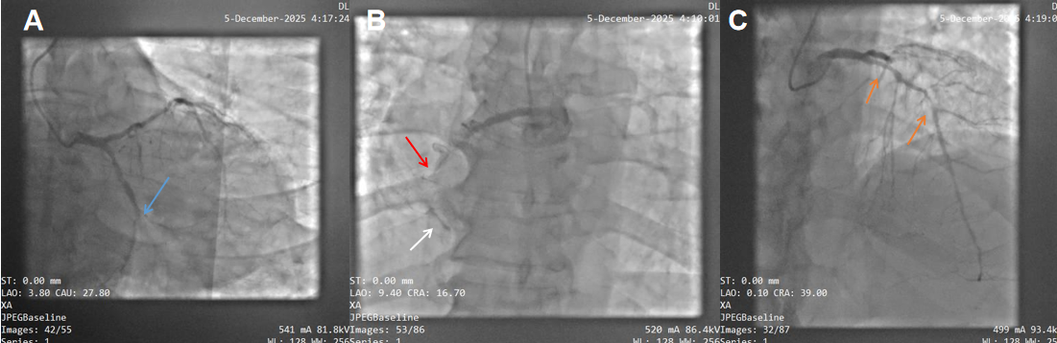
Figure 1: Coronary angiography.

- Caudal projection showing an in-stent occlusion of the distal left circumflex artery (LCx) (blue arrow).

- Cranial projection of the right coronary artery (RCA) demonstrating an occlusion of the RCA (red arrow). Contrast staining at the level of the inferior bend is suggestive of thrombus formation or severe calcification (white arrow).

(C) Cranial projection of the left coronary system showing a severe, calcified double lesion of the left anterior descending artery (LAD), with preserved TIMI grade 3 flow and good distal runoff (orange arrow).

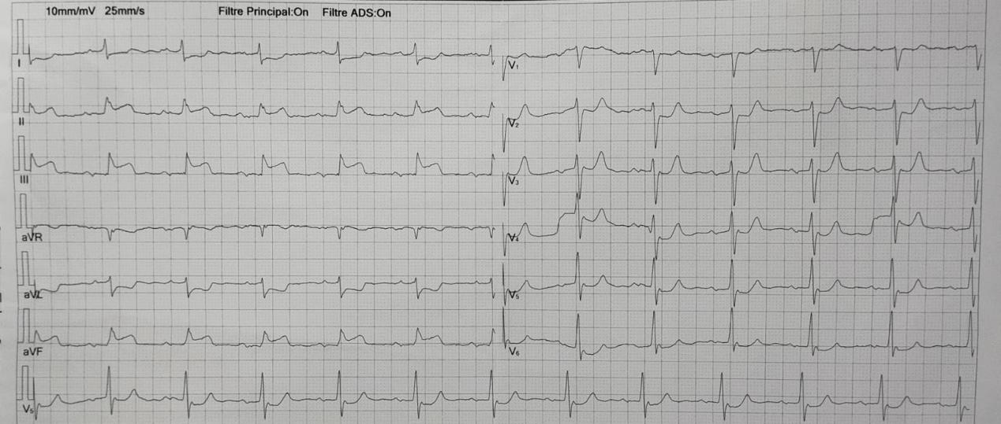
Figure 2: Electrocardiogram showing inferior ST-segment elevation, maximal in lead III, with reciprocal ST-segment depression in the high-lateral leads and in V2–V3.

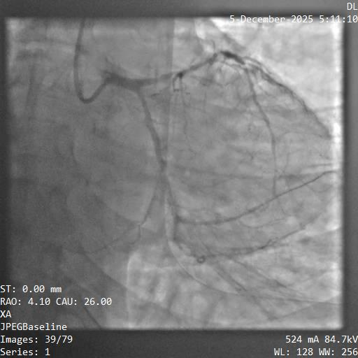
Figure 3: Coronary angiography showing successful recanalization of the left circumflex artery after guidewire crossing and balloon angioplasty

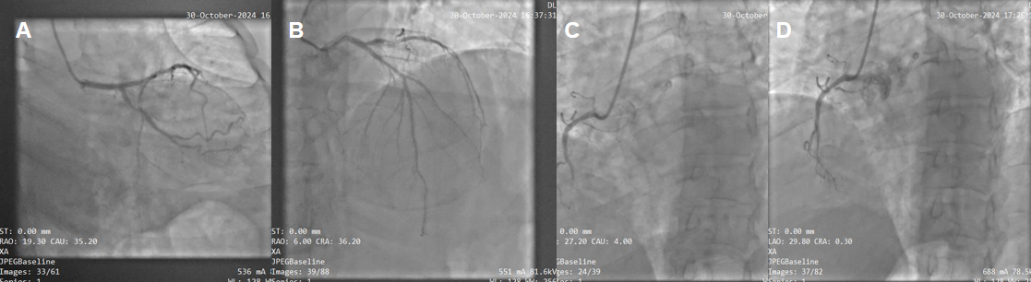
Figure 4: Coronary angiography findings.
A: Right anterior oblique caudal view showing a severe stenosis of the proximal circumflex artery (red arrow).
B: Cranial view demonstrating patency of the previously implanted stents in the left anterior descending artery, with no evidence of in-stent restenosis.
C: Left anterior oblique view of the right coronary system showing a complete occlusion of the right coronary artery (blue arrow).
D: Failure to advance the guidewire within the right coronary artery, confirming the chronic nature of the occlusion.

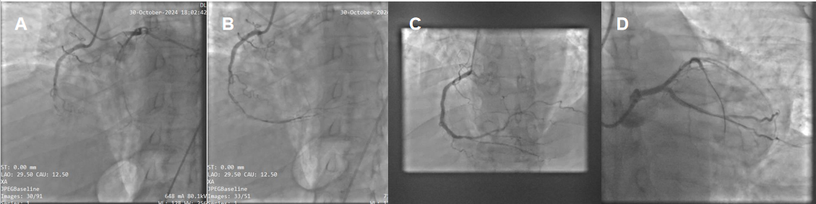
Figure 5: Percutaneous coronary intervention of the right coronary artery and circumflex artery.
A: Dual vascular access: right radial approach for PCI of the right coronary artery, and right femoral approach for retrograde injections to assess the distal vessel bed and distal guidewire position.
B: Successful recanalization of the right coronary artery using a Fielder XT guidewire; sequential balloon inflations were performed to prepare the lesion.
C: Successful angioplasty of the mid–right coronary artery with implantation of a drug-eluting stent, yielding an optimal final angiographic result.
D: Successful angioplasty of the proximal circumflex artery with implantation of a drug-eluting stent, with a good final angiographic outcome.

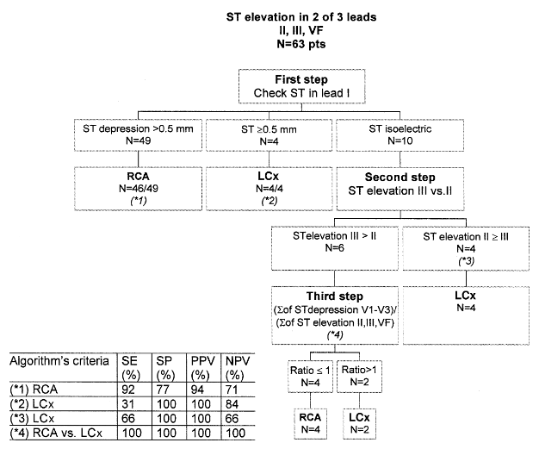
Figure 6: Algorithm based on electrocardiographic criteria

