Case report
Mitro-aortic Infective Endocarditis on Bicuspid Aortic Valve Complicated by Pseudoaneurysm of the Left Coronary Sinus: A Case Report

Abstract

Infective endocarditis (IE) remains a severe disease associated with high morbidity and mortality despite advances in diagnostic imaging and antimicrobial therapy. Bicuspid aortic valve (BAV), the most common congenital cardiac anomaly, is a well-recognized predisposing factor for IE and its complications. Peri-annular extension of infection may lead to abscess formation, fistulization, or, more rarely, pseudoaneurysm of the sinus of Valsalva, a condition associated with life-threatening consequences. We report the case of a 36-year-old man with mitro-aortic infective endocarditis occurring on a bicuspid aortic valve, complicated by a pseudoaneurysm of the left coronary sinus and systemic embolization that underwent a surgical approach.
This case highlights the importance of early detection and prompt surgical management of complicated infective endocarditis on a bicuspid aortic valve, and illustrates the key role of multimodality imaging in guiding treatment.

Introduction

Infective endocarditis (IE) is a potentially fatal condition defined by infection of the endocardial surface of the heart, most frequently involving native or prosthetic valves [1]. Despite improvements in diagnostic tools and antimicrobial strategies, IE continues to be associated with high rates of complications and mortality, particularly when diagnosis is delayed or when peri-valvular extension occurs .

Bicuspid aortic valve (BAV) is the most common congenital cardiac malformation, affecting approximately 1–2% of the general population. The abnormal valve morphology and altered flow patterns predispose patients to accelerated valvular degeneration, aortic dilation, and infective endocarditis [2,3]. Compared with tricuspid aortic valves, BAV is associated with a higher lifetime risk of IE, particularly in young and middle-aged men [4].

One of the most severe complications of aortic valve endocarditis is extension of infection beyond the valve annulus into adjacent cardiac structures. This may result in peri-annular abscesses, pseudoaneurysm formation, or fistulous communications, all of which significantly worsen prognosis and often necessitate urgent surgical intervention [5]. Pseudoaneurysm of the sinus of Valsalva secondary to IE is rare, especially when involving the left coronary sinus, but carries a high risk of rupture, coronary compression, and hemodynamic collapse.

We report a rare and complex case of mitro-aortic infective endocarditis on a bicuspid aortic valve complicated by a pseudoaneurysm of the left coronary sinus, illustrating the importance of early recognition, multimodality imaging, and timely surgical management.

Case Report

A 36-year-old man with no known cardiovascular risk factors was admitted to our department for evaluation of prolonged fever and progressive asthenia. His medical history was notable for a dental extraction performed several weeks prior to symptom onset, without antibiotic prophylaxis.

Seven months before admission, the patient developed intermittent undocumented fever associated with night sweats, diffuse arthralgias, and general malaise. Initial empirical antibiotic therapy prescribed resulted in transient and partial improvement. However, symptoms recurred two months later, prompting consultation with an internist. A cardiac murmur was detected on physical examination, and the patient was subsequently referred to a cardiologist, who arranged transfer to our cardiology department for further evaluation and management.

On admission, the patient was conscious, oriented, and febrile, with a body temperature of 38°C. Blood pressure was stable, and there were no signs of acute heart failure. Oral examination revealed poor dental hygiene. Cardiovascular examination identified a grade 3/6 holodiastolic murmur best heard at the aortic area and radiating along the left sternal border. No peripheral stigmata of infective endocarditis were observed.

Electrocardiogram (figure1) showed sinus rhythm at 93 beats per minute with a normal electrical axis and no conduction abnormalities. Chest radiography was unremarkable. Laboratory investigations revealed severe normocytic, normochromic anemia (hemoglobin 7 g/dL), elevated inflammatory markers, and impaired renal function with an estimated glomerular filtration rate of 45 mL/min/1.73 m². Serial blood cultures remained negative, likely due to prior antibiotic exposure.

Transthoracic echocardiography (figure2) demonstrated a bicuspid aortic valve (Sievers type 1) with fusion of the right and left coronary cusps. Two mobile vegetations were visualized on the aortic valve, associated with severe aortic regurgitation. A peri-annular pseudoaneurysm originating from the aortic annulus and extending toward the mitro-aortic trigone was identified. The left ventricle was markedly dilated with preserved wall thickness, while the right ventricle had normal size and systolic function.

Transesophageal echocardiography (figure 3) provided better anatomical delineation and confirmed mitro-aortic infective endocarditis involving the bicuspid aortic valve, with severe aortic regurgitation. A pseudoaneurysm of the left coronary sinus was clearly visualized, as well as aneurysmal dilation of the tubular ascending aorta.

Computed tomography angiography revealed a splenic infarction, consistent with systemic embolization, without evidence of cerebral or mesenteric ischemia.

The diagnosis of infective endocarditis complicated by peri-annular extension and systemic embolization was retained based on clinical, echocardiographic, and imaging findings. Empirical broad-spectrum intravenous antibiotic therapy was initiated (Ampicillin+ Ceftriaxone + Gentamicin). Given the severity of valvular destruction, the presence of a pseudoaneurysm, and the embolic complication, the patient was referred for early surgical management with good evolution.

Discussion

This case illustrates several key aspects of infective endocarditis in patients with bicuspid aortic valves, including delayed diagnosis, peri-annular extension, and systemic embolization.

BAV is a well-established risk factor for IE, particularly in young male patients. Michelena et al. demonstrated a significantly increased incidence of IE in BAV patients compared with the general population, with a predilection for aggressive disease and structural complications [4]. The abnormal valve architecture and turbulent flow patterns contribute to endothelial injury, facilitating bacterial adhesion and colonization.

The clinical presentation of IE can be highly variable. Subacute forms, as observed in this patient, often manifest with nonspecific symptoms such as prolonged fever, fatigue, and arthralgias, leading to diagnostic delay. Prior antibiotic exposure further complicates diagnosis by reducing blood culture positivity, resulting in culture-negative endocarditis in a significant proportion of cases [3].

Peri-annular extension is a feared complication of aortic valve endocarditis, occurring in approximately 20–40% of cases and associated with increased mortality [5]. The infectious process may extend beyond the valve annulus into surrounding structures, leading to abscess formation, pseudoaneurysm, or fistula. Pseudoaneurysm of the sinus of Valsalva typically develops when an abscess ruptures into the aortic sinus, creating a contained cavity that communicates with the aortic lumen [6].

Pseudoaneurysms most commonly involve the right coronary sinus, followed by the non-coronary sinus, while involvement of the left coronary sinus is rare[7]. Left-sided pseudoaneurysms are particularly concerning due to the risk of coronary artery compression, rupture into adjacent chambers, and acute hemodynamic deterioration [6].

Echocardiography remains the cornerstone of diagnosis in IE. While transthoracic echocardiography is useful as an initial modality, transesophageal echocardiography offers superior sensitivity and specificity for detecting vegetations, abscesses, and pseudoaneurysms, particularly in complex anatomical settings such as BAV [5]. Multimodality imaging, including cardiac CT, plays an important complementary role in assessing extracardiac complications and surgical anatomy.

Systemic embolization is a frequent complication of left-sided IE, occurring in up to 50% of patients[8]. Embolic events most commonly affect the central nervous system, but splenic infarctions, as observed in this case, are also frequent and may remain clinically silent .

Current guidelines emphasize the importance of early surgical intervention in patients with IE complicated by heart failure, uncontrolled infection, peri-annular extension, or high embolic risk [6]. In this patient, the presence of severe aortic regurgitation, pseudoaneurysm formation, and systemic embolization constituted strong indications for surgery.

Conclusion

Infective endocarditis on a bicuspid aortic valve may present insidiously and evolve toward severe local and systemic complications. Pseudoaneurysm of the left coronary sinus is a rare but life-threatening manifestation of peri-annular extension. Early recognition, systematic use of transesophageal echocardiography, and timely surgical referral are essential to improve outcomes. This case underscores the need for heightened clinical vigilance in young patients with prolonged fever and underlying congenital valve disease.

Disclaimer (Artificial intelligence)
Author(s) hereby declare that NO generative AI technologies such as Large Language Models (ChatGPT, COPILOT, etc.) and text-to-image generators have been used during the writing or editing of this manuscript.
References
1. G.B. Pettersson, S.T. Hussain Current AATS guidelines on surgical treatment of infective endocarditis Ann Cardiothorac Surg, 8 (6) (2019), pp. 630-644, doi: 10.21037/acs.2019.10.05.
2. Braverman, A. C., Güven, H., Beardslee, M. A., Makan, M., Kates, A. M., & Moon, M. R. (2005). The bicuspid aortic valve. Current Problems in Cardiology, 30(9), 470–522. https://doi.org/10.1016/j.cpcardiol.2005.06.002 .

3. Michelena, H. I., Suri, R. M., Katan, O., Eleid, M. F., Clavel, M. A., Maurer, M. J., Pellikka, P. A., Mahoney, D., & Enriquez-Sarano, M. (2016). Sex differences and survival in adults with bicuspid aortic valves: Verification in 3 contemporary echocardiographic cohorts. Journal of the American Heart Association. https://doi.org/10.1161/JAHA.116.004211 .

4. Graupner, C., Vilacosta, I., San Román, J., Ronderos, R., Sarriá, C., Fernández, C., Mújica, R., Sanz, O., Sanmartín, J. V., & González Pinto, A. (2002). Periannular extension of infective endocarditis. J Am Coll Cardiol, 39(7), 1204–1211. https://doi.org/10.1016/s0735-1097(02)01747-3 .

5. Lee, C. C., & Siegel, R. J. (2016). Sinus of Valsalva Pseudoaneurysm as a Sequela to Infective Endocarditis. Tex Heart Inst J, 43(1), 46–48. https://doi.org/10.14503/THIJ-14-4841

6. Delgado, V., Ajmone Marsan, N., de Waha, S., Bonaros, N., Brida, M., Burri, H., Caselli, S., Doenst, T., Ederhy, S., Erba, P. A., Foldager, D., Fosbøl, E. L., Kovac, J., Mestres, C. A., Miller, O. I., Miro, J. M., Pazdernik, M., Pizzi, M. N., Quintana, E., Rasmussen, T. B., Ristić, A. D., Rodés-Cabau, J., Sionis, A., Zühlke, L. J., & Borger, M. A. (2023). 2023 ESC Guidelines for the management of endocarditis. European Heart Journal, 44(39), 3948–4042. https://doi.org/10.1093/eurheartj/ehad193 .

7. Chu SH, Hung CR, How SS, Chang H, Wang SS, Tsai CH, Liau CS, Tseng CD, Tseng YZ, Lee YT, et al. Ruptured aneurysms of the sinus of Valsalva in Oriental patients. J Thorac Cardiovasc Surg. 1990 Feb;99(2):288-98. PMID: 2299866
8.S.A. Hubers, D.C. DeSimone, B.J. Gersh, N.S. Anavekar Infective endocarditis: a contemporary review Mayo Clin Proc, 95 (5) (2020),pp. 982997 , doi: 10.1016/j.mayocp.2019.12.008. View PDFView articleView in ScopusGoogle Scholar

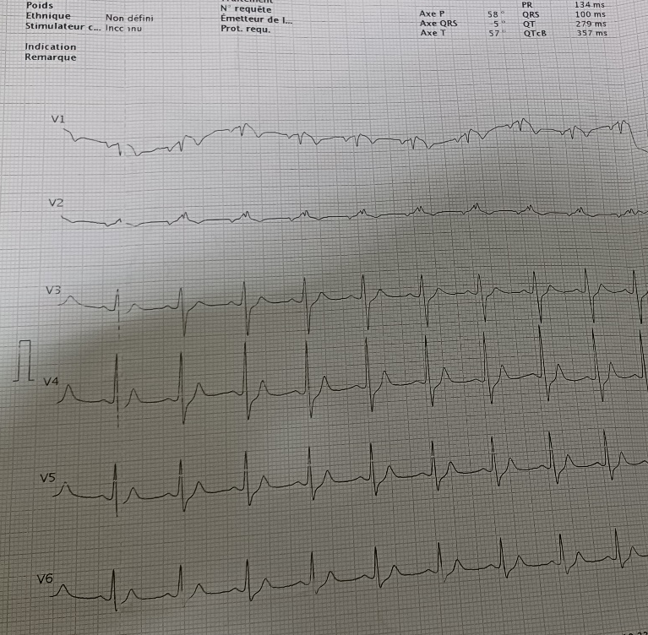
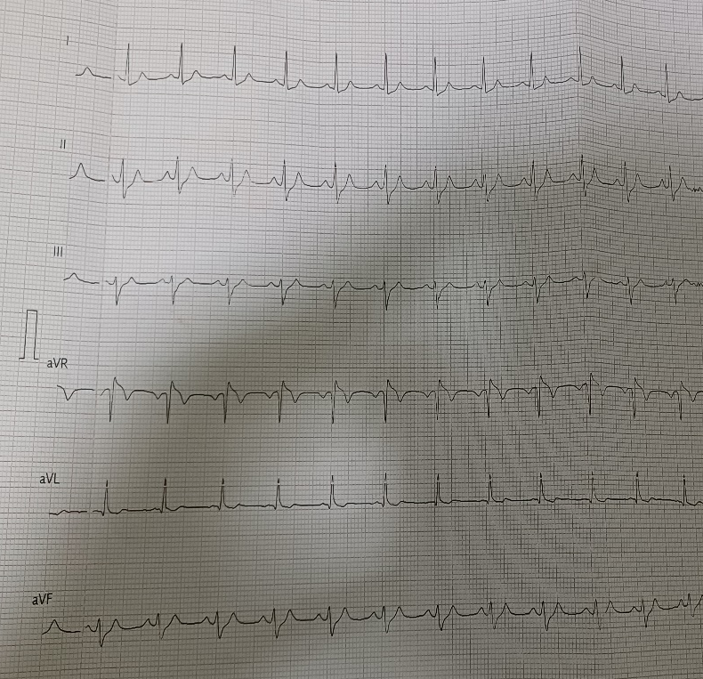
-Figure1: Electrocardiogram:

-Figure2: Transthoracic echocardiography findings:
(a): Apical four chamber view showing pseudoaneurysm of the aortic root with systolic extension.
(b): Parasternal long axis view demonstrating the pseudoaneurysm with a vegetation attached to the right coronary cusp of the aortic valve
(c): Apical four chamber view showing measures of the pseudoaneurysm

(a)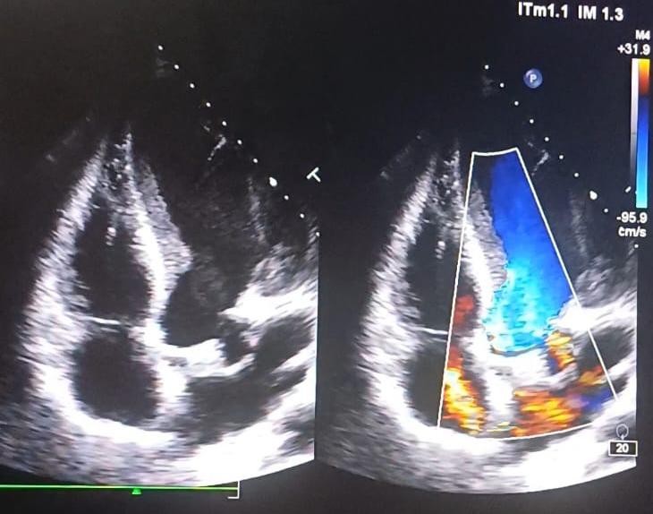
(b) 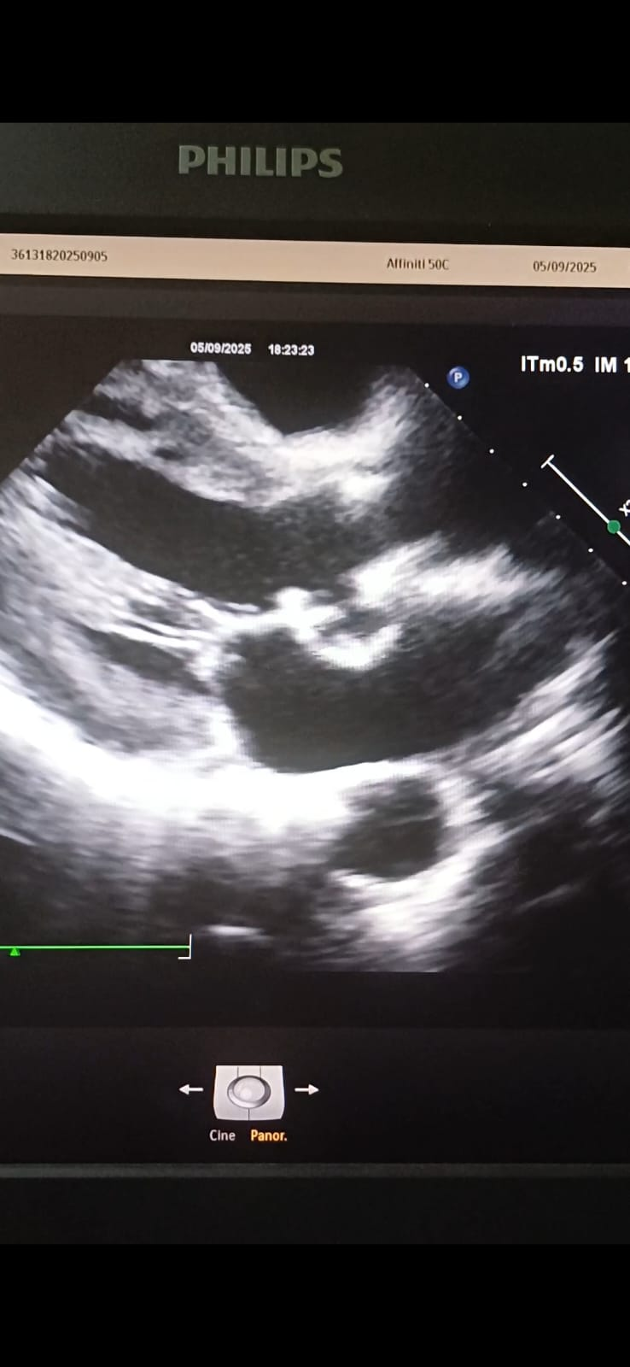
(c) 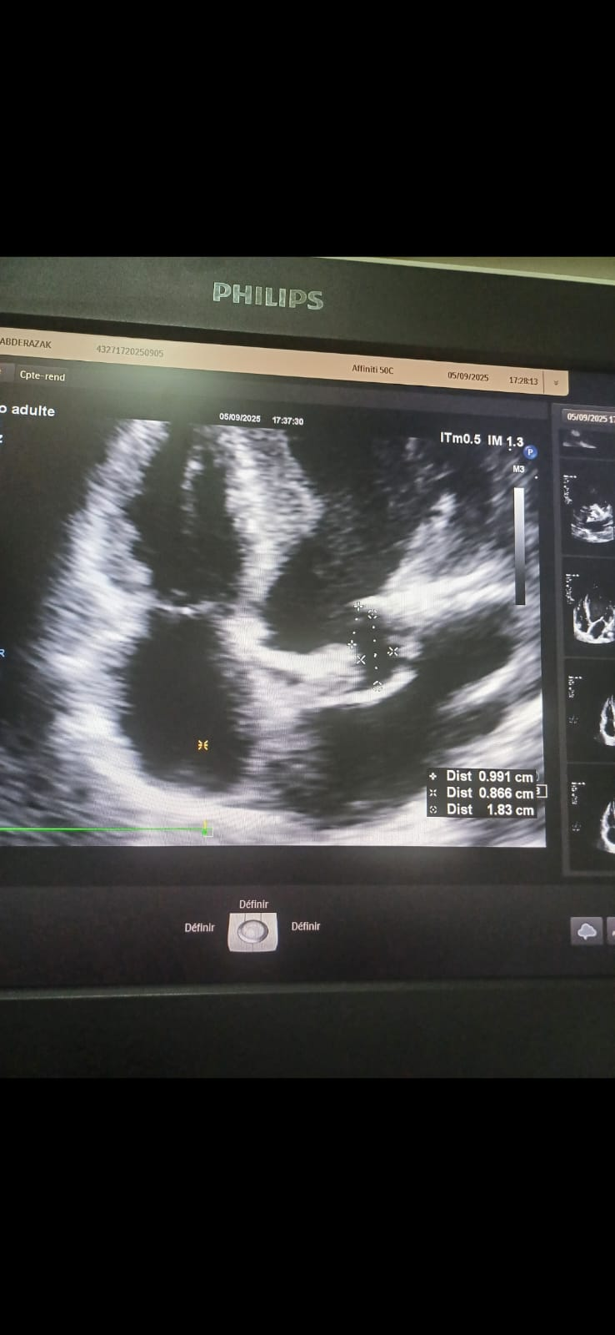
Figure3: Transesophageal echocardiography findings.
(a) Vegetation attached to the cusp of the aortic valve.
(b) Pseudoaneurysm of the left coronary sinus extending toward the mitro-aortic intervalvular fibrosa.
(c) Fusion of the right and left coronary cusps confirming a bicuspid aortic valve (Sievers type 1).
(a) 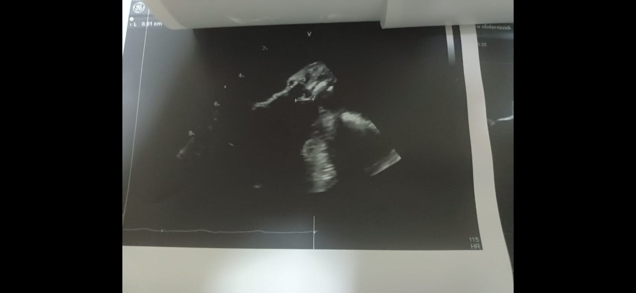
(b) 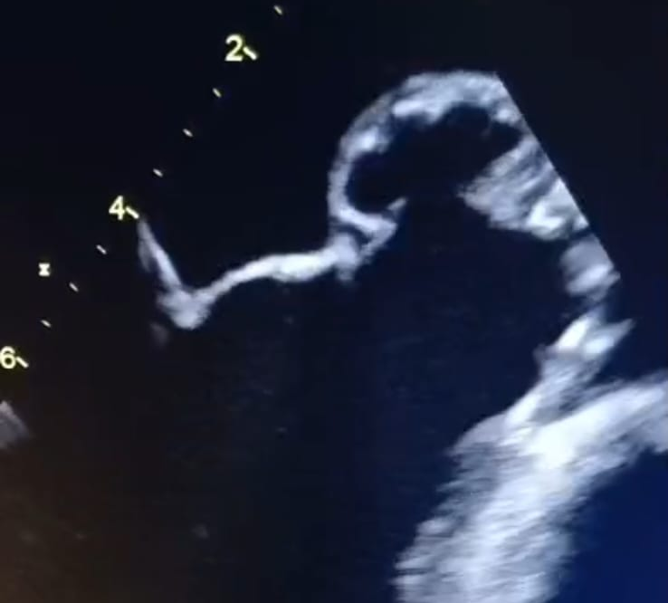
(c) 