Duplicate Gallbladder Diagnosed on Ultrasonography Alone and Managed Conservatively in an Obese Patient: A Rare Case Report

  - ABSTRACT
Duplication of the gallbladder is a rare congenital biliary anomaly with significant clinical and surgical implications. Most cases are detected incidentally during surgery or advanced imaging, and preoperative diagnosis remains challenging, particularly in resource-limited settings. We report a rare case of gallbladder duplication diagnosed solely on ultrasonography in an obese adult presenting with postprandial upper abdominal pain. The patient was managed conservatively with dietary modification, proton pump inhibitors, and antispasmodics, resulting in complete symptom resolution. This case highlights the diagnostic value of ultrasonography and demonstrates that conservative management may be appropriate in carefully selected patients with uncomplicated duplicate gallbladder.

Keywords: Duplicate gallbladder, gallbladder duplication, ultrasonography, congenital biliary anomaly, conservative management

  - INTRODUCTION
Duplication of the gallbladder, also referred to as double or accessory gallbladder, is a rare congenital anomaly of the biliary system, with an estimated incidence of approximately 1 in 4000 individuals [1,2]. First described in the 18th century, this anomaly arises due to abnormal budding of the hepatic diverticulum during embryogenesis [3]. Various anatomical configurations have been described, including bilobed gallbladder, true duplication with two cystic ducts, and accessory gallbladders draining into the biliary tree at different levels [4].
Although many individuals with gallbladder duplication remain asymptomatic, the condition gains clinical significance when associated with gallstone disease, cholecystitis, or biliary colic [5]. Symptoms are often indistinguishable from those of a single gallbladder pathology, making preoperative diagnosis difficult. Failure to recognize duplication may result in persistent symptoms or biliary complications following cholecystectomy [6].
Ultrasonography is the first-line imaging modality for gallbladder evaluation due to its availability, safety, and cost-effectiveness. However, differentiating gallbladder duplication from other entities such as folded gallbladder, Phrygian cap, or pericholecystic fluid collections can be challenging [7]. While magnetic resonance cholangiopancreatography (MRCP) is considered superior for delineating biliary anatomy, it is not always available or necessary in uncomplicated cases [8].
We report a rare case of gallbladder duplication diagnosed solely on ultrasonography in an obese patient presenting with postprandial abdominal symptoms, who was successfully managed conservatively.

CASE REPORT
An adult obese 41 year old lady presented to the surgical outpatient department with complaints of intermittent upper abdominal pain for several months. The pain was predominantly postprandial, especially after ingestion of fatty meals, and was localized to the right upper quadrant and epigastrium. The discomfort was associated with bloating and dyspepsia but was not accompanied by fever, jaundice, vomiting, or weight loss.
There was no significant past medical or surgical history. The patient had no known metabolic disorders or history of alcohol intake. On general examination, the patient was obese with stable vital signs. Abdominal examination revealed mild epigastric tenderness without guarding, rigidity, or palpable mass. Murphy’s sign was negative.
Routine laboratory investigations, including complete blood count, liver function tests, lipid profile and serum amylase/lipase were within normal limits.
Imaging Findings:
Abdominal ultrasonography revealed two distinct pear shaped cystic structures located in the gallbladder fossa with echogenic septa in between, consistent with gallbladder duplication. Both sacs were anechoic. The gallbladder walls were not thickened, and no pericholecystic fluid collection was observed. The common bile duct was normal in calibre, with no evidence of intrahepatic biliary dilatation. Fatty liver grade1 was noted.
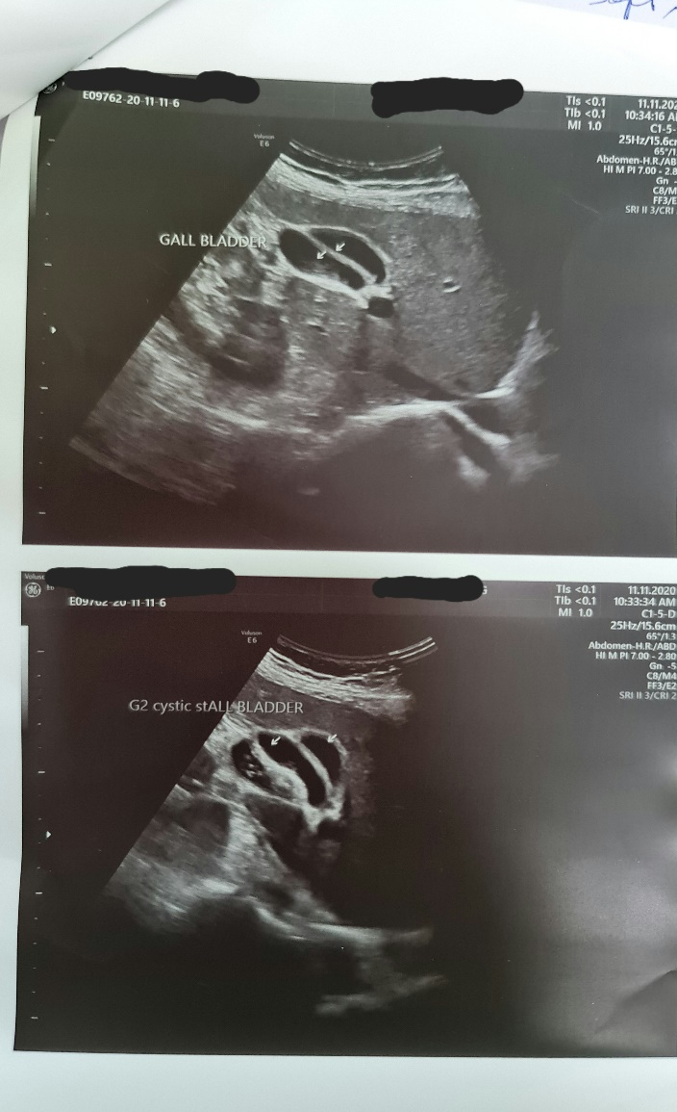
Figure 1: Ultrasonography of the abdomen demonstrating two distinct gallbladder sacs (arrows) within the gallbladder fossa, lumen anechoic, consistent with gallbladder duplication without features of acute inflammation.
No additional imaging such as CT scan or MRCP was performed, as the ultrasound findings were considered diagnostic and there were no features of complicated biliary disease.

  - MANAGEMENT AND OUTCOME
Given the absence of complications, stable clinical status, and patient preference, a conservative management approach was adopted. The patient was advised dietary modification with avoidance of fatty foods. Pharmacological therapy included proton pump inhibitors and antispasmodic agents.
The patient showed significant symptomatic improvement over the following weeks. At follow-up, postprandial pain and dyspeptic symptoms had resolved completely. No further episodes were reported during continued follow-up, and surgical intervention was deferred. Abnormal biliary anatomy can make future surgery technically challenging. For this reason, the patient was counselled regarding the anomaly, educated about warning symptoms, and placed on regular follow-up with a low threshold for surgical intervention in case biliary complications develop.

  - DISCUSSION
Gallbladder duplication is an uncommon congenital anomaly that poses diagnostic and therapeutic challenges. Embryologically, it results from excessive budding or splitting of the gallbladder primordium during the fifth to sixth week of gestation [3,9]. Several classification systems exist, with the most widely used being those proposed by Boyden and Harlaftis, based on anatomical and ductal variations [4]. Recognition of the specific anatomical subtype is clinically relevant because it influences both the risk of complications and operative planning.
Clinical presentation varies widely. While many cases remain asymptomatic, symptoms typically arise due to associated gallstone disease or inflammation, similar to pathology in a single gallbladder [10]. Obesity, as seen in our patient, further increases the risk of gallstone formation due to altered cholesterol metabolism and gallbladder hypomotility [11]. However, not all patients with duplicated gallbladders develop calculous disease or cholecystitis, and some may present with only functional biliary-type symptoms or dyspepsia without structural pathology.
Preoperative diagnosis of gallbladder duplication is notoriously difficult. Ultrasonography, although operator-dependent, remains the most commonly used diagnostic modality. Previous reports have demonstrated that careful ultrasonographic examination can identify duplicated gallbladders, especially when two separate cystic structures are visualized [7,12]. However, misinterpretation may lead to missed diagnosis, with serious implications during surgery [6]. MRCP is considered the imaging modality of choice for detailed biliary anatomy mapping [8,13], but its routine use may not be justified in uncomplicated cases, particularly in resource-limited settings. Our case demonstrates that ultrasonography alone can be sufficient for diagnosis when characteristic features are clearly identified.
The optimal management of duplicate gallbladder remains controversial. Surgical excision of both gallbladders is generally recommended when patients are symptomatic, particularly in the presence of gallstones or cholecystitis, to prevent recurrence and avoid future diagnostic confusion [14]. Contemporary case reports further support operative management in symptomatic patients with structural pathology.[15-18]
Nevertheless, the available literature also support that asymptomatic or minimally symptomatic patients without complications can be managed expectantly with close follow-up as was in our case[10,19,20]. Roldan-Valadez et al. described asymptomatic true gallbladder duplication detected incidentally on imaging, where observation was considered appropriate in the absence of biliary pathology [10].
Non-operative management strategies primarily focus on symptom control and risk-factor modification. Dietary fat restriction, proton pump inhibitors for dyspeptic symptoms, and antispasmodics for biliary colic–like discomfort have been reported to provide symptomatic relief in selected cases without structural disease. Conservative management is particularly relevant in obese individuals, in whom functional biliary dyskinesia or Acid peptic disease may contribute to postprandial upper abdominal pain independent of gallbladder morphology. In such scenarios, symptom resolution with medical therapy supports avoidance of unnecessary surgery.
Importantly, careful patient selection is essential before adopting a non-operative approach. Conservative management should be limited to patients with: (1) absence of gallstones or cholecystitis on imaging, (2) normal liver function tests and bile duct calibre, (3) mild or intermittent symptoms responsive to medical therapy, and (4) ability to comply with regular follow-up. Serial ultrasonography can be useful for monitoring development of calculi or inflammatory changes. HIDA scan may be done in suspected biliary dyskinesia [21].
Therefore, this case adds to the limited body of evidence suggesting that conservative management can be a safe and effective option in carefully selected patients with uncomplicated duplicate gallbladder. Nonetheless, long-term follow-up is crucial, as the potential for future gallstone formation or inflammatory episodes persists.

  - CONCLUSION
Gallbladder duplication is a rare congenital anomaly that should be considered in patients with biliary symptoms and atypical ultrasonographic findings. Ultrasonography alone can be diagnostic in experienced hands. Conservative management may be a viable option in selected, uncomplicated cases with careful follow-up, potentially avoiding unnecessary surgical intervention.

Additional Information

Consent
As per international standards or university standards, patient(s) written consent has been collected and preserved by the author(s).

Disclaimer:

Author hereby declare that NO generative AI technologies such as Large Language Models (ChatGPT, COPILOT, etc.) and text-to-image generators have been used during the writing or editing of this manuscript.

  - REFERENCES
- Desolneux G, Mucci S, Lebigot J, et al. Duplication of the gallbladder. Gastroenterol Res Pract. 2009;2009:1–3.
- Hishinuma M, Isogai Y, Matsuura Y, et al. Double gallbladder. J Gastroenterol Hepatol. 2004;19:233–235.
- Vijayaraghavan R, Belagavi C. Double gallbladder with different disease entities. J Minim Access Surg. 2006;2:23–26.
- Singh B, Ramsaroop L, Allopi L, et al. Duplicate gallbladder: an unusual case report. Surg Radiol Anat. 2006;28:654–657.
- Alfadlil A, et al. Double gallbladder: a rare congenital anomaly. Clinics in Surgery. 2016;1:1016.
- Smelt JLC, Wright H, Sagar J, et al. Laparoscopic removal of a double gallbladder for cholelithiasis. Ann R Coll Surg Engl. 2011;93:e105–e106.
- Bulus K, Koyuncu A, Coskun A. Preoperative diagnosis of double gallbladder: a case report. Turk J Gastroenterol. 2012;23:172–174.
- Mazziotti S, Minutoli F, Blandino A, et al. Gallbladder duplication: MR cholangiography demonstration. Abdom Imaging. 2001;26:287–289.
- Weibel D, Kaufmann M, Reidtmann-Klee H. Accessory gallbladder originating from the right hepatic duct. Surg Endosc. 2001;15:519.
- Roldan-Valadez E, Osorio-Peralta S, et al. Asymptomatic true gallbladder duplication. Acta Radiol. 2004;45:810–814.
- Portincasa P, Moschetta A, Palasciano G. Cholesterol gallstone disease. Lancet. 2006;368:230–239.
- Shea JA, Berlin JA, Escarce JJ, et al. Revised estimates of diagnostic test sensitivity in biliary disease. Arch Intern Med. 1994;154:2573–2581.
- Tazuma S. Gallstone disease. Best Pract Res Clin Gastroenterol. 2006;20:1075–1083.
- Everhart JE, Yeh F, Lee ET, et al. Prevalence of gallbladder disease in obesity. Gastroenterology. 2002;122:903–910.
- Causey MW, Miller S, Fernelius CA, Burgess JR, Brown TA. Duplication of the gallbladder: a case report and review of the literature. Am Surg. 2010;76:112–115.
- Paraskevas G, Papaziogas B, Gigis I, et al. Accessory gallbladder: a review of the literature and report of a case. Surg Radiol Anat. 2011;33:417–422.
- Yalagachin G, Hiregoudar AD, Bagur A, Choudhari A. A rare case of double gall bladder: a case report and review of literature. Int Surg J. 2021;8(11):3488–3491. doi:10.18203/2349-2902.isj20214401.
- Ahunayizhi A, Zhang XL, Chen Q, Wang H, Ding G, Akumuo S, Wang XX, Ruan XJ. Laparoscopic management of gallstones in a duplicate gallbladder with double cystic ducts: A case report. World J Gastrointest Surg. 2025;17(9):110796. doi:10.4240/wjgs.v17.i9.110796.
- Qingbo Feng, Xiaobing Wu, Xiaoqing Jiang. Conservative treatment for H-type duplicated gallbladder with cholecystitis. ANZ Journal of Surgery 90(6):p 1178-1179, June 2020. | DOI: 10.1111/ans.15606
- Baltaga L, Chrysikos D, Delis S, Triantopoulou C, Filippou D, Protogerou V, Troupis T (2023) Duplicated gallbladder: an incidental anatomical variation in a patient with symptomatic cholelithiasis. Folia Medica 65(5): 834-838. https://doi.org/10.3897/folmed.65.e91397
- Puranik AD, Agrawal A, Purandare NC, Shah S, Rangarajan V. Duplicated gall bladder detected on 99m Tc HIDA hepatobiliary scintigraphy: A report of two cases. Indian J Nucl Med. 2012 Oct;27(4):266-8. doi: 10.4103/0972-3919.115404. PMID: 24019663; PMCID: PMC3759094.

