Case report
SUPERIOR MESENTERIC ARTERY SYNDROME ASSOCIATED WITH A MALROTATED ECTOPIC LEFT KIDNEY: A RARE CASE REPORT AND SURGICAL CONSIDERATIONS

ABSTRACT
Background:
Superior mesenteric artery (SMA) syndrome, also referred to as Wilkie syndrome, represents an uncommon aetiology of proximal intestinal obstruction, arising from extrinsic compression of the third portion of the duodenum between the abdominal aorta and the superior mesenteric artery. The syndrome is frequently precipitated by rapid or significant weight loss, which results in a reduction of the mesenteric fat pad and consequent narrowing of the aortomesenteric angle. While most cases are acquired, congenital anatomical variations contributing to SMA syndrome are relatively rare. Furthermore, the simultaneous occurrence of SMA syndrome with renal ectopia and intestinal malrotation is exceedingly uncommon, with only a limited number of cases documented in the literature. Recognition of these atypical associations is crucial for accurate diagnosis and appropriate management.
Aim:
To report a rare case of SMA syndrome associated with a malrotated ectopic left kidney and to emphasize the importance of detailed preoperative imaging and anatomical understanding in surgical planning.
Case Presentation:
An 18-year-old female presented with chronic postprandial epigastric pain, recurrent bilious vomiting, early satiety, and significant weight loss. Symptoms were exacerbated during menstruation and partially relieved in the supine position. Contrast-enhanced computed tomography (CT) with angiography demonstrated a markedly reduced aortomesenteric angle and distance, confirming SMA syndrome. Additionally, a malrotated ectopic left kidney was identified in the pelvis with anomalous renal vasculature. Conservative management failed, following which the patient underwent an elective retrocolic side-to-side duodenojejunostomy, resulting in complete symptomatic resolution.
Conclusion:
This case highlights a rare association of SMA syndrome with a malrotated ectopic kidney. Awareness of such anatomical anomalies and meticulous preoperative imaging are crucial to prevent iatrogenic vascular injury during surgery due to distorted retroperitoneal architecture.
This case report highlights the presence of a rotational vascular anomaly and a condition that does not require prior structural anatomical alteration, but rather specific phenotypic characteristics, which could potentially confuse the physician in their diagnostic approach
Keywords: Superior mesenteric artery syndrome; Wilkie syndrome; Duodenojejunostomy; Renal ectopia; Renal malrotation

- INTRODUCTION
Superior mesenteric artery (SMA) syndrome is an uncommon but clinically important cause of proximal intestinal obstruction. It was initially described by Rokitansky in 1842 and subsequently elaborated by Wilkie in 1927. The condition arises from extrinsic compression of the third portion of the duodenum, which becomes trapped between the abdominal aorta posteriorly and the SMA anteriorly. Under normal anatomical conditions, the aortomesenteric angle ranges from 38° to 65°, with an aortomesenteric distance of 10–28 mm. In SMA syndrome, these measurements are markedly reduced, with the angle decreasing to less than 22° and the distance narrowing to under 8 mm, resulting in significant duodenal compression and functional obstruction. Accurate characterisation of these anatomical parameters is essential for the diagnosis, and imaging modalities such as computed tomography or magnetic resonance angiography play a pivotal role in confirming the condition.

The condition predominantly affects young, thin individuals and is commonly associated with rapid weight loss due to chronic illness, eating disorders, trauma, burns, or postoperative states. Congenital and anatomical factors such as high insertion of the ligament of Treitz, low origin of the SMA, and spinal deformities have also been implicated.

Renal ectopia and malrotation are developmental anomalies resulting from abnormal ascent and rotation of the kidneys during embryogenesis. Although renal anomalies are relatively common, their association with SMA syndrome is extremely rare. The presence of aberrant renal vasculature and altered retroperitoneal anatomy in such cases poses additional challenges during surgical intervention.

We present a rare case of SMA syndrome associated with a malrotated ectopic left kidney, highlighting the diagnostic challenges, surgical considerations, and importance of comprehensive preoperative imaging.

- PRESENTATION OF CASE
An 18-year-old female presented with a six-month history of postprandial epigastric pain, recurrent bilious vomiting, early satiety, and progressive weight loss. The pain was described as dull, non-radiating, and typically manifested within 20–30 minutes of meal ingestion. Of note, the patient reported exacerbation of pain during menstruation and partial symptomatic relief when adopting a supine or left lateral decubitus position.
The patient had no prior history of abdominal surgery, trauma, tuberculosis, or disordered eating behaviours. On physical examination, she appeared underweight, with a body mass index of 17 kg/m². Mild tenderness was elicited in the epigastric region, without palpable masses or organomegaly. Routine laboratory investigations, including complete blood count, liver and renal function tests, and serum electrolytes, were all within normal limits.

Contrast-enhanced CT of the abdomen with angiography revealed compression of the third part of the duodenum between the SMA and the aorta. The aortomesenteric angle was reduced to approximately 15°, and the aortomesenteric distance measured less than 6 mm. Proximal duodenal dilatation was noted.

Incidentally, imaging also demonstrated a malrotated ectopic left kidney located in the pelvis. The renal pelvis faced anteriorly, and anomalous renal vessels were seen arising from the right common iliac artery, contributing to distorted retroperitoneal anatomy.

Initial conservative management included nasogastric decompression, high-calorie nutritional supplementation, postural therapy, and correction of electrolyte imbalance. Despite adequate nutritional optimization over several weeks, the patient continued to experience persistent symptoms, necessitating surgical intervention.

An elective retrocolic side-to-side duodenojejunostomy was performed. Intraoperatively, the altered retroperitoneal anatomy and anomalous renal vessels were carefully identified and preserved. The postoperative course was uneventful, and the patient tolerated oral feeds by postoperative day 5. At 6-month follow-up, she remained asymptomatic with significant weight gain.

- DISCUSSION
SMA syndrome remains a rare clinical entity with an estimated incidence between 0.013% and 0.3%. Delayed diagnosis is common due to nonspecific symptoms. The classical presentation includes postprandial epigastric pain, nausea, bilious vomiting, early satiety, and weight loss, creating a vicious cycle that worsens mesenteric fat depletion and duodenal compression.

Pathophysiology
The primary mechanism involves narrowing of the aortomesenteric angle due to loss of mesenteric fat. The third part of the duodenum becomes compressed between the SMA and the aorta, resulting in partial or complete obstruction. Postural changes relieve symptoms by temporarily increasing the aortomesenteric angle. In thin individuals, even minor reductions in retroperitoneal fat may significantly reduce the angle.
Embryologically, renal ectopia results from failure of normal ascent of the metanephric kidney from the pelvis. Malrotation occurs due to incomplete medial rotation of the renal hilum. Aberrant vascular supply is common in ectopic kidneys. In the present case, anomalous renal vessels arising from the right common iliac artery distorted the retroperitoneal anatomy. Although not directly responsible for duodenal compression, the altered vascular arrangement increased operative complexity.

Radiological Considerations
CT angiography is the diagnostic modality of choice. It enables accurate measurement of the aortomesenteric angle and distance, visualization of duodenal compression, and identification of associated vascular anomalies. Three-dimensional reconstruction is particularly useful when congenital anomalies coexist. Differential diagnoses include annular pancreas, pancreatic head mass, lymphadenopathy, and other causes of proximal obstruction.
In cases with renal anomalies, vascular mapping is essential to prevent inadvertent injury. Aberrant renal arteries may cross the operative field during mobilization of the duodenum or jejunum.

Management Strategies
Conservative management remains first-line therapy. Nutritional rehabilitation aims to restore mesenteric fat and widen the aortomesenteric angle. Postural therapy, nasogastric decompression, and correction of electrolyte imbalance are supportive measures.
Surgical intervention is indicated in patients with persistent or severe symptoms. Duodenojejunostomy is considered the gold standard procedure with success rates exceeding 90%. It bypasses the compressed segment and provides definitive relief. Laparoscopic approaches have gained popularity due to reduced postoperative pain and faster recovery.
In the present case, open retrocolic duodenojejunostomy was preferred due to altered anatomy and vascular anomalies. Careful dissection prevented injury to aberrant renal vessels.

Literature Review and Rarity
Although SMA syndrome has been reported in association with other vascular compression disorders, coexistence with renal ectopia and malrotation is extremely rare. Only isolated reports describe similar anatomical combinations. This case contributes to the limited literature and emphasizes the importance of thorough preoperative evaluation.

Surgical Considerations in Congenital Anomalies
When congenital renal anomalies are present, surgeons must anticipate: • Aberrant arterial supply from iliac vessels • Altered ureteric course • Distorted retroperitoneal planes • Increased risk of vascular injury
Meticulous preoperative planning and intraoperative vigilance are crucial to avoid complications.

LEARNING POINTS
• SMA syndrome should be suspected in thin patients with postprandial pain relieved by positional changes.
• CT angiography with vascular mapping is essential when congenital anomalies coexist.
• Nutritional therapy remains first-line management but may fail in chronic cases.
• Duodenojejunostomy is a safe and definitive treatment with high success rates.
• Awareness of aberrant renal vasculature is critical to prevent intraoperative injury.
- CONCLUSION
Superior mesenteric artery syndrome is a rare but treatable cause of chronic duodenal obstruction. Its association with a malrotated ectopic kidney is exceedingly uncommon and poses unique diagnostic and surgical challenges. Comprehensive preoperative imaging and a thorough understanding of altered retroperitoneal anatomy are essential to guide safe and effective surgical management. Duodenojejunostomy remains a definitive and reliable treatment in patients who fail conservative therapy.
This article gives surgeons important information about the possible risks of doing a duodenojejunostomy in the presence of deformed retroperitoneal anatomy and aberrant iliac-origin renal vasculature, which were discovered on preoperative imaging. It reaffirms that angiography and extensive cross-sectional imaging are essential tools for mapping abnormal anatomy and preventing catastrophic iatrogenic vascular injury, in addition to being a diagnostic tool for SMA syndrome. In the end, this case adds a useful illustration to the surgical literature, highlighting the necessity of customized, imaging-guided planning for safe and efficient management when congenital abnormalities make a routine surgical procedure more difficult.

CONSENT
Written informed consent was obtained from the patient for publication of this case report and accompanying images.
ETHICAL APPROVAL

As per international standards or university standards written ethical approval has been collected and preserved by the author(s).

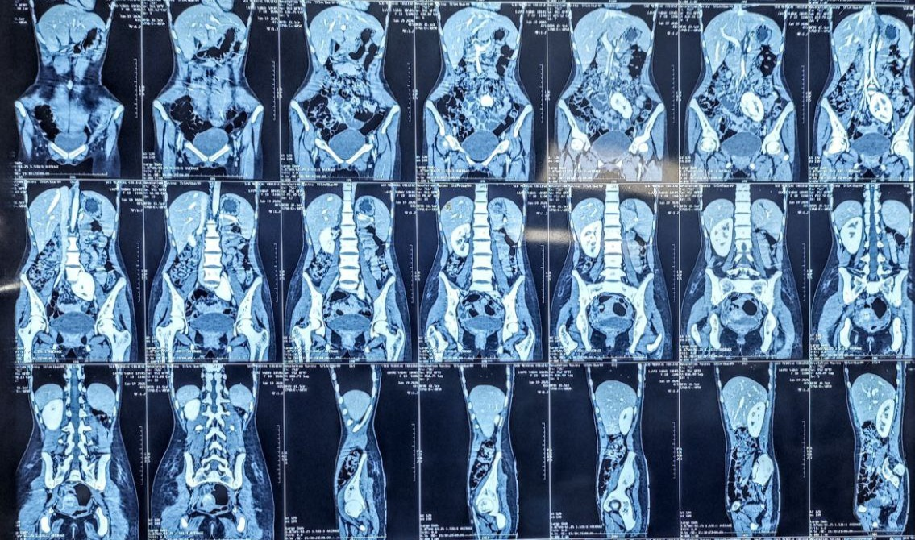
Figure 1 : CECT Abdomen & Pelvis showing reduced aortomesenteric angle and compression of the third part of the duodenum.

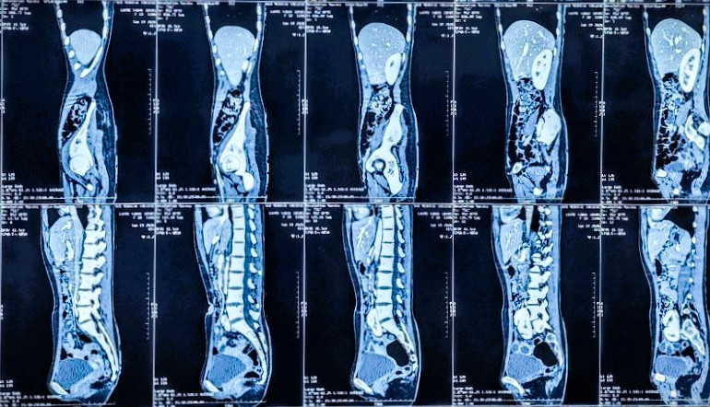
Figure 2 : CT abdomen demonstrating ectopic malrotated left kidney located in the pelvis.

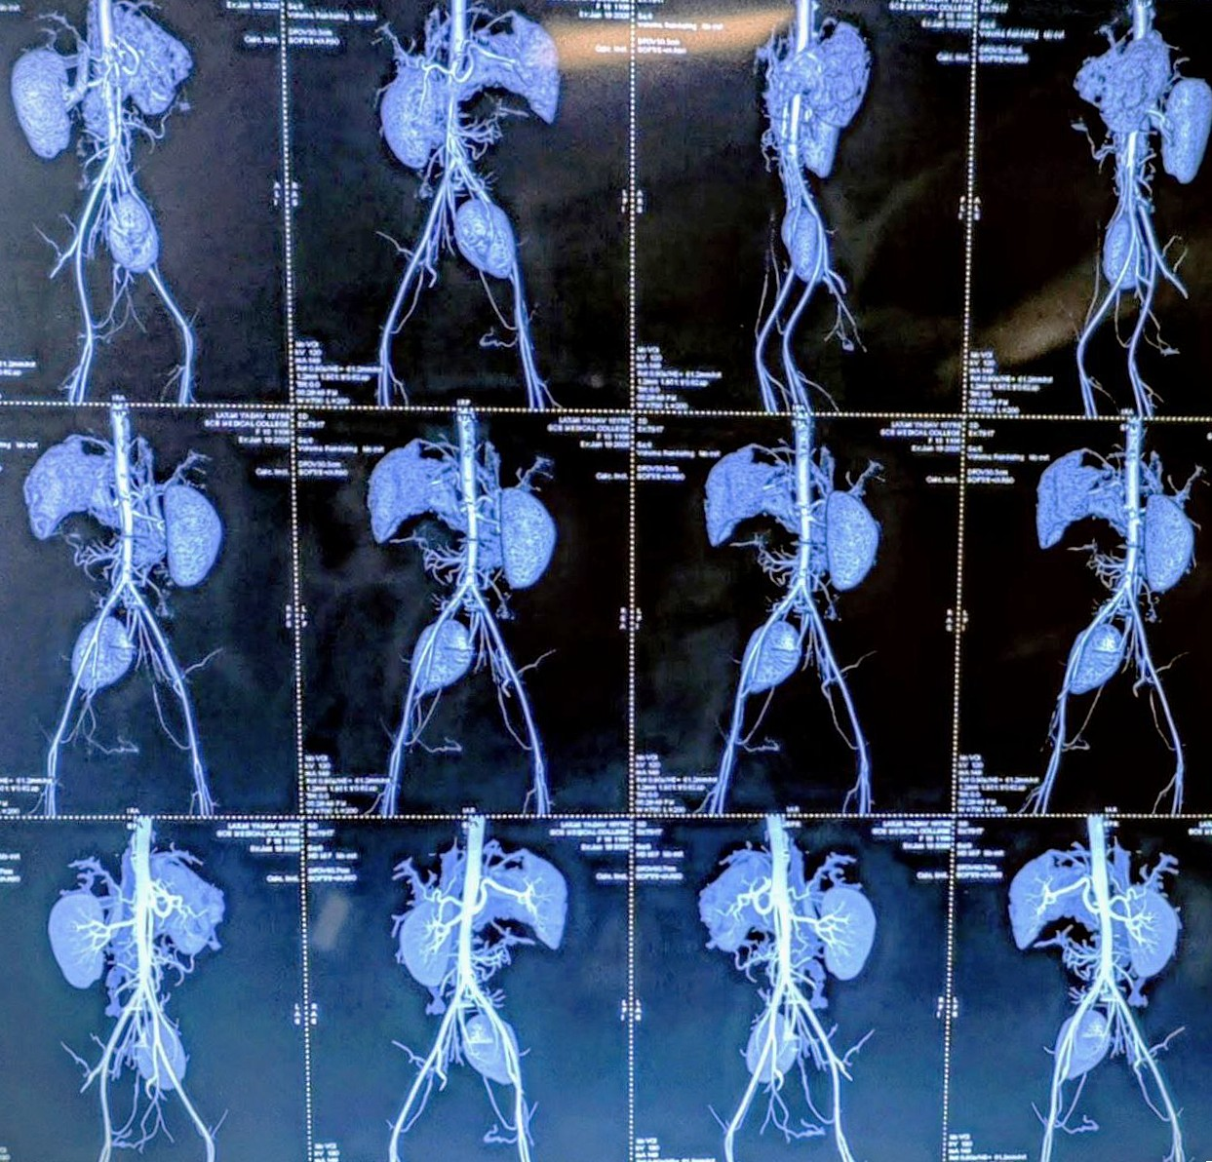
Figure 3: 3D CT angiography showing anomalous renal vessels, with left main renal artery arising from right common iliac artery.
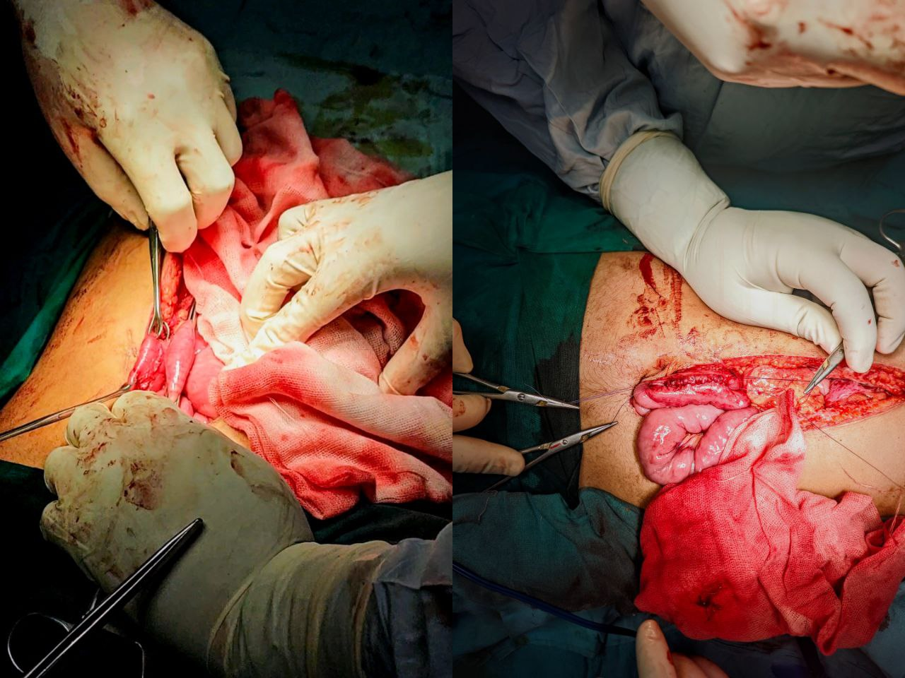
Figure 4 : Intraoperative image showing Retrocolic Side to Side Duodenojejunostomy

Disclaimer (Artificial intelligence)

Author(s) hereby declare that NO generative AI technologies such as Large Language Models (ChatGPT, COPILOT, etc.) and text-to-image generators have been used during the writing or editing of this manuscript.
REFERENCES
- Lee TH, Lee JS, Jo Y, Park KS, Cheon JH, Kim YS, et al. Superior mesenteric artery syndrome: where do we stand today? J Gastrointest Surg. 2012;16(12):2203–2211. doi:10.1007/s11605-012-2049-5. Available from: https://pubmed.ncbi.nlm.nih.gov/23076975/
- Türkvatan A, Olçer T, Cumhur T. Multidetector CT urography of renal fusion anomalies. Diagn Interv Radiol. 2009;15(2):127–134. Available from: https://pubmed.ncbi.nlm.nih.gov/19517383/
- Shi Y, Shi G, Li Z, Chen Y, Tang S, Huang W. Superior mesenteric artery syndrome coexists with Nutcracker syndrome in a female: a case report. BMC Gastroenterol. 2019;19(1):15. doi:10.1186/s12876-019-0932-1. Available from: https://bmcgastroenterol.biomedcentral.com/articles/10.1186/s12876-019-0932-1
- Oka A, Awoniyi M, Hasegawa N, Yoshida Y, Tobita H, Ishimura N, et al. Superior mesenteric artery syndrome: diagnosis and management. World J Clin Cases. 2023;11(15):3369–3384. doi: https://doi.org/10.12998/wjcc.v11.i15.3369
Available from: https://www.wjgnet.com/2307-8960/full/v11/i15/3369.htm
- England J, Li N. Superior mesenteric artery syndrome: a review of the literature. J Am Coll Emerg Physicians Open. 2021;2(3):e12454. doi: https://doi.org/10.1002/emp2.12454
. Available from: https://pubmed.ncbi.nlm.nih.gov/34179879/
- Ledezma Flores E, Calderón Fernández A, Urias Pompa A, et al. Clinical insights into Wilkie’s syndrome: a case report and review of relevant literature. Radiol Case Rep. 2025;20(8):3964-3969. doi: https://doi.org/10.1016/j.radcr.2025.04.096.
Available from: https://pubmed.ncbi.nlm.nih.gov/40496073/
- Welsch T, Büchler MW, Kienle P. Recalling superior mesenteric artery syndrome. Dig Surg. 2007;24(3):149-156. doi:10.1159/000102097. Available from: https://doi.org/10.1159/000102097
- Merrett ND, Wilson RB, Cosman P, Biankin AV. Superior mesenteric artery syndrome: diagnosis and treatment strategies. J Gastrointest Surg. 2009;13(2):287-292. doi:10.1007/s11605-008-0695-4. Available from: https://doi.org/10.1007/s11605-008-0695-4
- Shin MS, Kim JY. Optimal duration of medical treatment in superior mesenteric artery syndrome in children. J Korean Med Sci. 2013;28(8):1220-1225. doi:10.3346/jkms.2013.28.8.1220. Available from: https://doi.org/10.3346/jkms.2013.28.8.1220
- Ho D. Phytobezoar mimicking superior mesenteric artery syndrome in acute duodenal obstruction: a case report and review of literature. J Surg Case Rep. 2025 Jun 31;2025(6):rjaf358. doi:10.1093/jscr/rjaf358. Available from: https://doi.org/10.1093/jscr/rjaf358

