Case report
Spot Diagnosis of Gas-Forming Pyelonephritis in a Diabetic Woman: Underscoring the Value of Timely Radiological Evaluation.
Abstract
Background: Emphysematous pyelonephritis (EPN) is a fulminant, necrotizing, gas-forming infection of the kidney, encountered predominantly in diabetic patients and associated with high mortality when diagnosis is delayed.
Case Presentation: A 45-year-old woman with Type-II Diabetes Mellitus presented with five days of fever and left flank pain. A kidney, ureter, and bladder (KUB) radiograph demonstrated gas in the region of the left kidney. Subsequent CT of the kidneys and urinary bladder revealed destruction of more than one-third of the renal parenchyma with a mottled gas pattern, consistent with EPN. The disease was categorized as Type II emphysematous pyelonephritis and classified as Huang–Tseng Class 3b, showing gas within the renal parenchyma and extension into the pararenal space.
Management and Outcome: The patient was treated with prompt CT imaging-based diagnosis, aggressive intravenous antibiotic therapy, and appropriate urological intervention, which led to clinical improvement and renal preservation.
Conclusion: This case underscores the critical importance of early imaging in diabetic patients with suspected pyelonephritis. Timely radiologic evaluation enables accurate classification, guides appropriate management, and improves outcomes in emphysematous pyelonephritis.
Key words: Emphysematous pyelonephritis, Gas-forming urinary tract infection, Huang–Tseng classification, Early imaging, Renal parenchymal destruction.
Introduction
Emphysematous pyelonephritis is a severe, necrotizing infection characterized by gas production within the renal collecting system, renal parenchyma, and perirenal tissues.¹ The condition is strongly associated with diabetes mellitus and occurs more frequently in females due to the combined effect of diabetes plus female anatomy, with reported high mortality rates in the absence of early diagnosis and adequate treatment.¹⁻³ Clinically, EPN often presents as sepsis of renal origin and may be difficult to distinguish from uncomplicated acute pyelonephritis based solely on clinical and laboratory findings.²⁻³ Imaging therefore plays a pivotal role in emphysematous pyelonephritis by enabling early and accurate diagnosis, providing a less invasive modality for real-time monitoring, delineating the extent and severity of renal and perirenal involvement, detecting precipitating factors such as urinary tract obstruction, and thereby directly influencing and guiding therapeutic decision-making. This case highlights a rare presentation of left-sided EPN in a diabetic woman and illustrates the importance of early imaging for a “spot diagnosis.”
Case presentation
A 45-year-old female with a known history of diabetes mellitus presented to the hospital with complaints of fever, vomiting, and left flank pain persisting for five days. The pain was progressive and associated with systemic features suggestive of a Severe UTI. On admission, She appeared systemically ill, and the clinical picture was consistent with sepsis of renal origin, although there were no distinctive signs to suggest a gas-forming infection. Initial laboratory evaluation supported the diagnosis of severe pyelonephritis, but, as is typical in EPN, the results were non-specific for gas formation. Given the high-risk background of poorly controlled diabetes and the severity of presentation, imaging was promptly pursued to clarify the underlying pathology.​
Imaging findings
A kidney, ureter, and bladder (KUB) radiograph revealed the presence of gas in the region of the left kidney, raising a strong suspicion of emphysematous involvement. Radiographically, such cases may show gas bubbles or a diffusely punctate renal outline, and gas can sometimes be seen tracking along the renal pyramids. In more advanced disease, gas may accumulate within Gerota’s fascia, indicating extensive renal necrosis and perirenal spread.​
Further evaluation with CT imaging of the kidneys and urinary bladder was performed. CT demonstrated an enlarged left kidney with destruction of more than one-third of the renal parenchyma and a mottled pattern of intraparenchymal gas, along with focal necrotic areas and abscess formation. The CT scan allowed quantification of gas, assessment of the degree of parenchymal destruction, and visualization of fluid–gas levels within the kidney. It also enabled evaluation for underlying urinary tract obstruction that could have contributed to the infection.​
Based on radiological findings, the case was classified as Type II emphysematous pyelonephritis, characterized by the presence of both gas and fluid within the kidney. According to the Huang–Tseng CT classification, gas within the renal parenchyma with extrarenal extension into the pararenal space or presence of an abscess corresponds to Class 3b disease, indicating more extensive involvement and a potentially poorer prognosis.​
Figures (KUB and CT images) illustrate gas in the area of the left kidney on plain radiograph and an enlarged, destroyed kidney with necrotic areas and abscess on CT.​
Discussion
EPN is a rare yet rapidly progressive, necrotizing infection involving the renal parenchyma and surrounding perirenal tissues, seen most frequently in individuals with poorly controlled diabetes mellitus. Although advances in imaging, antimicrobial therapy, and critical care have reduced case-fatality compared with historical cohorts, EPN still entails considerable mortality, particularly in the presence of shock, multiorgan dysfunction, or delayed diagnosis.^{3,4} The present case of a diabetic patient with Type II, Huang–Tseng Class 3b EPN, exemplifies how expeditious radiological evaluation and organ-preserving intervention can substantially alter the trajectory of a potentially catastrophic infection.⁵⁻⁷
Pathophysiologically, EPN emerges at the nexus of impaired host immunity, tissue hypoperfusion, and a hyperglycaemic milieu that favours proliferation of gas-forming uropathogens and intraparenchymal gas accumulation. The preponderance of diabetic females in large series has been attributed to microangiopathy, diminished neutrophil function, and frequent obstructive uropathy, all of which predispose to rapid tissue necrosis. In this context, our patient’s decompensated diabetes and septic presentation align with canonical risk factors and underscore the need for heightened suspicion of EPN when systemic toxicity appears disproportionate to ostensibly uncomplicated pyelonephritis.^{5,7}
Pathophysiologically, EPN emerges at the nexus of impaired host immunity, tissue hypoperfusion, and a hyperglycaemic milieu that favours proliferation of gas-forming uropathogens and intraparenchymal gas accumulation.^{2-5,7} The preponderance of diabetic females in large series has been attributed to microangiopathy, diminished neutrophil function, and frequent obstructive uropathy, all of which predispose to rapid tissue necrosis.⁵⁻⁷ In this context, our patient’s decompensated diabetes and septic presentation align with canonical risk factors and underscore the need for heightened suspicion of EPN when systemic toxicity appears disproportionate to ostensibly uncomplicated pyelonephritis.⁵⁻⁸
Imaging, particularly non-contrast CT, is pivotal for diagnosis, staging, and management planning in EPN. While a “spot diagnosis” may occasionally be achieved on a KUB radiograph, plain films frequently underestimate disease extent and may be confounded by overlying bowel gas. CT permits precise delineation of gas distribution, quantification of parenchymal destruction, recognition of perinephric and pararenal extension, and detection of obstructive lesions, thereby directly informing decisions regarding conservative therapy, percutaneous drainage, or nephrectomy. In our case, CT characterization as Huang–Tseng Class 3b justified early percutaneous drainage with a kidney-sparing intent.⁶⁻⁸ Important differentials for gas within the renal region include emphysematous pyelitis, emphysematous cystitis, xanthogranulomatous pyelonephritis, renal or perinephric abscess, and non-infectious intraluminal gas related to instrumentation or enterourinary fistulas.
Evidence from contemporary cohort studies and systematic reviews has shifted the therapeutic paradigm away from routine emergency nephrectomy toward risk-stratified, minimally invasive strategies.^{3,5} Higher Huang–Tseng classes correlate with adverse outcomes; however, percutaneous drainage combined with intensive medical therapy has demonstrated favourable survival and renal preservation even in advanced disease, reserving nephrectomy for non-responders or those with overwhelming destruction. This case thus reinforces the imperative for early CT in high-risk diabetics with severe urosepsis and illustrates how integration of CT-based classification with evidence-informed management algorithms can optimize both survival and renal salvage.^{3,5-6}
Management and outcome
Management of emphysematous pyelonephritis (EPN) should follow a structured, protocol-driven approach integrating early sepsis resuscitation, meticulous metabolic optimization, and timely urologic source control.^{3,9-10} Initial stabilization should be undertaken in accordance with contemporary sepsis- 3 guidelines, incorporating early hemodynamic resuscitation with intravenous fluids, timely initiation of vasopressor therapy when indicated, close intensive care monitoring for patients with shock or evolving organ dysfunction, and prompt correction of metabolic derangements. Broad-spectrum intravenous antibiotics active against Gram-negative bacilli, including extended–spectrum beta–lactamase–producing Enterobacter ales, should be administered as early as possible and subsequently de-escalated according to culture and susceptibility profiles. Concurrently, strict glycaemic control using intravenous insulin, careful electrolyte correction, and close surveillance of renal function and urine output are critical, given the central role of uncontrolled diabetes and acute kidney injury in EPN pathobiology and prognosis.^{6,7}
CT-guided urological intervention constitutes a cornerstone of contemporary EPN management, permitting precise delineation of gas distribution, parenchymal destruction, and obstructive uropathy to individualize drainage strategies. In the presence of obstruction, early decompression with retrograde ureteric stenting or percutaneous nephrostomy is recommended to relieve back pressure and expedite sepsis control. For moderate-to-severe disease (Huang–Tseng classes 2–4), percutaneous catheter drainage or nephrostomy combined with antibiotics has emerged as a nephron-sparing first-line strategy associated with high clinical success and lower mortality compared with isolated medical therapy or routine emergency nephrectomy. Nephrectomy is now largely reserved for patients with nonviable kidneys or persistent septic shock despite optimized resuscitation and adequate drainage.^{6.8}
In this patient, adherence to these principles—early ICU-level care, prompt broad-spectrum antibiotics, rigorous glycaemic optimization, and CT-directed drainage—resulted in clinical stabilization, preservation of renal function, and avoidance of emergent nephrectomy, consistent with outcomes reported in contemporary series of kidney-sparing EPN management.^{3,10-11}
Conclusion
This case represents a rare presentation of left-sided emphysematous pyelonephritis in a diabetic woman and highlights the indispensable role of imaging in its diagnosis and management. While clinical and laboratory findings point to severe pyelonephritis, they do not confirm gas formation; plain KUB radiograph can provide an important early clue, but CT is essential for accurate delineation of disease extent, application of CT-based classifications such as Huang–Tseng, and detection of underlying obstruction. Prompt radiologic assessment, combined with aggressive medical and urological management, is key to reducing morbidity and mortality and to preserving renal function in patients with EPN.​
Disclaimer (Artificial intelligence)
Author(s) hereby declare that NO generative AI technologies such as Large Language Models (ChatGPT, COPILOT, etc.) and text-to-image generators have been used during the writing or editing of this manuscript.

References
- Schainuck LI, Fouty R, Cutler RE. Emphysematous pyelonephritis. A new case and review of previous observations. Am J Med. 1968 Jan;44(1):134-9. doi: 10.1016/0002-9343(68)90245-3. PMID: 4865194.
- Falagas ME, Alexiou VG, Giannopoulou KP, Siempos II. Risk factors for mortality in patients with emphysematous pyelonephritis: a meta-analysis. J Urol. 2007 Sep;178(3 Pt 1):880-5; quiz 1129. doi: 10.1016/j.juro.2007.05.017. Epub 2007 Jul 16. PMID: 17631348.
- Huang J, Tseng C. Emphysematous pyelonephritis: Clinicoradiological classification, management, prognosis, and pathogenesis. Arch Intern Med. 2000;160(6):797-805.​
- Wan Y, Lee T, Bullard M, Tsai C. Acute gas-producing bacterial renal infection: Correlation between imaging findings and clinical outcome. Radiology. 1996;198(2):433-438.​
- Wu SY, Yang SS, Chang SJ, Hsu CK. Emphysematous pyelonephritis: classification, management, and prognosis. Tzu Chi Med J. 2022 Apr 13;34(3):297-302. doi: 10.4103/tcmj.tcmj_257_21. PMID: 35912050; PMCID: PMC9333110.
- Labbi Z, Cherif A, Beqqali B, El Abidi H, Ibrahimi A, Messaoud O, Houssaini ZI, El Aoufir O, Jrondi L. Severe emphysematous pyelonephritis with extensive extra-renal gas dissemination: A radiological emergency. Radiology Case Reports. 2025 Oct 28;21(1):339.
- Sherchan R, Hamill R. Emphysematous Pyelonephritis. [Updated 2024 Jan 11]. In: StatPearls [Internet]. Treasure Island (FL): StatPearls Publishing; 2025 Jan-. Available from: https://www.ncbi.nlm.nih.gov/books/NBK599505/
- Rafiq N, Nabi T, Rasool S, Sheikh RY. A Prospective study of Emphysematous Pyelonephritis in Patients with Type 2 Diabetes. Indian J Nephrol. 2021 Nov-Dec;31(6):536-543. doi: 10.4103/ijn.IJN_411_19. Epub 2021 Nov 9. PMID: 35068760; PMCID: PMC8722543.
- Evans L, Rhodes A, Alhazzani W, Antonelli M, Coopersmith CM, French C, et al., Surviving sepsis campaign: international guidelines for management of sepsis and septic shock 2021. Intensive Care Med. 2021 Nov;47(11):1181-1247. doi: 10.1007/s00134-021-06506-y. Epub 2021 Oct 2. PMID: 34599691; PMCID: PMC8486643.
- Somani BK, Nabi G, Thorpe P, Hussey J, Cook J, N'Dow J; ABACUS Research Group. Is percutaneous drainage the new gold standard in the management of emphysematous pyelonephritis? Evidence from a systematic review. J Urol. 2008 May;179(5):1844-9. doi: 10.1016/j.juro.2008.01.019. Epub 2008 Mar 19. PMID: 18353396.
- Newcomer JB, Myers CB, Chacon E, Kim JK, Raissi D. Percutaneous drainage for non-operative management of emphysematous pyelonephritis: Clinical characteristics and predictors of success. J Clin Imaging Sci. 2022 Nov 11;15:59. doi: 10.25259/JCIS_103_2022. PMID: 36601423; PMCID: PMC9805613.

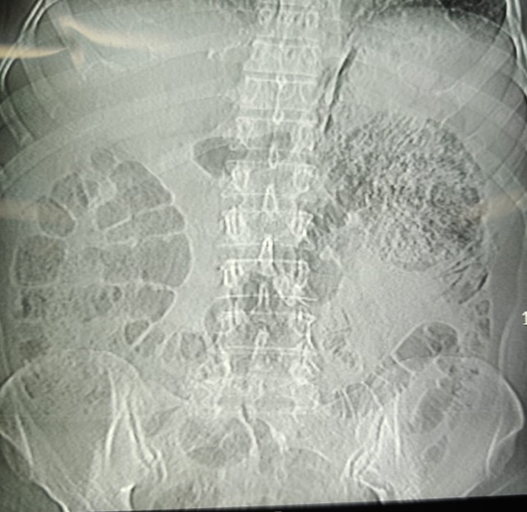 | 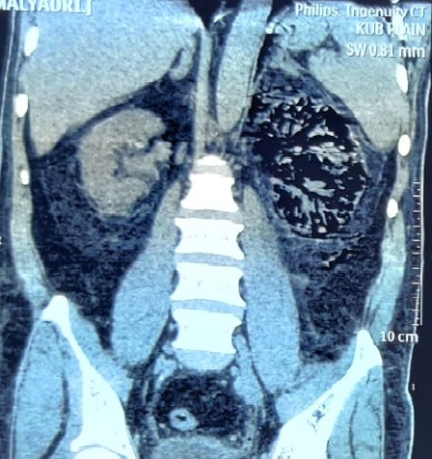
Figure 1: Plain kidneys–ureters–bladder radiograph demonstrating gas lucencies projected over the region of the left kidney. | Figure 2: Coronal Non-Contrast CT KUB demonstrating an enlarged left kidney with markedly destroyed renal parenchyma, multiple focal necrotic areas, and intraparenchymal abscess formation.

