Case report

Double Chin Deception: A Case of Intraoral Dermoid Cyst in the Floor of the Mouth

ABSTRACT
Dermoid cysts of the oral cavity are rare, benign developmental lesions most commonly found in the midline of the floor of the mouth. They can present as painless swellings and may mimic other soft tissue masses, making diagnosis challenging¹.We report a case of a 35-year-old male who presented with a slow- growing, painless swelling in the submental region for over six months. Clinical examination revealed a midline swelling mimicking a “double chin” with intraoral extension elevating the floor of the mouth. MRI confirmed a well-defined, encapsulated cystic lesion situated above the mylohyoid muscle. Surgical excision was performed via an intraoral approach. Histopathology confirmed the diagnosis of a dermoid cyst².Although uncommon, dermoid cysts should be considered in the differential diagnosis of midline submental swellings, especially when intraoral involvement is present. Early diagnosis and complete excision are crucial to avoid complications and recurrence²⁴.
Keywords: Double Chin Deception, Intraoral Dermoid Cyst, cystic lesion, oral cavity

INTRODUCTION
Dermoid cysts are benign, slow-growing lesions of ectodermal origin that arise due to the entrapment of epithelial elements during embryological development³. While more commonly encountered in gonadal and periorbital regions, their occurrence in the oral cavity—particularly the floor of the mouth—is rare, accounting for less than 2% of all dermoid cysts¹. These cysts can be classified based on their anatomical relationship to the mylohyoid muscle: sublingual, submental, or submandibular².
Although they account for a small percentage of all cystic lesions of the head and

neck region, their clinical significance lies in the functional disturbances they can produce as they enlarge. Patients may experience difficulty in speech, swallowing, mastication, or, in advanced cases, breathing, depending on the size and anatomical location of the lesion. These cysts are typically soft, fluctuant, and painless, which can make early diagnosis challenging and may lead to confusion with other cystic entities such as ranula, epidermoid cyst, or thyroglossal duct cyst. Radiographic imaging plays an important role in assessing the lesion’s extent and its relationship to surrounding muscular structures, thereby guiding surgical planning. Histopathological evaluation is essential to confirm the diagnosis and differentiate dermoid cysts from related variants. Understanding the clinical presentation and management of intraoral dermoid cysts is crucial for accurate diagnosis and effective treatment 4.
The differential diagnosis includes ranula, thyroglossal duct cyst, lipoma, and lymphoepithelial cysts⁵. Imaging studies such as MRI are essential for preoperative evaluation and surgical planning³.
We present a rare case of a dermoid cyst located above the mylohyoid muscle in the floor of the mouth of a 35-year-old male, emphasizing the importance of thorough clinical and radiological evaluation for accurate diagnosis and management.

CASE PRESENTATION

A 35 year old male patient presented to our department with chief complaint of swelling below his lower jaw in the midline since more than 6 months. Swelling was of slow growing, painless and complained of mild difficulty in swallowing. But no difficulty in speech or breathing.
Patient did not have any relevant medical history nor any drug allergy.

EXTRA ORAL EXAMINATION Comment by nandhini s: Swelling size and extension

A diffuse swelling in the submental region mimicking a double chin noted in the midline.
Overlying skin appeared normal with no erythema, ulceration. No movement of swelling while swallowing.
Swelling was of semihard, non tender, fluctuant and not fixed to underlying

structures.Comment by nandhini s: Consistency - term semihard may be reconsidered and replaced with a better terminology
No local rise in temperature noted.
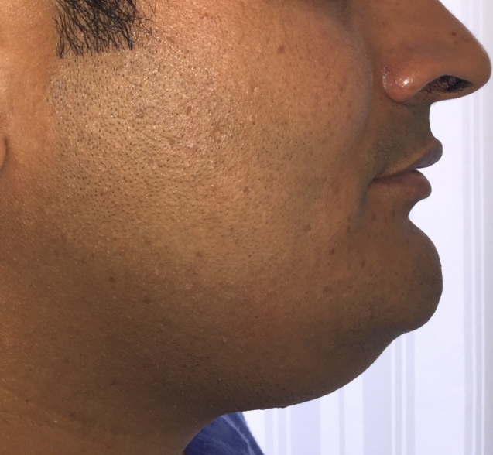

FIG -1 : DOUBLE CHIN APPEARANCE

INTRA ORAL EXAMINATION
Mouth opening of 3 finger breadth noted.Comment by nandhini s: Mouth opening description in mm
Raised floor of mouth noted on left side.
Swelling was non tender, overlying mucosa appeared normal with no erythema, ulceration or sinus opening noted.Comment by nandhini s: Swelling extension and size
Swelling was semi hard , fluctuant and fixated to underlying structures.

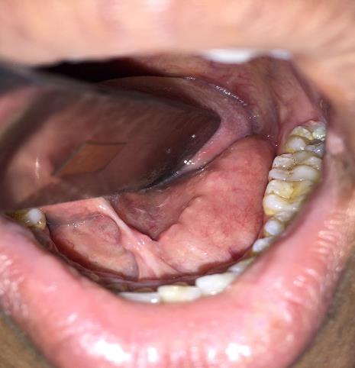

FIG 2 : RAISED FLOOR OF THE MOUTH NOTED.

INVESTIGATIONSComment by nandhini s: MRI Image ? Required more detailed description on MRI image
MRI revealed encapsulated cystic lesion above the attachment of mylohyoid with no invasion of adjacent structures or bone.

SURGICAL PROCEDURE
After basic blood investigations, patient was taken for the procedure under general anesthesia via nasal intubation.
After achieving the general anesthesia via nasal intubation, lignocaine with adrenaline 1:80000 administered intraorally to the proposed surgical site.
Tongue was retracted superiorly using the suture which was placed on the tip of tongue.
After that an incision of 2-3 cm was given lateral to lingual frenum
After the blunt dissection, cyst was located and was separated from surrounding tissues in toto.
Closure was achieved using 3-0 vicryl.

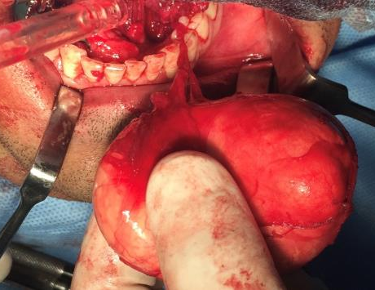

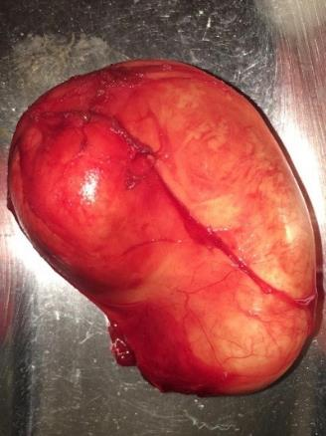

FIG 3 : CYST EXCISED IN TOTO

Patient was extubated and shifted to post operative recovery where he was under observation for 6 hours.
After 2 days of hospitalization, patient was discharged uneventfully.
Patient was followed up for every week in fisrt month and twice in the second month. No recurrence, bleeding or signs of infection noted.

DISCUSSION Comment by nandhini s: Lack of information about histological examination of the cyst.The case report has not been included the provisional diagnosis.
Dermoid cysts in the oral cavity are considered developmental anomalies arising from pluripotent cells that become trapped during midline fusion of the first and second branchial arches¹. Histologically, they can be classified into three types: epidermoid (lined with squamous epithelium only), true dermoid (containing skin adnexa), and teratoid (containing multiple germ layer derivatives)². These cysts are generally considered congenital in origin, arising from entrapment of ectodermal elements during embryologic fusion of the first and second branchial arches, although acquired forms related to traumatic or iatrogenic implantation of epithelial cells have also been described. Clinically, they often present as slow-growing, painless swellings in the midline of the floor of the mouth, and depending on their size and anatomical position relative to the mylohyoid and geniohyoid muscles, they may cause dysphagia, dysarthria, difficulty in mastication, or even respiratory compromise in severe cases.
The typical doughy or fluctuant consistency on palpation reflects their keratinaceous and sebaceous content, yet this feature alone is not pathognomonic, necessitating careful differential diagnosis. Conditions such as ranula, epidermoid cyst, thyroglossal duct cyst, lymphangioma, cystic hygroma, and obstructive salivary gland pathologies must be considered, as clinical overlap is common 7.
Imaging modalities play a crucial role in preoperative evaluation; ultrasonography provides an initial, noninvasive assessment, whereas computed tomography and

magnetic resonance imaging offer superior delineation of lesion extent, internal composition, and relationship to adjacent musculature. Accurate localization above or below the mylohyoid muscle is particularly important in determining the optimal surgical approach. Histopathological examination remains the gold standard for definitive diagnosis, distinguishing dermoid cysts from epidermoid and teratoid variants based on the presence of skin appendages such as hair follicles, sebaceous glands, and sweat glands within the cyst wall 9.
Complete surgical excision is the treatment of choice and is generally curative, with recurrence being rare when removal is thorough and the cyst wall remains intact. The choice between intraoral and extraoral approaches depends largely on lesion size and anatomical position; smaller cysts located above the mylohyoid muscle are typically managed intraorally to avoid external scarring, while larger or submental lesions may require an external approach for adequate exposure and safe dissection. Potential complications include infection, rupture, damage to adjacent neurovascular structures, and postoperative edema, underscoring the need for meticulous surgical planning. Although malignant transformation is exceedingly rare, long-standing lesions warrant timely intervention to prevent functional impairment and secondary complications. From a clinical perspective, awareness of intraoral dermoid cysts is essential for dental practitioners, oral surgeons, and otolaryngologists, as early recognition facilitates appropriate referral, imaging, and management 11.
Given their indolent growth pattern, patients may delay seeking care until symptoms interfere with daily activities, highlighting the importance of routine oral examinations in detecting asymptomatic swellings. Overall, intraoral dermoid cysts, while benign and uncommon, require a comprehensive diagnostic approach and individualized surgical management to ensure favorable functional and aesthetic outcomes, reinforcing the value of interdisciplinary collaboration in the management of lesions of the floor of the mouth 2.
Top of Form

Bottom of Form
In this case, although histological details were not elaborated, the clinical and radiological features were consistent with a dermoid cyst.
The patient’s presentation was typical: a painless, slow-growing midline swelling in the submental region with a concurrent intraoral elevation of the floor of the mouth⁴.

The absence of symptoms such as pain, infection, or respiratory difficulty helped rule out acute or aggressive pathology. MRI served as the ideal imaging modality, clearly delineating the cystic nature, location above the mylohyoid muscle, and absence of invasion into adjacent tissues³.
Surgical excision remains the definitive treatment, with the approach (intraoral vs. extraoral) guided by the cyst’s location in relation to the mylohyoid muscle²,⁴. In our case, an intraoral approach allowed complete removal of the lesion with minimal morbidity and satisfactory esthetic results.
Differential diagnoses considered included plunging ranula, thyroglossal duct cyst, and lymphadenopathy—all of which were ruled out based on location, consistency, and radiological findings.

CONCLUSION
Dermoid cysts of the floor of the mouth, though rare, should be considered in the differential diagnosis of midline submental swellings¹,². A careful clinical examination supported by imaging helps in accurate diagnosis and planning the surgical approach³. Complete surgical excision offers an excellent prognosis with minimal recurrence risk²,⁴. Early intervention also aids in preventing complications such as infection or interference with oral functions.
Consent
As per international standards or university standards, patient(s) written consent has been collected and preserved by the author(s).

Ethical Approval:

As per international standards or university standards written ethical approval has been collected and preserved by the author(s).

Disclaimer (Artificial intelligence)
Option 1:
Author(s) hereby declare that NO generative AI technologies such as Large Language Models (ChatGPT, COPILOT, etc.) and text-to-image generators have been used during the writing or editing of this manuscript.

References

Sahoo NK, Roy ID, Sharma R, Saxena V, Babu BKN, Bhat S. Sublingual dermoid cyst: case series and evaluation of pathology, clinical findings, and treatment. J Dent Defence Sect. 2020;14(2):96–100. doi:10.4103/JODD.JODD_37_20.
Omisakin OO, Kache SA, Ayuba IG, Aghadi IK, Ajike OS. Sublingual dermoid cyst: review of 14 cases. Ann Maxillofac Surg. 2020;10(1):279–283. doi:10.4103/ams.ams_207_19.
Santos HB, Rolim LS, Barros CC, Cavalcante IL, Freitas RD, Souza LB. Dermoid and epidermoid cysts of the oral cavity: a 48-year retrospective study with focus on clinical and morphological features and review of main topics. Med Oral Patol Oral Cir Bucal. 2020;25(3):e364–e369. doi:10.4317/medoral.23388.
Misch E, Kashiwazaki R, Lovell MA, Herrmann BW. Pediatric sublingual dermoid and epidermoid cysts: a 20-year institutional review. Int J Pediatr Otorhinolaryngol.

2020;138:110265. doi:10.1016/j.ijporl.2020.110265.
Priya R, Virmani N, Dabholkar J. Intraoral dermoid cyst: report of two cases. Int Surg
J. 2025;12(3):?. doi:10.18203/2349-2902.isj20163616.
Thirunavukarasu Y, Roy B, Arya A, Pari V. A giant dermoid cyst in the floor of the mouth: a case report. Int J Otorhinolaryngol Head Neck Surg. 2024;10(2):250–253. doi:10.18203/issn.2454-5929.ijohns20240711.
Dutta A, Vallur S, Bothra J. Sublingual dermoid cyst: a case report and review of literature. Int J Otorhinolaryngol Head Neck Surg. 2026;?:?. doi:10.18203/issn.2454- 5929.ijohns20194957.
Kishore HR, Reshma PR. Sublingual dermoid: an uncommon presentation and review of literature. Int J Otorhinolaryngol Head Neck Surg. 2026;?:?. doi:10.18203/issn.2454-5929.ijohns20205639.
Oliveira ALM Jr, Fontan Soares C, Frota Sá Nogueira Neves R, et al. Epidermoid cyst in mouth floor: case report. Res Soc Dev. 2020;9(8):e668986147. doi:10.33448/rsd-v9i8.6147.
(Optional additional reference) Karmakar S, Mishra B. Intraoral route for excising a large dermoid cyst of the floor of mouth: a discussion. J Surg Med. 2022;6(6):650–652. doi:10.28982/josam.977358.
Top of Form Bottom of Form
Koca H, Seçkin S, Sipahi A, Kazanç A. Dermoid cysts of the floor of the mouth: report of three cases. J Oral Maxillofac Surg. 2007;65(8):1539–42. doi:[10.1016/j.joms.2006.11.033](https://doi.org/10.1016/j.joms.2006.11.033)

Longo F, Maremonti P, Mangone GM, De Maria G, Califano L. Midline (dermoid) cysts of the floor of the mouth: report of 16 cases and review of surgical techniques. P l a s t R e c o n s t r S u r g . 2 0 0 3 ; 1 1 2 ( 6 ) : 1 5 6 0 – 5 . doi:[10.1097/01.PRS.0000085598.25752.56](https://doi.org/10.1097/01.PRS.00000 85598.25752.56)

Gadodia A, Bhalla AS, Sharma R, Thakar A, Parshad R. Congenital cystic masses of the neck: embryologic basis and imaging appearances. Indian J Radiol Imaging. 2011;21(1):69–74. doi:[10.4103/0971-3026.76063](https://doi.org/10.4103/0971-
3026.76063)

De Ponte FS, Brunelli A, Marchetti E, Bottini DJ. Sublingual dermoid cysts: a clinical and surgical study of 16 cases. Int J Oral Maxillofac Surg. 2002;31(2):146–9. doi:[10.1054/ijom.2001.0124](https://doi.org/10.1054/ijom.2001.0124)

Walstad WR, Solomon JM, Schow SR, Ochs MW. Midline cystic lesion of the floor of the mouth. J Oral Maxillofac Surg. 1998;56(1):70–4. doi:[10.1016/S0278- 2391(98)90895-3](https://doi.org/10.1016/S0278-2391%2898%2990895-3)

