Case report
A Case Report of Juvenile Systemic Lupus Erythematosus Presenting with Suspected Lupus Nephritis Flare: A Diagnostic and Therapeutic Challenge

ABSTRACT
Background: Juvenile systemic lupus erythematosus (JSLE) is an autoimmune disease, in most cases major organ systems are involved and the lupus nephritis flares are the major contributors to morbidity. A quick diagnosis and early treatment are important in preventing long-term renal damage.
Case Presentation: We present a 10-year-old female child, a case of a known juvenile case of SLE with history of nephritis since 2022 and presenting with sudden-onset abdominal distension, lack of appetite, nausea, low urine volume, abdominal pain, vomiting, fever, rashes, polyarthralgia, and melena. Laboratory investigations revealed leukopenia, anemia, hypoalbuminemia, increased ESR, 3+ proteinuria, high level of proteinuria 24 hours, and increasing urea levels. SLEDAI of 12 indicated flare and SLICE of 4+ indicated flare of lupus nephritis. She was treated using corticosteroids, diuretics, antibiotics, immunosuppressive therapy, and supportive therapy. She demonstrated progressive clinical and biochemical improvement, normalization of renal parameters by day nine and was discharged in stable condition.
Conclusion: The case demonstrates the relevance of early recognition of the nephritis flares in JSLE and the efficiency of timely immunosuppressive treatment in eliminating the further worsening of the renal condition.

Keywords: Juvenile SLE, Flare Lupus Nephritis, Proteinuria, Immunosuppression

INTRODUCTION
Systemic lupus erythematosus (SLE) is an autoimmune disease with a chronic progression that affects different organ systems and is associated with a relapsing-remitting pattern and flare-ups of the disease. Even though SLE may develop in all age groups, it is mostly prevalent in women aged between 15 and 44 years (Lam NV Brown JA Sharma R, 2023). Juvenile-onset systemic lupus erythematosus (jSLE) occurring before the age of 18 years has an incidence of 0.3-0.9 per 100,000 children per year with a peak onset age of about 12 years (Huerta-Calpe et al., 2023; Sherif M Gamal et al., 2022). jSLE tends to be more serious than adult-onset SLE, more active, more organ-affected and cumulatively damaged (Sherif M Gamal et al., 2022).
The pathogenesis of jSLE entails a great genetic predisposition which is thought to have a more eminent role in children than in adults. Disease susceptibility has been linked to a number of genomic regions that are related to immune dysregulation (B- and T-cell activation, inflammation, immune complex processing, and innate immune signaling). Other factors contributing to the formation of the disease include environmental, hormonal, immunoregulatory and drug related factors, which induce an aberrant immune response causing tissue damage (Huerta-Calpe et al., 2023).
Renal lupus nephritis (LN) is one of the most dangerous manifestations of SLE and is the one that is more common and more severe in children compared to adults. LN is a significant factor of morbidity and mortality in SLE children (Pennesi & Benvenuto, 2023; Pinheiro et al., 2019). Most patients with SLE who develop the condition in childhood experience renal involvement and this plays a significant role in determining long-term prognosis. Renal biopsy is the gold standard in classification, and it is used to make therapeutic decisions and prognostication (Shah & Dave, 2024). Children and adolescents with lupus nephritis still develop significant complications of the disease even though the immunosuppressive treatment and the improvement of kidney outcomes have improved (Pennesi & Benvenuto, 2023).
Proper monitoring of renal disease activity is the key to timely identification and treatment of lupus nephritis flares. The sensitivity of biomarker-based tooling, like the Renal Activity Index of Lupus (RAIL) has been found to be more sensitive than traditional clinical indices, including SLE Disease Activity Index (SLEDAI), in identifying active renal disease in children (Aljaberi et al., 2022). The current case report about a child with known JSLE who presented with a suspected case of a lupus nephritis failure has been outlined and the clinical approach and management strategies have been identified.

CASE PRESENTATION
A 10-year-old female patient with known case of juvenile systemic lupus erythematosus diagnosed in 2022, the previous history of bullous skin lesions and lupus nephritis was admitted to the clinic with sudden-onset abdominal distension, loss of appetite, nausea, and reduced urine output, with diffused abdominal pain. The child also experienced a one-day history of vomiting, low-grade fever that was relieved by medicine, generalized rashes with her facial involvement, polyarthralgia, and melena. Generally speaking, the patient was alert, understandable, and time-, place-, and person-oriented. She was a thin built and moderately nourished. Admission vital signs showed a blood pressure of 90/60mmHg, pulse rate of 86 beats per minute, oxygen saturation of 98 percent on room air, and random blood glucose of 86 mg/dL. Cardiovascular examination showed normal heart sounds. A juvenile SLE with renal involvement was provisionally diagnosed based on the clinical appearance and the medical history.

CLINICAL FINDINGS AND DIAGNOSTIC ASSESSMENT
Primary laboratory examination showed that there were serious hematological disturbances, such as anemia (hemoglobin 9.1 g/dL), leukopenia (total leukocyte count 3.1×10³/µL), and increased erythrocyte sedimentation rate (65 mm/hour). Peripheral smear revealed normocytic normochromic anemia and few ovalocytes and leukopenia. The renal tests indicated high blood urea (103 mg/dL) and close normal serum creatinine (0.9mg/dl). Liver function tests were normal except that of hypoproteinemia and severe hypoalbuminemia (serum albumin 1.6 g/dL). Urinalysis showed turbid urine that contained 3+ proteinuria, microscopic hematuria and slight pyuria. Quantitative assessment revealed significantly high levels of 24-hours urinary protein excretion (1382 mg/day). Autoimmune testing revealed that there were positive anti-nuclear antibodies (ANA 4+). Assessment of disease activity showed SLE Disease Activity Index (SLEDAI) 12 and SLICE 4+, which is an active disease with a possible flare of lupus nephritis. Culture in blood and urine did not grow which eliminated active infection. Electrocardiography and echocardiography Cardiac testing were not abnormal.

MANAGEMENT AND OUTCOME
A multidisciplinary approach to disease activity control, renal protection, and supportive care was applied to the patient. Primary treatment involved corticosteroids in the form of dexamethasone, diuretics to control fluid administration, and intravenous antibiotics in case of infection prophylaxis. The supportive measures were gastric protection and antipyretics. Close attention was paid to fluid balance, and the intravenous fluids were used sparingly.
In spite of initial treatment, laboratory values revealed the disease activity constantly with aggravating anemia, leukopenia, and prolonged proteinuria. Intravenous methylprednisolone pulse therapy was introduced at a high dosage and then mycophenolate sodium as immunosuppressive therapy was included. Respiratory symptoms were treated with Nebulization therapy and dietary supplementation such as protein supplementation recommended.
The patient gradually improved in a clinical condition during the period of his hospitalization. Urine excretion was elevated, and the abdominal distension decreased, with systemic symptoms disappearing. Serial laboratory observations showed an increase in hematological parameters and restoration of normal renal functions parameters. On the ninth day, the blood urea and serum creatinine were almost normal. The patient was sent home in a stable state, taking oral corticosteroids, mycophenolate sodium, diuretics, calcium and vitamin D supplementation, gastric protectors, antibiotic treatment, and dietary education.
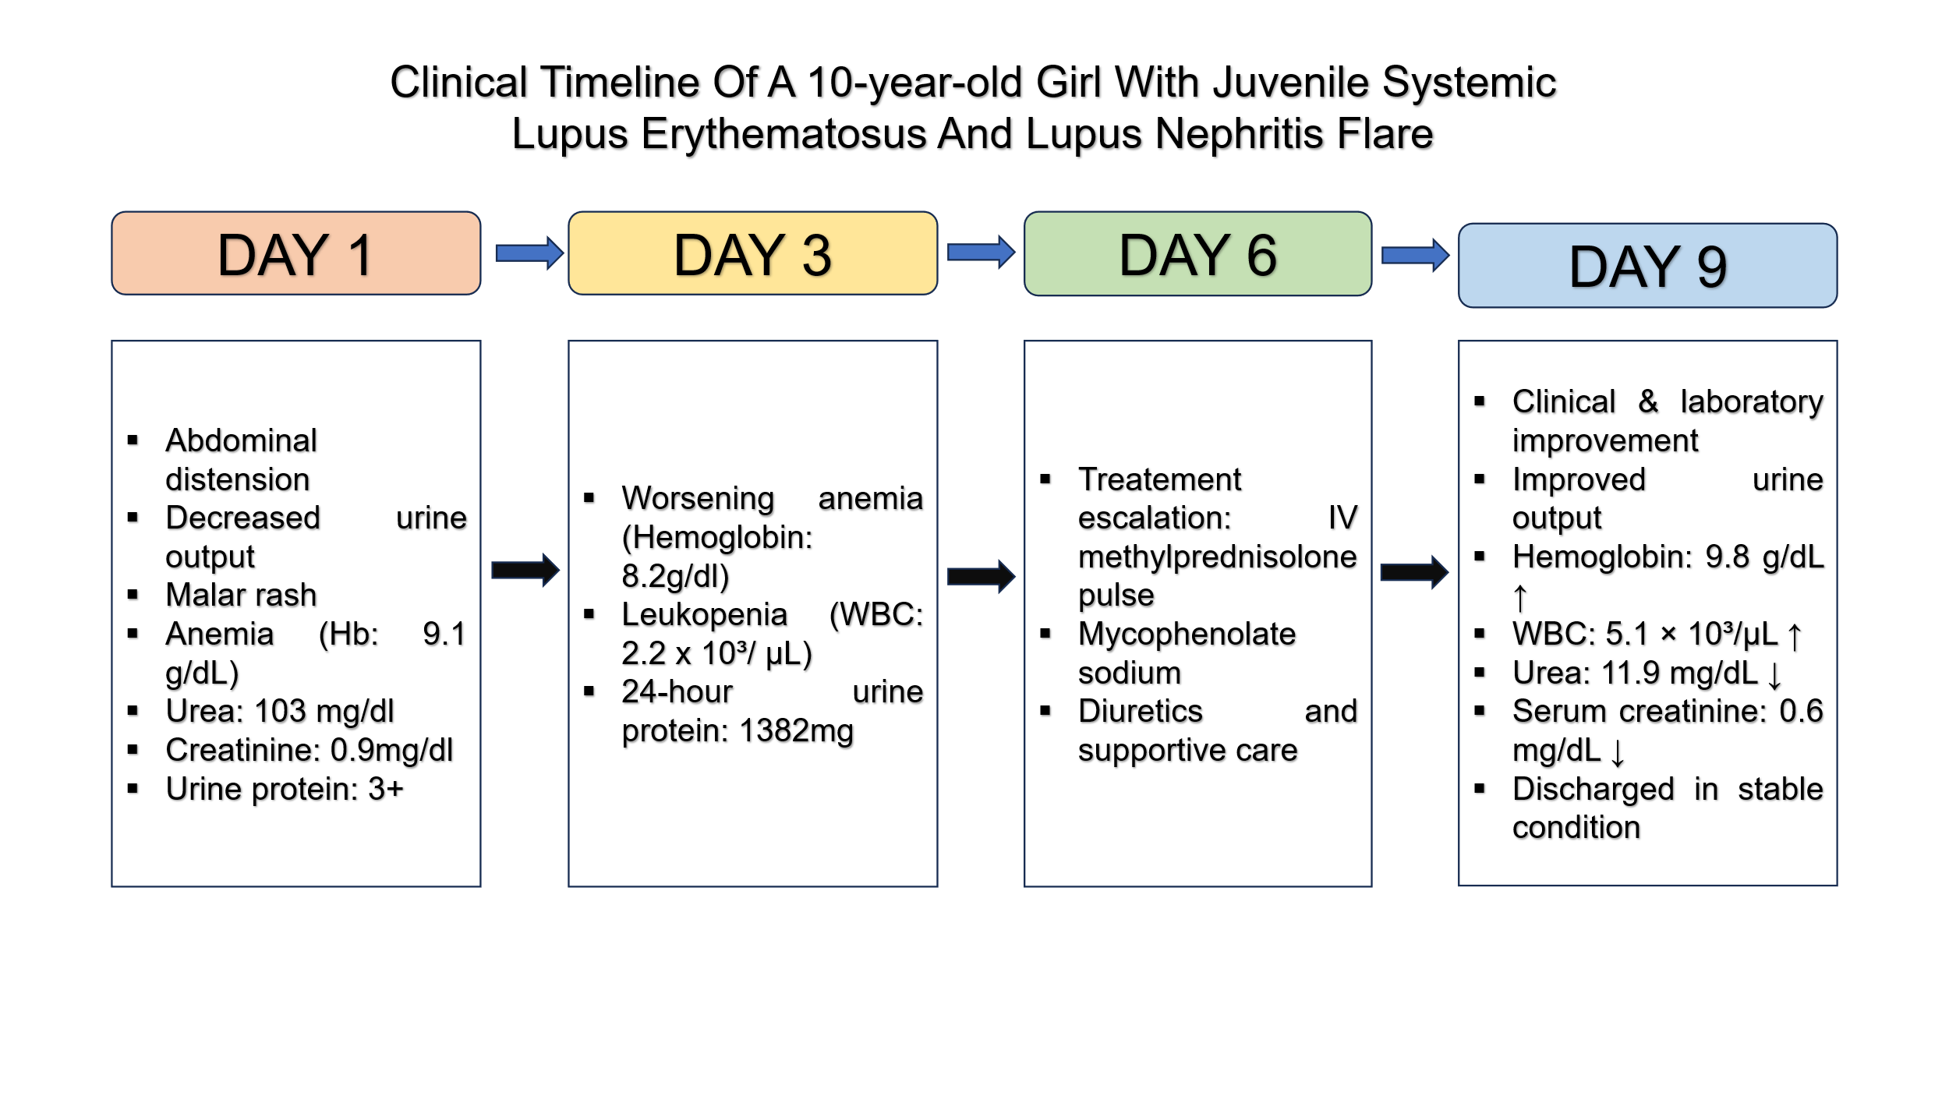
Figure 1. Clinical timeline illustrating the development of an illness, increase in therapy, and laboratory response in a child with lupus nephritis in juveniles.
Figure 1 depicts the clinical process of a 10-year-old girl with juvenile systemic lupus erythematosus with flare of lupus nephritis. Upon admission (Day 1), the patient experienced the development of abdominal distension, impaired urine flow, anemia, leukopenia, and severe renal dysfunction that was manifested by a high level of urea and proteinuria. Laboratory parameters revealed progression of the disease by Day 3 with deteriorating anemia, leukopenia, and proteinuria of nephrotic range. On Day 6, intravenous methylprednisolone and mycophenolate sodium were used as the escalation of treatment. Follow-up lab values showed that there was a clinical and biochemical improvement up to discharge (Day 9) such as normal urea and serum creatinine levels, restoration of hemoglobin and white blood cell counts.

DISCUSSION
The current case has classical characteristics of a lupus nephritis exacerbation, such as strong proteinuria, hypoalbuminemia, high inflammation levels, and high disease activity index, which is manifested in a SLEDAI score of 12 and a SLICE score of 4+. Clinical and laboratory responses have shown similarity in pediatric cohorts of lupus nephritis, in which proteinuria and hypoalbuminemia were common clinical and laboratory presentations, and in which inability to achieve a complete proteinuria remission was linked to worse renal prognoses, which highlighted the value of proteinuria as an indicator of active disease and kidney involvement (Khatri et al., 2025). Observation of cytopenia in this patient and high erythrocyte sedimentation rate is also an indication of active systemic inflammation, which is typical of disease flares in juvenile systemic lupus erythematosus as has been previously observed in case-based evidence (Warrier et al., 2021).
Systemic lupus erythematosus patients are at high risk of getting lupus nephritis and a large percentage of them may advance to end-stage renal disease unless the disease activity is managed effectively (Mahajan et al., 2020). In the current scenario, a constellation of clinical signs, lab tests, and high scores on the disease activity affected the diagnosis of an active nephritis flare and led to early increases in immunosuppressive treatment.
Corticosteroid induction therapy using high dose corticosteroids is also still a key component of induction therapy of active lupus nephritis, and are usually used in combination with immunosuppressive medications like mycophenolate mofetil or cyclophosphamide (Fanouriakis et al., 2020). Mycophenolic acid is first-line therapy in certain classes of lupus nephritis and is especially preferred in children since it has a desirable efficacy and safety profile (Bertsias et al., 2012). Also, mycophenolate mofetil is typically suggested as an induction and maintenance therapy in juvenile proliferative lupus nephritis, in particular, in class III disease (Palmer et al., 2017). The management of systemic lupus erythematosus relies on accurate monitoring of disease activity. The most popular and commonly used assessment tool in the contemporary assessment tool is the Systemic Lupus Erythematosus Disease Activity Index (SLEDAI) (Hanna et al., 2022).The case demonstrates the significance of the timely and aggressive management of the lupus nephritis flares in order to protect against the long-term renal damage and enhance the clinical outcomes.

CONCLUSION
Early diagnosis and vigorous treatment of lupus nephritis exacerbation in children with juvenile systemic lupus erythematosus is of significance in this case. Frequent check of the renal parameters and disease activity index are necessary to intervene in time and achieve better patient outcomes.

Consent
As per international standards, parental written consent has been collected and preserved by the author(s).

Disclaimer (Artificial intelligence)
Author(s) hereby declare that NO generative AI technologies such as Large Language Models (ChatGPT, COPILOT, etc.) and text-to-image generators have been used during the writing or editing of this manuscript.

REFERENCES
Aljaberi, N., Wenderfer, S. E., Mathur, A., Qiu, T., Jose, S., Merritt, A., Rose, J., Devarajan, P., Huang, B., & Brunner, H. (2022). Clinical measurement of lupus nephritis activity is inferior to biomarker-based activity assessment using the renal activity index for lupus nephritis in childhood-onset systemic lupus erythematosus. Lupus Science & Medicine, 9(1), e000631. https://doi.org/10.1136/lupus-2021-000631
Bertsias, G. K., Tektonidou, M., Amoura, Z., Aringer, M., Bajema, I., Berden, J. H. M., Boletis, J., Cervera, R., Dörner, T., Doria, A., Ferrario, F., Floege, J., Houssiau, F. A., Ioannidis, J. P. A., Isenberg, D. A., Kallenberg, C. G. M., Lightstone, L., Marks, S. D., Martini, A., … Boumpas, D. T. (2012). Joint European League Against Rheumatism and European Renal Association–European Dialysis and Transplant Association (EULAR/ERA-EDTA) recommendations for the management of adult and paediatric lupus nephritis. Annals of the Rheumatic Diseases, 71(11), 1771–1782. https://doi.org/10.1136/annrheumdis-2012-201940
Fanouriakis, A., Kostopoulou, M., Cheema, K., Anders, H.-J., Aringer, M., Bajema, I., Boletis, J., Frangou, E., Houssiau, F. A., Hollis, J., Karras, A., Marchiori, F., Marks, S. D., Moroni, G., Mosca, M., Parodis, I., Praga, M., Schneider, M., Smolen, J. S., … Boumpas, D. T. (2020). 2019 Update of the Joint European League Against Rheumatism and European Renal Association–European Dialysis and Transplant Association (EULAR/ERA–EDTA) recommendations for the management of lupus nephritis. Annals of the Rheumatic Diseases, 79(6), 713–723. https://doi.org/10.1136/annrheumdis-2020-216924
Hanna, A. A. A., Abdelnabi, H. H., Kholoussi, N. M., & Hana, N. M. A. El. (2022). Role of Some Apoptotic Proteins in Pathogenesis of Juvenile Systemic Lupus Erytheromatosis and Lupus Nephritis. Journal of Advances in Medicine and Medical Research, 272–282. https://doi.org/10.9734/jammr/2022/v34i2131546
Huerta-Calpe, S., Del Castillo-Velilla, I., Felipe-Villalobos, A., Jordan, I., & Hernández-Platero, L. (2023). Severe Juvenile-Onset Systemic Lupus Erythematosus: A Case Series-Based Review and Update. Children, 10(5), 852. https://doi.org/10.3390/children10050852
Khatri, S., Bajeer, I. A., Aziz, M., Mubarak, M., Lanewala, A. A., & Hashmi, S. (2025). Insights into pediatric lupus nephritis: clinical features and short-term outcomes from a single center retrospective study. BMC Nephrology, 26(1), 145. https://doi.org/10.1186/s12882-025-04059-6
Lam NV Brown JA Sharma R. (2023). Systemic Lupus Erythematosus: Diagnosis and Treatment. American Family Physician, 107(4), 383–395.
Mahajan, A., Amelio, J., Gairy, K., Kaur, G., Levy, R. A., Roth, D., & Bass, D. (2020). Systemic lupus erythematosus, lupus nephritis and end-stage renal disease: a pragmatic review mapping disease severity and progression. Lupus, 29(9), 1011–1020. https://doi.org/10.1177/0961203320932219
Palmer, S. C., Tunnicliffe, D. J., Singh-Grewal, D., Mavridis, D., Tonelli, M., Johnson, D. W., Craig, J. C., Tong, A., & Strippoli, G. F. M. (2017). Induction and Maintenance Immunosuppression Treatment of Proliferative Lupus Nephritis: A Network Meta-analysis of Randomized Trials. American Journal of Kidney Diseases, 70(3), 324–336. https://doi.org/10.1053/j.ajkd.2016.12.008
Pennesi, M., & Benvenuto, S. (2023). Lupus Nephritis in Children: Novel Perspectives. Medicina, 59(10), 1841. https://doi.org/10.3390/medicina59101841
Pinheiro, S. V. B., Dias, R. F., Fabiano, R. C. G., Araujo, S. de A., & Silva, A. C. S. e. (2019). Pediatric lupus nephritis. Brazilian Journal of Nephrology, 41(2), 252–265. https://doi.org/10.1590/2175-8239-jbn-2018-0097
Shah, Dr. K., & Dave, Dr. D. (2024). Clinical profile, laboratory parameters and management outcomes in an eight-year-old female with childhood lupus nephritis. Journal of Pediatrics & Neonatal Care, 14(2), 105–107. https://doi.org/10.15406/jpnc.2024.14.00549
Sherif M Gamal, Nermeen Fouad, Nora Yosry, Wael Badr, & Nesreen Sobhy. (2022). Disease characteristics in patients with juvenile- and adult-onset systemic lupus erythematosus: A multi-center comparative study. Archives of Rheumatology, 37(2), 280–287. https://doi.org/10.46497/ArchRheumatol.2022.8888
Warrier, K., Paisal, V., & Deepak, S. (2021). O06 Juvenile SLE with encephalopathy at onset. Rheumatology Advances in Practice, 5(Supplement_1). https://doi.org/10.1093/rap/rkab067.005

