Dapsone induced methemoglobinemia in a 16-year-old female with dermatitis herpetiformis: A case report

Abstract:

Background: Methemoglobinemia is a rare but potentially life-threatening disorder of oxygen carrying capacity, requiring prompt diagnosis. It could be congenital or acquired. This study presents a rare case of dapsone induced methemoglobinemia in a 16-year-old girl, managed with intravenous methylene blue.
Case presentation: A 16-year-old girl presented to the emergency department with a history of sudden loss of consciousness without seizure activity or trauma. The patient had a room air saturation of 76%. Despite high-flow oxygen therapy, oxygen
saturation did not improve. Methemoglobinemia was suspected based on clinical signs. Methemoglobin levels came back >30%. Treatment was initiated with intravenous methylene blue at a dose of 1mg/kg. Over the course of next 5 days, intravenous methylene blue was repeated as required to a maximum dose of 7 mg/kg. The patient’s cyanosis resolved, oxygen saturation normalized to 96% on room air, and methemoglobin levels decreased to 17%.
Conclusion: This case underscores the need for a high index of suspicion for methemoglobinemia in patients presenting with unexplained cyanosis and refractory hypoxia, especially in the context of known oxidizing agents like dapsone. Early diagnosis and intervention remain key to favorable outcomes.

KEYWORDS: Methemoglobinemia, Dapsone, Methylene blue, Saturation gap.

INTRODUCTION:
Methemoglobinemia is a rare disorder characterized by oxidation of the iron moiety in hemoglobin from a normal ferrous (Fe²⁺) to ferric (Fe³⁺) state.¹ The presence of iron in the ferric state leads to increased oxygen affinity and a leftward shift of the oxygen dissociation curve. This allosteric change leads to impaired oxygen release to tissues, causing hypoxia.² It thus manifests with symptoms of “functional anaemia”,³ ranging from asymptomatic to even death depending on

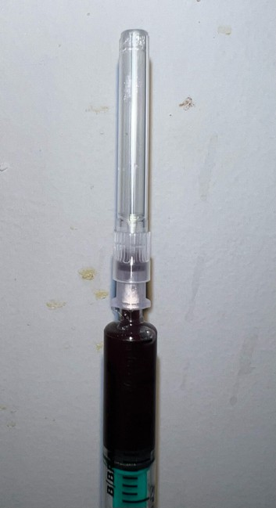
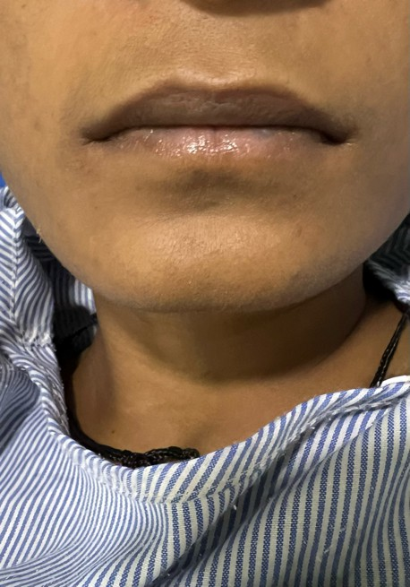
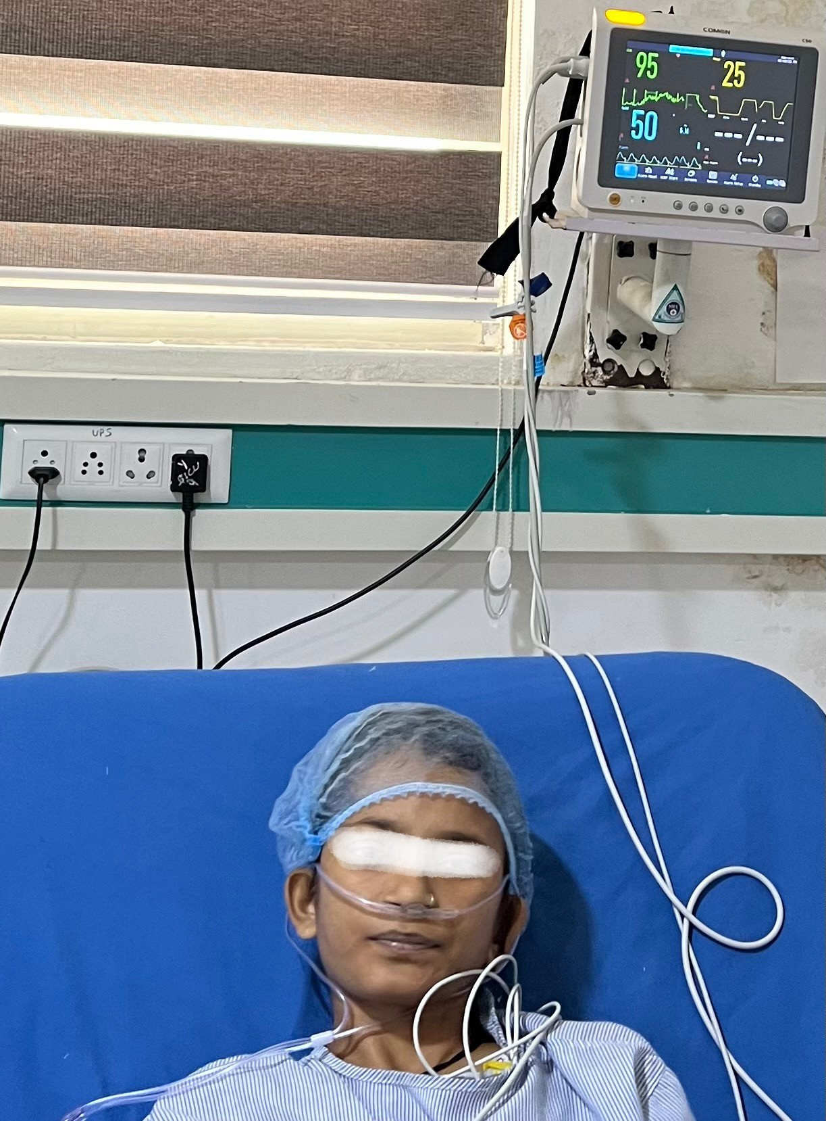
MethHb levels.² Dermatitis herpetiformis (DH) is a skin disease characterised by intensely pruritic papulovesicular eruptions affecting most commonly the extensor surfaces of the elbows, knees and buttocks, and it is considered the cutaneous manifestation of celiac disease¹². Methemoglobinemia can be acquired or genetic. Acquired causes of methemoglobinemia include oxidant drugs like dapsone, local anesthetics like benzocaine & lidocaine, nitrates and nitrites contaminating water or used as food preservatives.^{2,4} We present a rare case of dapsone induced methemoglobinemia in a 16-year-old girl, managed with intravenous methylene blue.

CASE REPORT:
A 16-year-old girl presented to the emergency department with a history of sudden loss of consciousness. The patient regained consciousness within 10-15 minutes. It was not associated with jerking/twitching, tongue bite, and urinary or fecal incontinence. There was no history of head trauma. On arrival the patient was conscious and oriented to time, place, and person. Vitals on arrival: Blood pressure-118/60 mmHg, pulse rate-170/minute, respiratory rate-30/minute, saturation-76% on room air. On examination, the patient was afebrile, but pallor and bluish discoloration around lips were present. Examination of the central nervous system, cardiovascular, and respiratory systems were unremarkable. Her past history was significant for dermatitis herpetiformis. G6PD levels were performed, which came back negative and dapsone therapy started to manage dermatitis herpetiformis. The patient was on dapsone therapy since one month. The patient was then shifted to the intensive care unit for further management. Oxygen therapy was started using a non-rebreather mask @ 10 litres/minute, but there was no significant improvement in her oxygen saturation. Arterial blood gas analysis revealed pO2 327 mmHg on NRBM @ 10L/minute, pcO₂ 23 mmHg, HCO₃- 16.4 mmol/L, sO₂ 100%. All her laboratory workup, chest X ray, 2D ECHO, and diagnostic imaging studies including MRI brain, came back negative. Dapsone induced methemoglobemia was suspected clinically based on cyanosis and unexplained hypoxemia refractory to oxygen therapy. The saturation gap and chocolate brown color of blood were additional clues. Blood methemoglobin levels came back >30%.
Treatment was initiated with intravenous methylene blue at a dose of 1mg/kg. After an hour of administration, room air saturation improved to 86% and cyanosis improved.
Methylene blue was repeated at a dose of 1 mg/kg. Over the course of next 5 days, i.v. methylene blue was repeated as required to a maximum dose of 7 mg/kg. The patient was clinically better, room air saturation improved to 96%, and methemoglobin levels fell to 17%.

Fig 1: Chocolate-brown discoloration of blood Fig 2 : bluish discoloration of the lips Fig 3 : intensive care management of the patient


Table 1: Clinical presentation of the patient at admission

ABG | AT ADMISSION
pH | 7.46
paO2 | 327
paCO2 | 23
HCO3 | 16.4
Spo2 | 100

INVESTIGATIONS | AT ADMISSION | AT DISCHARGE
Hb | 8.6 g/dL | 11.3 g/dL
TLC | 12,030/ cumm | 10,700/ cumm
Platelet count | 3,4,2,000/ cumm | 2,30,000/ cumm
Blood urea | 15.7 mg/dL | 35.3 mg/dL
S. Creatinine | 0.65 mg/dL | 0.59 mg/dL
S. Sodium | 137 mEq/L | 137 mEq/L
S. Potassium | 3.4 mEq/L | 4.2 mEq/L
S. Vitamin B12 | 928.3 pg/mL | -
LDH | 264 IU/L | -

Table 2: Clinical investigations of the patient at the time of admission time and discharge DISCUSSION:
Methemoglobinemia is a rare but potentially life-threatening disorder of oxygen carrying capacity, requiring prompt diagnosis. It could be congenital or acquired. The most common cause of congenital methemoglobinemia is cytochrome b5 reductase deficiency.⁵ However, majority of the clinically encountered cases are acquired due to exposure to substances that cause oxidation of haemoglobin. Normally, some degree of auto-oxidation of hemoglobin to methemoglobin occurs in the body, which is maintained at physiological levels by cytochrome b5 reductase and NADPH reductase, requiring co-factors methylene blue or riboflavin. As the reduction pathways become overwhelmed, oxidation of ferrous to ferric state leads to allosteric alteration, causing irreversible binding of oxygen and impaired oxygen release to the tissues, resulting in hypoxia. Symptoms of methemoglobinemia may range from asymptomatic to fatigue, cyanosis, dizziness, tachycardia, arrhythmia, seizures, or even death, depending on methemoglobin levels in the blood.⁶(Table 1)

Dapsone is a sulfone antibiotic that acts by inhibiting folic acid synthesis. Oral dapsone is used for the treatment of leprosy, dermatitis herpetiformis, acne vulgaris, and PCP prophylaxis. It has a half-life of 10-50 hours, with an average of 28 hours. It is one of the most common acquired
causes of methemoglobinemia, with an estimated incidence of up to 20% after oral administration. It occurs due to the direct hemolytic effect of free radicals by dapsone hydroxylamine.

The gold standard for diagnosis is arterial blood gas analysis with co-oximetry.⁷ It is usually a clinical diagnosis based on history and symptoms, including cyanosis in an individual with normal paO₂, saturation gap between recorded saturation from pulse

oximeter as compared to saturation in ABG,⁸ hypoxia not responding to 100% oxygen, and chocolate colored blood.

For asymptomatic cases, discontinuation of the offending agent might be sufficient. For symptomatic cases and patients with methemoglobin levels greater than 30%, intravenous methylene blue is recommended in a dose of 1-2 mg/kg (but not more than 7 mg/kg) administered over 3-5 minutes.⁹ It should be used cautiously in patients with G6PD deficiency. Side effects include blue-green discoloration of urine, serotonin syndrome in patients taking serotonergic drugs,¹⁰ and precipitation of methemoglobinemia or hemolysis in high doses. In patients with G6PD deficiency, high-dose ascorbic acid (300-1000 mg) may be used. Other therapeutic options include riboflavin (20-30 mg/ day) in congenital variants and cimetidine in subacute cases of dapsone induced methemoglobinemia. In life-threatening cases, hyperbaric oxygen and exchange transfusions may be effective.11

Table 3: Methemoglobin (MetHb) levels and associated clinical signs and symptoms

MethHb levels | Signs | Symptoms
<10% | Low pulse oximeter readings, alteration of the skin color (pale, gray, blue) | Asymptomatic
10-30% | Cyanosis  Dark brown blood | Asymptomatic/confusion
30-50% | Dyspnea, dizziness, syncope | Confusion, chest pain, palpitations, headache, fatigue
50-70% | Tachypnea, metabolic acidosis, dysrhythmias, seizure, delirium, coma | Confusion, chest pain, palpitations, headache, fatigue
>70% | Severe hypoxemia, death

CONCLUSION:
Methemoglobinemia is a rare but serious disorder. This case highlights the importance of maintaining a high index of suspicion for methemoglobinemia in patients presenting with unexplained cyanosis and hypoxia, especially in the context of known oxidizing agents like dapsone. Prompt recognition and timely administration of methylene blue can be life-saving and lead to rapid clinical improvement. Clinicians should be aware of this potential adverse effect, and consider routine monitoring when initiating dapsone therapy. Early diagnosis and intervention remain key to favorable outcomes.

Consent
As per international standards, parental written consent has been collected and preserved by the author(s).

Disclaimer (Artificial intelligence)
Author(s) hereby declare that NO generative AI technologies such as Large Language Models

(ChatGPT, COPILOT, etc.) and text-to-image generators have been used during the writing or editing of this manuscript.

REFERENCES:
- Prchal J. Chapter 51: Methemoglobinemia and Other Dyshemoglobinemias. 10th ed. McGraw Hill; 2021.
- Wright RO, Lewander WJ, Woolf AD. Methemoglobinemia: etiology, pharmacology, and clinical management. Ann Emerg Med. 1999;34(5):646-656.
- Ludlow JT, Wilkerson RG, Nappe TM. Methemoglobinemia. StatPearls Publishing; 2021.

- Jollow, D. J., Bradshaw, T. P., & Mcmillan, D. C. (1995). Dapsone-induced hemolytic anemia. Drug metabolism reviews, 27(1-2), 107-124.
- Percy MJ, Lappin TR. Recessive congenital methaemoglobinaemia: cytochrome b(5) reductase deficiency. Br J Haematol. 2008;141(3):298-308.
- Skold A, Cosco DL, Klein R. Methemoglobinemia: pathogenesis, diagnosis, and management. South Med J. 2011;104(11):757-761.
- Nappe TM, Pacelli AM, Katz K. An Atypical Case of Methemoglobinemia due to Self- Administered Benzocaine. Case Rep Emerg Med. 2015;2015:670979.
- Barker SJ, Tremper KK, Hyatt J. Effects of methemoglobinemia on pulse oximetry and mixed venous oximetry. Anesthesiology. 1989 Jan 1;70(1):112-7.
- Burke P, Jahangir K, Kolber MR: Dapsone-induced methemoglobinemia: case of the blue lady. Can Fam Physician. 2013, 59:958-61.
- Top WM, Gillman PK, de Langen CJ, Kooy A: Fatal methylene blue associated serotonin toxicity. Neth J Med. 2014, 72:179-81.
- Cho Y, Park SW, Han SK, Kim HB, Yeom SR. A Case of Methemoglobinemia Successfully Treated with Hyperbaric Oxygenation Monotherapy. J Emerg Med. 2017 Nov;53(5):685-687.
- Salmi T, Hervonen K. Current concepts of dermatitis herpetiformis. Acta Derm Venereol. 12 febbraio 2020;100(5):5664.

