Case Report
Unilateral exophthalmia revealing an orbital metastasis from esophageal adenocarcinoma: a case report and review of the literature

Abstract
Orbital metastases are uncommon manifestations of systemic malignancies and are most frequently associated with breast, lung, and prostate cancers. Digestive tract tumors rarely metastasize to the orbit, and esophageal adenocarcinoma represents an exceptional cause. We report the case of a 56-year-old man in whom esophageal adenocarcinoma was revealed by unilateral exophthalmia secondary to an osteolytic orbital metastasis. The patient presented with progressive dysphagia and significant weight loss. Imaging revealed an orbital mass with fronto-temporal extension, and histopathological analysis confirmed metastatic disease of esophageal origin. Upper gastrointestinal endoscopy demonstrated a budding tumor of the lower esophagus, histologically consistent with moderately differentiated adenocarcinoma. Given the presence of liver metastases and altered general condition, the patient was managed with palliative intent. This case highlights the importance of considering esophageal cancer in the differential diagnosis of orbital masses and underscores the poor prognosis associated with such atypical metastatic presentations. A review of the literature is provided to place this case within the broader context of orbital metastases of digestive origin.
Keywords: Esophageal neoplasms; Orbital metastasis; Adenocarcinoma; Exophthalmia; Digestive cancers

Introduction
Orbital metastases represent approximately 1–7% of all secondary orbital tumors and most commonly originate from breast, lung, and prostate malignancies¹–³. They pose a significant diagnostic challenge, as orbital symptoms may precede the diagnosis of the primary cancer or mimic benign inflammatory or infectious conditions²⁻⁴.
Gastrointestinal tumors are an uncommon source of orbital metastases, and esophageal carcinoma constitutes an exceptionally rare primary origin, with only sporadic cases reported in the literature⁵–⁸. Although the incidence of esophageal adenocarcinoma has increased worldwide, its metastatic spread typically involves the liver, lungs, and bones. Orbital involvement is highly unusual and often reflects advanced disease. This report describes a rare case of orbital metastasis revealing esophageal adenocarcinoma and emphasizes the need to consider digestive malignancies in patients presenting with unexplained unilateral exophthalmia.

Case Presentation
A 56-year-old chronic smoker with a history of type 2 diabetes mellitus and hypertension presented with progressive dysphagia evolving over one year, initially to solids and later to mixed consistencies, associated with a 30-kg weight loss over four months.
On physical examination, the patient had an altered general condition (performance status = 3) and a body mass index of 18 kg/m². Abdominal examination revealed mild epigastric tenderness without palpable lymphadenopathy. Ophthalmological assessment showed a progressive, non-pulsatile left-sided exophthalmia without diplopia or visual acuity impairment. Neurological examination was unremarkable (Figure 1).
Cranio-orbital magnetic resonance imaging revealed a heterogeneous osteolytic lesion involving the left orbit with extension to the fronto-temporal bone and associated soft tissue infiltration, highly suggestive of secondary involvement (Figure 2). Given the concomitant dysphagia and weight loss, a metastatic process was strongly suspected. Histopathological examination with immunohistochemistry confirmed metastatic adenocarcinoma of digestive origin.
Upper gastrointestinal endoscopy revealed a budding, friable tumor in the lower esophagus, located between 34 and 42 cm from the dental arches, bleeding on contact (Figure 3). Histological analysis demonstrated a moderately differentiated invasive adenocarcinoma.
Thoraco-abdominal computed tomography showed two hypodense liver metastases located in segment IV (12 × 13 mm) and segment III (23 × 26 mm), with no pulmonary involvement (Figure 4). Tumor markers were not contributive. In light of the advanced metastatic disease and the patient’s poor nutritional status, a multidisciplinary tumor board recommended jejunostomy feeding tube placement and palliative management.

Discussion
Orbital metastases are rare clinical entities that generally reflect disseminated systemic malignancy¹–³. The most frequent primary tumors include breast, lung, and prostate cancers, whereas gastrointestinal malignancies account for only a small proportion of reported cases²⁻⁴. Among digestive cancers, esophageal carcinoma remains an exceptionally rare source of orbital metastasis, with only isolated case reports described⁵–⁸.
Large retrospective series have highlighted the rarity of orbital metastatic disease. Bonavolontà et al. analyzed 2,480 space-occupying orbital lesions over a 35-year period and identified metastatic tumors in only a minority of cases¹. Shields et al. further emphasized that orbital metastases often mimic inflammatory or infectious orbital disorders, contributing to diagnostic delays³. Several reports have described orbital metastases presenting as orbital cellulitis or periorbital abscess, particularly in patients with esophageal carcinoma⁷,⁸.
Clinical manifestations are variable and nonspecific, including unilateral exophthalmia, diplopia, visual impairment, eyelid edema, and orbital pain²,⁴. In some patients, orbital involvement represents the first manifestation leading to the diagnosis of an underlying esophageal carcinoma⁶,⁹,¹³. Berdasco et al. reported a case of esophageal adenocarcinoma revealed by unilateral exophthalmos due to metastasis to the medial rectus muscle, emphasizing the diagnostic challenge posed by isolated orbital symptoms¹³. Similarly, Dempsey et al. described orbital metastasis from esophageal squamous cell carcinoma, highlighting the aggressive nature and poor prognosis associated with such presentations¹⁴.
Metastatic involvement of the extraocular muscles is particularly rare. In a pooled analysis, Leung et al. demonstrated that extraocular muscle metastases most commonly arise from breast and lung cancers, with gastrointestinal primaries representing a small minority of cases¹⁵. These findings further underline the exceptional nature of orbital metastases originating from esophageal malignancies.
Histologically, most reported orbital metastases from esophageal cancer arise from squamous cell carcinoma; however, adenocarcinoma has also been documented, albeit less frequently⁵,⁸. The mechanisms underlying orbital dissemination remain incompletely understood but are thought to involve hematogenous spread, facilitated by the rich vascular supply of orbital tissues²,³. The vertebral venous plexus has also been proposed as an alternative pathway, allowing tumor cells to bypass pulmonary filtration and directly reach the orbit².
Imaging modalities such as computed tomography and magnetic resonance imaging play a crucial role in the diagnostic evaluation, typically revealing infiltrative or osteolytic orbital lesions with possible involvement of extraocular muscles or adjacent bones²,⁴. Nevertheless, histopathological confirmation with immunohistochemistry remains essential for establishing the diagnosis and identifying the primary tumor origin⁵,⁷.
The prognosis of patients with orbital metastases is generally poor, reflecting advanced-stage disease. Reported survival following diagnosis ranges from a few months to approximately one year¹⁰,⁴. Management is predominantly palliative and focuses on symptom control and preservation of visual function. Treatment options include radiotherapy, systemic chemotherapy, or combined modalities, depending on the patient’s overall condition⁴. While targeted radionuclide therapies have shown promising results in selected neuroendocrine tumors¹¹,¹², such approaches are not applicable to esophageal adenocarcinoma.

Conclusion
Although exceedingly rare, esophageal carcinoma should be considered in the differential diagnosis of orbital masses, particularly in patients presenting with unilateral exophthalmia associated with systemic symptoms such as dysphagia or weight loss. Orbital involvement usually indicates advanced metastatic disease and carries a poor prognosis. Early recognition, histological confirmation, and multidisciplinary management are essential to avoid diagnostic delay and optimize palliative care.

Ethical Approval
As per international standards or university standards written ethical approval has been collected and preserved by the author(s).

Consent
As per international standards or university standards, patient(s) written consent has been collected and preserved by the author(s).

Disclaimer (Artificial Intelligence)
The authors declare that no generative artificial intelligence technologies, including large language models or text-to-image generators, were used in the writing or editing of this manuscript.

References
- Bonavolontà G, Strianese D, Grassi P, Comune C, Tranfa F, Uccello G, et al.
An analysis of 2,480 space-occupying lesions of the orbit from 1976 to 2011.
Ophthal Plast Reconstr Surg. 2013;29(2):79–86.
- Ng E, Ilsen PF.
Orbital metastases.
Optometry. 2010;81(12):647–657.
- Shields CL, Shields JA, Peggs M.
Tumors metastatic to the orbit.
Ophthal Plast Reconstr Surg. 1988;4(2):73–80.
- Valenzuela AA, Archibald CW, Fleming B, Ong L, O’Donnell B, Crompton JL, et al.
Orbital metastasis: clinical features, management and outcome.
Orbit. 2009;28(2–3):153–159.
- George NM, Charles MP, Wade AR, et al.
Orbital metastases: a review of clinical features and outcomes.
Orbit. 2015;34(1):51–55.
- Aralikatti DA, Nylander AG.
Orbital metastasis as the presenting feature of systemic malignancy.
Eur J Ophthalmol. 2006;16(3):458–460.
- Lee JY, Lee HJ, Jung MS, Kim SY.
Metastatic esophageal squamous cell carcinoma to the orbit and periorbit masquerading as periorbital abscess.
Korean J Ophthalmol. 2010;24(2):123–125.
- Collins MJ, Wojno TH, Grossniklaus HE.
Metastatic esophageal carcinoma to the orbit.
Ophthalmology. 1999;106(2):228–229.
- Marinkovic M, van Lanschot JJ, Schlingemann RO, et al.
Orbital metastasis as the first manifestation of esophageal carcinoma.
Ned Tijdschr Geneeskd. 2002;146(50):2393–2396.
- Magliozzi P, Strianese D, Bonavolontà P, et al.
Orbital metastases: a multicenter retrospective study.
Int J Ophthalmol. 2015;8(5):1018–1023.
- Peixoto RD, Lim HJ, Cheung WY.
Neuroendocrine tumor metastatic to the orbit treated with radiotherapy.
World J Gastrointest Oncol. 2013;5(8):177–180.
- Dobson R, Vinjamuri S, Hsuan J, et al.
Treatment of orbital metastases from a primary midgut neuroendocrine tumor with peptide receptor radionuclide therapy using 177Lu-DOTATATE.
J Clin Oncol. 2013;31(17):e272–e275.
- Berdasco KF, García-Feijoó J, Muñoz-Negrete FJ, et al.
Unilateral exophthalmos secondary to esophageal adenocarcinoma metastasis to the medial rectus muscle.
Arch Soc Esp Oftalmol (Engl Ed). 2019;94:510–513.
- Dempsey KS, Smith JH, Lee MS.
Esophageal squamous cell carcinoma metastatic to the orbit.
Ophthalmic Plast Reconstr Surg. 2018;34:e127–e128.
- Leung V, Thumboo J, Chee SP.
Metastasis to the extraocular muscles: a case report, literature review and pooled data analysis.
Clin Exp Ophthalmol. 2018;46:687–694


Figure 1: Left eye exophthalmia

Figure 2: Progressive exophthalmia over a two-month period
 | 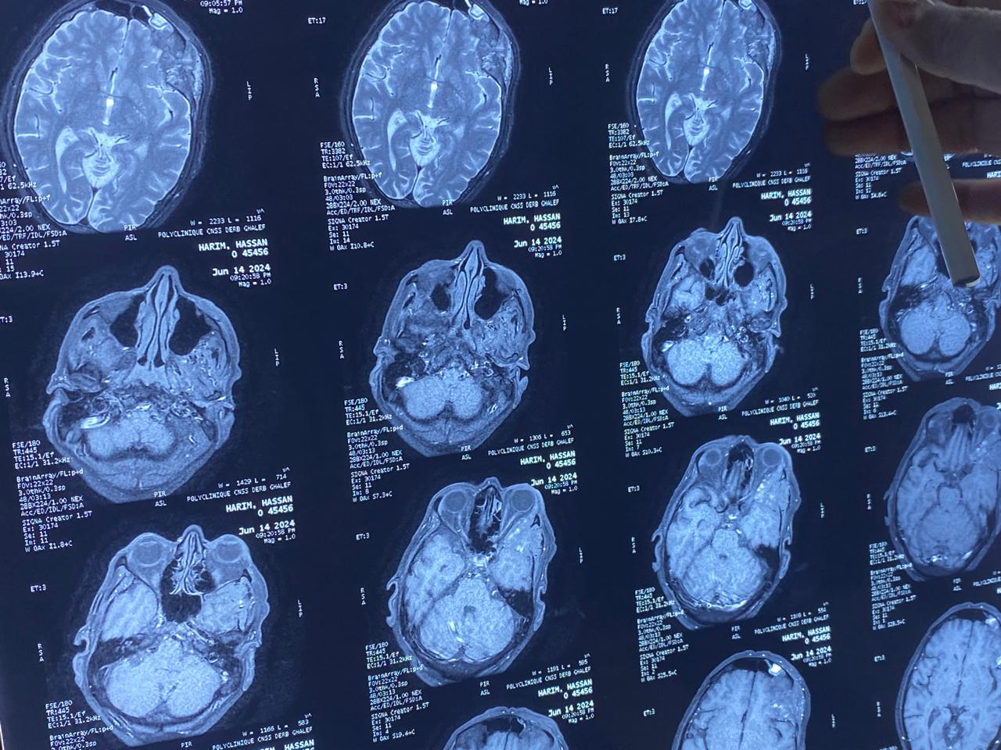

Figure 3 : Cranio-orbital MRI : a heterogeneous osteolytic lesion involving the left orbit with extension to the fronto-temporal bone.

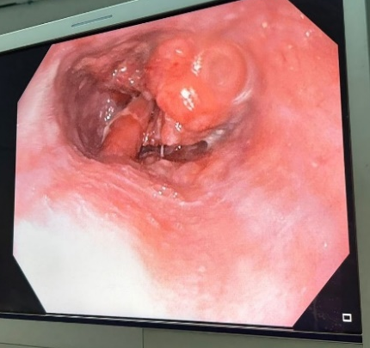
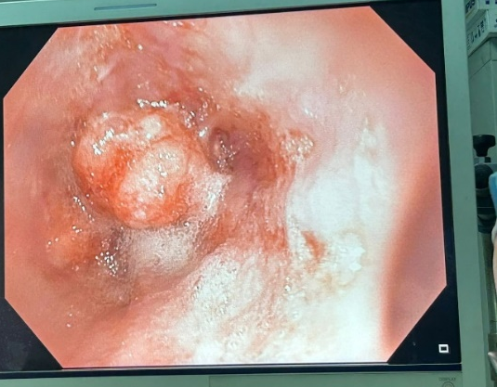
figure 4 : Upper GI endoscopy revealed a budding tumor process in the lower esophagus

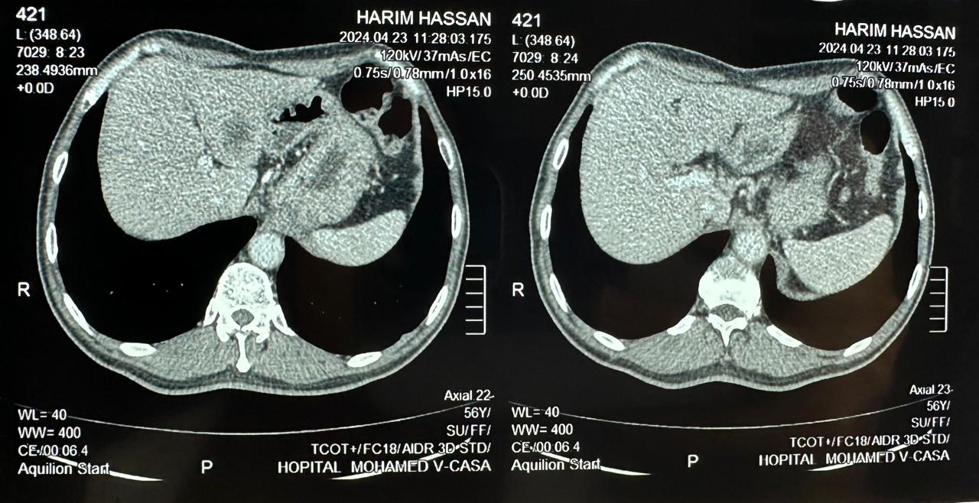Figure 5: CT scan revealed two hypodense liver metastases: segment IV and segment III

