Original Research Article

Biologic and molecular integrative approach for the diagnosis of hemoglobinopathies

ABSTRACT
Background: Hemoglobinopathies are a major public health issue in high-prevalence regions. They result from mutations affecting globin genes, causing qualitative abnormalities or quantitative defects. Phenotypic-based diagnosis often remains presumptive.
Aim: This article highlights, through a case series, the importance of integrating gene sequencing into the diagnostic workflow of hemoglobinopathies.
Methods: A prospective case series of patients was conducted over a three-month period in Mohammed VI National Laboratory of Medical Analyses (Casablanca-Morocco). Blood samples collected on EDTA tubes originated from private clinical laboratories. Hemoglobin electrophoresis was performed using capillary zone electrophoresis (CZE). Molecular analysis of the β-globin gene (HBB) was carried out by Sanger sequencing. Erythrocytes indices were obtained from the referring laboratories.
Results: Electrophoresis’ conclusion was coherent with findings of HBB sequencing in 3 cases (Case 1, 3 and 5). Cases 3 and 4 having thalassemia confirmed by the finding of c.118C>T heterozygous mutation; present elevated rates of HbA2. Case 4 appearing as homozygous hemoglobin S by electrophoresis was identified as compound heterozygous HbS/β⁰-thalassemia. For remaining cases, definitive conclusions have only been obtained after genetic molecular tests.
Discussion
Phenotypic methods such as CZE coupled with red blood cells indices are effective when
screening for hemoglobinopathies. However, they remain presumptive and have limitations in complex cases. Integrating genetic testing helps correct potential misinterpretations arising from phenotypic variability, solves complex cases and is crucial for genetic counseling as well as prevention strategies.
Conclusion: Integration of molecular testing into hemoglobinopathies diagnostic algorithms can contribute to prevention in high-prevalence regions.

Keywords: hemoglobinopathies, globin gene mutations, hemoglobin electrophoresis, molecular diagnosis.

- INTRODUCTION
Hemoglobinopathies are human hereditary disorders characterized by gene mutations affecting the synthesis of the globin chains constituting human hemoglobin (Hb). They are the most common hereditary disorders affecting approximately 7% of the world’s populations(Piel et al., 2013; Williams & Weatherall, 2012). In some geographical areas, healthcare systems can be burdened with these conditions due to their high frequency, the consequences on the quality of life of affected people and their need for frequent blood transfusions. Morocco belongs to these areas which includes countries of the Mediterranean region, North Africa, Middle East, Africa and Southeast Asia(Agouzal et al., 2010). Hemoglobinopathies fall into three groups: thalassemia syndrome (globin chain quantitative defects), structural hemoglobin variants (qualitative abnormalities in the globin’s chains) and hereditary persistence of Hemoglobin F. Clinical features range from asymptomatic, benign (discreet microcytosis) to severe forms (Major sickle cell syndromes, fetal hydrops due to Hb Bart, major thalassemia)(Kohne, 2011).
Laboratory diagnosis of hemoglobinopathies involves various fields of clinical laboratory such as hematology, biochemistry and genetics. The clinical laboratory has a significant role in the diagnosis, at different levels depending on its level of specialization. From the individual’s medical history interview, to performing a full cell blood count and a blood film up to molecular characterization of mutations having led to a hemoglobin abnormality found with a segregating hemoglobin fractions technique (gel electrophoresis, capillary electrophoresis or high-pressure liquid chromatography (HPLC)), the clinical laboratory is involved in the diagnosis strategy of hemoglobinopathies. By characterizing mutations, it contributes to the diagnosis and the confirmation of a hemoglobinopathy case as well as prevention by allowing family studies and genetic counseling during pre-conception period(Dell’Edera et al., 2025).
This article aims to highlight throughout a case series, the contribution and the necessity of an integrated biochemical and molecular diagnostic approach to hemoglobinopathies. To our knowledge and to date, this study is the first in Morocco to discuss discrepancies between phenotypic findings and genotype results following hemoglobin electrophoresis requests.

- MATERIALS AND METHODS
Patients were prospectively included on a 3-month-period (from July 2025 to September 2025). Samples originated from private city clinical laboratories located in Morocco. Tests were performed on whole venous blood sampled in EDTA tubes, stored and transported to our laboratory, the Mohammed VI National Laboratory of Medical Analysis (LNM6).
Tests performed are capillary zone electrophoresis and molecular analysis of the HBB mutations.
The cases included in the series presented an electrophoresis interpretation challenge.
Red cell indices data were collected from the laboratory sender:red blood cell count (RBC), hemoglobin concentration (Hb), mean corpuscular volume (MCV), mean corpuscular hemoglobin (MCH), and mean corpuscular hemoglobin concentration (MCHC).
Capillary zone electrophoresis was performed using the automated Sebia MiniCap (Sebia Inc.) using the Capillarys Hemoglobin kit. Specimens were subjected to onboard hemolysis prior to capillary injection and separated based on electrophoretic mobility. Migration is performed at a high voltage of 10000 volts under tight temperature control using a Peltier device. Quantitation of eluted fractions was performed spectrophotometrically at 415 nm, and peaks were presumptively identified based on their migration within defined zones on the x-axis according to Phoresis software which carries a database of hemoglobin variants (Fig.1).
Whenever there is a close proximity of migration positions of a variant and HbA2, both hemoglobins are quantified in one line.

In some instances where HbA was not present in the sample, the software was not able to identify the zones. In these cases, the sample was spiked at a 1:1 ratio with normal whole blood (Hb A and A2) to achieve zoning (Fig.2).

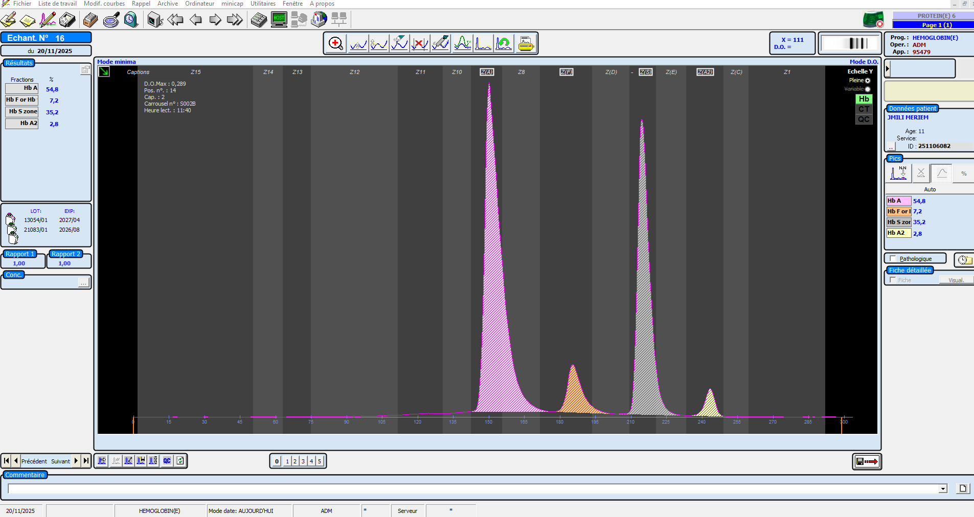
Fig. 1 Screenshot of Phoresis® software window showing a compound heterozygous profile (Hb A/S).

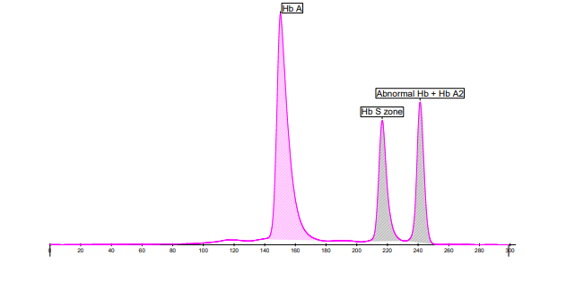
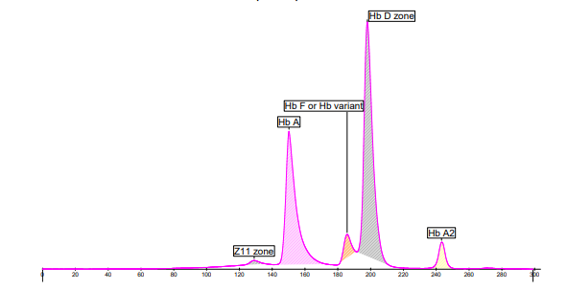
Fig.2. Images showing electrophoretic pattern of a mix at a 1:1 ratio of patients presenting an abnormal hemoglobin with a normal whole blood to achieve zoning. Identification of abnormal hemoglobin was still not possible on the first pattern while in the second case with the mix it has been presumably identified as HbD.
DNA was extracted from peripheral blood using the MagPurix® Blood DNA Extraction Kit (Zinexts Life Science) on the Amplix12 automated nucleic acid purification platform (Biosynex). HBB gene variants were identified by Sanger sequencing, targeting the coding exons, introns 1 and 2, exon–intron junctions, and proximal UTR regions; deep UTR regions were not analyzed.
PCR products were purified with the ExoSAP-IT Express PCR Product Cleanup Kit (Thermo Fisher Scientific). Sequencing reactions were performed using the BigDye® Terminator v3.1 Cycle Sequencing Kit (Thermo Fisher Scientific) and analyzed on a SeqStudio Genetic Analyzer (Thermo Fisher Scientific). Chromatograms were processed using Sequencing Analysis Software v7.0 (Thermo Fisher Scientific) and aligned to the HBB reference transcript NM_000518.5 using SeqScape Software v4.0.

- Results and Discussion
Eight (8) patients were included in the study. Epidemiological features of patients, red blood indices and results of electrophoresis are compiled in Table 1. Electropherograms of hemoglobin and molecular analysis of the HBB (fig 3 ).
In cases 5, 6, 7 and 8 ; proximity of migration of variants and HbA2 led to the quantifications of both hemoglobins in one line.
Red blood cells indices were not available for case 8.
Most cases were adults. Case 3 and 7 were children.
Table 1: Epidemiological features of patients, red blood indices and results of electrophoresis.

Case Number | Sex | Age (years) | City | RBC (10^6/uL) | HB (g/dl) | MCV (fL) | MCH (pg) | MCHC (%) | HbA (%) | HbA2 (%) | HbF (%) | Variant | % variant
1 | M | 34 | Rabat | 5.55 | 15.5 | 85.8 | 27.9 | 32.6 | 60.1 | 3.2 | 0 | S | 36.7
2 | F | 69 | Rabat | 4.55 | 12.2 | 81.9 | 26.8 | 32.7 | 58.3 | 2.8 | 0 | D | 38.9
3 | F | 10 | Casablanca | 5.16 | 8.8 | 54 | 17 | 31 | 42 | 5 | 2.5 | E | 50.5
4 | F | 37 | Beni Mellal |  |  |  |  |  | 0 | 4.4 | 21.8 | S | 73.8
5 | M | 22 | Sidi Kacem | 3.6 | 11.6 | 91 | 32 | 35 | 0 | 0 | 2.6 | S, C | S=51.1 A2+C=46.3
6 | M | 24 | Meknès | 3.91 | 10.2 | 72.6 | 26.1 | 35.9 | 0 | 0 | 0 | S, OTHER | S=52.4 A2+OTHER=47.6
7 | F | 2 | Ben  Slimane | 2.41 | 7.6 | 95 | 32 | 34 | 0 | 0 | 15 | S, OTHER | S=41 A2+OTHER =44
8 | M | 52 | Casablanca |  |  |  |  |  | 0 | 0 | 0 | C | A2+C=100

Fig3: Findings of hemoglobin electrophoresis and Sanger sequencing 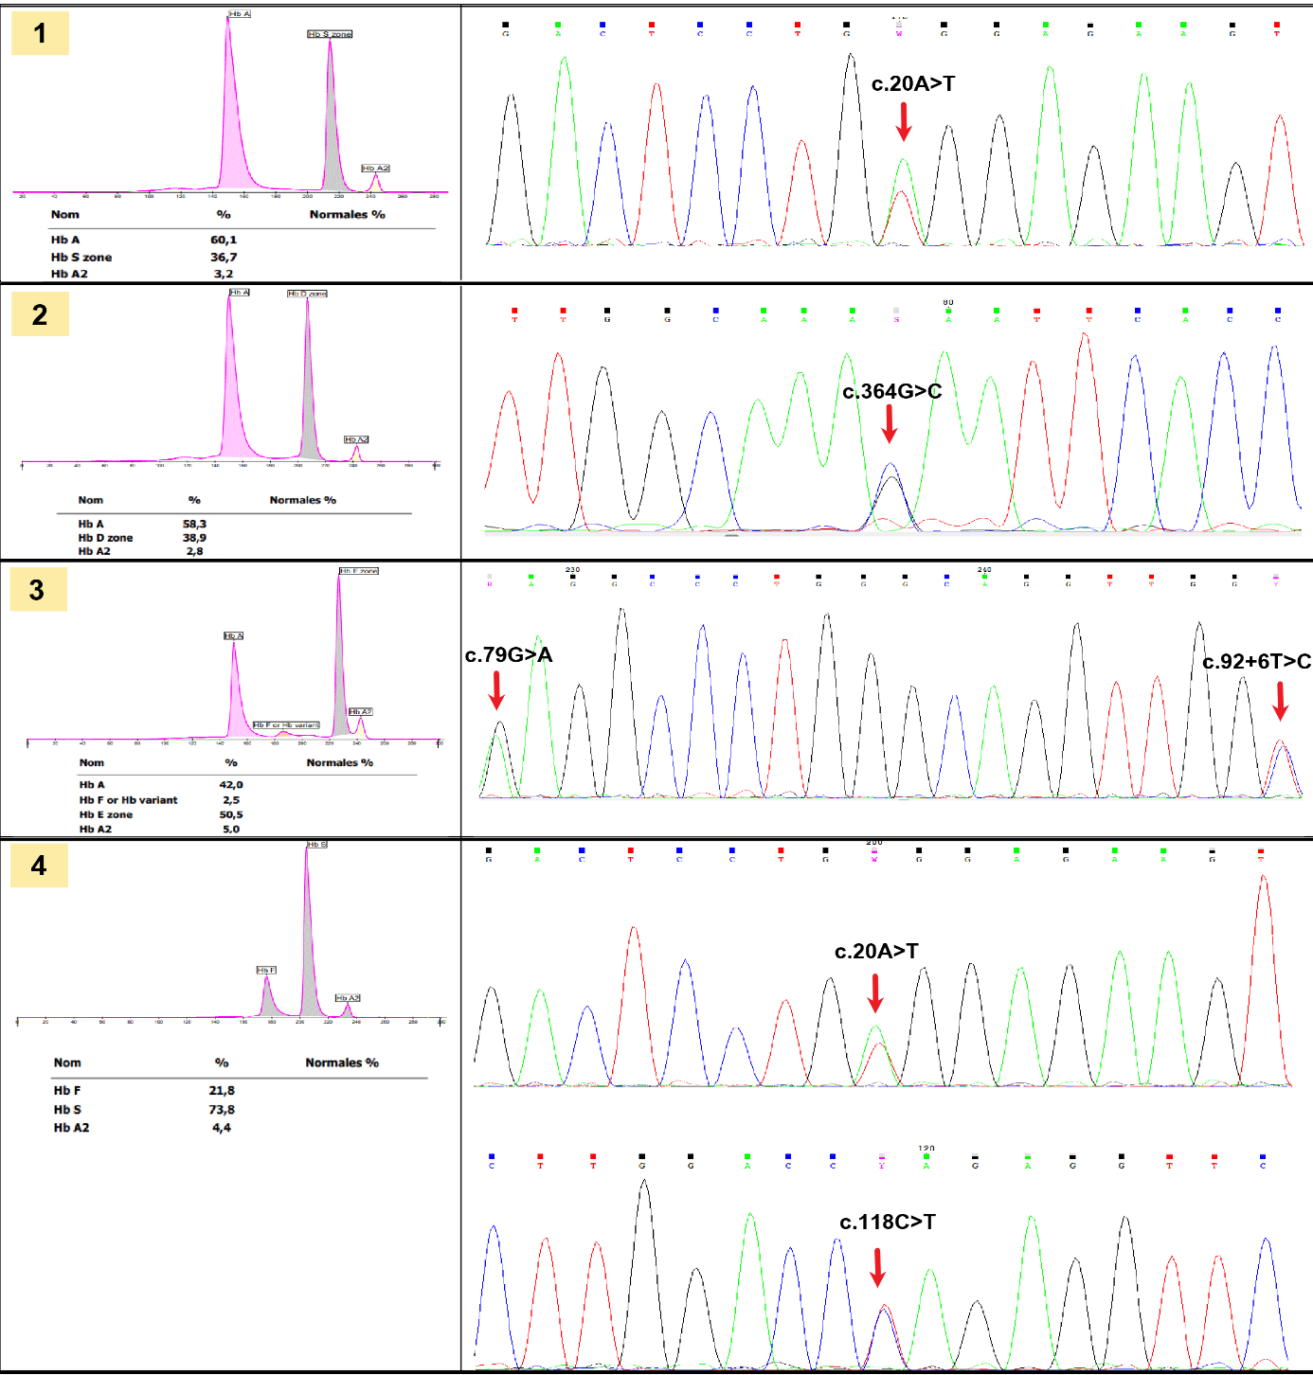
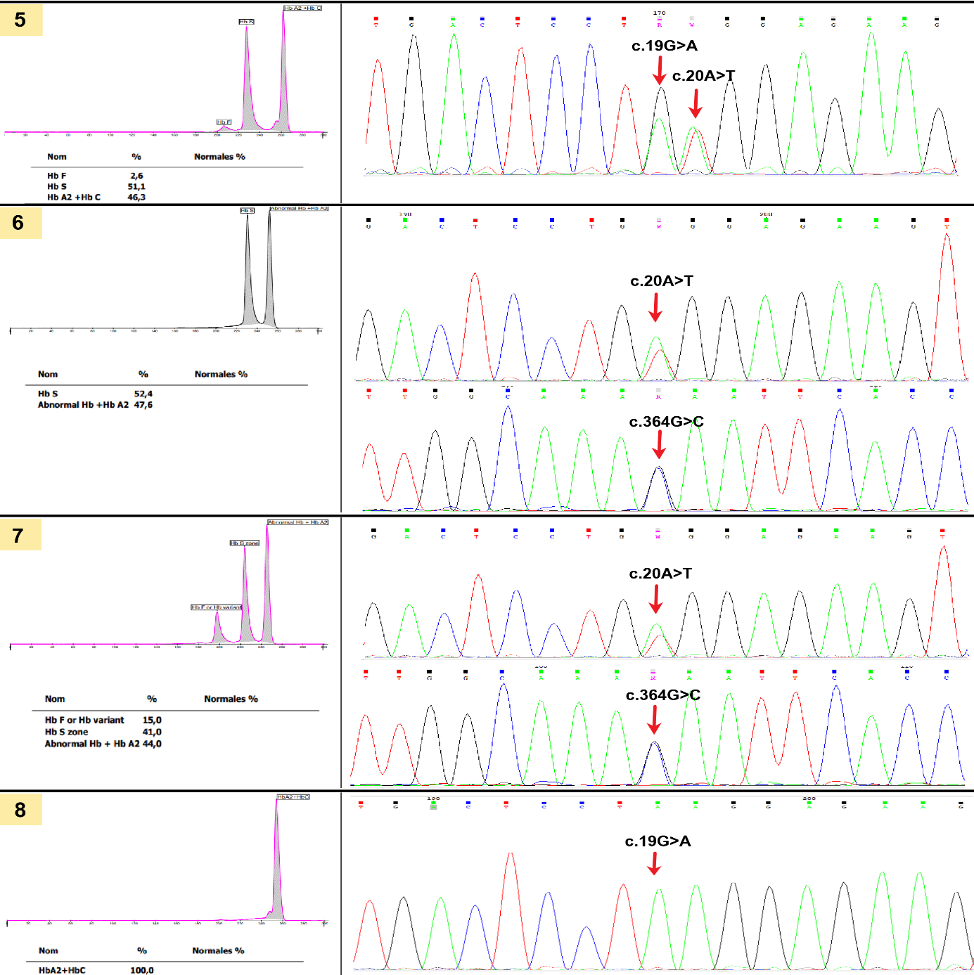

Table 2: Conclusions of hemoglobin capillary zone electrophoresis (CZE) and HBB Sanger Sequencing
Case Number | Hemoglobin CZE conclusion | Conclusion of HBB Sanger Sequencing
1 | Sickle cell trait (HbAS) | Presence of variant c.20A>T heterozygous, associated with hemoglobin S
2 | Hemoglobin D trait (or a heterozygous variant migrating in zone HbD) | Presence of variant c.364G>C heterozygous, associated with hemoglobin D.
3 | HbE (or variant migrating in Hb E zone) compound HbE+ β+⁻thalassemia) | Presence of variant c.79G>A heterozygous, associated with hemoglobin E. Presence of variant c.92+6T>C heterozygous, associated with β+-thalassemia.
4 | Sickle cell anemia HbS | Presence of variant c.20A>T heterozygous associated with hemoglobin S.  Presence of variant c.118C>T heterozygous associated with β°-thalassemia.
5 | Compound heterozygous profile Hb S/C | Presence of variant c.19G>A heterozygous, associated with hemoglobin C.  Presence of variant c.20A>T heterozygous, associated with hemoglobin S.
6 | Compound heterozygous profile S / variant migrating in HbA2 zone | Presence of variant c.20A>T heterozygous associated with hemoglobin S.  Presence of variant c.364G>C heterozygous associated with hemoglobin D.
7 | Compound heterozygous profile S / variant migrating in HbA2 zone | Presence of variant c.20A>T heterozygous associated with hemoglobin S.  Presence of variant c.364G>C heterozygous associated with hemoglobin D.
8 | HbC disease or HbC+ β-⁰⁻thalassemia) | Presence of variant c.19G>A homozygous associated with hemoglobin C.

Cases included all presented with a qualitative abnormality of Hb.
Interpretations and conclusions of Cases 1, 3 and 5 of both techniques were concordant (Table 2).
RBC indices of Case 3 showed microcytic hypochromic anemia, and the patient has a β+-thalassemia.
Hemoglobin patterns of cases having thalassemia (Case 3 et Case 4) show an elevated rate of HbA2.
Regarding Case 4, hemoglobin electrophoresis evoked a homozygous hemoglobin S while HBB sequencing reveals a compound heterozygous HbS+ β°-thalassemia.
We found c.118C>T as a mutation associated with β°-thalassemia and c.92+6T>C associated with β+-thalassemia.

For the other cases, definite conclusion was not possible after electrophoresis only. For cases 6 and 7, despite the 50:50 mix during CZE, the abnormal variant of hemoglobin had been identified only after molecular testing.

Hemoglobin (Hb) is a complex protein found in erythrocytes. It plays a role in oxygen’s transport throughout the organism. It is a tetramer composed of four subunits, each containing a heme group capable of binding to oxygen. In an adult hemoglobin (HbA), the molecule has two chains alpha ﻿(α) and two beta (β) globin chains. In healthy adults, HbA represents 97% of total hemoglobin, hemoglobin A2 (HbA2, α2δ2) accounts for 2-3% and fetal hemoglobin (HbF, α2γ2) constitutes less than 1%(Baudin, 2016).
Genes encoding for globin chains are arranged in clusters and are highly conserved across different species. In humans, these genes are located on chromosome 11 for the α-globin cluster and chromosome 16 for the β-globins(Baudin, 2016).
Phenotypic diagnosis of hemoglobinopathies is complex and relies on various disciplines and laboratory techniques: complete blood count, a peripheral blood smear examination as well as separation techniques such as capillary electrophoresis, high performance liquid chromatography or gel electrophoresis(Franco et al., 2024).
Capillary electrophoresis is widely adopted in laboratories due to its rapidity and robustness(Baudin, 2016).
Despite advances in capillary electrophoresis and an extensive knowledge of hemoglobin, variants’ identification remains presumptive. Diagnosis based only on phenotypic methods can be challenging(Wajcman & Moradkhani, 2015). It is not unusual for a definitive diagnosis to remain unobtained despite the combination of hematological and biochemical findings.
Hemoglobin abnormalities are either qualitative or quantitative. Qualitative abnormalities result from mutations leading to the synthesis of abnormal hemoglobin variants (HbS, HbD, HbE, HbC) whereas quantitative abnormalities result in globin chain quantitative defects.
The HBB gene encodes for the β-globin chain. β-thalassemias and structural β-hemoglobin variants result from defects in the HBB gene. Their genetic basis is remarkably heterogeneous as over 400 distinct pathogenic variants in the HBB gene have been documented, most of which are non-deletional, involving single nucleotide variants (SNVs) or small insertions/deletions (indels) that disrupt transcription, RNA processing, or β-globin chain translation (Dordevic et al., 2025; Rao et al., 2024). More than 95% of β-thalassemia alleles are attributable to SNVs (Harteveld et al., 2022). Globally, although there are hundreds of rare variants, only about 20 variants account for over 80% of β-thalassemia cases because of geographical clustering within populations (Rao et al., 2024).
These HBB variants are classified based on their impact on β-globin biosynthesis. β⁰-thalassemia alleles harbor variants that abolish transcription, pre-mRNA splicing, or translation, resulting in complete absence of β-globin chains, whereas β⁺thalassemia alleles partially impair these processes, allowing residual β-globin synthesis. On the other hand, structural variants arise from SNVs or small indels that alter the β-globin coding sequence, producing amino acid substitutions that modify protein folding, tetramer assembly, stability, or oxygen-binding properties. Some of the most widely reported β-globin variants include HbS (c.20A>T ; p.Glu6Val), which causes sickling under deoxygenated conditions; HbC (c.19G>A ; p.Glu6Lys), associated with mild hemolytic anemia; HbE (c.79G>A ; p.Glu26Lys), leading to a mild β⁺-thalassemia phenotype; HbD-Punjab (c.364G>C : p.Glu121Gln)), usually asymptomatic but clinically relevant when combined with other variants; and HbO-Arab (c.364G>A ; p.Glu121Lys), causing mild hemolysis in compound heterozygosity.
Molecular characterization of the genetic mutation affecting the globin genes is the mean of obtaining a definitive diagnosis of hemoglobinopathies.
Our case series illustrates the necessity of adopting an approach integrating biochemistry and molecular biology for diagnosing qualitative hemoglobinopathies, whether they are associated with β-thalassemia or not.
By comparing a patient's phenotype (Hemoglobin electropherogram obtained by CZE) to his genotype (Sanger sequencing findings), variability of the correlation genotype-phenotype is highlighted providing a key argument supporting the need for an approach that includes a comprehensive molecular diagnosis.
The need for such an integrated approach can be seen in different settings.
Globin gene sequencing is valuable given the wide genetic diversity that define hemoglobinopathies. Different variants of hemoglobin resulting from distinct mutations may share the same electrophoretic migration as reflected in the presumptive identification software. These software use zoning and a zone can include more than one hemoglobin variant(Riou et al., 2018).
It is also well established that different genotypes can produce one identical phenotype.
In cases 4 and 8 of our series, CZE electropherograms showed a predominant hemoglobin variant evoking a homozygote mutation. However, case 4 corresponded to a compound heterozygosity for HbS/β⁰-thalassemia, whereas case 8 represented true homozygosity.
Only the confrontation of genetic findings to biochemical ones allows such genotype-phenotype discrepancies.
Interpretation of hemoglobin capillary electrophoresis includes on one hand the presence/absence of an abnormal variant and on the other hand relative quantification of different fractions of hemoglobins. The electropherogram obtained by CZE shows a phenotypic expression of a genotype. However, phenotypic expressions can be influenced by different situations. For example, for HbS, the co-existence of α-thalassemia reduces HbS expression (its relative percentage), and the presence of extra α-globin genes increases its expression. A patient homozygous for HbS who has recently received a blood transfusion can be mis-diagnosed as having an S-trait, heterozygous. Certain α-globin variants associated with homozygous HbS may produce electrophoretic patterns resembling those of heterozygous HbS. β-globin genes may harbor a second mutation in -cis that alters hemoglobin S expression and consequently its electrophoretic behavior. This may lead to a missed diagnosis by using only electrophoresis(Wajcman & Moradkhani, 2015).
Considering such elements, cautious interpretation of electrophoretic hemoglobin patterns is essential. As shown by cases 2,3 and 8, it is appropriate to consider and evoke possible genotypes capable of producing such patterns, while recommending further molecular investigations.
In cases 1, 3 and 5, phenotypic and genotypic conclusions were concordant. Hematologic abnormalities in the red blood cells strengthen the presumption of hemoglobinopathy. Thalassemias typically present with microcytic anemia(Wajcman & Moradkhani, 2015).
Through cases 3 and 4, it appears that an elevated rate of HbA2 level should lead to the consideration of the existence of a thalassemia-trait. Red cell indices of case 3 make a hypochromic microcytic anemia which is consistent with thalassemia.
Thus, a phenotypic approach remains useful in the diagnosis workflow, helping to screen or detect patients who need further investigations. Phenotypic findings are particularly useful when interpreted in conjunction with elements such as clinical features, hematological data, serum ferritin and iron status, family history and epidemiological context. Also, this approach costs less, is widely available and extensively documented.

Formal identification of hemoglobin variants can only be obtained by molecular studies. Presumptive identification can fail to achieve identification, as observed in cases 6 and 7. In those cases, the software could not provide a hypothesis for identifying the abnormal variant despite the 50:50 mix. In such cases, gene sequencing is essential.
Mutations identified in our case series for thalassemia are NM_000518.5(HBB):c.92+6T>C (IVS-I-6) and NM_000518.5(HBB):c.118C>T (β039), corresponding to β⁺-thalassemia and β⁰-thalassemia, respectively. These findings are consistent with variants reported by a previous study led in Morocco (Lemsaddek et al., 2004)as well as with data from other Mediterranean Basin databases(Dell’Edera et al., 2025; Kaçmaz et al., 2024),(Kountouris et al., 2014).
Regarding hemoglobin variants, mutations identified correlate to well-known abnormal variants: c.20A>T for HbS, c.19G>A for HbC, c.79G>A for HbE, and c.364G>C for HbD(Bender et al., 2003).
Molecular identification of genetic mutations is important for cases of compound or mosaic hemoglobinopathies, particularly when there is a clinically silent thalassemia as illustrated in case 4.
The molecular spectrum of HBB-related disorders in Morocco and North Africa is highly heterogeneous. In Moroccan cohorts, several studies have documented a broad range of β-globin gene variants. In a cohort of 158 β-globin chromosomes, eight variants (c.118C>T (p.Gln40*), c.25_26del (p.Lys9Glufs*15), c.316-106C>G, c.-79A>G, c.20delA (p.Glu7Glyfs*), c.93-21G>A, c.93+2T>C, and c.92+1G>A) together accounted for ~76 % of mutated alleles (Agouti et al., n.d.). In a larger compilation of 187 independent β-thalassemic chromosomes, only six variants (c.118C>T (p.Gln40*), c.20delA (p.Glu7Glyfs*), c.25_26del (p.Lys9Glufs*15), c.92+6T>C, c.92+1G>A, and c.-79A>G comprised ~75.7 % of the total (Lemsaddek et al., 2004). In a more recent study from the eastern region of Morocco, nine known β-thalassemia variants were identified, with c.118C>T (p.Gln40*) being predominant (72.54 %)(Belmokhtar et al., 2022).
Because of this mutational heterogeneity, effective diagnosis of HBB-related disorders in Moroccan and North African populations requires a combined phenotypic and molecular approach. While hemoglobin electrophoresis or HPLC can reliably detect many structural variants, they may not pick up rare, silent, or splice-affecting β-thalassemia variants, particularly those in non-coding regions. In addition, phenotypic analysis provides a functional readout of hemoglobin composition, helping to interpret novel or complex genotypes. Comprehensive sequencing of the HBB gene, including exons, exon–intron boundaries, splice sites, and proximal regulatory regions, therefore provides a definitive molecular diagnosis, allowing detection of both common and rare variants; new variants(Aldakeel et al., 2020) and guiding precise genetic counseling and management.
Complete sequencing of globin genes highly contributes to prevention, genetic counseling, premarital examinations especially when there is consanguinity, risk population or family or personal history of another inherited genetic disorder affecting red blood cells (enzyme deficiency or membrane disorder).
By detecting carriers, genetic counselling allows individuals to make informed decisions.
In the case of an on-going pregnancy, prenatal or neonatal diagnosis can be proposed to parents. Molecular diagnosis is highly contributive in such cases as well.
Sequencing allows differential diagnosis when hyperthyroidism or anti-retroviral drugs cause HbA2 to rise above its normal levels.
Sequencing obtains a definite diagnosis in clinical settings involving an interference such as iron deficiency anemia, megaloblastic anemia and even a persistence of HbF(Dell’Edera et al., 2025).
300,000 to 400,000 children are born every year carrying severe forms of hemoglobinopathies (sickle cell diseases and β-thalassemia major) leading to major health problems(Williams & Weatherall, 2012). Such health problems constitute a costly burden for public health (prognosis, quality of life, iterative blood transfusions). Molecular analysis of globin genes therefore may represent a genuine health economics tool for countries having a high prevalence for hemoglobinopathies.
The majority of our cases are adults illustrating the need for an earlier diagnosis, either in childhood or before conception and having children who may present with a severe form of hemoglobinopathy.
World Health Organization (WHO) recommends the implementation of screening hemoglobinopathies in high-risk regions(Tuo et al., 2024). Such initiatives’ primary goal is to reduce the number of births of children affected by severe sickle cell disease and major thalassemia syndromes.
Molecular analysis of globin genes has been successfully integrated into screening algorithms in several countries including Iran(Joulaei et al., 2014)and Italy (Dell’Edera et al., 2025).

- CONCLUSION:
Molecular identification of mutations of globin genes is an available technique and easier to perform nowadays. By its high sensitivity, it constitutes an additional powerful asset in the diagnostic strategy of hemoglobinopathies. In clinical laboratories, molecular analysis complements and corrects presumptive diagnosis previously made based on a combination of clinical, hematological and biochemical findings.
In the era of personalized medicine, it is important that gene sequencing for mutations be fully integrated into diagnostic practices for hemoglobinopathies, particularly in high-risk regions such as the Mediterranean basin.
Without molecular diagnosis, the implementation of effective prevention strategies for these disorders, which continue to represent a substantial public health burden, would be difficult.
Historically, advances in the understanding of hemoglobin structure and function have been closely linked to progressive developments in biochemistry and biomedical sciences. To improve the health outcomes of at-risk populations, it is essential to preserve this synergy and to integrate globin gene studies into standard medical practice.
Ethical Approval:

As per international standards or university standards written ethical approval has been collected and preserved by the author(s).

Disclaimer (Artificial intelligence)
Author(s) hereby declare that NO generative AI technologies such as Large Language Models (ChatGPT, COPILOT, etc.) and text-to-image generators have been used during the writing or editing of this manuscript.

References

[1] Williams, T. N., & Weatherall, D. J. (2012). World Distribution, Population Genetics, and Health Burden of the Hemoglobinopathies. Cold Spring Harbor Perspectives in Medicine, 2(9), a011692. https://doi.org/10.1101/CSHPERSPECT.A011692
[2] Piel, F. B., Patil, A. P., Howes, R. E., Nyangiri, O. A., Gething, P. W., Dewi, M., Temperley, W. H., Williams, T. N., Weatherall, D. J., & Hay, S. I. (2013). Global epidemiology of sickle haemoglobin in neonates: a contemporary geostatistical model-based map and population estimates. The Lancet, 381(9861), 142–151. https://doi.org/10.1016/S0140-6736(12)61229-X
[3] M. Agouzal, A. Arfaoui, A. Quyou, and M. Khattab, “Beta thalassemia major: The Moroccan experience,” 2010.
[4] Kohne, E. (2011). Hemoglobinopathies: Clinical Manifestations, Diagnosis, and Treatment. Deutsches Ärzteblatt International, 108(31–32), 532. https://doi.org/10.3238/ARZTEBL.2011.0532
[5] Dell’Edera, D., Persia, B., Rocca, F. La, & Centoducati, C. (2025). Haemoglobinopathies: Integrated Biochemical and Molecular Diagnosis in 5243 Patients. Hemato 2025, Vol. 6, Page 36, 6(4), 36. https://doi.org/10.3390/HEMATO6040036
[6] Baudin, B. (2016). Les hémoglobines normales et pathologiques. Revue Francophone Des Laboratoires, 2016(481), 27–34. https://doi.org/10.1016/S1773-035X(16)30126-5
[7] Franco, E., Karkoska, K. A., & McGann, P. T. (2024). Inherited disorders of hemoglobin: A review of old and new diagnostic methods. Blood Cells, Molecules, and Diseases, 104, 102758. https://doi.org/10.1016/J.BCMD.2023.102758
[8] Wajcman, H., & Moradkhani, K. (2015). Pitfalls in the biological diagnosis of common hemoglobin disorders. Annales de Biologie Clinique, 73(5), 535–543. https://doi.org/10.1684/abc.2015.1074
[9] Rao, E., Kumar Chandraker, S., Misha Singh, M., & Kumar, R. (2024). Global distribution of β-thalassemia mutations: An update. In Gene (Vol. 896). Elsevier B.V. https://doi.org/10.1016/j.gene.2023.148022
[10] Dordevic, A., Mrakovcic-Sutic, I., Pavlovic, S., Ugrin, M., & Roganovic, J. (2025). Beta thalassemia syndromes: New insights. World Journal of Clinical Cases, 13(10). https://doi.org/10.12998/wjcc.v13.i10.100223
[11] Harteveld, C. L., Achour, A., Arkesteijn, S. J. G., ter Huurne, J., Verschuren, M., Bhagwandien-Bisoen, S., Schaap, R., Vijfhuizen, L., el Idrissi, H., & Koopmann, T. T. (2022). The hemoglobinopathies, molecular disease mechanisms and diagnostics. In International Journal of Laboratory Hematology (Vol. 44, Issue S1, pp. 28–36). John Wiley and Sons Inc. https://doi.org/10.1111/ijlh.13885
[12] Riou, J., Szuberski, J., Godart, C., Wajcman, H., Oliveira, J. L., Hoyer, J. D., & Bardakdjian-Michau, J. (2018). Precision of CAPILLARYS 2 for the Detection of Hemoglobin Variants Based on Their Migration Positions. American Journal of Clinical Pathology, 149(2), 172–180. https://doi.org/10.1093/AJCP/AQX148
[13] Lemsaddek, W., Picanço, I., Seuanes, F., Nogueira, P., Mahmal, L., Benchekroun, S., Khattab, M., & Osório-Almeida, L. (2004). The beta-thalassemia mutation/haplotype distribution in the Moroccan population. Hemoglobin, 28(1), 25–37. https://doi.org/10.1081/HEM-120028884.
[14] Kaçmaz, M., Yaşargil, G., & Aşıkovalı, S. (2024). Genotype-phenotype correlation and mutation spectrum of HBB gene in the Hatay province of Turkey Türkiye’nin Hatay ilinde HBB geninin genotip-fenotip korelasyonu ve mutasyon spektrumu. Cukurova Medical Journal Cukurova Med J, 49(1), 40–46. https://doi.org/10.17826/cumj.1394315
[15] Kountouris, P., Lederer, C. W., Fanis, P., Feleki, X., Old, J., & Kleanthous, M. (2014). IthaGenes: An Interactive Database for Haemoglobin Variations and Epidemiology. PLOS ONE, 9(7), e103020. https://doi.org/10.1371/JOURNAL.PONE.0103020
[16] Bender, M. A., Carlberg, K. ;, Adam, M. P., Bick, S., & Mirzaa, G. M. (2003). [Notable HBB Pathogenic Variants]. Dam MP, Bick S, Mirzaa GM, et al., Editors. GeneReviews®.
[17] Agouti, I., Badens, C., Abouyoub, A., Levy, N., & Bennani, M. (2008). Molecular Basis of b-Thalassemia in Morocco: Possible Origins of the Molecular Heterogeneity. In Genetic Testing (Vol 12, Number 4),563-568. DOI:10.1089/gte.2008.0058
[18] Belmokhtar, I., Lhousni, S., Elidrissi Errahhali, M., Ghanam, A., Elidrissi Errahhali, M., Sidqi, Z., Ouarzane, M., Charif, M., Bellaoui, M., Boulouiz, R., & Benajiba, N. (2022). Molecular heterogeneity of β-thalassemia variants in the Eastern region of Morocco. Molecular Genetics and Genomic Medicine, 10(8). https://doi.org/10.1002/mgg3.1970
[19] Aldakeel, S. A., Ghanem, N. Z., Al-Amodi, A. M., Osman, A. K., Al Asoom, L. I., Ahmed, N. R., Almandil, N. B., Akhtar, M. S., Azeez, S. A., & Borgio, J. F. (2020). Identification of seven novel variants in the β-globin gene in transfusion-dependent and normal patients. Archives of Medical Science, 16(2), 453–459. https://doi.org/10.5114/AOMS.2019.84825
[20] Tuo, Y., Li, Y., Li, Y., Ma, J., Yang, X., Wu, S., Jin, J., & He, Z. (2024). Global, regional, and national burden of thalassemia, 1990–2021: a systematic analysis for the global burden of disease study 2021. EClinicalMedicine, 72, 102619. https://doi.org/10.1016/J.ECLINM.2024.102619
[21] Joulaei, H., Shahbazi, M., Nazemzadegan, B., Rastgar, M., Hadibarhaghtalab, M., Heydari, M., Ghaffarpasand, F., & Rahimi, N. (2014). The diminishing trend of β-thalassemia in Southern Iran from 1997 to 2011: the impact of preventive strategies. Hemoglobin, 38(1), 19–23. https://doi.org/10.3109/03630269.2013.858638

