Validation and Procedural Refinement of an Ovum Pick-Up Protocol in Tharparkar Cows

ABSTRACT
Ovum pick-up (OPU) is widely applied in bovine assisted reproductive technologies; however, procedural variability may influence oocyte recovery efficiency and morphological integrity. The present technical report describes the adaptation and application of a defined OPU procedural preset in Tharparkar cows. Dominant follicle ablation was performed to synchronize follicular wave emergence, and transvaginal ultrasound-guided aspiration was conducted 4–7 days later using a fixed preset comprising an 18-gauge needle, regulated vacuum pressure (80–85 mmHg), controlled flow rate (~15 mL/min), and collection medium maintained at 38.5°C. During initial procedural refinement, aspiration pressures of 85–90 mmHg were associated with increased cumulus denudation, whereas pressures of 70-80 mmHg resulted in reduced oocyte recovery efficiency; therefore, an intermediate pressure range (80–85 mmHg) was selected for consistent application. Follicles measuring 3–9 mm were aspirated under uniform management conditions. A total of 210 follicles were aspirated, yielding 118 oocytes with an overall recovery rate of 56.08 ± 3.27%. Morphologically acceptable oocytes (Grade A+B) constituted 59.86 ± 3.11% of recovered oocytes. The defined protocol resulted in consistent follicular aspiration and satisfactory oocyte morphological quality under non-stimulated conditions. This approach may serve as a practical reference for breed-specific OPU application in Tharparkar cattle.

Keywords: Bos indicus; dominant follicle ablation; oocyte recovery; ovum pick-up; Tharparkar cattle.

Introduction
Ovum pick-up (OPU) is an established assisted reproductive technique that enables repeated transvaginal ultrasound-guided aspiration of ovarian follicles for in vitro embryo production in cattle. Despite its widespread use, technical parameters such as needle gauge, aspiration pressure, flow rate, ultrasound frequency, follicular selection criteria, and media handling conditions vary considerably across laboratories, potentially influencing oocyte recovery efficiency and cumulus–oocyte complex (COC) integrity (Sahu, 2025). Establishment of consistent procedural parameters is therefore critical to ensure reproducibility and stable oocyte yield across sessions. In many applied reproductive settings, parameter refinement occurs through controlled procedural adjustment rather than structured comparative trials. Development of defined operating presets under specific management conditions can thus contribute to practical reproducibility, particularly when adapting OPU protocols to indigenous breeds.
Breed-specific reproductive physiology further necessitates methodological consideration. Tharparkar cattle, an indigenous Bos indicus dairy breed adapted to arid and semi-arid environments, exhibit reproductive performance influenced by genetic and environmental factors (Pilania et al., 2022; Choudhary, Pannu, & Gahlot, 2024; Patel et al., 2024; Kaur et al., 2025). Early genetic characterization of reproductive traits in this breed documented variability in fertility-related parameters (Majumdar, 1969; Jose et al., 2022), while contemporary reviews emphasize structured reproductive management strategies for sustainable genetic improvement (Patel et al., 2024; Iqbal et al., 2019). Recent application of transvaginal OPU in Tharparkar donor cows has demonstrated feasibility of oocyte retrieval and developmental competence assessment in this breed (Donadkar et al., 2024). However, detailed documentation of defined procedural presets for OPU under non-stimulated conditions in Tharparkar cows remains limited. The present technical report describes the validation and procedural refinement of an ovum pick-up protocol that yielded consistent oocyte recovery and acceptable morphological quality under controlled experimental conditions.
Materials and Methods
Experimental Animals
The study was conducted on clinically healthy, cyclic Tharparkar cows maintained under uniform feeding, housing, and management conditions at the institutional dairy farm. Animals were screened through gynaecological examination and ultrasonographic evaluation to exclude detectable reproductive abnormalities. Selection criteria included normal ovarian morphology and the presence of either a functional corpus luteum or a dominant follicle at the time of enrolment (Sahu et al., 2026a). The stage of the estrous cycle was determined using real-time transrectal B-mode ultrasonography with a 7.5-MHz linear-array transducer as described earlier (Sahu et al., 2026b). Ovarian structures, including follicular size and corpus luteum status, were recorded prior to initiation of the experimental protocol.
Experimental Design
Dominant follicle ablation (DFA) was performed on ovarian follicles measuring ≥ 9 mm in diameter to induce synchronized emergence of a new follicular wave. DFA was carried out under aseptic conditions using transvaginal ultrasound-guided aspiration. Following DFA (Day 0), ovarian follicular dynamics were monitored daily via transrectal ultrasonography to confirm new wave emergence. Ovum pick-up (OPU) was performed between Day 4 and Day 7 post-DFA, corresponding to the early recruitment phase of the synchronized follicular wave.
All procedures were conducted under consistent operating conditions, including uniform animal restraint, standardized epidural anesthesia protocol, fixed ultrasound equipment settings, regulated vacuum pressure, controlled flow rate, and single-operator execution to minimize procedural variability. The experimental design and OPU schedule are illustrated in Fig. 1 and Fig. 2.
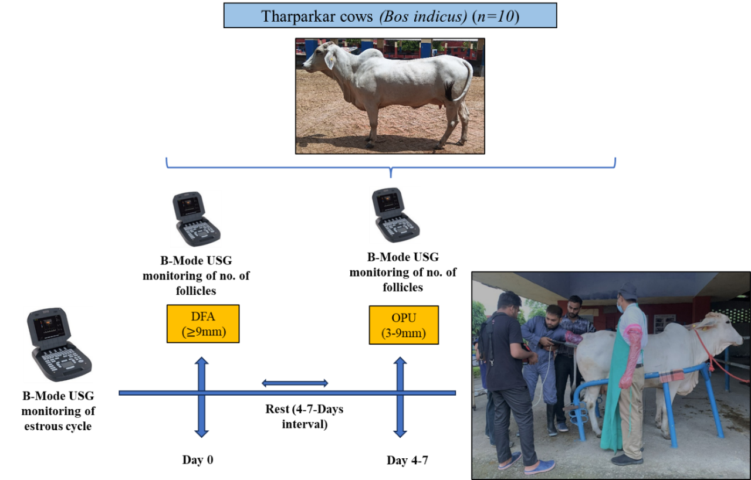

Fig. 1. Schematic representation of the experimental OPU protocol in Tharparkar cows.
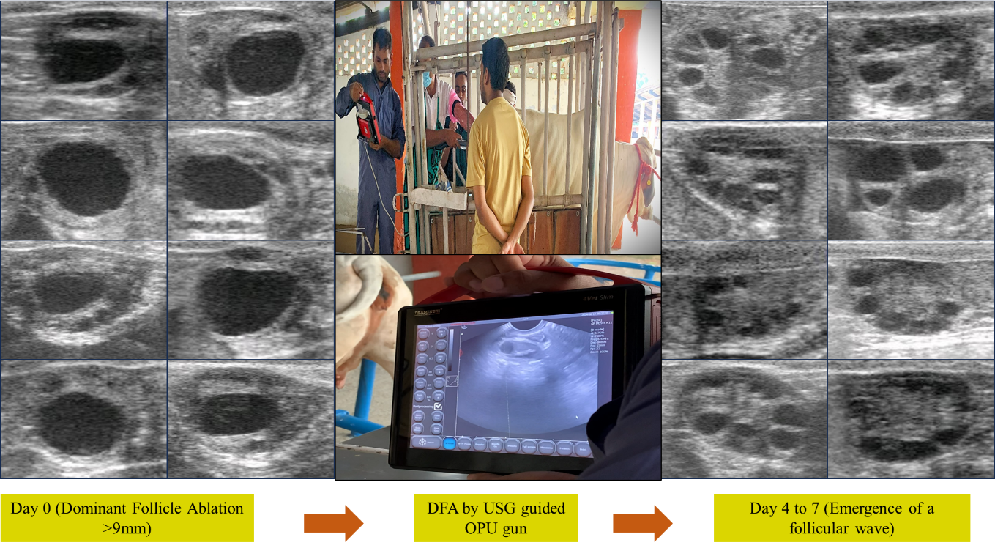

Fig. 2. Schematic representation of the experimental Dominant follicle ablation followed by OPU protocol in Tharparkar cows.

Ultrasound-Guided Ovum Pick-Up Procedure
Animals were restrained in a standing position using a squeeze chute. Caudal epidural anesthesia was administered with 2% lignocaine hydrochloride (4–5 mL) at the first intercoccygeal space to minimize straining. The perineal region was cleaned and disinfected using 1% chlorhexidine followed by 70% ethanol. The vaginal cavity was rinsed three times with 0.5% chlorhexidine solution and sterile 0.9% saline to ensure aseptic conditions. Both ovaries were visualized using a transvaginal sector ultrasound probe (5.0–7.5 MHz convex-array transducer; Draminski Vet-Slim, DRAMIŃSKI S.A., Olsztyn, Poland) equipped with a stainless-steel needle guide. Follicles measuring 3–9 mm in diameter were identified and aspirated under real-time ultrasonographic guidance. Follicular aspiration was performed using a sterile disposable 18-gauge single-lumen needle connected via silicone tubing to a regulated vacuum pump system. Aspirated follicular fluid was collected into sterile 50-mL tubes containing pre-warmed OPU collection medium supplemented with anticoagulant and maintained at 38.5°C. All OPU sessions were performed by the same experienced operator.

Defined OPU Procedural Preset
The operating parameters applied uniformly during OPU sessions are summarized in Table 1.
Table 1. Defined OPU preset adopted in Tharparkar cows

Parameter | Value
Needle size | 18 G, disposable
Vacuum pressure | 80–85 mmHg
Flow rate | ~15 mL/min
Ultrasound probe frequency | 5–7.5 MHz
Follicle size aspirated | 3–9 mm
Dominant follicle | Absent (post-DFA)
Collection media temperature | 38.5°C

During initial procedural refinement, aspiration pressures of 85–90 mmHg were associated with increased incidence of partially or fully denuded oocytes, whereas pressures of 70–80 mmHg resulted in reduced follicular evacuation efficiency and lower oocyte recovery rates. Based on these observations, an intermediate pressure range of 80–85 mmHg with a controlled flow rate (~15 mL/min) was selected and applied consistently in subsequent sessions. No formal comparative evaluation among different pressure groups was conducted.
All visible follicles measuring 3–9 mm were aspirated into collection tubes maintained at physiological temperature.
Oocyte Recovery and Evaluation
Aspirated follicular fluid was filtered using a 75-µm EmCon filter and rinsed with flushing medium. The filtrate was examined in 90-mm Petri dishes under a stereomicroscope for identification of cumulus–oocyte complexes (COCs). Oocytes were graded based on cumulus cell investment and cytoplasmic homogeneity according to established morphological criteria (Demetrio et al., 2021).

Recording of Follicular Population and Recovery Rate
Follicular counts were recorded on the day of DFA (Day 0) and on the day of OPU (Day 4–7). The following parameters were documented:
• Total follicles aspirated
• Total oocytes recovered
• Oocyte recovery rate (%)
• Mean oocytes recovered per session
• Morphological grade distribution (%)
Recovery rate was calculated as: Recovery rate (%) = (Number of oocytes recovered / Number of follicles aspirated) × 100. Data were expressed as mean ± standard deviation.

Results

A total of 210 follicles were aspirated from Tharparkar cows during the OPU sessions. From these, 118 oocytes were recovered, resulting in an overall recovery rate of 56.08 ± 3.27%. The mean number of follicles aspirated per session was 21.0 ± 0.81, while the mean number of oocytes recovered per session was 11.8 ± 0.87 (Fig. 3). Morphological evaluation of cumulus–oocyte complexes revealed that 32.09 ± 4.27% of recovered oocytes were classified as Grade A and 27.77 ± 3.90% as Grade B. Lower quality oocytes comprised 17.15 ± 3.52% Grade C and 23.00 ± 5.24% Grade D. Overall, morphologically acceptable oocytes (Grade A and B combined) constituted 59.86 ± 3.11% of recovered oocytes, whereas 40.13 ± 3.11% were categorized as Grade C and D (Fig. 4 & 5). The defined OPU procedural parameters were associated with consistent follicular aspiration and recovery outcomes across sessions.

Fig. 3. Follicular aspiration, oocyte recovery, and recovery rate in Tharparkar cows

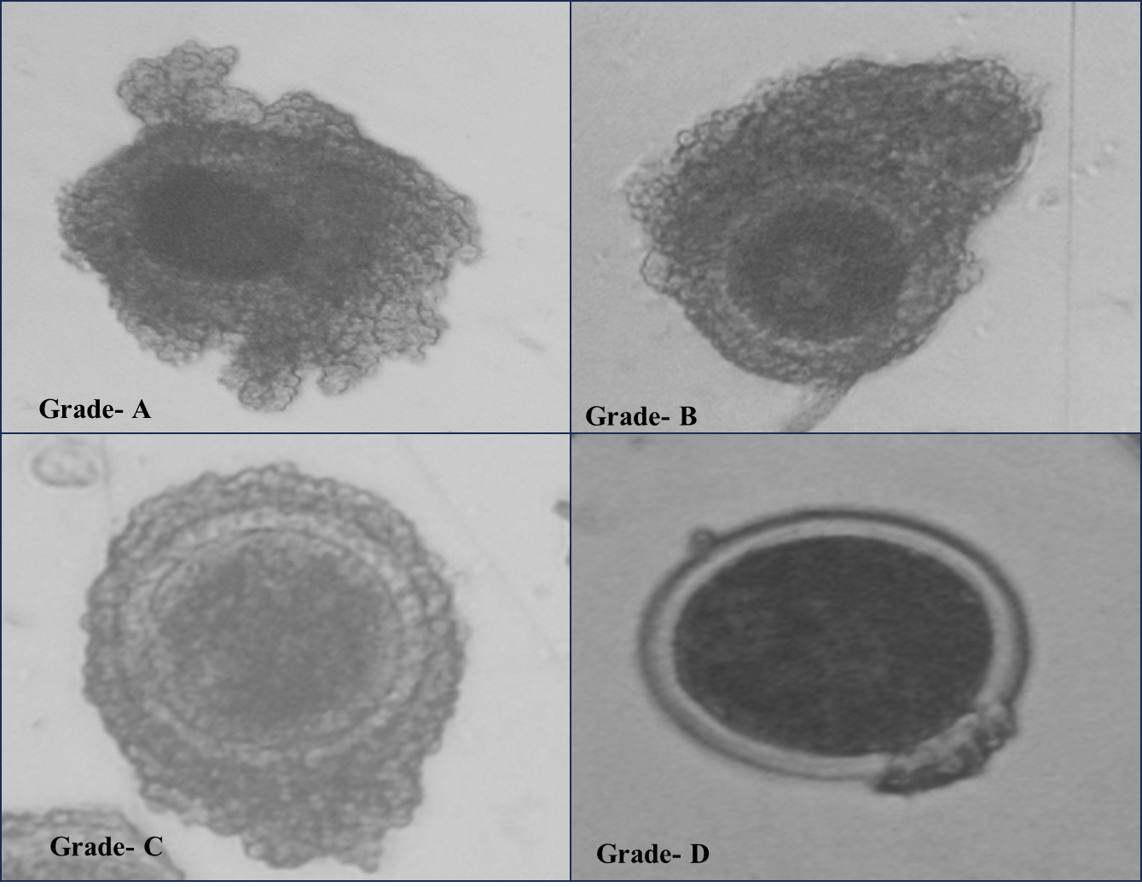

Fig. 4. Different grades of Cumulus oocyte complexes collected from Tharparkar cows

Fig. 5. Percentage recovered oocytes in Tharparkar cows
Discussion
Establishment of consistent ovum pick-up (OPU) operating parameters is critical for maintaining procedural stability and preserving oocyte structural integrity during follicular aspiration. In the present report, application of a defined procedural preset yielded an overall recovery rate of approximately 56%, with nearly 60% of recovered oocytes classified as morphologically acceptable (Grade A and B). These findings indicate stable follicular aspiration dynamics under the adopted technical conditions.
Mechanical determinants such as needle gauge and aspiration pressure directly influence recovery efficiency and cumulus preservation (Donadkar et al., 2024). The 18-gauge needle provided adequate lumen diameter for effective follicular evacuation while minimizing excessive turbulence within the aspiration system. During initial procedural refinement, aspiration pressures of 85–90 mmHg were associated with increased incidence of partially or fully denuded oocytes, whereas pressures of 70–80 mmHg resulted in reduced follicular evacuation efficiency and lower recovery rates. Based on these observations, an intermediate pressure range (80–85 mmHg) was selected for uniform application. This regulated vacuum pressure likely reduced shear stress during follicular collapse, thereby supporting preservation of cumulus compactness and cytoplasmic homogeneity. Controlled flow rate (~15 mL/min) further contributed to gradual follicular evacuation, minimizing abrupt pressure fluctuations that may compromise oocyte morphology. Maintenance of collection media at physiological temperature (38.5°C) supported cellular metabolic stability during handling.
Dominant follicle ablation (DFA) was incorporated prior to OPU to eliminate the suppressive endocrine influence of the dominant follicle. In bovine follicular wave dynamics, the dominant follicle secretes estradiol and inhibin, which exert negative feedback on circulating follicle-stimulating hormone (FSH). Declining FSH concentrations restrict subordinate follicle growth and predispose them to atresia. Ablation of the dominant follicle removes this inhibitory feedback, allowing a transient rise in FSH and synchronized recruitment of a new follicular wave. This increases the pool of medium-sized follicles available for aspiration (Saleem et al., 2020; Saleem et al., 2021; Sahu, 2025).
OPU in the present study was conducted between Day 4 and Day 7 following DFA. Acceptable recovery rates and morphological quality were observed within this interval under non-stimulated conditions in Tharparkar cows. However, no formal statistical comparison between individual post-DFA days was performed; therefore, the present findings should be interpreted as demonstrating procedural feasibility within this time window rather than optimization of a specific aspiration day.
Breed-specific reproductive characteristics must be considered when adapting OPU protocols to indigenous Bos indicus cattle. Historical genetic evaluation of Tharparkar cows documented variability in reproductive traits (Majumdar, 1969), and contemporary field studies have highlighted the influence of genetic and non-genetic factors on reproductive performance in this breed (Pilania et al., 2022; Choudhary et al., 2024). Structured reproductive and genetic improvement strategies have been emphasized for sustainable utilization of Tharparkar germplasm (Patel et al., 2024). Within this context, adaptation and validation of a reproducible OPU protocol tailored to Tharparkar cows contributes to strengthening applied reproductive infrastructure for breed-specific assisted reproductive programs.
Transvaginal OPU and assessment of oocyte developmental competence have previously been demonstrated in Tharparkar donor cows (Donadkar et al., 2024). The present report complements these findings by defining aspiration pressure range, needle specifications, flow dynamics, follicular selection criteria, and operational timing under non-stimulated conditions. Although no formal comparative evaluation among alternative parameter groups was conducted, the observed recovery rate and proportion of morphologically acceptable oocytes indicate that the adopted parameters provided consistent procedural outcomes in Tharparkar cows.
CONCLUSION
The defined ovum pick-up protocol applied in this study yielded consistent oocyte recovery and satisfactory morphological quality in Tharparkar cows under controlled experimental conditions. Application of an intermediate aspiration pressure range (80–85 mmHg), 18-gauge needle usage, regulated flow rate, synchronized follicular wave emergence through dominant follicle ablation, and maintenance of physiological handling conditions supported stable procedural outcomes. These findings demonstrate practical feasibility of a breed-adapted OPU protocol for Tharparkar cattle and may support assisted reproductive programs aimed at genetic conservation and improvement.

Ethical Approval
All experimental procedures were reviewed and approved by the Institutional Animal Ethics Committee (IAEC), ICAR–Indian Veterinary Research Institute (IVRI), Izatnagar (Approval No.: 26-3/2020-21/JD(R)/IAEC).

Disclaimer (Artificial intelligence)
Author(s) hereby declare that NO generative AI technologies such as Large Language Models (ChatGPT, COPILOT, etc.) and text-to-image generators have been used during the writing or editing of this manuscript.

References
Choudhary, G., Pannu, U., Gahlot, G. C., & Meena, S. (2019). Effect of Genetic and Non-Genetic Factors on First Lactation Production Traits in Tharparkar Cattle. Int. J. Curr. Microbiol. App. Sci, 8(2), 2160-2164.
Demetrio, D. G. B., Benedetti, E., Demetrio, C. G. B., Fonseca, J., Oliveira, M., Magalhaes, A., & Santos, R. M. D. (2020). How can we improve embryo production and pregnancy outcomes of Holstein embryos produced in vitro?(12 years of practical results at a California dairy farm). Animal reproduction, 17(3), e20200053.
Donadkar, M., Kumar, B., Singh, S. K., Chandra, P., Dangi, P., Gawai, M., Jackson, A., Jasrotia, N., Sharma, S., Chouhan, V., Patra, M. K., & Khan, M. H. (2024). Morpho-molecular evaluation for developmental competence of oocytes retrieved through transvaginal ovum pick-up from FSH-stimulated Tharparkar donor cows (Bos indicus). Zygote, 32(5), 376–385. https://doi.org/10.1017/S0967199424000376
Majumdar, S. C. (1969). Genetic studies on reproductive traits of Tharparkar cows (Master’s thesis). Magadh University, Bihar Veterinary College, Patna.
Patel, A. K., Patel, R. K., & Patil, N. V. (2024). Genetic Improvement of Tharparkar Cattle: A Review. Indian Journal of Animal Research, 58(3).
Pilania, S., Nehara, M., Pannu, U., Meena, R., & Choudhary, G. (2022). Production and reproduction performance of Tharparkar cattle in arid region of Rajasthan. Indian Journal of Dairy Science, 75(5). https://epubs.icar.org.in/index.php/IJDS/article/view/121556
Sahu, U. K. (2025). Uterine haemodynamics, follicular-luteal attributes and developmental competence of OPU-derived oocytes in subclinical endometritic dairy cows (Doctoral dissertation). Indian Veterinary Research Institute.
Sahu, U. K., Kumar, A., Kumar, B., Patra, M. K., & Khan, M. (2025). Early embryonic mortality in bovines: Current insights and interventions. Animal Reproduction Update, 5(2), 1–20. https://doi.org/10.48165/aru.2025.5.2.1
Sahu, U. K., Kumar, B., Khan, M. H., Warghat, C., Singh, M., Chauhan, V. S., … Singh, G. (2026a). Spectral Doppler assessment of middle uterine artery hemodynamics across the estrous cycle in Tharparkar cows. Frontiers in Animal Science, 7, 1740299. https://doi.org/10.3389/fanim.2026.1740299
Sahu, U. K., Kumar, P., Kumar, B., Khan, M. H., Baghel, M. S., Vadera, V., Kumar, M., Sahu, L., Kumar, A., Kharayat, N. S., & Priyadershi, A. (2026b). Transrectal Doppler characterization of uterine vascular dynamics in buffaloes with clinical metritis and subsequent recovery. International Journal of Bio-Resource and Stress Management, 17(1), 1–7. https://doi.org/10.23910/1.2026.6759
Saleem, M., Nawaz, M., Yaseen, M., Yousuf, M. R., Bajwa, A. G., & Riaz, A. (2021). Effect of clinical endometritis on follicle growth dynamics, oocyte recovery, oocyte quality, and in vitro developmental competence of oocytes using ovum pick-up in Sahiwal cattle. Reproduction, Fertility and Development, 33(2), 134. https://doi.org/10.1071/RDv33n2Ab54
Saleem, M., Sarwar, Z., Saad, M., Zahoor, I., Ahmad, N., & Riaz, A. (2020). Effect of clinical metritis on oocyte recovery, oocyte quality, and early in vitro developmental competence of embryos in Bos indicus dairy cattle. Reproduction, Fertility and Development, 32(2), 225. https://doi.org/10.1071/RDv32n2Ab193
Jose, B., Samad, H. A., Bharati, J., Tejaswi, V., Konda, P., Sharun, K., ... & Singh, G. (2022). Evaluation of thermo-adaptability between Tharparkar (Bos indicus) and crossbred (Bos indicus X Bos taurus) calves in a controlled environment. Journal of Thermal Biology, 110, 103381. https://doi.org/10.1016/j.jtherbio.2022.103381
Kaur, J., Singh, S., & Ukey, A. (2025). Scrotal thermography for evaluating temperature gradients and their association with semen quality and stress biomarkers of Karan Fries (Holstein Friesian× Tharparkar) and Tharparkar bulls under tropical climatic conditions. Biological Rhythm Research, 1-25. https://doi.org/10.1080/09291016.2025.2563869
Iqbal, N., Liu, X., Yang, T., Huang, Z., Hanif, Q., Asif, M., ... & Mansoor, S. (2019). Genomic variants identified from whole-genome resequencing of indicine cattle breeds from Pakistan. PLoS One, 14(4), e0215065. https://doi.org/10.1371/journal.pone.0215065

