Comparative study of the agronomic characteristics of four maize varieties (Zea mays L.) in Daloa, Côte d’Ivoire

ABSTRACT
Maize (Zea mays L.), an annual herbaceous plant of tropical origin belonging to the Poaceae family, is a cereal of major importance. It is used in both human and animal nutrition and as a raw material for a rapidly expanding agro-industry. However, its production remains low, mainly due to the effects of climate change, soil depletion and post-harvest losses. Yields can be improved by selecting more productive varieties. It is with this in mind that the present study was conducted to evaluate the agronomic behaviour of different maize varieties. A Fisher experimental design comprising four blocks was used, each subdivided into four sub-blocks representing the varieties studied. The results obtained revealed that all four varieties tested had a germination rate of over 97%. The kabamanoj variety recorded the highest germination rate (99.23%). However, differences were observed between the varieties in terms of growth, flowering and production parameters.
Keywords: Comparative study, characteristics, agronomic, varieties

- INTRODUCTION
At the heart of agricultural development strategies and the fight for food security in West Africa, the maize sector plays a key role. Once a subsistence crop, maize is now at the heart of major economic issues in Côte d’Ivoire, stimulating an intensification of its production. Indeed, it is used in human and animal food, but also serves as a raw material in the rapidly expanding agro-industrial sector (Kone, 2022). national production, which has exceeded one million tonnes in recent years, illustrates this dynamic. It has risen from 1.025.000 tonnes in 2017 to around 1.2 million tonnes in 2023 (fao, 2023). However, this growth masks structural weaknesses that continue to hamper the sector’s performance (Tshiabukole, 2018). These include limited access to quality inputs, sometimes inappropriate farming practices, but above all, heavy dependence on local varieties with low yield potential, which remain the most frequently cited issues in the literature (Kone, 2022). Added to this is climate uncertainty, with water stress being the most feared manifestation for a crop as sensitive as maize (Doh, 2024). Beyond the challenge of production lies the equally crucial challenge of conservation. Post-harvest losses, estimated at over 30%, pose a direct threat to household food security (Sossou et al., 2023). These losses often begin at harvest time, due to the intrinsic characteristics of the grains (high moisture content), which make them vulnerable to attacks by insect pests and the development of mould (Sankara et al., 2017). Faced with these constraints, improving productivity and reducing losses inevitably requires the adoption of more efficient plant material (Cirad, 2019). research efforts, particularly those carried out by the national agricultural research centre (cnra), have led to the development of improved varieties that are more productive and better suited to local conditions. the choice of variety by the farmer then becomes a strategic decision, which must take into account not only yield potential, but also grain quality and its ability to resist damage before and during storage. It is with this aim of finding alternative solutions in mind that this study was initiated. It aims to determine the agronomic behaviour of each variety of maize.
2-MATERIALS AND METHODS
2.1- STUDY SITE
The trial was conducted at the experimental site of Jean Lorougnon Guédé University in Daloa. Located approximately 340 km from Abidjan, Daloa, the capital of the Haut-Sassandra region in central-western Côte d'Ivoire, covers an area of 5,423 km² (Kouamé et al., 2020). This area is dominated by ferralitic soils typical of the region. This plot was chosen because it was fallow land with a flat, uniform topography and a soil texture free of visible coarse elements, ensuring uniform growing conditions for all the varieties tested (Ayolié et al., 2021).
2.2- PLANT MATERIAL
The plant material used in this study consists of plants grown from seeds of four maize varieties: F1Vn10, KABAMANOJ, LG336 and EV8728 (Figure 1).
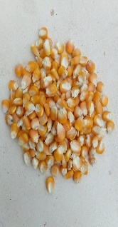
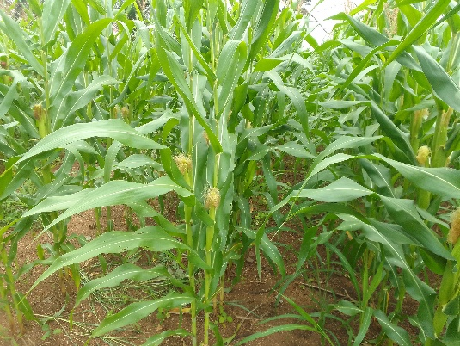
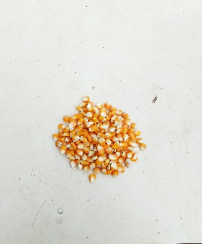
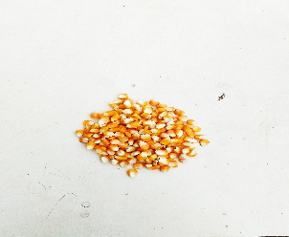
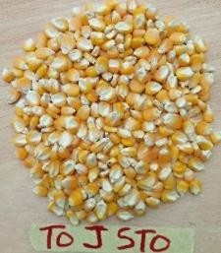
a
b
c
d

Figure 1 : Plant material
a : F1Vn10 ; b : KABAMANOJ ; c : LG336 ; d : EV8728
2.3- METHODS
2.3.1- EXPERIMENTAL SETUP AND CULTIVATION PRACTICES
The experiment was conducted using a Fisher block design, consisting of four randomised blocks spaced 2 m apart. The distribution of varieties within the blocks was carried out using CropStat v7.2 software. Each block was subdivided into four subplots spaced 1 m apart, each representing one variety. Each variety was assigned to five rows spaced 0.8 m apart within the subplot. Twenty-six holes spaced 0.4 m apart were dug in each row. The total area of the plot was 836 m², or 180 m² per block.
2.3.2- TEST SETUP AND EXECUTION
The preparation of the plot began with clearing the area. Stakes were then driven into the ground to mark out the plot according to the chosen layout. Holes were dug along the marked lines (Figure 2). Sowing consisted of placing three seeds per hole, at a depth of 2 to 3 cm. Two weeks later, thinning was carried out to keep only the two strongest plants per hole. The plot and its surroundings were maintained by regular manual weeding and constant weed control.
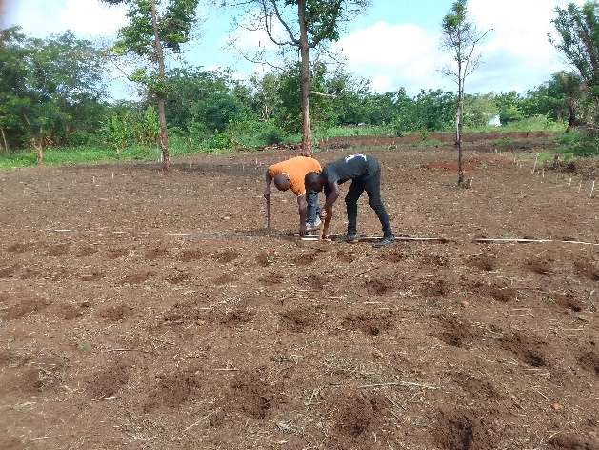

Figure 2: Setting up the plot and preparing the sowing points
2.4- DATA COLLECTION
The measurements were taken on a sample of 20 plants per variety selected at random in each block, giving a total of 80 plants per variety across the entire plot. The data covered 18 parameters chosen from among the maize descriptors (IPGRI, 1991). The germination parameters included the germination percentage (GP) and the germination rate of the grains. Growth variables included plant collar diameter (CD), plant height (PH), ear insertion height (EIH), plant leaf area (SLA) and ear insertion index (EII).
The variables relating to flowering in the four varieties studied concerned the time to ear emergence (TEE), the time to silking (TS), the time to panicle emergence (TPE), and the time to pollen emergence (TPoE). The production variables included the diameter of the ear without spathes (DEWS), the length of the ear without spathe (LEWS), the average number of grains per ear (NGear), the average weight of grains per ear (MGear), the weight of 1000 grains (W1000 gr) and the weight of the ear without spathe (WEWS).
2.5- METHODS OF STATISTICAL DATA ANALYSIS
The data collected in the field were organised in a Microsoft Excel 2021 workbook and analysed using SPSS software, version 22.0. A one-way analysis of variance (ANOVA) was used to compare the means of the quantitative traits studied. The Student-Newman-Keuls test was used post-ANOVA, at a 5% threshold, to classify the different varieties according to the chosen parameter.

3- RESULTS AND DISCUSSION
3.1- Percentage and average germination rate
The evaluation of the germination capacity of the four maize varieties studied revealed significant differences during their development. The F1Vn10, KABAMANOJ and LG336 varieties had a germination time of between 4 and 7 days (Figure 1), with germination percentages of 97.5%, 99.23% and 97.69% respectively (Table 1). The EV8728 variety had an early germination time ranging from 3 to 6 days and a germination percentage of 98.84%. The differences observed in the expression of germination capacity between the different varieties could be explained by a genetic effect showing the diversity existing within the varieties studied. This effect of genotypic variation was also highlighted by Oluwaranti et al. (2020) when evaluating the physiological quality of seeds and the agronomic performance of maize. In their view, seed germination under field conditions is closely linked to the genetic potential of the varieties. Similarly, Colombo et al. (2023) emphasised that the differences in germination observed between varieties are mainly due to the influence of genotype. This difference is therefore regulated by both the synergy of genetic traits and environmental factors during the vegetative phase of the seeds.
Table 1: Average percentage of germination
Varieties GP (%)
F1Vn10 | 97.5
KABAMANOJ | 99.23
LG336 | 97.69
EV8728 | 98.84
GP : germination percentage
Germination percentage (%)
(%)
Corn varieties
Figure 3 : Variation in the germination rate of maize varieties over time
3.2- Evaluation of growth parameters of maize varieties
Statistical analysis of the growth variables presented in Table 2 reveals significant differences (P < 0.05) between the maize varieties studied. The EV8728 variety recorded the highest values for collar diameter (22.50 mm), plant height (188.88 cm), ear insertion height (91.23 cm) and ear insertion index (0.53). In contrast, the F1Vn10 variety had the largest leaf area (652.97 cm²). However, the lowest average values were observed with the KABAMANOJ variety for all the parameters studied. These results reflect morphological heterodiversity between the varieties studied. This diversity could be attributed to the intrinsic variability of the genetic resources specific to each variety, as well as their ability to adapt to the environmental conditions of cultivation. According to Mtyobile (2021), the evaluation of the agronomic performance of maize cultivars in semi-arid environments showed that agro-morphological characteristics differed significantly. This demonstrates the genotypic diversity of these maize cultivars. Similarly, Sabrie et al. (2014) observed that variation in stalk height and diameter in maize subjected to water stress at different stages of growth results from the extent of genetic diversity within the genotypes studied. Tucker (2020) also emphasises that this diversity of growth lies in the interaction between the wide range of possible germplasm that contributes to the modification of plants in response to the multiple potential environmental conditions in which they express themselves.
Table 2: Comparison of varieties based on growth parameters
Variétés | CD (mm) | PH (cm) | EIH (cm) | SLA (cm²) | EII
F1Vn10 | 20,30±3,67ª | 181,21±8,87^{b} | 98,94±11,63^{ab} | 652,97±94,55^{c} | 0,54±0,06^{ab}
KABAMANOJ | 19,34±2,50ª | 170,64±15,23ª | 91,23±17,60ª | 555,84±87,98ª | 0,53±0,10ª
LG336 | 20,22±2,61ª | 179,46±16,37^{b} | 98,01±13,23^{ab} | 607,24±84,50^{b} | 0,54±0,12^{ab}
EV8728 | 22,50±2,48^{b} | 188,88±12,14^{c} | 114,03±13,05^{b} | 611,44±13369^{b} | 0,60±0,08^{c}
F | 17,75 | 24,71 | 32,12 | 12,15 | 10,45
P | 0,001 | 0,001 | 0,001 | 0,001 | 0,001
Within the same column, means marked with the same letter are not statistically significantly different at the 5% probability level, according to the Student-Newman-Keuls test. P: approximate probability of the tests; F: Fischer's constancy; CD: diameter at the collar; PH: plant height; EIH: ear insertion height; SLA: leaf area; EII: ear insertion index.
3.3- Characterisation of flowering parameters of maize varieties as a function of time
The results of the data analysis presented in Table 3 reveal highly significant differences (p < .05) between maize varieties for all flowering parameters studied, namely ear emergence date, silk emergence time, tassel emergence time and pollen emergence time. The female flowering time (silk emergence) varies between 55 and 60 days after sowing. The F1Vn10 variety flowered later (60 days), while the EV8728 variety flowered earlier (55 days). In terms of male flowering (pollen emergence), the period varies from 54 to 58 days after sowing. The F1Vn10 variety flowered later than the other varieties (58 days) after sowing. However, the earliest variety was EV8728 (54 days) after sowing. Regarding the appearance of the ear and panicle, the F1Vn10 variety also had the longest delays (57 days for the ear and 54 days for the panicle), unlike the EV8728 variety, which had the earliest appearance of the ear (52 days) and panicle (51 days) among the varieties studied. These differences in flowering observed between varieties could be explained by both agroecological factors, such as temperature, rainfall and isolation, and by the genetic characteristics of each variety. Global climate change, marked in particular by more intense heat waves, poses a major threat to flowering stages and, consequently, to agricultural productivity (Ahmed et al., 2022; Shao et al., 2021). Maize cultivation requires optimal temperature conditions to ensure good yields. Extreme temperatures (high and low) during the ear formation or flowering stage can disrupt the physiological processes involved in the emergence of floral organs. Such conditions can either slow down or accelerate the emergence of reproductive organs, depending on the variety (Waqas et al., 2021). The work of Wang et al. (2022) on the effect of heat stress around flowering has also highlighted shifts in the flowering of the ear, silk and pollen in maize.

Table 3 : Comparison of varieties based on phenological parameters
Variétés | TEE (days) | TS (days) | TPE (days) | TPoE (jrs)
F1Vn10 | 57±0,56^{d} | 60,3±0,73^{c} | 54,85±1,42^{c} | 58,15±0,67^{c}
KABAMANOJ | 53,1±1,02^{b} | 56,2±0,84ª | 51,95±0,68ª | 54,85±1,18ª
LG336 | 54,45±0,88^{c} | 57,05±0,60^{b} | 52,9±0,91^{b} | 56,3±0,73^{b}
EV8728 | 52±0,85ª | 55,95±0,94ª | 51,25±1,55ª | 54,6±1,46ª
F | 128,974 | 124,072 | 34,019 | 47,033
P | 0,001 | 0,001 | 0,001 | 0,001
In the same column, averages marked with the same letter do not show a statistically significant difference at the 5% probability threshold, according to the Student-Newman-Keuls test. P: Approximate probability of the tests; F: Fischer's constancy; TEE: date of emergence of the ear; TS: date of emergence of the silk; TPE: date of emergence of the panicle; TPoE: date of emergence of pollen
3.4- Characterisation of production parameters for maize varieties
The results of the data analysis recorded in Table 4 reveal that production parameters such as the diameter of the ear without spathe (DEWS), length of the ear without spathe (LEWS), grain mass per ear (GMear), 1000-grain weight (M1000 gr) and ear weight without husk (EWWS) showed highly significant differences (p ˂ 0.05) between the maize varieties studied. However, no significant differences were observed for the number of grains per ear (NGépi). Indeed, the KABAMANOJ variety proved to be more productive, recording the highest averages for cob diameter without spathe (50.20 mm), cob length without spathe (19.55 cm), grain weight per cob (193.27 g), weight of 1000 grains (469.14 g) and weight of ear without spathe (315 g). On the other hand, low average values were observed in the EV8728 variety for cob length without husk (17.62 cm), grain weight per cob (159.38 g), weight of 1,000 grains (372.37 g) and cob weight without husk (186.61 g). However, the lowest value for cob diameter without a spathe (41.63 mm) was recorded for the LG336 variety.
These results could be explained by better expression of the genetic traits of the KABAMANOJ variety, promoting more efficient assimilation and redistribution of assimilates to the storage organs. Similar results were reported by Makumbi et al. (2015) on the same variety. According to these authors, ear size and diameter are key indicators of maize productivity, as they reflect the filling capacity of the grains and the physiological vigour of the plant. It should also be noted that a short period of drought was observed during the ripening phase, which explains the poor performance of certain varieties, notably EV8728. These observations corroborate those of Moussa et al. (2018), who, in evaluating the agronomic performance of maize varieties in southern Niger, reported low yields for certain varieties. According to them, these results can be explained by the long period of drought experienced during their trial, which had negative effects on the production potential of the varieties.

Table 4: Comparison of varieties based on production parameters
Varieties | DEWS (mm) | LEWS (cm) | NGear | MGear (g) | W1000 gr (g) | WEWS (g)
F1Vn10 | 44,16±1,02^{b} | 17,84±0,64ª | 475,13±37,80ª | 182,89±2,69^{c} | 389,82±10,99^{b} | 208,43±3,97^{b}
KABAMANOJ | 50,20±1^{c} | 19,55±085^{c} | 485,6±27,45ª | 193,27±5,99^{d} | 469,14±9,52^{c} | 315±3,74^{d}
LG336 | 41,63±2,49ª | 18,11±0,88^{ab} | 493,93±73,65ª | 170,11±4,26^{b} | 378,34±12,66ª | 239,65±26,86^{c}
EV8728 | 50,41±1,07^{c} | 17,62±0,73ª | 479,6±140,51ª | 159,38±5,11ª | 372,37±11,24ª | 186,61±4,39ª
F | 123,90 | 3,97 | 0,15 | 150,12 | 244,62 | 245,15
P | 0,00 | 0,012 | 0,932 | 0,001 | 0,001 | 0,001
In the same column, averages marked with the same letter do not differ significantly at the 5% probability level, according to the Student-Newman-Keuls test. P: Approximate probability of tests; F: Fischer's constancy; DEWS: diameter of the ear without spathe; LEWS: length of the ear without spathe; NGear: number of grains per ear; MGear: mass of grains per ear; W1000 gr: weight of 1000 grains; WEWS: weight of the ear without spathe.

5- CONCLUSION
The objective of this study was to evaluate the agronomic behaviour of different maize varieties in the pre-storage phase in Côte d'Ivoire. The results showed that all four varieties tested had a good germination rate. However, differences were observed between varieties in terms of growth, flowering and production parameters.
Competing interests
The authors declare that they have no conflicts of interest.
DISCLAIMER (ARTIFICIAL INTELLIGENCE)
The author hereby declares that generative artificial intelligence (AI) technologies were used during the writing. However, they were used solely for translating the text into English.
REFERENCES
- Ahmed Z., Khalid M., Ghafoor A., ​​Shah M.K.N., Raja G.K., Rana R.M., Mahmood T. & Thompson A.M. (2022). SNP-Based Genome-Wide Association Mapping of Pollen Viability Under Heat Stress in Tropical Zea mays L. Inbred Lines. Journal Frontiers in Genetics, 13 : 9p.
- Ayolié K., Gogbeu S.J., Tonessia D.C., Kouassi N.J., Obo A.C X., Yapo S.E.S & Yatty K.J. (2021). Study of the Agronomic Quality of Some Ecotypes of Snowdrop (Vigna unguiculata) (1.) walp. (Fabaceae) collected in Ivory Coast. Africa Science, 12 (5) : 78-88
- CIRAD, (2019). A study of post-harvest loss reduction modalities in marachery crops in Côte d'Ivoire. PS n°010/FIRCA/DCARA/PRO2M/2018. EXPERTISE REPORT March 2019
- Colombo F., Pagano A., Sangiorgio S., Macovei A., Balestrazzi A., Aranti F. & Pilu R. (2023). Study of Seed Aging in lpa1-1 Maize Mutant and Two Possible Approaches to Restore Seed Germination. International Journal of Molecular Sciences, 24(1): 20-25.
- Doh G., G., C., (2024). Potential Climate Risks of Maize Cultivation and Food Security in the Poro Region of Northern Ivory Coast, University Felix Houphouët-Boigny, Abidjan-Ivory Coast, Zaouli Special No. December 2024 pp. 2024-2014. 307–334
- There. (2023). Statistics from the United Nations Food Fund, available at http://www.fao.org/., accessed 25/09/ 2025.
- IPGRI (1991). Descriptors for corn. CIMMYT/IBPGR, Rome, Italy, 88 p.
- Koné I. (2022). Physiological and biochemical characterizations of four novel lines (S116, S138, S143, S148) of red maize (Zea maize L.) in Daloa, Ivory Coast. Master's thesis in Bioresources-Agronomy, UFR Agroforestry, University of Jean Lorougnon Guédé Daloa, Côte d'Ivoire, 50p.
- Kouamé Y., Konan A., Kouassi K. & Koffi G. (2020). Street food and health risks in Daloa (Ivory Coast). Spanish Review, Territory, Society and Health, 3(5) : 25-40.
- Clouds, D., Betrán, F. J., Bänziger, M., & Ribaut, J. M. (2015). Combining ability, heterosis and genetic diversity in tropical maize (Zea mays L.) under stress and non-stress conditions. Euphytica, 180(2), 143–162.
- Mohammadi, S. A., & Prasanna, B. M. (2003). Analysis of genetic diversity in crop plants-salient statistical tools and considerations. Crop Science, 43(4), 1235-1248.
- Moussa A.A., Salako V.K., Gbemavo D.S.J., Zaman-Allah M., Kakaï R.G. & Bacasso Y. (2018). Agro-morphological performances of local and improved varieties of maize in South-West Niger. African Crop Science Journal, 26 (2): 157-173.
- Mtyobile M. (2021). Evaluation of the yield performance of maize cultivars (Zea mays L.) in à Semi Arid Region of the Eastern Cape Province, South Africa. International Journal of Agricultural Science and Food Technology, 7(3) : 327-330.
- [ PMC free article ] [ PubMed ] [ Cross Ref ] 14. A., A. E. & Amuda I.A. (2020). Genotypic Variation for Seed Physiological Quality and Agronomic Performance of Quality Protein Maize Genotypes. Nigerian Journal of Seed Science, 4(2): 53 - 65 .
- Sankara F., Sanou A. G., Waongo A., Somda M., PatriceOrtei, Somda I. (2017). Post-harvest farmer practice of maize in the Highlands of Burkina Faso, Journal of Animal and Plant Sciences, 33(1) : 5274-5288.
- Shao R-x., Yu K-k., Li H-w., Jla S-j., Yang Q-h., Zhao X., Zhao Y-l. & Liu T-X. (2021). The effect of elevating temperature on the growth and development of reproductive organs and yield of summer maize. Journal of Integrative Agriculture, 20(7): 1783-1795.
- Sossou C. H., Ayedoun O. A. A., Dossouhoui S., Missimahou D., Noukpozounkou, Sossou R., Koffi J. P., Dansou V. & Houssou P.A. (2023). Assessment of postharvest losses in maize field: The case of maillon production in Benin, International Journal of Biological and Chemical Sciences, 17(4): 1392-1403.
- Thanksgiving J.P.K. (2018). Assessment of water stress sensitivity of maize (Zea maize L.) grown in the Southwestern Savannah of DR Congo, Mvuazi case. Thesis of
- Tucker S.L., Dohleman F.G., Grapov D., Flagel L., Yang S., Kimberly M., Wegener K.M., Kosola K., Swarup S., Rapp R.A., Bedair M., Halls S.C., Glenn K.C., Hall M.A., Allen E.A. (2014). Evaluating maize phenotypic variance, heritability, and yield relationships at multiple biological scales across agronomically relevant environments. Plant Cell Environ, 43 :880-902.
- Wang N., Liu Q., Ming B., Shang W., Zhao X., Wang X., Wang J., Zhang J., Luo Z. & Liao Y. (2022). Impacts of Heat Stress around Flowering on Growth and Development Dynamic of Maize (Zea mays L.) Ear and Yield Formation. Plants, 11(24): 1-14.
- Waqas M.A., Wang X., Zafar S.A., Noor M.A., Hussain H.A., Nawaz M.A. & Farooq M. (2021). Thermal Stresses in Maize: Effects and Management Strategies. Plants, 10(2): 1-23.

