Development and Performance Evaluation of Cassava Chip Dryer
ABSTRACT
Over the years, the traditional method of cassava chips production by sun drying which exposes the product to various contaminations and post-harvest losses is usually employed by local farmers. Therefore, this research designed and fabricated a cassava chip dryer that can produce contamination-free cassava chips at higher efficiency and less drying time compare to local sun drying method. The study developed a cassava drying machine using locally available material for small scale industries. The machine was designed using an electric element as a heat source while it was encased in a L- shaped frame with dimensions 450 × 650 × 650 mm. The machine consists of an upper chamber, lower chamber, support frame, drying trays, pulley, bearing and V-belt. An electric motor of 1 horse power was mounted on the dryer to supply electric power to the blower in order to blow the hot air generated by the heating coil in the lower chamber to the trays at the upper chamber to dry the cassava chip The temperature controller device was installed on the side of the dryer to regulate heat from heating element based on the signal received from the sensor and maintain uniform heat distribution among all the trays. The results from the experiment showed that at no load, the drying rate was maintained at 70 $℃$ at the total time trials of 200 minutes. At loading, the drying rate was maintained at 70 $℃$ at the total time trials of 240 minutes. There is a great improvement in drying cassava chip using the machine with a drying time of 1,800 minutes and 80 % efficiency compared to the sun drying method. Also, the percentage moisture content reduced from 65.02 % to 13.10 % at the drying time of 240 minutes. The cost evaluation shows that the cassava chips that were developed was affordable.
Keywords: Cassava chips, Dryer, Drying time, Moisture content, Efficiency
1. Introduction
Cassava is a root crop, and a single specie plant which belongs to the family of Euphorbicease and it is the most important root crop in the tropics. (Liberty and Dzivama, 2013). Cassava (Manihot Esculenta Crantz) is a root tuber crop which originally originated from South America and widely grown in Africa today. Cassava serves as an important staple crop in Sub – Saharan Africa (Ogunyinka and Oguntuase, 2020). Due to the previous information, cassava was introduced into Nigeria more than 300 years ago. Its cultivation was generally accepted and then practiced towards the late 1890s. Cassava was, therefore, an important economic crop which is cultivated in many tropical countries, such as Thailand, India, Brazil, and other West African Countries including Nigeria which presently become ranked as the number one producer in the world (Okunola, 2002)
Nigeria has therefore maintained its production as the world largest producer of cassava, accounting for about 35% of the production output of the world generally and then the Africa respectively. As from then, production has become increased only by 33%, while the area that is under production figure for Nigeria has then risen to about 38 million tones in 2005 (FAO, 2006). As a result of this, the increase in cassava processing was shown to contribute to sustained growth in the area of Cassava production in Nigeria (Ugwu and Ukpai, 2002).
In Southern Nigeria, it was reported that cassava has contributed about 70% of the total requirement for over 50 % of the production. This is then utilized a s food for humans in the processed form, such as fufu, lafun, garri while some sweet (Low cyanide).Ghana has been included among high cassava exporting countries (FAOSTAT, 2019).
Cassava is often found in mixed stands together with a variety of other foods or cash crops. Cassava becomes a key food security staple since its introduction into Africa in the 16th century, particularly in sub-Saharan Africa. In addition, its metabolic efficiency, reliable production, functional properties, and general quality of cassava starch have made it the second most important source of starch worldwide (El - sharkawy, 1995). The largest producer of cassava, area wise, is Nigeria (about 26 % of total planting). Farmers readily adopt the available technologies (improved varieties and cultural practices) when they have certainty on the income they will obtain from the crop.
The quick deterioration of the Cassava roots is due to internal heat generated from high respiration rate of the tissues. (Ikujenlola and Opawale, 2017) and subsequently infected and rotated by microbes. In order to reduce post-harvest losses, cassava roots need to be processed 24 hours after harvest owing to its short shelf-life (Abong et al., 2016). Consequently, Nigeria did not only connect to her increasing demand as food item, but also as food security (.FAO, 2018).Cassava as a chip can be used in ethanol production and animal feed formulation (Ashaye et al,2005).
The woody plant known as cassava (Manihot esculenta) normally contains an edible root and lasts for two or three seasons. It is found in tropical and subtropical regions of the world, which are inaccessible to crops like sweet potatoes, sorghum, and maize (Kando and Bitane, 2023). In tropical Africa, cassava is a staple crop that is rich in critical minerals, glucose, calcium, and vitamins B and C (Bayata, 2019). However, the various forms, climate, environmental factors during production, crop longevity, and soil condition all affect the nutritional content (Bayata, 2019). The primary purpose of cassava is as a food crop for sustenance. Cock and Connor (2021) claim that cassava requires little work and grows well in poor soils. Because it grows underground, invaders find it difficult to destroy or exhume crops, providing food security during conflicts (Cock and Connor, 2021).
Vegetables, plantation crops including coconut, oil palm, coffee, yam, sweet potato, peanuts, or other legumes can all be planted alongside cassava (Cock and Connor, 2021). In addition to its use as food, cassava is a versatile crop that can be used to make a wide range of food products, including textiles, glues, monosodium glutamate, paper, plywood, confections, biodegradable goods, and medications (Cock and Connor, 2021). Additionally, cassava chips and pellets can be used to make alcohol and make animal feed (Thongmee, 2023).
Garri, lafun, and fufu are some of the different ways that cassava can be prepared (Fawole and Kolapo, 2022). Additionally, cassava can be used to produce industrially valuable derivatives such as adhesives, chips, flour, pellets, and starch. These products are used as raw materials in the culinary, soft drink, textile, confectionery, wood, livestock feed, and alcohol/ethanol industries (Fawole and Kolapo, 2022). According to Shimpy et al. (2023), cassava chips are pieces of dried, uneven slices of cassava that vary in size but don't go beyond 5 or 6 cm in length. Chipping cassava roots reduces their size, which speeds up the drying process and guarantees that the cyanide components found in fresh cassava roots are effectively removed (Nzuta et al., 2022). Chipping cassava roots can be done by hand, with a knife, or with a machine; these machines often come with a revolving disc that has holes in it with a cutting edge or with interchangeable corrugated blades (Nzuta et al., 2022).
When assessing and controlling the shelf life of food goods, water activity is an essential instrument (Labuza and Altunakar, 2020; Wang et al., 2024). According to Lohita and Srijaya (2024), a product's shelf life is the length of time it will remain safe, maintain its intended sensory, chemical, physical, and microbiological attributes, and stay true to its nutritional labeling. As water activity increases, the sensory crispness of dry starch and many cereal-based goods decreases. Shelf life is influenced by a variety of factors, such as oxygen concentration, pH, the use of preservatives, processing and storage conditions, redox potential, and water activity (Olufayo and Ogunkunle, 1996; Hawa et al., 2020). Food deterioration and microbial infection may be predicted, chemical stability can be preserved, and spontaneous autocatalytic lipid oxidation events and nonenzymatic browning reactions can be reduced by measuring and controlling food's water activity experimentally. Moreover, Olufayo and Ogunkunle (1996) and Hawa et al. (2020) have shown that it is possible to control enzyme activity, maintain nutrients and vitamins in food, and maximize the physical qualities of food.
Ajala and Ngody (2020) state that postharvest physiological deterioration occurs in cassava plants, which has the drawback of minimizing the drying, size, and moisture content reduction of cassava chips. According to research by Fadeyibi and Alaba (2020) and Dos Santos Cotta et al. (2023), data from moisture sorption isotherms is essential for resolving issues with cassava and its byproducts deteriorating. According to Ajala and Ngody (2020), this includes figuring out the necessary packaging, maintaining the chips' physical and microbiological stability, optimizing their nutritional qualities, and allowing them to be processed further.
Adegbite et al. (2025) developed a biomass-powered cabinet dryer designed to produce high quality cassava flour, featuring a heat exchanger, blower, and drying chamber constructed from locally sourced materials. The drying chamber contains two racks, each equipped with 10 trays, accommodating 40 to 80 kg of wet cassava mash per batch. The dryer, operating at temperatures between 50 and 115 ◦C for a duration of 10–120 minutes, decreased moisture content from 38.21% to around 11%.
The present study focused on the development of a cassava chip dryer that can produce cassava chips at higher efficiency and less drying time compare to local sun drying method.
2. MATERIALS AND METHODS
2.1 Material Selection
Some materials were fabricated while some were purchased. The components that were incorporated together in this constructed dryer as well as materials selected were used based on their advantages over the other. Henceforth, the following materials were selected:
- Gauge 18 metal sheet was used to construct the frame
- Stainless steel material was used to construct the frame internally to ensure good quality of the products.
- Angle iron high speed steel was used to provide support for the whole assembly.
- Fiber glass was used as lagging material owing to its ability to conserve heat.
- Temperature controller device was coupled to this dryer in order to regulate the drying temperature.

2.2 Estimation of the Power Requirements of the Machine

2.2.1 Design Calculation of the length of belt
Total length of the belt is
${½(D}_{2}∅_{2}+ D_{1}∅_{1})+ ½[4C^{2}D-(D_{2}-D_{1})^{2}]^{1/2}$
= ½ (150 x 3.54 + 50 x 2.74) + [4 x (250)² – (150 – 50)²] ½
= 334 + 490 = 823.89 mm
Therefore, the nearest standard belt chosen is 900 mm.
2.2.2 Estimating the power to drive the shaft with blower
The power required to drive the shaft with blower is given by
P = (T₁₋T_{C} )(1-1/e^{uα/sin 1/2𝞱} )V
Where a = angle of wrap = 2.74 rad, 0 = groove angle = 40°
P = p = (192.75) (0.96) (3.8)
P = 703.15 watt = 0.703 kw
Power required in h.p = $\frac{0.703}{0.746}$= 0. 942 h.p
The electric motor selected for the project has a rating of 1h.p. This allowance is given to make for effective performance of the blower during the heating process.
2.3 Determination of Area, Thickness and Length of Cassava Chips
2.3.1 Determination of Parameters
The area of cassava chips was determined by picking five chips at random from the sample. Their length, thickness and the width were measured and their average value calculated
2.3.2 Determination of average width, thickness and length of cassava chip
Width of five cassava chips by measurement are 9 mm, 10 mm,11 mm,12 mm and 8 mm.
Thickness of five chips by measurement are 4 mm, 6 mm,5 mm,4 mm and 6 mm
Length of five cassava chips by measurement are 45 mm, 50 mm,55 mm,52 mm and 48 mm
Average width = 10 mm, Average thickness = 5 mm, Average length = 50 mm
From the above,
A = L × W
A = 50 × 10
A = 500 mm²
It was assumed that the total number of chips in the dryer will be 300.It then means that the area of each tray is
AT = 500 × 300
AT = 150,000 mm²
AT₁ + AT₂ = 150000 × 2 = 300,000 mm²
The volume of a chip can be calculated by multiplying the area of a chip by its thickness.
Volume of chip can be found by using the below formula;
Volume of Chip = 500 × 5
Volume of Chip = 2,500 mm³
Total Volume of chips, V_{T} = Volume of chips × no of chip
= 2,500 × 300
V_{T} = 750,000 mm³
2.3.3 Design of the Dryer Capacity
Weights of five chips by weighing using beam balance were determined to be 0.021 kg, 0.020 kg, 0.018 kg, 0.022 kg and 0.019 kg respectively. Average weight of five chips were now calculated and determined to be 0.020 kg.
From above, average weight of one chip is 0.020 kg, if the tray will accommodate 300 chips, then,
Dryer Capacity = mass of chips × No of chips = 0.020 × 300 = 6 kg.
Henceforth, the mass of cassava chips to be dried on each tray will be 6 kg at 65 % moisture content on wet basis for the purpose of design
2.3.4 Drying Time (T)
The drying time can be estimated using the below formula
T = $w\left(\frac{m_{1- m_{2}}}{\frac{dw}{dθ}}\right)$ (Liberty and Dzivama, 2013)
W can then be calculated as
W =$M(1-M_{c1})$ where M is the mass of chips to be dried and Mc₁ is the initial moisture content.
W = $6 [1-0.65]$= $2.1 kg$
M₁ = $\frac{0.65}{1-0.65}$ = 1.86 kg

M₂ = $\frac{0.13}{1-0.13}$ = 0.15 kg
M_{c} = kg A (H₂- H_{a}) where kg is the mass transfer coefficient in (kg/m²s); A is the area of drying screen (m²), H₂ is saturated humidity; H_{a} is air humidity and M_{C} is the rate of evaporation or mass transfer. Kg = 0.083 kJ/m²s, A = 0.81, H₂ = 0.021 h_{a} = 0.017
M_{C} = 2.69 × 10⁻⁴ kg/s
T = $w\left(\frac{M_{1- M_{2}}}{\frac{dw}{dθ}}\right)$

T = 2.1 $\left(\frac{1.86-0.15}{2.69 × {10}^{-4}}\right)$ = 13349.442 sec = 3.70 hrs.
2.4 DETAIL DRAWING OF THE CASSAVA CHIP DRYER
The isometric drawing and sectional view of the cassava chip dryer are shown in Figures 1 and 2.
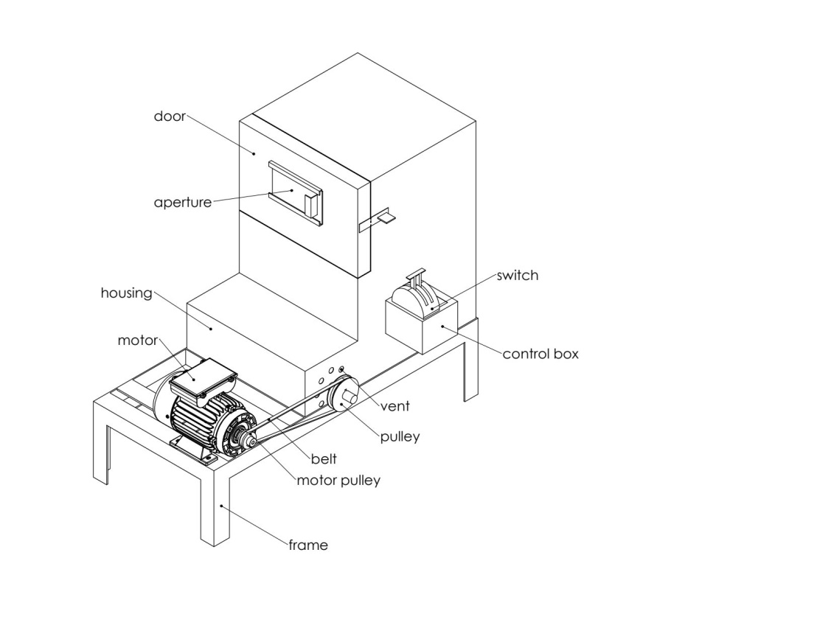
Figure 1: Isometric View of the Cassava Chip Dryer
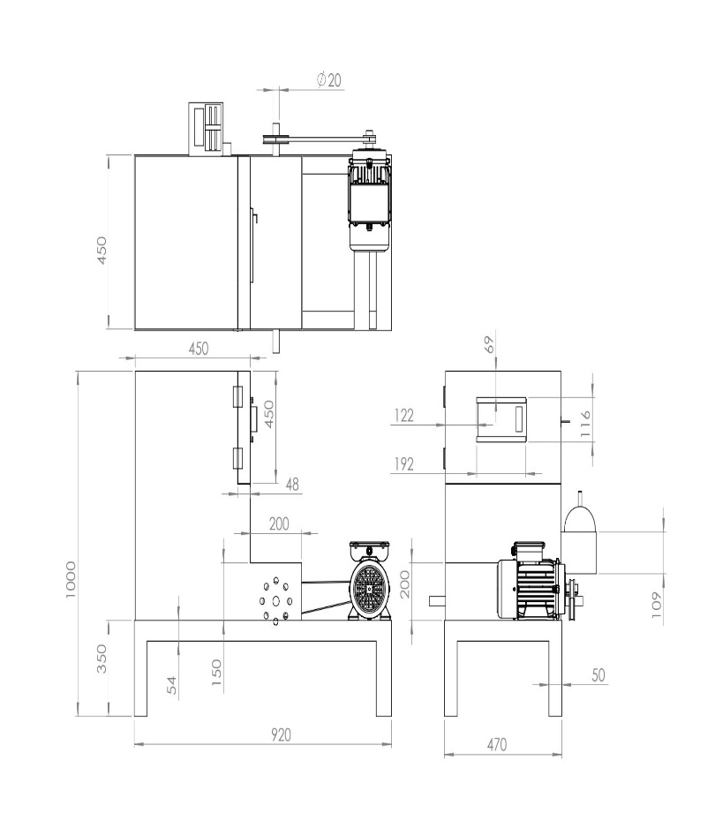
Figure 2: Sectional View of the Cassava Chip Dryer
3. Tests, Results and Discussion
3.1Test of Machine
The fabricated dryer is shown in Plate 1. The machine was tested with cassava chip on the trays in the workshop after the construction and the assembly of various components. Different experiments were carried out with the fabricated cassava chip dryer:
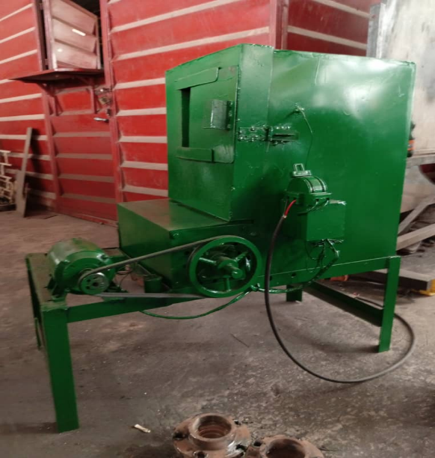
Plate 1: The Fabricated Cassava Chip Dryer

3.1.1 Experiment Carried Out on no Load
Determination of temperature at the drying chamber on no load was done. The apparatus used was stopwatch. The machine was switched on and the temperature was being taken at an interval of 5 minutes from 0 to 25 minutes. Table 1 and Figure 3 shows the temperature of the drying chamber on no load and the graph of temperature against time for a trial without loading respectively.
Table 1: Temperature at No Load
 | Trial 1 | Trial 2 | Trial 3 | Trial 4 | Trial5 | Trial 6 | Trial 7 | Trial 8
Time (minutes) | 1^{s}  test(⁰c) | 2nd test(⁰c) | 3rd test(⁰c) | 4th test(⁰c) | 5th test(⁰c) | 6th test(⁰c) | 7th test(⁰c) | 8th test(⁰c) | AVE. (⁰c)
0 | 45.00 | 45.00 | 44.99 | 45.00 | 45.00 | 44.98 | 44.98 | 45.00 | 44.99
5 | 52.00 | 51.00 | 51.50 | 51.00 | 52.00 | 52.00 | 51.00 | 52.00 | 51.63
10 | 58.00 | 57.00 | 56.00 | 56.50 | 57.00 | 58.00 | 56.00 | 57.00 | 56.93
15 | 62.00 | 62.00 | 60.00 | 61.00 | 62.00 | 61.50 | 62.00 | 61.00 | 61.38
20 | 66.00 | 65.00 | 64.00 | 65.00 | 66.00 | 64.00 | 65.00 | 66.00 | 65.13
25 | 70.00 | 70.00 | 70.00 | 70.02 | 70.02 | 70.01 | 70.01 | 70.02 | 70.01

Figure 3: Graph of Temperature against Time for a Trial without Loading
3.1.2 Observation on Experimental Results on no Load
It was observed from the temperature taken at no load that for each trial, the time taken to reach the drying temperature for cassava is 25 minutes. For the eight trials, it took 200 minutes (3 hours 20 minutes) which means at 3 hours 20 minutes, the temperature of drying chamber was maintained at around 70.0 ºC which is the temperature range, needed for drying cassava chips. Then, from Figure 3, the graph shows that drying temperature is increasing with time.
3.1.3 Experiment carried out on Loading at Lower Tray
Determination of the time, moisture content and temperature of drying 6 kg of Cassava chips on each tray was done. The apparatus used were beam balance, moisture meter, a stopwatch and the thermocouple at the upper chamber. The required mass was weighed by the use of beam balance. The cassava chip sample was spread on both trays. The reading were then taken or recorded at interval of 5 minutes. Table 2 shows the temperature of drying chamber on loading at lower tray.

Table 2: Temperature of the Dried Chip at Lower Tray (on loading)
 | Trial 1 | Trial 2 | Trial 3 | Trial 4 | Trial 5 | Trial 6 | Trial 7 | Trial 8
Time (minutes) | 1st Test(⁰c) | 2nd Test(⁰c) | 3rd Test(⁰c) | 4th Test(⁰c) | 5th Test(⁰c) | 6th Test(⁰c) | 7th Test(⁰c) | 8th Test(⁰c) | AVG. (⁰c)
0 | 45.00 | 45.00 | 44.99 | 44.98 | 45.00 | 44.99 | 44.98 | 45.00 | 44.99
5 | 50.00 | 49.00 | 48.00 | 48.00 | 49.00 | 48.00 | 49.00 | 50.00 | 48.88
10 | 54.00 | 53.00 | 52.00 | 53.00 | 53.00 | 52.00 | 53.00 | 54.00 | 53.00
15 | 58.00 | 57.00 | 56.00 | 57.00 | 58.00 | 56.00 | 57.00 | 58.00 | 57.12
20 | 61.00 | 62.00 | 60.00 | 61.00 | 62.00 | 60.00 | 61.00 | 62.00 | 61.12
25 | 66.00 | 65.00 | 64.00 | 66.00 | 66.00 | 65.00 | 66.00 | 65.00 | 65.38
30 | 70.00 | 70.00 | 70.00 | 70.01 | 70.02 | 70.02 | 70.01 | 70.02 | 70.01

The cassava chips dried by the dryer are shown in Plate 2.
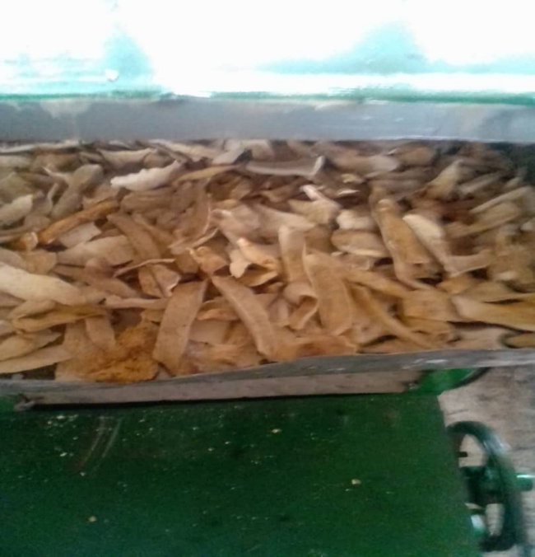
Plate 2: Cassava Chips dried by the Fabricated Dryer

3.1.4 Further Experiments carried out on Loading at Lower and Upper Trays
Determination of the time and moisture content of the cassava chip during drying using moisture meter, digital beam balance and a stopwatch was done. 6 kg of Cassava chips were held on each of the trays and the moisture content was determined at an interval of 30 minutes.

Table 3: Time and Moisture Content (MC) of the dried Cassava Chips at Lower Tray
Time (mins) | Moisture Content 1 (%) | Moisture Content 2 (%) | Previous moisture content (%) | Average moisture content (%)
0 | 65.02 | 65.02 | 65.02 | 65.02
30 | 57.50 | 56.90 | 57.60 | 57.33
60 | 44.30 | 44.10 | 44.40 | 44.27
90 | 39.10 | 38.85 | 39.22 | 39.05
120 | 33.20 | 34.20 | 34.10 | 33.83
150 | 28.22 | 28.32 | 28.02 | 28.19
180 | 24.02 | 25.06 | 25.04 | 24.71
210 | 19.03 | 20.01 | 19.10 | 19.38
240 | 13.10 | 13.08 | 13.12 | 13.10

Figure 4: Graph of Average Moisture Content against Time at Lower Tray
Table 4 and Figure 5 show the moisture content of chips at the upper tray and the graph of average moisture content against time at upper tray respectively.

Table 4: Time and Moisture Content (MC) of the Chips at Upper Tray
Time (mins) | Moisture Content 1 (%) | Moisture Content 2 (%) | Previous moisture Content (%) | Average moisture Content (%)
0 | 65.02 | 65.02 | 65.02 | 65.02
30 | 58.10 | 58.36 | 58.21 | 58.22
60 | 50.20 | 49.90 | 50.10 | 50.07
90 | 43.06 | 43.30 | 43.10 | 43.15
120 | 38.01 | 38.02 | 37.95 | 37.99
150 | 32.22 | 32.42 | 32.33 | 32.32
180 | 27.26 | 26.90 | 27.20 | 27.12
210 | 20.46 | 20.76 | 20.66 | 20.62
240 | 13.30 | 13.20 | 13.40 | 13.30

Figure 5: Graph of Average moisture content against time at upper tray
3.2 Drying Efficiency
The efficiency of drying was calculated as below:
Ƞ = $\frac{Moisture removed }{Initial Moisture content}$ × $\frac{100}{1}$
Where moisture removed formula was stated below:
Moisture removed = Initial moisture content – Final moisture content
Initial moisture content = 65.02 % = 0.6502
Final moisture content = 13.10 % = 0.131
Moisture removed = 0.6502 – 0.131
= 0.5192
From the above formula;
Ƞ = $\frac{0.5192}{0.6502}$ × $\frac{100}{1}$ = 79.8 % or 80 %
3.3 Discussion on Experimental Results on no Load and on Loading at Lower and Upper Trays
From tables 3 and 4, it can be seen that there is an increase in drying rate with increase in drying time i.e. as the time of drying increases, moisture content reduces. The drying temperature was maintained within the range of 70.0 $℃$ for the lower tray while that of the upper tray was maintained at 68$℃$. Also, from Figures 4 and 5, the graphs show that as moisture content reduces, the time of drying increases.
The machine performed as expected, but it was observed that at no load the drying temperature was maintained at the range of 70.0 $℃$ at the total trials of 3 hours 20 minutes. At loading, the drying temperature was maintained at around 70.0 $℃$ on the lower tray at the total trials of 4 hours which is within the range of drying temperature and drying time for drying cassava chips. The moisture content was reduced from 65.02 % to 13.10 %. At the latter part of the experiment, there was a lower rate of moisture content which was 13.10 %, this can therefore be attributed to the material (chips) becoming dried as the moisture content reduced.
The efficiency of the drying based on calculation was 80 % and the machine performed as expected. However, the moisture content was reduced to 13.10 % on the lower tray while that of upper tray was reduced to 13.30 %.
3.4 Traditional Method of Drying Cassava Chip
Traditional method that contained the drying of cassava chip pieces at an initial moisture content of 65.02 % on wet basis which were spread on the plastic paper surface on the open sun was carried out and experimented for comparison.12 kg of cassava chips were dried for 10 hours daily and it was turned twice a day to be able to dry uniformly, after which it was kept indoor overnight and this process was repeated on the next day. The process took 3 days and this experiment was terminated on the third day. The final moisture content was measured on the third day and it was measured to be 13.80 % on dried basis. The final moisture content (13.80 %) obtained falls within the range of safe moisture content for the dried cassava chips which is 12.6-14 % (Alonge and Adeyemi, 2010). The cassava chips dried traditionally by local sun are shown in Plate 3. Table 5 and Figure 6 show the percentage moisture content of the cassava chip and the graph of moisture content against time for traditional method of open sun drying respectively.
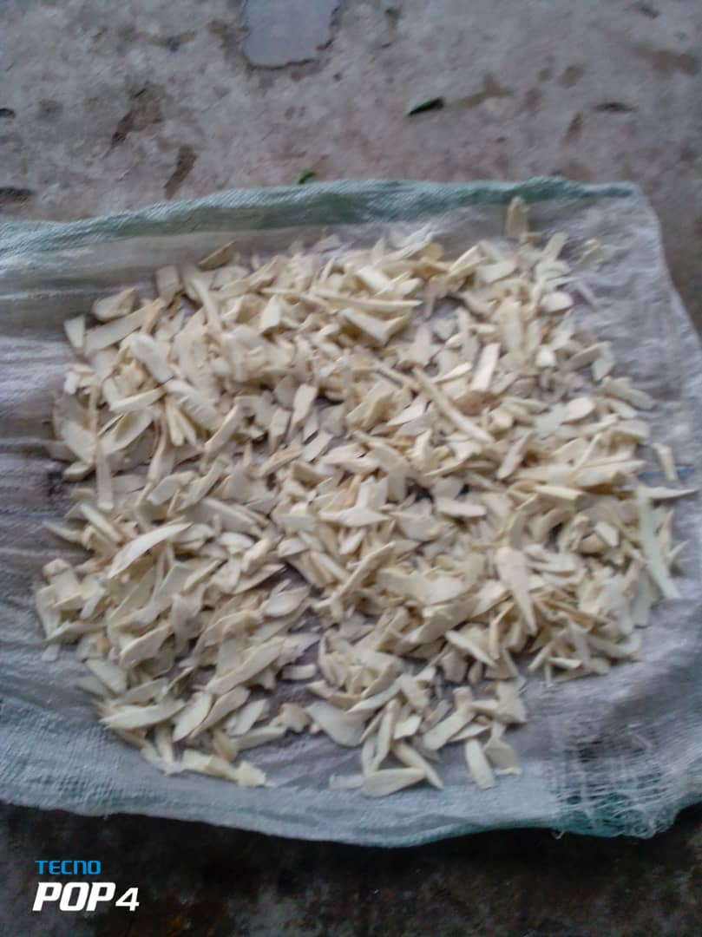
Plate 3: Cassava Chips Dried by Open Sun Traditional Method

Table 5: Results of Cassava Chips dried by Traditional Open Sun Method
Days | Duration | Time (hours) | Moisture Content (%)
 | 0 | 0 | 65.02
1 | 8am – 1pm | 5 | 58.00
 | 1pm – 6pm | 10 | 50.00
2 | 8am – 1pm | 15 | 40.00
 | 1pm – 6pm | 20 | 32.00
3 | 8am – 1pm | 25 | 21.00
 | 1pm – 6pm | 30 | 13.80

Figure 6: Graph of moisture content against time for local sun drying
3.5 Discussion of result for Local Sun Drying Method
The results from Table 5 above show that at interval of 5 hours, moisture content was being measured and the result was being taken. The initial moisture content reduced to 13.80 % from 65.02 % and the chip was dried at duration of 10 hours per day for 3 days. Figure 4 shows that the moisture content reduces with increase in time. Efficiency of Drying for Local Sun Drying Method by calculation was therefore estimated to be 79 %.

3.6 Performance Evaluation in Comparison with Local Sun Drying Method
The cassava chip dryer was therefore evaluated with 12 kg of cassava chips at a moisture content of 65.02 % on both trays. The moisture content was determined at the time interval of thirty minutes (30 minutes) until the chip was dried to 13.10 % on the lower tray and 13.30 % on the upper tray. The Dryer therefore performed better than local sun drying method. Based on the experiment performed, it took up to 10 hours per day for about 3 days (1800 minutes) for cassava chips to be dried by the local sun drying method while it takes 4 hours (240 minutes) for the chips to be dried by the developed Cassava chip dryer. The efficiency of drying the cassava chips by the dryer was evaluated to be 80 % while that of the local sun drying method was evaluated as 79 %. Therefore, the developed dryer can dry more efficiently in comparison to local sun drying method. Also, stainless steel used in the developed dryer ensured good quality of this product as compared with local sun drying method which is normally contaminated with dust, dirt, debris, stone, crawling insect and bird’s dropping. This may probably has a negative effect on the health of the consumers of the processed cassava products (Kanya and Ebuku, 2017).
4. Conclusions
A cassava chip drying machine has been designed and fabricated with locally available materials. The dryer was tested on no load at lower tray and on loading at lower and upper trays. The results from the experiment show that at no load; the temperature of drying was maintained around 70.0 $℃$ at 200 minutes (3 hours 20 minutes) which is within the range of drying temperature for cassava chip and at loading; it took about 240 minutes (4 hours) for the lower tray to maintain the temperature of 70.0 $℃$. The moisture content for the lower tray, upper tray and local sun drying reduced from 65.02 % to 13.10, 13.30 and 13.80 % respectively.
The efficiency of the dryer was estimated to be 80 % in comparison with the local sun drying method whose efficiency is 79 %. The cassava chips dried by the fabricated dryer were of good quality compared to those dried by local sun which are normally contaminated with sand, dust, debris, crawling insect and bird’s dropping among others.
Disclaimer (Artificial intelligence)
Author(s) hereby declare that NO generative AI technologies such as Large Language Models (ChatGPT, COPILOT, etc.) and text-to-image generators have been used during the writing or editing of this manuscript.
REFERENCES
- Abong, O. S., Shibairo, M.W., Okoth, Olamuka, P., Katama C. K. and J.Andouma, (2016). Quality and Safety Characteristics of Cassava crops sold in urban Kenya. African Crop Science Journal. 24(1): 89-94

- Adegbite, S.; Asiru, W.; Okewole, O.; Awoyale, W.; Kolawole, P.; Diallo, T.; and Abass, A. (2025). The Design, Development and Evaluation of a Biomass-Fueled Cabinet Dryer for High-Quality Cassava Flour Production. Proceedings 2025, 118, 7. https://doi.org/10.3390/ proceedings2025118007

- Ajala, A. S., and P. O. Ngody. (2020). Sorption isotherms and their fitted equations for dried chips of cassava roots (Manihot esculenta Crantz; Tme-7 variety) and the resulting isosteric heats of sorption. Food Research, 4(3): 703–711.

- Alonge. A, and Adeyemi. A.O. (2010). Performance Evaluation of a small scale cassava chip dryer . American Society of Agriculture and Biological Engineering’s. Joseph, michingan. www.asabe.org.DOI:10.13031/2013.32190.

- Bayata, A. (2019). Review on nutritional value of cassava for use as a staple food. Science Journal of Analytic Chemistry, 7(4): 83–91.

- Cock, J. H., and D. J. Connor. (2021). Cassava. In Crop physiology Case histories for Major Crops, eds. V. O. Sadras, and D. E. Calderini, ch. 19, 588–633. London, United Kingdom: Academic Press.

- Dos Santos Cotta, A. A. R., L. F. Ferreira, S. V. Borges, B. de Souza Nascimento, A. A. C. Cotta, and M. V. Dias (2023). Biodegradation, water sorption isotherms and thermodynamic properties of extruded packaging composed of cassava starch with tomato peel. Journal of Polymers and the Environment, 32(5): 2221-2238.
- E-lsharkawy, M.A (1995): Prospects of photosynthetic research for increasing agricultural production with emphasis on the tropical C 4 Amaranthus and the cassava C3 C4 crops. Photosynthetica, 31(2): 161-174.

- FAO (2006): Bankole Investment project profile cassava production, processing and marketing project. Food and Agriculture Organization of the United Nations, Rome. (4); 251-262
- FAOSTAT F (2019). Food and Agriculture Data. https://www.fao.org/faostat/en/#data/goggle scholar
- Fadeyibi, A., and J. O. Alaba (2020). Isothermal adsorption modelling of Pupuru flour. Croatian Journal of Food Science and Technology, 12(2): 229–237.

- Fawole, A., and A. Kolapo (2022). Optimization of Cassava (Manihot esculenta Crantz.) Fermentation Processes for Food-Secured Twenty-First Century Africa. In Trends and Innovations in Food Science, ed. Y. El-Samragy, ch. 8, 1-27. London, UK: IntechOpen.

- Hawa, L. C., U. Ubaidillah, R. Damayanti, and Y. Hendrawan (2020). Moisture sorption isotherms of modified cassava flour during drying and storage. Heat and Mass Transfer, 56(8): 2389–2396.
- Ikujenlola, AV and Opawale. B. O. (2017). Effect of processing on the yield and physio-chemical properties of cassava products. Advanced materials Research Scienctific. Net in Material Science and Engineering: 165-170. Retrieved from www.scientific.net/AMR, 18-19.165-170
- Kando, K., and B. Bitane. (2023). Cultivation of cassava (Manihot esculentus C.) with selected legumes for growth, yield, and economic advantages as climate change mitigations. International Journal of Smart Agriculture, 1(1): 1–10.
- Kanya. J. N., and Ebuku, E.P (2017). Mould and alfatoxin contamination of dried cassava chips in Eastern Uganda Association with traditional processing practices. Food control,73,137-145.doi:10.1016/j.foodcont.2016.07.037
- Labuza, T. P., and B. Altunakar (2020). Water activity prediction and moisture sorption isotherms. In Water Activity in Foods: Fundamentals and Applications, 2nd ed, eds. G. V. Barbosa-Cánovas, A. J. Fontana Jr., S. J. Schmidt, and T. P. Labuza, ch. 7, 161–205. Hoboken, New Jersey, United States: Wiley.
- Liberty, J. T., and Dzivama, A. U. (2013). Design, Construction and Performance Evaluation of Cassava Chips Dryer using Fuel Wood. International Journal of Engineering and Advanced Technology (IJEAT). 4 (2), 187-19
- Lohita, B., and M. Srijaya (2024). Novel technologies for shelflife extension of food products as a competitive advantage: A review. In Food Production, Diversity, and Safety Under Climate Change, eds. R. Chakraborty, P. Mathur, and S. Roy, ch. 24, 285-306. Singapore: Springer
- Nzuta, R. A., J. O. G. Elechi, I. S. Isa, H. J. Kittika’a, and C. T. Thomas (2022). Flour and cassava (Manihot spp) cultivars in Nigeria: Understanding their chemical functionalities and acceptability in food systems. International Journal of Scientific Research in Chemistry Sciences, 9(2): 20–29.
- Okunola O.I. (2002): Design and Construction of a Cabin dryer using electric elements as source of heat.4, Pg. 29-32.
- Ogunyinka, O. and Oguntuase, A. (2020): Analysis of Cassava production and processing by various groups in support of cassava value chain the South West of Nigeria. ISABB. Journal of Food and Agricultural sciences, Vol 9 (I), PP. 1 – 19.
- Olufayo, A. A., and J. O. Ogunkunle (1996). National drying of cassava chips in the humid zone of Nigeria. Bioresource Technology, 58(1): 89–91.
- Shimpy, M. Kumar, and A. Kumar (2023). Designs, performance, and economic feasibility of domestic solar dryers. Food Engineering Reviews, 15(1): 156–186.
- Thongmee, N. (2023). Thai cassava: Economic crops that grow in China. In Proceedings of the 15th NPRU National Academic Conference (pp. 2024–2034). Nakhon Pathom, Thailand: Nakhon Pathom Rajabhat University. https://publication.npru.ac.th/jspui/handle/123456789/2 065
- Ugwu, B.O., Ukpa, U.J. (2002): Potential of Soy cassava flour processing to sustain increasing cassava production in Nigeria Outlook on Nigeria Agriculture. Sage Journal. 31(2): 129-
- Wang, H., Z. Deng, B. Zhang, C. Ouyang, S. Liu, Y. Pan, and H. Li (2024). Shelf life extended: Focus on microbiota identification, nutrition value, color difference, and lipid oxidation of puffed bean products. Food Control, 163, 110517.

