Case report

Successful Management of Refractory Obstetric Antiphospholipid Syndrome in a Pregnant Woman with Homozygous MTHFR Mutation: A Case Report and Literature Review

.
ABSTRACT

Aims: To report the successful management and perinatal outcome of a high-risk pregnancy in a patient with Antiphospholipid Syndrome (APS) and a homozygous MTHFR mutation utilizing Enoxaparin therapy.
Presentation of Case: A 35-year-old primipara with a history of five recurrent miscarriages presented with positive Cardiolipin IgM and a homozygous MTHFR mutation. The patient was managed with daily subcutaneous Enoxaparin (4000 UI) and low-dose aspirin. The pregnancy was complicated by Gestational Diabetes Mellitus and placental insufficiency, manifesting as severe Fetal Growth Restriction (FGR) and oligohydramnios. Due to breech presentation and fetal compromise, a cesarean section was performed at 35 weeks and 2 days, resulting in the delivery of a live female infant weighing 1800g.
Discussion: This case illustrates the complexity of thrombophilia involving APS and MTHFR mutations. While Enoxaparin played a pivotal role in prolonging the pregnancy, the development of severe FGR indicates that microthrombosis or placental inflammation persisted despite anticoagulation. The patient required intensive monitoring to balance the risks of placental failure against prematurity.
Conclusion: Enoxaparin therapy can successfully achieve a live birth in women with APS and MTHFR mutations. However, these pregnancies remain at high risk for placental insufficiency, necessitating strict surveillance and timely intervention to ensure optimal outcomes.

Keywords: Antiphospholipid Syndrome, Recurrent Pregnancy Loss, Fetal Growth Restriction, Enoxaparin, High-risk Pregnancy.

1. INTRODUCTION

Antiphospholipid Syndrome (APS) is a leading treatable cause of recurrent pregnancy loss(Garcia & Erkan, 2018). The standard of care involves Low-Dose Aspirin combined with Low-Molecular-Weight Heparin (LMWH) (The ESHRE Guideline Group on RPL et al., 2022). However, treatment failure occurs in 20-30% of cases, termed Refractory Obstetric APS (Beltagy et al., 2021).
The management becomes increasingly complex when co-occurring with Homozygous MTHFR C677T mutation. While the independent role of MTHFR in adverse pregnancy outcomes remains debated by ACOG (“ACOG Practice Bulletin No. 197,” 2018), in the context of APS, hyperhomocysteinemia acts as a second hit. It exacerbates endothelial dysfunction already compromised by antiphospholipid antibodies (aPL), creating a hypercoagulable state at the maternal-fetal interface (Aldabie et al., 2026). aPL antibodies activate endothelial cells, monocytes, and platelets, leading to thrombosis and complement activation which damages the trophoblast (Ma et al., 2025). The homozygous C677T mutation significantly reduces MTHFR enzyme activity, leading to elevated homocysteine. Hyperhomocysteinemia induces oxidative stress and reduces nitric oxide availability, further impairing placental perfusion.
The management of pregnant patients presenting with refractory obstetric APS and homozygous MTHFR mutations requires a stratified, multidisciplinary approach that addresses both metabolic and immunologic dysfunctions (Moll & Varga, 2015). Regarding metabolic optimization, standard folic acid may be insufficient due to the enzymatic bottleneck associated with the MTHFR mutation; therefore, supplementation with L-5-Methyltetrahydrofolate is preferred to bypass this defect, directly lower homocysteine levels, and reduce the thrombotic risk (He & Li, 2023). When the standard regimen of low-dose aspirin and LMWH fails, current literature supports the integration of immunomodulatory therapies (Siniscalchi et al., 2024). Hydroxychloroquine (HCQ) is currently regarded as the primary evidence-based add-on intervention(Ghembaza & Saadoun, 2020). Mechanistically, HCQ inhibits Toll-like receptor signaling and restores the protective Annexin A5 shield on the trophoblast (Schreiber et al., 2018). Other second-line options include low-dose corticosteroids, particularly in lupus anticoagulant-positive cases, though this requires careful monitoring for complications such as gestational diabetes (Riancho-Zarrabeitia et al., 2022). Finally, Intravenous Immunoglobulin is generally reserved for super-refractory cases to downregulate the autoimmune response when HCQ or steroids have failed (Carp et al., 2005).

2. Presentation of Case

A 35-year-old primigravida of advanced maternal age presented with a significant obstetric history of five prior miscarriages. The patient reported that during these previous pregnancies, she received only LMWH monotherapy and had not been prescribed aspirin. Her medical, surgical, and family histories were otherwise unremarkable. Pre-conception thrombophilia screening identified a positive titer for Cardiolipin IgM (32.6 CU), which was confirmed by repeat testing after 12 weeks, alongside a homozygous MTHFR mutation, while testing for Lupus Anticoagulant and Beta-2 Glycoprotein antibodies (IgM and IgG) yielded negative results. The patient was subsequently managed with a therapeutic regimen of daily subcutaneous Enoxaparin (4000 UI) combined with low-dose aspirin.
The antenatal course was complicated by the development of Gestational Diabetes Mellitus (GDM), which was successfully controlled through dietary restriction and verified by stable home glucose monitoring. However, at 35 weeks and 2 days of gestation, ultrasound evaluation revealed signs of placental insufficiency, including a thickened placenta and severe Fetal Growth Restriction (FGR) with an estimated fetal weight of 1840g (<1st percentile). This was accompanied by oligohydramnios, evidenced by an Amniotic Fluid Index of 4.5 cm and a maximum vertical pocket of 1.6 cm. Doppler velocimetry indicated compensated fetal circulation, showing an Umbilical Artery Pulsatility Index (PI) of 1.09, a Middle Cerebral Artery PI of 1.94, and a Cerebroplacental Ratio of 1.7 (31st percentile).
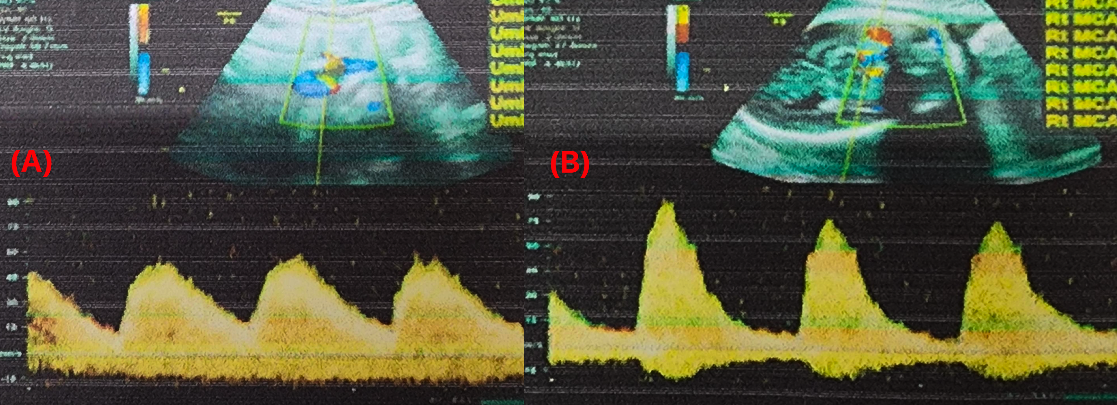
Figure 1. Doppler velocimetry showing (A) Umbilical Artery and (B) Middle Cerebral Artery waveforms
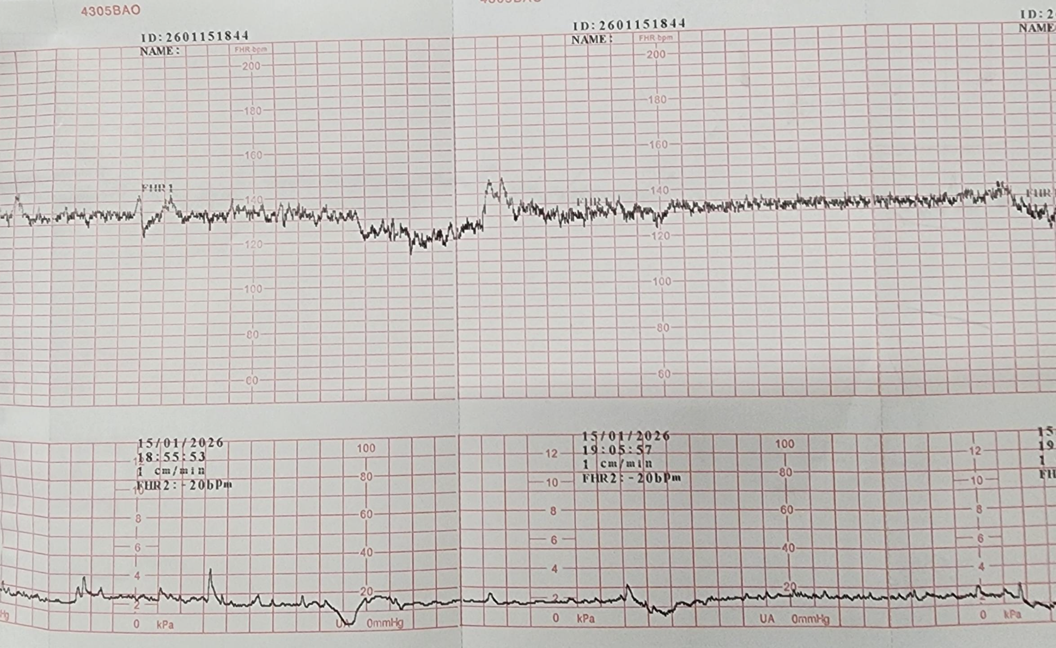
Figure 2. Cardiotocography tracing of the patient
Given the complex clinical picture involving breech presentation, severe FGR, oligohydramnios, and a refractory obstetric history, the patient was admitted for pregnancy termination. Enoxaparin was discontinued 24 hours prior to surgery. A cesarean section was performed successfully, resulting in the delivery of a female infant weighing 1800g with Apgar scores of 5 and 7 at 1 and 5 minutes, respectively. The procedure resulted in an intraoperative blood loss of 400 ml; the patient had a stable postoperative recovery and was discharged on the fifth day.

3. discussion

The clinical management of this complex case highlights the multifaceted nature of refractory obstetric APS, particularly when synergized with a homozygous MTHFR C677T mutation in a patient with five previous recurrent pregnancy losses. While the combination of low-dose aspirin and LMWH, specifically Enoxaparin 4000 UI, was instrumental in extending the gestational period beyond the thresholds of previous losses, the emergence of severe fetal growth restriction and oligohydramnios at 35 weeks underscores the limitations of conventional anticoagulation in high-risk thrombophilic environments. The role of the homozygous MTHFR mutation is especially significant as it potentially serves as a hit to the endothelial dysfunction initiated by cardiolipin IgM antibodies, creating a profound hypercoagulable state at the maternal-fetal interface. Mechanistically, this homozygous C677T mutation drastically reduces MTHFR enzymatic activity, culminating in systemic and localized hyperhomocysteinemia which induces oxidative stress and diminishes the bioavailability of nitric oxide, a critical vasodilator for placental bed resistance. This pathological cascade impairs placental perfusion and promotes a persistent state of microthrombosis or chronic placental inflammation, as evidenced by the ultrasound finding of a thickened placenta and the failure of standard anticoagulation to prevent fetal compromise. Furthermore, the enzymatic bottleneck associated with the MTHFR defect suggests that standard folic acid supplementation may be metabolically insufficient; current literature posits that active L-5-Methyltetrahydrofolate is preferred to bypass the compromised enzyme, directly lowering homocysteine levels and more effectively mitigating the secondary thrombotic risk. In this refractory context, where comorbid GDM further exacerbated the vascular compromise, the persistence of severe FGR despite standard therapy warrants the consideration of additional immunomodulatory interventions in future management, such as Hydroxychloroquine. Ultimately, the decision to proceed with a cesarean section at 35 weeks and 2 days represented a critical clinical balance between the escalating risks of intrauterine fetal death due to placental failure and the morbidity of late-preterm delivery, demonstrating that in the presence of these dual thrombophilic drivers, achieving a successful perinatal outcome requires a stratified, multidisciplinary approach involving intensive surveillance and decisive surgical intervention.

4. Conclusion

In women with recurrent pregnancy loss due to Antiphospholipid Syndrome and MTHFR mutations, Enoxaparin therapy can achieve a live birth. Nevertheless, these pregnancies remain at high risk for placental insufficiency, manifested as FGR and oligohydramnios. Strict surveillance and timely intervention, as demonstrated by the cesarean section at 35 weeks in this case, are essential for ensuring optimal perinatal outcomes.

ABBREVIATIONS

aPL: Antiphospholipid antibodies
APS: Antiphospholipid Syndrome
FGR: Fetal Growth Restriction
GDM: Gestational Diabetes Mellitus
HCQ: Hydroxychloroquine
IgG: Immunoglobulin G
IgM: Immunoglobulin M
LMWH: Low-Molecular-Weight Heparin
MTHFR: Methylenetetrahydrofolate Reductase
PI: Pulsatility Index

Consent

As per international standards or university standards, patient(s) written consent has been collected and preserved by the author(s).

COMPETING INTERESTS DISCLAIMER:
Authors have declared that they have no known competing financial interests OR non-financial interests OR personal relationships that could have appeared to influence the work reported in this paper.
Disclaimer (Artificial intelligence)
Author(s) hereby declare that NO generative AI technologies such as Large Language Models (ChatGPT, COPILOT, etc.) and text-to-image generators have been used during the writing or editing of this manuscript.

References

ACOG Practice Bulletin No. 197: Inherited Thrombophilias in Pregnancy. (2018). Obstetrics & Gynecology, 132(1), e18–e34. https://doi.org/10.1097/AOG.0000000000002703
Aldabie, G., Almarzooqi, A., Aljohani, R., Altawash, M., Alkadi, A., & Khamashta, M. (2026). Navigating obstetric antiphospholipid syndrome: Pathophysiology, diagnosis, and therapeutic advances. Expert Review of Clinical Immunology, 1–12. https://doi.org/10.1080/1744666X.2025.2612589
Beltagy, A., Trespidi, L., Gerosa, M., Ossola, M. W., Meroni, P. L., & Chighizola, C. B. (2021). Anti‐phospholipid antibodies and reproductive failures. American Journal of Reproductive Immunology, 85(4), e13258. https://doi.org/10.1111/aji.13258
Carp, H. J. A., Sapir, T., & Shoenfeld, Y. (2005). Intravenous Immunoglobulin and Recurrent Pregnancy Loss. Clinical Reviews in Allergy & Immunology, 29(3), 327–332. https://doi.org/10.1385/CRIAI:29:3:327
Garcia, D., & Erkan, D. (2018). Diagnosis and Management of the Antiphospholipid Syndrome. New England Journal of Medicine, 378(21), 2010–2021. https://doi.org/10.1056/NEJMra1705454
Ghembaza, A., & Saadoun, D. (2020). Management of Antiphospholipid Syndrome. Biomedicines, 8(11), 508. https://doi.org/10.3390/biomedicines8110508
He, Q., & Li, J. (2023). The evolution of folate supplementation – from one size for all to personalized, precision, poly-paths. Journal of Translational Internal Medicine, 11(2), 128–137. https://doi.org/10.2478/jtim-2023-0087
Ma, G., Han, J., Gao, R., & Qin, L. (2025). Immune-mediated mechanisms and maternal-fetal interface dysfunction in obstetric antiphospholipid syndrome. Frontiers in Immunology, 16, 1722080. https://doi.org/10.3389/fimmu.2025.1722080
Moll, S., & Varga, E. A. (2015). Homocysteine and MTHFR Mutations. Circulation, 132(1). https://doi.org/10.1161/CIRCULATIONAHA.114.013311
Riancho-Zarrabeitia, L., Lopez-Marin, L., Cacho, P. M., López-Hoyos, M., Barrio, R. D., Haya, A., & Martínez-Taboada, V. M. (2022). Treatment with low-dose prednisone in refractory obstetric antiphospholipid syndrome: A retrospective cohort study and meta-analysis. Lupus, 31(7), 808–819. https://doi.org/10.1177/09612033221091401
Schreiber, K., Sciascia, S., De Groot, P. G., Devreese, K., Jacobsen, S., Ruiz-Irastorza, G., Salmon, J. E., Shoenfeld, Y., Shovman, O., & Hunt, B. J. (2018). Antiphospholipid syndrome. Nature Reviews Disease Primers, 4(1), 17103. https://doi.org/10.1038/nrdp.2017.103
Siniscalchi, C., Bernardi, F. F., Di Micco, P., Perrella, A., Meschi, T., & Trama, U. (2024). Antithrombotic Treatment in Antiphospholipid Syndrome: A Review. Immuno, 4(4), 620–628. https://doi.org/10.3390/immuno4040036
The ESHRE Guideline Group on RPL, Bender Atik, R., Christiansen, O. B., Elson, J., Kolte, A. M., Lewis, S., Middeldorp, S., Mcheik, S., Peramo, B., Quenby, S., Nielsen, H. S., Van Der Hoorn, M.-L., Vermeulen, N., & Goddijn, M. (2022). ESHRE guideline: Recurrent pregnancy loss: an update in 2022. Human Reproduction Open, 2023(1), hoad002. https://doi.org/10.1093/hropen/hoad002

