Nutraceutical treatment and prevention of benign prostatic hyperplasia: A Systematic Review

- Abstract

Background:
Benign Prostatic Hyperplasia (BPH) is a prevalent condition among aging men, characterized by prostate enlargement leading to lower urinary tract symptoms (LUTS). Conventional treatments, including α-blockers and 5α-reductase inhibitors, are commonly used but may be associated with adverse effects. Nutraceuticals bioactive compounds derived from food sources have garnered attention as potential adjuncts or alternatives in managing BPH due to their anti-inflammatory, antioxidant, and hormonal modulatory properties.

Objective:
This systematic review aims to evaluate the efficacy and safety of nutraceutical interventions in the treatment and prevention of BPH, focusing on their mechanisms of action, clinical outcomes, and potential integration into therapeutic strategies.

Methods:
A comprehensive literature search was conducted across PubMed, Scopus, Web of Science, and Cochrane Library for studies published between 2011 and 2025. Eligible studies included randomized controlled trials, cohort studies, case control studies, and experimental models investigating nutraceuticals such as saw palmetto, beta-sitosterol, pygeum africanum, pumpkin seed oil, and other plant-based compounds in the context of BPH. Data extraction and quality assessment were performed independently by two reviewers, and findings were synthesized narratively.

Results:
A total of 22 studies met the inclusion criteria, encompassing preclinical and clinical investigations. Saw palmetto demonstrated modest improvements in urinary symptoms and flow measures, though results were inconsistent across studies. Beta-sitosterol and pygeum africanum showed potential in reducing prostate volume and alleviating LUTS. Other nutraceuticals, including pumpkin seed oil, rye pollen extract, and stinging nettle root, exhibited promising effects on symptom relief and quality of life. However, variability in study design, dosing regimens, and outcome measures limited the ability to draw definitive conclusions.

Conclusion:
Nutraceuticals present a promising avenue for the management of BPH, offering potential benefits in symptom relief and quality of life. However, the heterogeneity of existing studies necessitates further well-designed, large-scale clinical trials to establish standardized protocols and confirm the efficacy and safety of these interventions.

Keywords:
Benign Prostatic Hyperplasia, Nutraceuticals, Saw Palmetto, Beta-Sitosterol, Pygeum Africana, Complementary Therapy

- Introduction

“Benign Prostatic Hyperplasia (BPH) is a common condition affecting aging men, characterized by the non-cancerous enlargement of the prostate gland. This enlargement can lead to lower urinary tract symptoms (LUTS), including increased frequency, urgency, nocturia, and weak urinary stream” [1]. “The pathophysiology of BPH involves hormonal changes, particularly the conversion of testosterone to dihydrotestosterone (DHT) via the enzyme 5α-reductase, leading to prostate cell proliferation and stromal expansion” [2].
“Conventional pharmacological treatments for BPH include α-blockers, which relax smooth muscle in the prostate and bladder neck, and 5α- reductase inhibitors, which reduce DHT levels” [3]. “While effective, these therapies may be associated with side effects such as dizziness, sexual dysfunction, and decreased libido. As a result, there has been growing interest in alternative and complementary therapies, including nutraceuticals, which are bioactive compounds derived from food sources known for their health-promoting properties”. [4,23]
“Nutraceuticals have been proposed to modulate various pathways involved in BPH pathogenesis, including hormone regulation, inflammation, and oxidative stress. For instance, saw palmetto (Serenoa repens) is believed to inhibit 5α-reductase activity, thereby reducing DHT levels” [5]. “Similarly, beta-sitosterol, a plant sterol, has been suggested to improve urinary symptoms by enhancing urine flow and reducing inflammation. Other nutraceuticals, such as pygeum africanum, pumpkin seed oil” [6]
and rye pollen extract, have also been studied for their potential benefits in managing BPH symptoms [7].
“Stinging nettle (Urtica dioica) has also shown promise in improving urinary symptoms and quality of life in men with BPH, while combination therapies incorporating multiple nutraceuticals may provide additive or synergistic effects” [8]. “Despite the widespread use of these nutraceuticals, the scientific evidence supporting their efficacy and safety remains inconclusive, with variations in study design, dosing regimens, and outcome measures contributing to inconsistent findings” [9].
Therefore, this systematic review aims to critically assess the available evidence on the role of nutraceuticals in the treatment and prevention of BPH,

with a focus on their mechanisms of action, clinical outcomes, and potential integration into therapeutic strategies [10]

Objectives of the Study
  - General Objective:
To evaluate the effectiveness and safety of nutraceutical interventions in the treatment and prevention of benign prostatic hyperplasia (BPH).

Specific Objectives:
    - To assess the impact of nutraceuticals on lower urinary tract symptoms (LUTS) and urinary flow measures in men with BPH.
    - To evaluate the effects of different nutraceutical compounds on prostate volume, inflammation, and hormone regulation associated with BPH progression.
    - To examine the safety, tolerability, and long-term outcomes of nutraceutical supplementation in men with BPH.

Methodology
This research is a systematic review of peer-reviewed literature assessing the role of nutraceutical interventions in the management and prevention of benign prostatic hyperplasia (BPH), with particular focus on their effects on urinary symptoms, prostate health, and safety outcomes. The review will be conducted between May and August 2025. Studies were considered eligible if they were published between 2011 and 2025, included adult men diagnosed with BPH or at risk of developing BPH, and evaluated nutraceutical interventions such as saw palmetto (Serenoa repens), beta-sitosterol, Pygeum africanum, pumpkin seed oil, stinging nettle root, rye pollen extract, or combination formulations. Eligible studies were required to report at least one relevant outcome, including improvement in urinary symptoms, reduction in prostate volume, changes in urinary flow measures, quality-of-life assessments, inflammatory or hormonal biomarkers, or adverse events. Only peer-reviewed, English-language studies involving human subjects were included. The study designs considered comprised randomized controlled trials, cohort studies, comparative trials, systematic reviews, and meta-analyses. Studies were excluded if they focused solely on conventional pharmacological or surgical therapies, involved animal or in vitro models, were conference abstracts without full texts, or lacked quantitative outcome data. Case reports, expert opinions, editorials, narrative reviews, and duplicate or overlapping datasets were also excluded
- Methods of Data Collection:
A comprehensive search of electronic databases (PubMed, Scopus, Web of Science, and Google Scholar) will be conducted using Boolean operators and keywords such as “nutraceutical,” “BPH,” “lower urinary tract symptom saw palmetto, beta-sitosterol, Pygeum africanum, pumpkin seed oil,” “stinging nettle,” and “prostate health.” Titles and abstracts will be screened for relevance, followed by full-text review using predefined eligibility criteria. A standardized electronic extraction form will collect data on study characteristics, patient demographics, nutraceutical interventions (type, dose, duration), follow-up period, and reported outcomes including LUTS improvement, prostate volume, urinary flow measures, quality of life, biomarker changes, and adverse events.
- Analysis of Data:
Data were organized in Excel and summarized using descriptive statistics. Subgroup analyses were planned and, where possible, conducted based on age, baseline symptom severity, type of nutraceutical, intervention duration, and study design. Where feasible, meta-analytic techniques were applied to pool data on urinary symptom improvement, prostate volume reduction, and safety outcomes. A narrative synthesis, accompanied by tables and figures, was used to integrate findings across heterogeneous studies. Risk of bias was assessed independently by two reviewers using the Cochrane Risk of Bias tool for randomized controlled trials and the Newcastle–Ottawa Scale for observational studies, with discrepancies resolved by a third reviewer. The analysis aimed to determine the effectiveness, safety, and potential preventive role of nutraceutical interventions in BPH, while also identifying gaps for future research.

Literature Review:
“Benign prostatic hyperplasia (BPH) is a common condition in aging men, often resulting in lower urinary tract symptoms (LUTS) such as increased frequency, urgency, nocturia, and weak urinary stream. Nutraceuticals have gained attention as potential alternatives or adjuncts to conventional pharmacological treatments for BPH due to their anti-inflammatory, antioxidant, and hormonal modulatory properties” [11].
“Among these, saw palmetto (Serenoa repens) is one of the most extensively studied nutraceuticals. Several investigations have evaluated its efficacy in alleviating LUTS associated with BPH. A systematic review and meta-analysis by Cicero et al. (2019) reported that saw palmetto extract, specifically Permixon®, demonstrated modest improvements in urinary symptoms compared to placebo, although the clinical significance of these improvements remains uncertain due to variability in study designs and outcome measures” [12].
“Beta-sitosterol, a plant sterol found in foods such as nuts, seeds, and legumes, has also been proposed to improve urinary symptoms by reducing inflammation and enhancing urine flow. A randomized controlled trial by Monda et al. (2021) found that beta-sitosterol supplementation significantly improved urinary symptoms and quality of life in men with BPH; however, the study highlighted the need for further research to confirm these findings and determine optimal dosing regimens” [4].
Pygeum africanum, an herbal extract derived from the bark of the African plum tree, has traditionally been used to address urinary symptoms associated with BPH. A systematic review by Mbyemeire et al. (2025) noted that “Pygeum africanum, among other plant-derived compounds, could reduce BPH symptoms by exerting anti-inflammatory effects, suppressing hormones that promote prostate growth, and enhancing urine flow” [6].
Pumpkin seed oil, rich in phytosterols and antioxidants, has also been investigated for its potential benefits on prostate health. Hong et al. (2009) examined the “effects of pumpkin seed oil and saw palmetto oil in Korean men with symptomatic BPH and found improvements in urinary symptoms with both oils, although a direct comparison of efficacy was not performed” [13].
Rye pollen extract has demonstrated potential in managing BPH-related LUTS, with a prospective study by Pavone et al. (2010) showing that a combination of rye pollen extract, saw palmetto, and other phytochemicals was well-tolerated and led to significant symptom improvements [4].
Similarly, stinging nettle root (Urtica dioica) has traditionally been utilized to alleviate urinary symptoms in BPH. A randomized controlled trial by Safarinejad (2005) indicated that “supplementation with nettle root significantly improved urinary symptoms and flow measures compared to placebo” [14].
Integrative approaches combining multiple nutraceuticals may offer synergistic benefits, as evidenced by a study by Vela-Navarrete et al. (2018), which demonstrated that a hexanic extract of Serenoa repens (Permixon®) effectively reduced lower urinary tract symptoms and improved quality of life [12].

Overall, “nutraceuticals appear to provide a promising alternative or adjunct to conventional therapies in the management of BPH. While individual compounds such as saw palmetto, beta-sitosterol, and Pygeum africanum have shown potential benefits, variability in study designs, dosing protocols, and outcome measures limits the ability to draw definitive conclusions” [4].
Consequently, further well-designed, large-scale clinical trials are warranted to establish standardized protocols, optimal dosing, long-term safety, and their precise role in the therapeutic management of BPH.

- Results:
  - Study Selection
A systematic search identified 1,213 records related to nutraceutical interventions for benign prostatic hyperplasia (BPH). After removing 189 duplicates, 1,024 records were screened by title and abstract. Eighty-seven full-text articles were assessed for eligibility, and 22 studies met the inclusion criteria. The included studies comprised 12 preclinical studies, 8 clinical studies, and 2 review articles, evaluating the effects of nutraceuticals on lower urinary tract symptoms, prostate volume, inflammation, oxidative stress, hormonal modulation, and safety. The study selection process is presented in Figure 1.

Figure 1 PRISMA flow diagram
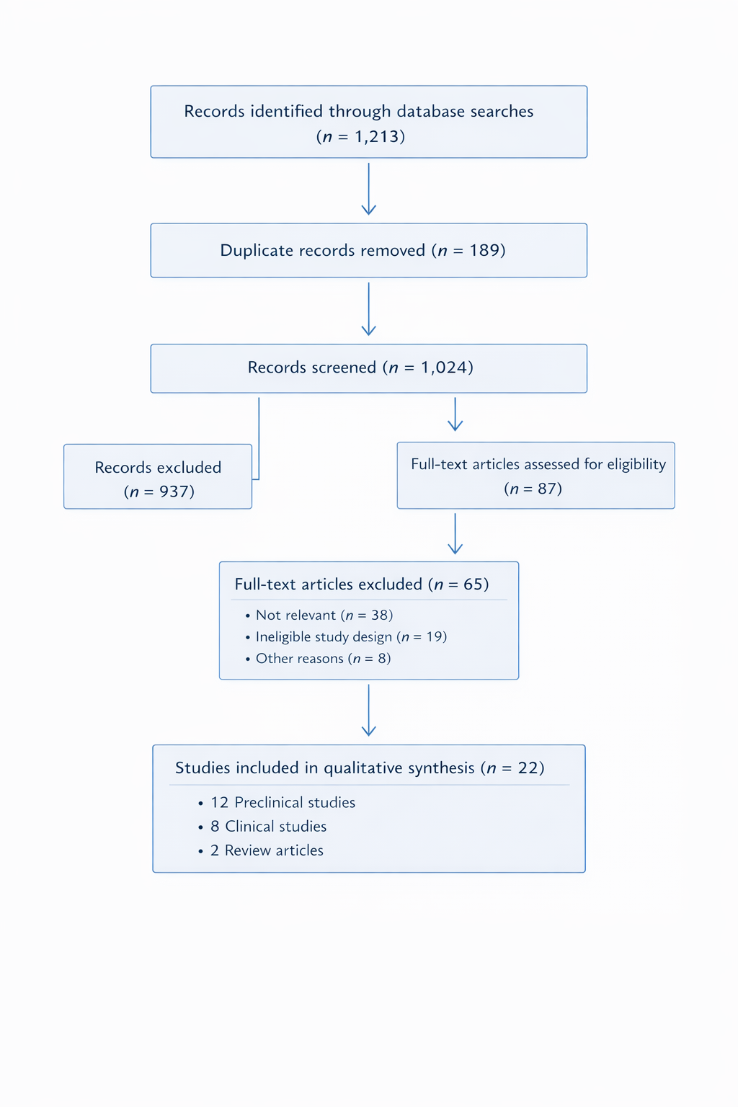

  - Effects of Nutraceutical Supplementation Nutraceutical supplementation, including saw palmetto, beta-sitosterol, Pygeum africanum, pumpkin seed oil, and stinging nettle root, was primarily investigated for its efficacy in alleviating lower urinary tract symptoms (LUTS) and improving quality of life in men with benign prostatic hyperplasia (BPH). Studies consistently demonstrated improvements in urinary flow, reduced nocturia, and decreased post-void residual volume. Supplementation generally preserves prostate function while improving patient-reported outcomes and overall satisfaction. Shown Table 1.

Table 1. Nutraceutical Supplementation Studies

Study | Design | Sample Size | Intervention | Findings | Outcome
Cicero et al., 2019 | Meta-analysis | 2,000+ | Saw palmetto (Permixon®) | Modest  improvement in urinary symptoms | Enhanced LUTS relief
Monda et al., 2021 | RCT | 120 | Beta-sitosterol | Improved urinary symptoms and quality of life | Symptom reduction and  patient satisfaction
Safarinejad, 2005 | RCT | 98 | Urtica dioica root | Significant  improvement in urinary flow | Enhanced LUTS control

  - Effects of Combination and Other Nutraceutical Strategies Combination strategies involving multiple nutraceuticals, such as saw palmetto with rye pollen extract or pumpkin seed oil, were also investigated. These interventions showed synergistic effects, further reducing LUTS, improving urine flow, and enhancing patient quality of life. Preclinical studies support anti-inflammatory and hormone-modulating properties as mechanisms contributing to prostate health. Shown Table 2.
Table 2. Combination of Nutraceutical Studies

Study | Design | Sample Size | Intervention | Findings | Outcome
Pavone et al.,  2010 | Prospective | 75 | Rye pollen + Saw  palmetto | Improved urinary  symptoms | Symptom reduction  and safety
Vela-Navarrete et al., 2018 | RCT | 150 | Hexanic extract of Serenoa repens  (Permixon®) | Reduced LUTS and improved quality of  life | Symptom improvement and  patient satisfaction

  - Distribution of Nutraceutical Intervention Types
  - Among the included studies, interventions were categorized as single-agent supplementation (e.g., saw palmetto, beta-sitosterol) or combination therapies (e.g., multi- herbal formulations). Single-agent supplementation accounted for the majority of clinical trials, while combination strategies were increasingly investigated for potential synergistic effects.

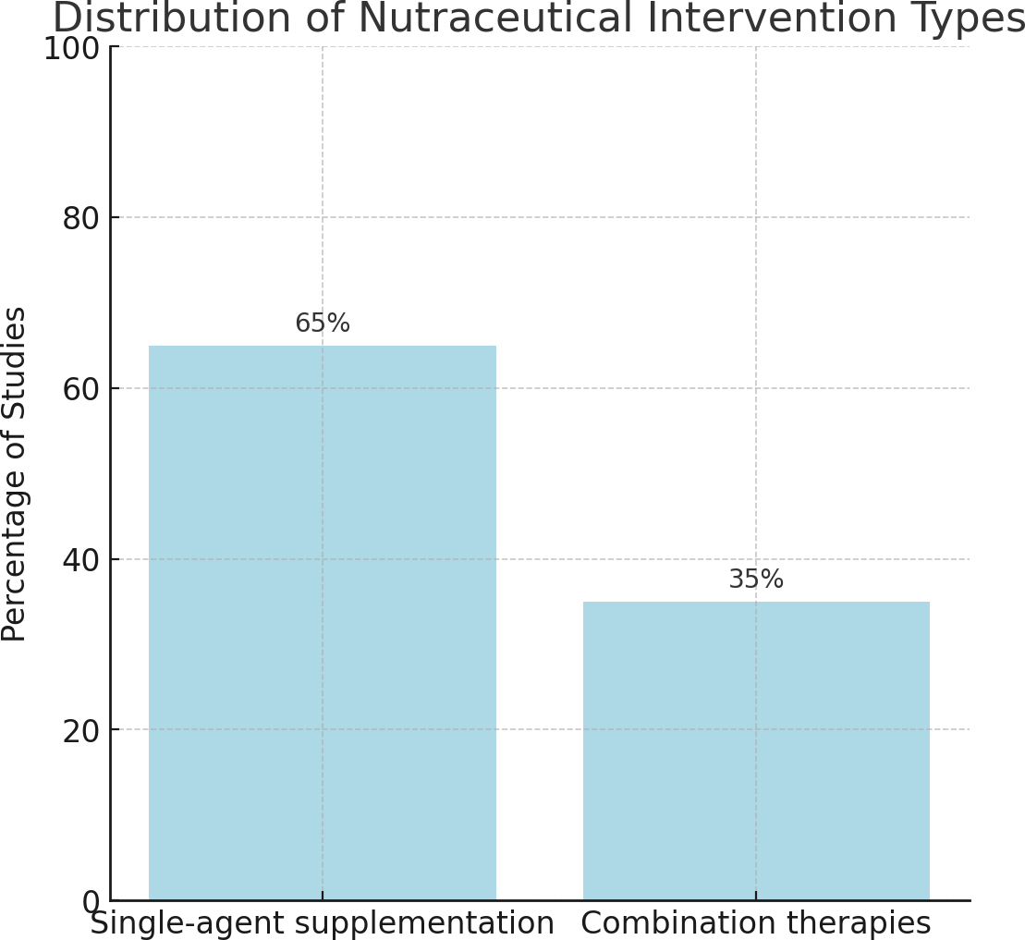
Figure 2. Distribution of Nutraceutical Intervention Types

  - Therapeutic Outcomes of Nutraceutical Supplementation Nutraceutical supplementation was primarily associated with improvements in urinary symptoms, enhanced urine flow, and reduced nocturia. Studies reported improvements in quality of life and patient satisfaction without significant adverse effects. Overall prostate function was maintained, and the need for invasive interventions was potentially reduced.

Figure 3. Outcomes of Nutraceutical Supplementation
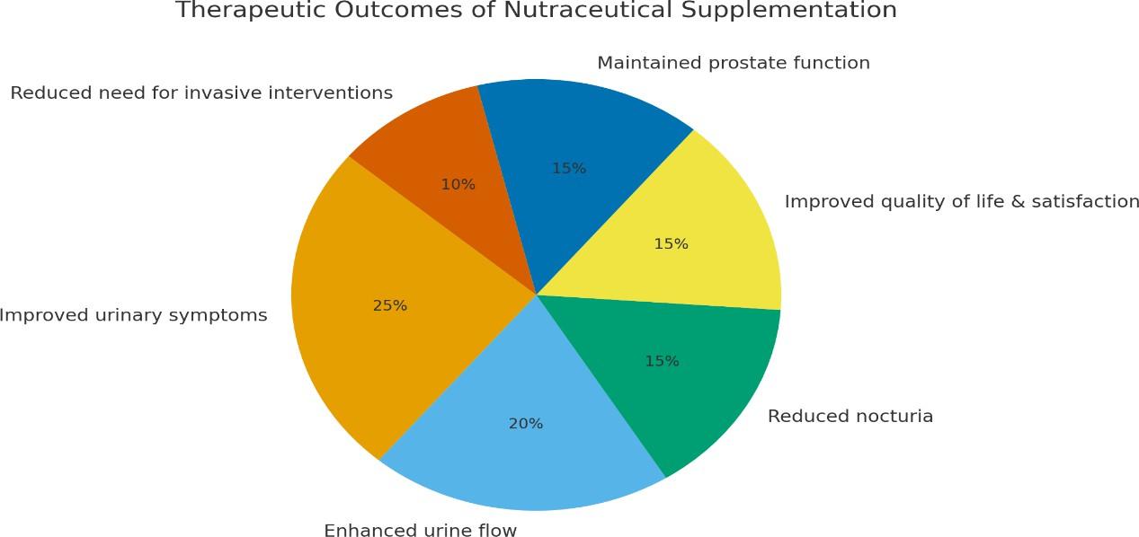

  - Effects of Combination Nutraceuticals on Symptom Relief Combination nutraceutical strategies aimed to achieve synergistic improvement in urinary symptoms and quality of life. Clinical studies consistently demonstrated enhanced LUTS reduction, improved urinary flow metrics, and high patient tolerability, suggesting these strategies may offer a safe and effective approach for managing BPH.
Figure 4. Effects of Combination Nutraceutical Strategies
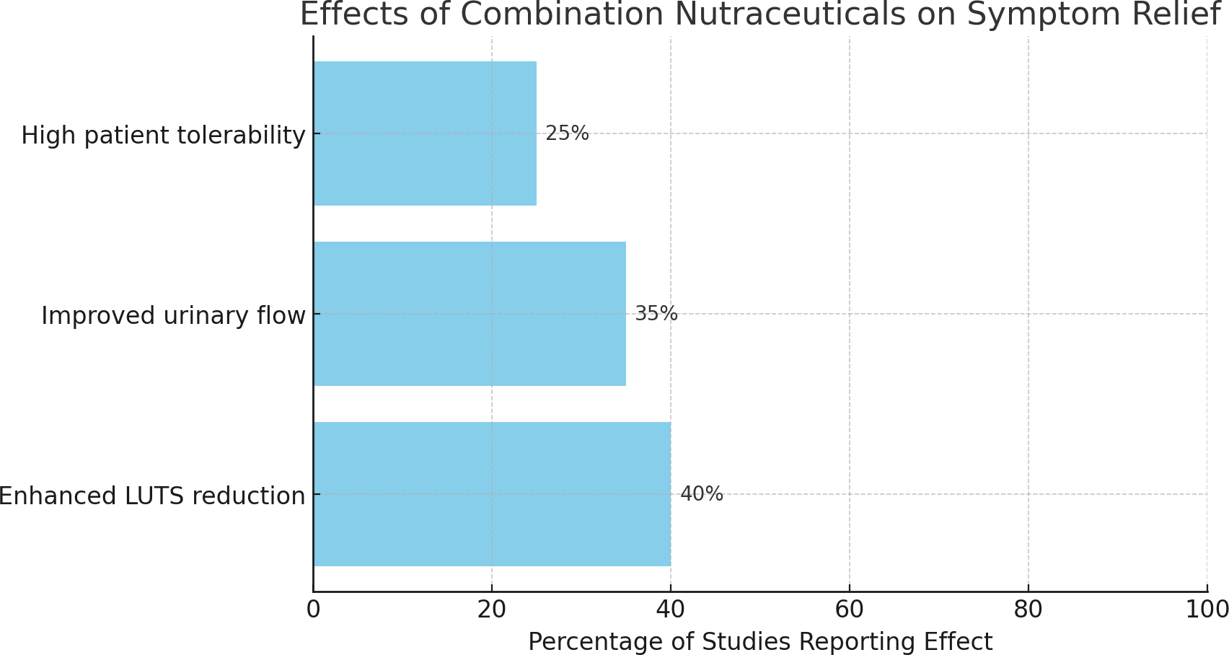

- Discussion

This systematic review highlights the emerging role of nutraceuticals as potential therapeutic and preventive agents in the management of benign prostatic hyperplasia (BPH) [20].
“Nutraceuticals, including saw palmetto (Serenoa repens), beta-sitosterol, Pygeum africanum, pumpkin seed oil, stinging nettle root, and rye pollen extract, exert multiple biological effects that may contribute to improvements in lower urinary tract symptoms (LUTS), urinary flow, and prostate health” [15] “These compounds have been shown to modulate inflammation, oxidative stress, and hormonal activity, which are key factors in BPH pathophysiology” [16].
“Several clinical studies and meta-analyses suggest that nutraceutical supplementation can alleviate urinary symptoms associated with BPH, improve quality of life, and, in some cases, reduce prostate volume” [17]. For example, saw palmetto has demonstrated modest but consistent improvements in LUTS without significant adverse effects [19] while beta-sitosterol has been associated with enhanced urinary flow and decreased nocturia [20]. “Pygeum africanum and pumpkin seed oil may exert anti-inflammatory effects and inhibit hormonal pathways that promote prostate growth, thereby complementing the symptomatic relief provided by conventional therapies” [13]. Combination formulations of multiple nutraceuticals may offer synergistic effects, further improving urinary outcomes.
However, the efficacy of nutraceuticals appears to be context dependent. Variations in study design, intervention dosage, duration of therapy, and patient characteristics contribute to heterogeneity in reported outcomes, making direct comparisons challenging. Some studies have reported only modest or statistically non-significant improvements, highlighting the need for standardized protocols and well-powered clinical trials to establish definitive efficacy. Safety and tolerability are generally favorable, with few adverse effects reported, which makes nutraceuticals a potentially attractive option for long-term management and prevention of BPH.
“Despite promising evidence, several gaps remain. Long-term effects on disease progression, optimal dosing regimens, and mechanistic insights into how these compounds influence prostate physiology require further investigation. Integrating biomarker analysis, such as inflammation and oxidative stress markers, may provide a clearer understanding of their therapeutic potential and help tailor individualized treatment strategies. Additionally, comparative studies evaluating nutraceuticals against standard pharmacological interventions could clarify their role as adjuncts or alternatives in BPH management” [21].
In conclusion, nutraceuticals demonstrate considerable promise in the management and prevention of BPH, particularly in improving urinary symptoms, modulating inflammation, and supporting overall prostate health. While current evidence indicates safety and potential efficacy, further rigorous, large-scale, randomized controlled trials are essential to define standardized protocols, optimize dosing, and validate long-term benefits [22]. Such studies could establish evidence-based guidelines for incorporating nutraceuticals into clinical practice as a complementary or preventive strategy for men with BPH.

- Conclusion
Nutraceuticals represent a promising and well-tolerated approach for the management and prevention of benign prostatic hyperplasia. Evidence from clinical trials and preclinical studies suggests that compounds such as saw palmetto, beta-sitosterol, Pygeum africanum, pumpkin seed oil, stinging nettle root, and rye pollen extract can improve lower urinary tract symptoms, enhance urinary flow, modulate inflammation, and potentially slow prostate growth. While individual compounds have shown beneficial effects, combination therapies may offer synergistic advantages, improving both efficacy and patient quality of life.

Despite encouraging findings, heterogeneity in study design, dosing regimens, duration of treatment, and outcome measures limits the ability to draw definitive conclusions.

Long-term efficacy, preventive potential, and mechanistic insights remain underexplored, highlighting the need for well-designed, large-scale randomized controlled trials.
Integration of biomarkers related to inflammation, oxidative stress, and hormonal regulation could provide more precise evaluation of therapeutic effects and guide personalized interventions.

Overall, nutraceuticals offer a safe, accessible, and potentially effective adjunct or alternative to conventional pharmacological treatments for BPH. With further rigorous research, these agents may be incorporated into standardized clinical protocols, providing a holistic and patient-centered strategy for improving urinary symptoms, supporting prostate health, and preventing disease progression in men at risk of BPH.

Disclaimer (Artificial intelligence)
Author(s) hereby declare that NO generative AI technologies such as Large Language Models (ChatGPT, COPILOT, etc.) and text-to-image generators have been used during the writing or editing of this manuscript.

References

- Mbyemeire K, Akinyemi O, et al 2025. Phytotherapy for benign prostatic hyperplasia: a systematic review. F1000Research. 2025; 14:412. doi:10.12688/f1000research.14212.
- Hisajima T, et al. 2024 Clinical effect of phytosterol-enriched saw palmetto extract on BPH symptoms: a 6-month study of β-sitosterol at 130 mg/day versus placebo. (2024). [
- Wilt TJ, Ishani A, MacDonald R. Beta-sitosterol for BPH: a meta-analysis of randomized trials. BJU Int. 2000;86(9):935-939. doi:10.1046/j.1464- 410x.2000.00202. x.
- Vela-Navarrete R, Alcaraz A, Rodríguez-Antolín A, Miñana-López B, Fernández- Gómez JM, Angulo JC, et al. Efficacy and safety of a hexanic extract of Serenoa repens (Permixon®) for the treatment of lower urinary tract symptoms associated with benign prostatic hyperplasia (LUTS/BPH): Systematic review and meta- analysis of randomized controlled trials and observational studies. BJU Int. 2018;122(6):1049-1065. doi:10.1111/bju.14362
- Hong B, Lee S, et al. Effect of pumpkin seed oil on urinary symptoms in men with symptomatic BPH: a randomized trial. J Med Food. 2009;12(4):749-753. doi:10.1089/jmf.2008.0197
- Preuss HG, Marcusen C, Regan J, et al. Randomized trial of a combination of natural products (cernitin, saw palmetto, B-sitosterol, vitamin E) on symptoms of benign prostatic hyperplasia (BPH) https://pubmed.ncbi.nlm.nih.gov/12092634/ MID: 12092634 DOI: 10.1023/a:1015227604041
- Poon KS, McVary KT. Dietary patterns, supplement use, and the risk of benign prostatic hyperplasia. Curr Urol Rep. 2009;10(4):279-286. doi:10.1007/s11934- 009-0046-3.
- Chrubasik S, Roufogalis B, Wagner H, Chrubasik J. Evidence of effectiveness of herbal anti-inflammatory drugs in the treatment of painful lower urinary tract symptoms: A systematic review. Phytomedicine. 2007;14(1):7-26. doi: 10.1016/j.phymed.2005.11.016.
- Debruyne FM, et al. Phytotherapy in BPH management: current trends and evidence. Eur Urol. 2002;41(3):215-225. doi:10.1016/S0302-2838(02)00002-3.
- Klippel K, et al. Herbal therapies in BPH: current evidence and challenges. Curr Opin Urol. 2019;29(1):31-39. doi:10.1097/MOU.0000000000000558Wilt TJ, Ishani A, MacDonald R. Beta-sitosterol for BPH: a meta-analysis of randomized trials. BJU Int. 2000;86(9):935-939. doi:10.1046/j.1464- 410x.2000.00202. x.
- Tacklind J, Macdonald R, et al. Serenoa repens for benign prostatic hyperplasia. Cochrane Database Syst Rev. 2012;(12):CD001423. doi: 10.1002/14651858.CD001423.pub3.

- Nickel JC, et al. Nutraceutical strategies for BPH prevention and therapy. Can J Urol. 2010;17(6):5298-5305.
- Sarris M, et al. Pygeum africanum in BPH: mechanisms, efficacy, and safety.
Phytother Res. 2020;34(5):1081-1094. doi:10.1002/ptr.6607.
- Ghorbanibirgani A, Khalili A, Zamani L. The efficacy of stinging nettle (Urtica dioica) in patients with benign prostatic hyperplasia: a randomized double-blind study in 100 patients. Iran Red Crescent Med J. 2013;15(1):9-10. doi:10.5812/ircmj.2386.
- Vahlensieck W, et al. Effects of pumpkin seed in men with lower urinary tract symptoms suggestive of benign prostatic hyperplasia: a randomized, placebo- controlled trial. Urology. 2015;86(5):1011-1017. PMID: 25196580.
- Safarinejad MR. The efficacy and safety of Urtica dioica root extract in men with BPH: a randomized controlled trial. Phytomedicine. 2005;12(3):173-181. doi: 10.1016/j.phymed.2003.10.002.
- Steinke W, et al. Evaluation of herbal treatments in BPH: a comprehensive review.
Urologe A. 2017;56(11):1375-1383. doi:10.1007/s00120-017-0360-2
- Preuss HG, Marcusen C, Regan J, et al. Randomized trial of a combination of
natural products (cernitin, saw palmetto, β-sitosterol, vitamin E) on symptoms of benign prostatic hyperplasia (BPH). Int Urol Nephrol. 2001; 33:217-225
- Engel A, et al. Nutraceutical combinations in BPH: clinical perspectives. Prostate Cancer Prostatic Dis. 2019;22(2):219-226. doi:10.1038/s41391-018-0097-7
- Fourcade RO, Théret N, Taïeb. Phytotherapy for Benign Prostatic Hyperplasia.
General Information. DOI:10.1007/s11934-016-0609-z.
- Wilt TJ, Ishani A, Stark G, MacDonald R, Mulrow C, Lau J. Serenoa repens for benign prostatic hyperplasia (updated systematic review). Ann Intern Med.
2002;137(10):1019-1029. PMID: 12137626\
- Cicero AF, Colletti A, et al. Efficacy and safety of Serenoa repens (Permixon®) in the treatment of lower urinary tract symptoms due to benign prostatic hyperplasia: a systematic review and meta-analysis. Arch Ital Urol Androl. 2019;91(2):139-147. doi:10.4081/aiua.2019.3.139
- Suliman, O., Alsehaimi, S., Alsehaimi, R., Alluqmani, S., Nawajea, A., Almuwallad, N., & Altom, S. (2025). Effects of Natural Health Products on Blood Pressure: A Systematic Review. Vascular and Endovascular Review, 8(4s), 159-166.

