Design and Characterization of a Self-Micro Emulsifying Drug Delivery System (SMEDDS) for the Delivery of Omega Fatty Acids
ABSTRACT
Introduction: The global market for nutraceuticals is expanding due to increased health awareness, yet the bioavailability of bioactive components, such as polyunsaturated fatty acids, is often compromised by low aqueous solubility and stability in the gastrointestinal tract. To overcome these limitations, Self-Micro Emulsifying Drug Delivery Systems (SMEDDS) have emerged as a vital strategy to enhance solubility and oral bioavailability.
Aim: This study focuses on the design and characterization of a SMEDDS formulation specifically aimed at improving the delivery of omega fatty acids.
Methodology: Surfactants and co-surfactants were screened via miscibility studies to determine optimal solubility. Pseudo-ternary phase diagrams were constructed using the aqueous titration method to identify the optimal ratios of oil, surfactant (Tween 80), and co-surfactant (PEG 400). The formulation was prepared using a high-shear homogenizer and characterized for self-emulsification time, viscosity, droplet size, zeta potential, in-vitro dissolution, and stability under accelerated conditions.
Results: The miscibility study identified Tween 80 and PEG 400 as the ideal surfactant and co-surfactant, with a 2:1 ratio yielding the largest monophasic region on the phase diagram. The optimized SMEDDS exhibited a rapid self-emulsification time of less than one minute, a mean globule size of 645.2 nm, and a stable zeta potential of -34.9 mV. In-vitro dissolution studies demonstrated a drug release of over 63% in the first 15 minutes, significantly higher than that of pure oil.
Conclusion: The developed SMEDDS formulation successfully improved the solubility and dissolution profile of omega fatty acids. The formulation remained physically stable for a month under various storage conditions, suggesting this approach is a viable strategy for delivering poorly water-soluble nutraceuticals.
Keywords: Nutraceutical formulation, SMEDDS, Fatty acids, Solubility

INTRODUCTION
The growing awareness among people to live healthy lives has led to a significant increase in the global market for nutraceuticals in recent years. Nutraceuticals are gaining importance owing to the current pandemic situation and increasing focus on overall health. Nutraceuticals include products, which help in maintaining immunity and prevent diseases. It also includes products that support the optimal functioning of the human body. Poor nutrition plays an important role in lifestyle-related disorders as well (Farooqui et al., 2021; Malve & Bhalerao, 2023). Additionally, there is a significant desire among some segments of the general public to use nutraceuticals to augment daily nutritional needs in order to prevent chronic diseases associated with deficiencies (Shah et al., 2018). The term "nutraceutical" refers to a food or element of food which offers health or clinical advantages, such as illness prevention or therapy. Products like nutritional supplements, isolated nutrients, herbal products, genetically modified designer foods, processed and functional foods, etc. are all included in this description (DeFelice, 1995). Nutraceuticals hold promising opportunities for improving underlying health conditions, alleviating symptoms, and improving overall well-being. Existing pre-clinical studies demonstrate beneficial effects of many nutraceuticals, including phytochemical enriched and food extracts as means of reducing inflammation and oxidation and nutraceuticals of marine origin that go beyond omega-3 fatty acids (Yahaya et al., 2018; Chopra et al., 2022).
A formulator may find it simple to create a pharmaceutical formulation that contains bioactive food, but achieving a good bioavailability for these nutraceuticals can be very difficult. Low solubility, stability, and/or permeability of the bioactive component in the GIT frequently compromise the bioavailability (Keservani, n.d.).
One of the nutrients with exceptional nutraceutical potential is polyunsaturated fatty acids. Numerous metabolites of polyunsaturated fatty acids, particularly essential fatty acids and eicosanoids derived from arachidonic acid or eicosapentaenoic acid, actively contribute to the nutraceutical qualities associated with polyunsaturated fatty acids. Through several biochemical pathways, including antioxidant and anti-inflammatory properties, polyunsaturated fatty acids have nutraceutical functions in diseases like cancer, fatty liver condition, cardiovascular disorders, type II diabetes, and neurodegeneration (Şimşek and Uçar, 2025).
It has been discovered that the majority of novel and natural chemical entities, including fatty acids, are poorly soluble in water. Formulation scientists must solve the problem of poor aqueous solubility in order to deliver such medications more effectively. Simple oily solutions, micellar solutions, microemulsions, nanoemulsions, and, more recently, SMEDDS, are the best examples (Hauss, 2007). The SMEDDS has several advantages over traditional emulsions, including ease of manufacture, scalability, and robust physical stability (Laddha et al., 2014).
SMEDDS are isotropic oil and surfactant combinations that, when added to water and gently swirled, produce oil-in-water microemulsions (Huo et al., 2018a). The SMEDDS have globule sizes ranging from 50 to 250 nm (Emad et al., 2021). It has been demonstrated that their self-dispersion tendency and small droplet sizes upon dispersion enhance the absorption of drugs from the wide interfacial region. This formulation has received a lot of interest lately because it is simple to create (Dokania and Joshi, 2015), has a higher drug loading capacity (Yang et al., 2022), and reduces the food effect (Han et al., 2015). SMEDDS can drastically lower the dose volume in comparison to microemulsions and nanoemulsions, which leads to appealing business sustainability and patient compliance. Usually, a water-free approach reduces the dose volume, improves medication stability, and has less solvent effects (Hsieh et al., 2023).
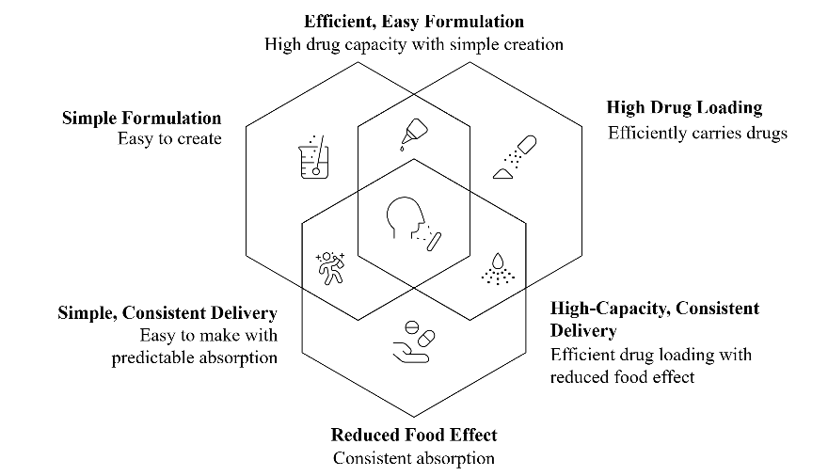

Fig. 1: Advantages of SMEDDS
The key objective of current research was to improve the solubility and oral bioavailability of omega fatty acids through SMEDDS. The formulated SMEDDS was assessed for its morphology, self-emulsification performance, in-vitro dissolution, and stability tests. The findings of this study will assist in designing lipid-based formulations for other nutraceuticals that are poorly soluble in water.

MATERIALS AND METHODS

Materials
The fatty acid-rich oil was obtained from Research-Lab Fine Chem Industries, Mumbai. Cremophor RH 40, Polyethylene Glycol 400, Tween 20 and Tween 80 were procured from Himedia Laboratories. Span 20 and Span 60 were obtained from Molychem Industries. All the chemicals and solvents used in the research were of analytical quality and were used without further purification.

Methods

Miscibility Study
The different surfactants were screened by homogenizing them with an excess quantity of fatty acid using a high-shear homogenizer at 3000 rpm while maintaining the temperature at 35ºC. To this mixture, phosphate buffer was added to mimic the ionic composition and pH of intestinal fluid (Bellesi et al., 2014). The vortexing was continued to make the oil phase miscible with the aqueous phase. After attaining equilibrium, the mixtures were given a centrifuge for 10 minutes at 1000 rpm. The supernatant was then removed using a glass pipette for visual examination, and the concentration of ALA was determined using a UV-visible double beam spectrophotometer. (Shimadzu UV-1800) at 230 nm. (Naso et al., 2021) (Laddha et al., 2014)

Construction of pseudo-ternary phase diagram
Based on the miscibility study, the pseudo-ternary phase diagram was constructed for fatty acid as oil component, a selected mixture of surfactant and co-surfactant (Smix). Water, oil and Smix in specific ratio (1:1, 2:1, 1:2) were the three variables utilized. The aqueous titration method was used to create the ternary phase diagram (Gupta et al., 2011; Kumar et al., 2011). To create the phase diagram, a gradual titration with distilled water was performed to each weight fraction of oil and Smix by increasing the proportion of oil by 10% up to 90%. The production of a transparent and easily flowable o/w microemulsion was then visually seen. A pseudo-ternary phase diagram was used to depict the physical condition of the microemulsion. The aqueous phase was represented by one axis, the oil phase by another, and the Smix at different weight ratios (1:1, 2:1, 1:2) by a third. The transition of the sample's appearance from transparent to turbid was used to identify the phase boundary. The online software ternary plot was used to create the phase diagram. Ternary phase diagrams were also created for different surfactant to co-surfactant ratios, such as 1:2 and 2:1 (Emad et al., 2023) (Laddha et al., 2014).

Preparation of SMEDDS
The SMEDDS were prepared using a Smix ratio based on pseudo-ternary phase diagrams. The fatty acid was used as the oil phase and the selected amount of Smix was mixed with the oil phase slowly while stirring continuously using a high shear homogenizer until a uniform mixture was obtained (Lee et al., 2014). To ensure complete mixing, this mixture was heated to 40°C in a water bath for 10 minutes while being stirred occasionally (Laddha et al., 2014). After being examined for turbidity, phase separation, or gelling impact, this formulation preconcentrate was stored at room temperature for further analysis.

Evaluation of SMEDDS
- Self-emulsification time and visual evaluation
Using distilled water as an aqueous medium at 37±0.5ºC and magnetic stirrer running at 200 rpm were used to test the self-emulsification capability. 1 ml SMEDDS formulation was added to 100 ml of distilled water, and the time required between the SMEDDS addition and completion of emulsification process was noted. The emulsification process was visually examined (Huo et al., 2018).

- Viscosity
Viscosity of the prepared SMEDDS was determined by using rotating spindle Brookfield viscometer (Karamustafa and Çelebi, 2008). After weighing, 20 g of preconcentrate was added in to a beaker. Viscosity was determined with the help of spindle no. 6 and a speed of 12 rpm at 25°C for 5 min. Viscosity measurement was done in triplicate.

- Droplet size
The measurement of emulsion droplet size was achieved by Particle Size Analyzer- Litesizer DLS 500 (Anton Paar) with the dynamic light scattering at 25°C. Using a magnetic stirrer, 100 μL of SMEDDS was mixed with 100 mL of distilled water with gentle stirring. To settle the undissolved fraction, beakers were incubated at 25°C for 30 minutes. All investigations were conducted three times, and the z-average diameter values were utilized. The polydispersity index (PDI) and % transmittance was also determined in the same procedure. (Kim et al., 2019)

- Zeta potential
The magnitude of surface charge has a direct correlation with emulsion stability. Using a Litesizer DLS 500 (Anton Paar), the zeta potential of the diluted SMEDDS formulation was determined. The SMEDDS are diluted 20 times with distilled water and stirred for a minute using a magnetic stirrer.

- In-vitro dissolution
The Paddle type (USP type II) dissolution apparatus was used to conduct an in-vitro drug release study. Fatty acid-containing SEMDDS was put into hard gelatin capsules ("size 00") and added to pH 6.8 phosphate buffer, which is perpetuated at 37±0.5°C. The paddle's revolution speed was maintained at 50 revolutions per minute. At 5, 10, 15, 30, 45, and 60 minutes, the 5 mL aliquot was taken out and passed via membrane filters with 0.45 µm pores. To maintain the sink condition, the dissolving medium aliquot was replaced. The concentration of ALA was determined spectrophotometrically at 230 nm. (Laddha et al., 2014)

- Stability study
As a part of stability analysis conducted in compliance with ICH guidelines to evaluate the effects of humidity and temperature on the SMEDDS, the prepared SMEDDS was held for a month at room temperature (RT) and under accelerated circumstances (40ºC ± 2ºC and 75% ± 5% RH). To confirm the stability of the produced formulation during the storage phase, parameters including emulsification efficiency, physical appearance, globule size and percent transmittance were evaluated. (Emad et al., 2023)

RESULTS AND DISCUSSION
3.1. Miscibility Study
When added to the aqueous phase at suitable temperature, self-emulsifying formulation made of surfactant, co-surfactant and oil should be a transparent, single phase liquid with a high solvent capacity. (Kohli et al., 2010) The miscibility of fatty acids with aqueous phase in the presence of various surfactants was evaluated visually and the concentration of ALA in each mixture was noted using spectrophotometer. The results were mentioned in the table 1:

Table 1: Miscibility Study
Sr. No. | Surfactant | Visibility | ALA concentration
1 | Cremophor RH 40 | Clear | 248.63 µg/ml
2 | PEG 400 | Clear | 344.26 µg/ml
3 | Span 20 | Turbid | 45.29 µg/ml
4 | Span 60 | Hazy | 158.49 µg/ml
5 | Tween 20 | Hazy | 106.06 µg/ml
6 | Tween 80 | Clear | 438.389 µg/ml
On visual inspection, the Cremophor RH 40, PEG 400 and Tween 80 showed a clear emulsion. Thus, Tween 80 and PEG 400 were chosen as surfactant and co-surfactant, respectively, considering the ALA concentration.

3.2. Pseudo-ternary phase diagram
SMEDDS formulation should be simple and safe, prepared using nontoxic surfactants (Kang et al., 2004). The key to achieving balance during loading and avoiding phase separation when diluted in GIT fluids is figuring out the excipient ratio for SMEDDS. In order to determine the link between the SMEDDS components, a phase diagram study was carried out (Emad et al., 2023).
The pseudo ternary phase diagram was plotted for three variables i.e. water, oil and Smix in specific ratios (1:1, 2:1, 1:2) shown in fig 2. The Smix ratio of 2:1 shows the higher monophasic region. Because Tween 80 lowers interfacial tension and allows surfactants to penetrate into the aqueous phase, small globules were generated at high concentrations. Additionally, a flexible film was created by PEG 400, which raises the system's entropy. It also modifies the viscosity, polarity, refractive index and density of the aqueous phase, further reducing interfacial tension. Therefore, the 2:1 Smix ratio was chosen for additional investigation.
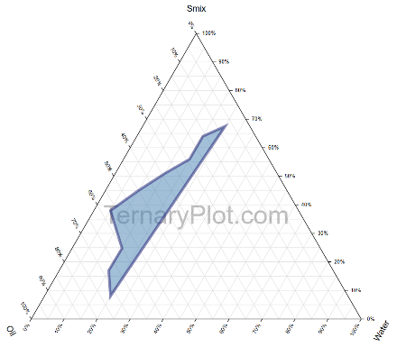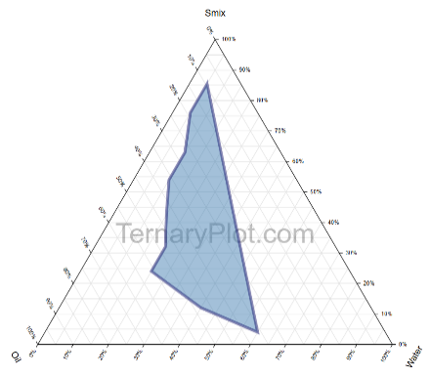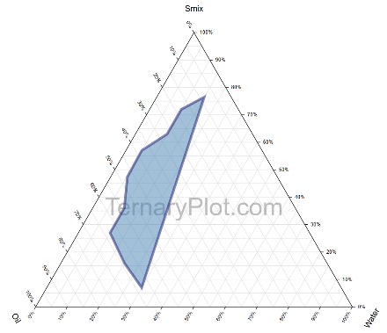

Fig. 2: Pseudo-ternary phase diagrams (a) Smix 1:1 (b) Smix 2:1 (c) Smix 1:2

3.3. Characterization of SMEDDS
The SMEDDS was prepared utilizing a high shear homogenizer according to the miscibility test and pseudo ternary phase diagram. The prepared SMEDDS was stored in a tightly closed container for further evaluation.
- Self-emulsification time and visual evaluation
Visual assessment was used to evaluate self-emulsification. Under the defined conditions, the time required for complete emulsification of the SMEDDS was found to be less than a minute. The clear, isotropic, fine solution indicates the formation of a microemulsion (Bahadur et al., 2020).

- Viscosity
The viscosity character has been evaluated to make sure SMEDDS is physically stable. Additionally, the more viscous formulations can impact drug release and its bioavailability due to low emulsification rate. Thus, SMEDDS dispersion in an aqueous medium is crucial (Patel and Sawant, 2019). The viscosity of the formulation was found to be 64.6 ± 2.4 cP, that is low enough to assist rapid emulsification.

- Droplet size and zeta potential
The prepared SMEDDS had a mean globule size of 645.2 nm and a PDI of 0.861 (Fig. 3). The adsorbed surfactant layer and the observed zeta potential of -34.9 mV (Fig. 4) provide the repulsion needed to stop globular coalescence. This outcome validates SMEDDS's physical stability.
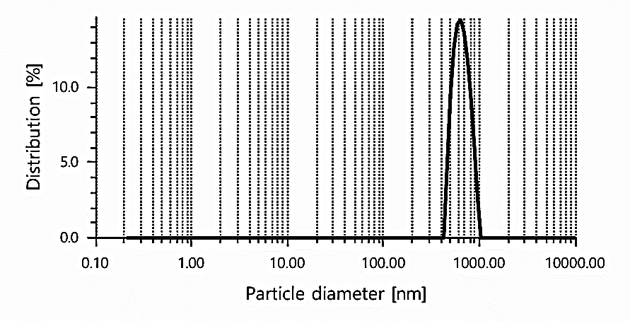

Fig. 3: Mean globule size of SMEDDS

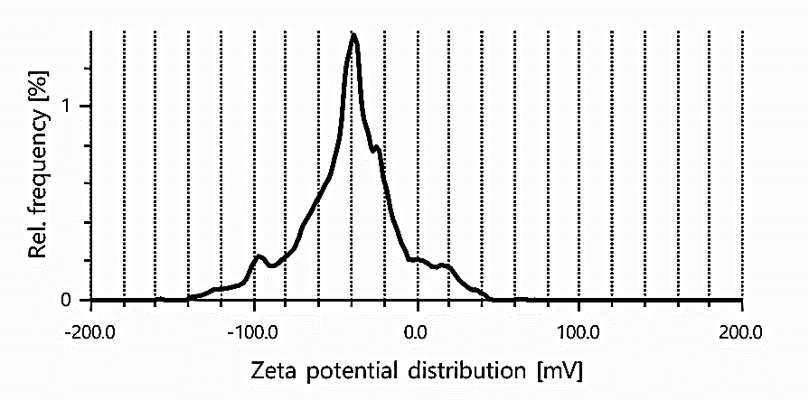

Fig. 4: Zeta potential of SMEDDS

- In vitro dissolution studies
Since a drug dissolve as a free molecule, micelle, or microemulsion droplet upon contact with water, conventional in-vitro dissolution techniques are inadequate for studying the in-vitro dissolution of SMEDDS (Ahmad et al., 2011). Consistent release kinetics are ensured by dissolution studies utilizing hard gelatin capsules. The release of fatty acid from SMEDDS was studied in a phosphate buffer (pH 6.8) as a dissolving medium (Fig. 5). The first 15 minutes showed a greater drug release (63.19%). When SMEDDS formulations are added to dissolution media and gently stirred, the fatty acids in the oil phase of the SMEDDS may cause immediate emulsification into the water. When compared to the pure oil contained in the hard gelatin capsule, the fatty acid release from SMEDDS was significantly higher.

Fig. 5: In-vitro drug release profile

- Stability study
The outcomes of the stability study parameters are shown in Table 2. The self-emulsification time, visual assessment, drug content assay, transmittance percentage, and globule size of SMEDDS formulation were examined. SMEDDS did not exhibit any cloudiness or precipitation during storage. After dilution, the microemulsion system showed a consistent globule size distribution. Self-emulsification duration, percentage transmittance, and globule size all exhibit negligible variations. As a result, it was concluded that the SMEDDS was stable under both room temperature and accelerated circumstances (40±2º C/75±5% RH).

Table 2: Stability study parameters
Condition | Parameters | 0th Day | 30th Day
At room temperature | Visual inspection  Self-emulsification time  Drug content  % Transmittance  Droplet size | Clear  48 sec  95.6 %  89.6 %  645.2 nm | Clear  52 sec  92.2 %  88.5 %  715.8 nm
Accelerated condition | Visual inspection  Self- emulsification time  Drug content  % Transmittance  Droplet size | Clear  48 sec  95.6 %  89.6 %  645.2 nm | Clear  55 sec  89.2 %  92.0 %  749.1 nm

CONCLUSION
This study successfully developed a Self-Micro Emulsifying Drug Delivery System (SMEDDS) for omega fatty acids, addressing the critical challenge of poor water solubility often found in nutraceuticals. By utilizing a specific mixture of Tween 80 and PEG 400, the researchers achieved a stable, isotropic formulation that rapidly emulsifies in water with a small droplet size (645.2 nm), which is essential for enhancing absorption.
The study confirmed that SMEDDS significantly outperforms pure oily solutions in terms of drug release rates, offering a more effective delivery method for bioactive fatty acids. Furthermore, stability tests confirmed the formulation's robustness over a month, indicating its potential for commercial scalability and use in the nutraceutical industry to treat conditions like cardiovascular disorders and neurodegeneration.
Disclaimer (Artificial intelligence)

Author(s) hereby declare that NO generative AI technologies such as Large Language Models (ChatGPT, COPILOT, etc.) and text-to-image generators have been used during the writing or editing of this manuscript.

REFERENCES

Ahmad, J., Kohli, K., Mir, S.R., Amin, S., 2011. Formulation of self-nanoemulsifying drug delivery system for telmisartan with improved dissolution and oral bioavailability. J. Dispers. Sci. Technol. 32, 958–968.

Bahadur, S., Yadu, K., Baghel, P., Naurange, T., Sahu, M., 2020. Review of formulation and evaluation of self-micro emulsifying drug delivery system (SMEDDS). Sci. Pharm. Sci. 0, 25–35. https://doi.org/10.15587/2519-4852.2020.210825

Bellesi, F.A., Ruiz-Henestrosa, V.M.P., Pilosof, A.M., 2014. Behavior of protein interfacial films upon bile salts addition. Food Hydrocoll. 36, 115–122.

DeFelice, S.L., 1995. The nutraceutical revolution: its impact on food industry R&D. Trends Food Sci. Technol. 6, 59–61. https://doi.org/10.1016/S0924-2244(00)88944-X

Dokania, S., Joshi, A.K., 2015. Self-microemulsifying drug delivery system (SMEDDS) – challenges and road ahead. Drug Deliv. 22, 675–690. https://doi.org/10.3109/10717544.2014.896058

Emad, N.A., Ahmed, B., Alhalmi, A., Alzobaidi, N., Al-Kubati, S.S., 2021. Recent progress in nanocarriers for direct nose to brain drug delivery. J. Drug Deliv. Sci. Technol. 64, 102642. https://doi.org/10.1016/j.jddst.2021.102642

Emad, N.A., Sultana, Y., Aqil, M., Saleh, A., Al Kamaly, O., Nasr, F.A., 2023. Omega-3 fatty acid-based self-microemulsifying drug delivery system (SMEDDS) of pioglitazone: Optimization, in vitro and in vivo studies. Saudi J. Biol. Sci. 30, 103778. https://doi.org/10.1016/j.sjbs.2023.103778

Gupta, A., Mishra, D., Mahajan, S., 2011. Preparation and in-vitro evaluation of self emulsifying drug delivery system of antihypertensive drug valsartan. Int J Pharm Life Sci 2, 633–639.

Han, S.D., Jung, S.W., Jang, S.W., Son, M., Kim, B.M., Kang, M.J., 2015. Reduced Food-Effect on Intestinal Absorption of Dronedarone by Self-microemulsifying Drug Delivery System (SMEDDS). Biol. Pharm. Bull. 38, 1026–1032. https://doi.org/10.1248/bpb.b15-00110

Hauss, D.J., 2007. Oral lipid-based formulations. Adv. Drug Deliv. Rev. 59, 667–676. https://doi.org/10.1016/j.addr.2007.05.006

Hsieh, C.-M., Yang, T.-L., Putri, A.D., Chen, C.-T., 2023. Application of Design of Experiments in the Development of Self-Microemulsifying Drug Delivery Systems. Pharmaceuticals 16, 283. https://doi.org/10.3390/ph16020283

Huo, T., Tao, C., Zhang, Minxin, Liu, Q., Lin, B., Liu, Z., Zhang, J., Zhang, Meijing, Yang, H., Wu, J., Sun, X., Zhang, Q., Song, H., 2018a. Preparation and comparison of tacrolimus-loaded solid dispersion and self-microemulsifying drug delivery system by in vitro/in vivo evaluation. Eur. J. Pharm. Sci. 114, 74–83. https://doi.org/10.1016/j.ejps.2017.12.002

Kang, B.K., Lee, J.S., Chon, S.K., Jeong, S.Y., Yuk, S.H., Khang, G., Lee, H.B., Cho, S.H., 2004. Development of self-microemulsifying drug delivery systems (SMEDDS) for oral bioavailability enhancement of simvastatin in beagle dogs. Int. J. Pharm. 274, 65–73.

Karamustafa, F., Çelebi, N., 2008. Development of an oral microemulsion formulation of alendronate: Effects of oil and co-surfactant type on phase behaviour. J. Microencapsul. 25, 315–323. https://doi.org/10.1080/02652040801977045

Keservani, R.K., n.d. Chapter 9 - Nutraceutical Formulations and Challenges.

Kim, D.S., Cho, J.H., Park, J.H., Kim, J.S., Song, E.S., Kwon, J., Giri, B.R., Jin, S.G., Kim, K.S., Choi, H.-G., Kim, D.W., 2019. Self-microemulsifying drug delivery system (SMEDDS) for improved oral delivery and photostability of methotrexate. Int. J. Nanomedicine Volume 14, 4949–4960. https://doi.org/10.2147/IJN.S211014

Kohli, K., Chopra, S., Dhar, D., Arora, S., Khar, R.K., 2010. Self-emulsifying drug delivery systems: an approach to enhance oral bioavailability. Drug Discov. Today 15, 958–965. https://doi.org/10.1016/j.drudis.2010.08.007

Kumar, M.S., Shailaja, P., Murthy, K., Pradesh, A., 2011. Improvement of oral bioavailability of nifedipine through self-microemulsifing drug delivery systems. J Glob Trends Pharm Sci 2, 364–388.

Laddha, P., Suthar, V., Butani, S., 2014. Development and optimization of self microemulsifying drug delivery of domperidone. Braz. J. Pharm. Sci. 50, 91–100. https://doi.org/10.1590/S1984-82502011000100009

Lee, D.W., Marasini, N., Poudel, B.K., Kim, J.H., Cho, H.J., Moon, B.K., Choi, H.-G., Yong, C.S., Kim, J.O., 2014. Application of Box–Behnken design in the preparation and optimization of fenofibrate-loaded self-microemulsifying drug delivery system (SMEDDS). J. Microencapsul. 31, 31–40. https://doi.org/10.3109/02652048.2013.805837

Naso, J.N., Bellesi, F.A., Pizones Ruiz-Henestrosa, V.M., Pilosof, A.M.R., 2021. A new methodology to assess the solubility of fatty acids: Impact of food emulsifiers. Food Res. Int. 139, 109829. https://doi.org/10.1016/j.foodres.2020.109829

Patel, M.H., Sawant, K.K., 2019. Self microemulsifying drug delivery system of lurasidone hydrochloride for enhanced oral bioavailability by lymphatic targeting: In vitro, Caco-2 cell line and in vivo evaluation. Eur. J. Pharm. Sci. 138, 105027. https://doi.org/10.1016/j.ejps.2019.105027

Shah, A.V., Desai, H.H., Thool, P., Dalrymple, D., Serajuddin, A.T.M., 2018. Development of self-microemulsifying drug delivery system for oral delivery of poorly water-soluble nutraceuticals. Drug Dev. Ind. Pharm. 44, 895–901. https://doi.org/10.1080/03639045.2017.1419365

Şimşek, H., Uçar, A., 2025. Functional Aspects of Polyunsaturated Fatty Acids as Nutraceuticals, in: Amir Ashraf, S., Adnan, M. (Eds.), Food Bioactives and Nutraceuticals. Springer Nature Singapore, Singapore, pp. 211–223. https://doi.org/10.1007/978-981-97-9723-3_8

Yang, T.-L., Hsieh, C.-M., Meng, L.-J., Tsai, T., Chen, C.-T., 2022. Oleic Acid-Based Self Micro-Emulsifying Delivery System for Enhancing Antifungal Activities of Clotrimazole. Pharmaceutics 14, 478. https://doi.org/10.3390/pharmaceutics14030478

Malve, H., & Bhalerao, P. (2023). Past, present, and likely future of nutraceuticals in India: Evolving role of pharmaceutical physicians. Journal of Pharmacy and Bioallied Sciences, 15(2), 68-74.

Chopra, A. S., Lordan, R., Horbańczuk, O. K., Atanasov, A. G., Chopra, I., Horbańczuk, J. O., ... & Arkells, N. (2022). The current use and evolving landscape of nutraceuticals. Pharmacological Research, 175, 106001.

Farooqui, Heena, and Prashant Upadhyay. 2021. “Optimization and Characterization of Self Nano Emulsifying Drug Delivery System Loaded With 18- β Glycyrrhetinic Acid”. Journal of Pharmaceutical Research International 33 (59A):304-24. https://doi.org/10.9734/jpri/2021/v33i59A34275.

Yahaya, Z. S., A. R. Oyi, T. S. Allagh, and A. Abdulsamad. 2018. “Development and Characterization of Self-Nano Emulsifying Drug Delivery System of Ibuprofen”. Journal of Pharmaceutical Research International 23 (2):1-13. https://doi.org/10.9734/JPRI/2018/43090.

