Multivariate Modelling of Total Petroleum Hydrocarbon Reduction in Crude Oil-Contaminated Soil using Costus Afer Plant

ABSTRACT
Phytoremediation is a cost-effective and environmentally friendly approach for the treatment of crude oil-contaminated soil. Costus afer is widely available in the Niger Delta region and has shown strong potential for the remediation of polluted sandy loam soils. This study developed a predictive model describing the phytoremediation performance of Costus afer in reducing total petroleum hydrocarbon (TPH) concentrations over a 90-day treatment period. A multivariate regression model was applied to quantify the relationship between TPH removal and two independent variables: crude oil volume (0.5, 1.0 and 1.5 litres) and remediation time (30, 60, and 90 days). Model evaluation showed close agreement between measured and predicted TPH removal, with correlation coefficients ranging from 0.808 to 0.828. Prediction errors were low, as indicated by root mean square error values between 3.06 and 5.60, while residual prediction deviation values ranged from 2.05 to 8.21. Over 80% of the variance in TPH removal was explained by the model (R² > 0.80), confirming strong reliability. The model provides a practical tool for estimating crude oil volume and remediation time required for effective cleanup of contaminated sandy loam soils using Costus afer plants of known age. This study supports the use of predictive modelling for optimizing phytoremediation system design and management in crude oil-contaminated environments.

KEYWORDS: Phytoremediation, bioremediation, TPH, modelling quality, Costus afer plant.

INTRODUCTION
Crude oil exploration and production activities constitute a major source of petroleum hydrocarbon contamination, largely resulting from pipeline vandalization, ruptures, and leakage from storage facilities (NNPC, 2021; Okparanma et al; 2023; Emeka et al; 2023). Petroleum hydrocarbon contamination alters the physical, chemical, and biological characteristics of the soil, and poses significant risks to the environment and human health (Sales da Siva et al., 2020). Crude oil comprises thousands of organic compounds, most of which are hazardous and hydrophobic. Petroleum hydrocarbons account for approximately 50–98% of crude oil, depending on its origin (Al-Dhabaan, 2019). Chemical composition of crude oil is broadly classified into saturates, aromatics, resins, and asphaltenes (Al-hawash et al., 2018).
Soil is one of the most essential natural resources on earth, substantially for infrastructural development and agricultural production for the well-being of humans (Bhattacharya et al., 2015; Okparanman et al., 2023). Petroleum contaminants enter the soil systems mainly through pipeline failures, storage tank leakage, and vandalization thereby altering soil functionality. Several research has discussed different methods and approaches for treating contaminated soils (Muttaleb & Ali, 2022). Among these, ex-situ phytoremediation is recognized as an environmentally friendly and cost-effective approach for removing organic contaminants such as total petroleum hydrocarbon (TPH), benzene, toluene, ethylbenzene, xylene (BTEX), and polychlorinated biphenyls (PCBs).
Phytoremediation method has several approaches such as phytoaccumulation, phytostabilization, volatilization, phytofiltration, phytoextraction and rhizodegradation (Thijs et al., 2017). In this study, phytostabilization was adopted, a process in which green plants immobilize contaminants through root uptake, adsorption onto root surfaces, or precipitation within the rhizosphere (Berti & Cunningham, 2000; Muthusaravanan et al., 2018).
Numerous plant species have been reported for the remediation of crude oil-contaminated soils, including Abelmoschus esculentus, Moench, Corchorus Olitorius L, Cordia myxa, maize, and elephant grass, spear grass, guinea grass, and gamba grass (Ayotamuno et al., 2006; Njoku et al., 2012; Rad et al., 2020; Kogbara et al., 2018). These studies have shown that remediation efficiency varies with plant species and age. Emeka et al. (2023) further emphasized that the appropriate selection of plant type and maturity significantly enhances phytoremediation performance. Costus afer, which is abundant in the tropical moist Niger Delta region of Nigeria, grows prolifically and remains underutilized for soil remediation despite its recognized pharmaceutical value, justifying its investigation as seen in Plate 1. Therefore, this study provides qualitative insight into the regression relationship between the percentage of TPH removed and varying contamination levels classified as low, medium, and high, using Costus afer plants of different ages.
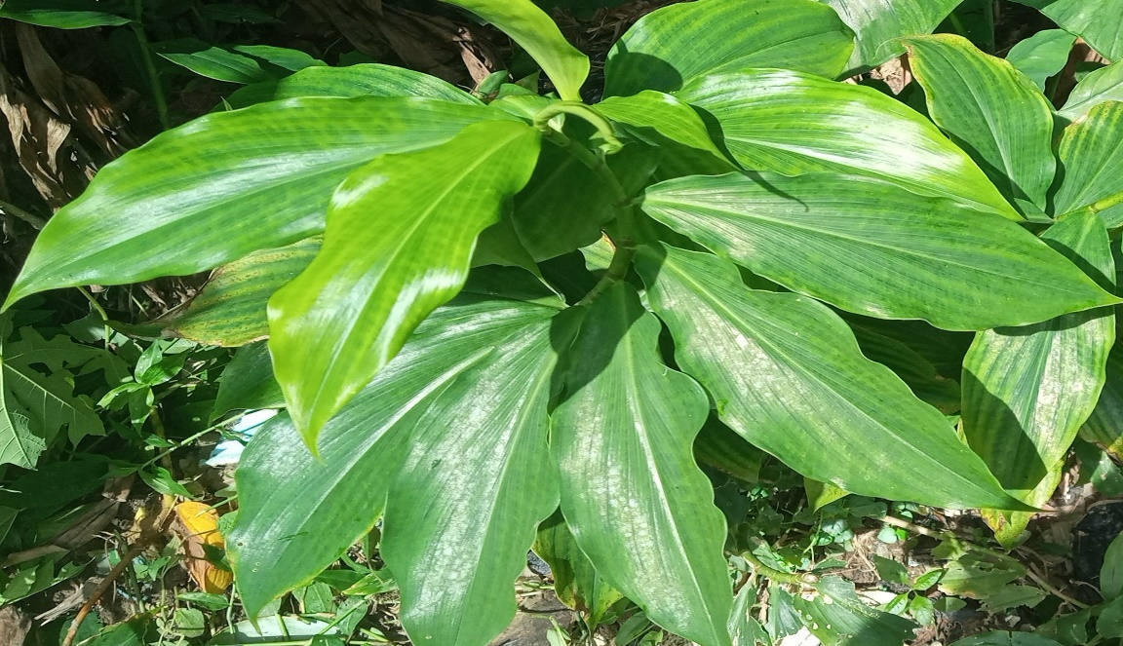Plate 1: Costus afer Plant
The phytoremediation process is driven by the absorptive capacity of the Costus afer, which contributes to the restoration of petroleum hydrocarbon-contaminated soils. This mechanism further expands current understanding of the role of plant age in enhancing the removal of harmful organic compounds from impacted environments. This study aims to develop a multivariate regression model capable of predicting the phytoremediation performance of crude oil-contaminated sandy loam soils based on contamination level and the ages of Costus afer plants. The developed model serves as a predictive tool for assessing remediation efficiency under varying site conditions and plant growth stages, thereby supporting informed decision making in the design and optimization of phytoremediation strategies for petroleum hydrocarbon contaminated environemnts.

MATERIALS AND METHODS
The Study Area
The study was carried out at the research farm of the Rivers State Institute of Agricultural Research and Training (RIAT) located within Rivers State University premises, Port Harcourt. The soil of the study area is predominantly oxisols according to the United States Department of Agriculture (USDA) soil taxonomic system, classified as sandy loam texture (Ayotamuno & Kogbara, 2007). Rivers State lies within the tropical rainforest ecological zone and is characterized by high rainfall and warm climatic conditions. Annual rainfall ranges from 2000 to 2484 mm, with approximately 70% occurring between May and August, and an average temperature of 27 °C (Ayotamuno et al., 2006; Fubara-Manuel et al., 2021). These climatic and edaphic conditions provide a suitable natural environment for phytoremediation studies, particularly for evaluating plant-based remediation processes in petroleum hydrocarbon-contaminated sandy loam soils.

Experimental Design and Setup
The experimental design used in this study was a group-balanced block design (GBBD). The procedure described by Ayotamuno et al. (2006) was followed to establish three crude oil contamination levels: low, medium, and high. Soil samples of 48kg was weighed and distributed equally into four separate reactors. Three of the reactors were contaminated with 0.5, 1.0, and 1,5 litres of Bonny-Light crude oil, to generate the stated contamination levels. The medium contamination level was duplicated to form a fourth reactor, which serves as the control. Two independent variables were considered: crude oil concentration constituted factor A with three levels: low (C1), medium (C2), and high (C3), and the age of Costus afer plants constituted factor B with six levels: 7 days (T1), 14 days (T2), 21 days (T3), 28 days (T4), 35 days (T5), and 42 days (T6) respectively.

Wide-mouth black plastic basins (reactors) with 0.5m top diameter and 0.3m depth were filled with the prepared soil-oil mixture to serve as the planting medium (Plate 2.1). The reactors were kept in an open barn to shield them from direct rainfall and ensure controlled moisture conditions. Before transplanting, the contaminated soils were incubated for three days to allow stabilization of soil-oil interactions. The Costus afer plants were nursed separately for the designated age periods and subsequently transplanted into the reactors. Each reactor was irrigated with 0.5 L of water three times a week until the cessation of remediation. This irrigation regime was consistent with established remediation protocols (Ayotamuno et al., 2010), and ensured uniform moisture conditions throughout the field experiment. The design ensured experimental reliability, reduced bias, and allowed systematic evaluation of treatment interactions under controlled environmental conditions for accurate interpretation purposes.
Sampling and Analytical Methods
Soil samples were collected from uncontaminated soil before crude oil and from soil-crude oil mixtures during the field experiment. Samples were collected from different spots and bulked together for analysis. About 5g of soil sample was used for the analysis. The sample was dried chemically using 5g of anhydrous sodium sulphate to remove residual moisture. Extraction was carried out separately by using 10ml Dichloromethane, and O-Terphenyl was used as a surrogate. The soil-solvent mixture was agitated for 45 minutes using a Vortex mixer with glass wool to enhance extraction efficiency. The extract was decanted through a glass funnel and concentrated to 1ml before gas chromatography injection for total petroleum hydrocarbon analysis. Quantification of TPH compounds was performed using the external standard method, and TPH removal percentage was calculated using equation 1.
$TPH removal (\%)=\frac{IC-FC}{IC}×100$ (1)
Where IC is the initial concentration, and FC is the final concentration of TPH.

Modelling Procedure
Theoretical Development
Regression can be expressed as the functional relationship between independent and dependent variables. The independent variable (X) is the predictor or regressor while the dependent variable (Y) is the predicted (Chikwue et al., 2020). When there are more than two variables and one of them is assumed to be dependent upon the others, the functional relationship between the variables is known as multiple regressions. The multiple linear regression analysis of the function with two independent variables namely the remediation time (X₁) and crude oil volume (X₂) of the petroleum hydrocarbon while the percentage removal of TPH was the dependent variables as shown in equation 2. The linear regression model was strictly based on changes in the remediation period and crude oil volume. As shown in equation 2, the linear regression of Y on X₁ and X₂ because the dependent variable Y varies partially due to variation in X₁ and X₂ respectively. The coefficient β_{o}, β_{1,} β₂ represents partial regression coefficient on Y on X₁ with X₂ held constant and Y on X₂ with X₁ held constant respectively.
Formulation of predictive multiple linear regression model for phytoremediation of petroleum hydrocarbon contaminated soil can be expressed using equation (2) as reported in Ehirim et al. (2020)
$Y = βo + β_{1}X_{1} + β_{2}X_{2}+ e$ (2)
Where TPH is the dependent variables, equation 2 can be rewritten as;
$TPH (\%) = βo + β_{1}X_{1}+ β_{2}X_{2} + e$ (3)
In considering percentage reduction of TPH equation 3 can be expressed as
$TPH \left(\%\right)= f(R_{t}, V)$ (4)
Y = the percentage of TPH Removal (%)
X₁ = Remediation Periods (Days)
X₂ = Crude oil volume
e = error
β_{o}, β_{1,} β₂, represents partial regression coefficients of the variables
The error can be evaluated by rearranging equation (3) as follows.
$e = y-\left(βo + β_{1}X_{1}+ β_{2}X_{2}\right)$ (5)
The sum of square is expressed as
$Sr= ∑e^{2}=∑( y-βo-β_{1}X_{1}-β_{2}X_{2})^{2}$ (6)
Partial differential of equation (6) with respect to partial regression coefficients, are as follows.
Differentiating partially with respect to $βo$
$\frac{∂S_{r}}{∂a_{0}}$ = $-2∑( y-βo-β_{1}X_{1}-β_{2}X_{2})$ (7)
Differentiating partially with respect to $β_{1}$
$\frac{∂S_{r}}{∂a_{1}}$ = $-2∑( y-βo-β_{1}X_{1}-β_{2}X_{2})X_{1}$ (8)
Differentiating partially with respect to $β_{2}$
$\frac{∂S_{r}}{∂a_{2}}$ = $-2∑( y-βo-β_{1}X_{1}-β_{2}X_{2})X_{2}$ (9)
Reduce to zero to minimize error.
$\frac{∂S_{r}}{∂a_{0}}$ = $0$ (10)
$\frac{∂S_{r}}{∂a_{1}}$ =$0$ (11)
$\frac{∂S_{r}}{∂a_{2}}$ = $0$ (12)
Rearranging of equation 7, 8 and 9 by substituting equation 10, 11 and 12 respectively
0 = $-2∑( y-βo-β_{1}X_{1}-β_{2}X_{2})$ (13)
$0$= $-2∑( y-βo-β_{1}X_{1}-β_{2}X_{2})X_{1}$ (14)
$0$= $-2∑( y-βo-β_{1}X_{1}-β_{2}X_{2})X_{2}$ (15)
Arrangement and simplification of equation (13 to 15)
$∑βo+ β_{1} ∑X_{1}+ β_{2 }∑X_{2}= ∑ y$ (16)
$∑βo$ is the number samples which is represented by n
$∑βo=n$, then the equation (15) becomes
$n+β_{1}∑X_{1}+ β_{2} ∑X_{2}= ∑ y$ (17)
From equation (13), we have
$βo∑X_{1}+β_{1}∑X_{1}^{2}+β_{2}∑X_{1}X_{2 }= ∑X_{1}y$ (18)
From equation (14), we have
$βo∑X_{2}+β_{1}∑X_{1}X_{2 }+β_{2}∑X_{2}^{2}+= ∑X_{2}y$ (19)
Using matrix form to rearrange equation (17 to 19), can be expressed as follows
{A} {X} = {B}
{A} is the partial regression coefficient matrix
{X} is the independent variables
{B} is the dependent variable
n ∑X₁ ∑X₂ $β$₀ ∑ y
∑X₁ ∑X₁² ∑X₁ X₂ $β$₁ ∑ X₁ y (20)
∑X₂ ∑X₁ X₂ ∑X₂² $β$₂ ∑X₂y
The summation required for equation (20) are computed in Table 1 and 2 and substituting the values using cramer’s rule with the aid of MDETERM in Microsoft excel toolbox.
Evaluation of Model Quality
Remediation periods and crude oil volume were the varying factors, the phytoremediation potential of Costus afer plant was determined experimentally and fitted into the multiple regression model. The models were determined by statistical method using Minitab 19 software (Microsoft Inc, USA) at experimental periods of remediation (0, 30, 60 and 90 days), and crude oil volume (0.5, 1.0 and 1.5 litres). The validity (goodness of fit) of the phytoremediation potential models was tested by comparison with the experimental data and the prediction ability was determined by the following indicators: coefficient of determination (r²), adjusted coefficient of determination, residual prediction deviation (RPD) and root mean square error (RMSE). The best model describing the phytoremediation potential of petroleum hydrocarbon contaminated soil treated with different ages of Costus afer at various periods of remediation and levels of contamination was opted for based on the greater value of r² and lesser value of RMSE (Munawar & Kusumiyati, 2019; Hayati et al., 2020). Model prediction ability was categorized based on the following criteria: excellent if RPD $>$2.0, almost good if RPD $≤1.4 or <2.0$ and unreliable if RPD$<1.4$
(Chang et al., 2001)

$RMSE=\sqrt{\frac{\sum_{i-1}^{i-N}{{\left(\hat{γ}-Y_{i}\right)}^{2}}}{N}}$
Where:
$\hat{γ}$ = Predicted reference value
$Y_{i}$ = Measured refence value
N = Number of samples in the set
$$r_{Adj}^{2}=1-\frac{{{SS}_{E}}/{\left(n-p\right)}}{{{SS}_{T}}/{\left(n-1\right)}}$$
Where:
n = number of samples
p = predicted value
$r^{2}=\frac{{SS}_{model}}{{SS}_{T}}$
Where:
SS_{model} = Model sum of squares,
SS_{T} = Total sum of squares
RPD = $\frac{SD}{RMSE}$
Where SD = Standard deviation of the measured reference values

RESULTS AND DISCUSSION
Effect of Costus afer Plant on Percentage TPH Removal
The use of Costus afer plant to promotes TPH reduction across all contamination levels (C1–C3), and control (C4) with different plant age of 7, 14, 21, 28, 35, and 42 days corresponding to (T1 to T6) in the treatment details shown in Fig 1. It was observed that the early ages of the plant demonstrated the highest removal efficiency compare to the control. Specifically, younger plants achieve greater hydrocarbon reduction, while older plants show a gradual decrease in effectiveness. Averagely, 80% of TPH reduction were seen in C1 to C3 after 8 and 12 weeks of planting reflecting the dissipation of TPH through vigorous root of aged plant Fig 1b and 1c. The metabolic activity in younger Costus afer plants enhance rhizodegradation and stimulate microbial communities that degrade total petroleum hydrocarbons (TPH) in the rhizosphere.

The growth of Costus afer plants within 12 weeks of planting mirror the findings in related studies, where plant species and age influence TPH dissipation through root exudates and associated microbial stimulation that catalyze hydrocarbon breakdown. Okparanma et al. (2022) reported highest TPH reduction with younger Costus afer plants at early ages (7 days) relative to older ages after 90 days of treatment. Likewise, recent literature highlights that effective phytoremediation depends on plant vigor, root biomass, and rhizosphere interactions for hydrocarbon loss from soils (Cheng et al., 2025). The low TPH removal in the control (C4) also aligns with other studies showing limited natural attenuation without active vegetative remediation, reinforcing that plant-driven mechanisms accelerate TPH dissipation relative to unplanted soils (Fang et al., 2025). The sustained high removal rates for C1 -C3 shown in Fig 1b align with the findings of (Okparanma et al., 2022), showing the robustness of plant-microbe interactions in rhizosphere activity, which can maintain hydrocarbon degradation across extended growth periods.

Fig 1: TPH Removal Percentage in Crude oil Contaminated Soil Treated with Costus afer at Different ages of Plant over Time: (a) 4 Weeks after Planting; (b) 8 Weeks after Planting; (c) 12 Weeks After planting. Treatments (T1 =7 Days Old Plant; T2 =14 Days Old Plant; T3 =21 days Old Plant; T4 = 28 days Old Plant; T5: 35 Days Old Plant; T6 = 42 Days Old Plant; C1: Low Contamination Level; C2: Medium Contamination Level; C3: High Contamination Level; C4: Medium contamination Without Treatment; Error bar is standard error)

The model prediction in Table 1 described the TPH reduction (Y) as a function of remediation time (R_{t}) and crude oil volume (V) for six plant ages (T1 – T6). The positive coefficients of R_{t (}0.27 – 0.29) indicate that TPH removal increases with remediation time, confirming time-dependent degradation kinetics. Conversely, the negative coefficient of V (-0.54 to –1.70) showed that higher crude oil loading reduces removal efficiency, reflecting contaminant-stress inhibition. The progressive decrease in T1 to T6 suggests slightly lower baseline remediation with increasing plant age. Variation in V coefficients also implies age-dependent tolerance to hydrocarbon loads.
Overall, the models indicate statistically consistent trends: time enhances phytoremediation performance, whereas contaminant volume exerts a suppressive effect, with plant age modulating both influences.
Table 1: Model for Percentage TPH removed from Soil Treated with Costus Afer Plant
Treatment | Multivariate Regression Model
T1 | Y = 74.0222 + 0.2857R_{t} – 1.7033V
T2 | Y = 72.7744 + 0.2738R_{t} – 0.7533V
T3 | Y = 70.6856 + 0.2677R_{t} – 0.95V
T4 | Y = 70.6856 + 0.2684R_{t} – 0.5367V
T5 | Y = 69.5989 + 0.274R_{t} – 0.77V
T6 | Y = 68.3544 + 0.2798R_{t} – 1.1933V

Table 2 presents the percentages of TPH removed with Costus afer plant nursed for 7 to 42 days with measures and predicted values alongside associated prediction errors from crude oil-contaminated soil. The measured TPH removed 79.81% was closely related to the prediction of 81.74%, yielding to small errors of -1.93%, indicating model reliability. These relatively low error magnitudes and corresponding squared errors suggest good model accuracy and robustness across the treatment conditions. The rate of TPH reduction with increased retention time aligns with established phytoremediation principles, where prolonged plant-soil interaction enhances rhizodegradtion and microbial activity (Glick, 2010). The performance of Costus afer corroborates reports that certain tropical plants possess high tolerance to hydrocarbons and can stimulate biodegradation in crude oil-contaminated soils (Agamuthu et al., 2013). The close agreement between measured and predicted values supports the robustness of the developed predictive model and confirms Costus afer as an effective phytoremediator for crude oil-contaminated soils.
Table 2: Predicted and Percentage TPH removed in Crude Oil-Contaminated Soils with Costus afer Plant
Rt | V | Measured (%) | Predicted (%) | Error | Error²
30 | 0.5 | 79.81 | 81.74 | -1.93 | 3.7249
60 | 0.5 | 93.63 | 90.31 | 3.32 | 11.0224
90 | 0.5 | 97.42 | 98.88 | -1.46 | 2.1316
30 | 1 | 79.69 | 80.89 | -1.2 | 1.44
60 | 1 | 93.92 | 89.46 | 4.46 | 19.8916
90 | 1 | 94.91 | 98.03 | -3.12 | 9.7344
30 | 1.5 | 76.53 | 80.04 | -3.51 | 12.3201
60 | 1.5 | 94.1 | 88.61 | 5.49 | 30.1401
90 | 1.5 | 95.12 | 97.18 | -2.06 | 4.2436
 |  |  |  |  | ∑94.6487

Model Prediction Ability
The multivariate linear regression model developed on TPH reduction under phytoremediation conditions. The model validation was done by using constant plant age at different remediation period and levels of contamination. The regression analysis as computed using MINITAB computer software to establish the relationships. The values obtained showed a strong correlation between phytoremediation with crude oil volumes and remediation periods. The graph of phytoremediation experimental values vs predicted values was to determine the coefficient of determination (r²), root square mean error (RMSE) and residual prediction to deviation (RPD) values. The RMSE as presented in Fig 2 ranged from 3.06 to 5.60, R² (80.8 to 82.8%), standard error (3.46 to 3.76) with an RPD value ranging from 2.05 to 8.21. The model prediction ability can be described as excellent (Chang et al., 2001).
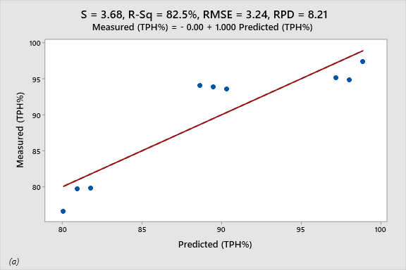
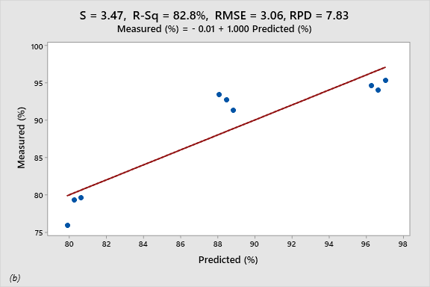
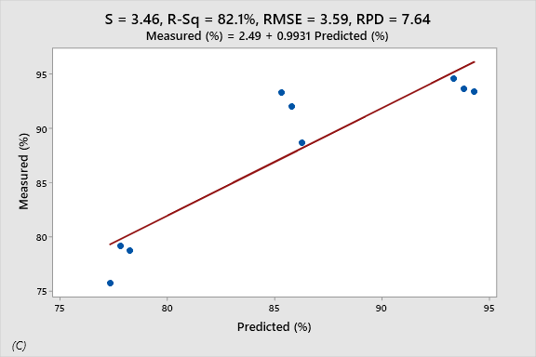
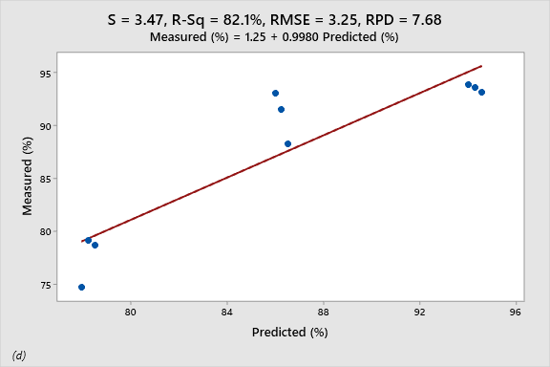

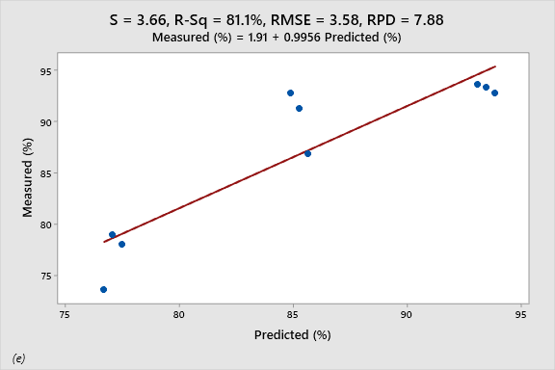
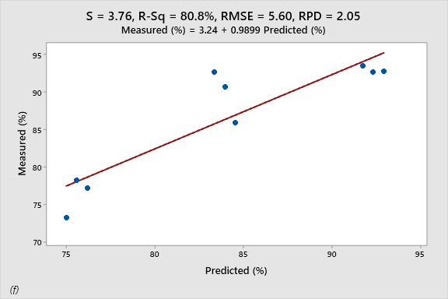
Fig 2. Measured and predicted percentage TPH removed from Different crude oil contamination levels (Low, medium, and high) treated with (a) 7 days old plant;(b) 14 days old plant;(c) 21 days old plant; (d) 28 days old plant; (e) 35 days old plant; (f) 42 days old plant (S: Standard error; R²: Coefficient of determination; RMSE: Root mean square error; RPD: Residual prediction deviation).
Conclusion
The multivariate linear regression model developed for predicting TPH reduction under a phytoremediation system demonstrated that Costus afer effectively supports remediation in crude oil-contaminated sandy loam soils across different plants ages. Even young plants at 7 days showed measurable TPH degradation, while 42-day-old plants achieved 85% removal efficiency. Model performance indicates strong predictive reliability, with a high coefficient of determination (R²), favourable residual prediction deviation, and low standard error alongside a correspondingly low root mean square error. These indicators confirm the robustness of model accuracy and goodness of fit. The model exhibits good prediction quality for estimating TPH reduction in the phytoremediation system of crude oil-contaminated sandy loam soils using Costus afer plant. This study further proposed field experiment of hydrocarbon contaminated soil to validate the expository on the remediation efficiency of Costus afer plant.

Disclaimer (Artificial intelligence)
Author(s) hereby declare that NO generative AI technologies such as Large Language Models (ChatGPT, COPILOT, etc.) and text-to-image generators have been used during the writing or editing of this manuscript.

References
- Agamuthu, P., Abioye, O. P., & Aziz, A. A. Phytoremediation of soil contaminated with used lubricating oil using Jatropha curcas. Journal of Hazardous Materials, 2013. 262: 273-278.

- Ayotamuno, M. J., Kogbara, R. B., & Taleat, M. O. Bioremediation of a petroleum hydrocarbon polluted agricultural soil at different levels of water application, Nigeria, Journal of Food, Agriculture & Environment 2006, 4(3 &4): 214 – 217.

- Cheng, P-C., Lin, M-s., Huamg, C-Y., Cheng, S-F., & Lin, Y-C. Adaptation and carbon reduction for petroleum contaminated soil remediation in response to climate change: a case study of phytoremediation combined with biochar. Journal of Environmental Management. 2025. 393: 126956. https://doi.org/10.1016/j.jenvman.2025.126956.

- Ehirim, E. O., Walter, C., & Okpaka, P. C. Mix model formulation for TPH prediction using bioremediation of hydrocarbon contaminated soils. American Journal of Engineering Research (AJER). 2020, 9(4): 01-11.

- Emeka, C., Okparanma, R. N., & Achinike, O.-W. Bioremediation of Total Polycyclic Aromatic Hydrocarbon in Crude Oil-Contaminated Soil using Costus afer Plant. Research Journal of Ecology and Environmental Sciences. 2023, 3(1): 26–36.

- Fang, X., Zheng, P., Wang, H., Wang, K., Shi, C., & Shi, F. Phytoremediation of oil-contaminated soil by Tagetes erecta L. combined with biochar and microbial agent. Plant, 2025, 14, 243: https://doi.org/10.3390/plants14020243.

- Glick, B. R. Using soil bacteria to facilitate phytoremediation. Biotechnology Advances, 2010. 28(3): 367-374.

- Kogbara, R. B., Badom, B. K., & Ayotamuno, M. J. Tolerance and phytoremediation potential of four tropical grass species to land applied drill cuttings. International Journal of Phytoremediation 2018, 20(14): 1446-1455.

- Muthusaravanan, N., Sivarajasekar, J. S., Vivek, T., Paramasivan, M., Naushad, J., Prakashmaran, V., Gayathri, Omar, K., & Al‑Duaij. Phytoremediation of heavy metals: Mechanisms,methods and enhancements. 2018. Available from:https://www.researchgate.net/publication/325661073

- Muttaleb, W. H.; Ali, Z. H. Bioremediation and eco-friendly method for administration of environmental contaminants. International Journal of Applied Sciences and Technology, 2022, 4 (6)22-32.
- Njoku,K. L.; Oboh,B.O.; Akinola, M.O.; Ajasa, A.O. Comparative Effects of Abelmoschus esculentus (L) Moench (Okro) and Corchorus olitorius L (Jew Mallow) on Soil Contaminated with Mixture of Petroleum Products. Research Journal of Environmental and Earth Sciences 2012, 4(4): 413.

- Okparanma, R. N., Emeka, C., & Igoni, A. H. Phytoremediation of Petroleum Hydrocarbon- Contaminated Soil using Costus afer Plant. Journal of Newviews in Engineering and Technology. 2022, 4(3): 27 – 38.

- Rad, K.V.; Motesharezadeh, B.; Alikhani, H.A.; Dadrasnia, A. The potential use of Cordia myxa in the remediation of crude oil pollution, International Journal of Phytoremediation, 2020, 5(23): 445-453.

- Thijs, S., Sillen, W., Weyens, N., & Vangronsveld, J. Phytoremediation: state-of-the-art and a key role for the plant microbiome in future trends and research prospects. International journal of phytoremediation. 2017, 19: 23-38.

