Original Research Article

Probabilistic Break-even analysis of field crops in Madhya Pradesh

ABSTRACT
A study was conducted to assess farmers’ profitability for major field crops in Madhya Pradesh. Cross-sectional data for the year 2019–20 on plot and state level cost of cultivation were obtained from the Directorate of Economics and Statistics, Government of India. Break-even yield was estimated and the probability of farmers failing to achieve this threshold was calculated. The study adopted an integrated analytical framework combining break-even analysis with probabilistic risk assessment. Yield distributions were first tested for normality and, where normality was not satisfied, probability estimates were obtained using numerical integration techniques. The findings revealed that the probability of not breaking even was highest for cotton, followed by pigeon pea and maize, indicating significant production and income risk in these crops. The negative break-even yield values observed for soybean and black gram suggest that, under prevailing cost and revenue conditions, farmers may not be able to cover even their variable costs, reflecting a situation of severe economic stress rather than short-term losses. The results further indicate considerable variation in profitability risk across crops. However, since the analysis is based on pooled cost data, differences in farm-level cost structures and management practices may not be fully captured. The study demonstrates that probabilistic break-even analysis can serve as a useful decision-support tool for designing crop-specific and risk-sensitive policy interventions, especially for vulnerable crops such as cotton, pigeon pea and maize.
Key words: break-even yield, probability, profitability
1. INTRODUCTION
After the Green Revolution, there has been an increase in the availability of rice and wheat per person, whereas a decrease in the availability of pulses and millets per person has been observed. The major reason for this unavailability was the focus given mainly to wheat and rice production during the Green Revolution. Per capita availability of pulses decreased from 22.1 kg/year in 1951 to 19.9 kg/year in 2017 (Eliazer Nelson et al., 2019). However, the question of profitability in Indian agriculture remained a concern. The income levels in non-agricultural occupations have been at least three times higher than the average income of a cultivator in India since 1983–84. The lagging income growth motivated the Government of India to launch the programme “Doubling Farmers’ Income in India” (Chand, 2017).
A summary measure of profitability in agriculture is how fast a farmer can achieve break-even output and how many farmers can achieve such output levels. Break-even output is the output level which, when produced, leads to a zero-profit, zero-loss situation (Rajput & Vani, 2021). It shows the ability of the producer to recover fixed costs after covering variable costs. Rajput et al. (2023), while analysing major field crops of Madhya Pradesh, reported that break-even output is highly sensitive to output prices and that many farmers fail to achieve break-even even under small adverse price or cost shocks, revealing risks not captured by static point estimates. Recent policy and market analyses highlight that price volatility and gaps in organised storage and market access substantially increase revenue risk for growers, implying that break-even calculations must explicitly incorporate price and market-risk dimensions for realistic profitability assessment (Price risk management for agricultural commodities, 2023). National-level assessments also document rising spatial and temporal variability in yields and production outcomes, reinforcing the need to move beyond static point estimates when evaluating farm incomes and viability (Ministry of Agriculture and Farmers Welfare, 2024).
The recent estimates of break-even yield for Madhya Pradesh by Rajput & Vani (2021), Kolar et al. (2021), Sahu et al. (2021), and Kolar et al. (2020) were point estimates which neither inform about how many or what proportion of farmers achieve break-even output, nor do these publications provide estimates on how fast farmers achieve break-even output. Giaoutzi (2012) suggested using scenario building to overcome such problems. Working in this direction, Rajput (2020) developed scenarios and also assessed the sensitivity of break-even output to changes in price, average variable cost, and fixed cost for the period 2000–01 to 2016–17. This study was very elaborate, and as such, conducting scenario-building exercises is cumbersome. Thus, the search for alternate methods must begin. Also, recent estimates for 2019–20 and onwards for break-even yield and output are missing. Field-level evaluations of recent frontline demonstrations and improved practices find substantial differences between demonstration and farmer yields and show that break-even yields for crops such as soybean are sensitive to the adoption of improved technologies, a point that strengthens the case for probabilistic, technology-aware break-even assessment (Jaybhay et al., 2025).
Thus, with this background, this study was conducted to estimate break-even yield for major field crops of Madhya Pradesh and to identify a suitable methodology to assess the probability of achieving break-even yield in the state.
2. METHODOLOGY
Madhya Pradesh is the second largest state in the country in terms of area, accounting for 9.36 percent of the total area of the country. Out of the total geographical area of 307.56 lakh hectares in the state, only about 151.91 lakh hectares are arable. The economy of Madhya Pradesh is primarily agrarian in nature, with nearly 62 percent of the labour force employed in agriculture. At current prices, the Gross State Domestic Product (GSDP) of Madhya Pradesh for 2020–21 stood at Rs. 9.18 trillion. In rupee terms, between 2015–16 and 2020–21, the state’s GSDP grew at a CAGR of 11.14 percent, and Net State Domestic Product (NSDP) grew at a CAGR of around 11.22 percent. The contribution of the primary sector to the state’s Gross Value Added (GVA) increased from 33.85 percent in 2011–12 to 46.98 percent in 2020–21.
The cross-sectional data for the year 2019–20 on plot and state-level cost of cultivation for various crops were obtained from the official website of the Directorate of Economics and Statistics, Government of India (https://eands.dacnet.nic.in/) (Government of India, n.d.). Summary statistics of yield of sample plots were obtained using Tukey’s five-number summary, which includes the minimum, first quartile, median, third quartile, and maximum value of the distribution. The break-even yield, defined as the minimum yield required per unit area to achieve a zero-profit, zero-loss situation, was calculated using the following formula.

where F was total fixed cost (Rs. per hectare), Y was the average yield (quintal per hectare) obtained from the sample, TR was total revenue from both main and by-product sales (Rs. per hectare), and TVC was total variable cost (Rs. per hectare). This formula can be derived by dividing both sides of the break-even production formula by the area under crop production and multiplying the numerator and denominator of the right-hand side by the actual yield of the crop.

The break-even yield was derived using cost and revenue components available at the aggregate level. This formulation provides an approximate threshold for profitability under average conditions. However, the use of pooled data does not capture variation across farms in terms of technology use, input intensity, and production efficiency. Therefore, the results should be interpreted as indicative rather than farm-specific estimates.

To determine the extent to which farmers could break even, two different approaches were used. Both approaches involved estimation of the area under the curve. In the first approach, which was developed on the lines of Jaedicke and Robichek (1964), if the distribution of yield follows a normal distribution, then the area under the curve below the break-even yield provides the probability that a farmer, on average, would not be able to break even. One minus this probability would be the probability of achieving at least the break-even yield. To determine whether the distribution of yield of different crops was normal, the Shapiro–Wilk test was used. This test has the null hypothesis that the population follows a normal distribution versus the alternative hypothesis that it does not. If yield was not found to follow a normal distribution, then the Box–Cox power transformation was used to find the value of λ such that yield raised to λ follows a normal distribution. However, it is not guaranteed that the transformed variable would follow a normal distribution. Hence, this method was limited to validating the second approach. The second approach was based on numerical integration techniques. While the first approach was statistical in nature, the second approach was mathematical. Thus, the second approach provides estimates of the area under the curve without assuming normality of data.

The R software for statistical computing (R Core Team, 2022) was used along with the car package (Fox & Weisberg, 2019) for computing the Box–Cox transformation of variables. The Shapiro–Wilk test for testing normality of yield of sample farmers was also performed in R. Numerical integration techniques were applied in R using the DescTools package (Andri Signorell et al., 2022).

3. results and discussion
Table 1 provides summary statistics for yield of several crops in Madhya Pradesh for 2019–20. Among all the crops, yield of maize had the highest inter-quartile range of 10.81 quintals per hectare, followed by paddy (10.4) and wheat (10.19). However, the IQR to median ratio was the highest for black gram (79.62%), followed by cotton (44.81%) and maize (38.61%). The higher IQR to median ratio is indicative of a wider spread of the density curve around the median. Figure 1 provides the boxplot of yield of various crops. The observation made about the spread of the data can be visualised by the height of the box. Cotton, lentil, and mustard have no outliers, while pigeon pea and black gram each have one outlier in the data. All other yield data have several outliers. The presence of outliers and wider spread weakens the probability that the data follow a normal distribution. These results indicate considerable variability in crop performance across farmers, which increases uncertainty in achieving minimum profitability levels. Therefore, a probabilistic framework becomes essential to capture production risk more realistically than static point estimates.
Table 2 provides the results for normality (Shapiro–Wilk test) before and after Box–Cox transformation of yield data. It can be seen that before transformation, except for pigeon pea and lentil, all other crops do not follow a normal distribution. Only three crops, namely pigeon pea, lentil, and mustard, follow normality even after transformation. Thus, using normal distribution parameters, only probabilities associated with some crops can be found. This situation was already discussed in the methodology section, and therefore the second approach had to be used. This finding further strengthens the justification for the use of numerical integration techniques, as they do not rely on strict distributional assumptions. Consequently, the probability estimates obtained are more robust under conditions of non-normal yield variability.
Table 3 provides the results of break-even yield. It can be seen from the table that for soybean and black gram, break-even yields were negative, which was the result of total variable cost being greater than total revenue. This means that farmers in the state suffered losses for soybean and black gram and were operating below the shutdown point. From an economic perspective, such negative break-even yield values imply that farmers are unable to recover even their variable production costs under prevailing price and cost conditions. This situation reflects serious economic stress and indicates the presence of structural profitability challenges in these crops. Continued cultivation of these crops may be driven by factors such as risk diversification, crop rotation needs, lack of alternative livelihood options, or expectations of future price improvement. Therefore, these findings should be interpreted as indicators of structural profitability constraints rather than temporary inefficiency. It is also important to recognise that the break-even estimates are based on pooled cost and revenue data. As a result, farm-level differences in input use, irrigation access, technology adoption, and management practices may not be fully captured. This limitation should be considered while interpreting the results. Further, break-even yields for cotton and pigeon pea were higher than the average yield levels observed for the sample. The greater the observed sample yields over break-even yields, the greater is the margin of safety.
The large gap between observed yield and break-even yield in cotton indicates a narrow or negative margin of safety for many farmers. This increases exposure to production and market risks, particularly under conditions of climatic variability and price fluctuations, making cotton a relatively high-risk crop in the study area.
Table 4 provides the probability of not achieving break-even yields from two different approaches. The results were available from both approaches for crops where yields followed a normal distribution. Accordingly, for pigeon pea, lentil, and mustard, the probability estimates from both approaches were very close. The difference between the two estimates can be understood by observing Figure 2. From this figure, it can be observed that for lentil, where the difference was higher, the shape of the density curve was not exactly normal, and hence estimates from approach 1 were higher than those from approach 2. Thus, the second method was validated, and now the estimates of the remaining crops from the second approach are also valid. Overall, the probability of not achieving break-even yields was the highest for cotton, followed by pigeon pea and maize. These findings highlight the need for crop-specific risk management strategies and targeted policy interventions. Crops with higher probabilities of loss may require targeted interventions such as price stabilisation mechanisms, improved extension support, cost-reducing technologies, and crop insurance coverage. However, the probability estimates should be interpreted with caution because the analysis assumes uniform cost structures across farms. Future research may improve the robustness of such estimates by incorporating farm-level panel data, price variability, and dynamic cost conditions. This would enhance the practical usefulness of probabilistic break-even analysis for policy formulation.
Table 1. Tukey’s five number summary of yield of various crops in Madhya Pradesh Unit: Qtl/ha
Crops | Minimum | 1st Q | Median | 3rd Q | Maximum | Inter-Quartile Range (IQR) | IQR to Median (%)
Pigeon pea | 5 | 7.07 | 8 | 9.19 | 12.5 | 2.12 | 26.5
Cotton | 8.02 | 10.58 | 15.6 | 17.57 | 19.73 | 6.99 | 44.81
Gram | 6.25 | 13 | 14.34 | 15.83 | 25 | 2.83 | 19.74
Maize | 14.74 | 21.82 | 28 | 32.63 | 70 | 10.81 | 38.61
Lentil | 7.5 | 9.35 | 11 | 12 | 13.55 | 2.65 | 24.09
Paddy | 10 | 27.24 | 31.75 | 37.64 | 66.67 | 10.4 | 32.76
Mustard | 5 | 14.36 | 17.78 | 18.8 | 20.83 | 4.44 | 24.97
Soybean | 1.6 | 5.88 | 7.89 | 9.36 | 16.98 | 3.48 | 44.11
Black gram | 1.25 | 2.5 | 3.14 | 5 | 8.67 | 2.5 | 79.62
Wheat | 17.89 | 37.5 | 43 | 47.69 | 61.4 | 10.19 | 23.7
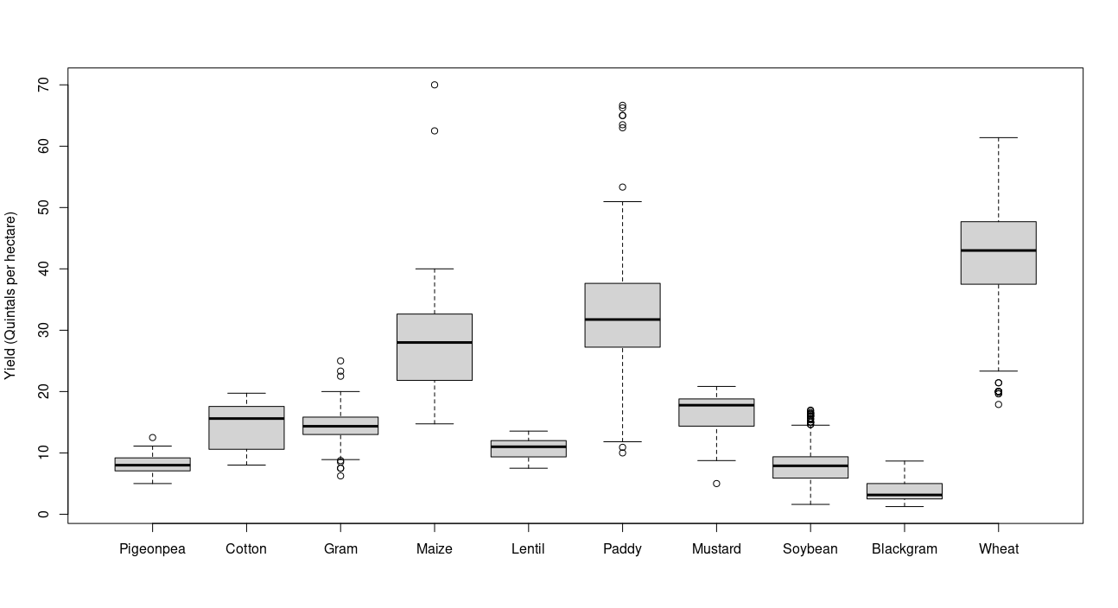
Figure 1. Boxplot of yield (Qtl./ha.) of various crops in Madhya Pradesh for 2019-20

Table 2. Shapiro-Wilk test results before and after BC transformation of various crops yield
Crop | Before Transformation |  | Box-Cox power | After Transformation
Crop | W | p-value | Box-Cox power | W | p-value
Pigeon pea | 0.98 | 0.87 | 0.41 | 0.99 | 0.98
Cotton | 0.91 | 0.01 | 1.23 | 0.91 | 0.01
Gram | 0.96 | 0 | 0.87 | 0.96 | 0
Maize | 0.86 | 0 | -0.08 | 0.94 | 0
Lentil | 0.96 | 0.29 | 1.17 | 0.96 | 0.3
Paddy | 0.94 | 0 | 0.6 | 0.95 | 0
Mustard | 0.85 | 0 | 3.22 | 0.96 | 0.14
Soybean | 0.96 | 0 | 0.38 | 0.99 | 0
Black gram | 0.89 | 0 | -0.15 | 0.97 | 0
Wheat | 0.97 | 0 | 1.73 | 0.99 | 0

Table 3. Information on cost, revenue and break-even yield of various crops in Madhya Pradesh (2019-20)
Crop | Fixed cost  (Rs. per hectare) | Operational Cost  (Rs. per hectare) | Derived Yield (Quintal per hectare) | Total revenue (Rs. per hectare) | Break-even yield (Quintal per hectare)
Pigeon pea | 12823 | 26921 | 8.52 | 39317 | 8.81
Cotton | 19781 | 57359 | 13.73 | 62888 | 49.13
Gram | 14750 | 29340 | 14.33 | 57244 | 7.58
Maize | 12766 | 38530 | 27.61 | 52283 | 25.63
Lentil | 12239 | 22730 | 10.58 | 45897 | 5.59
Paddy | 14563 | 38102 | 23.19 | 52645 | 20.52
Mustard | 19717 | 30030 | 17.84 | 66370 | 9.68
Soybean | 8800 | 27524 | 7.7 | 25972 | -43.63
Blackgram | 5150 | 20220 | 3.71 | 14817 | -3.54
Wheat | 18896 | 33457 | 39.71 | 81904 | 15.49

Table 4. Probability of not achieving break-even yield in Madhya Pradesh (2019-20)
Crop | Approach 1 | Approach 2
Pigeon pea | 0.6756 | 0.6651
Lentil | 0.0011 | 5.807387e-05
Mustard | 0.0308 | 0.0548
Cotton | - | 1.0000
Gram | - | 0.0160
Maize | - | 0.3996
Paddy | - | 0.1108
Wheat | - | 0.0004

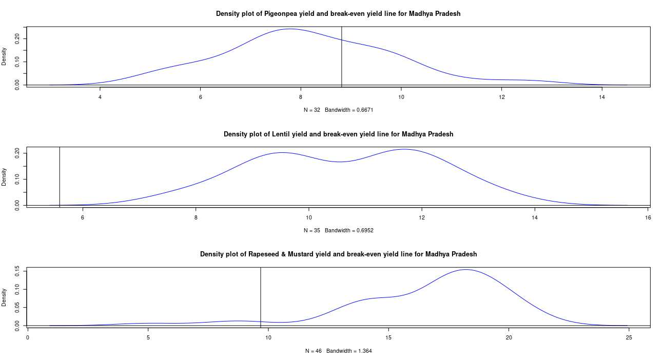
Figure 2. Density plot of Pigeon pea, Lentil and Rapeseed & Mustard yield in Madhya Pradesh (2019-20) with break-even yield.
4. Conclusion

The break-even analysis of field crops in Madhya Pradesh offered important insights into agricultural profitability in the state. The results of the study provided first-of-its-kind estimates of the probability of achieving break-even output or yields. Policymakers can use these estimates to redesign agricultural support programmes in Madhya Pradesh to better address the needs of the farming community. Greater policy attention should be given to legumes, especially pigeon pea, soybean, and black gram, as well as maize, where the probability of not achieving break-even yield was high. It is also necessary that, at the policy level, such probabilities are estimated regularly for annual monitoring and evaluation. Such an approach would improve risk-sensitive agricultural planning and strengthen the resilience of farming systems in the state.

Disclaimer (Artificial intelligence)

Author(s) hereby declare that NO generative AI technologies such as Large Language Models (ChatGPT, COPILOT, etc.) and text-to-image generators have been used during the writing or editing of this manuscript.

References

Andri Signorell et mult. al. (2022). DescTools: Tools for descriptive statistics. R package version 0.99.45.
Chand, Ramesh. (2017). DOUBLING FARMERS INCOME Rational, Strategy, Prospects and Action Plan (Policy Paper NITI Policy Paper No. 1/2017). National Institute for Transforming India, GOI, New Delhi. https://www.niti.gov.in/writereaddata/files/document_publication/DOUBLING%20FARMERS%20INCOME.pdf
Eliazer Nelson, A. R. L., Ravichandran, K., & Antony, U. (2019). The impact of the Green Revolution on indigenous crops of India. Journal of Ethnic Foods, 6(1), 1-10.
Fox, John, and Sanford Weisberg. (2019). “An R Companion to Applied Regression.” https://socialsciences.mcmaster.ca/jfox/Books/Companion/.
Government of India, Directorate of Economics and Statistics. (n.d.). Cost of cultivation/production & related data. Ministry of Agriculture & Farmers Welfare. Retrieved from https://eands.dacnet.nic.in/Cost_of_Cultivation.htm.
Giaoutzi, M., Stratigea, A., Van Leeuwen, E., & Nijkamp, P. (2012). Scenario analysis as a foresight tool in agriculture. International Journal of Foresight and Innovation Policy, 8(2-3), 105-128.
Jaedicke, R. K., & Robichek, A. A. (1964). Cost-Volume-Profit Analysis under Conditions of Uncertainty. The Accounting Review, 39(4), 917–926.
Jaybhay, S. A., Idhol, B. D., Waghmare, B. N., & Salunkhe, D. H. (2025). Impact of improved practices on soybean yield and profitability: Insights from frontline demonstrations. Journal of Farm Sciences, 38(2), 98–103.
Kolar, P., Awasthi, P. K., & Sahu, A. (2020). An economic analysis of cost, return and profitability of groundnut across leading states of India. International Research Journal of Agricultural Economics & Statistics, 11(2), 278-284.
Kolar, P., Awasthi, P. K., Vani, G., & Sahu, A. (2021). Dynamics of Cost, Returns and Profitability of Soybean across Leading States of India. Indian Journal of Economics and Development, 17, 282–288. https://doi.org/10.35716/IJED/20307
Ministry of Agriculture and Farmers Welfare. (2024). Agricultural statistics at a glance 2024. Directorate of Economics and Statistics, Government of India.
https://desagri.gov.in/en/document-report/agricultural-statistics-at-a-glance-2024/
Price risk management for agricultural commodities (Consultancy report submitted to National Commodity & Derivatives Exchange Limited). (2023). National Commodity & Derivatives Exchange Limited.
R Core Team. 2022. “R: A Language and Environment for Statistical Computing.” https://www.R-project.org/.
Rajput, Ankita. (2020). Break Even and Sensitivity Analysis of Cost of Cultivation for Major Crops of Madhya Pradesh [Jawaharlal Nehru Krishi Vishwa Vidyalay]. https://krishikosh.egranth.ac.in/handle/1/5810179117
Rajput, A., Vani, G. K., & Chaturvedi, P. (2023). Decomposition of changes in break-even output and scenario building for major crops of Madhya Pradesh. Indian Journal of Economics and Development, 19(1), 243–259. https://doi.org/10.35716/IJED/22238
Sahu, Ankita, Nahatkar, Sunil, Vani, Gourav Kumar, & Kolar, Prasanna. (2021). Study on Profitability of Wheat in Major Wheat Producing States of India. Asian Archive, 39(7). https://asianarchive.co.in/index.php/AJAEES/article/view/10246

