Empowering Communities through Dialogue and Critical Consciousness on Food Security in Odisha, India

Abstract
Nutrition literacy is the degree to which a person can obtain, process, and grasp basic dietetic information and services to make healthy food choices. This study explores a nutrition literacy initiative based on Paulo Freire's critical consciousness approach, integrated into an agricultural intervention aimed at improving nutrition outcomes in tribal communities in Odisha, through dialogic pedagogy. The action research is conducted across 1,575 households in 47 villages within Mathpada and Doraguda Panchayats, located in Boipariguda Block, Koraput district, Odisha, Eastern India. The program trained 108 adult participants, designated Community Hunger Fighters (CHFs), in two intensive residential modules totalling five days over two months. Using facilitated dialogue, the CHFs critically examined the causes of low dietary diversity within their communities, identifying interconnected social, economic, and cultural obstacles to adequate food intake amidst poverty. They collaboratively engaged in planning agricultural activities sensitive to nutritional needs. Researchers documented transformative behaviours among the CHFs using qualitative methods (observations, interviews, focus groups) and specific indicators. The dialogic approach successfully stimulated community-wide discourse on food security. CHFs distilled key messages from their discussions and disseminated them creatively to fellow villagers. This process of critical analysis enabled participants to recognise gender inequalities, pinpoint constraints in local food production, adopt lifestyle changes to improve dietary intake, and express demand for agricultural technical training. Outcomes included 38 CHFs establishing nutri-gardens and many assuming leadership roles on broader community issues beyond food security. This experience demonstrates that employing dialogue as a core educational strategy within agricultural nutrition programs can effectively catalyse critical reflection on the socio-cultural and economic barriers hindering both food production and consumption. This reflection, in turn, can empower communities and drive transformative actions towards improved food security and nutrition.
Keywords: Nutrition, Literacy, Community Hunger Fighters (CHFs), Food Security
1. Introduction
While essential to health and nutrition initiatives, traditional nutrition communication has often yielded limited long-term improvements in dietary practices or faced sustainability challenges (Bull et al., 2014; Black et al., 2017). Health literacy plays a vital role in helping consumers make informed dietary choices, yet many struggle to understand food labels effectively (Vishwakarma et al., 2025). Nutbeam (2000) argues that programs focusing solely on information transfer, neglecting socio-economic contexts, frequently fail to achieve lasting behaviour change. He distinguishes between "education" and "literacy," defining health literacy as the outcomes of education and communication efforts, categorised into three levels:
Functional Literacy: Imparts basic knowledge to enable compliance with instructions, lacking interactivity and autonomy.
Interactive Literacy: Develops skills to understand and apply health information, fostering confidence, motivation, and behaviour change.
Critical Literacy: Empowers individuals to critically analyse information and practices, enhancing control over their lives.
Critical literacy integration in school health programs emerged in Europe/North America during the mid-1980s (St Leger, 2001), challenging top-down methods. It expanded focus to include school environments, policies, health service links, and community partnerships, entering a dynamic, political domain aimed at advocacy skills and empowerment. This framework operationalised all three of Nutbeam's literacy levels.
Beyond schools, adult learning principles showed promise. Brown (2015) describes adapting a weight-loss nutrition program for Mexican American women using a tripartite approach (planning, teaching/learning, research). Pilot feedback led to revised classes emphasising socialisation; participants achieving 50% attendance lost weight and shared knowledge.
Experiential learning proved powerful when community college students engaged in interdisciplinary food/agriculture studies combined with producing food for low-income residents (Adelman & Sandiford, 2007). This direct involvement revealed local poverty/hunger and environmental threats from industrial agriculture, convincing students of organic farming's viability and the potential for grassroots food security solutions, leading to national advocacy.
Implementing empowerment-based literacy necessitates multidisciplinary strategies (education, development, communication, social sciences), raising questions about effective pedagogies, especially in low-literacy, resource-poor contexts. Paulo Freire's (1994) dialogic approach to foster "critical consciousness" among non-literate populations demonstrated success, leading to sustainable outcomes as confirmed by others (Wallerstein & Bernstein, 1988; Naiditch, 2010). Nutrition literacy is the degree to which a person can obtain, process, and grasp basic dietetic information and services to make healthy food choices. It entails understanding nutritional concepts and having the capacity to comprehend, evaluate, and apply nutrition information, i.e., to be aware of the nutrients and their impact on health. It concerns an individual’s ability to gather, comprehend, and apply dietary data from various sources (Silva, 2023; Escott-Stump, 2011). An Indian nutrition literacy program based on Freirean principles reported individual dietary improvements, broader lifestyle changes (e.g., reducing tobacco/alcohol), and critical realisations about seasonal meal skipping and grain quality choices (Narayanan & Rao, 2019). Participants identified actionable strategies for enhancing food security. In the developed countries, the condition of food and nutrition security is determined by both the availability of safe, nutritious, economic, and tasty food, as well as by individuals’ possibility and capacity to access and use it (Velpini et al., 2022; Godrich et al., 2017).
Despite these examples, Gavaravarapu (2019) notes a scarcity of published research on innovative nutrition education approaches in India, with most community nutrition research focused elsewhere. This paper addresses this gap by discussing an ongoing action research program in Eastern India. Implemented by the MS Swaminathan Research Foundation and funded by the Department of Agriculture and Farmers’ Empowerment, Government of Odisha, under RKVY, the program employs dialogue as a pedagogic tool within an agricultural intervention to raise critical consciousness about nutrition. Given its current status, the paper details the conceptual framework, methodology, and preliminary field observations.
1.1 Research Questions
The study addresses two questions throughout our methodology:
RQ1: To what extent does engaging participants in critical dialogue about socio-cultural and economic barriers (e.g., gender inequality, poverty, production constraints) lead to measurable shifts in gender norms and collective action addressing nutritional inequities within households and communities?
RQ2: What are the enabling factors and challenges in sustaining community-led initiatives embedded within agricultural programming in resource-poor, tribal settings?
Review of Literature
2.1 Defining Nutrition Literacy
Krause et al. (2018) note limitations in early definitions of nutrition literacy, which primarily focused on skills for acquiring and comprehending nutrition information. A broader perspective is emphasised by the International Union of Nutrition Sciences (IUNS) and World Health Policy Forum, defining nutrition science as the interdisciplinary study of food systems, nutrients, and their biological, social, and environmental interactions (Cannon and Leitzmann 2006). Building on this, the project adopts an operational definition: Nutrition literacy is the process empowering individuals/communities to critically analyse their nutritional context and engage meaningfully with social, cultural, biological, political, and environmental realities. This engagement aims to achieve dietary diversity, access to safe water, sanitation, and adequate health services for optimal nutrition outcomes.
2.2 Integrating Nutrition Literacy into Agricultural Interventions
Nutrition-sensitive agricultureprioritises nutrient-rich foods, dietary diversity, and fortification to combat malnutrition. The Farming System for Nutrition (FSN) approach specifically integrates "nutritional criteria into selecting farming system components (crops, livestock, fish) to address local nutritional deficiencies" (Nagarajan et al. 2014). Embedding nutrition literacy within such agricultural interventions focuses on the opportunities and challenges in producing and consuming nutritious foods. While acknowledging non-food determinants of nutrition, this project concentrates on crop and food-related issues within participants' socio-economic, political, and environmental contexts.
2.3 Evolution of Communication Strategies
Behaviour Change Communication (BCC) is a research-based process using interpersonal, group, and media channels (including participatory methods) to address knowledge, attitudes, and practices. Evolving from health education and Information, Education, and Communication (IEC) (Nancy and Dongre 2021), BCC employs various individual, interpersonal, and community-level models to develop strategies promoting positive behaviours and supportive environments. This concept expands into social marketing – applying marketing principles to foster individual and collective action for sustained social transformation, positioning the marketer as a facilitator of change (Saunders et al. 2015).
Recognising that individual change requires addressing social determinants, BCC evolved into Social and Behaviour Change Communication (SBCC). The 'S' signifies that individual behaviour and social relationships are shaped by structural systems: gender norms, class/caste hierarchies, cultural practices, and political/economic environments (Kumar 2020). SBCC utilises a socio-ecological model, integrating these aspects to address barriers, leverage opportunities, and promote sustainable change (McKee et al. 2014), combining communication, behaviour change, and social change strategies.
2.4 Dialogue as a Core SBCC Strategy: The Freirean Influence
Central to SBCC implementation is dialogue, discussion, and negotiation. Paulo Freire pioneered dialogic pedagogy in adult literacy, emphasising that adult learners possess valuable knowledge which should be co-constructed democratically, breaking the "culture of silence" (Freire 2005). Engaging learners in critical dialogue raises awareness of their situation ("conscientization"), fostering hope and empowering action based on new understanding.
Dialogue, rooted in respect, links critical reflection with informed action, enabling learners to perceive socio-economic-political contradictions and act within their realities. Utilising dialogue as an educational instrument for nutrition literacy within an agricultural intervention program can promote critical reflection on the socio-cultural and economic obstacles to food production and consumption, ultimately resulting in transformative action (Rama Narayanan et al, 2022).
Case studies by Bonatti et al. (2021) illustrate Freirean principles in Brazilian food security initiatives:
Community Seed Bank (Northeast): Partnering with an NGO and farmers, this initiative conserved local species through seed loans. Farmers collaboratively selected seeds for multiplication, employed agroecological knowledge (including storage), and promoted exchange via fairs and a cultural festival ("Seeds of Passion"), advocating for supportive policies.
Biodiversity Kits (South): Addressing disappearing landraces, kits were co-created with farmers, technicians, and scientists. Farmers articulated needs in meetings, received training, identified seed multipliers, and distributed kits. The authors link these social learning and Freirean-based initiatives to improved food security through landrace conservation.
2.5 Addressing Critical Literacy Gaps in Interventions
Nichols (2021) observes numerous nutrition-sensitive agriculture projects integrating women's empowerment and BCC. Analysis of Indian projects revealed women preferred discussions on early marriage and dietary diversity over complex topics like gender and health, indicating an unmet need for structured spaces to discuss gendered aspects of diet and health. This raises critical questions: Do agriculture-nutrition interventions create spaces for critical literacy? Do they enable questioning hierarchical relations (caste, class, gender) that contribute to poor diets?
Therefore, a nutrition literacy program aiming for critical consciousness must incorporate dialogue, action, reflection, and dedicated spaces for these activities. Guided by this understanding of nutrition literacy, behaviour change, critical reflection, and dialogic pedagogy, a dedicated nutrition literacy component was designed and integrated into the agricultural intervention program.
3. Methodology
The action research is conducted across 1,575 households in 47 villages within Mathpada and Doraguda Panchayats, located in Boipariguda Block, Koraput district, Odisha, Eastern India. Koraput is a predominantly tribal, rural district characterised by high biodiversity.
Figure 1: Map of Koraput highlighting the Area of Research
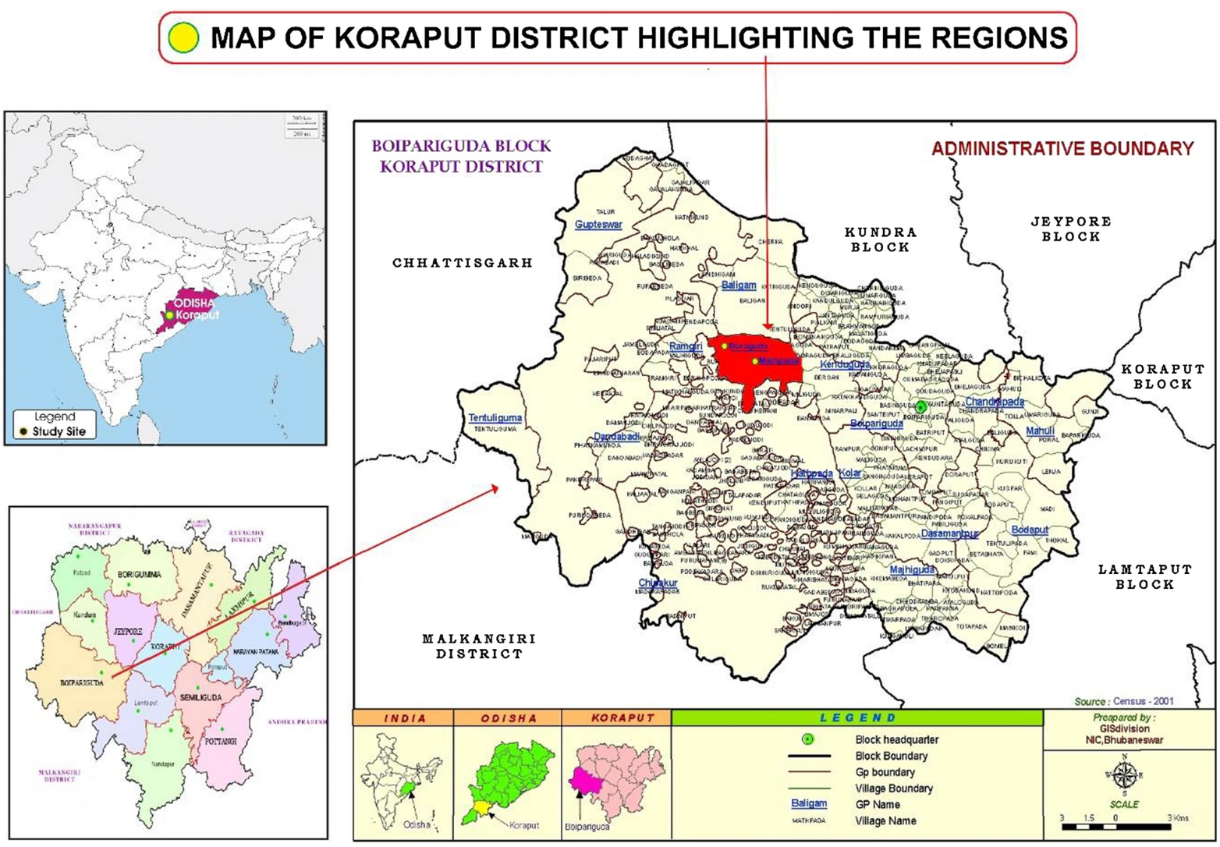
Source: DPMU 2017; NFHS 2015

To establish the project foundation, 37 village meetings introduced secondary agricultural, health, and nutritional data to 1,047 community members (513 women, 534 men). Early-stage productivity trials focused on improved varieties and practices for finger millet, pigeon pea, and orange-fleshed sweet potato. A household census provided core socioeconomic information, followed by a baseline survey employing random sampling (SPSS version 2) of 315 households to characterise existing agricultural systems, food consumption habits, and nutrition awareness.
3.1 Dietary Assessment Methods
Household food consumption frequency was captured using two complementary recall methods:
24-hour Dietary Recall: Documented all foods consumed (including outside meals) on a typical non-festive day prior to the interview. Advantages include better recall accuracy.
30-day Food Frequency Recall: Recorded all food items consumed and their sources over the previous month. This captures greater dietary diversity (including infrequently consumed items) but risks recall bias.
Both methods provide a snapshot and may not fully capture seasonal dietary variations.
3.2 Process of Social Engagement
An experienced adult literacy facilitator (with English-Odiya translation support) led the training. The residential setting fostered unprecedented interaction across caste, village, and gender lines, as displayed in Figure 2.
Figure 2: Framework depicting Dialogue as a Nutrition Literacy Tool
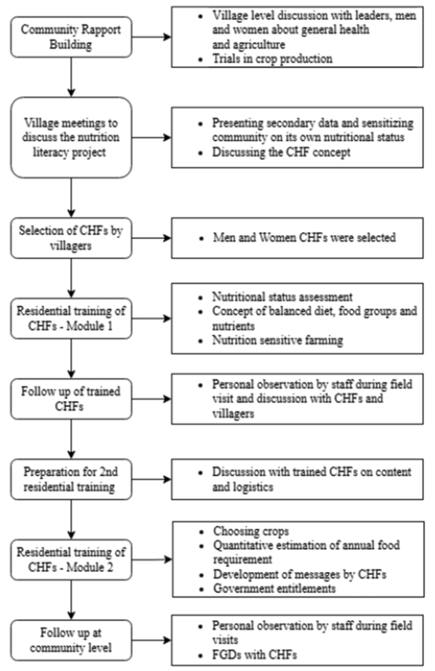
Source: Ramanarayanan et al, 2022
This environment enabled shared experiences and collective reflection on food/nutrition status, building relationships and support, foundational steps towards collective action (Oakley et al. 1984). While acknowledging that workshops alone cannot transform social structures, the training sensitised CHFs to power hierarchies impacting food security. This aimed to break the "culture of silence" and amplify marginalised voices for future discourse. Post-training, CHFs identified key messages for community dissemination. The program design anticipated emergent, sequential community actions.
Observations were coded into themes (e.g., dietary diversity, food production, entitlement claims). Interviews captured message dissemination methods (one-on-one vs. group sharing). FGDs explored CHF's views on the transformative process.
This paper examines dialogue's role in fostering critical analysis, reflection, and individual-level action.
4. Results and Discussion
4.1 Socio-Demographic and Economic Setting
The study population comprised predominantly marginalised groups: Scheduled Tribes (74%) and Scheduled Castes (13%), together constituting 87% of residents. Landholding patterns revealed significant constraints: 79% were small or marginal farmers (holding <1 hectare or 1-2 hectares), 11% were landless, 8% held semi-medium plots (2–4 hectares), and only 2% had medium holdings (4–10 hectares). Smallholders frequently supplemented their income through paid labour. Formal education levels were very low, with 74% of household heads having no schooling. Household size distribution showed 52% with 1–4 members, 47% with 5–8 members, and 1% with more. Drinking water sources included tube wells (85%), taps (10%), open wells (4%), and surface water (1%). Despite 70% of households possessing toilets, the lack of water rendered them largely unused. This profile depicts a community of resource-poor subsistence farmers with limited assets, inadequate infrastructure, and minimal technological access.
4.2 Food Consumption, Production, and Nutrition Awareness
Household food frequency data, as tabulated in Table 1 include items consumed weekly by ≥25% of the population. Rice and finger millet served as staple energy sources: rice was consumed daily by all households, and finger millet by 85%. While paddy cultivation was near-universal, finger millet was grown by 62% of households. Despite 91% adopting improved paddy varieties, domestic production was insufficient for 86% of households, necessitating market rice purchases. Ninety per cent held ration cards, accessing subsidised rice (5 kg/person at ₹1/kg) via the Public Distribution System (PDS). However, rice functioned as a primary cash crop; households consumed only ~85% of their harvest, selling the remainder to cover expenses. Finger millet cultivation favoured traditional varieties, yet 86% still bought additional millet from markets. Daily oil use (for tempering) was reported by 57% of households, and daily sugar consumption (primarily in tea) by 70%.
Table 1: Frequency of Food Consumption by Households
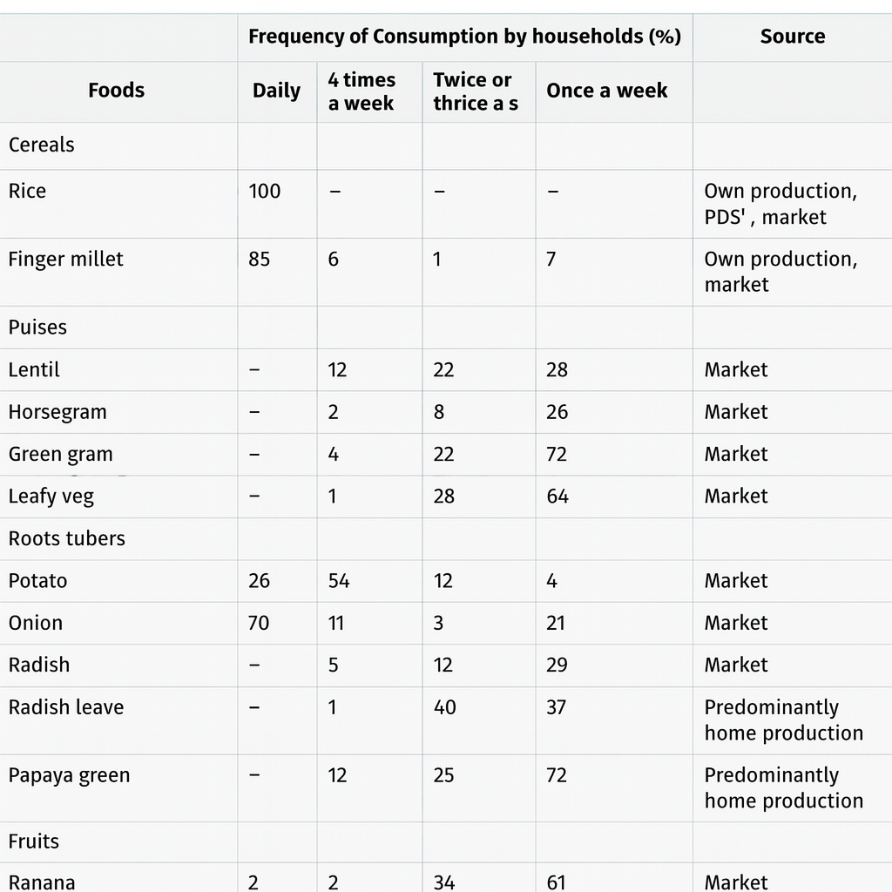
Source: Own Data
Awareness of improved agricultural practices was limited: only 14% had attended skill development programs in the past three years. Over 90% lacked knowledge of seed treatment for paddy or finger millet, and adoption of improved sowing methods was minimal.
Pulses, consumed as thin gruels accompanying rice, were unaffordable for daily consumption due to market dependence. Limited cultivation occurred: only 22 households grew horse gram, and 2 cultivated green gram. Consumption frequency reflected scarcity:
Lentils: 12% consumed 4 times/week (entirely purchased), 34% once/week
Horse gram: 2% consumed 4 times/week (61% purchased), 26% once/week
Green gram: 2% consumed 4 times/week (97% purchased), 22% once/week
A CHF participant explained the challenges: "The soil is unsuitable for lentils. We buy them as the cheapest, easiest-to-cook pulse. We lack green gram cultivation knowledge. Horse gram is traditional but low-yielding and tedious to process, so we sell it." Animal protein was rarely consumed, despite 80% of households rearing poultry.
4.3 Vegetable and Fruit Consumption
Market-dependent vegetables dominated diets:
Daily Consumers: Onions (70%), Tomatoes (74%), Potatoes (25%)
Weekly Consumers: Cabbage (23% - 4 times/week), Amaranthus, onion stalk, radish leaves, cauliflower leaves (once/week)
Although 80% of households had small gardens (avg. 15 cents, operational 5 months/year, growing broad beans, beans, brinjal, papaya), homegrown vegetable consumption was low. Excess produce was shared or sold due to a lack of storage. Fruit intake was negligible: bananas were consumed once/week by 34% of households (mostly purchased; only 6 households grew bananas).
4.3 Dietary Diversity and Nutrition Awareness
Diets showed low diversity with inadequate protein and micronutrients:
62% of households ate only two meals daily.
Community understanding of nutritional status was poor, likely due to its subclinical nature.
Iron Supplement Awareness: 19 of 20 households receiving iron tablets during pregnancy didn't know their purpose (though women noted receiving blood transfusions indicated weakness).
Micronutrient Knowledge: Only 4 households had heard of Vitamin A; just 18% recognised the importance of daily fruit/vegetable consumption.
4.4 Community Hunger Fighter (CHF) Selection Process
Participation: Household participation rates ranged from 60-89% in most villages (35% in four villages).
Process: Villagers sat in gender-segregated circles. Men selected male candidates based on communication skills and the availability of replacement farm labour. Both genders participated in selecting female candidates, generally choosing trusted individuals.
Gender Barriers: Borapuda village selected no women, deeming them "incapable of communicating." Women expressed apprehension about leaving their villages for the first time. Mothers with childcare responsibilities were often excluded.
Concerns arose about staying away from home for two nights; some women agreed only because a neighbour was also attending.
Literacy influenced selection, with many CHFs in their early 20s chosen for their reading/writing skills. Selected individuals included Women's SHG leaders, a school committee president, youth leaders, and a caste leader, as shown in Table 2.

Table 2: Profile Distribution of Community Hunger Fighters (CHFs)
Source: Own Source

Continuous dialogue fostered dynamic stakeholder exchanges, catalysing community-wide discourse on household food and nutrition security. Classroom reflection exercises enabled Community Hunger Fighters (CHFs) to critically identify socio-cultural and political barriers to food security. A pivotal outcome was the evolution of perspectives on gender inequity. Sensitisation regarding women’s nutritional vulnerability, disproportionate labour burdens, and restricted dietary agency prompted critical questioning of entrenched norms ("should it be so?"). Male CHFs explicitly acknowledged the need to address patriarchal structures, shaping the co-created community message on "supporting women."
This cognitive shift aligns with Mezirow’s (1997) theory of transformative learning, where critical reflection and evidential dialogue disrupt ingrained assumptions, fostering autonomous reasoning. Subsequent actions—such as male and female CHFs co-facilitating village meetings or leading SHG sessions—demonstrate this behavioural transformation. These findings validate the project’s premise that sensitising men to female disempowerment is fundamental to challenging patriarchal systems. This corroborates Nichols' (2021) argument for male inclusion in participatory initiatives, particularly as women engaged more deeply with messages where they held agency.
For women accustomed to self-sacrificing caregiving roles, experiencing communal concern was profoundly impactful. This resonates with Niehof’s (2019) analysis, which notes that "women’s hegemonic role in family food care and their relational definition as mothers often leads their nutritional needs to be viewed instrumentally, rather than as intrinsically important."
5. Conclusion
The efficacy of critical literacy and dialogic pedagogy in adult interventions fundamentally relies on fostering interpersonal relationships and direct engagement. These core components faced significant disruption during pandemic lockdowns, necessitating the exploration of alternative engagement methods. Partial mitigation was achieved through small-group interactions and brief mobile phone consultations. Future implementation under similar constraints should investigate supplementary channels like community radio broadcasts and instructional video screenings for technical skill development. Participant demand for ongoing refresher training (noted among CHFs) underscores the need for sustained engagement. Consequently, structured collaboration between government departments and CHFs will be established to co-design frameworks for continuous community involvement, advancing the operationalisation of hunger-free villages.
Dialogue, employed as a core pedagogical strategy within critical nutrition literacy programmes, holds significant potential when grounded in participants' socio-cultural-political contexts. This approach empowers individuals to derive contextually relevant meanings and messages, potentially driving behavioural change. Creating a non-prescriptive, open learning environment enabled the co-construction of nutrition-sensitive agricultural knowledge, fostering shared learning that extended into the wider community.
Critical reflection on daily food practices and production systems revealed patterns in food preferences, challenges in diversifying production, cultural erosion of traditional foods, and gender-based nutritional disparities.
Future initiatives should prioritise engaging mixed-gender groups, as dialogue between men and women effectively sensitises men to gender disparities in agricultural roles and nutritional access. Implementing such programmes necessitates skilled facilitators experienced in adult critical literacy methodologies. Finally, long-term interventions are essential to rigorously assess the sustainability of these transformative approaches.
Disclaimer (Artificial intelligence)

Option 1:

Author(s) hereby declare that NO generative AI technologies such as Large Language Models (ChatGPT, COPILOT, etc.) and text-to-image generators have been used during the writing or editing of this manuscript.

Option 2:

Author(s) hereby declare that generative AI technologies such as Large Language Models, etc. have been used during the writing or editing of manuscripts. This explanation will include the name, version, model, and source of the generative AI technology and as well as all input prompts provided to the generative AI technology

Details of the AI usage are given below:
1.
2.
3.

References
- Adelman, D., & Sandiford, S. (2007). Reflections from the garden: Developing a critical literacy of food practices.
- Batliwala, S. (2007). Taking the power out of empowerment–an experiential account. Development in practice, 17(4-5), 557-565.
- Black, A. P., D’Onise, K., McDermott, R., Vally, H., & O’Dea, K. (2017). How effective are family-based and institutional nutrition interventions in improving children’s diet and health? A systematic review. BMC public health, 17, 1-19.
- Bonatti, M., Borba, J., Löhr, K., Tremblay, C., & Sieber, S. (2021). Social learning and Paulo Freire concepts for understanding food security cases in Brazil. Agriculture, 11(9), 807.
- Brown, N. (2015). Facing Language, Funding, and Personnel Barriers? How Adult Education Principles and Practices Facilitate Nutrition Education for Low-Income Mexican American Audiences.
- Bull, E. R., Dombrowski, S. U., McCleary, N., & Johnston, M. (2014). Are interventions for low-income groups effective in changing healthy eating, physical activity and smoking behaviours? A systematic review and meta-analysis. BMJ open, 4(11), e006046.
- Burke, L. A., & Hutchins, H. M. (2007). Training transfer: An integrative literature review. Human resource development review, 6(3), 263-296.
- Cannon, G., & Leitzmann, C. (2006). The new nutrition science project. Scandinavian Journal of Food and Nutrition, 50(1), 5-12.
- Freire, P. (1994). Pedagogy of hope: Reliving pedagogy of the oppressed.
- Freire, P. (2000). Pedagogy of the oppressed (30th anniv. ed.). New York: Continuum, 35.
- Gavaravarapu, S. M. (2019). Nutrition communication-Rhetoric & reality. Indian Journal of Medical Research, 149(3), 333-344.
- Hentschel, T., Heilman, M. E., & Peus, C. V. (2019). The multiple dimensions of gender stereotypes: A current look at men’s and women’s characterizations of others and themselves. Frontiers in psychology, 10, 11.
- Krause, C., Sommerhalder, K., Beer-Borst, S., & Abel, T. (2018). Just a subtle difference? Findings from a systematic review on definitions of nutrition literacy and food literacy. Health promotion international, 33(3), 378-389.
- Kumar, N., Raghunathan, K., Arrieta, A., Jilani, A., & Pandey, S. (2021). The power of the collective empowers women: Evidence from self-help groups in India. World Development, 146, 105579.
- Lee, M. T., Hartsough, M., Borick, S., & Gathagan, B. (2021). Open space, transformative education, and the pursuit of flourishing. Journal of Transformative Education, 19(3), 198-217.
- McKee, N., Becker‐Benton, A., & Bockh, E. (2014). Social and behavior change communication. The handbook of development communication and social change, 278-297.
- Mezirow, J. (1997). Transformative learning: Theory to practice. New directions for adult and continuing education, 1997(74), 5-12.
- Nagarajan, S., Bhavani, R. V., & Swaminathan, M. S. (2014). Operationalizing the concept of farming system for nutrition through the promotion of nutrition-sensitive agriculture. Current Science, 959-964.
- Naiditch, F. (2010). Critical Pedagogy and Teaching Reading for Social Action. Critical Questions in Education, 1 (2), 94-107.
- Nancy, S., & Dongre, A. R. (2021). Behavior change communication: past, present, and future. Indian Journal of Community Medicine, 46(2), 186-190.
- Narayanan, R., & Rao, N. (2020). Adult learning for nutrition security: Challenging dominant values through participatory action research in Eastern India. In Indigenous Women and Adult Learning (pp. 63-81). Routledge.
- Narayanan, R., Panda, A. K., Nithya, D. J., & Bhavani, R. V. (2022). Dialogue as a tool of nutrition literacy in an agricultural intervention programme in Odisha, India. CABI agriculture and bioscience, 3(1), 28.
- Nichols, C. E. (2021). Spaces for women: Rethinking behavior change communication in the context of women's groups and nutrition-sensitive agriculture. Social Science & Medicine, 285, 114282.
- Niehof, A. (2019). Gender and nutrition security. CABI Reviews, (2019), 1-10.
- Nutbeam, D. (2000). Health literacy as a public health goal: a challenge for contemporary health education and communication strategies into the 21st century. Health promotion international, 15(3), 259-267.
- Oakley, P., & Marsden, D. (1989). Approaches to participation in rural development.
- Roumell, E. A. (2019). Priming adult learners for learning transfer: Beyond content and delivery. Adult Learning, 30(1), 15-22.
- Saunders, S. G., Barrington, D. J., & Sridharan, S. (2015). Redefining social marketing: beyond behavioural change. Journal of Social Marketing, 5(2), 160-168.
- St Leger, L. (2001). Schools, health literacy and public health: possibilities and challenges. Health promotion international, 16(2), 197-205.
- Wallerstein, N., & Bernstein, E. (1988). Empowerment education: Freire's ideas adapted to health education. Health education quarterly, 15(4), 379-394.
- Vishwakarma, U., Singh, N., Daniel, M., & Nanda, A. (2025). Health Literacy and Food Label Comprehension: A Review of Barriers, Insights and Policy Recommendations. Asian Journal of Food Research and Nutrition, 4(2), 582–594. https://doi.org/10.9734/ajfrn/2025/v4i2269
- Silva, P. (2023). Food and nutrition literacy: Exploring the divide between research and practice. Foods, 12(14), 2751.
- Escott-Stump, S. A. (2011). Our nutrition literacy challenge: Making the 2010 dietary guidelines relevant for consumers. Journal of the American Dietetic Association, 111(7), 979.
- Silk, K. J., Sherry, J., Winn, B., Keesecker, N., Horodynski, M. A., & Sayir, A. (2008). Increasing nutrition literacy: testing the effectiveness of print, web site, and game modalities. Journal of nutrition education and behavior, 40(1), 3-10.
- Godrich, S. L., Davies, C. R., Darby, J., & Devine, A. (2017). What are the determinants of food security among regional and remote Western Australian children?. Australian and New Zealand journal of public health, 41(2), 172-177
- Velpini, B., Vaccaro, G., Vettori, V., Lorini, C., & Bonaccorsi, G. (2022). What is the impact of nutrition literacy interventions on children’s food habits and nutrition security? A scoping review of the literature. International Journal of Environmental Research and Public Health, 19(7), 3839.

