Effects of different sources of organic manures and chemical fertilizers on growth & yield of BJRI developed kenaf variety

Abstract
Jute, frequently referred to as Bangladesh’s “golden fibre,” continues to play a vital role in the country’s agrarian economy, supporting industrial sustainability and sustaining rural livelihoods. This study investigated the effects of integrated organic and inorganic nutrient management on the growth and fibre yield of BJRI Kenaf-5 at Kishoreganj, Bangladesh, during the 2023 growing season. The experiment was established using a randomized complete block design with three replications and six nutrient management treatments. These treatments involved the application of the recommended dose of fertiliser (RDF: 132–50–40 kg N–P–K ha⁻¹) in combination with various organic amendments, including cow dung (CD), poultry manure (PM), and vermicompost (VC). Key growth parameters—such as plant population, plant height, base diameter, fibre yield, and stick yield—were systematically recorded. The results demonstrated significant differences (p ≤ 0.05) among the treatments, highlighting the influence of integrated nutrient management on both vegetative growth and fibre production in BJRI Kenaf-5. The integrated treatment T6 (100% RDF + CD 1.5 t ha⁻¹ + PM 1.5 t ha⁻¹ + VC 1.5 t ha⁻¹) produced the highest fiber yield (3.36 t ha⁻¹) and stick yield (6.73 t ha⁻¹), representing a 75.9% increase in fiber yield over the control. Plant height was highest under T5 (3.11 m), while maximum base diameter was observed in T4 (19.63 mm). Principal component analysis explained 99.1% of total variance, confirming strong positive associations among growth parameters. Pearson’s correlation revealed highly significant relationships (r = 0.96–0.99) between vegetative growth and yield traits.The results demonstrate that integrated nutrient management significantly enhances biomass accumulation and fiber productivity in BJRI Kenaf-5, suggesting T6 as an optimal nutrient strategy for sustainable kenaf cultivation in the agro-ecological conditions of Kishoreganj

Keywords:Kenaf; Integrated nutrient management; Organic manure; Fiber yield; BJRI Kenaf-5; Sustainable agriculture

Introduction:
Jute often termed Bangladesh’s “golden fiber,” remains integral to thenation’s agrarian economy, industrial sustainability, and rural livelihoods (Das et al.,2025). Bangladesh is a leading producer of jute, which represents a major cash crop within its agricultural sector. As a biodegradable and renewable natural fibre, jute is widely recognised for its environmentally sustainable characteristics. Jute also occupies a significant position in the industrial sector of the Bangladeshi economy, underpinning agro-based industries and contributing to overall economic activity. (Islam and Ali, 2017). Jute constitutes the principal bast fibre crop globally and represents a significant element of national pride in Bangladesh. Owing to its favourable agro-climatic conditions and longstanding cultivation practices, Bangladesh has maintained a prominent position in global jute production. Together, Bangladesh and India account for more than 92% of the world’s total jute fibre output, underscoring their dominant role in the international jute sector. Kenaf plays an important role in fiber production leading to more income with low cost involvement. It is a short day, herbaceous fiber crop belonging to the family Malvaceae (H'ng et al., 2009). The Malvaceae family is noted for their economic and horticultural importance (Akinrotimi&Okocha, 2018).The production of jute and kenaf allied fiber crops in Bangladesh is decreasing day by day due to improper fertilizer management. In the coming years, the utilisation of organic manures to meet crop nutrient requirements will become an indispensable practice for the advancement of sustainable agriculture. This necessity arises from the capacity of organic amendments to improve the physical, chemical, and biological properties of soil. Such improvements enhance soil structure, nutrient availability, microbial activity, and overall soil health, thereby promoting increased crop productivity while preserving the quality and nutritional value of agricultural produce (Maheswarappa et al.,1999). Although organic manures generally contain lower concentrations of essential plant nutrients compared with inorganic fertilisers, their agronomic significance remains substantial. The application of inorganic fertilisers has proven effective in enhancing crop yields in the short term; however, sustained productivity often necessitates their continuous and long-term use. Such dependence may not be economically viable, particularly for resource-poor farmers, owing to the high cost of these inputs. Moreover, the excessive or indiscriminate use of inorganic fertilisers is environmentally undesirable, as it may contribute to soil degradation, water pollution, and other adverse ecological consequences (Olowoake.,2014). Compost represents a vital resource for soil amendment within organic farming systems, offering the distinct advantage of being environmentally sustainable. The application of composted manure improves the physical, chemical, and biological properties of the soil, enhances its water-holding capacity and nutrient retention, and provides a gradual, slow release of essential nutrients. Consequently, compost not only supports soil health but also contributes to increased crop productivity and the long-term sustainability of agricultural practices (Agbede et al. 2008; Moral et al. 2009). Composted organic manures, particularly those derived from poultry waste, have been reported to enhance the mineral composition of vegetable crops, including Jute mallow. The nutrient-rich nature of poultry-based compost provides essential macro- and micronutrients that are readily available to plants, thereby improving both the nutritional quality and overall growth performance of the produce (Mazen et al. 2010; Jonathan et al. 2012). The application of animal manure has been shown to significantly enhance soil structure. It can reduce soil bulk density, increase porosity, and improve water infiltration and percolation rates. Additionally, animal manure contributes to greater aggregate stability, thereby promoting better root development, aeration, and overall soil health, which collectively support sustainable crop production [Edmeades2003 ,Thangarajan et al.,2016]. Furthermore, the application of manure-based amendments has been shown to stimulate soil microbial activity and increase microbial biomass. Such amendments can also influence the composition and diversity of soil microbial communities, enhancing beneficial microbial populations that contribute to nutrient cycling, disease suppression, and overall soil fertility. This microbial enrichment further reinforces the role of organic manures in promoting sustainable and resilient agricultural systems [Liu et al.,2016 , Reardon et al.,2016]. Proper dose of nutrients is essential for each of the variety of jute for its optimum growth and yield. Judicial application of NPKS is also important to complete life cycle of jute plant (Sarkeret al., 2000; Das et al., 1996). Therefore, it is imperative to investigate the use of locally available organic materials that are environmentally sustainable, cost-effective, and potentially efficient in enhancing and maintaining the productivity of soils and fibre crops such as kenaf. Establishing appropriate nutrient requirements for specific varieties or strains is a necessary prerequisite prior to their final release. Organic manures and fertilisers play a critical role not only in improving fibre quality but also in sustaining crop yield and soil health. Identifying an optimal combination of organic and inorganic inputs that is both economically viable and capable of achieving yields close to the crop’s maximum potential is therefore essential. In light of this, an experiment has been undertaken to evaluate the effects of organic and inorganic fertilisers on the growth, yield, and fibre quality of kenaf, as well as their influence on the physicochemical properties of the soil.

3. Materials and Methods

3.1 Experimental Site and Duration
The field experiment was conducted during the 2023 growing season at the Bangladesh Jute Research Institute (BJRI) Regional Station, Kishoreganj, Bangladesh. The experimental site represents a typical agro-ecological condition suitable for kenaf cultivation. Standard agronomic practices were followed throughout the cropping period.

3.2 Experimental Design and Layout
The experiment was laid out in a Randomized Complete Block Design (RCBD) with three replications and six treatments.
Each unit plot measured 2.1 m × 2.0 m. A spacing of 1.0 m was maintained between plots and blocks to minimize treatment interference. Drainage channels of 30 cm depth were constructed around the experimental field to ensure proper water management.

3.3 Test Crop
The test crop used in the experiment was BJRI Kenaf-5 (Hibiscus cannabinus L.), a variety developed by Bangladesh Jute Research Institute for improved fiber production.

3.4 Treatment Details
Six fertilizer treatments were evaluated:
- T1: Control (no fertilizer)
- T2: 100% Recommended Dose of Fertilizer (RDF)
- T3: 50% RDF + Cow dung (CD) @ 1 t ha⁻¹ + Poultry manure (PM) @ 1 t ha⁻¹ + Vermicompost (VC) @ 1 t ha⁻¹
- T4: 50% RDF + CD @ 1.5 t ha⁻¹ + PM @ 1.5 t ha⁻¹ + VC @ 1.5 t ha⁻¹
- T5: 75% RDF + CD @ 1.5 t ha⁻¹ + PM @ 1.5 t ha⁻¹ + VC @ 1.5 t ha⁻¹
- T6: 100% RDF + CD @ 1.5 t ha⁻¹ + PM @ 1.5 t ha⁻¹ + VC @ 1.5 t ha⁻¹
The recommended fertilizer dose (RDF) consisted of 132–50–40 kg N–P–K ha⁻¹.

3.5 Fertilizer and Organic Amendment Application
Organic manures (cow dung, poultry manure, and vermicompost) were incorporated into the soil during final land preparation according to the treatment combinations.
Nitrogen fertilizer was applied in two splits:
- 50% as basal application at sowing
- Remaining 50% top-dressed at 45 days after sowing (DAS)
Phosphorus and potassium were applied as basal doses during final land preparation.

3.6 Crop Management Practices
Seeds of BJRI Kenaf-5 were sown following recommended spacing. Proper agronomic management practices, including weeding, irrigation (if required), pest control, and rouging, were performed uniformly across all treatments to ensure unbiased treatment effects.

3.7 Data Collection
Data were recorded from randomly selected plants in each plot on the following parameters:
- Plant population (plants m⁻²)
- Plant height (m)
- Base diameter (mm)
- Fiber yield (t ha⁻¹)
- Stick yield (t ha⁻¹)
Fiber and stick yields were calculated on a hectare basis after harvest.

3.8 Statistical Analysis
Data were subjected to analysis of variance (ANOVA) using the RCBD model to determine treatment effects. Mean comparisons were performed using the Least Significant Difference (LSD) test at the 5% probability level.
Multivariate statistical analyses including Principal Component Analysis (PCA) and Pearson’s correlation were conducted to evaluate relationships among growth and yield parameters.

Result and Discussion

Table 1: Yield and yield contributing characters of BJRI Kenaf-5 with different sources of inorganic & organic fertilizer at Kishoreganj.

Sl. No. | Treatment | Plant Population/m² | Plant Height(m) | Base Diameter(mm) | Fiber Yield(t/ha) | Stick Yield(t/ha)
1 | T₁ | 25.00 b | 1.98 c | 11.99 d | 1.91 e | 3.88 e
2 | T₂ | 28.00 a | 2.42 b | 15.39 c | 2.41 d | 4.87 d
3 | T₃ | 29.00 a | 2.81 a | 17.43 b | 2.68 c | 5.43 c
4 | T₄ | 30.00 a | 3.04 a | 19.63 a | 3.11 ab | 6.43 ab
5 | T₅ | 31.00 a | 3.11 a | 18.87 ab | 3.05 b | 6.11b
6 | T₆ | 32.00 a | 3.06 a | 19.17 a | 3.36 a | 6.73 a
7 | Mean | 29.16 | 2.73 | 17.08 | 2.75 | 5.56
8 | CV | 7.35 | 6.06 | 5.56 | 5.50 | 5.34

According to table 1 the results indicate significant differences among the treatments. The plant population per square meter was lowest in the T₁ treatment. In case of plant height was highest in the T₅ treatment, reaching 3.11 meters. The base diameter was greatest in the T₆ treatment at 19.17 mm. Importantly, fiber yield peaked in the T₆ treatment at 3.36 t/ha, while T₁ treatment had the lowest fiber yield at 1.91 t/ha. Stick yield was also highest in the T₆ treatment, producing 6.73 t/ha, whereas the T₁ treatment yielded the lowest at 3.88 t/ha. Additionally, the T₄ and T₅ treatments showed significant stick yield values. The mean values for fiber yield across all treatments was 2.75 t/ha, with a coefficient of variation (CV) of 5.50%. This indicates a relatively consistent effect of the treatments on fiber yield across different trials.
In conclusion, the study highlights the effectiveness of the T₆ treatment in enhancing both fiber and stick yields in the BJRI-developed kenaf-5 variety. These findings suggest that the combined use of organic and inorganic fertilizers can optimize kenaf-5 cultivation at the Kishoreganj station.

4.1 Plant Population
Plant population varied significantly (p ≤ 0.05) among treatments (Table 1). The highest plant population (32.00 plants m⁻²) was recorded in T6, which was statistically similar to T2–T5, whereas the control (T1) produced the lowest population (25.00 plants m⁻²).
The improved plant stand under integrated nutrient treatments may be attributed to enhanced early seedling vigor and improved soil physical conditions resulting from organic amendments. Organic manures improve soil aggregation, porosity, and moisture retention, which collectively enhance germination and establishment. Similar improvements in plant density under integrated nutrient management have been reported in kenaf and related fiber crops, where balanced nutrient availability ensured better seedling survival and reduced early mortality.
Maintaining optimal plant density is critical in fiber crops because biomass accumulation per unit area largely depends on stand establishment efficiency.

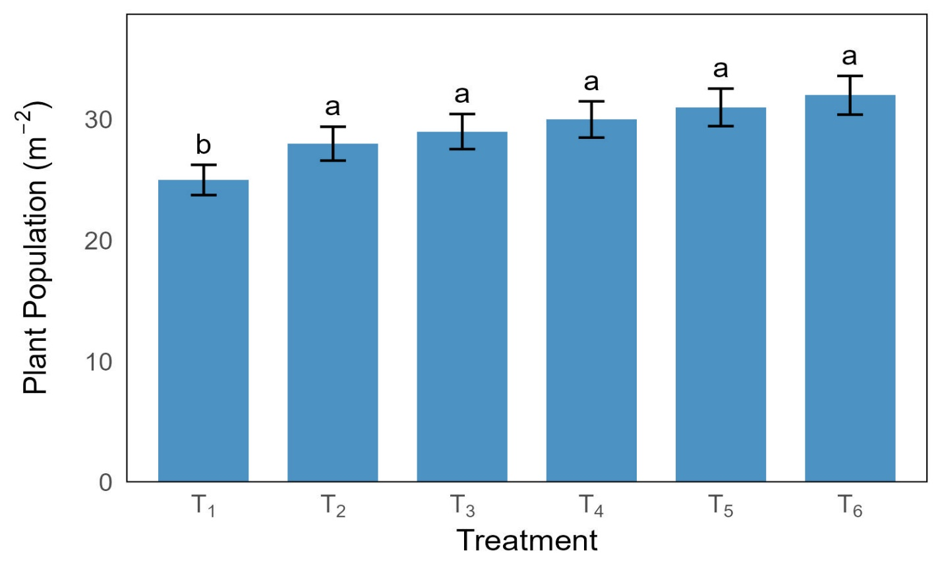
Figure 1.Effect of fertilizer treatments on plant Population of BJRI Kenaf-5

4.2 Plant Height
Plant height responded positively to increasing levels of integrated nutrient application. The tallest plants were recorded in T5 (3.11 m), followed closely by T6 (3.06 m) and T4 (3.04 m), with no significant differences among these treatments. In contrast, the control treatment produced significantly shorter plants (1.98 m).
The increase in plant height under integrated treatments can be attributed to improved nitrogen availability, which promotes cell division and elongation through enhanced protein synthesis and chlorophyll formation. Phosphorus likely supported energy transfer processes (ATP synthesis), while potassium improved enzymatic regulation and water balance, collectively stimulating vertical growth.
Furthermore, organic amendments may have contributed to synchronized nutrient release, preventing nutrient stress during critical growth stages. This balanced nutrient supply promotes sustained internode elongation, which is directly associated with fiber-producing stem tissues in kenaf.
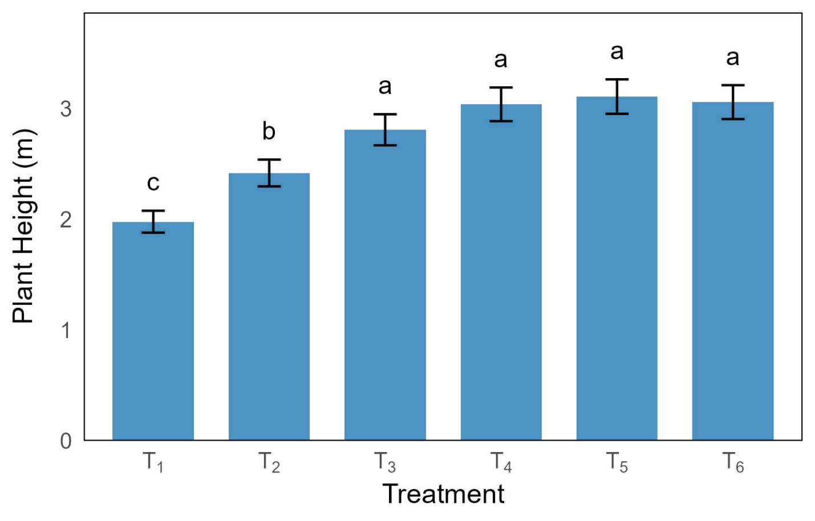
Figure 2.Effect of fertilizer treatments on plant height of BJRI Kenaf-5
4.3 Base Diameter
Base diameter ranged from 11.99 mm (T1) to 19.63 mm (T4), with T4, T6, and T5 forming the statistically superior group. The marked increase in stem thickness under integrated treatments suggests improved radial growth.
Stem diameter is strongly influenced by carbohydrate translocation and cambial activity. Organic amendments enhance microbial activity and improve nutrient mineralization, thereby sustaining nutrient supply during the vegetative growth phase. Improved potassium availability may have enhanced assimilate transport and fiber bundle development, resulting in thicker stems.
The superior base diameter observed in T4 indicates that moderate RDF combined with higher organic inputs may optimize structural growth, possibly due to improved soil carbon dynamics and enhanced cation exchange capacity.
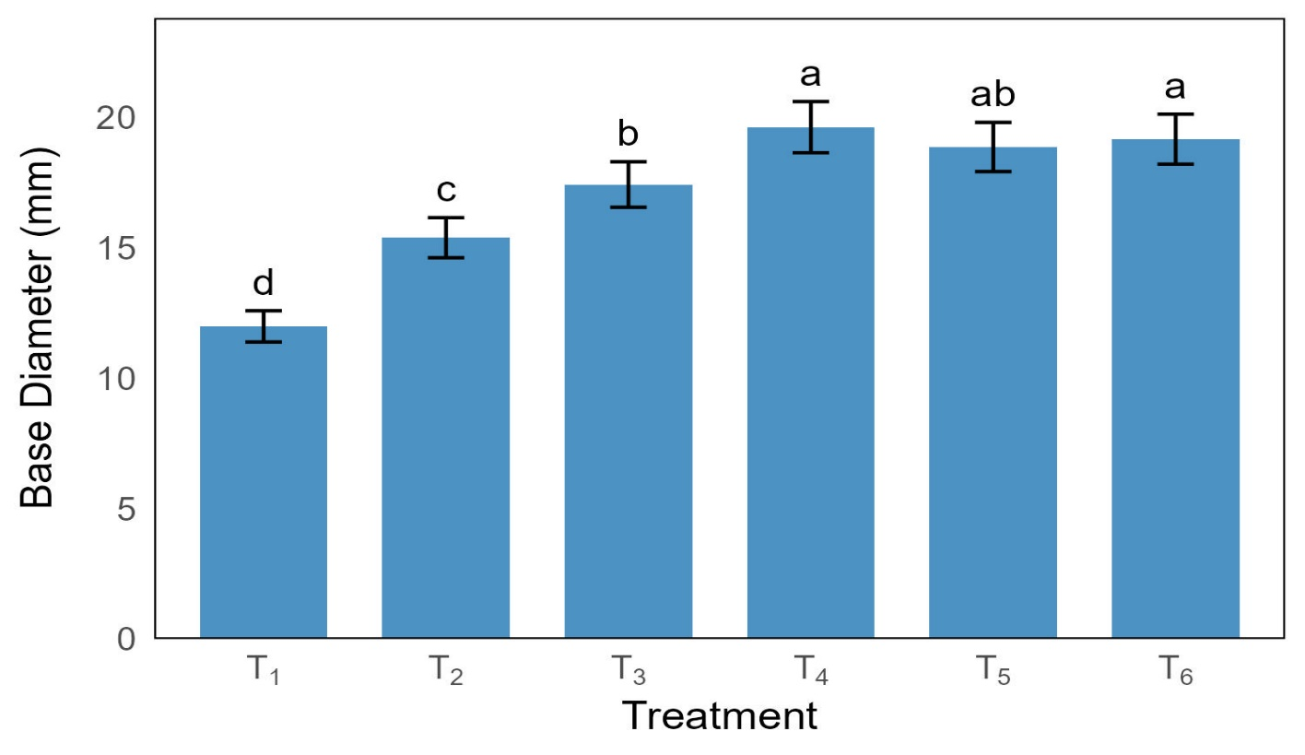
Figure 3.Effect of fertilizer treatments on base diameter of BJRI Kenaf-5

4.4 Fiber Yield
Fiber yield showed a highly significant response to fertilizer integration. The maximum fiber yield (3.36 t ha⁻¹) was obtained in T6, followed by T4 (3.11 t ha⁻¹) and T5 (3.05 t ha⁻¹). The control treatment produced the lowest yield (1.91 t ha⁻¹), representing nearly a 76% reduction compared to T6.
The superior performance of T6 demonstrates the synergistic effect of combining 100% RDF with organic amendments. Inorganic fertilizers provide immediately available nutrients, while organic sources ensure slow-release nutrient supply and improve soil biological activity. This integrated nutrient supply likely minimized nutrient losses through leaching and volatilization, thereby enhancing nutrient use efficiency.
Fiber yield in kenaf is directly associated with stem elongation and thickening, as fiber bundles develop in the phloem tissues of elongated stems. The strong response observed in T6 indicates that balanced macro-nutrient availability, supported by improved soil structure and microbial processes, maximized the genetic potential of BJRI Kenaf-5.

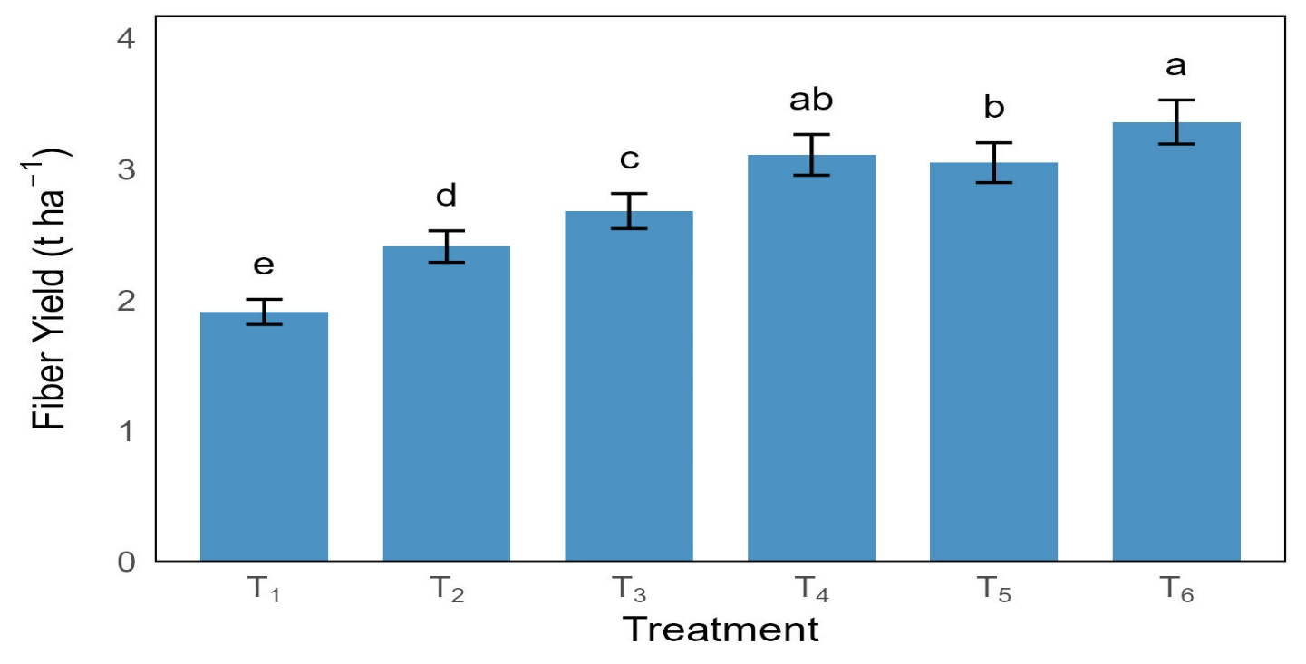
Figure 4.Effect of fertilizer treatments on fiber yield of BJRI Kenaf-5

4.5 Stick Yield
Stick yield followed a trend similar to fiber yield. T6 produced the highest stick yield (6.73 t ha⁻¹), whereas T1 recorded the lowest (3.88 t ha⁻¹). The mean stick yield across treatments was 5.56 t ha⁻¹ with a low coefficient of variation (5.34%), indicating experimental reliability.
Higher stick yield reflects enhanced total biomass production. Since stick biomass represents the woody core of the stem, its increase under integrated treatments suggests improved carbon assimilation and structural tissue formation. Balanced phosphorus and potassium nutrition likely enhanced root development and assimilate partitioning, contributing to overall biomass accumulation.

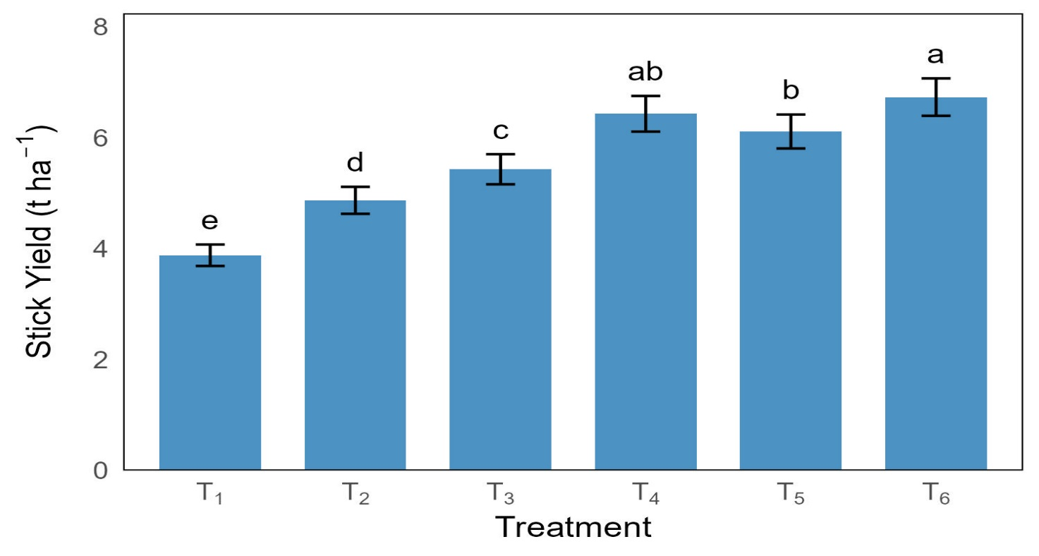
Figure 5.Effect of fertilizer treatments on stick yield of BJRI Kenaf-5

4.6 Multivariate Analysis (PCA)
Principal Component Analysis revealed that the first principal component (PC1) explained 97.7% of the total variation, while PC2 accounted for 1.4%, together explaining 99.1% of total variability.
All growth and yield variables were positively loaded on PC1, indicating a strong collective response to integrated nutrient application. Treatments T4, T5, and T6 were positioned on the positive side of PC1, confirming their superior performance across measured traits. In contrast, T1 and T2 clustered on the negative side, indicating lower productivity.
The close angular proximity among vectors for plant height, base diameter, fiber yield, and stick yield suggests strong positive associations among vegetative growth and yield traits. The dominance of PC1 indicates that nutrient management was the primary driver of variation in this experiment.

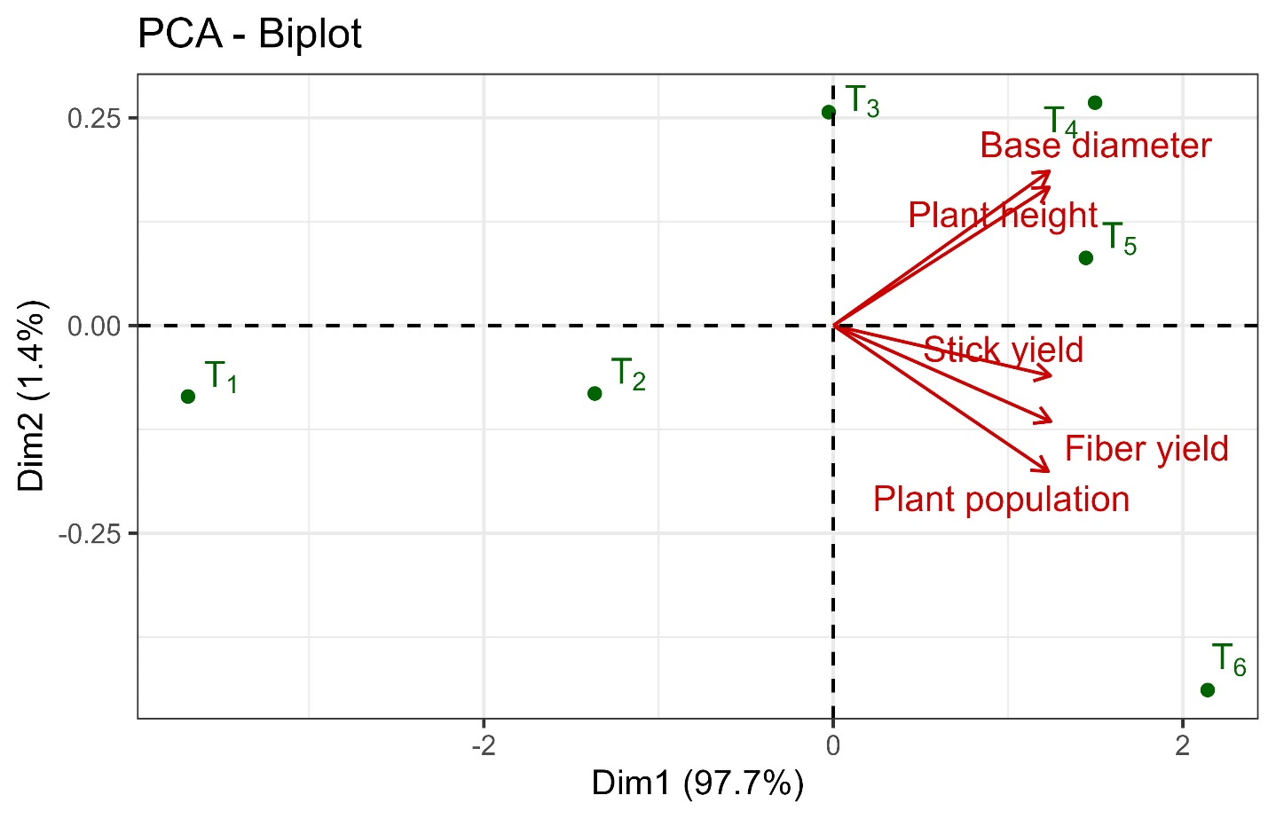

Figure 6. Principal component analysis (PCA) biplot illustrating the relationships among growth and yield parameters of BJRI Kenaf-5 (Hibiscus cannabinus L.) under different integrated nutrient management treatments (T1–T6) at Kishoreganj. The first principal component (PC1) explained 97.7% of the total variance, while PC2 accounted for 1.4%. Vector length indicates the contribution of each variable to total variation, and the angle between vectors reflects the degree of correlation among traits. Treatments located on the positive side of PC1 (T4, T5, and T6) demonstrated superior performance across growth and yield attributes.

4.7 Pearson’s Correlation Analysis
Pearson’s correlation analysis demonstrated strong and highly significant (p < 0.001) positive relationships among all growth and yield parameters.
Fiber yield showed strong positive correlations with:
- Plant height (r ≈ 0.96–0.98)
- Base diameter (r ≈ 0.97–0.99)
- Plant population (r ≈ 0.95–0.97)
Similarly, stick yield exhibited strong associations with vegetative traits, confirming that biomass accumulation is closely linked to structural growth parameters.
The near-linear relationship between plant height and base diameter suggests coordinated longitudinal and radial stem development under balanced nutrient supply. These strong correlations indicate that integrated nutrient management influenced the crop growth cycle in a synchronized manner, enhancing both vegetative growth and final yield.
Importantly, the extremely high correlations observed are likely influenced by the limited number of treatments (n = 6), which may inflate correlation coefficients. Nevertheless, the biological relationships remain consistent with fiber crop physiology.

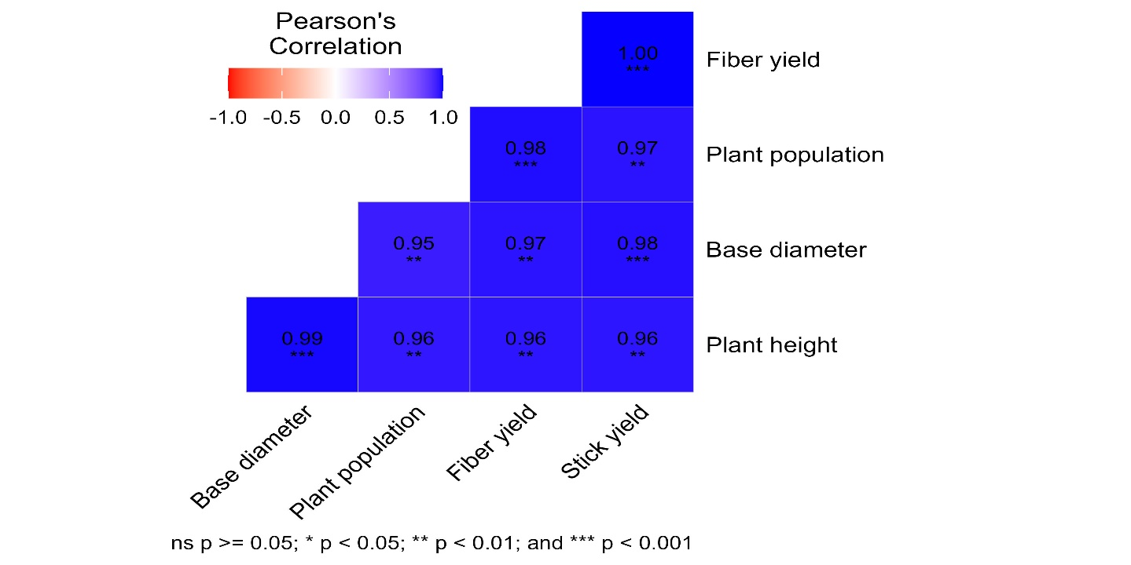

Figure 7. Pearson’s correlation matrix showing the relationships among plant population, plant height, base diameter, fiber yield, and stick yield of BJRI Kenaf-5 under different fertilizer treatments. Positive correlations are indicated by darker shading, while lighter tones represent weaker associations. All measured growth parameters exhibited strong positive relationships with fiber and stick yield, indicating coordinated vegetative and biomass development under integrated nutrient management.

5. Conclusion
Integrated nutrient management significantly enhanced the growth and fiber productivity of BJRI Kenaf-5 under the agro-ecological conditions of Kishoreganj. The combined application of inorganic fertilizers with organic amendments improved plant height, base diameter, plant population, and ultimately fiber and stick yield.
Among the evaluated treatments, T6 (100% RDF + cow dung + poultry manure + vermicompost at 1.5 t ha⁻¹ each) demonstrated superior performance, producing the highest fiber yield (3.36 t ha⁻¹) and stick yield (6.73 t ha⁻¹). The strong positive associations observed between vegetative growth traits and yield parameters confirm that balanced nutrient supply promotes synchronized longitudinal and radial stem development, which is essential for maximizing fiber production.
The multivariate analyses further validated that integrated fertilization was the primary driver of yield variability, emphasizing the importance of combining organic and inorganic nutrient sources rather than relying solely on chemical fertilizers.
Overall, the findings indicate that integrated nutrient management not only enhances fiber productivity but also supports sustainable soil fertility improvement, making it a viable strategy for long-term kenaf cultivation in Bangladesh.

6. Future Recommendations

6.1 Economic Evaluation
Although T6 produced the highest yield, treatments T4 and T5 also showed statistically competitive performance. A detailed cost–benefit analysis is recommended to determine the most economically viable nutrient combination for smallholder farmers, considering input costs and market prices.

6.2 Multi-Location Validation
To ensure the broader applicability of these findings, similar experiments should be conducted across different agro-ecological zones of Bangladesh to evaluate treatment stability under varying soil and climatic conditions.

6.3 Long-Term Soil Health Monitoring
Long-term studies are necessary to assess the residual effects of repeated organic amendment application on soil organic carbon, nutrient dynamics, microbial activity, and sustainability of fiber production.

6.4 Nutrient Use Efficiency Studies
Future research should focus on quantifying nutrient use efficiency (NUE) and carbon sequestration potential under integrated nutrient management to better understand environmental benefits.
Disclaimer (Artificial intelligence)
Author(s) hereby declare that NO generative AI technologies such as Large Language Models (ChatGPT, COPILOT, etc.) and text-to-image generators have been used during the writing or editing of this manuscript.

References
Agbede, T. M., Ojeniyi, S. O., & Adeyemo, A. J. (2008). Effect of poultry manure on soil physical and chemical properties, growth and grain yield of sorghum in South-West, Nigeria. American Eurasian Journal of Sustainable Agriculture, 2, 72–77.
Akinrotimi, C. A., & Okocha, P. I. (2018). Evaluation of genetic divergence in kenaf (Hibiscus cannabinus L.) genotypes using agro‐morphological characteristics. Journal of Plant Sciences and Agricultural Research, 2(12), 1–10.
Alam, M. S., Islam, M. S., & Nasreen, S. (2021). Effect of integrated nutrient management on the growth and yield of Kenaf (Hibiscus cannabinus L.). Journal of Agriculture and Ecology Research International, 22(4), 1–10. https://doi.org/10.9734/jaeri/2021/v22i430191
Das, K., Guha, B., & Pathak, D. (1996). Response of capsularis to potassium fertilization. Annals of Agricultural Research, 17(2), 188–189.
Das, R. C., Mallick, C., Syfullah, K., Kabir, M. H., Zhumur, T. K., Fahim, F. A., Ali, M. I., & Ali, M. Y. (2025). BJRI-developed Tossa jute (Corchorus olitorius) varieties: Agronomic traits, fiber quality, economic significance, and future prospect in Bangladesh. Journal of Bioscience and Agriculture Research, 35(01), 2783–2798.
Edmeades, D. C. (2003). The long-term effects of manures and fertilisers on soil productivity and quality: A review. Nutrient Cycling in Agroecosystems, 66, 165–180.
H'ng, P. S., Khor, B. N., Tadashi, N., Aini, A. S. N., & Paridah, M. T. (2009). Anatomical structure and morphology of new kenaf varieties. Asian Journal of Scientific Research, 2(3), 161–166.
Hossain, M. A., Ahmed, F., & Gani, M. N. (2019). Biomass partitioning and yield of BJRI Kenaf-5 under varied agro-climatic conditions. Bangladesh Journal of Agricultural Research, 44(3), 453–465. https://doi.org/10.3329/bjar.v44i3.43478
Islam, M. M., & Ali, M. S. (2017). Economic importance of jute in Bangladesh: Production, research achievements and diversification. International Journal of Economic Theory and Application, 4(6), 45–57.
Islam, M. M., Ahmed, S., & Rahman, M. S. (2020). Impact of organic and inorganic fertilizers on fiber quality and yield of kenaf in Bangladesh. International Journal of Plant & Soil Science, 32(12), 45–56. https://doi.org/10.9734/ijpss/2020/v32i1230351
Jonathan, S. G., Oyetunji, O. J., Olawuyi, O. J., & Asemoloye, M. D. (2012). Growth responses of Corchorus olitorius L. (Jute) to the application of organic manure as an organic fertilizer. Academic Arena, 4(9), 48–56.
Liu, T., Chen, X. Y., Hu, F., Ran, W., Shen, Q. R., Li, H. X., & Whalen, J. K. (2016). Carbon-rich organic fertilizers to increase soil biodiversity: Evidence from a meta-analysis of nematode communities. Agriculture, Ecosystems & Environment, 223, 199–207.
Maheswarappa, H. P., Nanjappa, H. V., Hegde, M. R., & Prabhu, S. R. (1999). Influence of planting material, plant population and organic manures on yield of East Indian galangal (Kaempferia galanga), soil physico-chemical and biological properties. Indian Journal of Agronomy, 44(3), 651–657.
Mazen, A., Faheed, F. A., & Ahmed, A. F. (2010). Study of potential impacts of using organic manure in the amendment of desert reclaimed soil on wheat and Jews mallow plants. Brazilian Archives of Biology and Technology, 53(4), 917–930. https://doi.org/10.1590/S1516-89132010000400022
Moral, R., Paredes, C., Bustamante, M. A., Marhuenda-Egea, F., & Bernal, M. P. (2009). Utilisation of manure composts by high-value crops: Safety and environmental challenges. Bioresource Technology, 100(22), 5454–5460. https://doi.org/10.1016/j.biortech.2008.12.007
Olowoake, A. A. (2014). Influence of organic, mineral and organomineral fertilizers on growth, yield, and soil properties in grain amaranth (Amaranthus cruentus L.). Journal of Organic Systems, 1(1), 39–47.
Reardon, C., & Wuest, S. B. (2016). Soil amendments yield persisting effects on the microbial communities: A 7-year study. Applied Soil Ecology, 101, 107–116.
Sarker, A. K., & Bandopaddhay, P. K. (2000). Effect of potassium, boron and crop age on the yield and quality of white jute (Corchorus capsularis). Indian Agriculture, 26, 212–216.
Sarkar, S. K., Mostofa, M. G., & Ali, M. A. (2018). Management of soil fertility for sustainable fiber production. Fiber Crops Research Journal, 6(2), 112–125.
Thangarajan, R., Bolan, N. S., Tian, G., Naidu, R., & Kunhikrishnan, A. (2013). Role of organic amendment application on greenhouse gas emission from soil. Science of the Total Environment, 465, 72–96.

