The Dynamics of Urban Agriculture in Dhaka City, Bangladesh: Location, Patterns and Process

Abstract
The most challenging issues of Bangladesh today include alleviation of poverty and environmental management in the context of the rapidly growing population. Promoting gardening among urban residents holds the potential to improve urban diets in low- and middle-income countries, but there is a lack of evidence of impact. The study reveals that various types of agriculture exist in Dhaka city e.g., vegetable garden, ornamental plants, floriculture, pigeon and birds fostering, dairy and goat farming. The survey identified that it is a hobby for most of the people in three Thana in Dhaka City (Bashabo, Gulshan and Pallabi). As it creates the aesthetic beauty of the houses and environment, people become interested in making gardens. Nowadays, with the desire to have fresh and chemical-free food, people are trying to grow some vegetables and fruits in their backyard. Thus, research has been set to find out how urban agriculture plays a role in our country's context. So, this study has been decorated by some issues like the condition of existing urban agriculture in Dhaka city and its pattern and process, types, spaces and location of urban agriculture. The findings of the survey reveal that various types of agriculture exist in Dhaka city e.g., vegetable garden, ornamental plants, floriculture, pigeon and birds fostering, dairy and goat farming. The agro climatic condition is well suited for growing many flowers and foliage plants in Bangladesh. Since Floriculture is a new industry in Bangladesh it has a tremendous scope to develop. Dairy farm has become also popular for demand of milk. Dairy farm is commonly seen in every ward.
Keywords: Urban Agriculture, location, spaces, types, pattern, rooftop, dairy, cultivation, farming
Introduction
“Urban cities are facing the challenges of microclimatic changes with substantially warmer environments and much less access to fresh vegetables for a healthier food supply than in adjacent rural areas. In this respect, urban rooftop agriculture is considered as a green technology for city dwellers and the community to attain environmental and socioeconomic benefits in a city” (Begum et al., 2021; Krishnaveni et al., 2024). “City governments can support urban gardening by recognizing its importance in local food security strategies and allocating resources to support gardeners. Lack of space and water, seasonal flooding, or uncertain tenure rights—all of which are regularly mentioned as unsurmountable constraints to urban food production, were not mentioned as significant hurdles by urban gardeners interviewed for this study. The main constraints were the lack of knowledge and skills, control of insect pests and diseases, lack of inputs, and lack of access to good soil—each of which can be addressed through extension support” (Schreinemachers et al., 2025). “Urban and peri-urban agriculture is the practice of cultivating, processing and distributing food in and around town or city. In addition, urban agriculture also involves animal husbandry, aquaculture, agroforestry, and horticulture. Urban farming is generally practiced for income-earning or food-producing activities, though in some groups the main impetus is recreation and relaxation” (Smith et. al., 2019). The most challenging issues of Bangladesh today include alleviating poverty and environmental management in the context of the rapidly growing population. Dhaka is the sixth-largest and seventh-most densely populated city in the world. The population influx in Dhaka is very high. Natural disasters like flood, drought, cyclones, and river-bank erosion destroy agricultural crops every year and force farmers to go to the cities. People are pushed to the cities because of the absence of job opportunities in rural areas. So, urban agriculture is an urgent need not only for food security but also for a sustainable urban environment in Dhaka or elsewhere in urban Bangladesh.Ogendi (2014) found that “urban and peri-urban agriculture can play a vital role in the economic, social, and dietary life of the urban poor since urban farming households cultivate a wide range of crops and rear various types of livestock with substantial yields”. Steele, (2017), shows that “urban agriculture exists in many forms, including community and backyard gardens, rooftop and balcony gardening, growing in vacant lots, rights-of-way, and parks, aquaculture, hydroponics, fruit trees and orchards, market farms, raising livestock and beekeeping”. “Hydroponic agriculture primarily relies on highly soluble inorganic salts as fertilizers to create nutrient solutions, although certain inorganic acids are also utilized. Extensive research has been conducted on plant nutrition within hydroponic systems, categorizing the essential nutrients into three main groups: primary, secondary, and trace or micro-nutrients. These nutrient solutions are carefully balanced to provide plants with optimal nutrition for growth and development. Primary nutrients such as nitrogen, phosphorus, and potassium are crucial for basic metabolic functions and structural integrity” (ŢĂLU, 2024). “Urban agriculture means that its forms and practices vary according to the conditions of the local environment – social, cultural, economic, physical and political. A rooftop garden can be the primary & preeminent way of our urban agriculture. Keeping the environment calm and cool, it can be a great source of our local food system, employment, and daily engagement with nature. Even with a small space, one can dream for a beautiful garden” (Daily Star, 2016).
Rahman, (2016), revealed that “Rearing of goats and pigeons on the rooftop has been on-going for some years in Dhaka city. A self-help-based community approach has been developed which is devoted to building community and strengthening local economies. If a pragmatic approach is taken, this will help nourish and protect soil, plants, animals, and the community. Currently, one demonstration farm is running on 300 sq.ft roof top —using a unique model of farming that protects food from being contaminated by the soils below”. Brown and Carter (2003) argue that there are three main types of urban agriculture: backyard gardens, community gardens, and commercial farms (Quoted from Hui, 2011). “Research published by the National Research Council of Canada shows that an extensive green roof reduces the daily energy demand for air conditioning in the summer by over 75 percent” (Liu 2003, retrieved from Daily Star, 2016).
At least one dairy farm is found in every ward of Dhaka city. But it is necessary to establish almost 5 to 10 farms in every ward to meet the demand for milk. So, the survey is described and designed for analyzing the present condition of dairy farms in Dhaka city.
Materials and Methods
Five different types of survey were conducted for the survey. These are
1. Pilot survey: The first survey was a pilot survey. The purpose of the pilot survey was to know how many homes have rooftop gardens, corridor gardens, livestock, and birds and so on. Though the survey was purposive, for the pilot survey, respondents were randomly selected. It includes 60 respondents from four thanas e.g. Gulshan (15), Bashabo (15), Pallabi(15) and Kotowali (15).
2. Questionnaire Survey for Urban Agriculture: The second survey was a comprehensive survey on urban agricultural patterns. Where information was collected on how, what is cultivated, kind of house, whether it is for hobby or for a business, for calculating income and expenses. A total of 100 questions have been generated for the survey. Accordingly, surveys were conducted in 25 homes in every ward.
4. Key Persons Interview (KPI): This survey plays an important role in making decisions, planning and recommendations. A total of 10 categories of respondents were selected for this interview. They are Milk Distributors, Consumers, Urban planner of RAJUK, Veterinary officer of City Corporation,

Map -1: Location Map of Study Area in Dhaka City
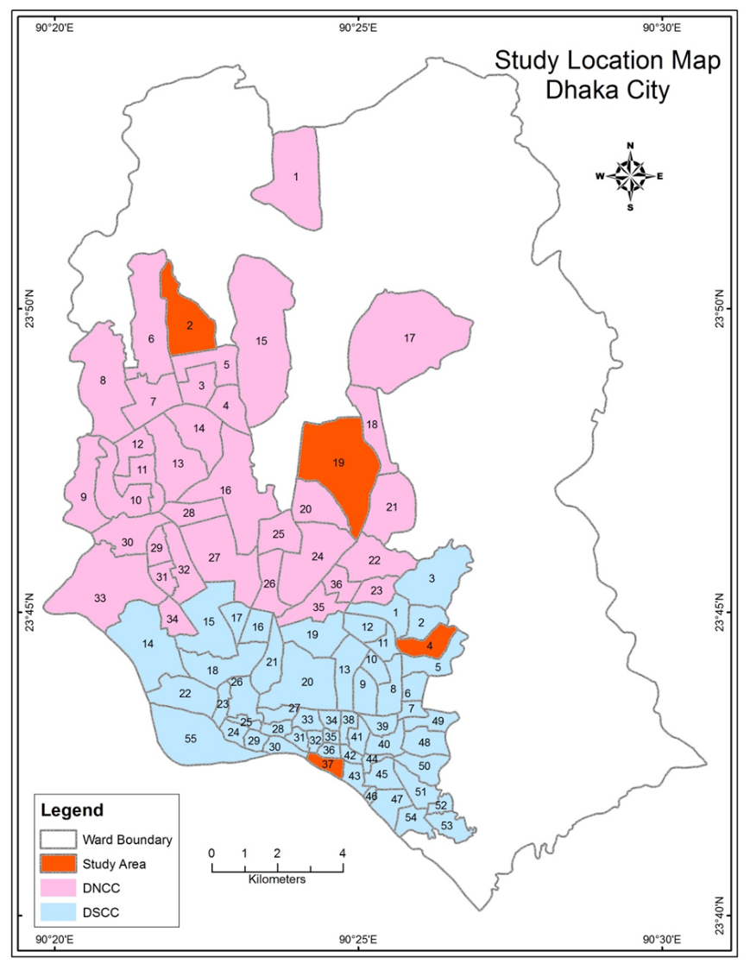
Source: Prepared by Researcher Using GIS, 2015

Director of district livestock Office, Senior Journalist, Researcher and Environmentalist, General Physician, Public Representative, Veterinary Surgeon. Basically, the questions were done in the light of open-ended questions. Different people were asked different questions in light of different topics.
Thus, it is seen that the primary data collection was completed in five steps. Besides, secondary data has also been collected from various sources e.g. BBS, DLO office, Agriculture Census Book, CUS, DNCC, DSCC, RAJUK, Organization’s data, Company’s reports etc
Results and Discussion
The Driving Forces Behind the Green Shift are the following motivations. The motivations are multi-faceted. With rising concern over pesticides and formalin in commercial produce, households prefer "growing their own for food safety. Urban gardens act as carbon sinks and help combat the "Urban Heat Island" effect, keeping homes cooler. In a chaotic megacity, gardening provides a vital connection to nature and a sense of relaxation. Economic Resilience: For lower-income groups, small-scale poultry or vegetable cultivation provides a buffer against fluctuating market prices.
The findings of the survey reveal that various types of agriculture exist in Dhaka city e.g., vegetable garden, ornamental plants, floriculture, pigeon and birds fostering, dairy and goat farming. The findings of the study discovered that many people are doing rooftop gardening, corridor gardening, and gardening in the open area even though they have no idea about agriculture in Dhaka City. The survey identified that because of the production of vegetables or fruits are very low in case of rooftop or corridor gardens, it is a hobby for most of the people in the three Thana (Bashabo, Gulshan and Pallabi). As it creates the aesthetic beauty of the houses and environment, people become interested in making gardens. Nowadays, the desire to have fresh and chemical-free food, people are trying to grow some vegetables and fruits in their backyard.
The survey has also done in Kotowali Thana. Agricultural practice has not been found in this area. Primarily, it can be assumed that the shortage of space and the economic crisis of the people is responsible for this condition.
From the pilot survey, thanas are compared in two ways according to the spaces where the people cultivate and which they cultivate. The following plate represents the spaces where the people cultivate.

Table-1:Types of Agriclture in Four Thanas
Source: Field Survey,2015.
Gulshan thana is rich in agricultural practice. Most houses have trees in the ground and outside the boundary. Roof top and corridor gardening is not much less. As the same way,Bashabo thana is also rich in agricultural practice. But the difference has been noticed that the rooftop and corridor gardening is high in this area. On the contrary, Pallabi thana is not rich in agricultural Practice (Table-1). There are some old houses in which some big trees of fruits are seen in the ground of the houses. The highest agricultural practice is seen in Gulshan thana which is shown in Figure-1.
Figure-1. Spaces for cultivation in four thanas
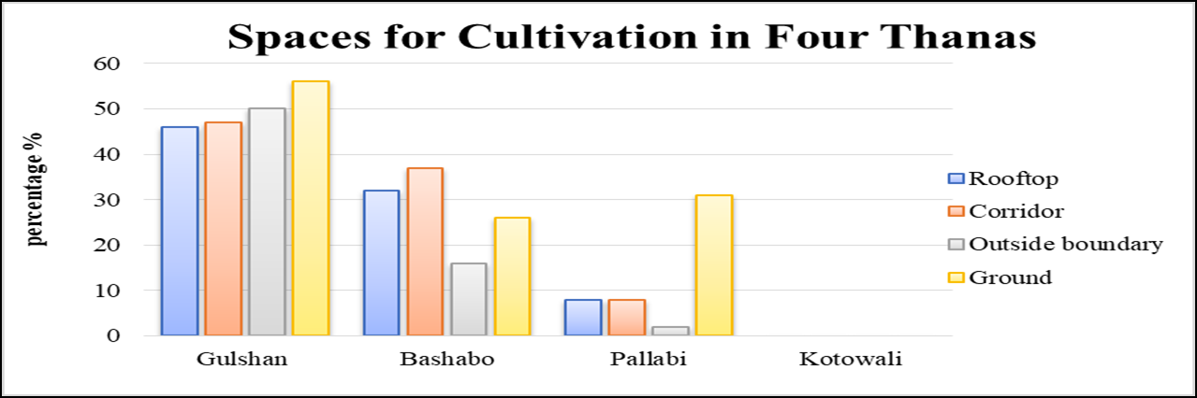
Source: Field Survey,2015.

From the survey, it is observed that people are also taming goat, hen, dog, cats, rabbits, etc. There are seven types of cows in the dairy farms in Dhaka City. These are the domestic cow, Australian cow, Vutti cow, Indian Cow, the foreign cross, Ox, etc. The survey found that about 90 percent of dairy farms contain Australian cows —the reason behind this is to get more milk. Only four or five farms contain Vutti cows. Besides Australian cows, the firms also keep Domestic cows. An Australian cow gives about 15-liter milk per day. So obviously, it is possible to make profitable dairy farms with 2/3 cows.
Fig 2. Agriculture practice in Dhaka city
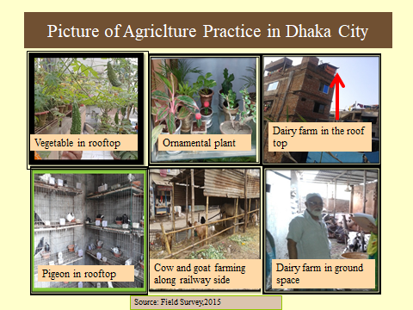
Due to high prices of milk, it is a profitable business to farmers. The consumers of the inner-city area support dairy farms because they can get fresh milk easily. They also collect milk from dairy farm easily in their locality, which is shown in MAP-2. But dairy farms are a threat to environmental pollution. Also, the large-sized dairy farm is enough to ruin the beauty of the city. The survey shows that the dairy farms that are present in the city are not following the rules to control pollution. It is therefore necessary to intervene in this regard. Thus, large-scale dairy farming is not possible in the inner city. However, if there is a license, then it will not be illegal. So, there are more arguments about specialization of dairy farms in the metropolitan area. The town planner or the environmentalist supports dairy farms outside the city but the consumers and veterinary officers support dairy farms in the inner part of the city.

Value Chain & Marketing System
Value Chain is a strategic framework used to identify specific activities through which an organization creates value and competitive advantage. While a supply chain focuses on the logistics of getting a product to a customer, the value chain focuses on the process of adding value at every step, from the initial spark of an idea to the final sale.
Islam, M. S. (2025) explained that a typical value chain for a small-scale dairy farm in the Dhaka district generally involves the following stages and actors:
General Dairy Value Chain Model in Dhaka
- Input Suppliers: Provide essential items like feed (high price is a common problem), medicine, and veterinary services.
- Production (Farmer): The farmer or producer rears the cattle (often Australian breeds are popular), manages the farm (facing challenges like electricity supply interruptions), and produces raw milk.
- Collection & Aggregation: Milk is collected from various small-scale farmers by collectors, farias (local traders), or beparis (wholesalers).
- Processing (Optional/Traditional): Aggregated milk is sometimes sold to traditional processors who make sweetmeats or curd, or to larger dairy companies for pasteurization and packaging.
- Distribution Channels:
  - Direct Sale: Farmers often sell directly to local consumers via home delivery.
  - Intermediaries: Milk is sold through a network of collectors, farias, beparis, and local retailers.
  - Modern Channels: Larger farms and companies (like North Bengal Dairy Farm, PRAN Dairy, Arla Foods) use more structured logistics, including temperature-controlled transport, to supply modern urban markets and supermarkets.
- Final Consumer: The end consumer who purchases milk or value-added products like sweetmeats.
Small-scale dairy farming in the region is generally a profitable enterprise despite challenges, with a benefit-cost ratio of around 1.80 for farms in the Dhaka district.

Figure 3.-: Value chain of Gardening/Nursery

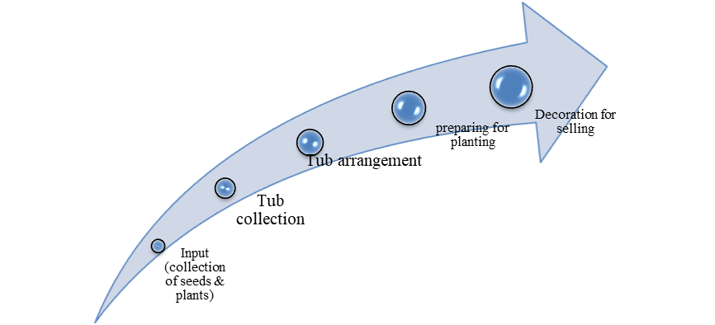

Source: Field Survey 2015.
Urban agriculture in the city is diverse in nature. People in city grow products mainly for their recreation, not for business. On the contrary, the nursery has become a popular business for floriculture. If the nursery is taken as an economic activity, the following activities are seen in a value chain shown below.
The survey also analyses the value chain of dairy farms in Dhaka city. The details of the dairy farm analysis have been discussed in the next chapter.

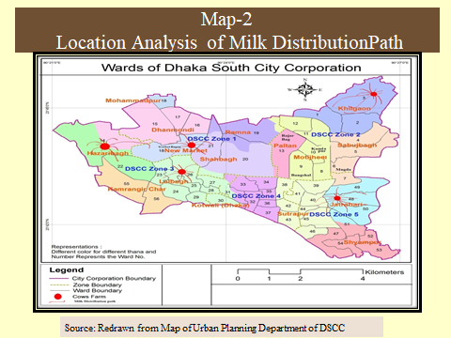

Methods of Urban Agriculture
Agriculture in city area is different from that in rural area. So, the techniques applied for agricultural activities in city area are simple. But plants or animal need much care. Building conditions, collecting seedlings or products, diseases and their remedial measures, using fertilizer and pesticides, training, involved people etc. have been taken into account for methods of urban agriculture.
“Increasing urban food deserts in many parts of the world have motivated the improvement of methods of UA in order to complement urban food needs” (Hendrickson & Porth, 2012). “Urban Agriculture was categorized into two spheres, Controlled Environment Agriculture (CEA)” (Despommier, 2013) and “Uncontrolled Environment Agriculture or open space agriculture (UEA)” (Nelson, Rosegrant, & Koo, 2009).

- Involved Person in Agriculture Activities
Spaces used for cultivation and building condition have been discussed before. Now, the persons who are directly involved in cultivation are mentioned specifically. In the survey, involved persons were categorized as self, mali, guard, family members, relatives or friends. “Self” means the owner of the garden. The person may be the male or female person of the family. It is found that, most of the owners do their garden work himself in Gulshan area. Sometimes they get helps from others. But, in the Pallabi and Bashabo, mali and guard maintain the garden.
- Information on Having Training
Then the question was doing they have any training. Some respondents had training or working experience from nursery (about 10%). But the dairy farmers had working experience from their past.
- Collection of products
The respondents were asked from where they collect plants or products of cultivation. They said that they collect the child plants from the nursery. Sometimes they bring seeds from their relatives or friends. Some people also buy little plants from van. Domestic animals are collected from market or the dairy farm.
- Information on Using Fertilizers or Pesticide
To grow vegetable and fruit plants, using fertilizer and pesticide is necessary in city area. Thus, there was a question to the respondents that did they used fertiliser or pesticides for their garden. Almost 92 percent respondents answered positively. The gardener collects mud mixed with fertilizer from the nursery. But the percentage of using pesticides is very low. The people who have dairy farms must use pesticides to clean the farm area. Some people also use mosquito spray.
- Remedial Measures from Diseases
The survey also found some information about the remedial measures of plants or domestic animals. Most of the people take suggestions from nursery in Gulshan and Bashabo. But in Pallabi Thana, most of people take decision themselves in such case. People go to veterinary hospital to treat the domestic animals. People also take suggestions from Pharmacy of animal medicine .
There are some organizations that are working for green vegetation in the city environment; such as Green Savers, Bonayon, Shetol etc. These organizations help people for rooftop or balcony garden. They make contact with the people to decorate houses for beautiful gardening. They use big drums, tub, plastic bottle, self-etc. for gardening. They collect mud and process it with fertilizers and other necessary chemicals for such gardening. They also give suggestions the owners to make a successful garden. Sometimes they make agreement with owners to take care the gardens for year-round. In this way they help the city to be green and make a profitable business now-a-day. Various TV programs like “Hridoye Mati O Manush” show programs about rooftop gardening frequently. As a result, People are inspired day by day.
4.5 Productions of Urban Agriculture
In Dhaka city, urban agriculture has evolved from a leisure-time hobby into a structured means of production. While space constraints in the inner city often limit individual vegetable and fruit yields, specific sectors like floriculture and dairy demonstrate high commercial and production potential.Primarily practiced for household consumption, this sector focuses on leafy and vine-based vegetables. According to the BRAC (2020) and ScienceDirect (2017), yields are relatively low but significant for household resilience, providing roughly 6% of a family's vegetable needs. High-yield winter crops include cabbage (25–26 units/season), cauliflower (20–25 units/season), and tomatoes (10–15 kg/season) (Hossain, M. A., & Rahman, M. M., 2024).Fruit cultivation is often integrated into rooftop gardens using containers or portable pots. Household gardens meet approximately 18% of a family's fruit demand. Common varieties include guava, pomegranate, and seasonal mangoes. Guava and lemon plants typically produce year-round, while star fruits may yield 8–10 fruits three times a year. (Islam, K. M. S., 2025). Unlike food crops, flowers are highly identified with market production due to their aesthetic and commercial value in the city center. High-value nursery production includes potted shrubs, flowers (48 identified species), and ornamental plants. Often found in the city's periphery or specialized urban nurseries to serve the high demand for landscaping and events (Bengal Institute, 2023). Dairy production is highly recognized for its economic feasibility, even within the city's outskirts. Small-scale livestock, including poultry and pigeons, is a growing sector utilized for both protein and supplemental income.
Conclusion
There is a brief description of location of these agricultures. That means which spaces are used by the people for agriculture. Dhaka south and north Corporation have the practice of agriculture. But periphery areas have immense agriculture practice. Gulshan area is rich in agriculture practice. The people of this use rooftop corridor, ground and all the spaces for gardening. But, in Pallabi Thana people mostly use the ground portion of their home. The scenery is average in Bashabo Thana. The location of dairy farms is mainly in the ground areas of buildings. Moreover, the space variation of dairy farms has been discussed in the next chapters.
The identification of methodology and value chain is not elaborate for urban agriculture in Dhaka city. The method for gardening is very simple i.e. collection of tub and mud and then planting the seeds or plants. Value chain comprises full range of activities – including design, production, marketing and distribution. The value chain for gardening includes collection of seeds & plants, tub collection, tub arrangement, preparation for planting and decoration for selling.
The findings of the survey reveal that various types of agriculture exist in Dhaka city e.g., vegetable garden, ornamental plants, floriculture, pigeon and birds fostering, dairy and goat farming. The survey also found camel farm at Kamalapur. Among the pet animals, dog, cat, rabbit different birds are popular. As most of the important foliage and flowering plants are native to the tropical region, they can successfully be grown in Bangladesh as well as for export from Bangladesh. Bangladesh has a very good potentiality to become an important supplier of flower and ornamental plants to different countries of Asia, Middle East and Europe. The agro climatic condition is well suited for growing many flowers and foliage plants in Bangladesh. Since Floriculture is a new industry in Bangladesh it has a tremendous scope to develop. Dairy farm has become also popular for demand of milk. Dairy farm is commonly seen in every ward.
The survey identified that it is a hobby for most of the people in three Thana. As it creates the aesthetic beauty of the houses and environment, people become interested to make garden. Now a days, the desire for having fresh and chemical free food, people are trying to grow some vegetables and fruits in their house boundary.
Urban agriculture in Dhaka is no longer just about beautifying apporch; it is a vital component of a sustainable urban future. Whether it is a dairy farm in the outskirts or a tomato plant on a Gulshan balcony, these practices contribute to a cooler, healthier, and more food-secure city. As the city continues to grow, nurturing these green spaces will be essential for the survival and well-being of its residents.
Disclaimer (Artificial intelligence)
Author(s) hereby declare that NO generative AI technologies such as Large Language Models (ChatGPT, COPILOT, etc.) and text-to-image generators have been used during the writing or editing of this manuscript.

References:
- Bengal Institute (2023). Dhaka Food Flow and Dynamics: The Case of Dhaka City. Mohammad Arfar Razi. https://bengal.institute/news/dhaka-food-flow-and-dynamics/
- BRAC (2020). Urban Agriculture: A Future Source of Organic Food for City Dwellers. BRAC Annual Report Series. www.brac.net
- Brown, K. H., & Carter, A. (2003). Urban Agriculture and Community Food Security in the United States: Farming from the City Center to the Urban Fringe. North American Urban Agriculture Coalition. (Quoted in Hui, 2011).
- Daily Star. (2016, May 17). Gardening on the roof. The Daily Star. Access Source (Cited for information on energy demand reduction and urban gardening potential).
- Despommier, D. (2013). The vertical farm: Feeding the world in the 21st century. Picador.
- Hendrickson, M. K., & Porth, M. (2012). Urban agriculture—Best practices and possibilities. University of Missouri Extension.
- Hossain, M. A., & Rahman, M. M. (2024). Prospect and Scope of Urban Agriculture in Dhaka City. The Dhaka University Journal of Earth and Environmental Sciences, 13(1), 91-104. www.banglajol.info
- https://extension.missouri.edu/media/wysiwyg/Extensiondata/Pro/FoodSystems/Docs/urbanagreport_072012.pdf
- Hui, S. C. (2011). Green roof urban farming for buildings in high-density urban cities. Proceedings of the 2011 Solar Conference, Raleigh, NC.
- Hui. S. C. M. (2011), “Green roof urban farming for buildings in high-density urban cities”, Department of Mechanical Engineering, The University of Hong Kong.March,2011 customized-7/14/2011, Accessed at 7 July 2011.
- Islam, K. M. S. (2025). Rooftop Gardening as a Strategy of Urban Agriculture for Food Security: The Case of Dhaka City, Bangladesh. Acta Horticulturae/R Discovery. https://discovery.researcher.life/article/urban-agriculture-for-environmental-sustainability-perception-of-city-dwellers/83014ec952483dd5a10aec22012ad10c
- Islam, M. S. (2025). Value chain analysis of dairy milk production and marketing: A farm level study in Dhaka District (Master’s thesis). Department of Agribusiness and Marketing, Sher-e-Bangla Agricultural University. http://archive.saulibrary.edu.bd:8080/xmlui/handle/123456789/1763
- Liu, K. (2003). Engineering performance of rooftop gardens through field monitoring. National Research Council of Canada.
- Nelson et al. (2009).Climate change: Impact on agriculture and costs of adaptation (Food Policy Report No. 21). International Food Policy Research Institute. https://doi.org/10.2499/0896295354
- Ogendi, G. M. (2014). Urban and peri-urban agriculture and its impact on the economic, social, and dietary life of the urban poor.
- Ogendi, M.N., Mukundi, J.B. & Orege, M.O.(2014) “Type and distribution of urban and peri-urban agriculture production syste”, ,Research Application Summary, Fourth RUFORUM Biennial Regional Conference 21 - 25 July 2014.
- Rahman, M. H, 2016. Roof-top Farming in Dhaka, Bangladesh, City Farmer News.
- ScienceDirect (2017). Rooftop Farming: A Viable Strategy for Sustainable Food Security in Dhaka City. Journal of Earth and Environmental Sciences. https://www.sciencedirect.com/science/article/pii/S2226585617300407
- Smith, J., et al. (2019). Urban farming for income and recreation. (General research on motivation for urban farming).
- Steele, K 2017. An Introduction to Urban Farming, from Types and Benefits to Strategies and Regulations, Urban Farming Workbook, Vitalyst Health Foundation. www.vitalysthealth.or.
- The Daily Star (2025). Urban Gardening Reshapes Bangladesh’s Cities Amid Climate and Economic Pressures. July 17, 2025. www.thedaily-star.net
- Schreinemachers, P., Kumar, S.S. & Uddin, N.M. Impact of home gardens promoted among urban residents in Dhaka, Bangladesh. Food Sec. 17, 1039–1052 (2025). https://doi.org/10.1007/s12571-025-01543-7
- Begum, M. S., Bala, S. K., Islam, A. K. M. S., & Roy, D. (2021). Environmental and Social Dynamics of Urban Rooftop Agriculture (URTA) and Their Impacts on Microclimate Change. Sustainability, 13(16), 9053. https://doi.org/10.3390/su13169053
- ŢĂLU Ș., Insights on Hydroponic Systems: Understanding Consumer Attitudes in the Cultivation of Hydroponically Grown Fruits and Vegetables. “Magazine of Hydraulics, Pneumatics, Tribology, Ecology, Sensorics, Mechatronics (HIDRAULICA)”, no. 1, 2024, p. 56-67.

- Krishnaveni, S.Anandha, G.Malathi, T. Sivasakthi Devi, G. Gomadhi, G.Kumar, T Senthilkumar, S.Jaya Prabhavathi, T. Sivasankari Devi, and M. Ramasamy. 2024. “Urban Agriculture: Exploring Its Potential, Challenges, and Socio-Economic Impacts”. Journal of Scientific Research and Reports 30 (10):54-64. https://doi.org/10.9734/jsrr/2024/v30i102430.

