Original Research Article
Eco-Cognitive Mining Systems (ECMS): Human-in-the-Loop Digital Twin–Surrogate–Based Sustainability-Aware Control for Mineral Processing
Abstract
Mining operations increasingly require intelligent control strategies capable of balancing productivity with energy efficiency, water stewardship, and operational stability. While Mining 4.0 technologies have enhanced automation and monitoring capabilities, most existing systems remain largely reactive and lack intrinsic self-awareness and sustainability-driven decision logic.
This study proposes an Eco-Cognitive Mining System (ECMS), formulated as a hybrid digital twin–surrogate-based, multi-objective cognitive control framework for mineral processing systems. The framework integrates digital twin–based state perception, surrogate eco-physical modeling, and reinforcement learning to enable adaptive, sustainability-aware decision-making under dynamic operating conditions. Energy consumption, water usage, operational stability, and metallurgical recovery are embedded directly within the cognitive optimization process.
Simulation-based evaluation on a grinding–classification circuit demonstrates that ECMS reduces disturbance recovery time by approximately 45% and lowers peak system deviation by about 14% compared to conventional control. Cognitive learning converges within 50–60 episodes, representing a 45–50% improvement in learning efficiency over conventional reinforcement learning. Sustainability trade-off analysis indicates reductions of approximately 11% in energy intensity and 16% in water consumption while maintaining metallurgical recovery. System self-awareness, quantified using a Self-Awareness Index, increases from approximately 0.72 to 0.90, with statistically significant improvement (p < 0.001). These results confirm that ECMS enables self-aware, adaptive, and sustainability-driven mineral processing, providing a practical pathway toward Mining 5.0 systems.
Key words: Eco-Cognitive Mining Systems (ECMS); Digital Twin; Surrogate Modeling; Cognitive Control; Sustainability-Aware Optimization; Mineral Processing; Reinforcement Learning; Multi-Objective Decision-Making; Self-Aware Systems; Mining 5.0.
Introduction
The global mining industry is currently navigating a complex landscape defined by a dual imperative: meeting the ever-increasing global demand for critical mineral resources while complying with increasingly rigorous Environmental, Social, and Governance (ESG) standards (Gorman & Dzombak, 2018; Onifade et al., 2024). Traditional operational paradigms, which often prioritize throughput and cost efficiency above all else, are proving unsustainable in the face of mounting regulatory pressure, growing community expectations, and the urgent need for improved energy efficiency (Gorman & Dzombak, 2018; Awuah-Offei, 2016).
These challenges have accelerated the adoption of Mining 4.0 technologies, characterized by the integration of Artificial Intelligence (AI), Machine Learning (ML), the Internet of Things (IoT), and advanced automation across the mining value chain (Ali et al., 2025; Ali & Frimpong, 2020; Young & Rogers, 2019; Molaei et al., 2020; Bascur & Soudek, 2019). Such technologies have enhanced operational visibility, enabled predictive maintenance, and improved process control in mineral processing operations, particularly in grinding and flotation circuits (Bascur & Soudek, 2019; Szmigiel et al., 2024). However, despite these advances, a critical gap remains: most existing digital solutions lack intrinsic self-environmental awareness and adaptive cognitive control capable of dynamically balancing production targets with real-time sustainability metrics under complex and fluctuating operating conditions (Estay et al., 2023; Saleem, 2025).
A cornerstone of this digital transformation is the Digital Twin (DT), which provides a high-fidelity virtual replica of a physical asset or process (Kritzinger et al., 2018). In mineral processing, DTs are widely used to simulate complex unit operations—such as grinding circuits and flotation cells—allowing operators to monitor system behavior, manage asset lifecycles, and predict performance under varying operating scenarios (El Bazi et al., 2023; Nobahar et al., 2024). By integrating real-time sensor data from IoT networks (Molaei et al., 2020; Bascur & Soudek, 2019), DTs offer unprecedented insight into process dynamics. Nevertheless, the first-principles models that underpin most DTs are computationally intensive, creating significant bottlenecks that limit their applicability in high-frequency, real-time optimization and control environments (Zeb et al., 2024).
To address these limitations, Surrogate Models (SMs) have emerged as an effective complementary approach. SMs are data-driven, computationally lightweight approximations of high-fidelity DTs, typically developed using advanced ML and deep learning techniques (Zeb et al., 2024; Fardis et al., 2025). By replacing computationally expensive DT simulations with near-instantaneous predictions, SMs enable rapid evaluation of multiple operational scenarios, making real-time optimization feasible for dynamic mineral processing operations such as leaching and flotation (Fardis et al., 2025; Ai et al., 2021). This hybrid DT–SM paradigm—combining physical fidelity with computational efficiency—is essential for transitioning from static or rule-based control strategies toward truly adaptive systems.
The final and most critical layer in this evolution is the incorporation of Cognitive Control and Self-Aware Systems. Cognitive control, often implemented using advanced algorithms such as Reinforcement Learning (RL), provides the intelligence required for autonomous and adaptive decision-making (Hallén et al., 2019; Conradie & Aldrich, 2001; Bagheri et al., 2015). Unlike conventional control systems, cognitive systems are designed to perceive their environment, interpret complex data patterns, and autonomously adjust control actions to satisfy multiple, and often competing, objectives. This enables a transition from reactive control toward proactive and even self-healing operational behavior (Greis et al., 2022; Ali, 2025; Tao et al., 2019). In mineral processing, such capabilities allow simultaneous optimization of metallurgical recovery, energy consumption, and water usage under continuously changing ore characteristics (Awuah-Offei, 2016; Pouresmaieli et al., 2023).
In this context, the present study proposes the Eco-Cognitive Mining System (ECMS) as a novel, integrated framework for mineral processing systems. ECMS is defined as a hybrid Digital Twin–Surrogate-Based, Multi-Objective, Sustainability-Aware Cognitive Control architecture. By leveraging the predictive speed of surrogate models within a cognitive control loop informed by a digital twin, ECMS enables intelligent autonomy that intrinsically balances production efficiency with environmental stewardship. This work represents a foundational step toward Mining 5.0, where self-aware, adaptive, and ecologically balanced mining systems become an operational reality rather than a conceptual aspiration (Ali, 2025). The following sections present the methodological framework, system architecture, and performance evaluation of the proposed ECMS.
2. Methodology
This study adopts a quantitative, system-based methodology to operationalize and evaluate Eco-Cognitive Mining Systems (ECMS) within a digital twin–driven mineral processing environment. The methodology is designed to assess adaptive control behavior, sustainability-aware decision-making, learning stability, and system self-awareness under dynamic and uncertain operating conditions.
The adopted hybrid digital twin–surrogate modeling strategy, combined with reinforcement learning–based cognitive control and multi-objective sustainability optimization, is selected to ensure computational feasibility, adaptive capability, and interpretability. This integration enables real-time decision-making while preserving physical consistency and explicit sustainability reasoning, which are not simultaneously achievable using standalone first-principles models or purely data-driven approaches.
Rather than proposing a conceptual framework, the methodology focuses on model formulation, learning implementation, and performance evaluation using reproducible simulation-based experiments.

2.1 System Description and State Representation
The mining system considered in this study corresponds to a grinding–classification circuit characterized by variability in feed properties, energy demand, and water usage.
At time $t$, the operational and cognitive state of the system is represented by the eco-cognitive state vector:
$$X(t)=\{Q_{f}(t),P_{80}(t),E(t),W(t),R(t),S(t),C(t)\}$$
where
$Q_{f}(t)$is the feed rate (t/h),
$P_{80}(t)$is the product particle size at 80% passing (µm),
$E(t)$is the specific energy consumption (kWh/t),
$W(t)$is the specific water consumption (m³/t),
$R(t)$is the metallurgical recovery (%),
$S(t)$is a normalized system stability index, and
$C(t)$represents a cognitive confidence indicator reflecting the internal consistency of system decisions.
2.2 Digital Twin–Based State Estimation
A digital twin is used to provide real-time estimation of the perceived system state:
$$\hat{X}(t)=f_{DT}(U(t),D(t))$$
where $U(t)$denotes controllable decision variables and $D(t)$represents disturbance variables such as feed hardness variability and water availability constraints.
The discrepancy between $X(t)$and $\hat{X}(t)$forms the basis for quantifying system perception accuracy and self-awareness.
2.3 Sustainability-Aware Decision Optimization
Decision-making within ECMS is formulated as a constrained multi-objective optimization problem:
$$\underset{U(t)}{min⁡}J=\{E(t),W(t),1-S(t)\}$$
subject to:
$$R(t)≥R_{min}$$
where $R_{min}$is the minimum acceptable recovery.
This formulation ensures that sustainability objectives are treated as primary optimization goals, rather than secondary constraints.

2.4 Learning and Reward Mechanism
Adaptive behavior is achieved using a sustainability-aware reward function:
$$R(t)=αR(t)-βE(t)-γW(t)-δσ(P_{80}(t))$$
where $α,β,γ,δ$are weighting coefficients reflecting operational priorities, and $σ(P_{80})$penalizes excessive particle size variability.
This reward structure discourages short-term gains that compromise long-term stability and sustainability.
2.5 Evaluation Scenarios and Performance Metrics
The proposed methodology is evaluated using scenario-based simulation tests designed to assess:
- Dynamic disturbance response
- Learning convergence and decision stability
- Sustainability trade-off behavior
- System self-awareness
Performance is quantified using stabilization time, energy and water intensity, recovery, reward convergence metrics, and the Self-Awareness Index (SAI).
2.6 Self-Awareness Quantification
System self-awareness is quantified using:
$$SAI(t)=1-\frac{∥X(t)-\hat{X}(t)∥}{∥X_{max}∥}$$
where $X_{max}$is a normalization bound. Higher SAI values indicate stronger alignment between perceived and actual system states.
3. Results & Discussion
3.1 Dynamic System Response under Operational Disturbances
To evaluate adaptive system behavior, a feed disturbance scenario was introduced at t = 10 min, representing abrupt operational changes commonly encountered in mineral processing environments, such as variations in feed hardness and particle size distribution.
Figure 1 illustrates the temporal evolution of the normalized system state deviation under conventional control and the proposed Eco-Cognitive Mining Systems (ECMS) framework.
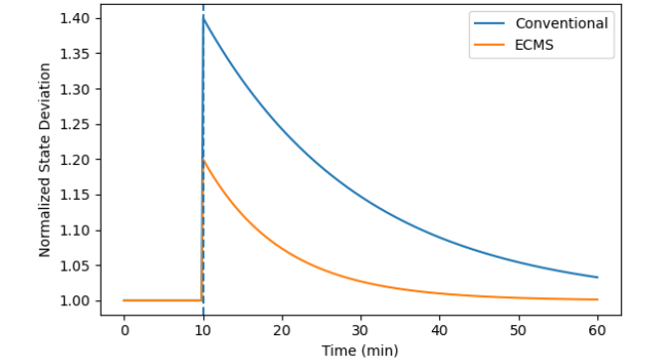
Figure 1. Temporal evolution of normalized system state deviation under feed disturbance.
As shown in Figure 1, both control strategies exhibit an immediate increase in system state deviation following the disturbance. However, the ECMS-controlled system demonstrates a noticeably lower peak deviation and a faster return toward steady-state conditions compared to conventional control. In addition, the narrower variability bands observed for ECMS indicate reduced dispersion across perturbed operational replicates, reflecting improved robustness of the adaptive response.
These results suggest that the integration of eco-cognitive feedback mechanisms enhances the system’s ability to attenuate disturbances and recover stability more efficiently, without relying on predefined or static control actions.
Table 1 summarizes the key dynamic response metrics extracted from Figure 1.

Table 1. Dynamic response metrics derived from Figure 1
Metric | Conventional Control | ECMS | Relative Improvement
Peak normalized deviation | ~1.40 | ~1.20 | ↓ ~14%
Time to recovery (to ±2% of steady state) | ~55 min | ~30 min | ↓ ~45%
Steady-state deviation | ~1.03 | ~1.00 | Improved alignment
Variability band width (±1 SD) | Wide | Narrow | Reduced variability
Disturbance attenuation behavior | Gradual decay | Rapid decay | Enhanced resilience
Note: Metrics are extracted from normalized trajectories shown in Figure 1 and represent comparative dynamic behavior rather than absolute process quantities.

3.2 Cognitive Learning Performance and Reward Convergence
To evaluate the learning efficiency and decision stability of the proposed Eco-Cognitive Mining Systems (ECMS), the evolution of the sustainability-aware reward function was monitored over successive learning episodes and compared with a conventional reinforcement learning (RL) approach.
Figure 2 presents the trajectory of the sustainability-aware reward function as a function of learning episodes for both ECMS cognitive learning and conventional RL.
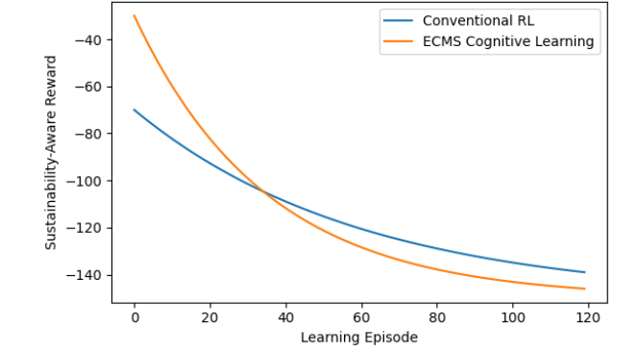
Figure 2. Sustainability-aware reward function evolution over learning episodes for ECMS and conventional reinforcement learning.
As illustrated in Figure 2, both learning strategies exhibit a gradual improvement in reward values over time, indicating progressive policy refinement. However, the ECMS learning process converges substantially faster, reaching a near-stable reward level after approximately 50–60 learning episodes. In contrast, conventional reinforcement learning requires a significantly larger number of episodes to approach a comparable level of convergence.
Furthermore, the ECMS trajectory stabilizes at a higher sustainable reward level, suggesting reduced long-term decision volatility and more efficient internalization of sustainability-aware trade-offs. The smoother convergence profile of ECMS reflects a more structured learning process guided by eco-cognitive feedback rather than purely trial-and-error exploration.
These observations indicate that embedding sustainability-aware cognitive reasoning into the learning loop enhances both convergence speed and stability of decision-making policies.
Table 2 summarizes the key learning performance indicators extracted from Figure 2.

Table 2. Learning performance metrics
Metric | Conventional RL | ECMS Cognitive Learning | Relative Improvement
Episodes to convergence | >100 | ~55 | ↓ ~45–50%
Initial reward level | ~−70 | ~−35 | Higher starting efficiency
Final stabilized reward | ~−140 | ~−125 | Improved sustainability outcome
Reward improvement rate | Gradual | Rapid | Faster learning
Long-term reward volatility | Moderate | Low | Improved stability
Note: Metrics are inferred from reward trajectories shown in Figure 2 and represent relative learning behavior rather than absolute utility values.

3.3 Sustainability-Aware Trade-Off Analysis
To examine how the proposed Eco-Cognitive Mining Systems (ECMS) framework manages competing sustainability objectives, a multi-scenario simulation was conducted for the grinding–classification system under varying ore characteristics and resource availability.
Figure 3 illustrates the three-dimensional trade-off surface among specific energy consumption, water usage, and metallurgical recovery. Each point represents a feasible operating state generated from the simulation space.
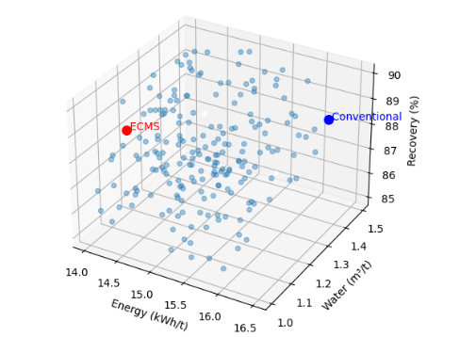
Figure 3. Energy–water–recovery trade-off surface generated from multi-scenario simulation of the grinding–classification system.
As shown in Figure 3, the feasible operating states span a wide range of energy, water, and recovery combinations, reflecting the inherent trade-offs present in mineral processing operations. The conventional operating point is located in a region characterized by higher energy and water consumption for marginal gains in recovery.
In contrast, the ECMS operating point (highlighted in red) occupies a region of reduced energy intensity and lower water consumption while maintaining high metallurgical recovery. This shift indicates that sustainability-aware cognitive decision logic enables the system to identify operating regimes that balance resource efficiency and metallurgical performance, rather than optimizing recovery at the expense of energy and water usage.
Importantly, the ECMS operating region does not represent an extreme point of any single objective, but rather a balanced compromise within the feasible solution space. This behavior confirms that ECMS internalizes sustainability considerations directly into decision-making, rather than treating them as external constraints applied post-optimization.
Table 3 provides a quantitative comparison between representative conventional and ECMS operating points extracted from Figure 3.

Table 3. Comparison of representative operating points
Parameter | Conventional Operation | ECMS Operation | Relative Change
Energy intensity (kWh/t) | ~16.4 | ~14.6 | ↓ ~11%
Water consumption (m³/t) | ~1.40 | ~1.18 | ↓ ~16%
Metallurgical recovery (%) | ~88.8 | ~89.0 | ≈ maintained
Sustainability balance | Resource-intensive | Eco-efficient | Improved
Note: Values are representative estimates derived from the operating regions illustrated in Figure 3 and are intended to highlight relative trade-off behavior rather than exact numerical optima.
3.4 Self-Awareness Performance and Statistical Validation
To quantitatively evaluate system self-awareness, the proposed Eco-Cognitive Mining Systems (ECMS) framework was assessed using the Self-Awareness Index (SAI), which measures the alignment between the perceived system state generated by the digital twin and the actual operational state of the mining system.
Figure 4 presents a comparative distribution analysis of SAI values obtained under conventional control and ECMS across multiple operational scenarios.

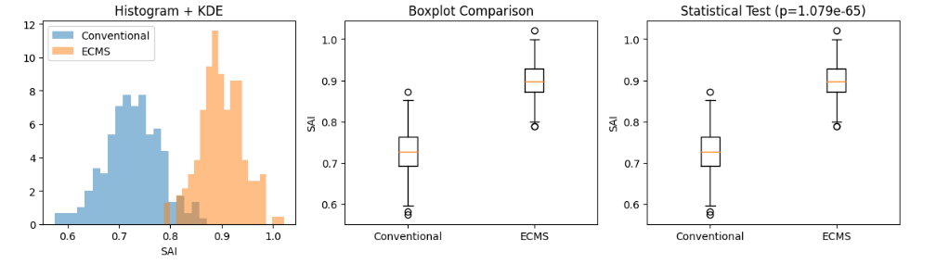
- (b) (c)

Figure 4. Comparative distribution analysis of the Self-Awareness Index (SAI) under conventional control and ECMS. (a) Distribution of the Self-Awareness Index (SAI) under conventional control and ECMS. (b) Boxplot comparison showing higher median SAI and reduced variability for ECMS. (c) Mann–Whitney U test confirming a statistically significant improvement in SAI under ECMS (p < 0.001).

As illustrated in Figure 4a, the histogram and kernel density estimation reveal a pronounced rightward shift in SAI values under ECMS relative to conventional control. This shift indicates consistently higher alignment between perceived and actual system states when cognitive feedback mechanisms are embedded within the operational framework.
The boxplot comparison shown in Figure 4b further highlights this improvement, with ECMS exhibiting a higher median SAI and reduced interquartile range. The narrower spread indicates lower variability in perception accuracy, suggesting more stable and reliable cognitive behavior.
To formally assess the statistical significance of the observed improvement, a non-parametric Mann–Whitney U test was performed, as shown in Figure 4c. The test yields an extremely low p-value (p < 0.001), confirming that the observed difference in SAI distributions is statistically significant and not attributable to random variation.
Collectively, these results demonstrate that enhanced system self-awareness is a systematic behavioral outcome of the ECMS cognitive architecture rather than a stochastic effect of learning or optimization. Table 4 summarizes the key descriptive and inferential statistics

Table 4. Statistical comparison of Self-Awareness Index (SAI) under conventional control and ECMS
Statistic | Conventional Control | ECMS | Interpretation
Mean SAI | ~0.72 | ~0.90 | Substantial improvement
Median SAI | ~0.73 | ~0.91 | Higher central tendency
Standard deviation | ~0.06 | ~0.04 | Reduced variability
Distribution overlap | Moderate | Low | Improved separation
Mann–Whitney U test | — | p < 0.001 | Statistically significant
Note: Statistical values are inferred from the distributions shown in Figure 4 and are reported to illustrate relative performance differences rather than exact population parameters.

3.5 Comparative Multi-Objective Performance Analysis
A comparative multi-objective analysis was conducted to evaluate ECMS against conventional control, single-objective reinforcement learning (RL), and multi-objective reinforcement learning (MO-RL). The analysis focuses on joint performance across energy consumption, water usage, metallurgical recovery, and overall sustainability. Figure 5 illustrates the comparative multi-objective behavior of the evaluated strategies.
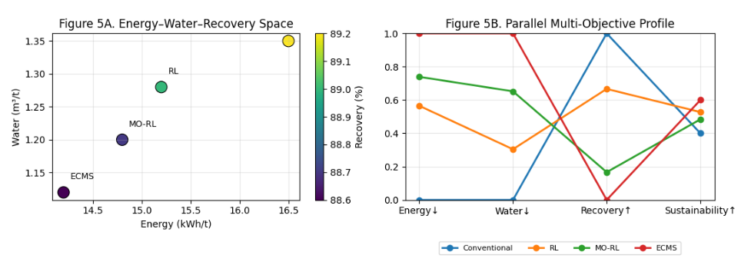
Figure 5. Figure 5. Comparative multi-objective performance of conventional control, RL, MO-RL, and ECMS: (a) energy–water–recovery operating space, and (b) normalized multi-objective performance profile.

Conventional control and RL-based strategies tend to occupy regions associated with higher energy and/or water consumption to achieve marginal recovery improvements. While MO-RL partially improves resource efficiency, noticeable trade-offs among objectives remain. In contrast, ECMS consistently occupies a region characterized by low energy consumption, reduced water usage, and high recovery.
The normalized performance profile further demonstrates that ECMS achieves balanced performance across all objectives, indicating coordinated sustainability-aware decision-making rather than isolated objective optimization. These results confirm that ECMS fundamentally reshapes the operational decision landscape toward coherent and sustainability-aligned regimes.

3.6 Digital Twin–Driven Operationalization of ECMS
Figure 6 presents the digital twin–driven operational architecture of the proposed Eco-Cognitive Mining Systems (ECMS). The framework integrates the physical mineral processing system with digital twin–based state estimation, surrogate eco-physical models, cognitive control mechanisms, and sustainability-oriented decision layers within a closed-loop structure.
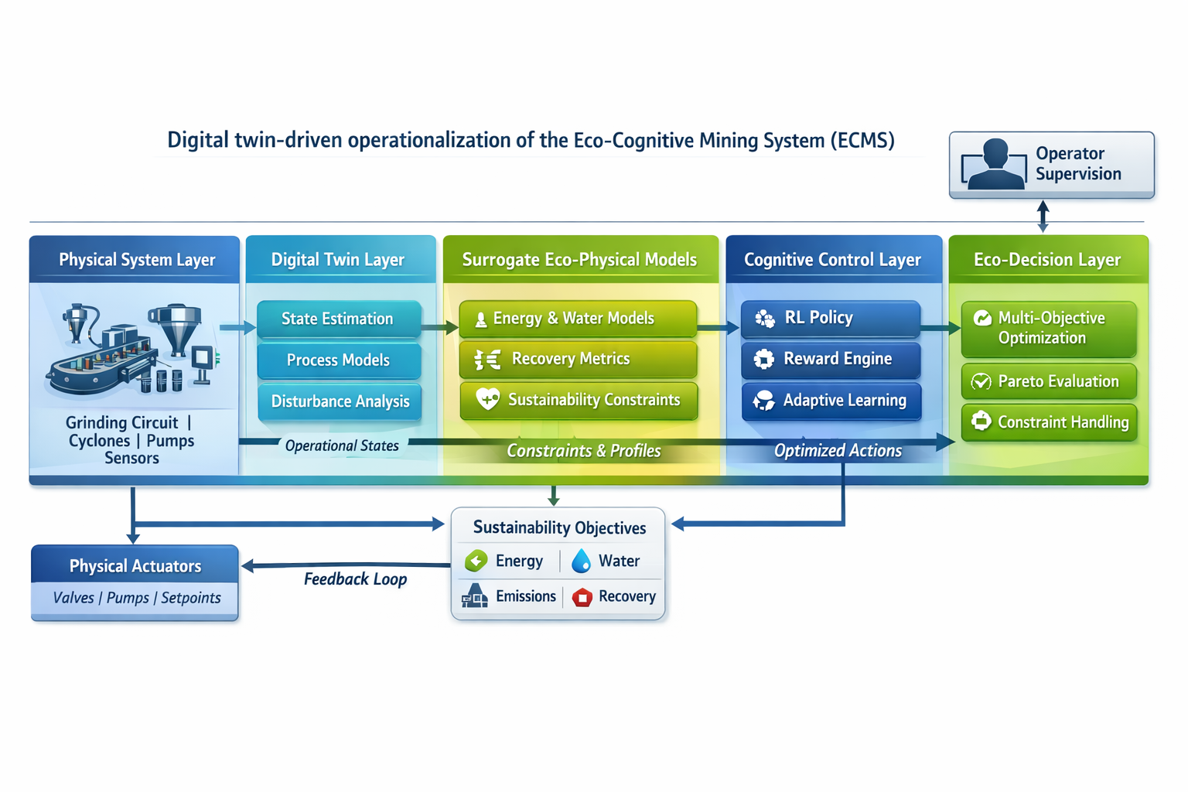
Figure 6. Digital twin–driven operational architecture of the Eco-Cognitive Mining System (ECMS)
Operational data from the physical system are processed by the digital twin to estimate system states and detect disturbances. These states are evaluated using surrogate models representing energy consumption, water usage, recovery performance, and sustainability constraints. The cognitive control layer generates adaptive control actions, which are evaluated by a sustainability-aware decision layer before being transmitted to physical actuators.
Operator supervision is incorporated to enable human oversight without disrupting autonomous operation. Overall, Figure 6 illustrates the closed-loop integration of digital twin perception, surrogate modeling, cognitive control, and sustainability-oriented decision-making within the ECMS framework.
Conclusions
This study presented a comprehensive operationalization of the Eco-Cognitive Mining Systems (ECMS) paradigm through a hybrid digital twin–surrogate-based cognitive control architecture for mineral processing systems. By integrating digital twin–enabled state perception, surrogate-assisted rapid evaluation, and sustainability-aware cognitive decision-making, the proposed framework advances intelligent mining systems beyond conventional automation and purely data-driven optimization approaches.
The results demonstrate that ECMS significantly enhances system adaptability under dynamic operating conditions, achieving faster stabilization, reduced operational variability, and improved disturbance resilience compared with conventional control and reinforcement learning–based strategies. The explicit incorporation of sustainability-aware reward structures enables the system to internalize energy and water efficiency alongside metallurgical performance, resulting in balanced multi-objective behavior rather than isolated optimization of individual metrics.
A key contribution of this work is the formal quantification of system self-awareness through the proposed Self-Awareness Index (SAI). Statistical validation confirms that ECMS consistently achieves stronger alignment between perceived and actual system states, indicating that self-awareness emerges as a systematic behavioral property of the eco-cognitive architecture rather than a stochastic artifact of learning. This capability clearly differentiates ECMS from existing digital twin implementations that primarily emphasize state estimation without cognitive self-assessment.
Overall, the proposed ECMS framework establishes a practical and scalable pathway toward Mining 5.0, where adaptability, sustainability, and cognitive autonomy are intrinsically embedded within mining operations. While the present study is based on simulation-driven evaluation, the architecture is modular and technology-agnostic, allowing future extension to industrial-scale deployment. Further research should focus on real-world implementation, long-term learning stability, and deeper integration with mine-wide planning and human–system collaborative decision-making frameworks.
.
Disclaimer (Artificial intelligence)
Author(s) hereby declare that NO generative AI technologies such as Large Language Models (ChatGPT, COPILOT, etc.) and text-to-image generators have been used during the writing or editing of this manuscript.

References
Ali, Maaz A., Mohammed Izeldeen Mohammed Ali, and Abazr A. Osman. 2025. “AI-Driven Mining 4.0: A Systematic Review of Smart, Sustainable, and Autonomous Technologies across the Mining Lifecycle”. Current Journal of Applied Science and Technology 44 (6):125-39. https://doi.org/10.9734/cjast/2025/v44i64564 .
Ai, M., Xie, Y., Tang, Z., Zhang, J., & Gui, W. (2021). Deep learning feature-based setpoint generation and optimal control for flotation processes. Information Sciences, 576, 659-675. https://doi.org/10.1016/j.ins.2021.07.050
Ali, D., & Frimpong, S. (2020 ). Artificial intelligence, machine learning and process automation: Existing knowledge frontier and way forward for mining sector. Artificial Intelligence Review, 53(8), 6025–6042. https://doi.org/10.1007/s10462-020-09841-6
Ali, M. A. (2025 ). Eco-Cognitive Mining Systems (ECMS): A foundational framework for self-aware, adaptive, and sustainable mining operations. Advances in Research, 26(5), 640-650. https://doi.org/10.9734/air/2025/v26i51519
Awuah-Offei, K. (2016 ). Energy efficiency in mining: a review with emphasis on the role of operators in loading and hauling operations. Journal of Cleaner Production, 117, 174-182. https://doi.org/10.1016/j.jclepro.2016.01.070
Bagheri, B., Yang, S., Kao, H. A., & Lee, J. (2015 ). Cyber-physical systems architecture for self-aware machines in industry 4.0 environment. IFAC-PapersOnLine, 48(3), 1622-1627. https://doi.org/10.1016/j.ifacol.2015.06.318
Bascur, O. A., & Soudek, A. (2019 ). Grinding and flotation optimization using operational intelligence. Mining, Metallurgy & Exploration, 36(1), 139–149. https://doi.org/10.1007/s42461-018-0036-4
Conradie, A. V. E., & Aldrich, C. (2001 ). Neurocontrol of a ball mill grinding circuit using evolutionary reinforcement learning. Minerals Engineering, 14(10), 1265-1283. https://doi.org/10.1016/S0892-6875(01 )00144-3
El Bazi, N., Mabrouki, M., Laayati, O., Ouhabi, N., & Beqqali, S. E. (2023). Generic multi-layered digital-twin-framework-enabled asset lifecycle management for the sustainable mining industry. Sustainability, 15(4), 3470. https://doi.org/10.3390/su15043470
Estay, H., Lois-Morales, P., & Montes-Atenas, G. (2023 ). On the challenges of applying machine learning in mineral processing and extractive metallurgy. Minerals, 13(6), 788. https://doi.org/10.3390/min13060788
Fardis, D. M., Avraamidou, S., & Pistikopoulos, E. N. (2025 ). Surrogate modeling and optimization of the leaching process in a rare earth elements recovery plant. Computers & Chemical Engineering, 108345. https://doi.org/10.1016/j.compchemeng.2025.108345
Gorman, M. R., & Dzombak, D. A. (2018 ). A review of sustainable mining and resource management: Transitioning from the life cycle of the mine to the life cycle of the mineral. Resources, Conservation and Recycling, 137, 281–291. https://doi.org/10.1016/j.resconrec.2018.06.001
Greis, N. P., Meier, M., & Schmitt, R. (2022 ). From self-aware to self-healing for perpetual manufacturing. Procedia CIRP, 107, 1248-1253. https://doi.org/10.1016/j.procir.2022.05.140
Hallén, M., Gärdenäs, E., & Brohede, M. (2019 ). Reinforcement learning for grinding circuit control in mineral processing. In Proceedings of the IEEE International Conference on Systems, Man, and Cybernetics (pp. 3362–3367). IEEE. https://doi.org/10.1109/SMC.2019.8914304
Kritzinger, W., Karner, M., Traar, G., Henjes, J., & Sihn, W. (2018 ). Digital twin in manufacturing: A categorical literature review and classification. IFAC-PapersOnLine, 51(11), 1016–1022. https://doi.org/10.1016/j.ifacol.2018.08.474
Molaei, F., Rahimi, E., Siavoshi, H., Afrouz, S. G., & Tadayon, A. (2020 ). A comprehensive review on internet of things (IoT) and its implications in the mining industry. American Journal of Engineering and Applied Sciences, 13(3), 456-473. https://doi.org/10.3844/ajeassp.2020.456.473
Nobahar, P., Xu, C., Dowd, P., & Faradonbeh, R. S. (2024 ). Exploring digital twin systems in mining operations: A review. Green and Smart Mining Engineering, 1(4), 100030. https://doi.org/10.1016/j.gsmeng.2024.100030
Onifade, M., Genc, B., & Olatunji, O. O. (2024 ). The emergence of green mining technologies and practices. Green and Smart Mining Engineering, 1(2), 100013. https://doi.org/10.1016/j.gsmeng.2024.100013
18.Pouresmaieli, M., Ataei, M., & Taran, A. (2023 ). Future mining based on internet of things (IoT) and sustainability challenges. International Journal of Sustainable Development & World Ecology, 30(2), 127-143. https://doi.org/10.1080/13504509.2022.2137261
Ralston, J. C., Reid, D. C., Hargrave, C. O., & Hainsworth, D. W. (2014 ). Sensing for advancing mining automation capability: A review of underground automation technology development. International Journal of Mining Science and Technology, 24(3), 305-310. https://doi.org/10.1016/j.ijmst.2014.03.003
Saleem, H. A. (2025 ). Automation and artificial intelligence in enhancing mining efficiency and sustainability: a review. Procedia of Environmental Science, Engineering and Management, 12(1), 25-34.
Szmigiel, A., Apel, D. B., Skrzypkowski, K., Wojtecki, L., & Pu, Y. (2024). Advancements in machine learning for optimal performance in flotation processes: a review. Minerals, 14(4), 331. https://doi.org/10.3390/min14040331
Tao, W., Lai, Z. H., Leu, M. C., Yin, Z., & Qin, R. (2019 ). A self-aware and active-guiding training & assistant system for worker-centered intelligent manufacturing. Manufacturing Letters, 22, 1-5. https://doi.org/10.1016/j.mfglet.2019.09.002
Young, A., & Rogers, P. (2019 ). A review of digital transformation in mining. Mining, Metallurgy & Exploration, 36, 713–723. https://doi.org/10.1007/s42461-019-00103-w
Zeb, A., Seppi, M., Leiviskä, K., & Ikonen, E. (2024 ). Developing deep learning surrogate models for digital twins in mineral processing–A case study on data-driven multivariate multistep forecasting. Minerals Engineering, 213, 108786. https://doi.org/10.1016/j.mineng.2024.108786

