Antibacterial And Antifungal Activity Of Soft Tissue Extracted From Ariophanta bistrialis snail

ABSTRACT
Molluscs are a diverse group of species that have been recognized for their valuable contributions to pharmacology. These organisms are known to be important natural sources of novel bioactive compounds that have shown potential in various medicinal applications. Among these land snails are notable for their nutritional and medicinal uses. Land snails are not only a good source of protein but also play a significant role in traditional medicine. Moreover, different components from land snails exhibit antimicrobial activities. In this study, the soft tissue of extracts of acetic acid, methanol and chloroform was evaluated for antibacterial and antifungal properties. The antibacterial activity of Ariophanta bistrialis was tested against Pseudomonas aeruginosa, Klebsiella pneumoniae, Escherichia coli, Bacillus cereus and Salmonella typhi. The antibacterial and antifungal properties were evaluated using the agar well diffusion technique. Significant differences were analyzed by one-way analysis of variance (ANOVA). Differences at p < 0.05 were considered significant. Acetic acid extracts showed maximum inhibition against Pseudomonas aeruginosa, Escherichia coli, and Bacillus cereus (13 and 12 mm). Ariophanta bistrialis soft tissue extracts exhibited antifungal activity against Aspergillus flavus, and Aspergillus niger Aspergillus terreus. This study shows that the soft tissue of the snail Ariophanta bistrialis possesses antimicrobial compounds and can be used as a promising antimicrobial agent. The positive control, gatifloxacin, exhibited effective inhibition across all tested bacteria, particularly against Klebsiella pneumoniae (10 mm) and Salmonella typhi (10 mm), validating the reliability of the antimicrobial assay. In contrast, the solvent control (DMSO) did not show any zones of inhibition, confirming that the antimicrobial activity observed in the test samples was attributable to the snail tissue extracts and not to the solvents used. The results encourage further investigation of Ariophanta bistrialis as a potential source of bioactive compounds for applications in biomedical research.

Keywords: Antibacterial activity; Antifungal activity; Snail

INTRODUCTION

Gastropods comprise approximately 80% of molluscans, of which land snails are used variably as food and traditional medicines due to their high protein content. Moreover, different components from land snails exhibit antimicrobial activities (Nantarat et al., 2019; Azeem et al., 2022). Molluscs are rich and important groups in the animal kingdom. Snails are especially successful from an evolutionary standpoint, as they have lived for over 600 million years. Their ability to adapt to various environments and to survive on dry land has helped them endure extreme environmental change (Gonzalez et al., 2007). This indicates that land snails are high in protein content, which helps the snails to adapt to various environments. Snails are not only important for nutrition but are also believed to contain bioactive compounds. These bioactive compounds may be useful in pharmaceutical and biomedicine for antimicrobial, anti- inflammatory and antioxidant activity. (Nagash et al., 2010 and Cheung et al 2015). Numerous studies on snail mucus composition have clarified many aspects of its properties, although much remains to be investigated on its antibacterial activity. Recently, several studies carried out on snail secretion composition have confirmed that the mucus contains a great number of natural substances with beneficial and therapeutic properties for human skin, such as allantoin and glycolic acid (Ibrahim et al., 2021).

Antimicrobial resistance caused by bacterial and fungal pathogens is a major health issue that affects countries all over the world these days. Because of this, there’s an urgent need of new antimicrobial therapies that can help reduce the resistance (Arias et al., 2009). Molluscs have bioactive compounds, including peptides, sterols, nitrogenous compounds, and fatty acid derivatives, which have been extracted and isolated from the protein-rich meat of molluscs (Blunt et al., 2009). Molluscs' bioactive compounds have shown various health benefits, including antitumour, antibacterial, and antiviral properties (Kamiya et al., 1989 and Rajaganapathi et al., 2000).
Studies of plant and animal compounds are important for potential medical use (Bansemir et al., 2006). Pharmaceutical companies are looking for new methods to combat diseases caused by harmful germs and increasing drug resistance. There is a rising demand for effective and safe antibacterial infections are becoming more frequent (Chellaram et al., 2004). Hence, new antibiotics that are safer for both the environment and human health are necessary. In the present study, the antibacterial and antifungal activity of soft tissue extracts of Ariophanta bistrialis is evaluated and discussed.

MATERIALS AND METHODS
  - Sample Collection
The land snail species, Ariophanta bistrialis were collected from various fields in and around Tiruppur District, Tamil Nadu. They were transported to the laboratory and acclimatised at room temperature for 2 to 3 days. The weight of each snail was recorded using a weighing balance.

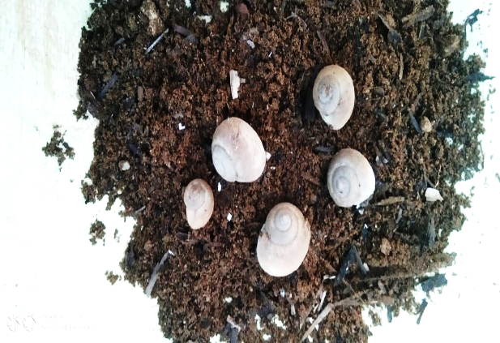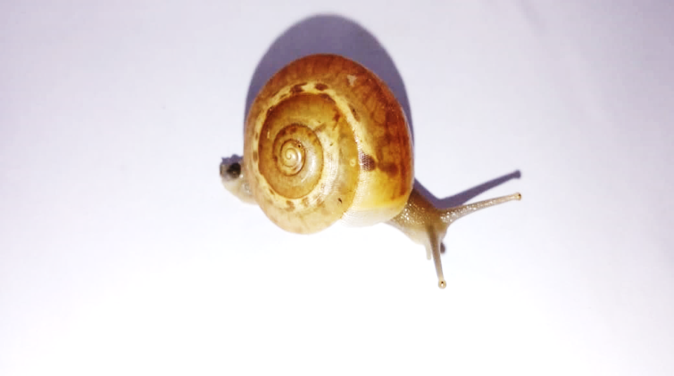

Fig.1. Ariophanta bistrialis collected from Tiruppur District, Tamil Nadu, India

Tissue Extraction
The collected snails were deshelled and cleaned. After being chopped into tiny pieces, the soft tissue (viscera) was homogenized in solvents like acetic acid, methanol and chloroform (Ulagesan et al., 2018; Periyasamy et al., 2012). Each solvent (Acetic acid, Methanol and Chloroform) was employed in two concentrations: 1 mL and 3 mL per gram of tissue (viscera) and it was concentrated using a rotary vacuum evaporator with reduced pressure. After spinning at maximum speed in a chilled centrifuge, the homogenates were moved into sterile tubes and stored at 4⁰C for future use. The crude extracts were evaluated for their antibacterial and antifungal properties.

2.3. Antibacterial and Antifungal Activity Assay
The antibacterial and antifungal properties were evaluated using the agar well diffusion technique. 70 µl aliquot of fresh bacterial or fungal culture was added to sterile petri plates with solidified medium (sterilized at 121°C for 15 minutes). In 1000 milliliters of distilled water, 39 grams of Mueller-Hinton agar were dissolved for bacteria, while 38 grams of malt agar were used for fungus. A cotton swab was used to equally distribute the culture throughout the surface, and a sterile cork borer was used to make wells that were 6 mm in diameter. Following the addition of 50 µl of each extract to the appropriate well, the plates were incubated for 24 hours at 37°C. By measuring the zone of inhibition that developed after incubation (apart from the well width), antimicrobial activity was assessed. The positive controls were fluconazole (10 mg/ml) for fungi and gatifloxacin (5 µg) for bacteria, whereas the negative control was dimethyl sulfoxide (DMSO).

  - Statistical Analysis
All analyses were carried out in triplicate, and results are reported as the mean ± standard deviation (SD). Significant differences were analyzed by one-way analysis of variance (ANOVA). Differences at p < 0.05 were considered significant.
- RESULTS
The acetic acid, methanol and chloroform tissue extraction of Ariophanta bistrialis taken for the present study was subjected to antimicrobial activity and revealed the following results.

3.1. Antibacterial Activity:
The antibacterial potential of Ariophanta bistrialis soft tissue extracts was evaluated using three different solvents—acetic acid (A), chloroform (C), and methanol (M)—to determine their efficacy against clinically significant bacterial pathogens: Pseudomonas aeruginosa, Klebsiella pneumoniae, Escherichia coli, Bacillus cereus, and Salmonella typhi. Gatifloxacin served as the positive control (Disc), while DMSO was used as the solvent control.
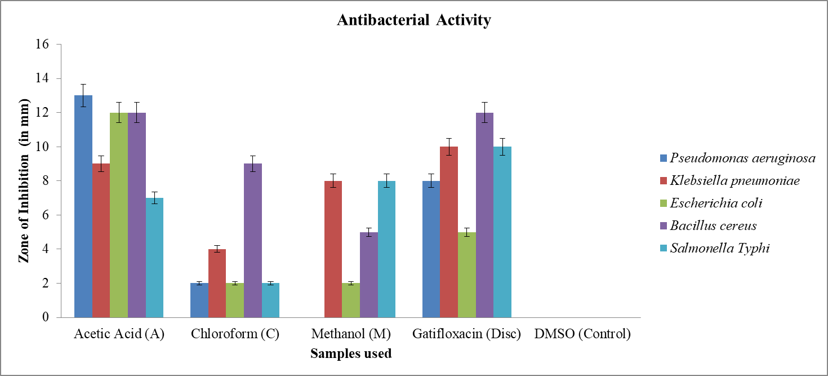
Fig.2. Antibacterial Activity of different tissue extract of Ariophanta bistrialis against different pathogens

Among the three extracts, the acetic acid extract exhibited the most prominent antibacterial activity. It showed the highest inhibition zone of 13 mm against Pseudomonas aeruginosa and 12 mm inhibition zone against both Escherichia coli and Bacillus cereus, 9 mm Klebsiella pneumoniae and 7 mm for Salmonella typhi, indicating a broad-spectrum antibacterial effect. The methanol extract showed moderate activity against Pseudomonas aeruginosa and Salmonella typhi, both with 8 mm inhibition zones and minimal zones (2 – 5 mm) for the other pathogens. The chloroform extract exhibited limited antibacterial activity, particularly against Bacillus cereus 9 mm and slight inhibitory effects against Klebsiella pneumonia (4 mm), while its activity against the other pathogens was minimal (2mm or nil). The positive control, gatifloxacin, exhibited effective inhibition across all tested bacteria, particularly against Klebsiella pneumoniae (10 mm) and Salmonella typhi (10 mm), validating the reliability of the antimicrobial assay. In contrast, the solvent control (DMSO) did not show any zones of inhibition, confirming that the antimicrobial activity observed in the test samples was attributable to the snail tissue extracts and not to the solvents used.

3.2. Antifungal Activity:
The antifungal potential of Ariophanta bistrialis soft tissue extracts prepared from three different solvents —acetic acid (A), chloroform (C), and methanol (M)— was assessed against clinically significant fungal pathogens Aspergillus niger, Aspergillus flavus and Aspergillus terreus. Fluconazole served as the positive control while DMSO was used as the solvent control.

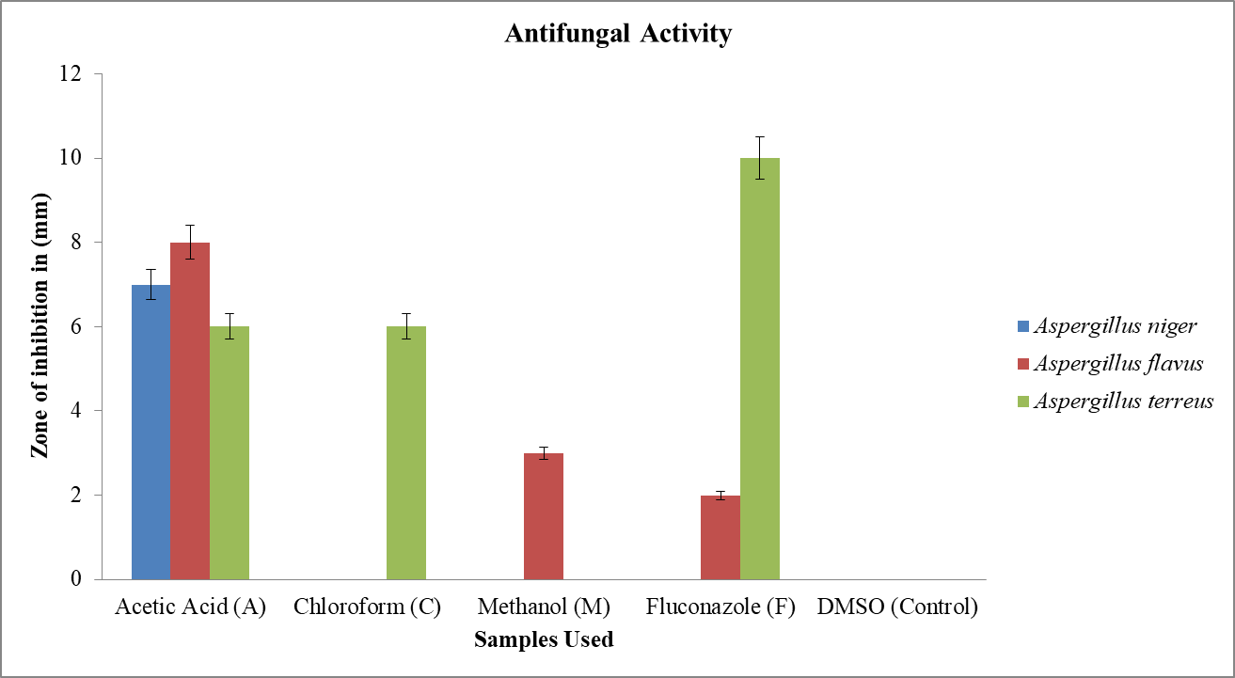

Fig.3. Zone of Inhibition produced by Ariophanta bistrialis soft tissue extracts and standard antibiotics against selected fungal strains.

Among the tested solvents, the acetic acid extract (A) demonstrated the highest antifungal activity. It produced an inhibition zone of 8 mm against Aspergillus flavus 7 mm against Aspergillus niger and 6 mm against Aspergillus terreus. The chloroform extract (C) exhibited an inhibition zone 6 mm against Aspergillus terreus and no effect against the other two fungal species. The methanol extract (M) showed weak activity, with only minor inhibition against Aspergillus flavus (3 mm) and no activity against Aspergillus terreus and Aspergillus niger. In contrast, the positive control, fluconazole (F), showed strong antifungal activity, particularly against Aspergillus terreus, where it produced a 10 mm inhibition zone. The DMSO control did not exhibit any antifungal activity, confirming that the inhibition zones observed were due to the bioactive compounds in the extracts.

DISCUSSION

Molluscs are important natural sources of bioactive compounds that possess antimicrobial and anti - inflammatory activities (Benkendorff et al., 2011). There are studies on the antimicrobial activity of crude extracts of gastropods. There are a few reports on the antimicrobial activity of different species of land snails (Periyasamy et al., 2012; Valarmathi, 2016; Ulagesan and Kim, 2018; Azeem et al., 2022).

In the present study acetic acid, methanol and chloroform crude extracts of Ariophanta bistrialis were evaluated for antibacterial and antifungal activity. The acetic acid extract showed the highest antibacterial activity with a large zone of inhibition against Pseudomonas aeruginosa, Escherichia coli and Bacillus cereus. The relatively large zone of inhibition suggested that the bioactive compounds in the acetic acid extract are more effectively solubilized and diffused enhancing their antimicrobial action. The moderate activity of methanol extract and the limited efficacy of the chloroform extract suggest that the solvents may not be the most suitable solvents for extracting potential antibacterial compounds from Ariophanta bistrialis or the exhibited compounds had limited efficacy.

Similar antibacterial activity of gastropods has been reported. The antibacterial activity against Salmonella typhi was reported by Rajaganapathi et al. (2000). The antibacterial activity of ethanol extract in Pila virens, fresh water gastropod was investigated by (Gayathri et al., 2014).
According to (Dolashka et al 2015) the peptides isolated from Helix lucorum, the garden snail were found to exhibit inhibitory activity against Staphylococcus aureus, Staphylococcus epidermidis and Escherichia coli.
In the present study the maximum antifungal activity was observed against Aspergillus flavus using acetic acid extract and minimal activity was recorded in Aspergillus flavus using methanol extract. Similar results have been reported by Azeem et al. (2002) in the garden snail Helix aspersa. The result showed that the land snail Ariophanta bistrialis is not only a major food source but also a potential candidate for antimicrobial activity.

CONCLUSION
The findings of the study show that Ariophanta bistrialis soft tissue extracts have antibacterial and antifungal properties, with the acetic acid extract (A) showing the strongest activity against the majority of infections. In particular, the acetic acid extract had the highest efficacy against the tested strains of bacteria and fungi, indicating its potential as a natural antibacterial agent. Methanol and chloroform extracts were less active, while DMSO, which was utilized as a solvent control, had no antibacterial properties. The acetic acid extract from Ariophanta bistrialis exhibited the strongest antibacterial and antifungal properties among the soft tissue extracts. Additional research is required to isolate and identify the active compounds responsible for these bioactivities. These results encourage further investigation of Ariophanta bistrialis as a potential source of bioactive compounds for applications in biomedical research.
DISCLAIMER (ARTIFICIAL INTELLIGENCE)
Author(s) hereby declare that NO generative AI technologies such as Large Language Models (ChatGPT, COPILOT, etc) and text-to-image generators have been used during writing or editing of this manuscript.

REFERENCES
1.Abd-El Azeem, M. A., Adly, E. M., & Shaaban, O. A. (2016). Antifungal Activity of Proteins Extracted from the Soft Tissue of the Garden Snail, Helix aspersa. Journal of Natural Sciences Research, 6(1), 16-22
2.Arias, C. A., & Murray, B. E., (2009). Antibiotic-resistant bugs in the 21st century—A clinical super-challenge. New England Journal of Medicine, 360, 439–443. https://doi.org/10.1056/NEJMp0804651
3.Bansemir, A., Blume, M., Schröder, S., & Lindequist, U., (2006). Screening of cultivated seaweeds for antibacterial activity against fish pathogenic bacteria. Aquaculture 252, 79-84. DOI: 10.1016/j.aquaculture.2005.11.051. https://doi.org/10.1016/j.aquaculture.2005.11.051
4.Benkendorff, K., McIver, C.M. and Abott, C.A., 2011. Bioactivity of the murex homeopathic remedy and ofextracts from an Australian murcid mollusc against human cancer cells. Evid-Based Compl. Altern. Med., 1, 12-16. https://doi.org/10.1093/ecam/nep042
5.Blunt, J. W., Copp, B. R., Hu, W.-P., Munro, M. H. G., Northcote, P. T., & Prinsep, M. R. Chellaram C, Gnanambal KME, Edward JKP., (2004). Antibacterial activity of the winged oyster Pteriachinensis (Pterioida: Pteridae). Indian Journal of Geo-Marine Sciences 33, 369–372. https://nopr.niscpr.res.in/
6.Chellaram, C., Gnanambal, K.M.E and Edward, J.K.P. (2004). Antibacterial activity of the winged oyster Pteriachinensis (Pterioida: Pteridae). Indian Journal of Geo-Marine Sciences 33, 369–372. https://nopr.niscpr.res.in/bitstream/123456789/6000/1/IJMS%2033%284%29%20369-372.pdf

7.Cheung, R., Ng, T. and Wong, J. (2015). Marine peptides: Bioactivities and applications. Mar. Drugs, 13(7): 4006-4043. https://doi.org/10.3390/md13074006
8.Dolashka, P., Dolashki, A., Voelter, W., Van Beeumen, J., & Stevanovic, S. (2015) Antimicrobial activity of peptides from the hemolymph of Helix lucorum snails. Int. J. Curr. Microbiol. Appl. Sci., 4, 1061–1071
9.Gayathri, M., and Sanjeevi, S.B. (2014) Antipathogenic activity of freshwater Gastropod Pila virens (Lamarck, 1822) from Lower Grand Anaicut Reservoir, Tamilnadu. Int. J. Pharm. Life Sci., 5, 3894–3898. https://ijplsjournal.com/index.php/ijpls/article/view/1000
10.González, Y., Tanaka, A. S., Hirata, I. Y., del Rivero, M. A., Oliva, M. L. V., & Araujo, M. S., (2007). Purification and partial characterization of human neutrophil elastase inhibitors from the marine snail Cenchritis muricatus (Mollusca). Comparative Biochemistry and Physiology Part A: Molecular & Integrative Physiology, 146, 506–513. https://doi.org/10.1016/j.cbpa.2006.01.022
11.Kamiya, H., Muramoto, K., Goto, R., Sakai, M., Endo, Y., & Yamazaki, M. (1989). Purification and characterization of an antibacterial and antineoplastic protein secretion of a sea hare, Aplysia juliana. Toxicon, 27, 1269–1277. https://doi.org/10.1016/0041-0101(89)90058-5
12.Nagash, Y. S., Nazeer, R. A. and Kumar, N. S. (2010). In vitro antioxidant activity of solvent extracts of mollusks (Loligo duvauceli and Donax strateus) from India. World J. Fish Mar. Sci., 2: 240-245. https://idosi.org/wjfms/wjfms.htm
13.Periyasamy, N., Srinivasan, M., & Balakrishnan, S., (2012). Antimicrobial activities of the tissue extracts of Babylonia spirata Linnaeus, 1758 (Mollusca: Gastropoda) from Thazhanguda, southeast coast of India. Asian Pacific Journal of Tropical Biomedicine, 2, 36–40. https://doi.org/10.1016/S2221-1691(11)60186-X
14.Rajaganapathi, J., Thyagarajan, S. P., & Patterson Edward, J. K. (2000). Study on cephalopod’s ink for anti-retroviral activity. Indian Journal of Experimental Biology, 38, 519–520. https://pubmed.ncbi.nlm.nih.gov/11272422/
15.Ulagesan, S., & Kim, H. J. (2018). Antibacterial and antifungal activities of proteins extracted from seven different snails. Applied Sciences, 8, 1362. https://doi.org/10.3390/app8081362
16.Valarmathi, R., (2016). Antibacterial activit y of Cryptozona bistrialis. Journal of Molluscan Studies,vol. 82, 90-95. https://www.ijzab.com/
17. Azeem HHA, Osman GY, El-Seedi HR, Fallatah AM, Khalifa SAM, Gharib MM. Antifungal Activity of Soft Tissue Extract from the Garden Snail Helix aspersa (Gastropoda, Mollusca). Molecules. 2022 May 16;27(10):3170. doi: 10.3390/molecules27103170. PMID: 35630647; PMCID: PMC9144933.

18. Ibrahim, A. M., Hamed, A. A., & Ghareeb, M. A. (2021). Marine, freshwater, and terrestrial snails as models in the biomedical applications. Egyptian Journal of Aquatic Biology & Fisheries, 25(3).
19. Nantarat, N., Tragoolpua, Y., & Gunama, P. (2019). Antibacterial activity of the Mucus Extract from the Giant African Snail (Lissachatina fulica) and Golden Apple Snail (Pomacea canaliculata) against pathogenic bacteria causing skin diseases. Tropical Natural History, 19(2), 103-112.

