Optimisation of Drying Temperature and Time for Ackee (Blighia sapida) Aril Flour using Response Surface Methodology

ABSTRACT
Ackee (Blighia sapida) aril is a nutrient-rich but highly perishable fruit, which limits its utilization and industrial application. While previous studies have reported physicochemical and functional properties of dried ackee aril and flours, they lack statistically optimisied drying conditions for ackee aril. This study therefore aimed to obtain an optimal combination of temperature and time for the drying of ackee aril using Response Surface Methodology (RSM). Optimisation was performed using Central Composite Design under RSM of Design Expert 12.0. The drying temperature was between 45-60 °C and the drying time was between 40-70 h. The total of thirteen experimental runs of the combination of drying time and temperature for drying of the ackee aril were produced by RSM. The responses chosen were Proximate and phytochemical (total phenol, flavonoid, total carotenoid, oxalate and phytate). The result showed that the optimal drying condition was 60 ºC for 72 h. Under this drying condition the moisture, fibre, protein and phytate content were 11.995, 7.271, 29.254 and 0.102%, respectively are desirably. This study demonstrates the effectiveness of RSM in optimizing the drying process for production of ackee aril flour and contribute to the value addition. This research’s finding can be scaled up industrially, potentially enhancing food security and economic development.
Keywords: Ackee aril, Drying, Response Surface Methodology Phytochemical and Proximate

1 INTRODUCTION
Ackee apple (Blighia sapida) is a tropical fruit tree indigenous to West Africa and widely recognized for its nutritional value and health-promoting properties. Despite its socio-economic and nutritional importance, the utilization of ackee remains limited due to the highly perishable nature of the fruit, which restricts its storage, processing, and commercialization. Ackee belongs to the family Sapindaceae and produces small, pear-shaped fruits that are pink to red in colour and contain large black seeds (Oloyede et al., 2023).
The edible portion of the ackee fruit is the aril, a thick, fleshy, cream-coloured tissue that partially surrounds the seed. Arils are specialized seed coverings distinct from the fruit pulp and become edible only when the mature fruit opens spontaneously, exposing the seeds and arils. Due to this unique ripening characteristic and rapid postharvest deterioration, fresh ackee fruits have a very short shelf life, resulting in significant postharvest losses. (Kakpo et al., 2020; Ojo et al., 2025).
Ackee apple is considered a valuable natural resource because of the diverse applications of its components, including the use of its wood for furniture, arils for food and medicinal purposes, and seeds for oil extraction, fuel, and soap production (Adeosun et al., 2024). Nevertheless, the fruit remains underutilised, particularly in food processing industries, largely due to challenges associated with preservation and quality retention. Converting ackee arils into shelf-stable flour offers a promising strategy for extending shelf life, reducing postharvest losses, and enhancing value addition.
Drying is one of the most widely applied preservation techniques in food and agricultural processing, as it reduces moisture content, inhibits microbial growth, and improves product stability. However, drying conditions, particularly temperature and time, play a critical role in determining the nutritional quality, functional properties, and phytochemical stability of dried products and flours (Abe-Inge et al., 2018; Olabinjo et al., 2020; Alam et al., 2023).
Several studies have evaluated the effects of different drying methods and pretreatments on the physicochemical, functional, and nutritional properties of ackee aril flour, including the influence of defatting and drying kinetics (Dossou et al., 2014; Olabinjo et al., 2020; Torres-Gallo et al., 2021; Ojo et al., 2025). Additionally, Olabinjo and Sama (2023) demonstrated that drying methods significantly affect the phytochemical composition and antioxidant activity of ackee arils. However, to date, no study has systematically investigated the combined effects of drying temperature and drying time on the proximate composition and phytochemical characteristics of ackee aril flour using an optimization-based approach.
Response Surface Methodology (RSM) is a robust statistical tool for modeling, analyzing, and optimizing complex processes involving multiple interacting variables. Its application in food drying processes enables the identification of optimal processing conditions that maximize product quality while improving process efficiency (Rahmawati et al., 2020; Madukasi et al., 2025). Therefore, this study aims to optimize drying temperature and drying time for the production of high-quality ackee (Blighia sapida) aril flour using Response Surface Methodology, with the goal of enhancing its suitability for food processing applications
2. MATERIALS AND METHOD
2.1 Material
The Ackee apple (Blighia sapida) was used in this study for both phytochemical and proximate examination. It is a tropical fruit tree native to West Africa that is highly recognized for its nutritional richness and health-promoting features. It is collected from Baba-Ode Farm in Ogbomoso, Nigeria.
2.2 Methsods
2.2.1 Preparation of ackee aril flour
The riped ackee arils were removed from the fruit pods, sorted, and washed with clean water. The ackee aril were grouped into 13 groups, each with an average weight of 100 g using a digital balance with ± 0.01 g accuracy, and kept for drying. Drying was done using an oven dryer (YIHENG DHG-9240A) based on the temperature and time formulation suggested by RSM. The oven was pre-set at each formulated temperature for one hour to allow the dryer to equilibrate before placing the ackee aril samples. The weighed sample (100 g) was spread on perforated drying trays and placed in the oven. After drying, the dried aril was milled into flour using a hammer mill and the flour produced was defatted due to high fat content. Defatting was done using n-hexane of ratio 1:10 (w/v) of flour/solvent for 24 h. Then, the defatted flour was dried at 50 °C for 1 h to remove residue n-hexane. Afterwards, the dried flour was milled and sieved through a micro sieve of 2 mm pore size (Torres-Gallo et al., 2021). This procedure was repeated for 12 other samples under each drying condition.

2.2.2 Optimisation of the drying process of ackee aril flour
Optimisation of the drying of ackee aril flour was carried out based on Response Surface Methodology (RSM) of the Design Expert® software (12.0.1). The design used was Central Composite Design and the selected factors were drying temperature (°C) and drying time (h), while the responses were moisture, ash, fibre, fat, protein, carbohydrate, total phenol, flavonoid, total carotenoid, oxalate and phytate. The drying temperature and time ranges were between 45-60 °C and 40-70 h (Olabinjo and Sama 2023: Torres-Gallo et al., 2021). (Table 1). The responses variables were chosen to evaluate the effect of drying temperature and time and to identify the optimal conditions for production of ackee aril flour. The experimental runs were carried out based on the design matrix generated by the Design-Expert software, which included 13 runs with varying combinations of independent variables.
Table 1: Factors and level used in the experiment
Factors | Units | Lower level | Higher level
Temperature | ºC | 45 | 60
Time | H | 40 | 70

2.3 Analysis
2.3.1 Proximate analysis
Protein, fat, ash, moisture and crude fibre contents of ackee aril flour were determined using the standard procedures of AOAC (2019). Carbohydrate content was determined by differences and analyses were performed in triplicate.
2.3.2 Phytochemical analysis
The procedures described by Ali et al. (2020), Ayo et al. (2020) and Orafa et al. (2023) were used in the determination of phenolic, flavonoid and total carotenoid, respectively. While oxalate and phytate were determined as reported by Ampofo-Asiama (2020) and analysis was performed in triplicate.
2.3.3 Statistical analysis
Data that has been obtained is then processed using Design Expert software. The results obtained were translated into the model of the response function equation to the independent variable chosen for the response and the interaction between responses. In the final stage of the optimisation, the program recommended an optimal combination of the processes. Optimal conditions are chosen by comparing the value of each drying condition. The selected combination is the one with the highest value. Standard deviation (Std. Dev), R², Adjusted R² (Adj R²), predicted R² and Predicted Residual Error Sum of Squares (PRESS) were the parameters often tested
3. RESULT AND DISCUSSION
3.1 Effect of drying temperature and time on oven-dried ackee aril flour
The results of the RSM optimisation for varied effects of temperature and time on proximate composition and phytochemicals of ackee aril flour are shown in Table 2. Proximate and phytochemical parameters analysed included moisture, ash, crude fibre, crude fat, crude protein, carbohydrate, total phenol, flavonoid, total carotenoid, oxalate, and phytate content. According to Adeyeye et al. (2020), lower moisture and higher protein enhance the functional value of flour products for both human and industrial use.
Among the different drying conditions, the drying condition at 60 °C for 72 h was optimal due to its high nutritional profile and minimal anti-nutrient levels. This condition yielded 11.995 % moisture content, 3.574 % ash content, 7.271 % crude fibre, 6.052 % crude fat, 29.254 % crude protein, 41.852 % carbohydrate, 189.71 mg/100 g total phenol, 25.31 mg/100 g flavonoid, 0.0787 mg/100 g total carotenoid, 8.857 % oxalate, and 0.102 % phytate (Table 2). It enhanced protein concentration and dietary fibre retention compared to values reported by Torres-Gallo et al. (2021).
The phytate content of 0.102 % was the lowest among all conditions, suggesting improved mineral bioavailability. The oxalate content (8.857 %) was within safe dietary limits and poses no risk of mineral chelation or kidney stone formation (Sromicki & Hess, 2020; Gupta et al., 2021). Although this drying condition exhibited relatively lower total phenol (189.71 mg/100 g), flavonoid (25.31 mg/100 g), and total carotenoid (0.0786 mg/100 g) levels compared to other conditions, a Nutritional Quality Index (NQI) was calculated to quantitatively evaluate overall nutritional value. The NQI was computed by scaling protein, crude fibre, and carbohydrate as positive contributors and phytate and oxalate as negative contributors to a 0–1 range, then summing these values for each drying condition. Analysis showed that 60 °C for 72 h had the highest NQI, confirming that the combined benefits of higher protein and fibre retention and reduced anti-nutrients outweigh the modest reductions in phenolic compounds.
Studies by Kunyanga et al. (2018) and Adefegha et al. (2022) highlighted that while phenolics and flavonoids are valuable for their antioxidant properties, protein and phytate levels are more critical for nutrient bioavailability and functionality in food systems. Therefore, the drying condition at 60 °C for 72 h was optimal due to its highest protein and fibre content, lowest phytate content, acceptable moisture content for shelf-life extension, and moderate retention of bioactive compounds.

3.2 Model summary statistics of the effect of temperature and time on ackee aril flour
The model summary statistics obtained from the software were generally employed to determine the most suitable model for the responses selected for the study. Consequently, the highest R² (but not aliased), lowest Std. Dev, and the least difference between the Adj and predicted R² (PRESS), measured the stability of the model. The model summary statistic for the optimisation of the responses, as presented in Table 3, indicated that the moisture, ash, crude fat, crude protein, CHO, total phenol, flavonoid, total carotenoid, oxalate and phytate content fitted well to quadratic design model, while the crude fibre fitted well to 2FI model. No transformation was done on moisture, ash, crude fat, crude protein, carbohydrate, flavonoid, oxalate and phytate content. However, power transformation was done on crude fibre and total phenol while inverse sqrt transformation was done on the total carotenoid.

Table 2: The result for the responses of the effect of drying temperature and time on ackee aril flour of RSM Optimisation
 | Factor |  | Responses
Run | A: Temperature | B: Time | Moisture content | Ash content | Crude fibre | Crude fat | Crude protein | CHO | Total Phenol | Flavonoid | Total carotenoid | Oxalate | Phytate
 | (ºC) | (h) | (%) | (%) | (%) | (%) | (%) | (%) | (mg/100g) | (mg/100g) | (mg/100g) | (%) | (%)
1 | 52.50 | 78.63 | 12.668 | 4.258 | 7.115 | 6.209 | 27.148 | 42.602 | 189.71 | 25.31 | 0.0787 | 8.857 | 0.102
2 | 63.11 | 56.00 | 11.291 | 4.095 | 6.045 | 6.844 | 29.071 | 42.654 | 228.96( | 28.29 | 0.0823 | 8.670 | 0.211
3 | 52.50 | 56.00 | 15.219 | 4.652 | 6.307 | 5.425 | 23.339 | 45.058 | 259.04 | 34.81 | 0.0876 | 7.205 | 0.171
4 | 60.00 | 72.00 | 11.995 | 3.574 | 7.271 | 6.053 | 29.254 | 41.852 | 237.75 | 31.27 | 0.1012 | 6.650 | 0.207
5 | 41.89 | 56.00 | 14.477 | 4.4346 | 6.713 | 5.521 | 24.496 | 44.447 | 264.76 | 28.36 | 0.2908 | 9.161 | 0.369
6 | 45.00 | 72.00 | 13.317 | 5.739 | 4.995 | 5.183 | 25.168 | 45.598 | 194.48 | 25.21 | 0.0807 | 8.631 | 0.322
7 | 52.50 | 56.00 | 15.219 | 4.652 | 6.307 | 5.425 | 23.339 | 45.058 | 213.61 | 34.15 | 0.2988 | 8.490 | 0.185
8 | 52.50 | 56.00 | 15.219 | 4.652 | 6.307 | 5.425 | 23.339 | 45.058 | 237.75 | 31.27 | 0.1012 | 6.650 | 0.207
9 | 60.00 | 40.00 | 13.753 | 5.086 | 5.225 | 6.034 | 27.723 | 42.178 | 237.75 | 31.27 | 0.1012 | 6.650 | 0.207
10 | 52.50 | 56.00 | 15.219 | 4.652 | 6.307 | 5.425 | 23.339 | 45.058 | 196.9 | 22.70 | 0.0825 | 7.585 | 0.114
11 | 52.50 | 33.37 | 15.605 | 5.672 | 6.517 | 5.138 | 23.530 | 43.537 | 237.75 | 31.27 | 0.1012 | 6.650 | 0.207
12 | 52.50 | 56.00 | 15.219 | 4.625 | 6.307 | 5.425 | 23.339 | 45.058 | 237.75 | 31.27 | 0.1012 | 6.650 | 0.207
13 | 45.00 | 40.00 | 15.515 | 6.406 | 6.288 | 5.676 | 26.763 | 39.352 | 235.42 | 31.37 | 0.1911 | 9.186 | 0.207

Table 3: Model summary statistics for the responses from the RSM Optimisation of dried ackee aril flour
Responses | Sources | Std. Dev. | R² | Adjusted R² | Predicted R | PRESS
Moisture content | Quadratic | 0.2049 | 0.9885 | 0.9803 | 0.9184 | 2.09 | *
Ash content | Quadratic | 0.0380 | 0.9987 | 0.9976 | 0.9821 | 0.1201 | *
Crude fibre | 2FI | 37.63 | 0.8155 | 0.7463 | 0.3500 | 39913.73 | *
Crude fat | Quadratic | 0.1196 | 0.9654 | 0.9366 | 0.4471 | 1.37 | *
Crude protein | Quadratic | 0.2369 | 0.9944 | 0.9898 | 0.9013 | 5.98 | *
Carbohydrate | Quadratic | 0.2543 | 0.9904 | 0.9823 | 0.8190 | 7.29 | *
Total phenol | Quadratic | 6.805E+05 | 0.9788 | 0.9612 | 0.7917 | 2.735E+13 | *
Flavonoid | Quadratic | 0.1913 | 0.9986 | 0.9972 | 0.9165 | 10.80 | *
Carotenoid | Quadratic | 0.0795 | 0.9891 | 0.9782 | 0.5638 | 1.26 | *
Oxalate | Quadratic | 0.3469 | 0.9464 | 0.9017 | 0.2611 | 9.95 | *
Phytate | Quadratic | 0.0003 | 1.0000 | 1.0000 | 0.9997 | 0.0000 | *
*-Suggested; ^-Aliased; Predicted Residual Error Sum of Squares- PRESS
3.3 Moisture content
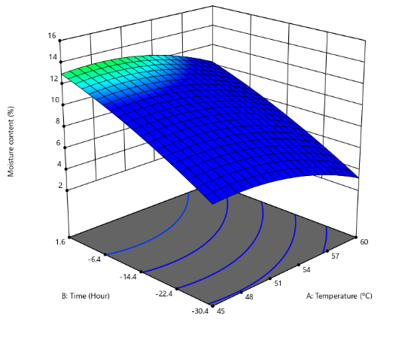
Moisture content of the dried ackee aril flour ranged from 11.291-15.6055% (Table 2). Both temperature and time significantly influenced the moisture content (Fig. 1). Optimum drying occurred at a moderate temperature and short-to-medium drying time, which effectively reduced moisture content without quality loss. (Doymaz, 2017). The model for the response was quadratic with an R² of 0.9885 (Table 3). The model has an F-value of 120.67 with a P-value (< 0.0001) less than 0.05, indicating that the model terms are significant (Montgomery, 2017; Alade et al., 2020). The ANOVA result showed that the temperature and time have a significant effect on moisture content (Table 4). The lack of fit F-value is not available, due to zero pure error; however, the low residual error and strong model statistics indicate that the fitted model satisfactorily explains the variability in moisture content (Myers et al., 2016).
Table 4: ANOVA for the Quadratic model for Moisture content
Df-Degree of Freedom; *-Significance

Figure 1: A 3D Graphical combination between temperature and drying time to the moisture content of ackee aril flour

Source | Sum of Squares | Df | Mean Square | F-value | p-value
Model | 25.33 | 5 | 5.07 | 120.67 | < 0.0001*
A-Temperature | 7.20 | 1 | 7.20 | 171.53 | < 0.0001
B-Time | 8.22 | 1 | 8.22 | 195.83 | < 0.0001
AB | 0.0484 | 1 | 0.0484 | 1.15 | 0.3185
A² | 8.94 | 1 | 8.94 | 213.04 | < 0.0001
B² | 1.79 | 1 | 1.79 | 42.69 | 0.0003
Residual | 0.2938 | 7 | 0.0420
Lack of Fit | 0.2938 | 3 | 0.0979
Pure Error | 0.0000 | 4 | 0.0000
Cor Total | 25.62 | 12

3.4 Ash content.
The ash content of dried ackee aril flour ranged from 3.57 to 6.41% (Table 2), indicating variations in mineral concentration influenced by drying conditions. As shown in Fig. 2, drying temperature significantly affected ash content, with higher temperatures generally increasing ash levels due to thermal degradation of organic components and consequent concentration of inorganic mineral residues (Oluwamukomi & Jolayemi, 2019; Afolayan et al., 2021).
A quadratic model adequately described the ash content response, yielding a high coefficient of determination (R² = 0.9987) and a highly significant model (F = 926.62; p < 0.0001) (Table 3). ANOVA revealed that both temperature and time significantly influenced ash content (Table 5). However, the significant lack of fit (F = 27.71) indicates that the model does not fully account for all sources of variability, possibly due to raw material heterogeneity, uneven heat distribution, or mineral migration at elevated temperatures (Montgomery, 2020; Bezerra et al., 2021). Despite this, the low residual error and high R² suggest that the model remains suitable for process optimization within the experimental range, though extrapolation beyond these conditions should be approached with caution.

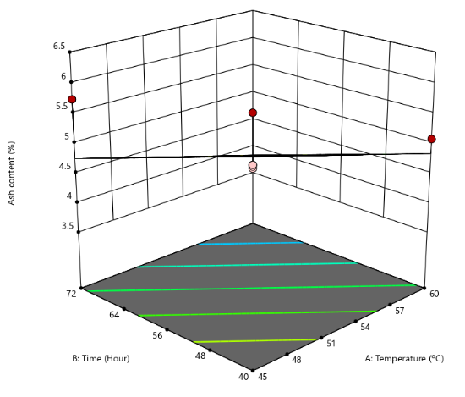
Table 5: ANOVA for the Quadratic model for Ash content
Figure 2: A 3D Graphical combination between temperature and drying time to the ash content of ackee aril flour

Df-Degree of Freedom; *-Significance

Source | Sum of Squares | Df | Mean Square | F-value | p-value
Model | 6.69 | 5 | 1.34 | 926.62 | < 0.0001*
A-Temperature | 3.75 | 1 | 3.75 | 2599.72 | < 0.0001
B-Time | 2.18 | 1 | 2.18 | 1511.89 | < 0.0001
AB | 0.1785 | 1 | 0.1785 | 123.65 | < 0.0001
A² | 0.5698 | 1 | 0.5698 | 394.66 | < 0.0001
B² | 0.1839 | 1 | 0.1839 | 127.41 | < 0.0001
Residual | 0.0087 | 6 | 0.0014
Lack of Fit | 0.0081 | 2 | 0.0040 | 27.71 | 0.0045*
Pure Error | 0.0006 | 4 | 0.0001
Cor Total | 6.70 | 11

3.5 Crude fibre
Crude fibre content of dried ackee aril flour ranged from 4.995 to 7.271% (Table 2), with a progressive increase observed as drying temperature and time increased (Fig. 3). This trend may be attributed to the concentration effect resulting from moisture loss and the thermal degradation of soluble components, which increases the relative proportion of insoluble fibrous materials. Similar increases in crude fibre content with elevated drying temperatures have been reported for plant-based food materials and flours (Afolayan et al., 2021; Ajuebor et al., 2021). The response, using a power transformation, was best described by a 2FI model with a coefficient of determination (R² = 0.8155). The model exhibited a significant F-value of 11.79 and a p-value of 0.0026, which is less than 0.05, indicating that the model terms were significant. The ANOVA result (Table 6) showed that both temperature and time had significant effects on crude fibre content. The lack-of-fit F-value was not available, indicating that the lack of fit was insignificant and that the model adequately fits the experimental data (Alade et al., 2020). The RSM equation for optimisation of crude fibre for ackee aril flour is as follows:
Table 6: ANOVA for 2FI model for crude fibre content

$${(Crude fibre)}^{3} = +6.28 + 0.0335A + 0.1998B + 0.8348AB$$
Source | Sum of Squares | df | Mean Square | F-value | p-value
Model | 50077.23 | 3 | 16692.41 | 11.79 | 0.0026*
A-Temperature | 1207.61 | 1 | 1207.61 | 0.8528 | 0.3828
B-Time | 704.72 | 1 | 704.72 | 0.4977 | 0.5006
AB | 41838.66 | 1 | 41838.66 | 29.55 | 0.0006
Residual | 11328.51 | 8 | 1416.06
Lack of Fit | 11328.51 | 4 | 2832.13
Pure Error | 0.0000 | 4 | 0.0000
Cor Total | 61405.75 | 11 | Df-Degree of Freedom; *-Significance
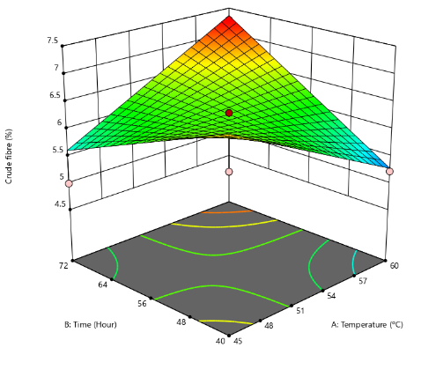
Where A = Temperature (ºC) and B = Time (h).
Figure 3: A 3D Graphical combination between temperature and drying time to the crude fibre content of ackee aril flour

3.6 Crude fat
Crude fat content of dried ackee aril flour ranged from 5.14 to 6.84% (Table 2). As shown in Fig. 4, crude fat content increased progressively with increasing drying temperature and time, indicating that both processing variables significantly influenced fat content. This increase may be attributed to the concentration effect resulting from moisture loss and the enhanced extractability of lipids due to thermal disruption of cellular structures during drying, as reported for other oil-bearing plant materials (Ajuebor et al., 2021). The response was best described by a quadratic model with a high coefficient of determination (R² = 0.9654). The model was statistically significant, with an F-value of 33.50 and a p-value of 0.0003, which is less than 0.05, indicating that the model terms were significant. Analysis of variance (Table 7) further showed that temperature and time were significant model terms. The lack-of-fit F-value was not available, indicating that the lack of fit was insignificant and that the model adequately fits the experimental data (Alade et al., 2020).
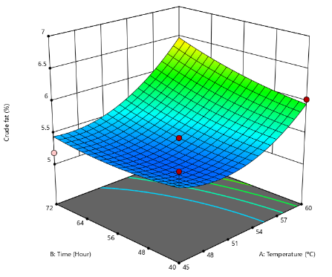
Table 7: ANOVA for the Quadratic model for Crude fat content
Source | Sum of Squares | Df | Mean Square | F-value | p-value
Model | 2.40 | 5 | 0.4792 | 33.50 | 0.0003*
A-Temperature | 1.20 | 1 | 1.20 | 83.92 | < 0.0001
B-Time | 0.0313 | 1 | 0.0313 | 2.19 | 0.1895
AB | 0.0655 | 1 | 0.0655 | 4.58 | 0.0761
A² | 1.07 | 1 | 1.07 | 74.53 | 0.0001
B² | 0.0913 | 1 | 0.0913 | 6.38 | 0.0449
Residual | 0.0858 | 6 | 0.0143
Lack of Fit | 0.0858 | 2 | 0.0429
Pure Error | 0.0000 | 4 | 0.0000
Cor Total  Df-Degree of Freedom; *-Significance | 2.48 | 11

Figure 4: A 3D Graphical combination between temperature and drying time to the crude fat content of ackee aril flour

3.7 Crude protein
Crude protein content ranged from 23.34 to 29.25% (Table 2). At lower levels of drying temperature and time, crude protein content was relatively high (Fig. 5). However, as temperature and time increased to moderate levels, a marked decline in crude protein content was observed, forming a trough in the middle of the response surface plot. At higher levels of both temperature and time, crude protein content increased again, reaching values comparable to or higher than those obtained under low-level conditions. The increase in crude protein at higher drying conditions may be attributed to moisture loss and partial breakdown of structural components, which concentrate protein in the dried samples (Adebowale et al., 2021).
The response was best described by a quadratic model with a high coefficient of determination (R² = 0.9944). The model was highly significant, with an F-value of 214.58 and a p-value of 0.0001, which is less than 0.05, indicating that the model terms were significant. Analysis of variance (Table 8) showed that drying temperature and time were significant model terms for crude protein content. The lack-of-fit F-value was not available, indicating that the lack of fit was insignificant and that the model adequately fits the experimental data.
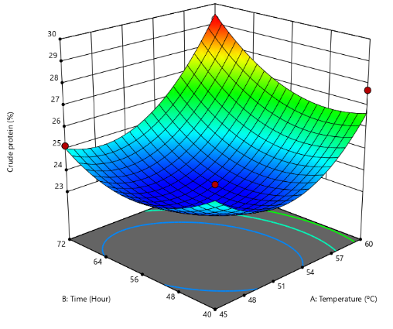
Table 8: ANOVA for the Quadratic model for Crude protein content
Source | Sum of Squares | df | Mean Square | F-value | p-value
Model | 60.22 | 5 | 12.04 | 214.58 | < 0.0001*
A-Temperature | 16.58 | 1 | 16.58 | 295.35 | < 0.0001
B-Time | 0.0269 | 1 | 0.0269 | 0.4799 | 0.5144
AB | 2.44 | 1 | 2.44 | 43.52 | 0.0006
A² | 20.18 | 1 | 20.18 | 359.56 | < 0.0001
B² | 17.54 | 1 | 17.54 | 312.42 | < 0.0001
Residual | 0.3368 | 6 | 0.0561
Lack of Fit | 0.3368 | 2 | 0.1684
Pure Error | 0.0000 | 4 | 0.0000
Cor Total | 60.56 | 11
Df-Degree of Freedom; *-Significance

Figure 5: A 3D Graphical combination between temperature and drying time to the crude protein content of ackee aril

3.8 Carbohydrate
Carbohydrate content ranged from 39.35 to 45.60% (Table 2). Maximum carbohydrate yield was observed at low to moderate temperature and short drying time, while high temperature and prolonged time resulted in the lowest values, indicating accelerated carbohydrate degradation (Montgomery, 2017) (Fig. 6). The response was described by a quadratic model (R² = 0.9904), which was significant (F = 123.42; p < 0.0001). Both temperature and time were significant model terms (Table 9), and the lack of fit was insignificant, indicating an adequate model fit.
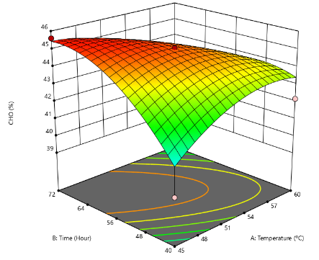
Table 9: ANOVA for the Quadratic model for Carbohydrate content
Figure 6: A 3D Graphical combination between temperature and drying time to the carbohydrate content of ackee aril
Source | Sum of Squares | Df | Mean Square | F-value | p-value
Model | 39.91 | 5 | 7.98 | 123.42 | < 0.0001*
A-Temperature | 1.49 | 1 | 1.49 | 23.08 | 0.0030
B-Time | 9.81 | 1 | 9.81 | 151.59 | < 0.0001
AB | 10.80 | 1 | 10.80 | 166.94 | < 0.0001
A² | 3.34 | 1 | 3.34 | 51.68 | 0.0004
B² | 19.77 | 1 | 19.77 | 305.65 | < 0.0001
Residual | 0.3881 | 6 | 0.0647
Lack of Fit | 0.3881 | 2 | 0.1940
Pure Error | 0.0000 | 4 | 0.0000
Cor Total | 40.30 | 11
Df-Degree of Freedom; *-Significance

3.9 Total phenol
Total phenolic content ranged from 189.71 to 264.76 mg/100 g (Table 2). Both drying temperature and time had a significant interactive effect, with moderate conditions favoring higher phenolic retention, while extreme temperatures or prolonged drying reduced total phenol levels (Fig. 7). The response was described by a quadratic model (R² = 0.9788), which was statistically significant (F = 55.53; p = 0.0001) indicating that the model terms were significant. ANOVA result confirmed that temperature and time were significant model terms affecting total phenolic content (Table 10). The lack-of-fit F-value was not available, suggesting it was insignificant and that the model provides an adequate fit for the data (Alade et al., 2020; Bezerra et al., 2021). The RSM equation for optimisation of total phenol for ackee aril flour is as follows:
$(Total Phenol) ³= +1.344E + 07 + 6.846E+05A - 1.184E+06B - 5.030E+06AB - 1.513E+06A² + 6.571E+05 B²$
Where A = Temperature (ºC) and B = Time (h).
Source | Sum of Squares | df | Mean Square | F-value | p-value
Model | 1.286E+14 | 5 | 2.571E+13 | 55.53 | < 0.0001*
A-Temperature | 2.812E+12 | 1 | 2.812E+12 | 6.07 | 0.0488
B-Time | 8.409E+12 | 1 | 8.409E+12 | 18.16 | 0.0053
AB | 6.072E+13 | 1 | 6.072E+13 | 131.13 | < 0.0001
A² | 1.485E+13 | 1 | 1.485E+13 | 32.06 | 0.0013
B² | 2.801E+12 | 1 | 2.801E+12 | 6.05 | 0.0492
Residual | 2.778E+12 | 6 | 4.631E+11
Lack of Fit | 2.778E+12 | 2 | 1.389E+12
Pure Error | 0.0000 | 4 | 0.0000
Cor Total | 1.313E+14 | 11
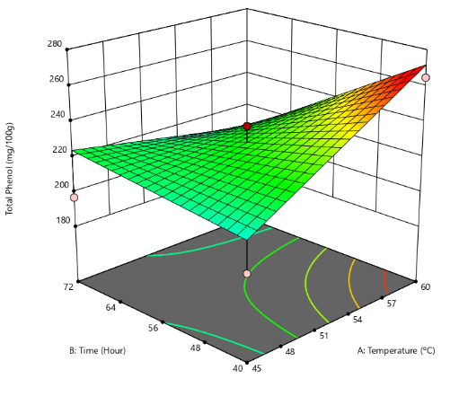
Table 10: ANOVA for the Quadratic model for total phenol
Figure 7: A 3D Graphical combination between temperature and drying time to the total phenol of ackee aril flour

Df-Degree of Freedom; *-Significance

3.10 Flavonoid
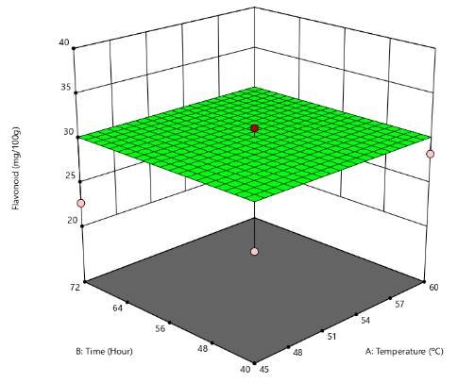
Flavonoid content ranged from 22.70 to 34.81 mg/100 g (Table 2). Flavonoids were relatively stable across most drying conditions; however, extended heating at elevated temperatures led to gradual losses (Fig. 8) (Oghenejoboh & Ani, 2021). The response was best described by a quadratic model with a high coefficient of determination (R² = 0.9788). The model was highly significant (F = 705.92; p < 0.0001), indicating that the model terms were significant. Analysis of variance (Table 11) showed that drying temperature and time were significant factors affecting flavonoid content in ackee aril flour. The lack-of-fit F-value was not available, suggesting it was insignificant and that the model adequately represents the experimental data
Table 11: ANOVA for the Quadratic model for flavonoid

Df-Degree of Freedom; *-Significance

Figure 8: A 3D Graphical combination between temperature and drying time to the flavonoid of ackee aril flour

Source | Sum of Squares | Df | Mean Square | F-value | p-value
Model | 129.18 | 5 | 25.84 | 705.92 | < 0.0001*
A-Temperature | 28.79 | 1 | 28.79 | 786.58 | < 0.0001
B-Time | 100.63 | 1 | 100.63 | 2749.54 | < 0.0001
AB | 31.29 | 1 | 31.29 | 854.88 | < 0.0001
A² | 0.0227 | 1 | 0.0227 | 0.6203 | 0.4666
B² | 16.26 | 1 | 16.26 | 444.25 | < 0.0001
Residual | 0.1830 | 5 | 0.0366
Lack of Fit | 0.1830 | 1 | 0.1830
Pure Error | 0.0000 | 4 | 0.0000
Cor Total | 129.37 | 10
3.11 Total carotenoid
Total carotenoid ranged from 0 to 0.0787-0.2988mg/100 g (Table 2). Both temperature and time significantly influenced the carotenoid content (Fig. 9). As the temperature and time increased simultaneously, there was a decrease in carotenoid concentration (Adegunwa et al., 2021). Total carotenoid with Inverse Sqrt has a quadratic model with R² value of 0.9891. The F-value of 90.69 with P-value < 0.0001 obtained for total carotenoid implies that the model is significant. The ANOVA result (Table 12) showed that temperature and time are significant model terms. The lack of fit F-value is not available, which shows it is insignificant to the fitness of the model (Alade et al., 2020). The RSM equation for optimisation of total carotenoid for ackee aril flour is as follows
$1/Sqrt (Total carotenoid) = +3.14 + 0.5414A - 0.4303B + 0.7979AB - 0.2426A² - 0.1549B$²
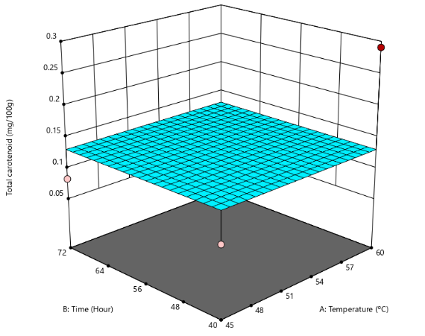
Where A = Temperature (ºC) and B = Time (h)
Table 12; ANOVA for the Quadratic model for total carotenoid
Source | Sum of Squares | Df | Mean Square | F-value | p-value
Model | 2.86 | 5 | 0.5729 | 90.69 | < 0.0001*
A-Temperature | 1.56 | 1 | 1.56 | 247.44 | < 0.0001
B-Time | 0.9876 | 1 | 0.9876 | 156.34 | < 0.0001
AB | 0.8488 | 1 | 0.8488 | 134.38 | < 0.0001
A² | 0.3363 | 1 | 0.3363 | 53.23 | 0.0008
B² | 0.1371 | 1 | 0.1371 | 21.70 | 0.0055
Residual | 0.0316 | 5 | 0.0063
Lack of Fit | 0.0316 | 1 | 0.0316
Pure Error | 0.0000 | 4 | 0.0000
Cor Total | 2.90 | 10
Figure 9: A 3D Graphical combination between temperature and drying time to the total carotenoid of ackee aril flour

Df-Degree of Freedom; *-Significance

3.12 Oxalate
The oxalate content ranged from 6.650 to 9.161% (Table 2). Drying temperature and time interacted synergistically to significantly influence oxalate concentration (Fig. 10), indicating that the combined effect of these factors was greater than their individual effects. Similar observations have been reported by Olapade et al. (2022), who demonstrated that processing conditions significantly alter antinutrient composition in plant-based materials. The response gave a quadratic model with R² value of 0.9464. The F-value of 21.18 with a P-value of 0.0010, of the model obtained implies the model is significant. ANOVA result (Table 13) showed that temperature and time are significant for oxalate when drying ackee aril. The non-significant lack-of-fit suggests that the model adequately represents the experimental data and can reliably predict oxalate content within the studied range.

Source | Sum of Squares | df | Mean Square | F-value | p-value
Model | 12.75 | 5 | 2.55 | 21.18 | 0.0010*
A-Temperature | 0.5287 | 1 | 0.5287 | 4.39 | 0.0809
B-Time | 0.2013 | 1 | 0.2013 | 1.67 | 0.2435
AB | 0.1376 | 1 | 0.1376 | 1.14 | 0.3260
A² | 4.92 | 1 | 4.92 | 40.90 | 0.0007
B² | 6.32 | 1 | 6.32 | 52.50 | 0.0004
Residual | 0.7222 | 6 | 0.1204
Lack of Fit | 0.7222 | 2 | 0.3611
Pure Error | 0.0000 | 4 | 0.0000
Cor Total | 13.47 | 11
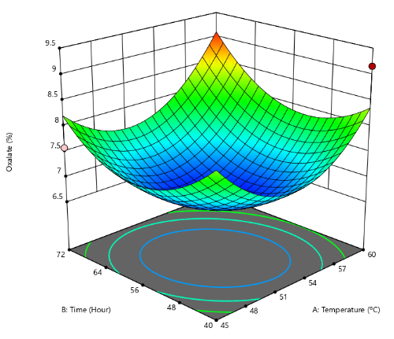
Table 13; ANOVA for the Quadratic model for oxalate
Figure 10: A 3D Graphical combination between temperature and drying time to the oxalate of ackee aril flour

Df-Degree of Freedom; *-Significance

3.13 Phytate
The phytate content ranged from 0.102 to 0.369% (Table 2). Temperature exhibited a strong linear effect on phytate reduction, while drying time also significantly influenced phytate levels. The interaction between temperature and time further contributed to phytate degradation, with the response showing a quadratic trend (Fig. 11). This observation is consistent with the findings of Abera et al. (2023), who reported that processing methods significantly affect antinutritional factors.
Response surface analysis produced a quadratic model with a coefficient of determination (R²) of 1.0000, indicating a perfect fit between the predicted and experimental values. The model F-value (151,512.85) with a P-value < 0.0001 indicates that the model is highly significant. ANOVA results (Table 14) further revealed that temperature and time were significant model terms (P < 0.05). The lack-of-fit was not significant relative to the pure error, indicating that the model adequately describes the relationship between the independent variables and phytate content within the experimental range (Myers et al., 2016).
Source | Sum of Squares | Df | Mean Square | F-value |  | p-value
Model | 0.0593 | 5 | 0.0119 | 1.515E+05 |  | < 0.0001*
A-Temperature | 0.0006 | 1 | 0.0006 | 8224.77 |  | < 0.0001
B-Time | 0.0564 | 1 | 0.0564 | 7.205E+05 |  | < 0.0001
AB | 0.0009 | 1 | 0.0009 | 11116.73 |  | < 0.0001
A² | 0.0001 | 1 | 0.0001 | 1478.16 |  | < 0.0001
B² | 0.0014 | 1 | 0.0014 | 17675.33 |  | < 0.0001
Residual | 3.914E-07 | 5 | 7.828E-08
Lack of Fit | 3.914E-07 | 1 | 3.914E-07
Pure Error | 0.0000 | 4 | 0.0000
Cor Total | 0.0593 | 10
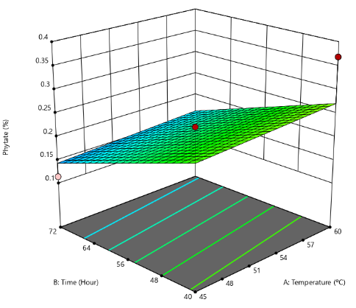
Table 14; ANOVA for the Quadratic model of phytate
Figure 11: A 3D Graphical combination between temperature and drying time to the phytate of ackee aril flour

Df-Degree of Freedom; *-Significance

4 Conclusion
This study concluded that the use of oven dryer at an optimal condition of (60 ºC for 72 h) gave the preferred result for proximate and photochemical analysis of ackee aril flour. This processing condition improved the nutritional quality of ackee aril flour. Processing of ackee aril at this condition will improve its commercial applications and potential development of value-added products.
Competing Interest Disclaimer
Authors have declared that they have no competing financial interests OR non-financial interests OR personal relationships that could have appeared to influence the work reported in this paper.

Disclaimer (Artificial intelligence)
Author(s) hereby declare that NO generative AI technologies such as Large Language Models (ChatGPT, COPILOT, etc.) and text-to-image generators have been used during the writing or editing of this manuscript.

References

Abera, S., Yohannes, W., & Chandravanshi, B. S. (2023). Effect of processing methods on antinutritional factors (oxalate, phytate, and tannin) and their interaction with minerals in kidney beans. International Journal of Analytical Chemistry, 2023, 6762027. https://doi.org/10.1155/2023/6762027
Adebowale, A. A., Sanni, L. O., Awonorin, S. O., & Adegoke, G. O. (2021). Effect of processing on nutritional composition of selected foods. Journal of Food Science and Technology, 58(3), 567–575.
Adefegha, S. A., Oboh, G., & Oyeleye, S. I. (2022). Effect of processing methods on the phytochemical content and antioxidant activity of plant-based flours. Functional Foods in Health and Disease, 12(1), 23–33. https://doi.org/10.31989/ffhd.v12i1.85I
Adegunwa, M.O. (2021). Effect of drying temperature and time on nutrient retention in biofortified crops. Food Chemistry, 347, 129022.
Adeosun Y.M., Adeoti O., and Oyedele O. A. (2024). An Investigation into the Fuel Properties of Ackee Apple (Blighia sapida) Seeds Oil. Asian Journal of Research in Biosciences. 6(2), 211-216.
Adeyeye, A., Oyewole, O. B., & Oladiji, A. T. (2020). Nutritional and functional properties of wheat flour fortified with protein-rich sources. Journal of Food Composition and Analysis, 89, 103470. https://doi.org/10.1016/j.jfca.2020.103470
Afolayan, M. O., Okunola, A. A., & Sanni, L. O. (2021). Optimization of drying conditions and quality evaluation of plant-based food powders using response surface methodology. Journal of Food Processing and Preservation, 45(7), e15634. https://doi.org/10.1111/jfpp.15634
Ajayi A.M, Ayodele E.O., Ben-Azu B., Aderibigbe A.O., Umukoro S. (2019). Evaluation of neurotoxicity and hepatotoxicity effects of acute and sub-acute oral administration of unripe ackee (Blighia sapida) fruit extract. Toxicology Reports 6:656–665.
Ajuebor, F., Aworanti, O. A., Agbede, O. O., Agarry, S. E., Afolabi, T. J., & Ogunleye, O. O. (2021). Drying process optimization and modelling the drying kinetics and quality attributes of dried chili pepper (Capsicum frutescens L.). Journal of Food Processing and Preservation, 45(11), e15910. https://doi.org/10.1111/jfpp.15910
Alade. A.O., Arinkola, A.O., Afolabi, T.J., Adegbola, A.A., Oloyed, O.G., and Odiasa, P.O. (2020). D-Optimal sOptimisation of Microwaved Assisted Synthesis of Moruga Olefera Pod Activated Carbon andApplication to Methylene Blue Adsorption, International Journal of Engineering, 18(3), 187-203.
Alam, M., Biswas, M., Meahadi, M., & Hossain, F. (2023). Heliyon Quality attributes of the developed banana flour : Effects of drying methods. Heliyon, 9(7), e18312. https://doi.org/10.1016/j.heliyon.2023.e18312
Ampofo-Asiama J., Zebede A.A., Abakah B., Quaye B. (2020). Effect of Different Processing Methods on the Quality of Ackee Fruit Arils. European Journal of Nutrition & Food Safety.12(2): 79-84,
AOAC. (2019). Official methods of analysis of AOAC International (21st ed.). AOAC International. ISBN: 978-0-935584-89-9.
Ayo, J. A., Thomas, J. E., and Gidado, I. Y. (2020). Nutritional, functional, and sensory evaluation of composite breads produced from wheat and underutilised tropical flours. Nigerian Food Journal, 38(1), 12–22.
Bezerra, C. V., Rodrigues, A. M. C., Amante, E. R., & Silva, L. H. M. (2021). Application of response surface methodology for food process optimization: Recent advances. Food Engineering Reviews, 13(1), 102–118. https://doi.org/10.1007/s12393-020-09245-6
Dossou V.M., Agbenorhevi J.K., Combey S., Afi-Koryoe. S. (2014). Ackee (Blighia sapida) Fruit Arils: Nutritional, Phytochemicals and Antioxidant Properties. International Journal of Nutrition and Food Sciences. 3(6),534-537.
Gupta, M., Gallante, B., & Bamberger, J. N. (2021). Prospective randomized evaluation of idiopathic hyperoxaluria treatments. Journal of Endourology, 35(12), 1844–1851. https://doi.org/10.1089/end.2021.0476
Kakpo A.K., Ahouassa J, Djohossou M.C., Djossou S., Adjalla C.A., Fagla C.A., Elegbede A.T. and Gomina M. (2020). Intoxication of the immature fruit of the ackee (Blighia sapida Koenig): Summary and development. GSC Biological and Pharmaceutical Sciences, 13(1): 67-77.
Madukasi, A. H., Onyenanu, I. U., Oghenekaro, P. O., Nzenwa, C. C., & Madu, K. E. (2025). Optimization of the Drying Parameters for Plantain Chips using a Locally Made Tray Dryer : A Study on Drying Efficiency and Drying Rate Modeling using RSM. Journal of Food Technology & Nutrition Science.7(2), 1–10
Montgomery, D. C. (2017). Design and analysis of experiments (9th ed.). Wiley.
Montgomery, D. C. (2020). Design and analysis of experiments (10th ed.). Wiley
Myers, R. H., Montgomery, D. C., & Anderson-Cook, C. M. (2016). Response surface methodology: Process and product optimization using designed experiments (4th ed.). Wiley.
Ojo J. A., Ogunlakin G. O. and Olajire A. S. (2025). Effect of Pretreatment and Drying Method on Drying Kinetics of Ackee ( Blighia sapida ) Arils. LAUTECH Journal of Engineering and Technology 19(4), 65–78.
Olabinjo O. O. (2020). Influence of Drying Temperature on Nutritional and Bioactive Compounds of (Blighia sapida) Ackee Apple Seeds. Food Science and Nutrition Technology, Vol (5), 2574-2701.
Olabinjo O.O. and Sama M.O. (2023). Evaluating the Effects of Drying Temperatures on the Nutritional and Bioactive Quality of Ackee Aril Apples. Turkish Journal of Agricultural Engineering Research (TURKAGER), 4(2): 289-300
Olapade, O.A. (2022). Processing methods and their effect on Oxalate reduction in tubers and legume flour. Journal of Food Biochemistry, 45(6), e13716.
Oloyede, G. K., Onocha, P. A., Ikiroma, T. R. and Olusola, O. W. (2023). Variation in chemical composition, insecticidal and antioxidant activities of essential oils from the leaves, stem barks, and roots of Blighia unijugata (Baker) and B. sapida (K. D. Koenig). International Journal of Plant-Based Pharmaceuticals, 3(1): 10-17.
Oluwamukomi, M.O., and Jolayemi, O.S. (2019). Influence of thermal processing on the mineral composition and functional properties of composite flour blends. International Journal of Food Science, 2019, 1-8
Orafa, P. N., Ogundele, O. O., Ayo, J. A., & Zephaniah, A. (2023). Quality Evaluation of Acha-Based Biscuits Incorporated with Defatted Melon Seed Cotyledon. Asian Journal of Food Research and Nutrition, 2(4), 695-707.
Rahmawati, R., Hunaefi, D., 1Basriman, I., Saputra, D., Apriliani, A.A. and Jenie, B.S.L. (2020). Optimisation of Temperature and Drying Time of Indigenous Cocktail Yeast Mold Culture using Response Surface Methodology (RSM). Food Research 4 (2) 389 – 395
Sromicki, J., & Hess, B. (2020). Simple dietary advice targeting five urinary parameters reduces urinary supersaturation in idiopathic calcium oxalate stone formers. Urolithiasis, 48(5), 425–433. https://doi.org/10.1007/s00240-020-01194-7
Torres-Gallo R., Durán R., García-Camargo J., Morales O., Acevedo D., and Tirado D.F. (2021). Pasting and Dough Rheological Properties of Ackee (Blighia sapida) Aril Flour: A Contribution to the Search for Wheat Flour Substitutes. International Journal of Food Science, 1(1), 1-7.

