Socio-Economic and Personal Profiles of Agriculture Graduates in India: Implications for Professional Pathways

Abstract
Agriculture graduates constitute an important human resource for the agricultural and allied sectors; however, their future contribution largely depends on their personal background and professional aspirations. The present study was undertaken to analyze the personal and socio-economic characteristics and professional aspirations of agriculture graduates. An ex-post facto research design was employed, and data were collected from the respondents using a structured and pre-tested interview schedule. The analysis was carried out using descriptive statistical tools such as frequency, percentage, mean, and standard deviation and inferential statistics. All final-year students enrolled during the study period were included, comprising a total sample of 175 respondents. Data were collected through a structured and pre-tested interview schedule administered via personal interviews. Descriptive statistics (frequency, percentage, mean, and standard deviation) and inferential analysis were used for data analysis. The findings revealed that most respondents were male, unmarried, belonged to non-reserved caste categories, and came from nuclear families. The majority had a science background at the 10+2 level, demonstrated good academic performance, and belonged to families with small landholdings and medium to high annual income. Regarding aspirations, a large proportion of graduates intended to pursue higher education within the agricultural discipline, with educational and research institutions and civil or administrative services emerging as preferred career options. Social recognition ranked high among social aspirations, while moderate to high income levels dominated economic aspirations. Professionally, many respondents aspired to become renowned scientists, reflecting a strong inclination towards academic and research-oriented careers. The study underscores the need for strengthened career guidance, academic mentoring and institutional support systems to effectively nurture and channel the aspirations of agriculture graduates.
Keywords: Agriculture graduates; socio-economic characteristics; professional aspirations; educational aspirations; career preferences

Introduction
Agriculture continues to play a pivotal role in ensuring food security, employment generation, and sustainable livelihoods, particularly in developing countries like India. With increasing population pressure, climate variability, technological advancements, and diversification of agricultural enterprises, the demand for professionally trained human resources in agriculture has grown substantially (Susanto & Masli, 2025). Agricultural universities are therefore expected not only to impart technical knowledge but also to prepare graduates to meet the evolving professional requirements of the sector. Begin by highlighting agriculture's critical role globally and, more specifically, in India. Agriculture is fundamental for food security, rural livelihoods, and economic development (Sreelakshmi et al., 2024). In India, a significant portion of the population relies on agriculture for their livelihood, and it is a major contributor to the economy (Naik et al.,2024). Stress that the sustainability and advancement of this sector depend heavily on a skilled and motivated workforce, which agricultural education aims to provide (Paliwal et al., 2025). Despite its importance, there is a recognized challenge of waning youth interest in agriculture, which could jeopardize future food security and agricultural innovation. This section should underscore the necessity of engaging and retaining young talent in the agricultural sector. The traditional perception of agriculture needs to evolve, moving beyond subsistence farming to embrace modern, technology-driven practices and entrepreneurial opportunities (Sharma & Phukan, 2024). Focus on agricultural graduates as a critical cohort for the sector's future. These graduates are expected to drive innovation, adopt modern techniques, and contribute to agribusiness (Bochalya et al., 2025). Therefore, understanding their professional aspirations is paramount. Their career goals, motivations, and perceptions significantly influence their decision to remain in or leave the sector (Quijano-Pagutayao, 2024). Factors such as career opportunities, financial expectations, self-interest, and social influences play a role in their choices.
Although previous studies have examined youth aspirations (Sharma & Phukan, 2024) and career choices in agriculture, there is a persistent need for in-depth analysis of the professional aspirations of agricultural graduates, particularly regarding how personal and socio-economic factors shape these goals in India. Despite the growing demand for skilled agricultural professionals, comprehensive studies analyzing the correlation between graduates’ personal attributes, socio-economic backgrounds, and professional aspirations are still limited (J., Naik, & Chaudhary, 2024). Addressing this gap is essential for informing academic policies and workforce strategies to ensure a robust agricultural talent pipeline. Agriculture graduates today have diverse career options beyond traditional farming, including higher education, government and administrative services, research and academia, agribusiness, entrepreneurship, and allied or non-agricultural employment (Paliwal et al., 2025). At the same time, limited government jobs, increased competition, and changing socio-economic conditions significantly influence their career decisions (Prasad, 2004). Professional aspirations encompassing goals, expectations, and ambitions related to education, occupation, income, social status, and recognition are shaped by multiple factors, including personal attributes, academic exposure, family background, economic conditions, access to information, and perceived career prospects (Tsikati & Motsa, 2024). Empirical evidence indicates that graduates often prefer higher education, secure employment, and socially prestigious professions. However, these preferences vary with gender, caste, academic performance, family occupation, landholding, income, and media exposure. Despite several studies on employment and motivation among agriculture students, systematic research linking professional aspirations with socio-economic characteristics remains limited in the Indian context. In the present scenario, where agriculture is undergoing structural and occupational transformation, it becomes essential to assess how agriculture graduates perceive their future professional roles (Rajveer et al., 2025). Such understanding can help identify mismatches between educational outcomes and labour market expectations, and can support the development of appropriate interventions such as career counseling, curriculum restructuring, skill development programmes, and policy initiatives aimed at human resource development in agriculture. In view of the above considerations, the present study was undertaken to analyze the personal and socio-economic characteristics of agriculture graduates and to examine their professional aspirations. The findings of the study are expected to provide meaningful insights for academic institutions, extension professionals, and policymakers to design strategies that effectively nurture and channel the aspirations of agriculture graduates toward productive and sustainable career pathways.

2. MATERIALS AND METHODS
The data were collected from all the students of final year in College of Agriculture, Hisar as well as college of Agriculture, Kaul during the academic year 2017-2018. The undergraduate students in the final year of their B. Sc (Hons.) Agri. Programme, from the CCSHAU, Hisar accounted as the respondents for the research study. They are henceforth, called as agriculture graduates in the present study. The total number of respondents was 175 out of which 128 belonged to Hisar campus and 47 belonged to Kaul campus that were well within the manageable limits for the data collection purpose.
The interview schedule was pretested for its comprehensiveness, validity and reliability on a non-sample group of eight students before its final application. It was also got examined by the faculty members of Department of Extension Education. It was rescripted, modified and reformed in the light of the suggestions obtained from them. A total number of 175 copies of the finalized interview schedule were got duplicated and used for the data collection. The selected respondents were interviewed personally. It helped to minimize the influence of the other fellow respondents. The data were collected during the month of middle of January-March, 2018. At this time period, students were relatively free, as most of them had finished their course work and undergoing RAWE programme. The responses to each question were marked in the interview schedule itself.
2.1 Analysis of Data
The raw data so collected were transferred in the work table and respondent-wise tabulation sheet was prepared by keeping in view the objectives of the study, nature of data, and applicability of the tests. The data were than tabulated, processed, classified, analyzed and given statistical treatments. Computer facilities helped to work out mean, percentage, standard deviation and correlation coefficient, etc. The correlation coefficient between the dependent and independent variables was measured with the help of Pearson’s correlation coefficient. Based on statistical analysis, conclusions were drawn.
Mean (X)
Mean, a measure of central tendency, was used to classify the respondents into different groups based on their score obtained. Mean was calculated by summing up all the scores and dividing by number of respondents.
Ʃ X
X =
N
X = Mean
Ʃ X = Sum of Respondents Score
N = Number of Respondents
Standard deviation (SD)
Standard deviation, a measure of dispersion, was used to classify the respondents into different groups based on their score obtained.
Co-efficient of correlation (r)
Correlation coefficient was calculated to determine the nature of relationship between personal and socio-economic characteristics and aspirations of the respondents by using the following formula.

Ʃ XY – (ƩX) (ƩY)/ n
r =
ƩX² – (ƩX) ²/n _ ƩY² – (ƩY) ²/n

Where,
r = Correlation coefficient
X = Independent variable
Y = Dependent variable
n = Number of observations
- RESULTS AND DISCUSSION
The personal and socio-economic background plays an important role to understand the strong bearing on attitude towards higher learning and personality development of the studentswhich has been presented in Table 1 Only verbal responses of the respondents do not reveal the realities unless the history of that particular respondent is known.
Table 1: Socio-cultural and personal profile of agriculture graduates
S.  No. | Trait | Categories | Frequency | Percentage
1. | Caste | General | 96 | 54.90
1. | Caste | Backward caste | 44 | 25.10
1. | Caste | Scheduled caste | 35 | 20.00
2. | Gender | Male | 130 | 74.30
2. | Gender | Female | 45 | 25.70
3. | Marital status | Married | 01 | 00.60
3. | Marital status | Unmarried | 174 | 99.40
4. | Stream of education  at 10+2 level | Medical | 107 | 61.10
4. | Stream of education  at 10+2 level | Non-medical | 68 | 38.90
4. | Stream of education  at 10+2 level | Agriculture | 00 | 00.00
5. | Academic  performance | Up to 60 per cent marks | 05 | 02.80
5. | Academic  performance | 60.1 to 70 per cent marks | 60 | 34.30
5. | Academic  performance | 70.1 to 80 per cent marks | 99 | 56.60
5. | Academic  performance | Above 80 per cent marks | 11 | 06.30
6. | Family type | Nuclear | 151 | 86.30
6. | Family type | Joint | 24 | 13.70
7. | Land holding | Land less | 57 | 32.60
7. | Land holding | Marginal farmer | 32 | 18.30
7. | Land holding | Small farmer | 67 | 38.30
7. | Land holding | Medium | 17 | 09.70
7. | Land holding | Large farmer | 02 | 01.10
8. | Parental  occupation | Labour | 05 | 02.85
8. | Parental  occupation | Farming | 47 | 26.85
8. | Parental  occupation | Dairy farming | 08 | 04.60
8. | Parental  occupation | Service  - Private service | 34 | 19.40
8. | Parental  occupation | - Govt. service | 64 | 36.60
8. | Parental  occupation | Business | 17 | 09.70
9. | Annual income | Low (Up to Rs. 3,05,000) | 37 | 21.15
9. | Annual income | Medium (3,05,001 to 5,70,000) | 51 | 29.15
9. | Annual income | High (5,70,001 to 8,35,000) | 78 | 44.60
9. | Annual income | Very high (above Rs. 8,35,000) | 09 | 05.10
10. | Social  participation | Member of no organization | 171 | 98.00
10. | Social  participation | Member of one organization | 03 | 01.50
10. | Social  participation | Member of more than one  organization | 01 | 00.50
10. | Social  participation | Office bearer | 00 | 00.00
10. | Social  participation | Student leader | 00 | 00.00
11. | Mass media  exposure | Low (Up to 21) | 16 | 09.15
11. | Mass media  exposure | Medium (22 to 29) | 136 | 77.70
11. | Mass media  exposure | High (above 29) | 23 | 13.15
12. | Allied activities | Low (Up to 15) | 59 | 33.70
12. | Allied activities | Medium (16 to 19) | 111 | 63.40
12. | Allied activities | High (above 19) | 05 | 02.90

The findings of the study reveal that a majority of agriculture graduates belonged to the general caste category, followed by backward and scheduled castes. This distribution may be attributed to comparatively better socio-economic conditions, higher literacy levels, and greater educational exposure among general caste families, enabling their children to pursue higher education in agriculture. Reservation policies have facilitated access for students from backward and scheduled castes to various professional courses such as engineering and medical sciences; however, agriculture education often emerges as an alternative pathway for students from farming backgrounds who are unable to secure admission in other professional streams. Similar trends were reported by Ajit (2004) and Rameshrao (2009). The study further indicated a marked dominance of male students over females, which reflects prevailing gender norms, particularly in rural areas where male children are often given preference for higher education. This observation aligns with the findings of Naderi et al. (2010), Rahim (2010), and Tayade et al. (2010).
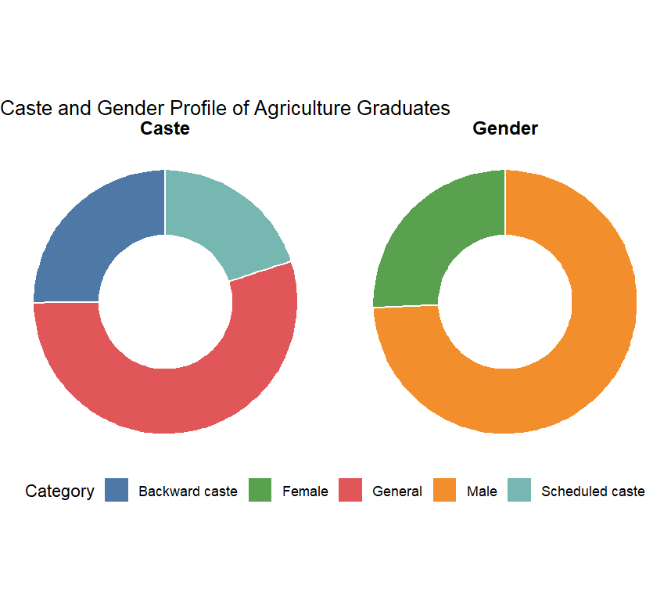
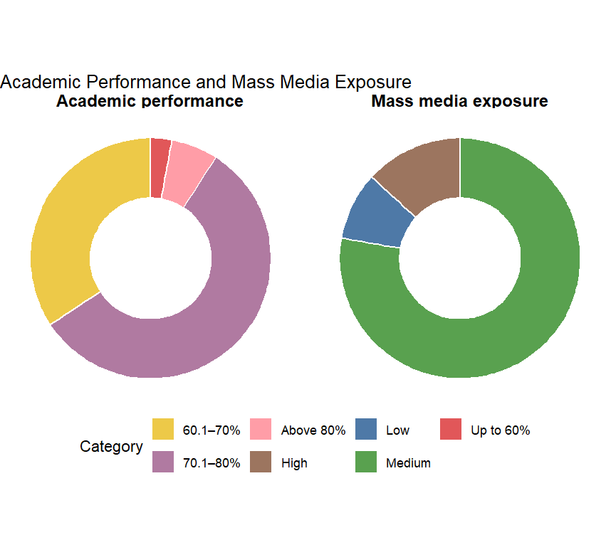

Fig 1- Personal and socio-economic background of the participants
Most respondents were unmarried, reflecting their younger age and unemployed status, consistent with societal norms (Ajit, 2004; Singh et al., 2014). Regarding education, most had completed 10+2 in the medical stream, with none from an agricultural background, indicating limited early exposure to agriculture and entry into agricultural studies as an alternative to medical or engineering courses (Rai, 2016). Academic performance was satisfactory, with over half securing 70.1–80% marks, suggesting supportive learning environments and faculty, which influence self-confidence and career aspirations (Sathyan, 2008; Tarde et al., 2014).
Family characteristics showed a predominance of nuclear families, reflecting urbanization and financial independence (Tayade et al., 2010; Singh et al., 2014). Most respondents belonged to small or landless farmer categories due to inheritance-based land fragmentation and urban expansion (Jadhav, 2008; Rokonuzzaman, 2013; Singh et al., 2014). Parental occupations were mainly in government service and farming, highlighting the influence of family background on career orientation (Shingare, 2005; Rameshrao, 2009).
Income profiles indicated a substantial proportion in high- and medium-income groups, providing better educational resources and support for professional aspirations (Rameshrao, 2009). Social participation was low, likely due to academic workload, while exposure to mass media was medium to high, facilitating access to career-related information (Rokonuzzaman, 2013; Mondal, 2014; Maloth et al., 2026; Pandey et al., 2017). Participation in allied and extracurricular activities was generally medium, reflecting campus infrastructure and opportunities. Overall, personal, educational, and socio-economic factors collectively shaped the professional aspirations of agriculture graduates.
CONCLUSION
The present study concludes that the professional aspirations of agriculture graduates are significantly shaped by a combination of personal, educational, and socio-economic factors (Henning et al., 2022). The dominance of general caste students, male participation, and unmarried status reflects existing social structures and cultural norms influencing access to higher agricultural education and career planning. The educational background of most respondents at the 10+2 level being from the medical stream indicates limited early exposure to agriculture, suggesting that agriculture education is often perceived as an alternative professional option rather than a primary career choice (Hassen et al., 2025). Academic performance of the majority of students was found to be satisfactory, which is likely to enhance self-confidence and positively influence their career ambitions, as supported by earlier studies (Sathyan, 2008; Rai, 2016).
The study further highlights that socio-economic variables such as family type, landholding size, parental occupation, and annual income play a crucial role in shaping career aspirations. The predominance of nuclear families and small or landless farming households suggests a shift away from traditional farming towards more secure and remunerative employment opportunities. Higher parental involvement in government service and medium to high income levels provide better exposure, resources, and encouragement for pursuing professional careers beyond farming (Rameshrao, 2009; Singh et al., 2014). Low levels of social participation among agriculture graduates indicate limited opportunities for leadership development, while moderate mass media exposure and allied activity participation suggest reasonable access to information and experiential learning, both of which influence aspiration formation (Mondal, 2014; Pandey et al., 2017). Overall, the findings emphasize the need for strengthening career guidance, early exposure to agriculture, and experiential learning opportunities within agricultural education systems. Enhancing awareness about diverse career avenues in agriculture, improving industry–academia linkages, and promoting student participation in professional and social organizations may help align the aspirations of agriculture graduates with emerging opportunities in the agricultural sector, thereby contributing to sustainable agricultural and rural development

Disclaimer (Artificial intelligence)

Author(s) hereby declare that NO generative AI technologies such as Large Language Models (ChatGPT, COPILOT, etc.) and text-to-image generators have been used during the writing or editing of this manuscript.

REFERENCES
- Ajo, A., Mardiyati, S., Edy, S., & Purnamasari, W. O. D. (2025). Bridging the gap: How entrepreneurship education shapes agribusiness graduates’ prospects. IOP Conference Series: Earth and Environmental Science, 1441(1), 012031. Ajit, A. (2004). Changes in the structure of employment in rural India. Indian Journal of Labour Economics, 47(4), 853-868.
- Aneesh, M. R., K., M., & Aneesh, K. A. (2024). Education inequality in India: An empirical analysis using National Sample Survey data. Indian Journal of Human Development, 18(2), 267–279.
- Arunachalam, R., Sathya Shri, K. P., & Sasmitha, R. (2020). An analysis of the aspirations of undergraduate agricultural students. Indian Journal of Extension Education, 56(2), 45–50.
- Bochalya, S. S., Gupta, S., Patel, M., Namdeo, S., Choudhary, P., & Palsaniya, R. (2025). Attributes of agricultural graduates about ELP programme. Journal of Scientific Research and Reports, 31(10), 534–541.
- Hassen, J. Y., Endris, G. S., Wordofa, M. G., Aweke, C. S., Hussein, J. W., & Kasa, L. (2025). Taking youth aspirations in agriculture seriously: Implications for livelihood programming in a fragile ecosystem. Cogent Social Sciences, 11(1), 1–15.
- Henning, I. F., Mabaso, S., Sithole, S., & Dlamini, T. (2022). Youths’ perceptions and aspirations towards participating in the agricultural sector: A South African case study. Social Sciences, 11(8), 356.
- Jadhav, P. G. (2008). Career aspirations of agricultural graduates of Mahatma Phule Krishi Vidyapeeth, Rahuri. M.Sc. (Ag.) Thesis, Mahatma Phule Krishi Vidyapeeth, Rahuri, Maharashtra
- J., J., Naik, R. M., & Chaudhary, K. L. (2024). Relationship between the profile of agricultural students and their career aspiration about prospects of agripreneurship. Archives of Current Research International, 24(5), 257–261.
- Maloth, S. P., Katkuri, S. S., & Choudhary, S. (2026). Career aspirations, achievement motivation and leadership orientation among graduate agriculture students. International Journal of Agriculture Extension and Social Development, 9(1), 1–8.
- Mondal, S. (2014). A study on career aspirations of agricultural graduates in West Bengal. Journal of Crop and Weed, 10(2), 438-442.
- Naik, B. M., Kaur, R., & Raveendran, A. (2024). Factors influencing occupational perception of agricultural undergraduates towards agriculture as a profession. Asian Journal of Agricultural Extension, Economics & Sociology, 42(8), 11–18.
- Naderi, H., Abdullah, R., Hamid, T. A., & Sharir, J. (2010). Intelligence, self-esteem and academic achievement of undergraduate students. Journal of Applied Sciences, 10(21), 2737–2743.
- Nagar, A., Nauriyal, D. K., & Singh, S. (2024). Factors influencing adoption of technical advice from agricultural extension services: Evidence from a field survey in Western Uttar Pradesh, India. The Indian Economic Journal, 72(5), 741–754.
- Paliwal, S., Pande, A., & K. (2025). The role of skill development in retaining youth in Indian agriculture: A theoretical perspective. Journal of Media & Management, 1–4.
- Pandey, R. K., et al. (2017). Career choices and professional aspirations of agricultural students. Indian Journal of Social Research, 58(2), 241-248.
- Prasad, K. (2004). Gender norms in education and the empowerment of rural women. Journal of Education and Social Change, 28(3), 45–58.
- Quijano-Pagutayao, A. (2024). Youth`s psychosocial characteristics in agriculture: The case of Bukidnon, Philippines. Davao Research Journal, 15(1).
- Rahim, H. (2010). Gender disparities in education and the role of social norms. International Journal of Gender and Women's Studies, 2(1), 112–125.
- Rajveer, Chawla, S., Kamboj, N., Choudhary, N., Khadda, B., Singh, J., Kumar, R., Soni, B., Jaipal, D., Singh, R., & Choudhary, K. (2025). Why students opt for agriculture as a discipline: Insights from Rajasthan, India. Asian Journal of Agricultural Extension, Economics & Sociology, 43(3), 103–109.
- Rameshrao, S. (2009). Socio-economic status and its influence on health. Journal of Community Medicine, 5(2), 114–119.
- Rai, S. K. (2016). A study on professional aspirations of agriculture graduates of Navsari Agricultural University. Ph.D. Thesis, Navsari Agricultural University, Navsari, Gujarat.
- Rokonuzzaman, M. (2013). A study on career aspirations of agricultural students in Bangladesh. International Journal of Agricultural Education and Extension, 1(1), 12-18.
- Sathyan, S. S. (2008). Professional aspirations of undergraduate students of Kerala Agricultural University. M.Sc. (Ag.) Thesis, Kerala Agricultural University, Vellanikkara.
- Sharma, N., & Phukan, D. (2024). Exploring the societal aspirations of youth in Himachal Pradesh, Bharat. Indian Journal of Social Science and Literature, 3(4), 12–17.
- Shingare, S. (2005). A study of the professional aspirations of the students of College of Agriculture, Pune. M.Sc. (Ag.) Thesis, Mahatma Phule Krishi Vidyapeeth, Rahuri
- Singh, R., et al. (2014). Socio-economic profile of agricultural students and their career aspirations. Journal of Community Mobilization and Sustainable Development, 9(2), 152-156.
- Sreelakshmi. C, Verma, R. K., & Jhajharia, A. K. (2024). Attitude of Rural Youth towards Agriculture as a Source of Livelihood in Rajasthan, India. Asian Journal of Agricultural Extension, Economics &amp; Sociology, 42(2), 56–64.
- Susanto, D., & Masli, A. (2025). From idea to publication: Constructing a quality research paper. Jurnal Akuntansi Dan Manajemen, 36(1), 73–99.
- Tsikati, A. F., & Motsa, N. (2024). A comparative analysis of career aspirations for agriculture students from rural and urban senior secondary schools. Global Journal of Guidance and Counseling in Schools: Current Perspectives, 14(2), 59–74.
- Tarde, V. J., Gujrathi, S. R., & Shinde, S. B. (2014). Educational aspirations and academic performance of agriculture students. Journal of Agriculture Research and Technology, 39(1), 154-157.
- Tayade, S. D., & Lanjewar, A. G. (2010). Socio-demographic profile of women in rural areas and their health seeking behavior. Indian Journal of Maternal and Child Health, 12(3), 1–7.
- Vart, P., Jaglan, A., & Shafique, K. (2015). Caste-based social inequalities and childhood anemia in India: results from the National Family Health Survey (NFHS) 2005–2006. BMC Public Health, 15(537).
- .

