Development and Clinical Evaluation of a Standardized Cervical Thermal Application Protocol for Incomplete Cervical Dilation in Buffaloes

ABSTRACT

Incomplete cervical dilation (ICD) is a significant maternal cause of dystocia in buffaloes, often resulting in prolonged labor and increased obstetrical intervention despite conventional pharmacological therapy. The present study aimed to develop and clinically evaluate a standardized cervical thermal application protocol as an adjunct to routine cervical relaxation treatment in buffaloes affected with ICD. Twenty full-term buffaloes diagnosed with ICD were enrolled in a randomized controlled clinical trial and allocated into Control (n = 10) and Thermal Intervention (n = 10) groups. Both groups received a standardized cervical relaxation protocol consisting of cloprostenol, dexamethasone, estradiol benzoate, valethamate bromide, and supportive intravenous fluids. The intervention group additionally received a standardized cervical thermal application using 2% carboxymethyl cellulose-soaked gauze maintained at 45–50°C for 20–25 minutes. The primary outcome was time to complete cervical dilation. Mean time to complete dilation was significantly reduced in the Thermal Intervention group (19.2 ± 1.3 h) compared to the Control group (29.4 ± 1.7 h; P < 0.01), representing an approximate 35% reduction. Cervical dilation scores at 2 and 4 hours were significantly higher in the intervention group (P < 0.05), and fewer cases required assisted delivery without evidence of maternal or neonatal complications. However, the study was limited by a modest sample size and absence of direct mechanistic evaluation of cervical tissue remodelling. The standardized cervical thermal application protocol demonstrated clinical efficacy as a safe and reproducible adjunct intervention in buffaloes with ICD.
Keywords: Buffalo; Cervical ripening; Dystocia; Incomplete cervical dilation; Obstetrics; Thermal therapy.

Introduction
Dystocia remains a major obstetrical problem in bovines, contributing significantly to perinatal mortality, postpartum reproductive disorders, and economic losses in dairy production systems (Noakes et al., 2009; Purohit et al., 2011). In buffaloes, both maternal and fetal factors predispose to dystocia, with incomplete cervical dilation (ICD) recognized as an important maternal aetiology (Das et al., 2008; Balamurugan et al., 2018). Failure of adequate cervical relaxation at term interferes with normal fetal expulsion, prolongs stage II labor, and increases the risk of fetal hypoxia and maternal exhaustion (Sahu et al., 2026a). Cervical dilation is a complex physiological process involving coordinated endocrine signaling, collagen remodelling, increased prostaglandin synthesis, leukocyte infiltration, and smooth muscle relaxation (Fuchs et al., 2002; Noakes et al., 2009). Inadequate cervical ripening has been associated with hormonal insufficiency, altered endocrine patterns at term, cervical fibrosis, and previous cervical injury (Das et al., 2008; Gahlot et al., 2017). Reports in cattle and buffaloes indicate that incomplete dilation may occur in both heifers and pluriparous animals and may be secondary to uterine torsion or other obstetrical complications (Gond et al., 2020).
Various therapeutic approaches have been described for the management of incomplete cervical dilation. These include administration of prostaglandin analogues such as misoprostol (Azawi et al., 2011; Azawi et al., 2012; Weeks et al., 2007), use of smooth muscle relaxants like valethamate bromide (Sharma et al., 1990), and surgical interventions such as cervicotomy in refractory cases (Raja et al., 2019). Intra-cervical prostaglandin E1 analogues have also been applied to enhance cervical softening and facilitate delivery (Monica et al., 2018). However, response variability and delayed progression to complete dilation are still encountered in clinical practice, necessitating exploration of adjunct, non-invasive approaches. Thermal application has been recognized in clinical medicine for its capacity to enhance local blood circulation, improve tissue perfusion, and reduce connective tissue stiffness. Increased vascular perfusion may facilitate metabolic activity and biochemical processes involved in collagen remodelling and cervical softening. Although pharmacological cervical priming is well documented (Fiala et al., 2007; Weeks et al., 2007), controlled clinical evaluation of a standardized local thermal protocol as an adjunct therapy in buffalo cervical dystocia remains limited.
Given the clinical significance of incomplete cervical dilation in buffaloes and the need for economical, field-applicable, and non-invasive supportive interventions, the present study was undertaken to develop and clinically evaluate a standardized cervical thermal application protocol as an adjunct to conventional pharmacological therapy in buffaloes diagnosed with incomplete cervical dilation.
Materials and Methods
Study Location and Experimental Animals
The study was conducted at the Referral Veterinary Polyclinic (RVP–OPD-1), Division of Animal Reproduction, ICAR–Indian Veterinary Research Institute (IVRI), Izatnagar, Bareilly, India. A total of 20 full-term pregnant buffaloes (n = 20) diagnosed with incomplete cervical dilation (ICD) during parturition were included. Animals ranged from first to fifth parity and were presented in stage II of labor with incomplete cervical dilation confirmed by per-vaginal examination. Only clinically stable animals with viable fetuses were enrolled. Animals were excluded if they had irreducible uterine torsion, uterine rupture, severe fetal emphysema, systemic shock, or required immediate surgical intervention.
Animal Metadata and Experimental Design
The overall mean age of the animals was 5.8 ± 0.42 years, and the mean parity was 2.6 ± 0.31. The study was designed as a prospective randomized controlled clinical trial. Animals were randomly allocated into two groups (n = 10 per group) using computer-generated simple random number allocation. Group I (Control) received routine cervical relaxation therapy, while Group II (Thermal Intervention) received routine therapy supplemented with the standardized cervical thermal application protocol. Blinding of the treating clinician was not feasible due to the procedural nature of the thermal intervention. However, cervical dilation was assessed using a predefined standardized scoring system applied uniformly across all animals to minimize observational bias.
Conventional Therapeutic Protocol
All enrolled buffaloes (Control and Thermal Intervention groups) received a standardized cervical relaxation regimen consisting of cloprostenol sodium (PGF₂α analogue) administered at 2 mL (500 µg) intramuscularly as a single dose, dexamethasone sodium phosphate at 0.04 mg/kg body weight intramuscularly, estradiol benzoate at 2 mg per animal intramuscularly, and valethamate bromide at 0.1 mg/kg body weight administered slowly via the intravenous route. Supportive intravenous fluid therapy (Ringer’s lactate or normal saline) was provided at 10–20 mL/kg body weight according to hydration status and clinical assessment. All medications were administered under aseptic conditions, and weight-based dosing was calculated individually for each animal prior to treatment initiation.
Development and Standardization of Cervical Thermal Application Protocol
In addition to the standardized therapeutic protocol described above, buffaloes allocated to the Thermal Intervention group received a standardized cervical thermal application procedure. Sterile cotton gauze pads were soaked in 2% carboxymethyl cellulose (CMC) solution maintained at 45–50°C (Fig. 1). Temperature was monitored using a calibrated digital thermometer and maintained within ±1°C to ensure controlled heat delivery. Following aseptic per-vaginal preparation, the warm CMC-soaked gauze was applied directly over the cervical os for 20–25 minutes (Fig. 2). Temperature was reassessed at 5-minute intervals during application. Gentle manual cervical massage was performed concurrently to enhance tissue pliability, and the duration and intensity of manual manipulation were standardized across intervention animals to minimize procedural variability. If adequate cervical progression was not achieved after 2 hours, the thermal application was repeated once under identical standardized conditions.

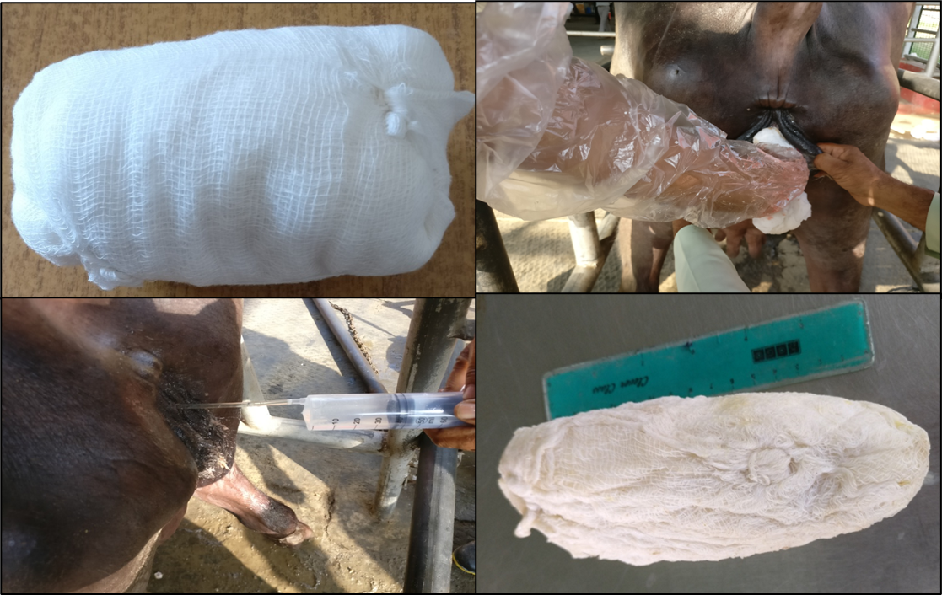

Fig. 1. Hot fomentation of cervix by cotton roll bundle

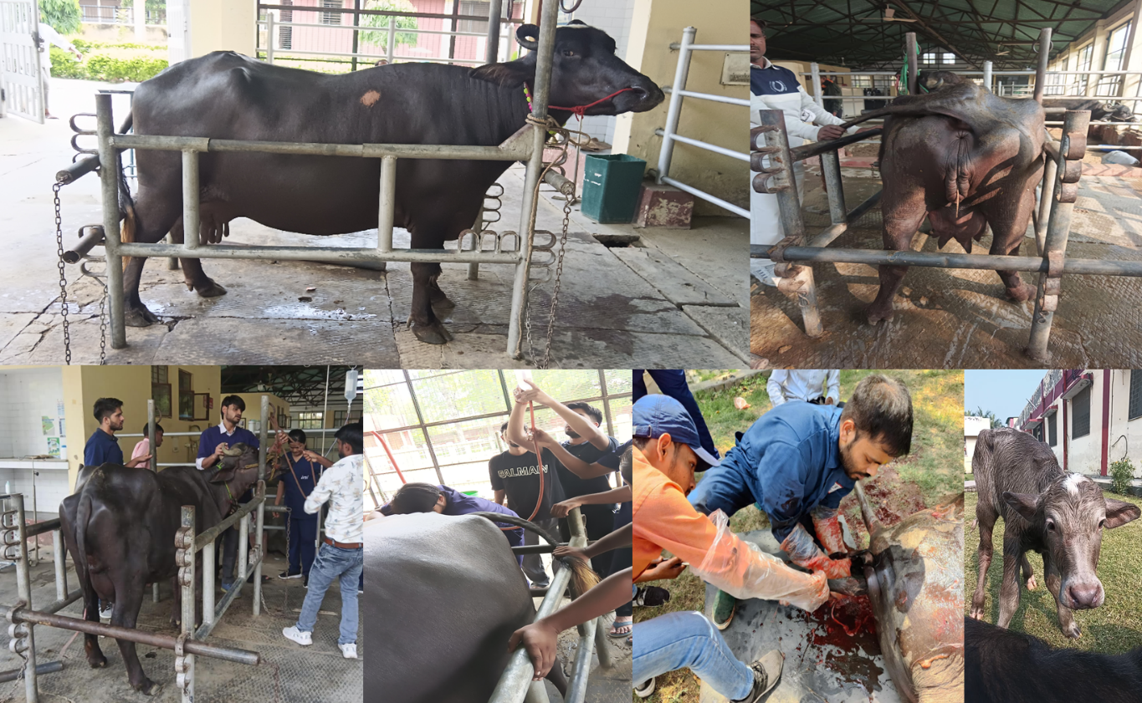

Fig. 2. Representative protocol procedural and clinical images of a buffalo affected with incomplete cervical dilation (ICD) showing signs of parturition without further cervical progression. Clinical features included raised tail and relaxation of the sacrosciatic ligaments. Following diagnosis, intravenous fluid therapy and the standardized cervical relaxation regimen were administered. The developed cervical thermal application protocol was subsequently applied as an adjunct intervention. Assisted fetal delivery was required in a few cases, resulting in the successful birth of a live calf.

Cervical Dilation Assessment
Cervical dilation was evaluated by per-vaginal digital examination using a standardized scoring system based on the number of fingers that could be passed through the cervical os, as described in Table 1. This tactile scoring system was adopted to enhance clinical reproducibility under field conditions and reduce subjectivity associated with percentage estimation. Dilation scores ranged from 0 to 5, where score 0 indicated a completely closed cervix and score 5 indicated full dilation permitting passage of the entire hand. Intermediate scores corresponded to progressive dilation assessed by the number of fingers passing through the cervical canal. Cervical dilation was recorded at baseline (0 hour), and subsequently at 2- and 4-hours following initiation of therapy. All examinations were performed by the same clinician to minimize inter-observer variability.

Table 1. Cervical Dilation Scoring System Based on Digital Examination

S. No. | Score | Description | Approximate No. of Fingers Passing
1 | 0 | Completely closed cervix | No finger
2 | 1 | <25% dilation | Tip of one finger
3 | 2 | 25–50% dilation | One finger
4 | 3 | 50–75% dilation | Two fingers
5 | 4 | >75% dilation | Three to four fingers
6 | 5 | Fully dilated cervix | Entire hand passage
Outcome Measures
The primary outcome measure was time (in hours) from initiation of treatment to complete cervical dilation (score 5). Secondary outcomes included cervical dilation score progression at 2 and 4 hours, requirement for assisted delivery, fetal viability at birth, and occurrence of maternal complications such as retained fetal membranes or postpartum metritis.
Fetal Viability Assessment
Fetal viability was assessed prior to delivery based on the presence of corneal and interdigital reflexes and confirmed immediately post-delivery by spontaneous respiration and detectable heart rate.
Statistical Analysis
Data were analyzed using GraphPad Prism (10.1.2) software. Results were expressed as mean ± standard error (SE). Normality of data distribution was assessed using the Shapiro–Wilk test prior to parametric analysis. An unpaired two-tailed t-test was used to compare time to complete cervical dilation between groups. Cervical dilation scores were also analyzed using an unpaired two-tailed t-test. Differences were considered statistically significant at P < 0.05. Categorical variables (assisted delivery, live calf delivery, retained fetal membranes) were compared descriptively due to the limited sample size.

RESULTS
All 20 buffaloes enrolled in the study completed the treatment protocol and were included in the final statistical analysis. No animals were excluded after randomization. Baseline cervical dilation scores at 0 hour were comparable between the Control and Thermal Intervention groups (P > 0.05), confirming baseline equivalence between groups.
Time to Complete Cervical Dilation
Buffaloes in the Control group required a longer duration to achieve complete cervical dilation, with a mean time of 29.4 ± 1.7 hours. In contrast, animals receiving the standardized cervical thermal application achieved complete dilation in 19.2 ± 1.3 hours. The reduction in time to complete dilation was statistically significant (P < 0.01). The observed difference corresponds to an approximate 35% decrease in dilation duration in the Thermal Intervention group compared with the Control group. The mean difference between groups was 10.2 hours. The distribution of individual values showed consistently lower dilation times in the Thermal Intervention group, with minimal overlap between groups. The comparative mean values with standard error are illustrated in Fig. 3.
Fig. 3. Comparison of time (hours) required to achieve complete cervical dilation in Control and Thermal Intervention groups. Adjunct standardized cervical thermal application significantly reduced the duration to complete dilation compared to conventional therapy alone. Bars represent mean ± SEM (n = 10 per group), with individual animal values shown. Statistical significance was observed at P < 0.01.
Cervical Dilation Score Progression
Cervical dilation progressed in both groups following initiation of therapy; however, the rate of progression was significantly greater in the Thermal Intervention group. At 2 hours post-treatment, the mean cervical dilation score in the Control group was 2.1 ± 0.18, whereas the Thermal Intervention group exhibited a significantly higher score of 3.4 ± 0.22 (P < 0.05). At 4 hours, cervical dilation scores increased to 3.0 ± 0.21 in the Control group and 4.6 ± 0.19 in the Thermal Intervention group, with the difference remaining statistically significant (P < 0.05). These findings demonstrate accelerated cervical dilation in buffaloes receiving adjunct thermal therapy. Detailed comparison of dilation scores and other clinical parameters is presented in Table 2.
Table 2. Comparison of Cervical Dilation Progression and Obstetrical Outcomes Between Control and Thermal Intervention Groups
Parameter | Control Group  (n = 10) | Thermal Intervention Group (n = 10) | P-value
Time to complete dilation (hours) | 29.4 ± 1.7 | 19.2 ± 1.3 | <0.01
Dilation score at 2 hours | 2.1 ± 0.18 | 3.4 ± 0.22 | <0.05
Dilation score at 4 hours | 3.0 ± 0.21 | 4.6 ± 0.19 | <0.05
Assisted delivery (no. of cases) | 4/10 | 1/10 | -
Live calf delivery (no. of cases) | 7/10 | 9/10 | -
Retained fetal membranes (no. of cases) | 2/10 | 1/10 | -
Obstetrical and Neonatal Outcomes
The requirement for assisted delivery was greater in the Control group, where 4 out of 10 animals required obstetrical traction, compared to 1 out of 10 animals in the Thermal Intervention group. Live calf delivery occurred in 7 out of 10 animals in the Control group and 9 out of 10 animals in the Thermal Intervention group. Retained fetal membranes were recorded in 2 animals in the Control group and 1 animal in the Thermal Intervention group. No evidence of thermal injury, cervical laceration, or procedure-related complications was observed in the intervention group. A comprehensive summary of time to dilation, cervical score progression, assisted delivery, fetal viability, and postpartum complications is presented in Table 2.

Discussion
Incomplete cervical dilation is a well-recognized maternal cause of dystocia in bovines, particularly in buffaloes where dense fibromuscular cervical tissue and slower remodelling contribute to delayed parturition (Das et al., 2008; Purohit et al., 2011). Classical veterinary obstetrical texts emphasize that cervical relaxation is a hormonally mediated process involving coordinated endocrine signaling, vascular changes, and structural softening of connective tissue (Roberts, 1956; Noakes et al., 2018). Failure of these mechanisms results in prolonged labor and increased obstetrical intervention. In the present study, adjunct standardized cervical thermal application significantly reduced the time required to achieve complete dilation and enhanced early cervical dilation scores. The approximately 10-hour reduction in dilation time suggests that localized thermal modulation may facilitate physiological cervical remodelling in conjunction with pharmacological therapy, although direct mechanistic assessment was not performed.
Cervical ripening involves collagen fibre disorganization, increased tissue hydration, leukocyte infiltration, and prostaglandin-mediated extracellular matrix remodelling (Noakes et al., 2018). Pharmacological approaches such as prostaglandin analogues and corticosteroids are commonly used to facilitate this process (Azawi et al., 2011; Monica et al., 2018), yet response variability persists (Gahlot et al., 2017). Case reports of misoprostol-induced cervical softening in bovines and small ruminants support the role of prostaglandin-mediated cervical priming (Azawi et al., 2011; Azawi et al., 2012; Weeks et al., 2007); however, controlled comparative clinical data remain limited. The present findings provide controlled evidence that adjunct non-pharmacological modulation may enhance cervical dilation beyond routine medical management alone.
The physiological rationale for thermal intervention is grounded in vascular modulation. Localized heat enhances tissue perfusion, increases metabolic activity, and may reduce collagen stiffness, thereby improving tissue extensibility. Oxytocin-induced prostaglandin E2 release from bovine cervical mucosa has been demonstrated (Fuchs et al., 2002), confirming biochemical responsiveness of cervical tissue during parturition. Enhanced perfusion secondary to thermal application may therefore facilitate endogenous prostaglandin activity and extracellular matrix remodelling. Recent Doppler-based studies have demonstrated cyclic variations in uterine arterial blood flow corresponding to endocrine changes (Sahu et al., 2026b), and altered uterine vascular dynamics have been documented in pathological reproductive conditions with improvement following recovery (Sahu et al., 2026c). These findings reinforce the concept that reproductive tissue function is closely linked to vascular perfusion. Accordingly, it is biologically plausible that localized thermal stimulation contributes to improved cervical dilation through microvascular augmentation; however, objective vascular measurements would be required to confirm this mechanism.
Earlier reports have attributed incomplete cervical dilation to endocrine imbalance, cervical fibrosis, or inadequate biochemical priming (Das et al., 2008; Gahlot et al., 2017). In refractory cases, invasive procedures such as cervicotomy have been described (Raja et al., 2019). In contrast, the present findings indicate that a non-invasive, standardized thermal adjunct may reduce the need for aggressive interventions. The lower requirement for assisted delivery in the Thermal Intervention group supports improved cervical compliance without increased maternal trauma. Importantly, fetal viability and postpartum complication rates were not adversely affected. Classical obstetrical literature indicates that prolonged labor increases the risk of fetal hypoxia (Roberts, 1956; Noakes et al., 2018); therefore, reduction in dilation time may confer secondary neonatal benefit, although larger studies would be required to establish this statistically. While pharmacological cervical priming remains fundamental, adjunct non-pharmacological modulation may offer additive benefit, particularly in field settings where minimally invasive and economical approaches are desirable. The present study contributes prospective controlled clinical data supporting this adjunct approach.
Several limitations warrant consideration. The sample size was relatively small (n = 20), limiting statistical power for secondary outcomes. Mechanistic parameters such as cervical collagen architecture, prostaglandin concentrations, or direct microvascular perfusion were not measured; thus, physiological inference remains indirect. Blinding was not feasible due to the nature of the intervention, introducing potential observational bias. Additionally, long-term postpartum reproductive performance and subsequent fertility were not evaluated. Multicentric trials incorporating objective biochemical and Doppler-based vascular assessments would strengthen understanding of thermal modulation in cervical remodelling.

CONCLUSION
The present study demonstrates that a standardized cervical thermal application protocol, when used as an adjunct to conventional pharmacological therapy, significantly reduces the time required for complete cervical dilation in buffaloes affected with incomplete cervical dilation. Accelerated cervical dilation score progression and a reduced need for assisted delivery were observed without compromising fetal viability or maternal safety. These findings support the clinical feasibility and reproducibility of this standardized thermal application protocol as a non-invasive supportive intervention in buffalo obstetrics. While the underlying physiological mechanisms require further elucidation, the approach shows potential for integration into routine clinical management. Larger-scale studies incorporating objective vascular and biochemical assessments are recommended to further validate and optimize this therapeutic strategy.

Consent
Written informed consent was obtained from the owners of all animals prior to their inclusion in the study.

Ethical Approval
All experimental procedures were approved by the Institutional Animal Ethics Committee (IAEC) of ICAR–Indian Veterinary Research Institute (IVRI), Izatnagar, Uttar Pradesh, India (Approval No.: 26-3/2020-21/JD(R)/IAEC).

Data Availability
The datasets generated and analyzed during the current study are available from the corresponding author upon reasonable request.

Disclaimer (Artificial intelligence)

The authors declare that generative artificial intelligence tools were not used in the conceptualization, data analysis, or preparation of this manuscript.

References

- Azawi, O. I., Lazim, E. H., Hussain, E. S., & Ibrahim, I. Y. (2012). Misoprostol treatment of dystocia due to ringwomb in Awassi ewe: A case report. Iraqi Journal of Veterinary Sciences, 26(2), 101–102.
- Azawi, O. I., Lazim, E. H., Hussain, E. S., & Ibrahim, I. Y. (2012). Misoprostol treatment of dystocia due to ringwomb in Awassi ewe: A case report. [Journal name missing].
- Azawi, O. I., Naoman, U. T., Al-Kass, Z. M., Lazim, E. H., & Fathi, N. G. (2011). Misoprostol treatment of dystocia due to incomplete dilatation of the cervix in a cow: A case report. Iraqi Journal of Veterinary Sciences, 25(2), 97–98. https://doi.org/10.1079/PA20123000100
- Balasundaram, B., Kharayat, N., Lavanya, M., Kumar, A., Ramamoorthy, M., Sushobhit, K. S., Gautam, D., Jena, D., & Katiyar, R. (2018). Dystocia due to incomplete cervical dilation concurrent with cervico-vaginal prolapse in cattle: A case report. Journal of Entomology and Zoology Studies, 6(6), 544–545.
- Das, G. K., Ravinder, R. D., Deori, S., Jaglan, P., Kumar, P., & Gokuldas, P. P. (2008). Incomplete cervical dilatation causing dystocia in a buffalo. Indian Journal of Veterinary Research, 17(2), 41–43.
- Fiala, C., Gemzell-Danielsson, K., Tang, O. S., & Von Hertzen, H. (2007). Cervical priming with misoprostol prior to transcervical procedures. International Journal of Gynecology & Obstetrics, 99(Suppl. 2), S168–S171. https://doi.org/10.1016/j.ijgo.2007.09.005
- Fuchs, A. R., Graddy, L. G., Kowalski, A. A., & Fields, M. J. (2002). Oxytocin induces PGE2 release from bovine cervical mucosa in vivo. Prostaglandins & Other Lipid Mediators, 70(1–2), 119–129. https://doi.org/10.1016/s0090-6980(02)00017-5
- Gahlot, S. C., Kumaresan, A., Kumar, S., Yadav, S., Saraf, K. K., Karan, P., & Verma, K. (2017). Incomplete cervical dilatation in animals—An update. International Journal of Science and Environment, 6, 1036–1048.
- Gond, M., Doddagouda, V., Pasha, M. M., Ashokappa, & Nidhishree. (2020). Post cervical right-side uterine torsion in nondescript buffalo: A case report. International Journal of Livestock Research. https://doi.org/10.5455/ijlr.20191214071611
- Monica, G., Sarath, T., Rangasamy, S., Joseph, C., & Sathiamoorthy, T. (2018). Clinical management of post cervical uterine torsion preceded by imperfect cervical dilation (ICD) in a Holstein Friesian crossbred cow. Indian Veterinary Journal, 95(9), 53–54.
- Noakes, D. E., Parkinson, T. J., & England, G. C. W. (Eds.). (2009). Arthur’s veterinary reproduction and obstetrics (9th ed.). Saunders Elsevier.
- Noakes, D. E., Parkinson, T. J., & England, G. C. W. (Eds.). (2018). Arthur’s veterinary reproduction and obstetrics (10th ed.). Elsevier.
- Purohit, G. N., Barolia, Y., Shekher, C., & Kumar, P. (2011). Maternal dystocia in cows and buffaloes: A review. Open Journal of Animal Sciences, 1, 41–53. https://doi.org/10.4236/ojas.2011.12006
- Raja, S., Palanisamy, M., Prabharan, V., Rajkumar, R., & Jayaganthan, P. (2019). Cervicotomy for the management of dystocia due to prepartum vagino-cervical prolapse in cow. Indian Journal of Animal Reproduction, 40(1), 65–66.
- Roberts, S. J. (1956). Veterinary obstetrics and genital diseases. Edwards Brothers.
- Sahu, U. K., Kumar, B., Khan, M. H., Baghel, M. S., Kumar, P., Sahu, L., & Verma, H. (2026). Major reproductive disorders in sheep and goats and its management. Indian Farmer, 13(2), 50–67.
- Sahu, U. K., Kumar, B., Khan, M. H., Warghat, C., Singh, M., Reddy, A. L., Yadav, V., Chouhan, V. S., & Sahu, L. (2026). Spectral Doppler assessment of middle uterine artery hemodynamics across the estrous cycle in Tharparkar cows. Frontiers in Animal Science. https://doi.org/10.3389/fanim.2026.1740299
- Sahu, U. K., Kumar, P., Kumar, B., Khan, M. H., Baghel, M. S., Vadera, V., Kumar, M., Sahu, L., Kumar, A., Kharayat, N. S., & Priyadershi, A. (2026). Transrectal Doppler characterization of uterine vascular dynamics in buffaloes with clinical metritis and subsequent recovery. International Journal of Bio-Resource and Stress Management, 17(1), 1–7. https://doi.org/10.23910/1.2026.6759
- Sharma, G. P., Reddy, V. S. C., & Raju, M. S. (1990). Effect of Valosin-Vet (valethamate bromide) in cervical dystocia. Indian Veterinary Journal, 67(6), 581–582.
- Weeks, A., Alfirevic, Z., Faúndes, A., Hofmeyr, G. J., Safar, P., & Wing, D. (2007). Misoprostol for induction of labor with a live fetus. International Journal of Gynecology & Obstetrics, 99(Suppl. 2), S194–S197. https://doi.org/10.1016/j.ijgo.2007.09.011

These authors contributed equally to this work and share first authorship.

