Exploring the Effect of Heavy Metal Treatment on Anatomy and Phytochemicals in Jacobaea maritima by GC-MS Analysis

.
ABSTRACT

Phytochemicals are the major components in the medicinal system where plant extracts are used to prepare various drugs. The crude form of these plant extracts with phytochemicals is purified and potentized to make it suitable for human consumption and usage. Most plants can produce medicinally important phytochemicals as some are potentially used in various systems of medicine including Ayurveda, Homoeopathy, and Unani. The plant Jacobaea maritima is an important plant in the homeopathic system of medicine which has the phytochemicals that are mainly useful in treating ophthalmological disorders. In this study, we target phytochemicals by treating the plant with heavy metals to see if the metal ions impact this phytochemical production and the anatomical changes crucial for plant growth. It was found that many phytochemicals have the properties of antioxidant, antimicrobial, anti-inflammatory, metabolism-modulating, and immune-modulating and are produced in higher quantities with the treatment.

Keywords: Jacobaea maritima, Phytochemicals, Heavy Metal Treatment, GC-MS.

1. INTRODUCTION

Medicinal plants have always been of great interest and importance in the field of medicine as well as the economy. The crude extracts from these plants can be made into a form suitable for human consumption in multiple processes including potentization (R. N. S. Yadav & Agarwala, 2011). The plant Jacobaea maritima (L.) Pelser & Meijden is one of the important medicinal plants in the homeopathic system of medicine. This has been of great use in preparing medicine mainly used for ophthalmological disorders including cataracts and conjunctivitis (William & Xavier, 2023).
The plant Jacobaea maritima (L.) Pelser & Meijden originated in the Capria islands of Italy and is a non-endemic plant to Indian terrain. The plant is cultivated by the Centre for Medicinal Plant Research Institute (CMPRI) under the Central Council for Research in Homeopathy (CCRH), in Ooty, Tamil Nadu, India (Durgapal et al., 2021).
This plant belongs to the Asteraceae family and is a perennial shrub that can grow from 0.5 to 1 m in height, It has a tomentose nature with dense white to gray hairs all over the plant giving it the name silver ragwort. The leaves are pinnate and have oblong or obtuse leaf ends (Passalacqua et al., 2008).
Any metal that can cause damage to the plant after a particular range is called a heavy metal. In the recent developments in the agricultural sector and others, using chemical-based fertilizers and pesticides has contaminated the soil with a lot of heavy metals (Nagajyoti et al., 2010). These heavy metals show a major impact on all kinds of plants that are grown on soil containing heavy metals and they also show the impact on the secondary metabolites that the plants produce along with their primary growth and development (Nasim & Dhir, 2010). Here the heavy metals are selected and given as a planned treatment cycle to replicate their effects in the natural habitat. The heavy metals that are chosen for the study are cadmium, chromium, and Lead (Banadka & Nagella, 2023). All these are given as treatment in a concentration range of 50-250 ppm in 7 days. The effects shown by these heavy metals are recorded and further analysed.
The accumulation of heavy metals leads to some major changes in the anatomical structures of J maritima roots and shoots. Compared with the control plant the thickening of the cell wall of the cortex and other regions are observed. The minute particles that are visible in the treated plants which look like raphides are not present in the control plant in any part which gives a conclusion that it is formed due to the treatment of the heavy metals. The petiole of the plant showed three vascular bundles arranged in a V shape whereas the root and stem had multiple vascular bundles arranged in concentric circles around the outer cortex region in shoot and scattered from in the root.
In the anatomical sections of control plants and the treated plants from Cd, Cr, and Pb in different concentrations, it was observed that in the control set of plants the cortex cells were clear and no disruptions in the cells were observed. Whereas in the treated set of plants, the cortex cells were found to have minute particles which can be some particles that were formed with the treatment of heavy metals. The main effect that was observed in the shoot and root sections was in the vascular bundle regions. With the increase in the concentration of heavy metals, the xylem and phloem vessels were found to be narrowed down.
Gas chromatography was used to find out the phytochemicals that are present in the plant which is untreated in comparison with the treated plants to find out the variation in the amount and different phytochemicals (Hassan et al., 2016). The phytochemicals that are found have different pharmacological properties and are economically important.

2. material and methods

2.1. Collection of plants
The plants are collected from CMPRI (CCRH) Ooty, Tamil Nadu, India. The plants are propagated from the stem cuttings and with a soil manure mixture of 3:1 ratio. The plants were transferred from CMPRI to the polyhouse at CHRIST (Deemed to be University) and were potted with red soil and manure, care was taken till the plants got acclimatized to the conditions (Agegnehu et al., 2016).
2.2. Heavy metal treatment
The heavy metal treatment was given using three different heavy metals and five different concentrations of each heavy metal which are 50, 100, 150, 200, and 250 ppm respectively (Shah et al., 2013; Street, 2012). The treatment was given to the plants of the same age, and at an interval of one week each. The plants were watered normally in between the treatment cycle to avoid the shock in the plants due to the heavy metals.
2.3. Anatomical Examination of the treated plants:
The plants that are treated are taken to observe the anatomical changes. The plant samples were taken in thin sections using a blade and then stained using the safranin stain and were observed under the Leica Microscope for the variations due to the treatment. The root and stem were compared with the control plant and the treated plant. There was a definite variation in the growth pattern and development conditions of different parts with different metal concentrations. The anatomical changes are verified with the help of checking the accumulation rate using the AAS (Atomic Absorption Spectrophotometer) to get an idea of accumulation metals in different plant parts
2.4. Criteria for selection of samples for GC - MS
Once the heavy metal treatment is done different parts of the plant like the root, shoot, and leaf are taken and subjected to acid digestion using aqua-regia which is 4:1 of nitric acid and hydrochloric acid. Based on the amount of accumulation of each heavy metal in different plant parts the highest and least accumulated with the help of data from atomic absorption spectroscopy.
2.5. Sample preparation for GC - MS
The dried plant parts were made into a coarse powder and were extracted using hexane as a solvent and the extract was taken for analysis using GC-MS. The samples were analysed using SHIMADZU, GCMS-QP2010SE, with an electron ionization and quadrupole mass analyser, using helium as a carrier gas (Gomathi et al., 2015). The samples that were prepared using hexane were analyzed using GC-MS, the major phytochemicals that are found in the plant are as follows.(Badalamenti et al., 2023)

3. results and discussion

It was observed that a few of the phytochemicals that were present in the control plant completely disappeared in the treated plants and vice versa. The phytochemicals like squalene and supraene which are found in the root of the control plant are seen in only Pb 200 ppm treated root and Cr 50 ppm Shoot samples and are absent in the rest of the samples. Meanwhile, compounds like eicosaonic acid, n-hexadecanoic acid, neophytadine, and phytol which are absent in the control plant are observed in the leaf tissue of Cr 50, Cr 200, Pb 150, and Pb 250 ppm concentrations respectively.

Table 1 - List of Phytochemicals and their Presence in Control Plants
S. No | Name of the Compound | Bioactivity | Control R | Control S | Control L
1 | Cosane, Cosanol ( Octa, Hexa, Hepta, Nona, Penta, Doco, Ei, Henei) | Antimicrobial | ✓ | ✓ | ✓
2 | Contane, Contanol (henitria, Hexatria, tetra tetra, Dotria) | Anti-inflammatory, antitumor, antimicrobial | ✓ | ✓ | ✓
3 | Decane (Octa, Nona, Do, Penta, Hexa, Hepta) | Antibacterial, Antioxidant, Antifungal | ✓ | ✓ | ✓
4 | Phenol, 2,4-bis(1,1-dimethylethyl)-, phosphite (3:1) | Antifungal, Antioxidant | ✓ | ✓ | ✓
5 | Eicosanoic acid | Antibacterial | ✕ | ✕ | ✕
6 | Squalene, Supraene | antimicrobial, antioxidant, anti-inflammatory, antitumor, and antidiabetic | ✓ | ✕ | ✕
7 | Farnesol isomer a | Anti oxidant | ✓ | ✕ | ✕
8 | Dibutyl phthalate | antimicrobial, antitumor and antioxidant | ✓ | ✓ | ✓
9 | n- Hexadecanoic acid | antioxidants, hypocholesterolemic, nematicide, and pesticide | ✕ | ✕ | ✕
10 | Neophytadiene | analgesic, antipyretic, anti-inflammatory, antimicrobial, and antioxidant compound | ✕ | ✕ | ✓
11 | Phytol | anxiolytic, metabolism-modulating, cytotoxic, antioxidant, autophagy- and apoptosis-inducing, antinociceptive, anti-inflammatory, immune-modulating, and antimicrobial | ✕ | ✕ | ✕

Table 2 - List of Phytochemicals and their Presence in Root of the Treated Plants
S. No | Name of the Compound | Bio-Activity | Cd 150 | Cd 100 | Cr 200 | Cr 50 | Pb 200 | Pb 50
1 | Cosane, Cosanol ( Octa, Hexa, Hepta, Nona, Penta, Doco, Ei, Henei) | Antimicrobial | ✓ | ✓ | ✓ | ✓ | ✓ | ✓
2 | Contane, Contanol (henitria, Hexatria, tetra tetra, Dotria) | Anti-inflammatory, antitumor, antimicrobial | ✕ | ✓ | ✓ | ✓ | ✓ | ✓
3 | Decane (Octa, Nona, Do, Penta, Hexa, Hepta) | Antibacterial, Antioxidant, Antifungal | ✓ | ✓ | ✓ | ✓ | ✓ | ✓
4 | Phenol, 2,4-bis(1,1-dimethylethyl)-, phosphite (3:1) | Antifungal, Antioxidant | ✓ | ✓ | ✕ | ✕ | ✕ | ✕
5 | Eicosanoic acid | Antibacterial | ✕ | ✕ | ✕ | ✕ | ✕ | ✕
6 | Squalene, Supraene | antimicrobial, antioxidant, anti-inflammatory, antitumor, and antidiabetic | ✕ | ✕ | ✕ | ✕ | ✓ | ✕
7 | Farnesol isomer a | Anti oxidant | ✕ | ✕ | ✕ | ✕ | ✕ | ✕
8 | Dibutyl phthalate | antimicrobial, antitumor and antioxidant | ✓ | ✓ | ✓ | ✓ | ✓ | ✓
9 | n- Hexadecanoic acid | antioxidants, hypocholesterolemic, nematicide, and pesticide | ✕ | ✕ | ✕ | ✕ | ✕ | ✕
10 | Neophytadiene | analgesic, antipyretic, anti-inflammatory, antimicrobial, and antioxidant compound | ✕ | ✕ | ✕ | ✕ | ✕ | ✕
11 | Phytol | anxiolytic, metabolism-modulating, cytotoxic, antioxidant, autophagy- and apoptosis-inducing, antinociceptive, anti-inflammatory, immune-modulating, and antimicrobial | ✕ | ✕ | ✕ | ✕ | ✕ | ✕
Table 3 - List of Phytochemicals and their Presence in Shoot of the Treated Plants

S. No | Name of the Compound | Bio-Activity | Cd 200 | Cd 50 | Cr 250 | Cr 50 | Pb 250 | Pb 50
1 | Cosane, Cosanol ( Octa, Hexa, Hepta, Nona, Penta, Doco, Ei, Henei) | Antimicrobial | ✓ | ✓ | ✓ | ✓ | ✓ | ✓
2 | Contane, Contanol (henitria, Hexatria, tetra tetra, Dotria) | Anti-inflammatory, antitumor, antimicrobial | ✓ | ✓ | ✓ | ✓ | ✓ | ✓
3 | Decane (Octa, Nona, Do, Penta, Hexa, Hepta) | Antibacterial, Antioxidant, Antifungal | ✓ | ✓ | ✓ | ✓ | ✓ | ✓
4 | Phenol, 2,4-bis(1,1-dimethylethyl)-, phosphite (3:1) | Antifungal, Antioxidant | ✕ | ✕ | ✓ | ✕ | ✕ | ✓
5 | Eicosanoic acid | Antibacterial | ✕ | ✕ | ✕ | ✕ | ✕ | ✕
6 | Squalene, Supraene | antimicrobial, antioxidant, anti-inflammatory, antitumor, and antidiabetic | ✕ | ✕ | ✕ | ✓ | ✕ | ✕
7 | Farnesol isomer a | Anti oxidant | ✕ | ✕ | ✕ | ✓ | ✕ | ✕
8 | Dibutyl phthalate | antimicrobial, antitumor and antioxidant | ✓ | ✓ | ✓ | ✓ | ✓ | ✓
9 | n- Hexadecanoic acid | antioxidants, hypocholesterolemic, nematicide, and pesticide | ✕ | ✕ | ✓ | ✕ | ✕ | ✕
10 | Neophytadiene | analgesic, antipyretic, anti-inflammatory, antimicrobial, and antioxidant compound | ✕ | ✕ | ✕ | ✕ | ✕ | ✕
11 | Phytol | anxiolytic, metabolism-modulating, cytotoxic, antioxidant, autophagy- and apoptosis-inducing, antinociceptive, anti-inflammatory, immune-modulating, and antimicrobial | ✕ | ✕ | ✕ | ✕ | ✕ | ✕

Table 4 - List of Phytochemicals and their Presence in Leaf of the Treated Plants

S. No | Name of the Compound | Bio-Activity | Cd 200 | Cd 250 | Cr 200 | Cr 50 | Pb 250 | Pb 150
1 | Cosane, Cosanol ( Octa, Hexa, Hepta, Nona, Penta, Doco, Ei, Henei) | Antimicrobial | ✓ | ✓ | ✓ | ✓ | ✓ | ✓
2 | Contane, Contanol (henitria, Hexatria, tetra tetra, Dotria) | Anti-inflammatory, antitumor, antimicrobial | ✓ | ✓ | ✓ | ✓ | ✓ | ✓
3 | Decane (Octa, Nona, Do, Penta, Hexa, Hepta) | Antibacterial, Antioxidant, Antifungal | ✓ | ✓ | ✓ | ✓ | ✓ | ✓
4 | Phenol, 2,4-bis(1,1-dimethylethyl)-, phosphite (3:1) | Antifungal, Antioxidant | ✓ | ✕ | ✓ | ✕ | ✕ | ✕
5 | Eicosanoic acid | Antibacterial | ✕ | ✕ | ✓ | ✓ | ✓ | ✓
6 | Squalene, Supraene | antimicrobial, antioxidant, anti-inflammatory, antitumor, and antidiabetic | ✕ | ✕ | ✕ | ✕ | ✕ | ✕
7 | Farnesol isomer a | Anti oxidant | ✕ | ✕ | ✕ | ✕ | ✕ | ✕
8 | Dibutyl phthalate | antimicrobial, antitumor and antioxidant | ✓ | ✓ | ✓ | ✓ | ✓ | ✓
9 | n- Hexadecanoic acid | antioxidants, hypocholesterolemic, nematicide, and pesticide | ✕ | ✕ | ✓ | ✓ | ✓ | ✓
10 | Neophytadiene | analgesic, antipyretic, anti-inflammatory, antimicrobial, and antioxidant compound | ✕ | ✕ | ✓ | ✓ | ✓ | ✓
11 | Phytol | anxiolytic, metabolism-modulating, cytotoxic, antioxidant, autophagy- and apoptosis-inducing, antinociceptive, anti-inflammatory, immune-modulating, and antimicrobial | ✕ | ✕ | ✕ | ✓ | ✓ | ✕

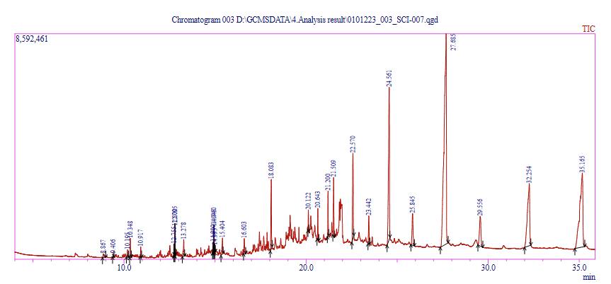
Fig 1 - GC-MS graph of control leaf sample showing different peaks 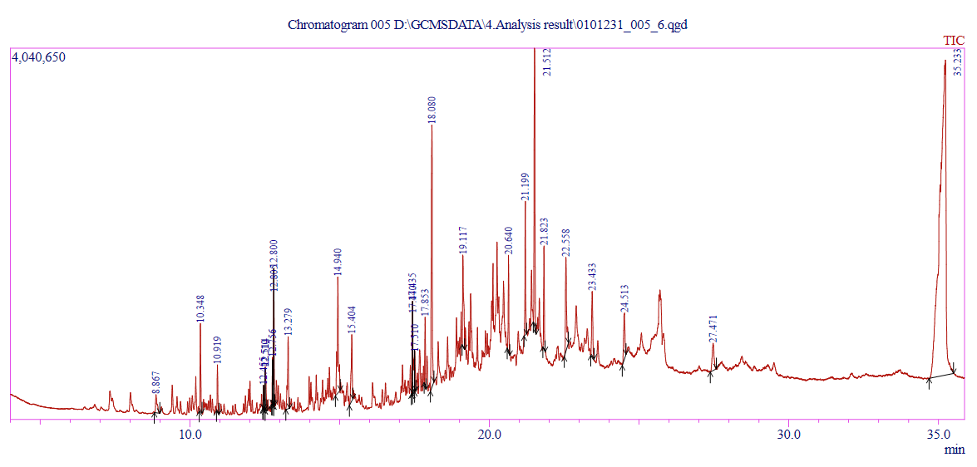
Fig 2 - GC-MS graph of Cd 100 ppm Root sample showing different peaks
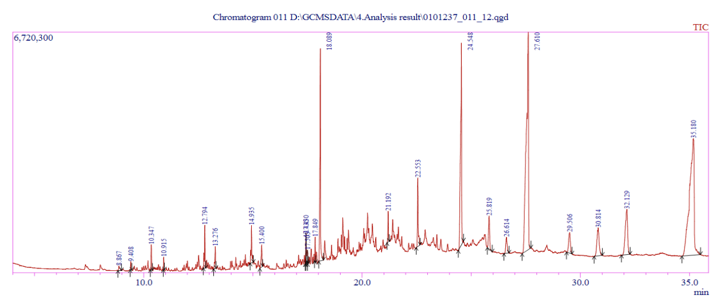

Fig 3 - GC-MS graph of Cd 50 ppm Shoot sample showing different peaks
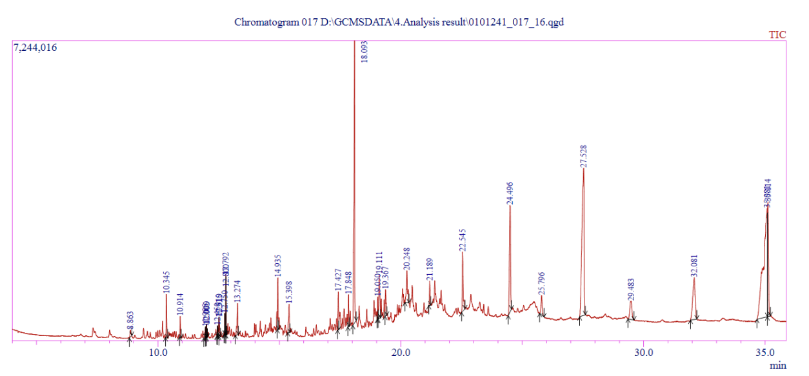
Fig 4 - GC-MS graph of Cd 250 ppm Leaf sample showing different peaks

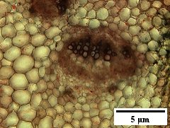

Fig 5. Image showing anatomical section of Control Leaf
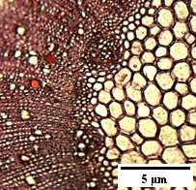
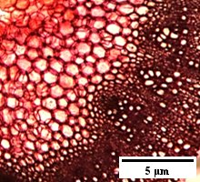

Fig 7. Image showing anatomical section of Cd 50 ppm treated J. maritima Shoot

Fig 6. Image showing anatomical section of Cd 100 ppm treated J. maritima Root

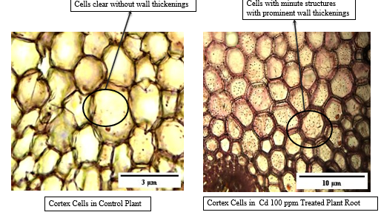
Fig 8. Anatomy of the Control and Treated plant showing wall thickenings

The current work shows the variation in the different phytochemicals which are having different medicinal properties in the plant J. maritima. There were limited works that were done with this plant in the heavy metal treatment module. The above work clearly shows heavy metal stress can significantly mitigate the biosynthetic pathways of secondary metabolites, which will impact the overall quality of plant and its therapeutic factors (Asiminicesei et al. 2024). These environmental factors tend to impact not only the presence but also quantitative and qualitative aspects of the secondary metabolites (Adeosun et al. 2022). In the work done by William et al, The heavy metals have shown a clear variation and impact in the pigmentation and photosynthetic capability (William & Xavier, 2023). The work done by Durgapal et al. proves that this plant has the phytochemicals that have the property of clearing the cataract when tested on the goat lens in in-vitro studies (Durgapal et al., 2021). In the work done by Viyinikov et al. in the genus Jacobaea the Hydroxybenzoic, Hydroxycinnamic Acids, and their Glycosides are present (Voynikov et al., 2023). According to the work of Jumai et al., the pyrrolizidine alkaloids are the major components in Jacobaea vulgaris (Jumai et al., 2023) which are 13-dehydrosenkirkine and chloromethylretrorsine.
Plant anatomy shows differed responses when they are subjected to heavy metal stress, including vascular structure enhancement and plasticity of the cells will change to mitigate the heavy metal stress by different strategies including accumulating them (Chudasama et al. 2024). These kind of plant responses contain synthesis and deposition of callose substance within the roots, which in turn prevents the uptake of heavy metals retaining the root plasticity (Mohamed et al. 2025). The physiological response for the exposure to adverse conditions by treating with heavy metals can elevate the plants nutraceutical values by production of various secondary metabolites (Ben Hsouna et al. 2022). Its also seen that the phenotypic plasticity of the plants shows a major impact on the phytochemical composition of the plants when they are exposed to the environmental stress inducers such as heavy metals (Bacong and Juanico 2021).
. In the work done by Batool et al, it was found that the anatomy of the plant like, disintegration and reduced size of parenchymatous tissue, xylem vessels, mesophyll tissue and reduced root and stem diameter is observed(Batool et al., 2015). The bioaccumulation of the Pb in Prosopis laevigata is seen significantly with the reduce in the number of leaves. While Zn has reduced the plant height, hence its proved to have a good potential to Phyto- remediate the environment(Muro-González et al., 2020). The work done by Yadav et al., proved that the heavy metal stress showed a positive impact by enhancing parenchymatous tissues like Xylem, phloem, vascular bundles and collenchyma (V. Yadav et al., 2021). In Leucanthemum vulgare Lam. The leaf area was reduced by 86%, the root length by 94% and root to length ratio by 69% with the treatment of heavy metal slag (Ahsan et al., 2019). In Atriplex centralasiatica the heavy metal stress increased the duct (Xylem and Phloem) thickness (Gao et al., 2021).

4. Conclusion

The work done here shows us the different aspects of plant in the anatomy and also phytochemicals affected by heavy metals at different concentrations. It was very evident that vascular bundle was affected with heavy metal accumulation which showed an effect on the whole plant growth and a few of the phytochemicals like squalene, Supraene, etc., completely disappeared with the treatment while a few of the phytochemicals like n-hexadecanoic acid, Neophytadine, phytol, Eicosaonic acid etc., are found only in the treated set of plants. This clarifies that with the treatment of heavy metals; the necessary phytochemicals can be elicited in economically important plants and for the production of medicine. The work can be further extended to quantify each phytochemical to get a precise idea and range before large-scale implementation.

COMPETING INTERESTS DISCLAIMER:
Authors have declared that they have no known competing financial interests OR non-financial interests OR personal relationships that could have appeared to influence the work reported in this paper.
Authors have declared that no generative AI technologies are used during writing and editing of this manuscript.

References

- Adeosun, W. B., More, G. K., Steenkamp, P., & Prinsloo, G. (2022). Influence of seasonal and geographic variation on the anti-HSV-1 properties and chlorogenic acids content of Helichrysum aureonitens Sch. Bip. Frontiers in Molecular Biosciences, 9, 961859.
- Asiminicesei, D.-M., Fertu, D. I., & Gavrilescu, M. (2024). Impact of heavy metal pollution in the environment on the metabolic profile of medicinal plants and their therapeutic potential. Plants, 13(6), 913.
- Agegnehu, G., Bass, A. M., Nelson, P. N., & Bird, M. I. (2016). Benefits of biochar, compost and biochar–compost for soil quality, maize yield and greenhouse gas emissions in a tropical agricultural soil. The Science of the Total Environment, 543, 295–306.
- Ahsan, M., Younis, A., Jaskani, M. J., Tariq, U., Shaheen, M. R., Tufail, A., Sherani, J., & Nawaz, F. (2019). Anatomical changes in stem of scented Rosa spp. in response to heavy metal accumulation under wastewater treatment. International Journal of Agriculture and Biology, 21, 1159–1165.
- Bacong, J. R. C., & Juanico, D. E. O. (2021). Predictive chromatography of leaf extracts through encoded environmental forcing on phytochemical synthesis. Frontiers in Plant Science, 12, 613507.
- Badalamenti, N., Merra, R., Schicchi, R., Geraci, A., Sgadari, F., & Bruno, M. (2023). The chemical composition of the aerial parts essential oil of Jacobaea delphiniifolia (Asteraceae) growing in Sicily (Italy). Natural Product Research, 1–5.
- Banadka, A., & Nagella, P. (2023). Effect of heavy metals on germination, biochemical, antioxidant and withanolide content in Withania somnifera (L.) Dunal. Plant Science Today, 10(3), 363–374.
- Batool, R., Hameed, M., Ashraf, M., Ahmad, M. S. A., & Fatima, S. (2015). Physio-Anatomical Responses of Plants to Heavy Metals. In M. Öztürk, M. Ashraf, A. Aksoy, & M. S. A. Ahmad (Eds.), Phytoremediation for Green Energy (pp. 79–96). Springer Netherlands.
- Ben Hsouna, A., Michalak, M., Kukula-Koch, W., Ben Saad, R., Ben Romdhane, W., Zeljković, S. Ć., & Mnif, W. (2022). Evaluation of halophyte biopotential as an unused natural resource: The case of Lobularia maritima. Biomolecules, 12(11), 1583.
- Chudasama, T., Dangar, K., Gadhvi, K., Vyas, S., & Dudhagara, D. (2024). Multivariate statistical analysis of bioavailability of heavy metals and mineral characterization in selected species of coastal flora. Scientific Reports, 14(1), 11282.
- Durgapal, S., Juyal, V., & Verma, A. (2021). In vitro antioxidant and ex vivo anti-cataract activity of ethanolic extract of Cineraria maritima: a traditional plant from Nilgiri hills. Future Journal of Pharmaceutical Sciences, 7(1), 1–15.
- Gao, T., Wang, H., Li, C., Zuo, M., Wang, X., Liu, Y., Yang, Y., Liu, Y., Yao, G.-Q., Chang, G., Xu, D., & Fang, X. (2021). Effects of complex heavy metal stress on the hydrodynamic parameters, stem anatomy and photosynthetic properties of three desert species in the Jinchang mining area. https://doi.org/10.21203/rs.3.rs-855904/v1
- Gomathi, D., Kalaiselvi, M., Ravikumar, G., Devaki, K., & Uma, C. (2015). GC-MS analysis of bioactive compounds from the whole plant ethanolic extract of Evolvulus alsinoides (L.) L. Journal of Food Science and Technology, 52(2), 1212–1217.
- Hassan, W., Rehman, S., Noreen, H., Gul, S., Neelofar, N., & Ali, N. (2016). Gas chromatography mass spectrometric (GCMS) analysis of essential oils of medicinal plants. Advances in Animal and Veterinary Sciences, 4(8), 420–437.
- Jumai, A., Zou, G.-A., Liu, G.-Y., & Aisa, H. A. (2023). Pyrrolizidine alkaloids from Jacobaea vulgaris Gaertn and theoretical studies on intramolecular interactions. Natural Product Research, 1–6.
- Mohamed, H. I., Ullah, I., Toor, M. D., Tanveer, N. A., Din, M. M. U., Basit, A., Sultan, Y., Muhammad, M., & Rehman, M. U. (2025). Heavy metals toxicity in plants: understanding mechanisms and developing coping strategies for remediation: a review. Bioresources and Bioprocessing, 12(1), 95.
- Muro-González, D. A., Mussali-Galante, P., Valencia-Cuevas, L., Flores-Trujillo, K., & Tovar-Sánchez, E. (2020). Morphological, physiological, and genotoxic effects of heavy metal bioaccumulation in Prosopis laevigata reveal its potential for phytoremediation. Environmental Science and Pollution Research International, 27(32), 40187–40204.
- Nagajyoti, P. C., Lee, K. D., & Sreekanth, T. V. M. (2010). Heavy metals, occurrence and toxicity for plants: a review. Environmental Chemistry Letters, 8(3), 199–216.
- Nasim, S. A., & Dhir, B. (2010). Heavy metals alter the potency of medicinal plants. Reviews of Environmental Contamination and Toxicology, 203, 139–149.
- Passalacqua, N. G., Peruzzi, L., & Pellegrino, G. (2008). A biosystematic study of theJacobaea maritimagroup (Asteraceae,Senecioneae) in the Central Mediterranean area. Taxon, 57(3), 893–906.
- Shah, A., Niaz, A., Ullah, N., Rehman, A., Akhlaq, M., Zakir, M., & Suleman Khan, M. (2013). Comparative Study of Heavy Metals in Soil and Selected Medicinal Plants. Journal of Chemistry and Chemical Engineering, 2013. https://doi.org/10.1155/2013/621265
- Street, R. A. (2012). Heavy metals in medicinal plant products—An African perspective. South African Journal of Botany: Official Journal of the South African Association of Botanists = Suid-Afrikaanse Tydskrif Vir Plantkunde: Amptelike Tydskrif van Die Suid-Afrikaanse Genootskap van Plantkundiges, 82, 67–74.
- Voynikov, Y., Balabanova, V., Gevrenova, R., & Zheleva-Dimitrova, D. (2023). Chemophenetic Approach to Selected Senecioneae Species, Combining Morphometric and UHPLC-HRMS Analyses. Plants, 12(2). https://doi.org/10.3390/plants12020390
- William, J. K. S., & Xavier, J. (2023). Effect of heavy metals on the pigmentation and photosynthetic capability in Jacobaea maritima (L.) Pelser & Meijden. Plant Science Today, 10(4), 192–197.
- Yadav, R. N. S., & Agarwala, M. (2011). Phytochemical analysis of some medicinal plants. Journal of Phytology, 3(12). https://www.researchgate.net/profile/Fatima-Hussen-2/post/How_can_I_isolate_the_active_constituents_of_a_plant/attachment/59d63f1bc49f478072ea9748/AS%3A273775847772169%401442284657308/download/1.+Phytochemical+analysis+of+some+medicinal+plants%281%29.pdf
- Yadav, V., Arif, N., Kováč, J., Singh, V. P., Tripathi, D. K., Chauhan, D. K., & Vaculík, M. (2021). Structural modifications of plant organs and tissues by metals and metalloids in the environment: A review. Plant Physiology and Biochemistry: PPB / Societe Francaise de Physiologie Vegetale, 159, 100–112.

