Surgical Management of Third Eyelid Gland Prolapse (‘Cherry Eye’) in a Rabbit: A Rare Clinical Case Report

Abstract Prolapse of the third eyelid gland, commonly known as cherry eye, is well documented in dogs but is considered uncommon in rabbits. The third eyelid gland contributes substantially to tear production, and its excision predisposes animals to keratoconjunctivitis sicca. Therefore, surgical repositioning rather than removal is recommended. This report describes the successful surgical management of cherry eye in a one-year-old New Zealand White rabbit using the modified Morgan’s pocket technique. The rabbit presented with a soft, reddish-pink swelling at the medial canthus of the right eye, accompanied by mild conjunctival hyperemia and ocular discharge. Ophthalmic examination confirmed prolapse of the third eyelid gland without corneal involvement. General anaesthesia was achieved using xylazine (6 mg/kg IM) and ketamine (60 mg/kg IM) with careful monitoring of heart rate, respiration, and temperature. Detailed anatomical considerations, including the location of the medial canthal ligament and conjunctival vascular supply, guided careful dissection. A conjunctival pocket was created to reposition and secure the prolapsed gland. The incision was closed with absorbable sutures, and postoperative care included systemic antibiotics, anti-inflammatory therapy, and topical eye drops. The rabbit recovered uneventfully, resumed normal feeding within 24 hours, and showed complete resolution of clinical signs without recurrence during a 30-day follow-up. This case demonstrates that cherry eye in rabbits can be effectively managed through surgical repositioning using the modified Morgan’s pocket technique, preserving glandular function and ensuring a favourable clinical outcome
Keywords: Cherry eye, Third eyelid gland, Ketamine, Modified Morgan’s pocket technique and Surgical management Introduction: Prolapse of the third eyelid gland, commonly referred to as cherry eye (White and Brennan, 2018). Third eyelid gland also known as harderian gland, nictitating gland or accessory lacrimal gland of the third eyelid. In rabbits, the harderian gland is located within the eye orbit at the nasal base of the third eyelid. The gland is anchored by a short, firm ligament to the periorbital connective tissue, and its anatomical position is adjacent to the medial canthus, overlying the lacrimal sac. Precise knowledge of this orientation is critical during surgical repositioning to avoid trauma to the gland or surrounding conjunctiva. Prolapse is generally observed in young animals, especially before one year of age. It is a common condition in dogs, however rare in rabbits (Janssens et al., 1999, Singh et al., 2017). Prolapse of the third eyelid gland has been reported in several rabbit breeds, including New Zealand Whites and smaller pet rabbits (Bennett, 2021) The prolapse mainly occurs due to weakening of the supportive ligament that anchors the gland (Raza et al., 2013). A genetic predisposition is responsible, as certain canine breeds show increased prevalence (Dakhane et al., 2022). Clinically, affected animals present with a pink to reddish mass at the medial canthus, often accompanied by conjunctival hyperemia, irritation, and ocular discharge. The gland plays an important role in maintaining ocular surface health, contributing approximately 30–50% of the aqueous component of the tear film (Kaswan and Martin, 1985); therefore, its excision may predispose affected animals to keratoconjunctivitis sicca. Consequently, surgical repositioning is preferred over gland removal. Several techniques have been described, including anchoring methods, the conjunctival pocket technique, and modifications of the Morgan’s pocket method (Dakhane, et al., 2022). Among these, the modified Morgan’s pocket technique is most commonly used in dogs; studies have documented high rates of successful repositioning using both the Morgan pocket and modified methods (Guionnet and Weverberg, 2026; Sowmya et al., 2024)). However, its application in rabbits is rarely reported. This case report describes the successful surgical management of cherry eye in a rabbit using modified Morgan’s pocket technique.
Case presentation
A clinical case of prolapse of the third eyelid gland (cherry eye) in a one-year-old New Zealand White rabbit presented to the Department of Veterinary Surgery and Radiology, Bihar Veterinary College, Patna (Bihar, India), with a history of swelling at the medial canthus of the right eye from two months. The animal was previously treated with Moxifloxacin eye drops and Azithromycin orally for 7 days. Clinical examination revealed a soft, round, reddish-pink mass protruding from the medial canthus. The rabbit exhibited mild conjunctival hyperemia and ocular discharge. Physiological parameters, including rectal temperature, respiration rate, and heart rate, were within normal limits. Ophthalmic examination ruled out corneal ulceration and confirmed the diagnosis of cherry eye.
Surgical management was planned to reposition the gland using the modified Morgan’s pocket technique under general anaesthesia. The rabbit was pre-medicated with xylazine (6 mg/kg IM) and induced with ketamine (60 mg/kg IM). Surgical plane of anaesthesia was maintained with intermittent boluses of ketamine as required. After aseptic preparation of the periocular region, the rabbit was positioned in lateral recumbency with the affected eye uppermost. The prolapsed gland was irrigated with sterile normal saline to remove discharge. The surgical site was isolated using drapes, and the eyelids were gently retracted with eyelid retractors.
A curvilinear conjunctival incision was made on both sides of the gland, parallel to the free margin of the third eyelid, creating a conjunctival pocket. Blunt dissection was performed to develop a sub-conjunctival a tunnel, and the gland was carefully repositioned into the pocket. The conjunctival edges were closed with absorbable polyglactin 910 (6-0) sutures in a simple continuous pattern, ensuring adequate coverage and minimal tension across the repair. Postoperatively, the rabbit treated with azithromycin (20 mg/kg orally once daily for 5 days), meloxicam (0.4 mg/kg orally once daily for 3 days), and topical moxifloxacin–olopatadine eye drops thrice daily for 7 days. The rabbit was monitored daily for surgical site integrity, signs of recurrence, pain or discomfort, and potential ocular complications (Badran et al., 2017)
Results and Discussion:
The rabbit recovered smoothly from the surgery, without intraoperative or postoperative complications. Postoperatively, the conjunctival pocket remained structurally intact, and the third eyelid gland was successfully repositioned in its anatomical location. The rabbit resumed normal feeding and activity the day after surgery. No recurrence of gland prolapse was observed during the 30-day follow-up period. Prolapse of the third eyelid gland is clinically significant because it can lead to mechanical irritation which can precipitate inflammation and conjunctival irritation, resulting in altered tear production, chronic conjunctivitis, and ocular discharge (Dehghan et al., 2012) Surgical repositioning is preferred over excision to preserve lacrimal function and prevent keratoconjunctivitis sicca (Thamizharasan et al., 2016). The rabbit was pre-medicated with xylazine (6 mg/kg IM) and induced with ketamine (60 mg/kg IM), a commonly used combination in rabbits that provides reliable sedation, analgesia, and adequate depth of anesthesia for surgical procedures (Kato et al., 1998; Flecknell, 2009). This protocol allowed smooth induction, stable anesthesia, and uneventful recovery in the present case. The Morgan’s pocket technique is simple to perform, minimizes recurrence, and preserves tear production (Morgan et al., 1993; Hendrix, 2007). The only reported limitation is reduced gland mobility (Plummer et al., 2008). Maintaining adequate visualization and gentle tissue handling reduces the risk of hemorrhage, postoperative inflammation, and recurrence. Additionally, proper anesthetic dosing tailored to rabbits’ physiological sensitivity is critical for safe surgical outcomes. Azithromycin (20 mg/kg orally, once daily) was selected as the postoperative systemic antibiotic in this case because of its high tissue distribution, effective intracellular penetration, and sustained concentrations at sites of infection. Importantly, azithromycin is regarded as relatively safe for use in rabbits, as it carries a lower risk of disruption of normal gastrointestinal microflora when compared with several other antimicrobial classes. In contrast, antibiotics such as clindamycin, lincomycin, and orally administered β-lactams are contraindicated in rabbits due to their strong association with antibiotic-induced enterotoxaemia (Lukehart, et al., 1990). Based on available exotic animal and rabbit medicine literature, azithromycin is therefore considered a prudent and safer systemic antimicrobial choice when postoperative antibiotic coverage is clinically indicated in rabbits. In the present case, surgical management was satisfactory, with complete resolution of clinical signs and restoration of normal ocular appearance. The gland remained in its anatomical position without recurrence, demonstrating the effectiveness of the modified Morgan’s pocket technique in rabbits. Postoperative care, including systemic antibiotics (azithromycin), anti-inflammatory drugs (meloxicam), and topical moxifloxacin–olopatadine drops, helped prevent infection, reduce inflammation, and relieve discomfort. Meticulous handling of the gland and precise formation of the conjunctival pocket are crucial to minimise tissue trauma and recurrence (Yaygingul et al., 2020).
Conclusion Surgical management of cherry eye in rabbits can be successfully performed using the modified Morgan’s pocket technique without any major complications. The modified Morgan’s pocket technique effectively repositions the prolapsed gland, prevents recurrence, and preserves its physiological function.
Conflict of Interest Statement The authors declare that there are no conflicts of interest regarding the publication of this manuscript.
Ethical Approval and Consent The surgical case was conducted with informed owner consent, and all procedures followed standard clinical and ethical guidelines of the Bihar Veterinary College, Bihar Animal Sciences University, Patna.
Disclaimer (Artificial intelligence)

The author(s) hereby declare that no generative AI technologies, such as large language models (e.g., ChatGPT, Copilot) or text-to-image generators, were used in the writing or editing of this manuscript. Artificial intelligence tools were used solely for language correction.
References
- Badran, K. W., Chang, J. C., Kuan, E. C., & Wong, B. J. (2017). Anatomy and surgical approaches to the rabbit nasal septum. JAMA Facial Plastic Surgery, 19(5), 386-391.
- Bennett, R. A. (2021). Rabbit soft tissue surgery. Surgery of Exotic Animals, 240-276.
- Dakhane, P. S., Kale, P. D., & Lokhande, D. U. (2022). Successful surgical correction of cherry eye by modified Morgan’s pocket technique in four dogs. The Pharma Innovation Journal, 11(SP-11), 92–94.
- Dehghan, M. M., Pedram, M. S., Azari, O., Mehrjerdi, H. K., & Azad, E. (2012). Clinical evaluation of the pocket technique for replacement of prolapsed gland of the third eyelid in dogs. Turkish Journal of Veterinary and Animal Sciences, 36(4), 352–356.
- Flecknell, P. A. (2009). Laboratory Animal Anaesthesia (3rd ed.). Academic Press.
- Guionnet, A., & Weverberg, F. (2026). Surgical Correction of Prolapse of NictitatingMembrane Gland Using a Variant of the Pocket Technique: A Retrospective Study on 101 Dogs and 126 Eyes. Veterinary Ophthalmology. 29 (1)
- Hendrix, D. V. H. (2007). Canine conjunctiva and nictitating membrane. In K. N. Gelatt (Ed.), Veterinary ophthalmology (4th ed., pp. 662–689). Ames, IA: Blackwell Publishing.
- Janssens, G., Simoens, P., Muylle, S., & Lauwers, H. (1999). Bilateral prolapse of the deep gland of the third eyelid in a rabbit: Diagnosis and treatment. Laboratory AnimalScience, 49(1), 105–109.
- Kaswan, R. L., & Martin, C. L. (1985). Keratoconjunctivitis sicca: Dry eye in the dog. Journal of the American Veterinary Medical Association, 186(11), 1182–1187.
- Kato, Y., et al. (1998). Anesthetic effects of ketamine-xylazine combination in rabbits. Journal of Veterinary Medical Science, 60(11), 1249–1254.
- Kiranjeet Singh, K. S., Aswathy Gopinathan, A. G., Sangeetha, P., Sarangom, S. B., Nitish Kallianpur, N. K., Shivaraju, S., & Naveen Kumar, N. K. (2017). Morgan's pocket technique for the surgical management of cherry eye in dogs: a report of 14 cases. Indian Journal of Animal Research. 51(4):795–797.
- Lukehart, S. A., Fohn, M. J., & Baker-Zander, S. A. (1990). Efficacy of azithromycin for therapy of active syphilis in the rabbit model. Journal of antimicrobial Chemotherapy, 25(suppl_A), 91-99.
- Morgan, R. V., Duddy, J. M., & McClurg, K. (1993). Prolapse of the gland of the third eyelid in dogs: A retrospective study of 89 cases. Journal of the American Animal Hospital Association, 29, 56–60.
- Plummer, C. E., Källberg, M. E., Gelatt, K. N., Gelatt, J. P., Barrie, K. P., & Brooks, D. E. (2008). Intranictitans tacking for replacement of prolapsed gland of the third eyelid in dogs. Veterinary Ophthalmology, 11, 228–233.
- Raza, A., Naeem, M. A., Ahmad, M., Manzoor, A., & Ijaz, M. (2013). Cherry eye: Prolapse of third eyelid gland in dog – A case report. International Journal of Molecular Veterinary Research, 3(1), 1–3. https://doi.org/10.5376/ijmvr.2013.03.0001
- Sowmya, D., Reddy, K., & Latha, C. (2024). A Clinical Study on the Surgical Management of Third Eyelid Gland Prolapse in Dogs. Indian Journal of Animal Research, 58(10), 1743-1750.
- Thamizharasan, A., Murugan, M. S., & Parthiban, S. (2016). Surgical management of cherry eye in a dog. Intas Polivet, 17(II), 420–421.
- White, C., & Brennan, M. (2018). An evidence-based rapid review of surgical techniques for correction of prolapsed nictitans glands in dogs. Veterinary Sciences, 5(3), 75.
- Yaygingul, R., Bozkan, Z., Bilgen, Z., Kurt Kibar, B., Bulut, O., & Belge, A. (2020). Surgical treatment of prolapse of the third eyelid gland in dogs using modified Morgan pocket technique. Indian Journal of Animal Research, 54(5), 619–622.

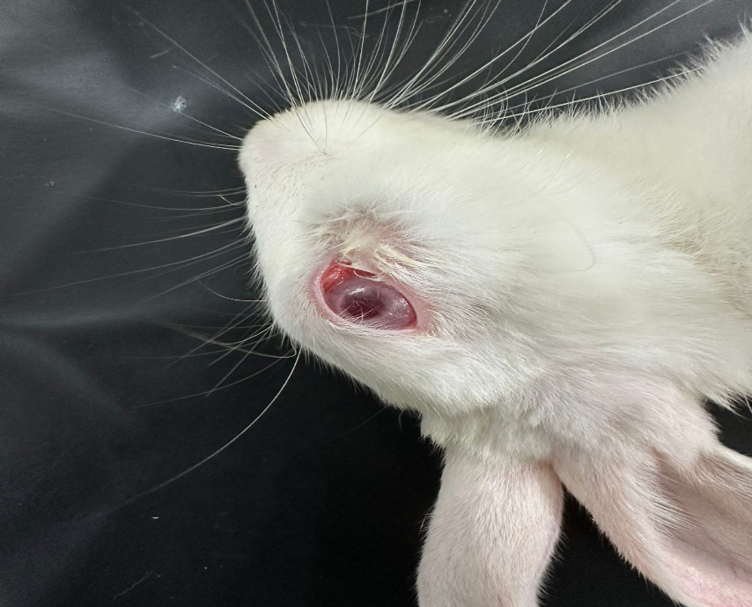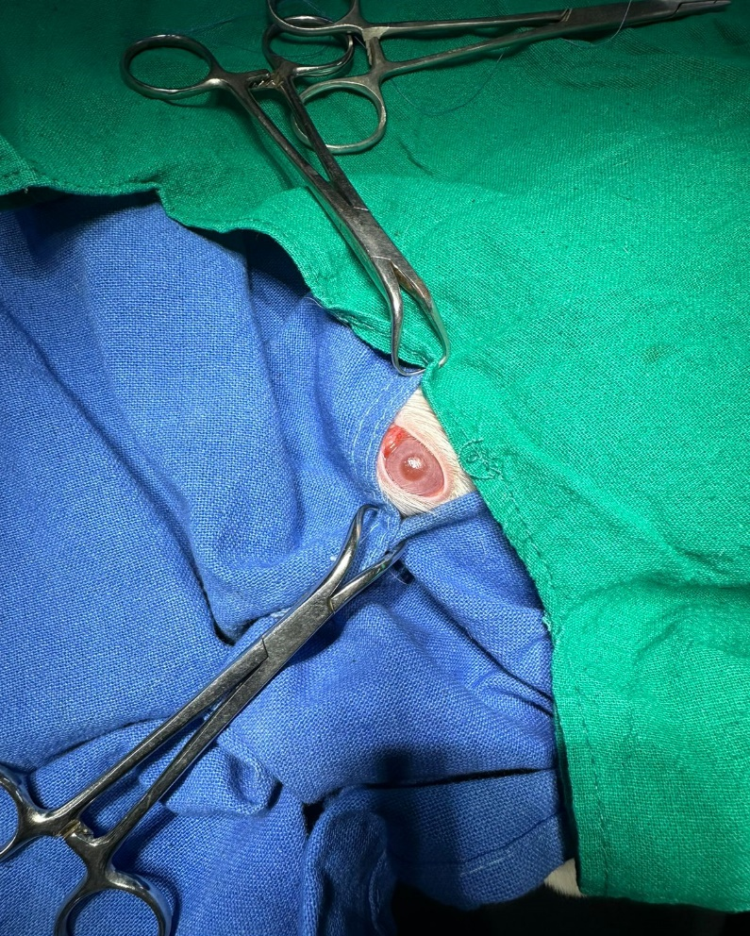
Fig.1. Clinical case of cherry eye in rabbit Fig.2. Surgical preparation of surgical site
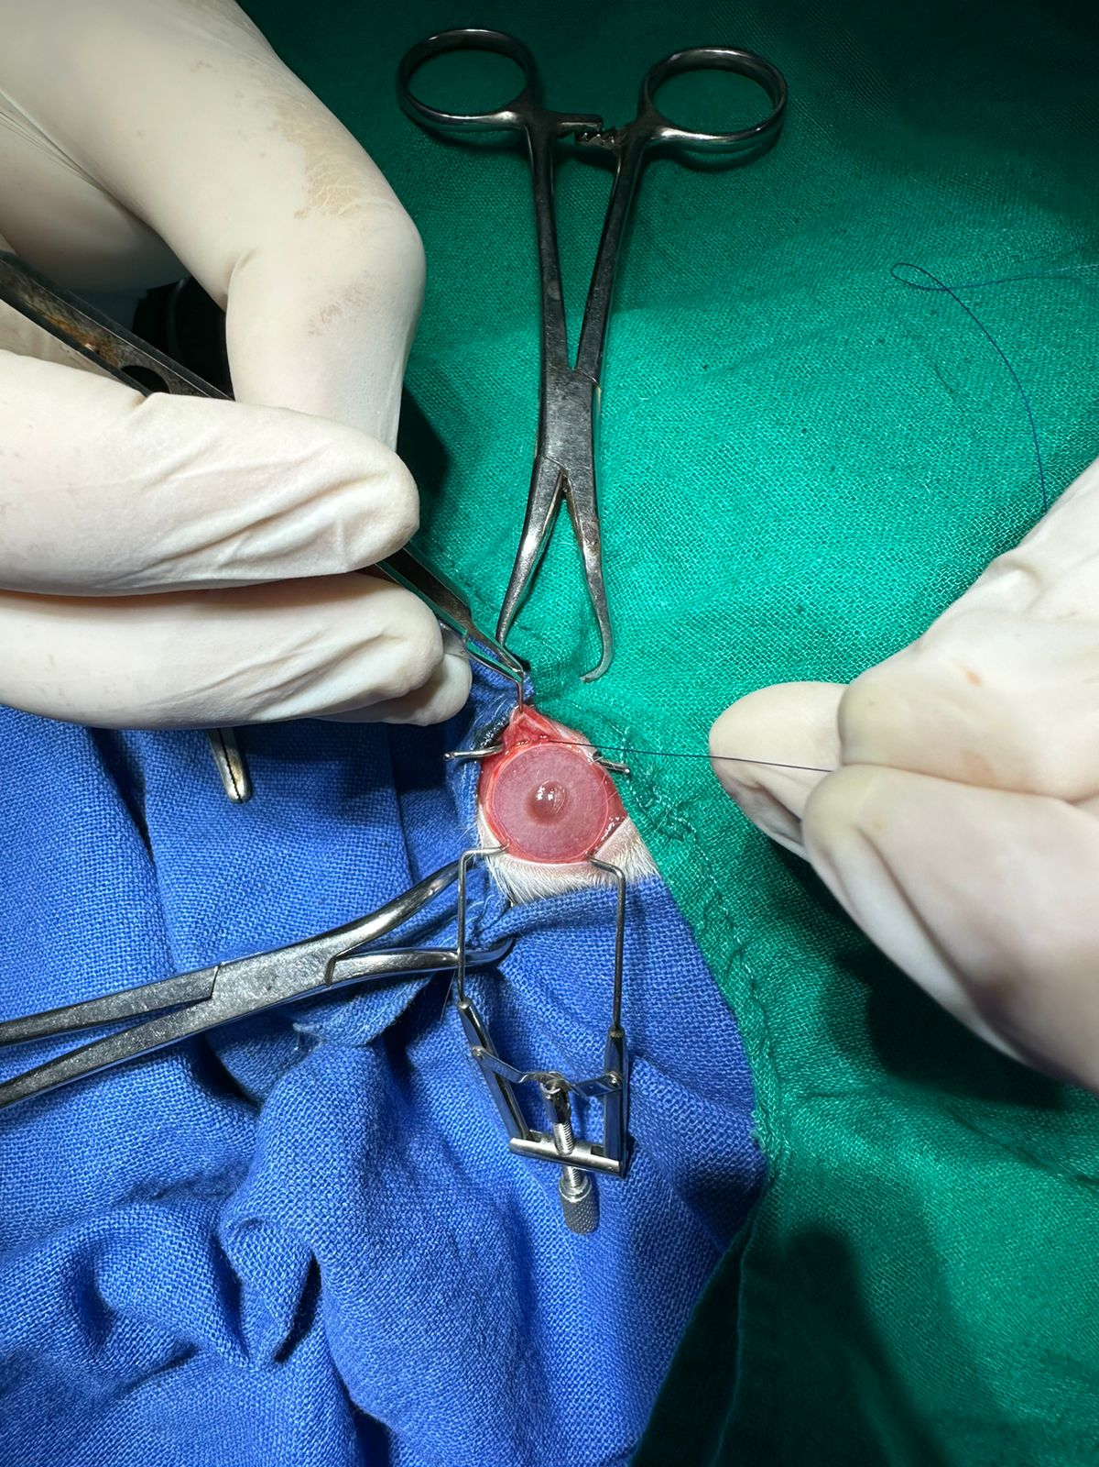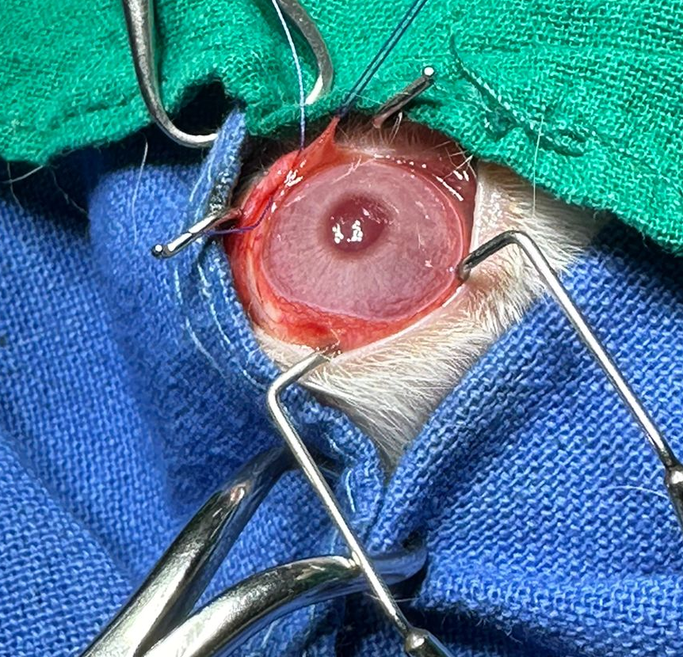
Fig. 3. conjunctival incision on gland Fig. 4. Suturing of conjunctival edges

