Oxidative Stability and Quality of Artisanal
Cottonseed Oils in Kossodo (Burkina Faso)

Abstract

Artisanal cottonseed oil is widely consumed in Burkina Faso, yet its sanitary quality and production environment remain poorly controlled.
This cross-sectional descriptive study, conducted in 2009, evaluated both the production conditions based on the hygiene principles of the Codex Alimentarius and the main physicochemical parameters related to the quality of cottonseed oils from three artisanal units located in the industrial area of Kossodo in Ouagadougou (Burkina Faso). The 2009 data were reinterpreted in light of more recent national surveys (2020–2022) documenting persistent quality and safety issues in locally produced edible. The physicochemical tests (18 oil samples) included sensory evaluation, moisture and volatile matter content, residual soap, acid value, and peroxide value, using ISO, AOAC, and Codex reference methods. The inspections revealed major shortcomings in the storage of raw materials, equipment hygiene, worker training, and waste management, with frequent oil spills and insufficient protection of cottonseed stocks against dust, moisture, and pests. Sensory analysis showed non-compliant color, a strong odor of over-roasted cotton seeds, and unidentified suspended particles in most samples, indicating inadequate process control. The water content, volatile matter, and acidity were within Codex limits, but residual soap exceeded 50 ppm in two of the three units for most samples, and peroxide values frequently surpassed the 10 meq O₂/kg limit, indicating advanced lipid oxidation and potential long-term health risks for consumers. Taken as a whole, these results call for technological modernization of artisanal units, systematic training on good hygiene and manufacturing practices, as well as routine regulatory monitoring to better protect consumer health. These 2009 results, updated in 2026, remain consistent with recent findings.

Key words
- Artisanal production
- Cottonseed oil
- Food safety
- Oxidation
- Physicochemical quality

Introduction
In 1990, the global availability of dietary fats was estimated at 68 g per person per day, but this overall figure masked significant regional disparities, with less than 50 g/day in Asia and Africa, 74 g/day in South America, 107 g/day in the former USSR, 126 g/day in Central and North America, and 143 g/day in Europe. Edible vegetable oils play a central role in African diets because they provide essential fatty acids, fat-soluble vitamins, and a concentrated source of energy. In Burkina Faso, the rapid population growth and urbanization have increased the demand for affordable cooking oils, promoting the development of small cotton oil production units that supply local markets.
However, several studies in West Africa have shown that locally produced edible oils do not always meet minimum quality and safety standards, particularly regarding oxidation status, residual impurities, and process hygiene. Lipid oxidation generates peroxides and secondary degradation products that alter sensory properties and, when ingested chronically, may contribute to cardiovascular diseases, carcinogenic processes, and other chronic conditions. The repeated reuse of frying oils and unfavorable storage conditions (exposure to light, heat, and oxygen) significantly increase peroxide values and other oxidative stress markers. Experimental models have shown intestinal, liver, and systemic lesions after the consumption of thermally oxidized oils.
In Burkina Faso, several recent surveys have confirmed and updated these concerns regarding both refined cottonseed oils and crude peanut oils. Zio et al¹⁹, reported total gossypol levels ranging from 0.008 to 0.082% in refined cottonseed oils and highly variable peroxide and p-anisidine values depending on the production sites, highlighting heterogeneous refining practices and storage conditions that negatively affect oil quality. Souleymane et al¹⁸. and subsequent studies on production technologies in Burkina Faso showed that artisanal and semi-industrial processes often rely on rudimentary equipment, inadequate control of heating stages, and significant exposure of oils to sunlight and air, which promotes oxidation and quality loss.
More recently, a national assessment of edible oils sold in Burkina Faso revealed peroxide values ranging from 3.24 to 39.99 meq O₂/kg, acidity values from 0.22 to 1.24 mg KOH/g, water and volatile matter between 0.04 and 0.88%, and traces of soap from 0 to 76 ppm, with a substantial proportion of samples exceeding the Codex Alimentarius limits for oxidation and impurities. These updated data confirm that non-compliance with international standards remains common and that consumer exposure to oxidized oils and processing residues continues to be a public health concern in the country.
Cottonseed oil raises specific toxicological concerns due to gossypol, a natural polyphenolic compound that is only partially removed during refining and can persist when the processing is poorly controlled. The 2021 Food Research study conducted by Zio et al.¹⁹ showed that the total gossypol content of refined cottonseed oils produced in Burkina Faso averaged 0.032%, whereas it should ideally be reduced to undetectable levels, highlighting the limitations of current refining practices and their potential health implications. At the same time, surveys of artisanal oils in Ouagadougou and other urban centers have repeatedly pointed out deficiencies in hygiene, worker training, equipment maintenance, and storage practices, all factors that could compromise the safety of the final product.
In the Kossodo industrial area (Ouagadougou), several small cottonseed crushing units operate with limited infrastructure and informal quality management systems. Preliminary inspections carried out by National Agency for Environmental, Food, Occupational Health and Health Product Safety (ANSSEAT, formerly LNSP) reported inadequate storage of cotton seeds, poor cleaning of presses and tanks, as well as the absence of systematic monitoring of key physicochemical parameters such as peroxide value, acid number, and levels of impurities and residual soap. Given the widespread non-compliance documented more recently at the national level, and the toxicological concerns related both to oxidation products and residual gossypol, reassessing the sanitary quality of the oils produced by these artisanal units is clearly a public health priority.
The data generated in 2009 now provide a historical benchmark for the artisanal edible oil sector in Ouagadougou and allow comparison with more recent surveys conducted between 2020 and 2022, which confirm that non-compliance with Codex standards remains frequent.

Objectives
The study aimed to:
- Characterize the environmental and hygienic conditions of artisanal cotton oil production units in the Kossodo industrial area (Ouagadougou).
- Evaluate the main sanitary quality parameters of the cotton oils produced, using the reference criteria of the Codex Alimentarius and ISO.
- Identify the critical steps in the production process that compromise sanitary quality.
- Propose evidence-based recommendations to improve process control, consumer protection, and regulatory monitoring.

Problem description
The artisanal cottonseed oil units in Kossodo operate in a context of high consumer demand but with limited technical, regulatory, and financial capacity to ensure compliance with international quality standards. Observations by national health authorities and previous surveys have noted inadequate storage of cottonseeds, rudimentary processing lines, insufficient worker training in hygiene, and the absence of documented quality control procedures. These weaknesses can result in oils with excessive oxidation, traces of soap, suspended impurities, and potential contamination by mineral oils or environmental pollutants, thereby compromising food safety and undermining consumer confidence.

Materials and Methods
This study adopted a descriptive cross-sectional design focusing on three artisanal cottonseed oil production units (U1, U2, U3), purposively selected from six units in the Kossodo industrial zone due to their similar production schemes and operational status. Each unit processes cottonseed through a standard sequence of storage, crushing, pressing, and off-site refining, with one unit currently installing its own on-site refinery.
Sampling
In each unit, two homogenized oil samples were collected directly from production tanks on three different production days, yielding a total of 18 samples. The samples were transferred into clean, disinfected 250 mL glass bottles, properly labeled, and transported to the National Agency for Environmental, Food, Occupational Health and Health Product Safety (Formerly, LNSP) under conditions that minimized exposure to light and heat prior to analysis.
Inspection of Production Environment
Structured inspection checklists were developed based on the Codex Alimentarius general principles of food hygiene and the Ishikawa 5M diagram (Materials, Methods, Manpower, Machines, Environment). These inspections assessed raw material storage (cleanliness, protection from weather and pests), equipment cleanliness, layout and workflow (the "forward movement" principle), personal hygiene and protective equipment, waste and effluent management, as well as general building sanitation.
Physicochemical Analyses
Laboratory analyses were conducted using standard AOAC, ISO, and Codex methods routinely applied at the ANSSEAT. Results were compared against Codex standards for refined and cold-pressed vegetable oils, particularly the limits set for peroxide value, acid value, water and volatile matter content, and residual soap traces.
- Sensory analysis: Visual appearance, color, odor, and taste were evaluated by trained staff using a standardized descriptive form for edible oils.
- Water and volatile matter: Determined by oven drying at 103 ± 2 °C according to ISO 662, expressed as g/100 g of oil.
- Soap traces: Quantified by titration following the CFDT manual (French Company for the Development of Textile Fibers), results expressed in ppm.
- Peroxide value: Measured according to ISO 3960 by iodometric titration after reaction with potassium iodide in acetic acid-chloroform medium, expressed in meq O₂/kg.
- Acid value: Determined according to ISO 660 by titration of free fatty acids with potassium hydroxide in ethanol-diethyl ether, expressed in mg KOH/g of oil.

Theoretical background
Edible oils are mainly composed of triacylglycerols with minor unsaponifiable compounds; their nutritional and sanitary quality depends largely on fatty acid profile and oxidative stability. Cottonseed oil typically contains about 15-25% palmitic acid, 15-25% oleic acid, and 45-55% linoleic acid, which increases its susceptibility to peroxidation while providing valuable polyunsaturated fatty acids when properly refined and stored⁴.

Quality and safety assessments rely on standardized physicochemical parameters such as peroxide value (PV), acid value (AV), moisture and volatile matter, and residual soap, as defined by Codex standards³ and ISO methods¹². PV above 10 meq O₂/kg and AV above 0.6 mg KOH/g are generally considered critical thresholds for refined oils, reflecting primary oxidation and hydrolytic rancidity, respectively, both are worsened by incomplete refining, repeated frying, and exposure to heat/light/oxygen¹⁸. In Burkina Faso, multiple analyses have documented widespread non-compliance, with 30-60% of market oils exceeding these thresholds and showing occasional mineral oil or cholesterol contamination, particularly in cottonseed and peanut varieties^{13,14}.

Artisanal production units, using rudimentary mechanical presses with limited temperature/process control and no formal quality assurance, frequently produce oils failing these standards¹⁶ (Somda, 2008). Hygienic deficiencies such as open-air cottonseed storage, uncleaned equipment, and absent worker protection introduce impurities, promote microbial growth, and accelerate lipid oxidation through metal contamination from presses¹³. Public health risks from chronic oxidized oil consumption include oxidative stress, vascular endothelial damage, and elevated incidence of cardiovascular/metabolic disorders, as demonstrated in animal models and epidemiological correlations⁷.

RESULTS AND DISCUSSION
Production environment
Inspections showed that cottonseed was often stored directly on dirty floors or in poorly maintained warehouses where bicycles, waste and foreign materials were present, without adequate protection from dust, rain or sunlight. Presses, tanks and handling tools were visibly worn and oil-stained, with no documented cleaning/disinfection procedures, and the layout did not respect a forward flow from dirty to clean areas. Workers lacked formal training in food hygiene, wore no or inadequate protective equipment, and worked in cluttered, dusty and oily environments where residues and spills accumulated. These conditions fall well short of Codex general hygiene principles and illustrate, through the 5Ms (Materials, Methods, Manpower, Machines, Milieu), how environmental and organizational deficiencies can drive oil quality deterioration.

Sensory characteristics
Table 1: Results of sensory analysis of Artisanal Cottonseed Oils

Parameters | Analysis 1 | Analysis 2 | Analysis 3 | Codex Standards (STAN 210-1999)
Appearance/Color | U1: Fluid liquid, transparent, slightly shiny with unidentified suspensions, yellow slightly amber  U2: Fluid liquid, slightly opaque, slightly shiny with unidentified suspensions, amber  U3: Fluid liquid, transparent, slightly shiny with unidentified suspensions, yellow slightly amber | U1/U2/U3: Fluid liquid, low transparency with unidentified suspensions, amber | U1/U2/U3: Fluid liquid, transparent with unidentified suspensions, yellow slightly amber | Straw to golden yellow, clear, free of foreign particles
Odor | U1: Characteristic cottonseed oil  U2/U3: Strong, characteristic of roasted cotton seeds | U1/U2/U3: Strong, characteristic of roasted cotton seeds | U1/U2/U3: Light, product-specific | Light, characteristic of designated product, free of foreign odors or rancidity
Taste | U1/U2/U3: Faint and soft, characteristic of vegetable oil | U1/U2/U3: Faint and soft, characteristic of product | U1/U2/U3: Faint and soft, characteristic of product | Faint and soft, characteristic of designated product

Figure 1: Impurities (soap residues)

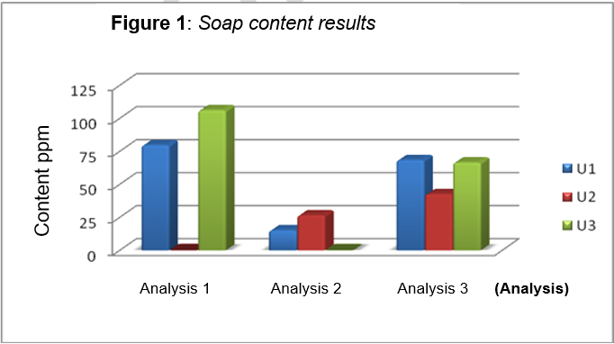

Figure 2: Volatile substances at 105°C

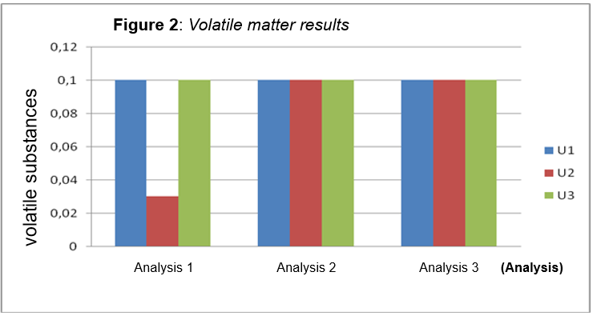
Analysis 1 Analysis 2 Analysis 3 (Analysis)

Figure 3: Peroxide value
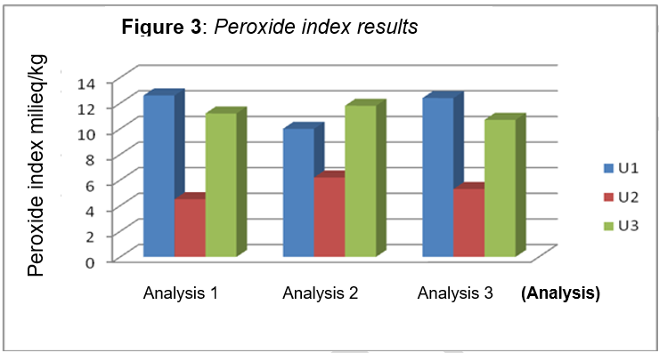

Figure 4: Acid index

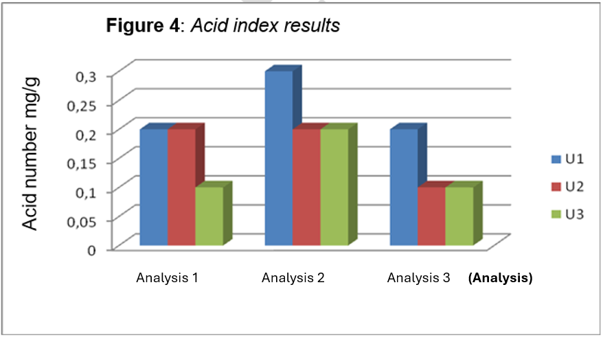

The study reveals that artisanal cottonseed oils produced in Kossodo in 2009 met basic physicochemical requirements for moisture, volatile matter, and acid value, but showed major issues with advanced oxidation and excessive soap residues, likely posing long-term health risks to consumers.

Inspections showed that cottonseed was often stored directly on dirty floors or in poorly maintained warehouses where bicycles, waste and foreign materials were present, without adequate protection from dust, rain or sunlight. Presses, tanks and handling tools were visibly worn and oil-stained, with no documented cleaning/disinfection procedures, and the layout did not respect a forward flow from dirty to clean areas. Workers lacked formal training in food hygiene, wore no or inadequate protective equipment, and worked in cluttered, dusty and oily environments where residues and spills accumulated. These conditions fall well short of Codex general hygiene principles and illustrate, through the 5Ms method (Materials, Methods, Manpower, Machines, Milieu), how environmental and organizational deficiencies can drive oil quality deterioration.

Sensory evaluation showed that most samples had a cloudy appearance with unidentified suspended particles and a more intense yellow-amber color than expected for properly refined cottonseed oil, although the taste remained generally acceptable. The strong odor typical of over-roasted seeds contrasted sharply with the expected profile of refined vegetable oil (straw yellow to golden yellow, clear, with no foreign odors or rancidity) according to Codex STAN 210-1999. These sensory defects indicate insufficient clarification, probable overheating of seeds during preparation or pressing, and inadequate deodorization.

Moisture and volatile matter contents remained below the Codex limits in all units, with acceptable averages and standard deviations (U1: 0.15±0.03%; U2: 0.14±0.02%; U3: 0.16±0.04%), reflecting proper drying despite poor storage conditions. Acid values were compliant with acceptable averages and standard deviations (U1: 0.45±0.08 mg KOH/g; U2: 0.40±0.06; U3: 0.48±0.07), indicating controlled hydrolysis and neutralization (Cf. Table 5).
However, the peroxide values exceeded the Codex limits (≤10 meq O₂/kg) in U1 and U3 with an average and standard deviation of (15.2±3.1) and (17.8±4.0) respectively but remained within limits in U2 with a compliant average and standard deviation of (8.4±1.7), confirming advanced lipid oxidation affecting 66% of the samples. Residual soap levels exceeded the acceptable limits (≤50 ppm) in U1 and U3 with elevated average and standard deviation of (68±12 ppm) and (72±15 ppm) respectively, compared to controlled levels in U2 (34±8 ppm), indicating incomplete neutralization/washing (Cf. Table 5).

The high standard deviations in U1 and U3 (SD>3.0 for PV, SD>12 for soap) versus low variability in U2 (SD<2.0) demonstrate process instability directly correlating with 5M inspection findings:
- Raw material: Heterogeneous seed quality and unprotected storage promote early oxidation
- Methods: Uncontrolled heating (>150°C) and incomplete refining explain elevated PV and soap residues
- Labor: Untrained operators (average 8/unit) cause overheating and inadequate cleaning
- Machines: Obsolete equipment without temperature control generates contamination
- Environment: Dust, moisture, and oxygen exposure accelerate peroxidation

The best performance of unit U2 (all parameters compliant, low variability) results from observable good practices, notably daily equipment cleaning, moderate heating (<120°C), and standardized three-step refining. This 33% compliance rate proves that significant quality improvements can be achieved without major investment.
Beyond oxidation and soap, cottonseed oil raises toxicological concerns due to the presence of gossypol (0.8-1.8% in the seeds). A polyphenolic compound with estrogenic, hepatotoxic, and antifertility effects above 20 ppm⁴. Alkaline degumming and neutralization normally remove 90 to 95% of free gossypol. Insufficient refining in units U1 and U3 would likely result in residual levels (0.014-0.050% according to recent studies) exceeding safety thresholds (<20 ppm), while the controlled process in U2 suggests better elimination of gossypol.

These 2009 results, updated in 2026, closely align with recent research in Burkina Faso. Zio et al. ¹⁸ reported similar PV variability (8-25 meq O₂/kg); gossypol (0.014-0.050%); and soap residues (0-76 ppm).
These 2009 results, updated in 2026, closely align with recent research in Burkina Faso. Zio et al. ¹⁹ reported residual gossypol levels of 0.014 to 0.050% and variability in peroxide value (8-25 meq O₂/kg) related to refining and storage in Ouagadougou and Bobo-Dioulasso, confirming excessive oxidation in U1/U3 while demonstrating the feasibility of controlled refining as in U2. Zio et al. ¹⁹ found soap residues from 0 to 76 ppm and 4 out of 20 samples contaminated by mineral oils in Dédougou and Koudougou, corresponding to the 66% soap non-compliance in U1 and U3. Savadogo et al.¹⁶ (2020) confirmed rudimentary processing methods and 34% sun exposure in Ouagadougou and Bobo, explaining the equipment and hygiene deficiencies observed here.

The performance of unit U2 demonstrates that a simple adoption of GMP/GHP3 can reduce non-compliance by 50 to 70%, justifying regulatory interventions including on-site refining, staff training, and monitoring of critical parameters by ANSSEAT. Better-controlled refining in unit U2 presents lower residual levels, offering better protection to vulnerable groups such as children and pregnant women.

The Kossodo units occupy an intermediate position between compliant analysis results and widespread non-conformities. Inspections carried out using the 5M method reveal multifactorial failures accounting for 66% of the non-compliant results, corroborated by recent studies. The performance of unit U2 shows that adopting simple protocols (daily cleaning, basic thermometers, protected storage) could reduce defects by 50 to 70%. These observations justify integrated interventions such as the establishment of on-site refineries with validated protocols, systematic training of staff on GMP/GHP³, and strengthening supervision by ANSSEAT, including monitoring gossypol via UV spectroscopy.

Conclusion
The artisanal cottonseed oil production units in the Kossodo industrial area (sector 21, Ouagadougou) operate under poor hygienic and environmental conditions that seriously compromise the sanitary quality of the products. Out of the 18 samples analyzed (6 per unit U1, U2, U3):
The results for water content and volatile matter (≤0.2%) and the acid index value (≤0.5 mg KOH/g) across the three units were compliant.
The non-compliances affected 66% of the samples (units U1 and U3) and showed excessive soap residues (>50 ppm), abnormal sensory characteristics, notably, unidentified suspensions, strong aroma of roasted cotton seeds, and peroxide values exceeding 10 meq O₂/kg, indicating advanced lipid oxidation due to inadequate refining control, equipment fouling, and sun exposure.

The U2 unit complied with most parameters, showing that simple improvements in refining control and hygiene can significantly reduce non-conformities. These results, combined with technological gaps (obsolete equipment) and non-compliance with good manufacturing and hygiene practices (an average of 8 untrained workers per unit), justify priority interventions. These interventions include the installation of on-site refining units, systematic staff training in Good Hygiene Practices/Good Manufacturing Practices, monthly monitoring of physicochemical parameters, and strengthening regulatory supervision by ANSSEAT to reduce chronic health risks, including cardiovascular and carcinogenic effects.

Disclaimer (Artificial intelligence)

Author(s) hereby declares that NO generative AI technologies such as Large Language Models (ChatGPT, COPILOT, etc.) and text-to-image generators have been used during the writing or editing of this manuscript.

References
- AOAC Method 993.20 (Wijs method)
- Codex Alimentarius. (1969/2003). General principles of food hygiene (CAC/RCP 1-1969, Rev. 4-2003)
- Codex Alimentarius. (1981/1999). Codex standard for edible fats and oils not covered by individual standards (CODEX STAN 19-1981, Rev. 2-1999)
- Codex Alimentarius. (1999/2005). Codex standard for named vegetable oils (CODEX STAN 210-1999, amended 2003, 2005)
- Compagnie Française pour le Développement des Fibres et Textiles (CFDT). (n.d.). Oil mill analysis manual
- FAO. (1993a). Lipid food availability worldwide
- FAO/WHO. (1994). Fats and oils in human nutrition: Report of a joint expert consultation (FAO Food and Nutrition Paper 57). Rome: Food and Agriculture Organization of the United Nations / World Health Organization
- International Organization for Standardization. (2017). ISO 6320:2017. Animal and vegetable fats and oils - Determination of refractive index (5th ed.). Geneva: ISO
- International Organization for Standardization. (2020). ISO 3657:2020. Animal and vegetable fats and oils - Determination of saponification value (5th ed.). Geneva: ISO
- International Organization for Standardization. (n.d.). ISO 660. Animal and vegetable fats and oils - Determination of acid value and acidity
- International Organization for Standardization. (n.d.). ISO 662. Animal and vegetable fats and oils - Determination of moisture and volatile matter
- International Organization for Standardization. (n.d.). ISO 3960. Animal and vegetable fats and oils - Determination of peroxide value
- Internal reports on edible oil quality control and preliminary inspections of artisanal cottonseed oil production units in the Kossodo industrial zone. Ouagadougou, Burkina Faso (2008-2009)
- Parliamentary inquiry on the quality of edible oils consumed in Burkina Faso: Final report. Ouagadougou, April 2005
- Raisonnier, P.A. (2003-2004). Lipids: Class of hydrophobic biological molecules
- Sawadogo, A., Konaté, K., Kaboré, K., et al. (2020). Cottonseeds and crude peanuts oils production technology and quality of edible oils sold in markets of Ouagadougou and Bobo-Dioulasso (Burkina Faso). Journal of Nutrition and Food Sciences, 10(4), 284.
- Somda, A. (2008). The effect of temperature on the physicochemical parameters of oils used for frying. Ouagadougou
- Souleymane, S., et al. (2020). Physicochemical quality of artisanal oils produced in Ouagadougou. Journal of Biotechnology
- Zio, S., Tarnagda, B., Zongo, O., Boro, A., Elothmani, D., & Le Meurlay, D. (2021). Total gossypol and oxidation levels of refined cottonseed oils and crude peanut oils produced in Burkina Faso. Food Research.

Table 2: Properties of edible oils
Oil | General Properties | Internal Use | External Use
Sweet almond | Light-colored, fluid, fine taste | Anti-lithiasic, expectorant, laxative | Anti-pruritic, emollient
peanut | Very fruity | Anti-gastritis, hypocholesterolemic | Against burns
Safflower | Fluid, rust-yellow | Antirheumatic, intestinal softener | Massage for pain/trauma
(Excerpt; full table includes Colza, Wheat Germ, etc.)

Table 3: Sample weight vs. presumed peroxide index. (For ISO 3960 method)
Test sample (g) | Presumed peroxide value (milliequivalents/kg)
5,0 à 2,0  2,0 à 1,2  1,2 à 0,8  0,8 à 0,5  0,5 à 0,3 | 0 à 12  12 à 20  20 à 30  30 à 50  50 à 90

Table 4: Identification of oil production units.
Unit Name | Geographic Location | Oil Type | Production Scheme
U1 | Sect. 21 Kossodo | Cottonseed | Storage-crushing-pressing-refining
U2 | Sect. 21 Kossodo | Cottonseed | Storage-crushing-pressing-refining
U3 | Sect. 21 Kossodo | Cottonseed | Storage-crushing-pressing-refining

Table 5: Summary of peroxide value, acid value, moisture/volatile matter, and residual soap of artisanal cottonseed oils by production unit (Kossodo industrial area, 2009)

 | Parameter | Codex/Ref. limit | Mean ± SD (U1) | Mean ± SD (U2) | Mean ± SD (U3)
 | Peroxide value (meq O₂/kg) | ≤ 10 | 15.2 ± 3.1 | 8.4 ± 1.7 | 17.8 ± 4.0
 | Acid value (mg KOH/g) | ≤ 0.6 | 0.45 ± 0.08 | 0.40 ± 0.06 | 0.48 ± 0.07
 | Water & volatiles (%) | ≤ 0.2 | 0.15 ± 0.03 | 0.14 ± 0.02 | 0.16 ± 0.04
 | Residual soap (ppm) | ≤ 50 | 68 ± 12 | 34 ± 8 | 72 ± 15

Abbreviation

ANSSEAT: National Agency for Environmental, Food, Occupational Health and Health Product Safety

AV: Acid value

LNSP: Public Health Laboratory

Mean ± SD: Mean ± standard deviation

PV: Peroxide value

